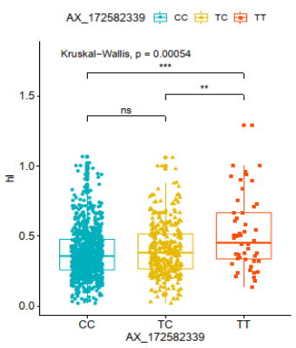
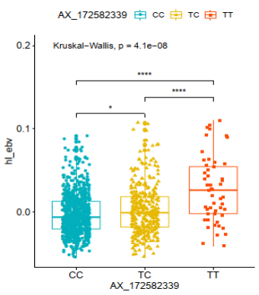
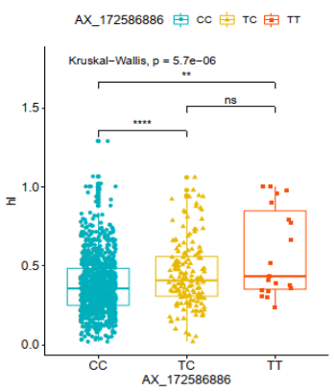
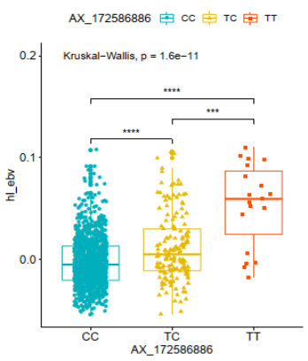
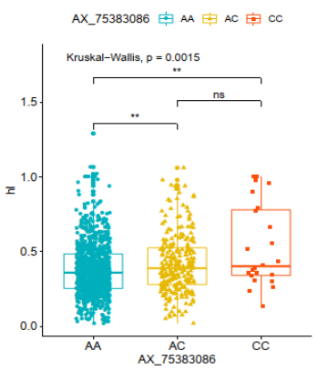
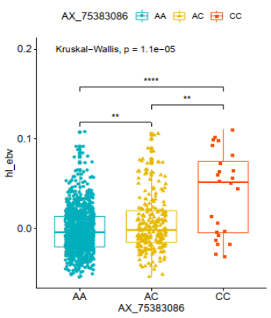
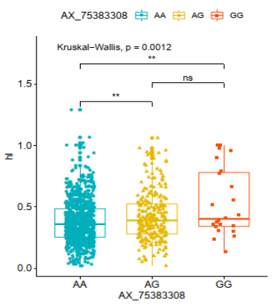
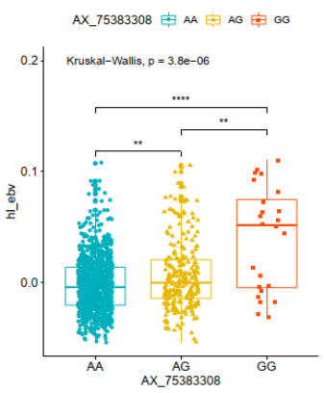
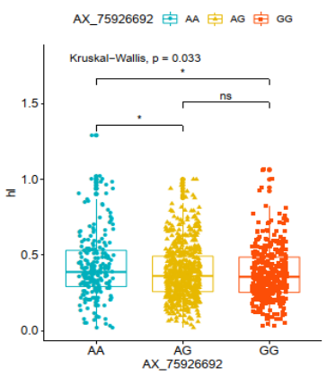
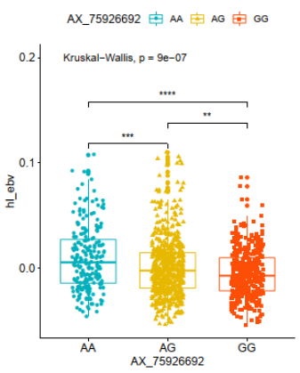
a
b
c
d
e

Figure S1 The relationship between separated SNPs with pleiotropic efffect and H/L.
a:Genotype effect plot of SNP AX_172582339 to indicate the significance among three types (n = 821, n = 330, and n = 52 for CC, TC, and TT, respectively).
b:Genotype effect plot of SNP AX_172586886 to indicate the significance among three types (n = 1025, n = 159, and n = 19 for CC, TC, and TT, respectively).
c:Genotype effect plot of SNP AX_75383086 to indicate the significance among three types (n = 936, n = 243, and n = 24 for AA, AC, and CC, respectively).
d:Genotype effect plot of SNP AX_75383308 to indicate the significance among three types (n = 939, n = 240, and n = 24 for AA, AG, and GG, respectively).
e:Genotype effect plot of SNP AX_75926692 to indicate the significance among three types (n = 219, n = 596, and n = 388 for AA, AG, and GG, respectively).

