Supplementary Figures and Tables
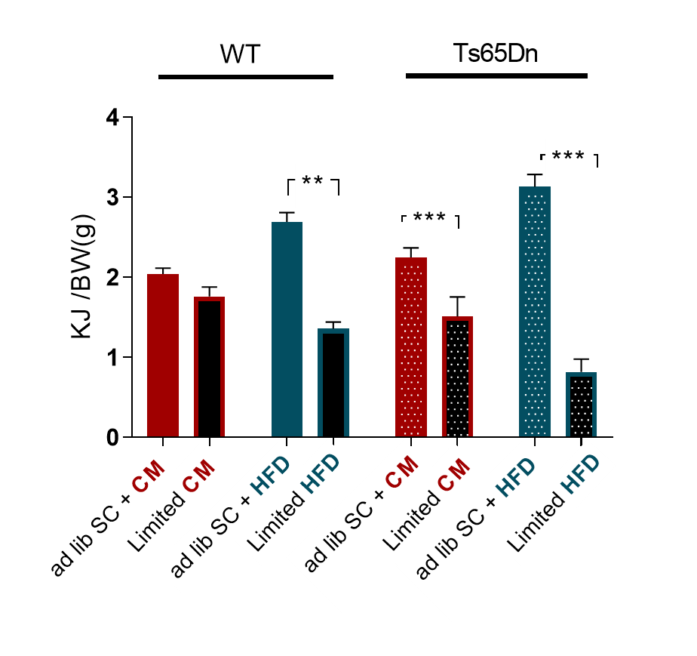
Supplementary Figure 1. During the limited access test the mice from energy-dense groups did show partial energy compensation. Total energy intake (SC+CM/ SC+HFD) in ad libitum (left) and in limited conditions of access to CM or HF, where only the SC was available (right). ad lib = ad libitum; Data are expressed as mean ± SEM. SC + CM group: WT = 9, Ts65Dn = 10; SC + HFD group: WT = 7; Ts65Dn = 7. * p < 0.05; ** p < 0.01.
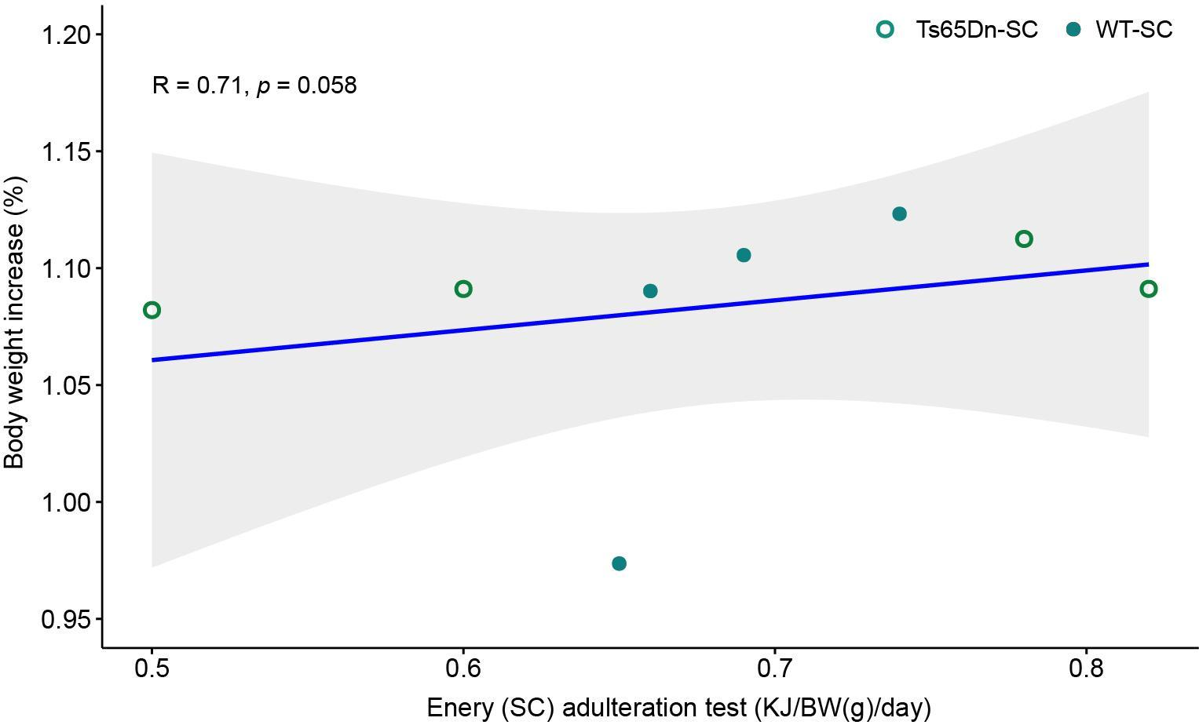

Supplementary Figure 2. Dot plot showing the relationship between energy intake of adulterated SC in the quinine adulteration test on the x-axis and the body weight increase on the y-axis in SC group. SC group: WT = 4, Ts65Dn = 4.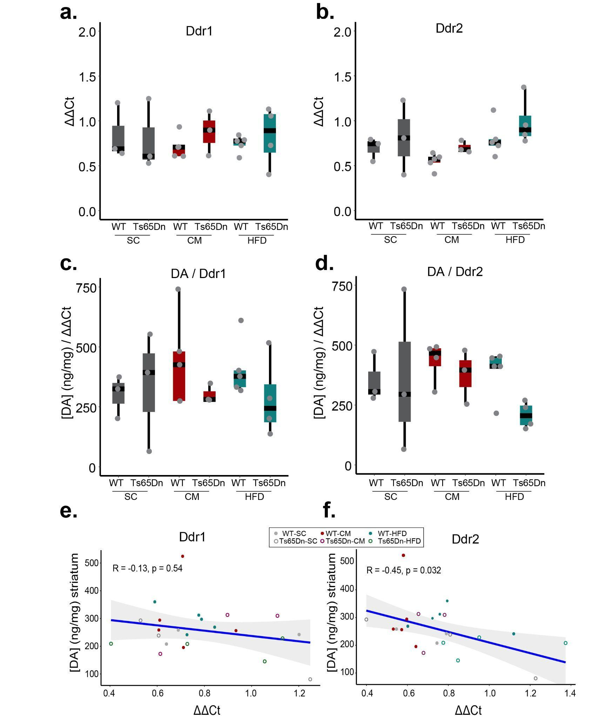
Supplementary Figure 3. There is a significant negative correlation between dopamine in the striatum and Ddr2 in the cortex. (a) RT-qPCR analysis of Ddr1 expression in the cortex of WT and Ts65Dn mice subjected to SC, CM or HFD. (b) RT-qPCR analysis of Ddr2 expression in the cortex of WT and Ts65Dn mice subjected to SC, CM or HFD. (c) Ratio between DA in striatum and Ddr1 expression in cortex. (d) Ratio between DA in striatum and Ddr2 expression in cortex. On the boxplots, the horizontal line indicates the median, the box indicates the first to third quartile of expression and whiskers indicate 1.5 × the interquartile range. (e) Correlation between DA in striatum and Ddr1 expression in cortex of WT and Ts65Dn subjected to SC, CM or HFD. (d) Correlation between DA in striatum and Ddr2 expression in cortex of WT and Ts65Dn subjected to SC, CM or HFD. Spearman correlation. SC group: WT = 3, Ts65Dn = 3; SC + CM group: WT = 5, Ts65Dn = 3; SC + HFD group: WT = 5; Ts65Dn = 4.
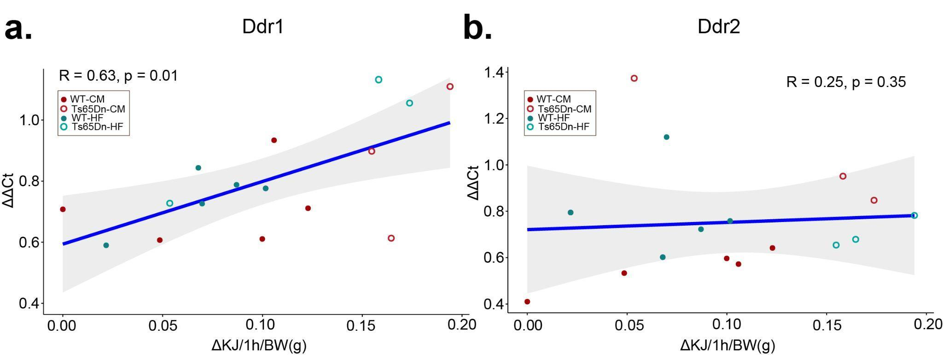
Supplementary Figure 4. There is a significant positive correlation between Ddr1 in the cortex and the increase of energy intake of HFD at the third day of limited access compared to ad libitum conditions. (a) Correlation between Ddr1 in cortex and the increase of energy intake of HFD at the third day of limited access compared to ad libitum conditions in WT and Ts65Dn mice. (b) Correlation between Ddr1 in cortex and the increase of energy intake of HFD at the third day of limited access compared to ad libitum conditions in WT and Ts65Dn mice. Spearman correlation. SC + CM group: WT = 5, Ts65Dn = 3; SC + HFD group: WT = 5; Ts65Dn = 3.
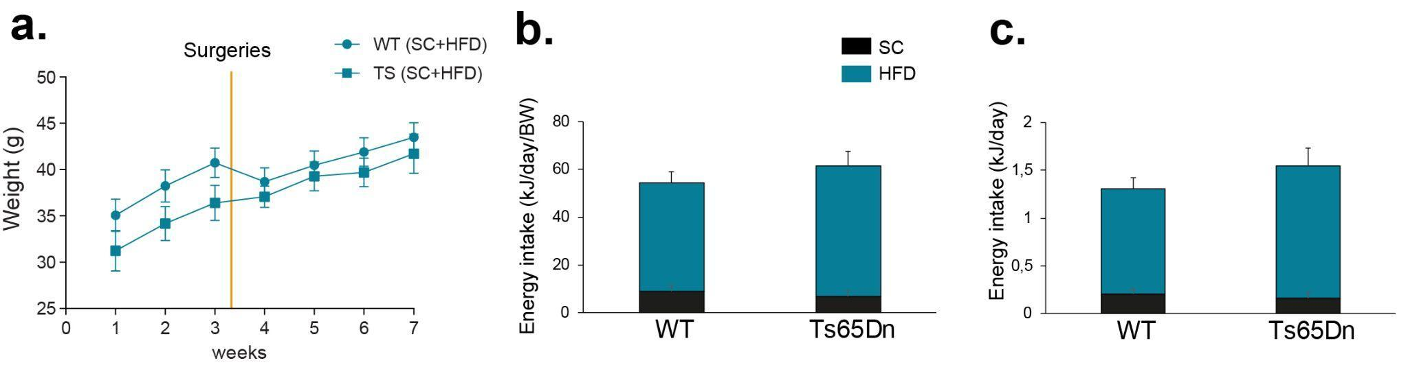
Supplementary Figure 5. (a) Injection of AAVs into the PL and NAc did have a significant effect on weight gain both on WT or Ts65Dn mice (WT = 12 mice, Ts65Dn = 6 mice). (b-c) AAV injection did not modify meal pattern both on WT and Ts65Dn mice. (WT = 12 mice, Ts65Dn = 6 mice). Note that after surgery recovery mice continue gaining weight.

 | ST (ng/mg)
 | NA | AD DOPAC | DA | 5HIAA | 5HT | 5HIAA/5HT | NA/DA
WT-SC | 6.23±2.37 | 42.70±3.57 | 194.43±27.20 | 44.88±5.43 | 35.48±3.51 | 1.39±0.30 | 0.05±0.03
TS-SC | 11.44±5.07 | 45.10±6.20 | 193.80±30.04 | 62.8±98.83 | 57.33±11.79 | 1.39±0.24 | 0.03±0.01
WT-SC+CM | 4.58±0.92 | 53.00±8.17 | 294.95±47.71 | 89.24±17.24 | 43.49±11.22 | 3.01±1.26 | 0.02±0.00
TS- SC+CM | 8.35±2.41 | 55.16±6.32 | 249.90±29.16 | 67.36±8.25 | 48.35±3.40 | 1.45±0.26 | 0.04±0.02
WT-SC+HF | 13.05±4.97 | 71.09±8.70 | 295.88±18.36 | 72.23±7.53 | 42.06±5.19 | 2.04±0.61 | 0.04±0.01
TS- SC+HF | 8.98±2.29 | 46.61±4.58 | 200.66±14.32 | 54.33±4.16 | 36.22±5.62 | 1.65±0.26 | 0.05±0.01

Supplementary Table 1. Tissue levels of monoamines and their metabolites in the striatum (ST) of wild-type (WT) and Ts65Dn (TS) mice. Levels (ng/mg) of noradrenaline (NA); serotonin (5HT); dopamine (DA), and 5-Hydroxyindoleacetic acid (5HIIA), a 5HT metabolite. Values for adrenaline (AD) and 3,4-Dihydroxyphenylacetic acid (DOPAC), a DA metabolite, are given together, since the 2 species could not be quantified separately due to similar elution times. The ratios between the neurotransmitters and their metabolites are also presented. Data are presented as mean ± SEM, of ng/mg total tissue. SC group: WT = 6, Ts65Dn = 6; SC + CM group: WT =6, Ts65Dn = 6; SC + HFD group: WT = 5; Ts65Dn = 5.
 | PFC (ng/mg)
 | NA | AD DOPAC | DA | 5HIAA | 5HT | 5HIAA/5HT | NA/DA
WT-SC | 36.91±8.33 | 5.18±0.86 | 6.20±1.41 | 39.66±3.76 | 71.66±10.99 | 0.64±0.15 | 8.51±3.08
TS-SC | 47.26±7.50 | 5.65±1.30 | 2.27±0.56 | 35.12±4.48 | 62.09±9.70 | 0.53±0.11 | 28.97±9.07
WT-SC+CM | 54.29±5.76 | 6.38±1.58 | 2.30±0.40 | 27.91±2.84 | 96.15±16.70 | 0.33±0.06 | 27.97±5.97
TS- SC+CM | 34.70±6.33 | 6.02±1.18 | 5.37±0.97 | 29.88±6.31 | 70.01±10.86 | 0.53±0.18 | 7.52±1.91
WT-SC+HF | 35.10±5.03 | 3.55±0.94 | 4.82±0.54 | 29.09±3.88 | 61.74±9.09 | 0.56±0.17 | 7.84±1.70
TS- SC+HF | 36.05±2.65 | 5.03±0.84 | 1.68±0.61 | 22.03±1.87 | 55.45±7.05 | 0.41±0.04 | 36.97±12.88

Supplementary Table 2. Tissue levels of monoamines in the prefrontal cortex (PFC) of wild-type (WT) and Ts65Dn (TS) mice. NA: noradrenaline; values for AD: adrenaline and DOPAC: 3,4-Dihydroxyphenylacetic acid, a metabolite of the neurotransmitter dopamine (DA) were given together, since 2 species could not be quantified separately due to similar elution times; 5-HT: serotonin; 5HIIA: 5-Hydroxyindoleacetic acid, a metabolite of 5-HT. The ratios between the neurotransmitters and their metabolites are also presented. Data are presented as mean ± SEM ng/mg total tissue. SC group: WT = 5, Ts65Dn = 5; SC + CM group: WT =6, Ts65Dn = 6; SC + HFD group: WT = 5; Ts65Dn = 5.

