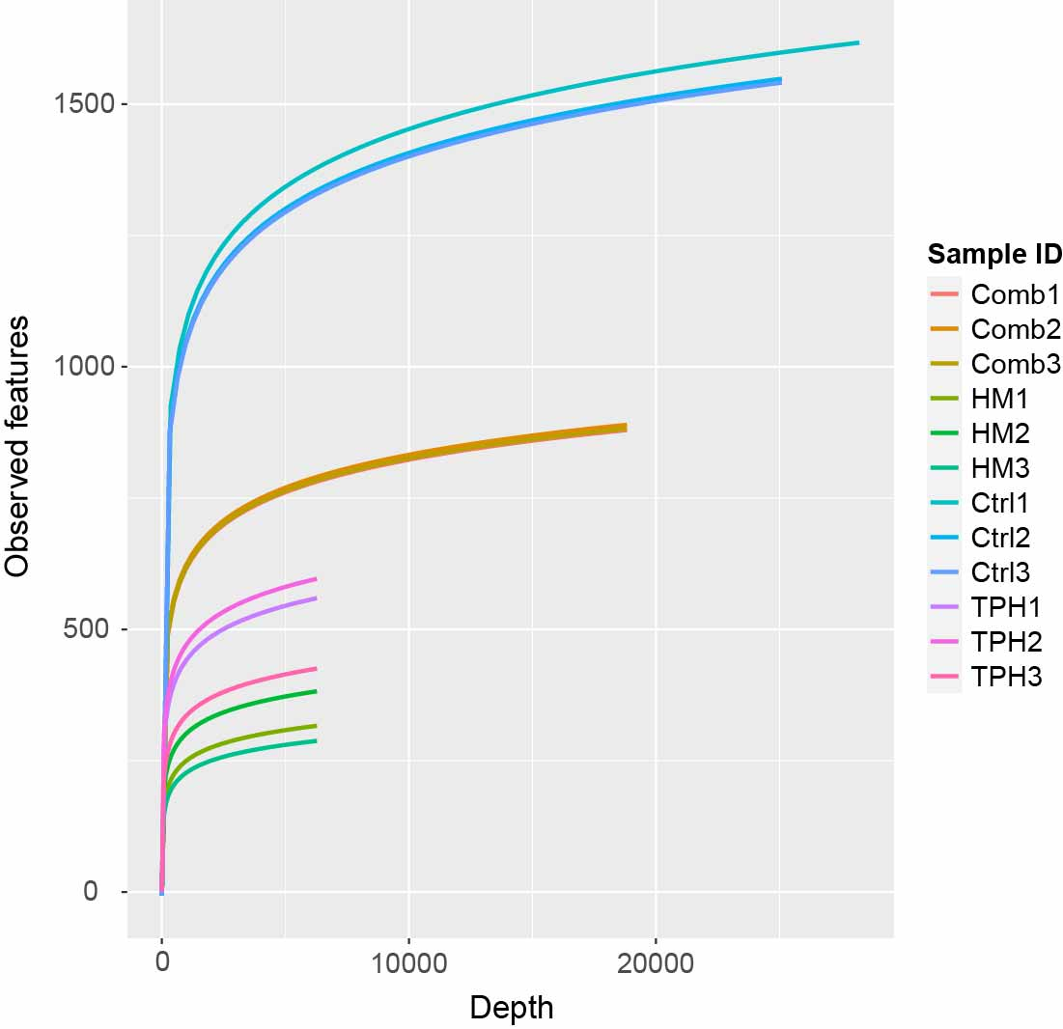
Figure S1. Rarefaction curve analysis of observed features for all samples.
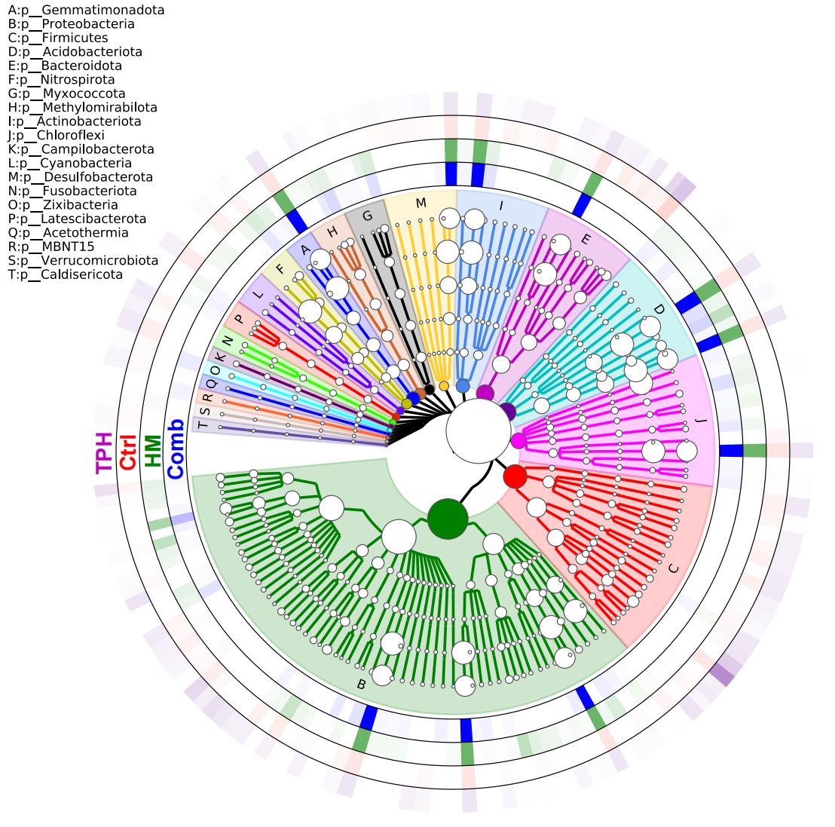
Figure S2. The phylogenetic tree of the top 150 genera of the four groups. From root to the branch points means kingdoms to genus taxonomic levels.
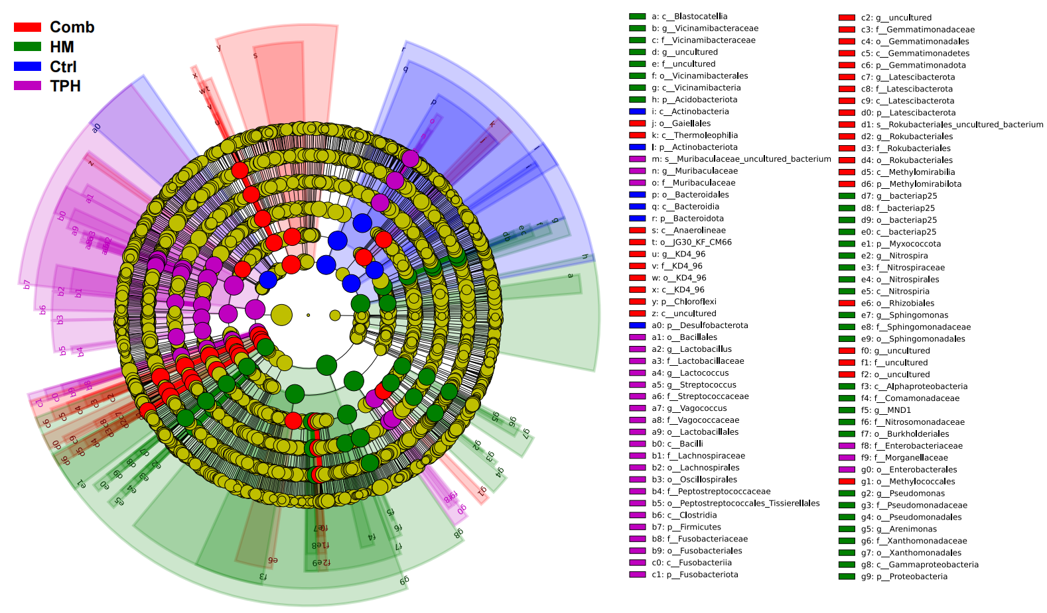
Figure S3. Linear discriminant analysis (LDA) effect size (LEfSe) revealed significant soil microbial taxa enrichment in Ctrl, TPH, HM and Comb. LDA scores >4.0 and p < 0.05 are shown.

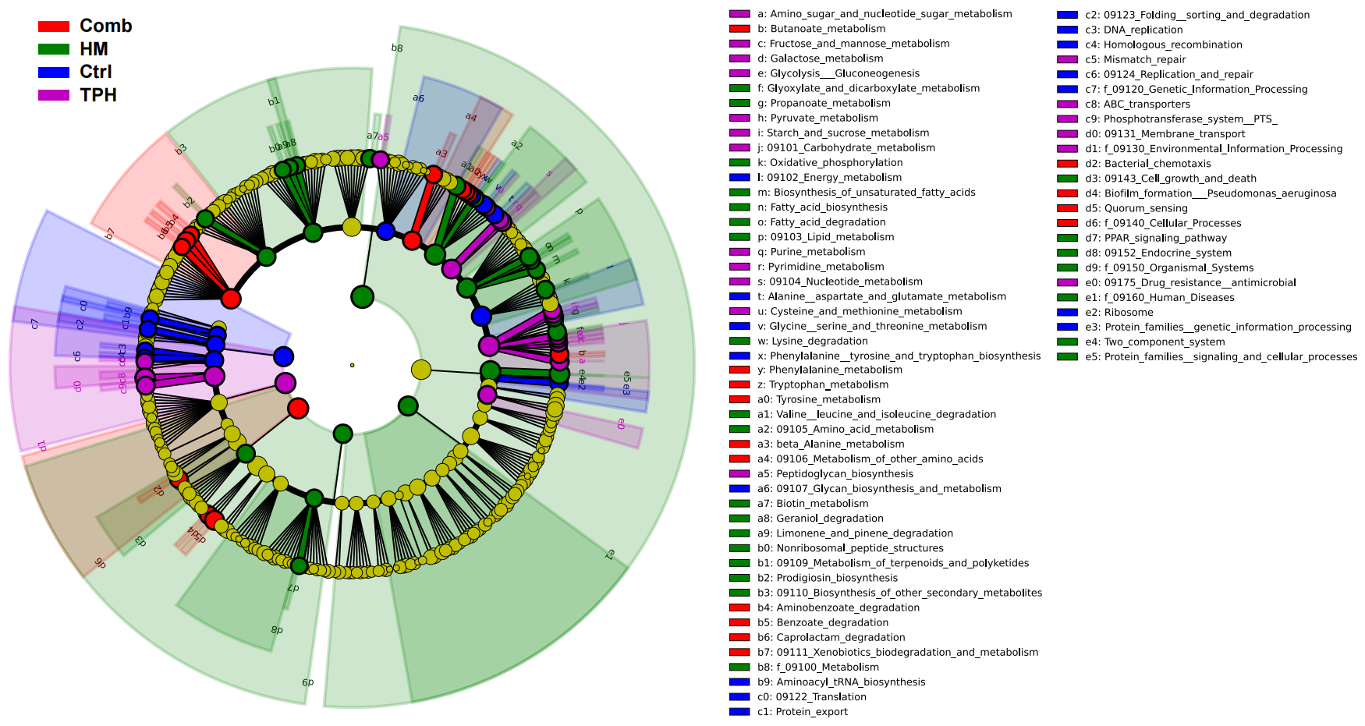
Figure S4. Linear discriminant analysis (LDA) effect size (LEfSe) revealed significant soil microbial pathways enrichment in Ctrl, TPH, HM and Comb. LDA scores >3.0 and p < 0.05 are shown.

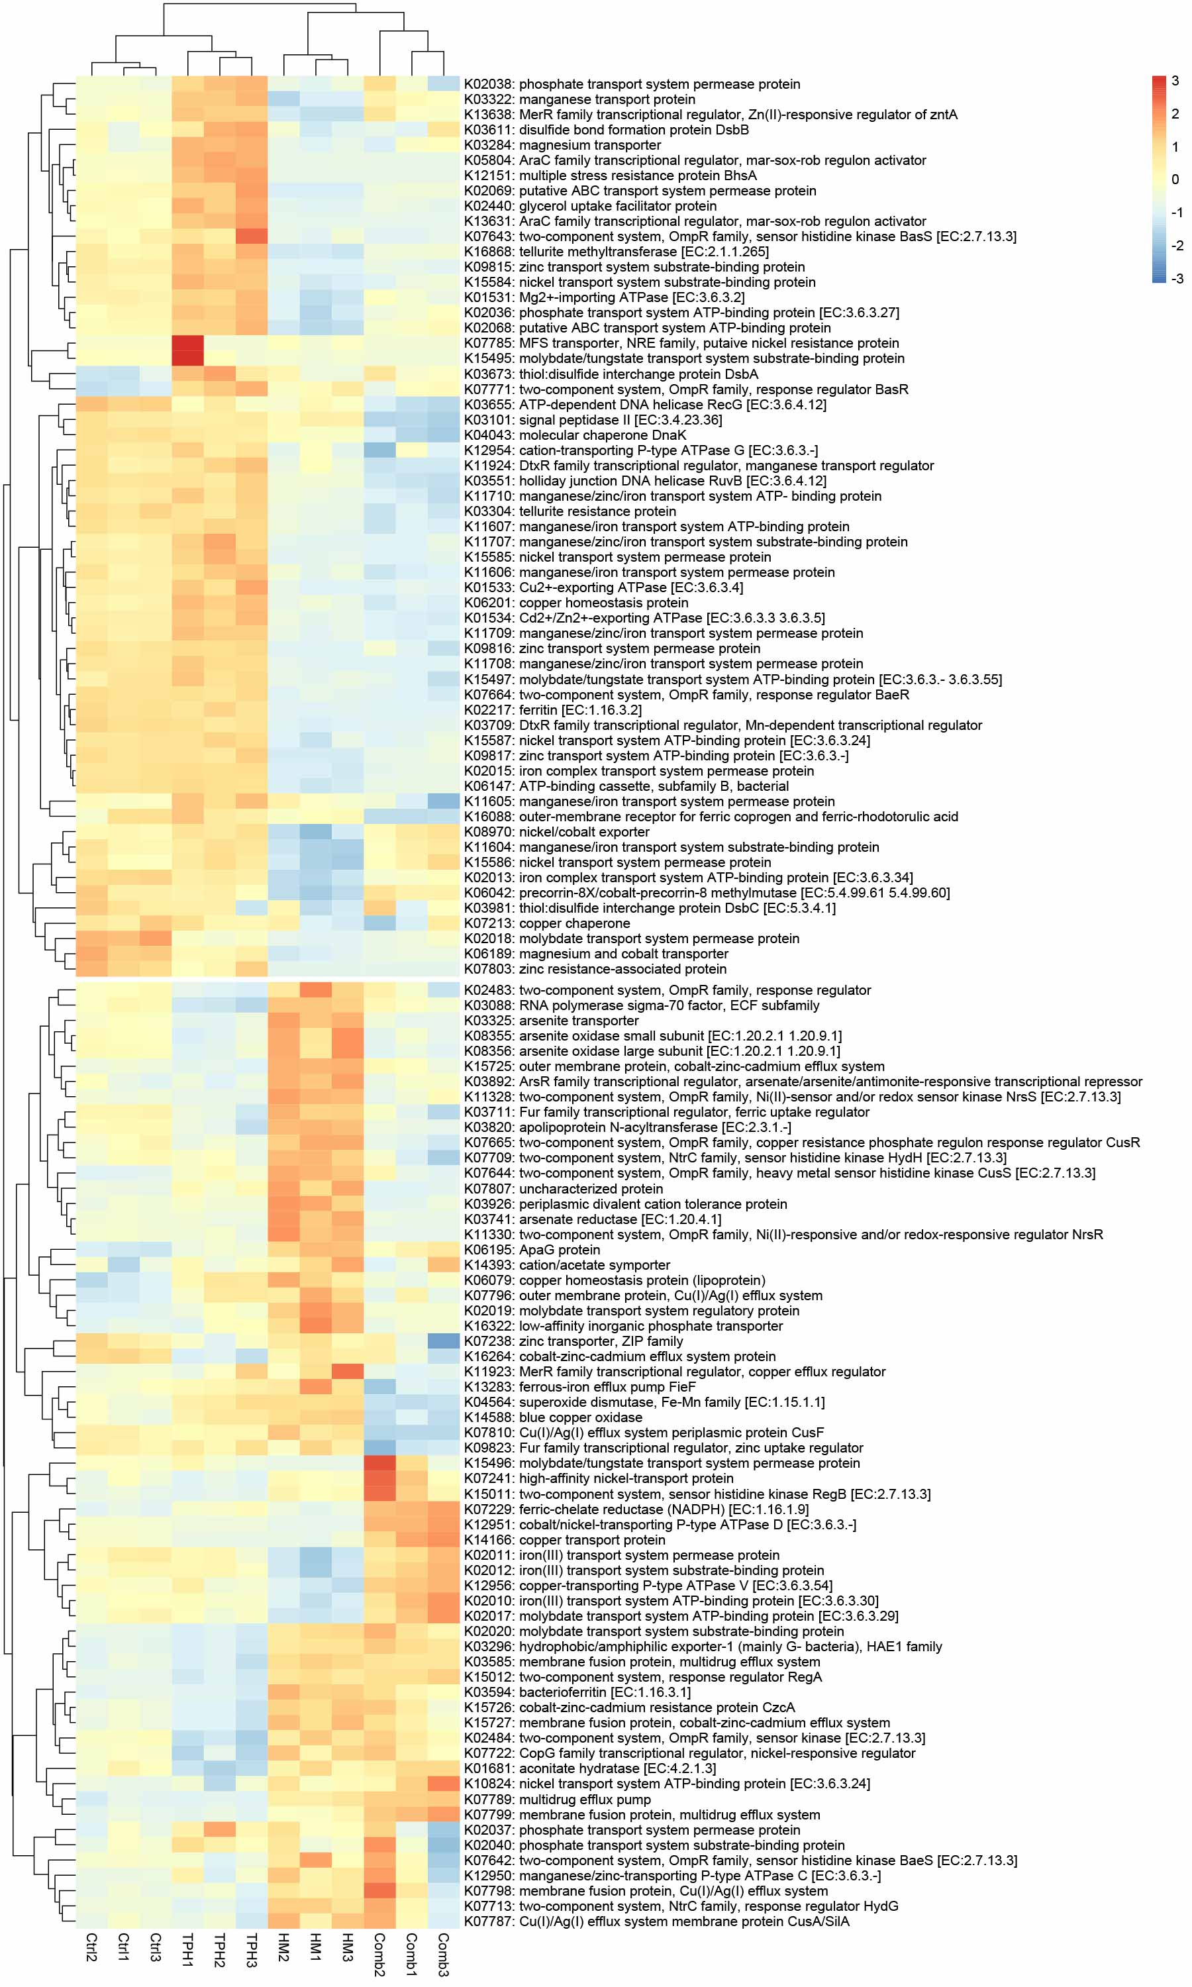
Figure S5. Heatmap illustrates the abundance changes of the 121 metals resistance genes.

