Supporting Information

Ionic liquid-modified TiO₂ nanoparticle-filled polyurethane as a new electro-responsive elastomer with controlled modulus and actuation strain by an electric field
Zhenjie Zhao,¹ Zhenke Chen,¹ Meiyu Zhang,¹ Yongri Liang,^{1*} Ying Dan Liu,^{1*} and Hyoung Jin Choi²
¹State Key Lab of Metastable Materials Science and Technology, and College of Materials Science and Engineering, Yanshan University, Qinhuangdao 066004, P.R. China
²Department of Polymer Science and Engineering, Inha University, Incheon 22212, Korea
*Corresponding author E-mail: ydliu@ysu.edu.cn (YDLIU); liangyr@ysu.edu.cn (YLIANG)

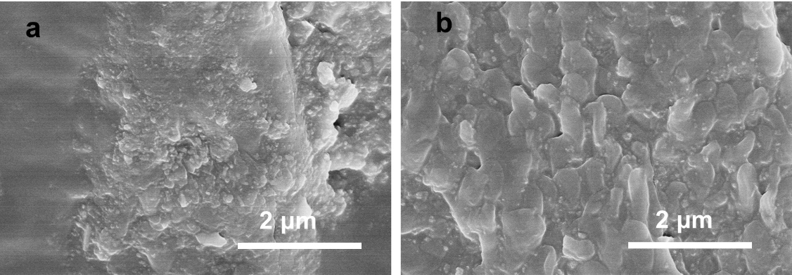
Figure S1. SEM images of PU-based EREs: TiO₂-IL-AA-10wt% (a) and TiO₂-IL-AA-20wt% (b), respectively.

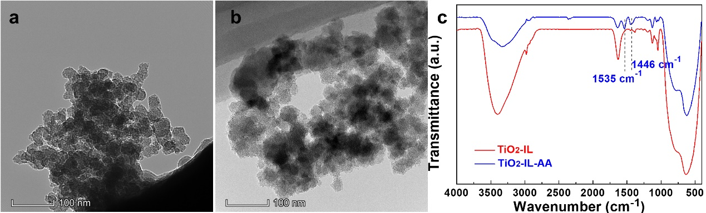
Figure S2. TEM image of TiO₂-IL (a), TiO₂-IL-AA (b) nanoparticles and their FTIR spectra (c).

Figure S3. TGA (a) and DSC (b) curves of the EREs containing TiO₂-IL-AA nanoparticles.

Figure S4. Storage modulus (G′) and loss modulus (G″) of PU-based EREs containing 10wt% TiO₂-IL (a), 10wt% TiO₂-IL-AA (b), and 20wt% TiO₂-IL-AA (c), respectively.

Figure S5. Storage modulus (G′) and loss modulus (G″) of PU-based EREs filled with 10wt% TiO₂-IL (a), 10wt% TiO₂-IL-AA (b), and 20wt%TiO₂-IL-AA (c).

Figure S6. Electrostriction effect of pure PU (a) and PU-based EREs filled with TiO₂-IL (b) and TiO₂-IL-AA (c) nanoparticles as a function of electric field strength.

