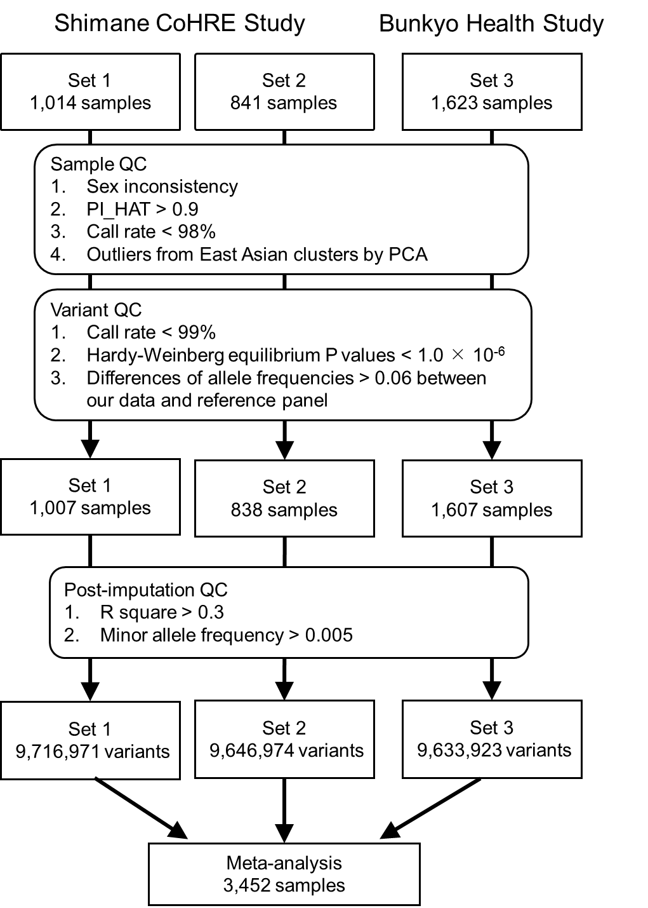

Supplementary Figure 1. Overview of the meta-analysis for the participants aged 60 years or older
Three genome-wide association studies (Set 1-3) from two cohort studies (Shimane CoHRE Study and Bunkyo Health Study) were analyzed. PCA, principal component analysis; QC, quality control.
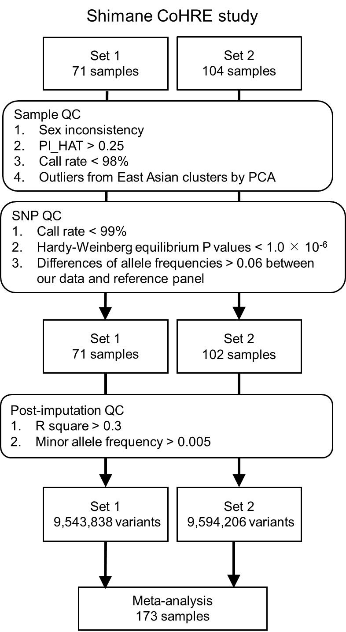

Supplementary Figure 2. Overview of the meta-analysis for the participants aged under 60 years
Two genome-wide association studies (Set 1-2) from Shimane CoHRE Study were analyzed. PCA, principal component analysis; QC, quality control.
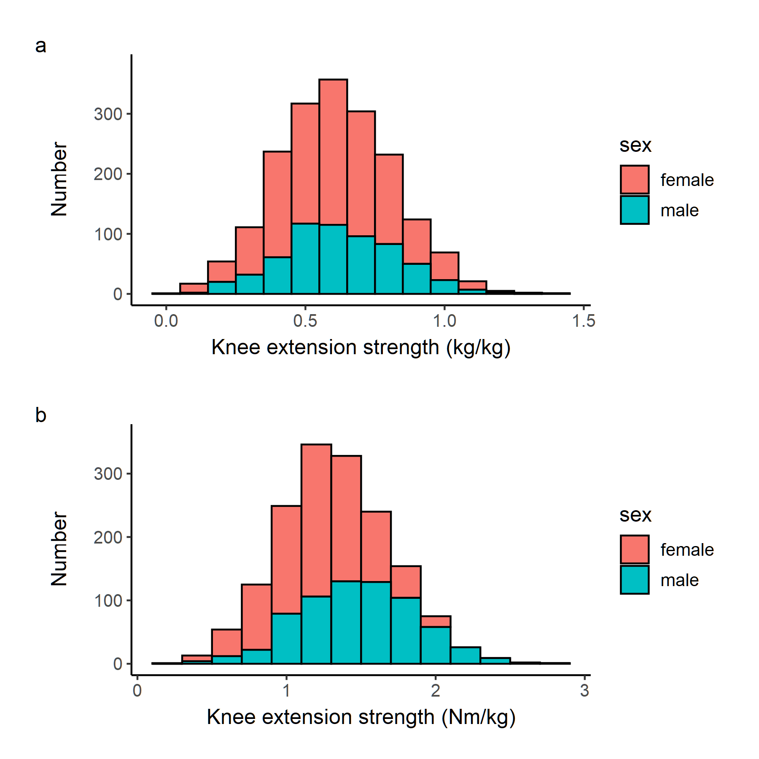

Supplementary Figure 3. Distribution of muscle strength in participants aged 60 years or older
(a) Shimane CoHRE Study (Set 1 and Set 2), (b) Bunkyo Health Study (Set 3). Both studies show similar distribution.

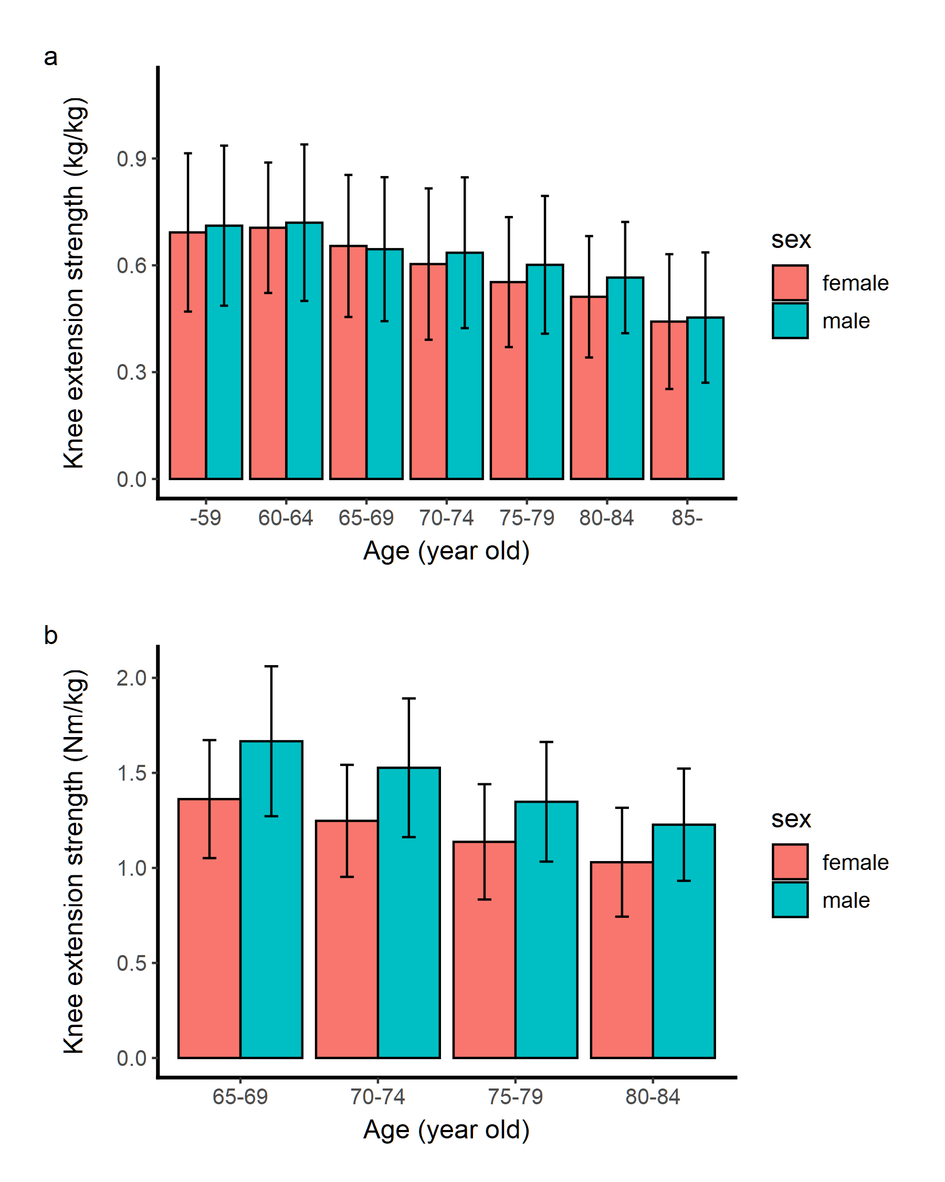
Supplementary Figure 4. Mean muscle strength in age groups
Error bar: standard deviation. (a) Shimane CoHRE Study. Set 1 and Set 2, (b) Bunkyo Health Study (Set 3).

a
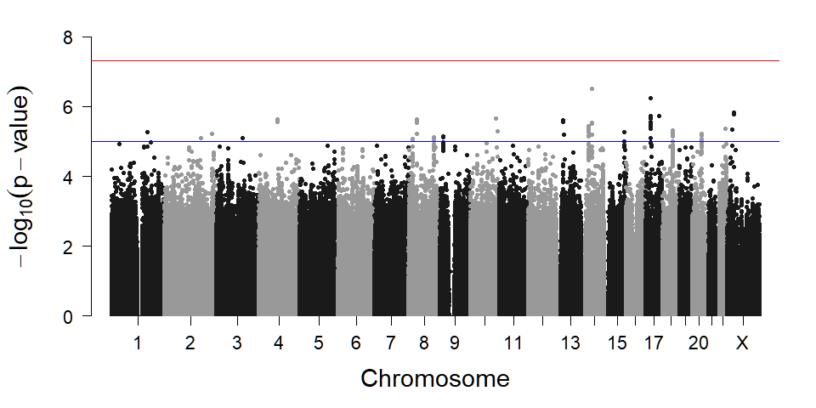
b
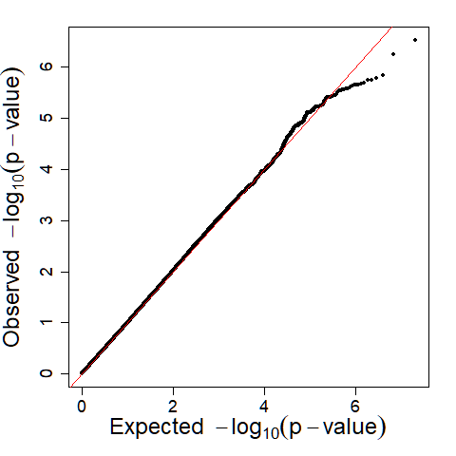

Supplementary Figure 5. A sub-analysis of the genome-wide association analysis of knee extension strength for 1,007 participants of Set 1 aged 60 years or older
(a) Manhattan plot. X-axis: chromosomal location. Y-axis: −log₁₀ P value for each genetic variant. Horizontal red line: genome-wide significance (p < 5 × 10⁻⁸). Horizontal blue line: suggestive genome-wide significance (p < 1 × 10⁻⁵). (b) Q-Q plot for the analysis. The genomic inflation factor (λ_{GC}) was 1.00.
a
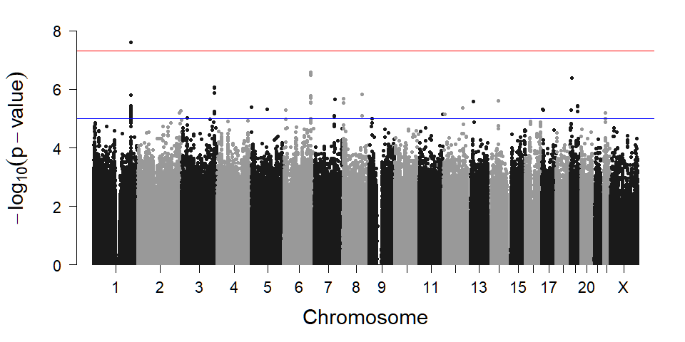
b
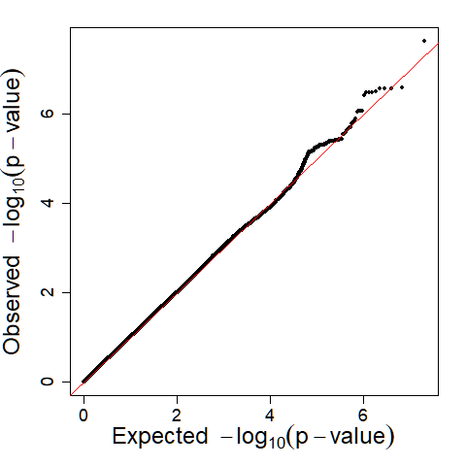

Supplementary Figure 6. A sub-analysis of the genome-wide association analysis of knee extension strength for 838 participants of Set 2 aged 60 years or older
(a) Manhattan plot. (b) Q-Q plot for the analysis. The genomic inflation factor (λ_{GC}) was 1.01.

a
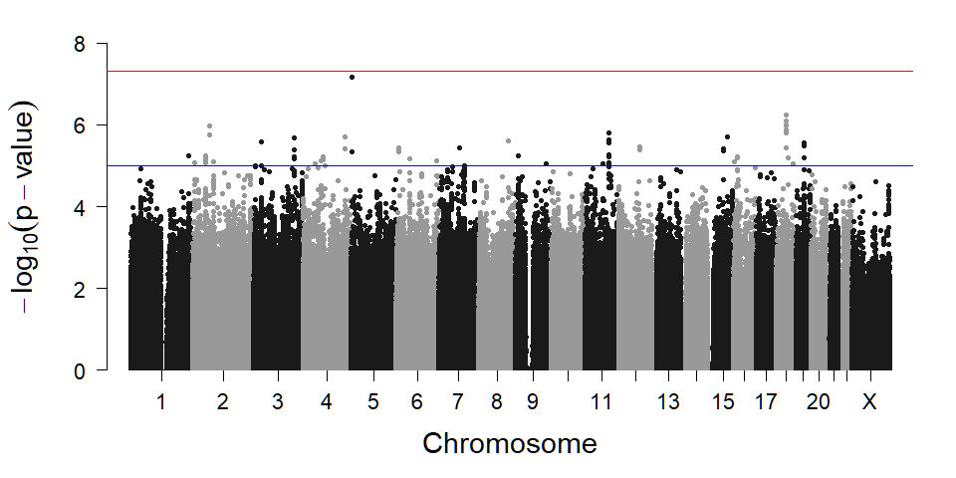
b
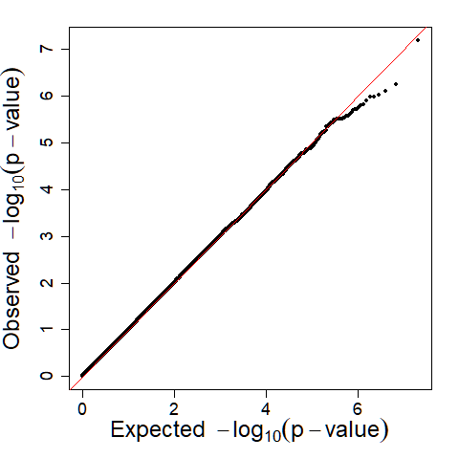

Supplementary Figure 7. A sub-analysis of the genome-wide association analysis of knee extension strength for 1,607 participants of Set 3 aged 60 years or older
(a) Manhattan plot. (b) Q-Q plot for the analysis. The genomic inflation factor (λ_{GC}) was 1.00.

Supplementary Figure 8. The mRNA expression of TACC2 in Gene-Tissue expression version 8
TACC2 is highly expressed in skeletal muscle (arrow) compared to other tissues or cells.
a
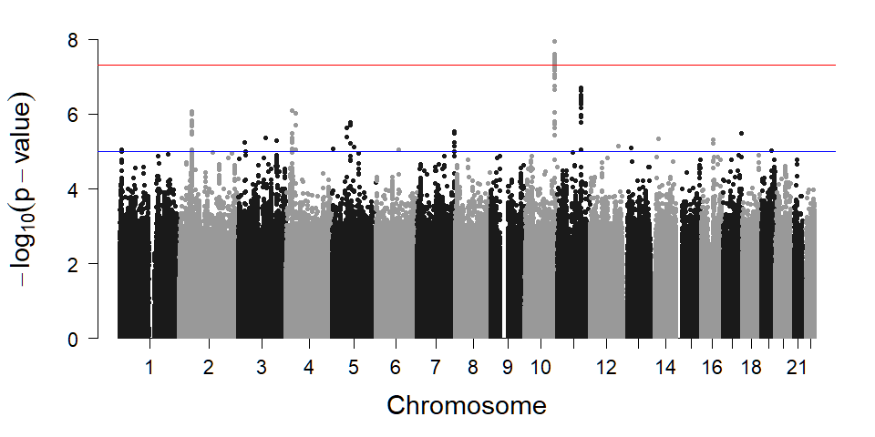
b
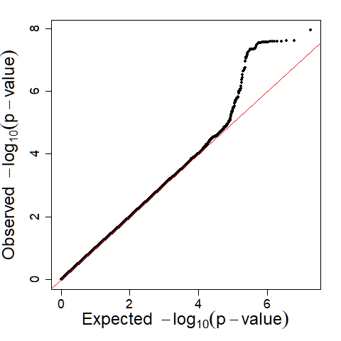

Supplementary Figure 9. A meta-analysis for 3,452 participants of Set 1-3 aged 60 years or older and 173 participants of Set 1-2 aged under 60 years
(a) Manhattan plot. A locus on chromosome 10 with genome-wide significance and many loci with suggestive genome-wide significance were identified. (b) Q-Q plot for the analysis. The genomic inflation factor (λ_{GC}) was 1.02.
a
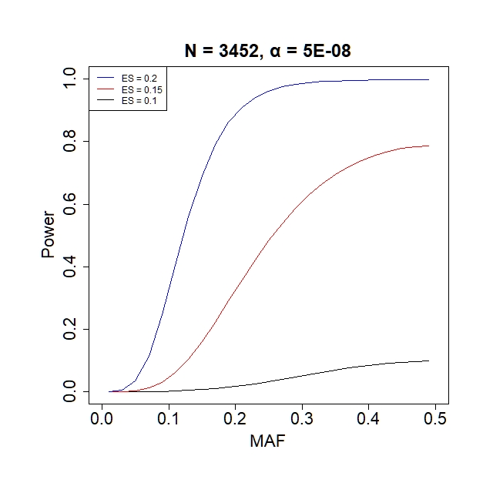

b
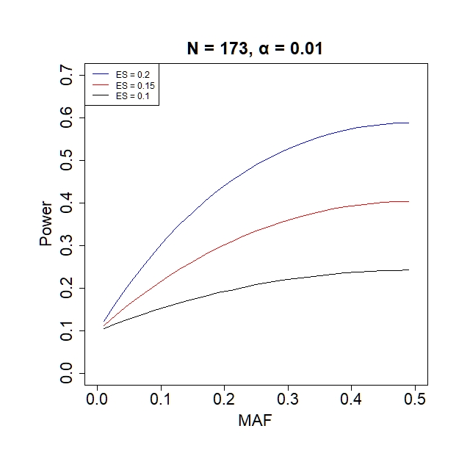
c
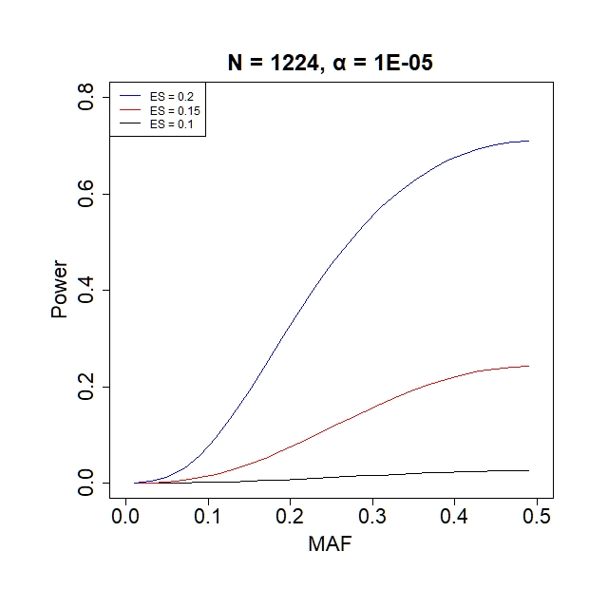

d
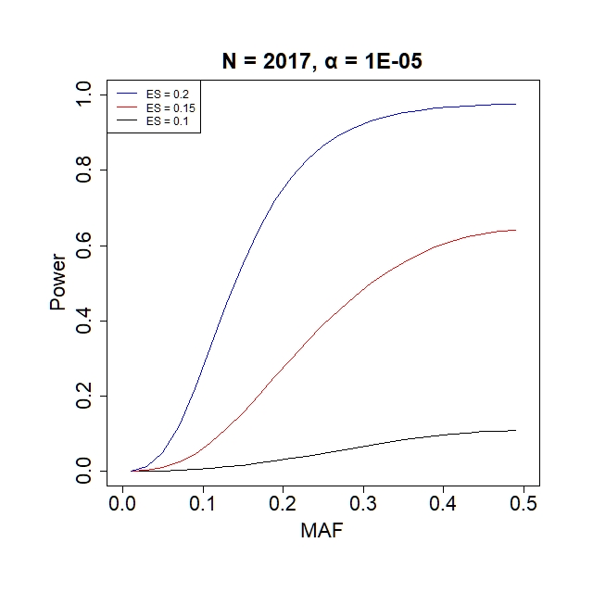
e
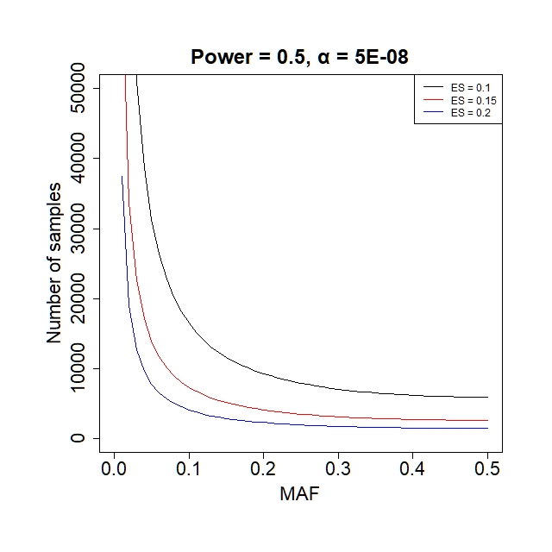

f
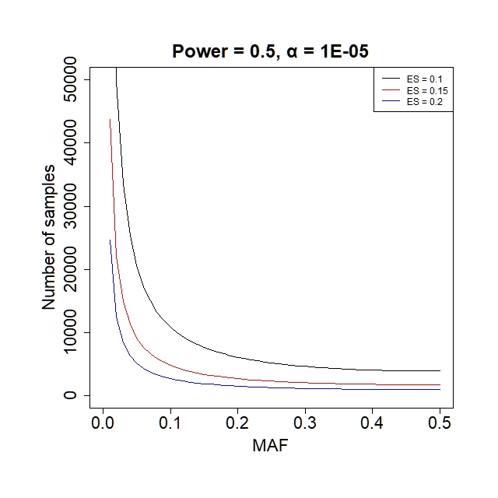
Supplementary Figure 10. Statistical power analyses
(a) The entire study (3,453 subjects) with alpha error of 5 × 10⁻⁸. (b) 173 subjects aged under 60 years old with alpha error of 0.1. (c) 1,224 subjects of male with alpha error of 1.0 × 10⁻⁵. (d) 2,017 subjects of female with alpha error of 1.0 × 10⁻⁵. (e) Calculation of number of samples with alpha error of 5 × 10⁻⁸. (f) Calculation of number of samples with alpha error of 1 × 10⁻⁵. N, number of samples; ES, effect size; MAF, minor allele frequency.

