Supplemental Figures
Contents
Figure S1. Study sample selection for the metabolomic analysis 2
Figure S2. Scree plot for Principal Component Analysis (PCA) on the sleep disordered breathing (SDB) phenotypes in HCHS/SOL 3
Figure S3. Super pathway breakdown for metabolites selected by LASSO for SDB PCs 4
Figure S4. The associations between SDB metabolomic indices in quartiles and incident cardiometabolic outcomes in combined batch 5
Figure S5. Comparison of progesterone steroids metabolites levels in combined batch 6

Figure S1. Study sample selection for the metabolomic analysis

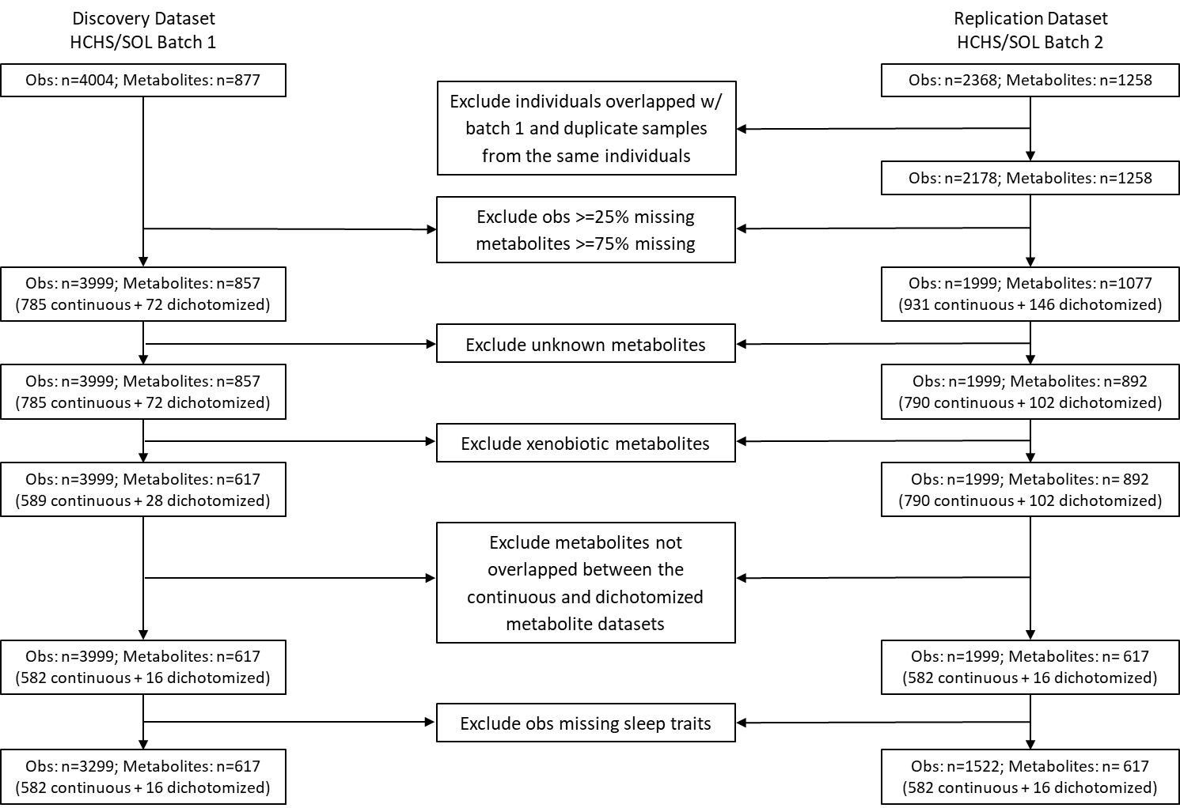

Obs: observations

Figure S2. Scree plot for Principal Component Analysis (PCA) on the sleep disordered breathing (SDB) phenotypes in HCHS/SOL

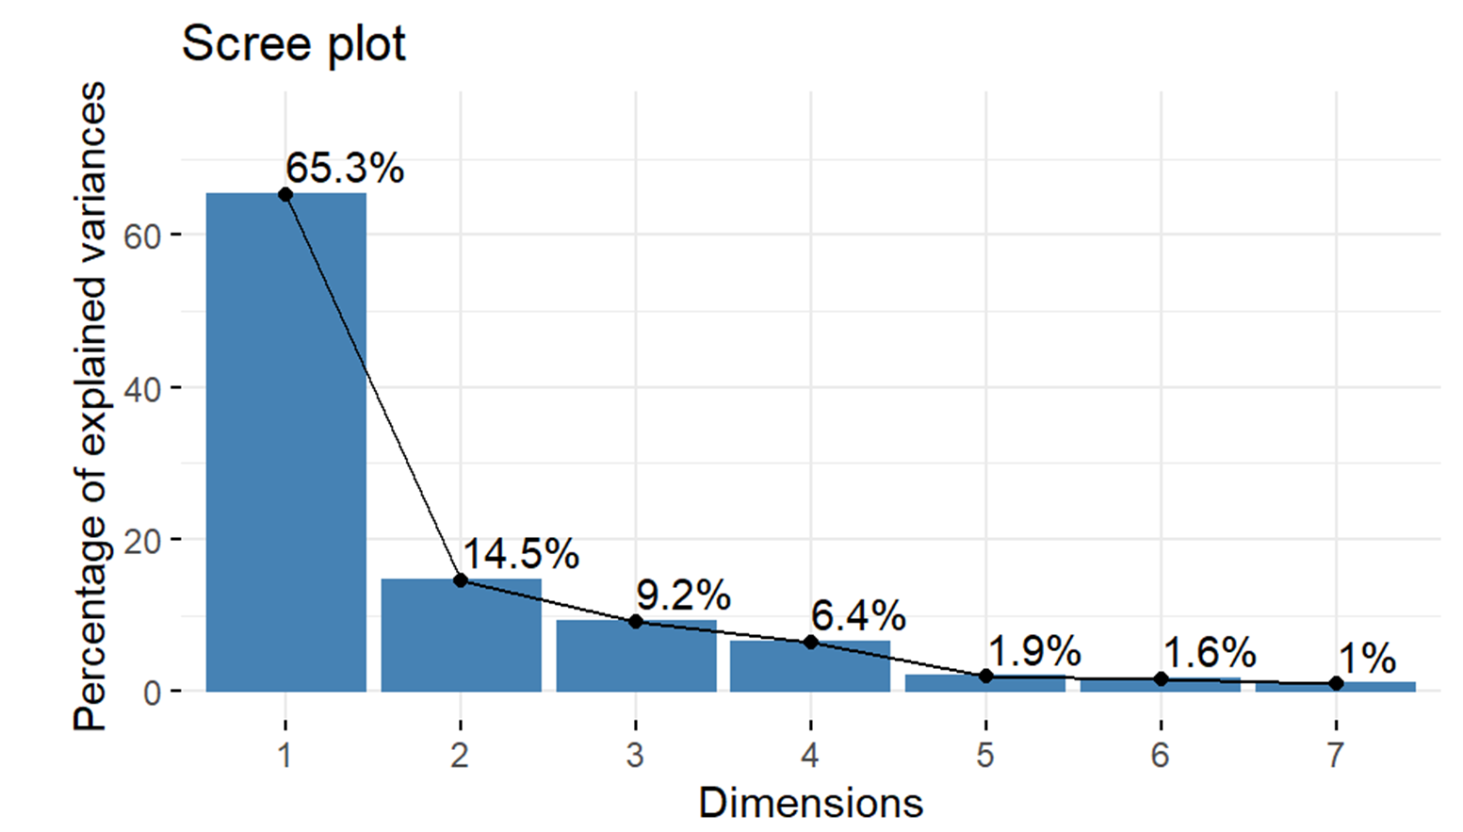

Figure S3. Super pathway breakdown for metabolites selected by LASSO for SDB PCs

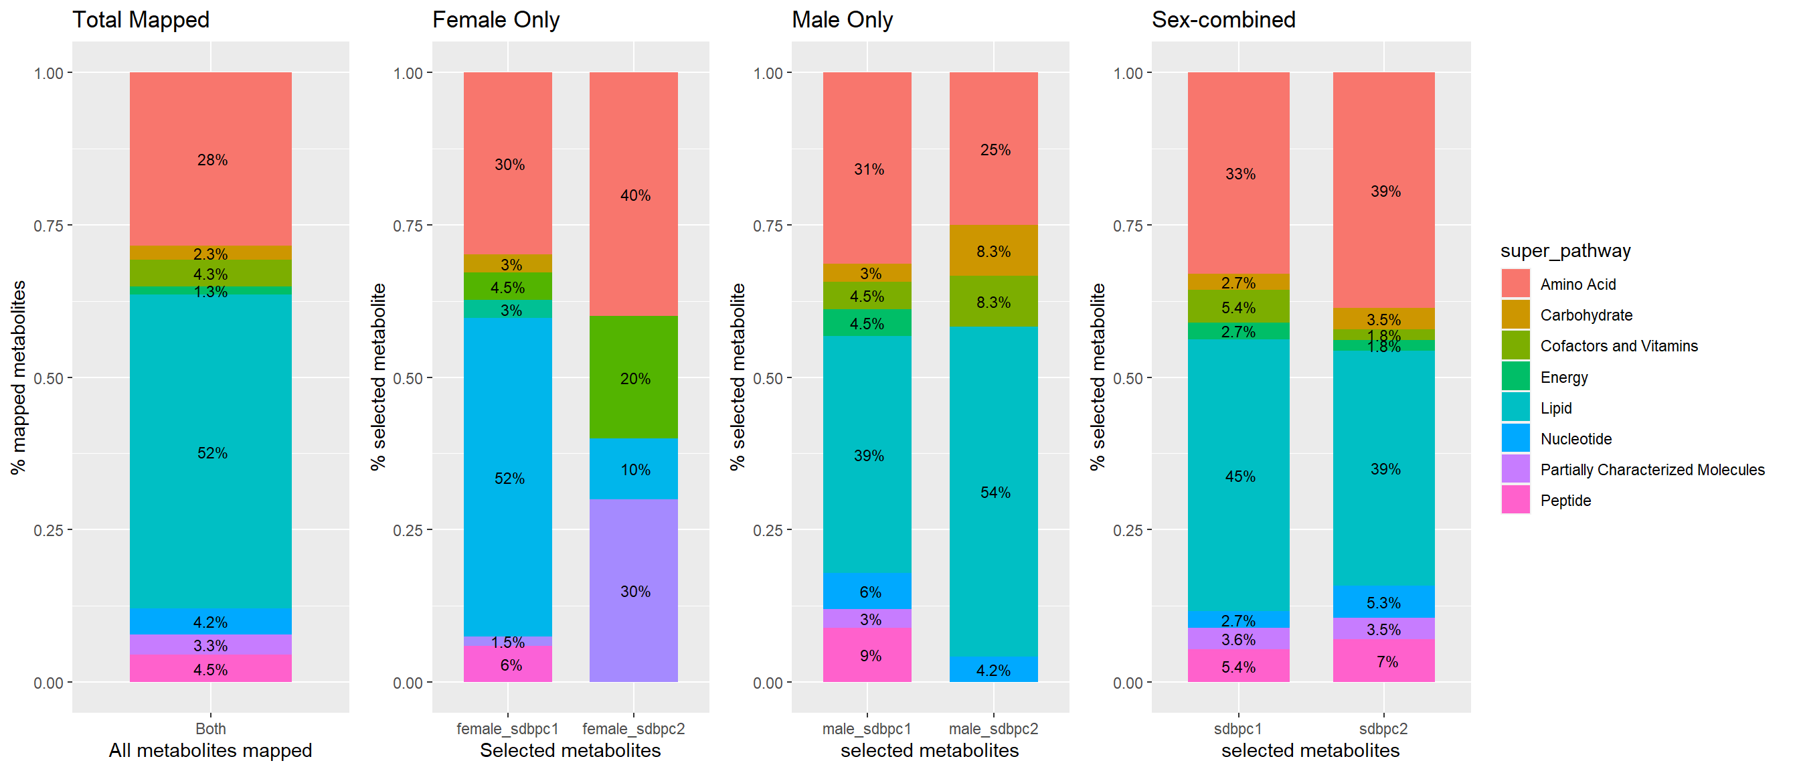

female_sdbpc1: metabolites selected by LASSO regression trained in females only to predict SDB PC1 in discovery dataset (batch 1); female_sdbpc2: metabolites selected by LASSO regression trained in females only to predict SDB PC2 in discovery dataset (batch 1); male_sdbpc1: metabolites selected by LASSO regression trained in males only to predict SDB PC1 in discovery dataset (batch 1); male_sdbpc2: metabolites selected by LASSO regression trained in males only to predict SDB PC2 in discovery dataset (batch 1); sdbpc1: metabolites selected by LASSO regression trained in both sexes combined to predict SDB PC1 in discovery dataset (batch 1); sdbpc2: metabolites selected by LASSO regression trained in both sexes combined to predict SDB PC2 in discovery dataset (batch 1);

Figure S4. The associations between SDB metabolomic indices in quartiles and incident cardiometabolic outcomes in combined batch
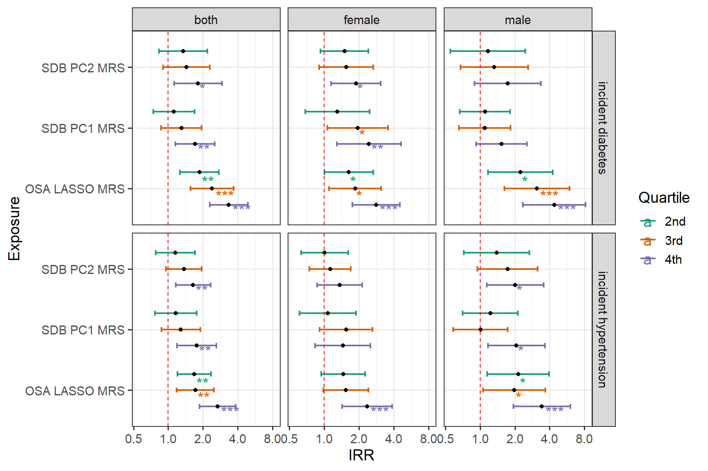

SDB PC1 MRS: metabolite index calculated based on the coefficients from LASSO regression trained in both sexes combined to predict SDB PC1 in discovery dataset (batch 1); SDB PC2 MRS: metabolite index calculated based on the coefficients from LASSO regression trained in both sexes combined to predict SDB PC2 in discovery dataset (batch 1); OSA LASSO MRS: metabolite index calculated based on coefficients from LASSO regression trained to predict OSA in previous publication (Zhang et al. 2022)

Figure S5. Comparison of progesterone steroids metabolites levels in combined batch
A
B
C
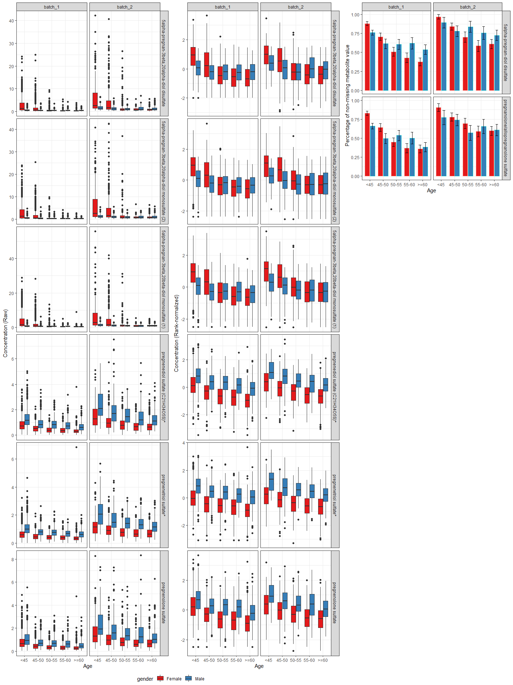
Panel A: Boxplot of raw concentration level of selected progesterone steroid sulfate metabolites in each sex strata by age group in batch 1 and 2. Panel B: Boxplot of rank-normalized selected progesterone steroid sulfate metabolites in each sex strata by age group in batch 1 and 2. The rank normalization was carried out in both sexes combined. Panel C: The percentage of study samples with non-missing value in each sex strata by age group.
Metabolite with * indicates they were identified based on accurate mass data, retention time and mass spectrometry but not reference standards. Therefore, the verification is not as robust as metabolites without *.

