Table 1. Description and location of samples in the walls
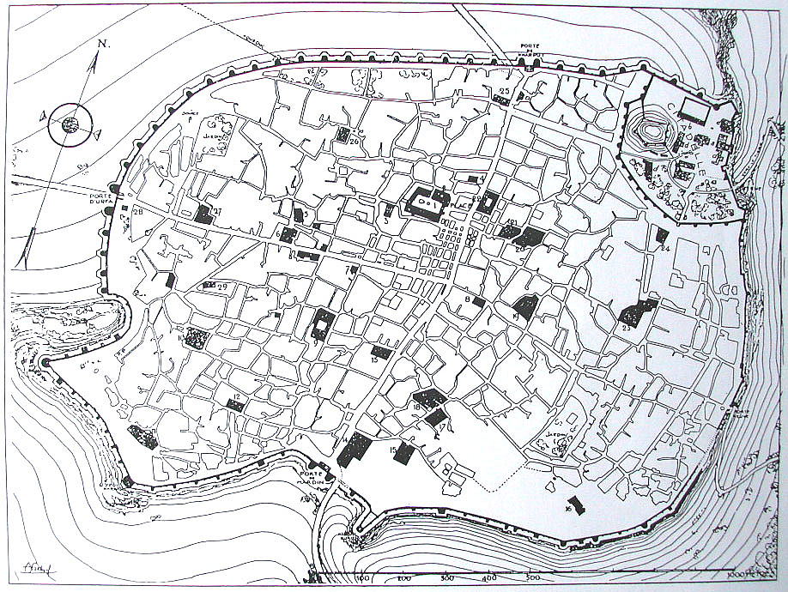 |  |  |  | 42st tower  41st tower  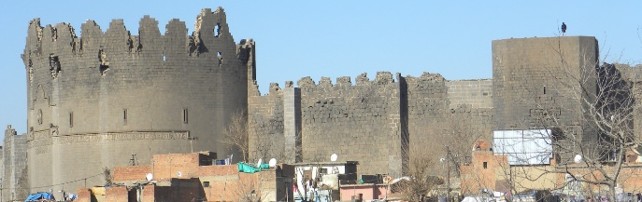
M1 | Sample 1, collected from Tower 41 (Yedikardeş Tower), is a well-preserved mortar sample with a gray color. It contains aggregates with a size of 4-5 mm and abundant white masses. | M4 | Sample 2, collected from Tower 42 (Yedikardeş Tower), is a well-preserved mortar sample with a whitish-gray color. It contains brick fragments with a size of 3-4 mm, abundant white masses, and black soot. |  | M7 | Sample 2, collected from Tower 42 (Yedikardeş Tower). It is a well-preserved mortar sample with a white color. It contains aggregates with a size of 3-4 mm, white masses, and black soot.
M2 | Sample 1, collected from Tower 41 (Yedikardeş Tower). It is a well-preserved mortar sample with a dark gray color. It contains aggregates with a size of 1-2 mm, black soot, and white masses. | M5 | Sample 1, collected from Tower 41 (Yedikardeş Tower). It is a well-preserved mortar sample with a white color. It contains aggregates with a size of 4-5 mm, sporadic brick fragments, and abundant white masses. |  | M8 | Sample 1, collected from Tower 41 (Yedikardeş Tower). It is a well-preserved mortar sample with a grayish-white color. It contains aggregates with a size of 2-3 mm, white masses, and black soot.
M3 | The given description is a solid structure sample of mortar, which is whitish-gray in color and contains mostly 1-2 mm-sized aggregates, occasional 5-6 mm-sized aggregates, scattered black particles, and white masses. | M6 | The given description is a solidly structured sample of mortar that is whitish-gray in color and contains 2-3 mm-sized aggregates, white masses, and black particles. |  | M9 | The 41st wall body is a sample of weakly structured joint mortar, taken from between regular cut stone masonry. It is light gray in color and contains predominantly 1-2 mm-sized aggregates, with occasional aggregates reaching sizes of 4-5 mm. It also has white masses and scattered black particles.

