Supplemental methods
Visual encounter surveys
During each amphibian survey, we waded into the pond and walked around the perimeter to look for amphibians. When we encountered an amphibian, we used a non-contact infrared thermometer (Dual laser IR thermometer, Model EC400L2) to measure skin temperature and the temperature of the substrate where the animal was sighted. We then attempted to catch the amphibian, and if successful, recorded its time of capture. We caught most of the amphibians by hand using a fresh pair of nitrile gloves to prevent pathogen transmission (Phillott et al., 2010). We sampled tadpoles in ephemeral ponds by dip netting, starting after the egg masses that had been deposited in those ponds had hatched. Because some amphibian species overwinter as larvae in permanent ponds in our study area, we sampled for tadpoles in permanent ponds haphazardly throughout the amphibian active season. We placed captured amphibians individually in clean Ziploc© bags for further data collection (see below). We discarded bags after one use. We disinfected waders and field gear with F10SC (a veterinary disinfectant that has been shown to kill Bd; Van Rooij et al., 2017) between sites.

For each captured individual, we recorded sex, life stage, mass (using a Pesola spring scale), snout-to-vent length (SVL) and, for salamanders, tail length (using dial calipers). We collected skin swab samples to test for Bd, swabbing adult and juvenile frogs and toads five times each on dorsal, ventral, right, and left sides, and feet with a sterile swab (Medical Wire MW113). For tadpoles, we swabbed the mouthparts only, five times. For salamanders, we swabbed five times on the dorsal and ventral surfaces, right and left sides, each foot, and the dorsal and ventral surface of the tail for a total of 45 strokes. We placed each swab into a labeled 1.5 mL tube, which we later stored at -20˚C. After taking all measurements, we released the animals near the location where they were collected.

Pitfall-trap surveys at fenced ephemeral ponds
The hydroperiod of the two fenced ephemeral ponds we sampled, depends on local precipitation and recharge from groundwater. The year before our surveys, Sanctuary Lake pond held water for six months and Wood Lab for seven months. In the year of the surveys, Sanctuary Lake pond held water from November to August (9 months) and Wood Lab pond held water from November to June (7 months). The maximum recorded water depth, which was measured once during each monthly sampling event, was 80 cm for both ponds.

We installed the drift fences in the fall preceding the study and left them open (so that animals could move freely to and from the pond) until the early spring, just before the first amphibians began to emerge from hibernation (see supplemental methods). The drift fences were made from rolls of 35 cm tall fine aluminum mesh buried 7-10 cm in the ground and held in place with wooden stakes every 1.5 m. When closed, the fences surrounded each pond. Along the inside and outside of each fence we buried 1-gallon buckets, which served as pitfall traps, so that their tops were flush with the ground. The buckets had holes drilled into their bottoms to let water drain. When no survey was planned for the following day, lids without holes were left on the buckets to keep animals from falling in. Twelve hours before each survey and we replaced these solid lids with lids that had 12 x 8 cm holes cut in them, allowing us to capture amphibians moving along the fence who fell through these holes. Prior to each survey we also placed a plastic bag liner with two holes in its bottom into each bucket. This liner was changed each time an amphibian was captured in a pitfall trap to avoid cross contamination among sampling nights.

During surveys, we checked each pitfall trap by removing the bucket lid and searching through any organic material that may have accumulated in the trap. During the breeding season and when new metamorphic animals were emerging from the ponds, we checked the pitfall traps once or twice daily. When animals were not breeding or metamorphosing, we opened the traps and checked the ponds two to three times a week, prioritizing rainy nights, between 1900 and 0200 h. All animals captured were processed as described above and then released approximately 4 m from the trap on the opposite side of the fence from where they were collected (because animals collected outside the fence were presumably trying to get to the pond, and vice versa).

During each survey, we checked within pitfall traps and along the entire inside and outside fence perimeter for amphibians. We collected samples and data from each amphibian encountered as described in the unfenced pond surveys above. For these animals we also recorded capture location (outside or inside fence, in pitfall trap or not) and, for animals found in traps, whether the animal was alone or with other captured amphibians. We cohort-marked each captured amphibian with a toe clip so that we could distinguish animals newly arriving at the pond from animals we had previously sampled that season. We did this by clipping the same single digit on all the adult animals using sharp clippers hat had been sterilized in 95% ethanol prior to each use.

eDNA collection, extraction, and qPCR
We used 1 L Nalgene bottles, which we washed in a freshly made 50% bleach solution for 10 min, rinsed in tap water, and dried thoroughly before each use, to collect eDNA water samples. We collected the water sample from the edge of the pond before entering the pond. To begin, we rinsed the bottles seven times with water from the pond, each time discarding the rinse water away from the pond, to remove any remaining bleach residue. The water that constituted the 1 L eDNA sample was collected from three separate locations (at least 3m apart at various points along the edge of the pond). We placed the water samples in a refrigerator within 3 hours of water collection and filtered the sample within 24 hours of collection. We used sterile MicroFunnel™ Pall 0.45 µm Cellulose nitrate filter funnels to filter the water and collect eDNA. We placed these on top of a vacuum flask and used a rubber stoper and reinforced Silicone tubing to attach the apparatus to a vacuum pump (Welch 2511B-01). We often had to use several sequential filters to pass the entire sample through because the filters clogged quickly (often within a few hundred ml) but in every case the entire liter of water was passed through one or more filters.

To extract genomic DNA from the filters, we first cut each filter in half, then used the Renshaw et al. (2015) protocol with the following modifications: all half filters from the same water sample were added to a single 15 ml falcon tube for DNA extraction. To this falcon tube we added 0.125 g Biospec beads (#11079105Z, zirconia/silica, 0.5 mm) and 350 ul CTAB buffer per ½ filter. The incubation time was for 15 min at 56 ºC and we did this incubation step twice with a 30 s vortex between incubations. After this, we transferred the supernatant to a phase-lock tube. Instead of drying the samples in a vacuum centrifuge for 15 min at 45 ºC, we used a pipette to remove any excess ethanol. At the end of the procedure, the pellet was resuspended in 100 ul Qiagen buffer AE. To detect and quantify Bd eDNA in these samples we used the same qPCR methods as for the amphibian skin swabs (see below) with the following exceptions: (1) we diluted the template eDNA samples 1:5 in molecular grade water, (2) we ran the samples in triplicate, and (3) we only used 0.5 ul of IPC mix and 0.1 ul of IPC DNA per reaction. The IPC was only included in one of each of the triplicate reactions. We did not attempt to genotype the Bd detected in the eDNA samples because the quantities of DNA detected were generally quite low.

Swab sample DNA extraction and qPCR
We extracted genomic DNA from swabs using the “animal tissue” protocol for the Qiagen DNeasy Blood and Tissue Extraction Kit with a final elution volume of 200 µL. We then ran a qPCR assay (Blooi et al., 2013) using a QuantStudio™ 3 Real Time PCR system to detect and quantify the presence of Bd DNA. This is a duplex assay that would also allow us to detect B. salamandrivorans (Bsal), a related amphibian fungal pathogen, if present, as well as Bd. We used 25-µL reactions containing 12.5 µL of 2x SensiFast probe Lo-Rox Mix, PCR primers at a concentration of 900 nM, MGB probes at 240 nM, 400 ng/µL BSA, 1/3x TaqMan Exogenous Internal Positive Control (IPC) reagents (Applied Biosystems), and 5 µL of template DNA. We included negative and positive control samples and a 7-fold dilution series of plasmid standards (Pisces Molecular, CO) in each qPCR run. To generate negative controls, we ran our DNA extraction protocol on a clean swab, and for the positive controls we extracted DNA from a swab that had been dipped in a broth culture of Bd. We amplified the DNA using 2 min at 50°C and 10 min at 95°C, followed by 40 cycles of 15 s at 95°C and 1 min at 60°C. We ran samples in singlicate and calculated whole-swab Bd load by multiplying detected Bd DNA copies by 40 to account for the proportion of the full extraction that was aliquoted for qPCR. We excluded any wells where the IPC did not amplify from analysis.

Statistical analysis of qPCR data
To test how Bd prevalence and infection load varied over time and with temperature, we fit generalized additive mixed models (GAMs) using the mgcv package (Wood 2017). Prevalence was examined using binomial GAM models, with infection status (positive or negative) as the response variable, and a binomial link function. We included pond type (ephemeral or permanent) as a fixed effect, Julian date by pond type as a smoothed effect (spline (k) = 20 for the rest of analysis), and pond code, species, and year as smoothed random effects. We also ran models examining the relationship between infection load and pond type including the same terms, but with body temperature (˚C) (instead of Julian date) by pond type as a smoothed effect. We fit the models with REML, ran diagnostic tests to determine whether the basis dimension choice was adequate and to assess diagnostic plots (library: mgcv, function: gam.check) and checked for concurvity (library: mgcv, function: concurvity). Some models demonstrated significance in the gam.check function, which may indicate the k is too low. However, the effective degrees of freedom (EDF) were not close in value to k’, even at high values (e.g., k =100). Following Wood (2017), results were consistent at k=20 and above, so k=20 was used.

To test for differences in Bd infection status and load among host species, life stages, and pond types, we fit generalized linear mixed models (GLMMs) in R using the lme4 package (Bates, 2010). In one case a model fit using generalized least squares failed the uniformity check; for this analysis, we re-fit the model using the nlme package in R (Pinheiro et al, 2017) with a variance structure to account for unequal variance across groups, which addressed the violation.

To compare Bd infection status between the two life stages (larval vs. post-metamorphic), we used a GLMM (package ‘lme4’, function ‘glmer’, Bates 2010) with a binomial distribution including life stage, pond type, species, and their interaction as fixed effects. We included pond as a random effect. To alleviate violation of the equal variance assumption, we only included the four species with sufficient sampling across ponds and life stages in this model. We did not test for differences in Bd load between the two life stages because there were too few (only 15) infected tadpoles.

For animals entering the fenced ponds, we tested whether Bd load was higher for species hibernating in permanent ponds relative to those hibernating terrestrially. To do this, we analyzed a subset of data that included only amphibians that were known to hibernate either terrestrially (spotted salamanders, Jefferson’s salamanders, four-toed salamanders, red-backed salamanders, wood frogs, spring peepers, American toads) or in permanent ponds (green frogs, northern leopard frogs, American bullfrogs) and only an individual’s first capture outside the fence (i.e., on their way into the pond for the first time). We used a LMM (‘nlme’ package, function ‘lme’) that included hibernation type (terrestrial vs. permanent pond, based on species natural history), pond (because there were different species arriving to the two fenced ponds), and their interaction as fixed effects. We included species as a random effect. To compare Bd infection status between the two hibernation types (permanent pond vs. terrestrial), we used a GLMM (package ‘lme4’, function ‘glmer’) with a binomial distribution including hibernation type, site, and their interaction as fixed effects. We included species as a random effect.

To test for differences in Bd load between in animals entering vs. leaving the pond, we fit a linear mixed model using generalized least squares (GLS LMM using ‘nlme’ package, function ‘gls’). The model included hibernation type (terrestrial vs. permanent pond, based on species natural history), whether the animal was found leaving (i.e., captured inside the fence) or coming to (i.e., captured outside the fence) the pond, and their interaction as fixed effects. Species was not included as a random effect in this model because doing so led to violations of model assumptions that we were unable to reconcile. To compare Bd infection status between animals entering vs. leaving the pond, we used a GLMM (package ‘lme4’, function ‘glmer’) with a binomial distribution, including hibernation type, whether the animal was captured inside or outside the fence, and their interaction as fixed effects. We again included pond as a random effect. Species was not included as a random effect in this model because doing so led to violations of model assumptions that we were unable to reconcile.

Bd genotyping and analyses of genetic variation
To prepare for sequencing, we cleaned and concentrated the remaining volume of Bd swab extracts (~190 µL) using an isopropanol precipitation. We resuspended DNA in 15 µL of low TE and stored it at 4°C. Next, we pre-amplified the samples in two separate PCR reactions, each containing 96 primer pairs at a final concentration of 500 nM. We added 1 µL of the cleaned DNA extract to each preamplification reaction. We then treated the pre-amplified products with 4 µL of 1:2 diluted ExoSAP-it (Affymetrix Inc.) and incubated for 15 min at 30˚C, then 30 min at 80˚C. We diluted treated products 1:5 in PCR-grade water. We then combined the diluted products from each of the two preamplification reactions in equal proportions and used them for downstream amplification and sequencing.

We loaded each pre-amplified sample onto the Fluidigm Access Array IFC (Fluidigm, Inc.) for amplification. We barcoded and amplified all samples, then pooled them for sequencing on an Illumina MiSeq lane using the 300 bp paired-end kits at the University of Idaho IBEST Genomics Resources Core. We pre-processed all sequencing data as described in Byrne et al. (2017) and we generated consensus sequences for all variants present for each sample at each locus using IUPAC ambiguity codes for multiple alleles. We filtered reads by selecting sequence variants that were present in at least five reads and represented at least 5% of the total number of reads for that sample/locus using dbcAmplicons (https://github.com/msettles/dbcAmplicons).

We used a gene-tree to species-tree approach to construct a phylogeny to explore the relationship of the Bd on the swab samples collected for this study to previously-published Bd samples representing all known Bd lineages. First, we trimmed the consensus sequence dataset to eliminate loci that had more than 50% missing data, resulting in 188 loci. Next, we individually aligned all loci using the MUSCLE package (Edgar 2004) in R (v.3.4.3), checked the alignments for errors in Geneious v.10.2.3 (Kearse et al. 2012), and used the RAxML plugin in Geneious to search for the best scoring maximum likelihood tree for each locus using rapid bootstrapping (100 replicates). We then collapsed all branches in all trees with <10 bootstrap support and used Astral III to generate a consensus tree. Astral generates an unrooted species tree given a set of unrooted gene trees (Zhang et al. 2018).

To further explore the genetic variation of Bd sampled from amphibians at the two fenced ponds, we used a principal components analysis (PCA). First, we aligned all reads for all samples to a reference FASTA with target sequences from Bd isolate JEL423 using bwa mem (Li and Durbin, 2009). We then used freebayes to call variants based on haplotypes (Garrison and Marth 2012). We called variants using the following flags to ensure high quality: --0 --min-coverage 5, --max-missing 0.5. We then used a total of 28 genotypes and 100 bi-allelic variants to calculate a PCA using the R package adegenet (v.2.1.1) (Jombart 2008). We plotted the first two PCs, which together explain 33.8% of the variation in our data.

To evaluate the relative contribution of season, pond, whether the sampled individual was entering or leaving the pond, and host species, we ran an analysis of molecular variance (AMOVA) (Excoffier et al., 1992) using our SNP data. We ran this analysis using the poppr package in R (Kamvar et al., 2014) and only used genotypes with < 70% missing data. We then tested for statistical significance using the “randtest” function in the package ade4, randomly permuting our data 999 times.

Supplemental References
Byrne, A. Q., Rothstein, A. P., Poorten, T. J., Erens, J., Settles, M. L., & Rosenblum, E. B. (2017). Unlocking the story in the swab: A new genotyping assay for the amphibian chytrid fungus Batrachochytrium dendrobatidis. Molecular Ecology Resources. https://doi.org/10.1111/1755-0998.12675.
Edgar, R. C. (2004). MUSCLE: multiple sequence alignment with high accuracy and high throughput. Nucleic Acids Research, 32(5), 1792–7. https://doi.org/10.1093/nar/gkh340
Excoffier L, Smouse PE, Quattro JM. (1992) Analysis of molecular variance inferred from metric distances among DNA haplotypes: application to human mitochondrial DNA restriction data. Genetics, 131(2):479–91.
https://doi.org/10.1093/genetics/131.2.479Garrison, E., & Marth, G. (2012). Haplotype-based variant detection from short-read sequencing. arXiv Preprint arXiv:1207.3907. https://doi.org/10.48550/arXiv.1207.3907
Jombart, T. (2008). adegenet: a R package for the multivariate analysis of genetic markers. Bioinformatics, 24(11), 1403–1405. https://doi.org/10.1093/bioinformatics/btn129
Kamvar ZN, Tabima JF, Grünwald NJ. (2014) Poppr: an R package for genetic analysis of populations with clonal, partially clonal, and/or sexual reproduction. PeerJ. 2014(2), e281. https://peerj.com/articles/281/
Kearse, M., Moir, R., Wilson, A., Stones-Havas, S., Cheung, M., Sturrock, S., … Drummond, A. (2012). Geneious Basic: An integrated and extendable desktop software platform for the organization and analysis of sequence data. Bioinformatics , 28(12), 1647–1649. https://doi.org/10.1093/bioinformatics/bts199
Li, H., & Durbin, R. (2009). Fast and accurate short read alignment with Burrows–Wheeler transform. Bioinformatics, 25(14), 1754–1760. https://doi.org/10.1093/bioinformatics/btp324
Phillott, A. D., Speare, R., Hines, H. B., Skerratt, L. F., Meyer, E., McDonald, K. R., Cashins, S.D., Mendez, D. & Berger, L. (2010). Minimising exposure of amphibians to pathogens during field studies. Diseases of Aquatic Organisms, 92(2-3), 175-185. http://doi.org/10.3354/dao02162
Renshaw, M. A., Olds, B. P., Jerde, C. L., McVeigh, M. M., & Lodge, D. M. (2015). The room temperature preservation of filtered environmental DNA samples and assimilation into a phenol–chloroform–isoamyl alcohol DNA extraction. Molecular Ecology Resources, 15(1), 168-176.
Wood, S.N. (2017) Generalized Additive Models: An Introduction with R (2nd edition). CRC/Taylor & Francis.
Zhang, C., Rabiee, M., Sayyari, E., & Mirarab, S. (2018). ASTRAL-III: polynomial time species tree reconstruction from partially resolved gene trees. BMC Bioinformatics, 19(6), 153. https://doi.org/10.1186/s12859-018-2129-y

Supplemental figures

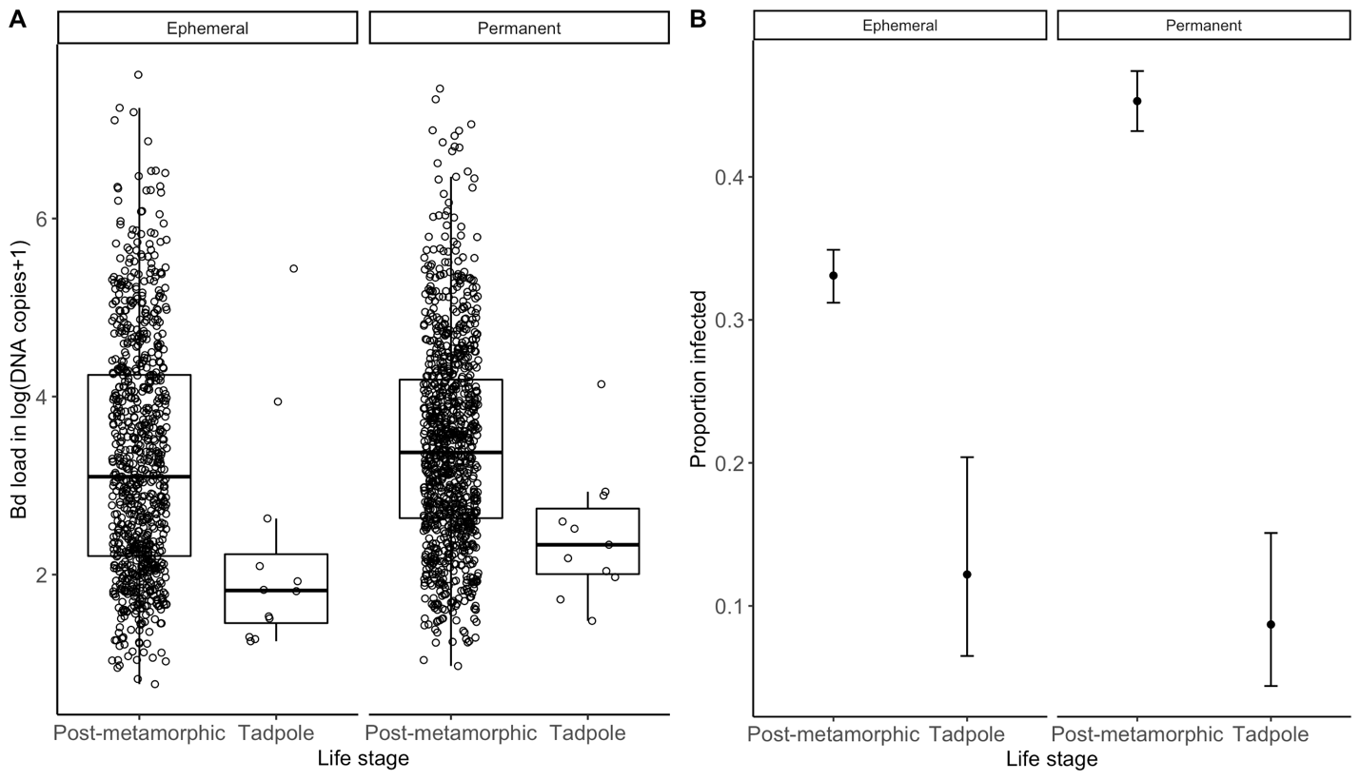

Figure S1. Box and whiskers plots showing the relationship between Bd load (A), in log (DNA copies + 1), for all Bd-infected tadpoles and post-metamorphic animals in ephemeral and permanent ponds. Each dot represents one individual. In (B), dots represent the proportion of individuals infected with Bd in ephemeral and permanent ponds for each life stage. Error bars in B represent 95% confidence intervals on the proportions, calculated using the Clopper-Pearson method (Clopper 1934).
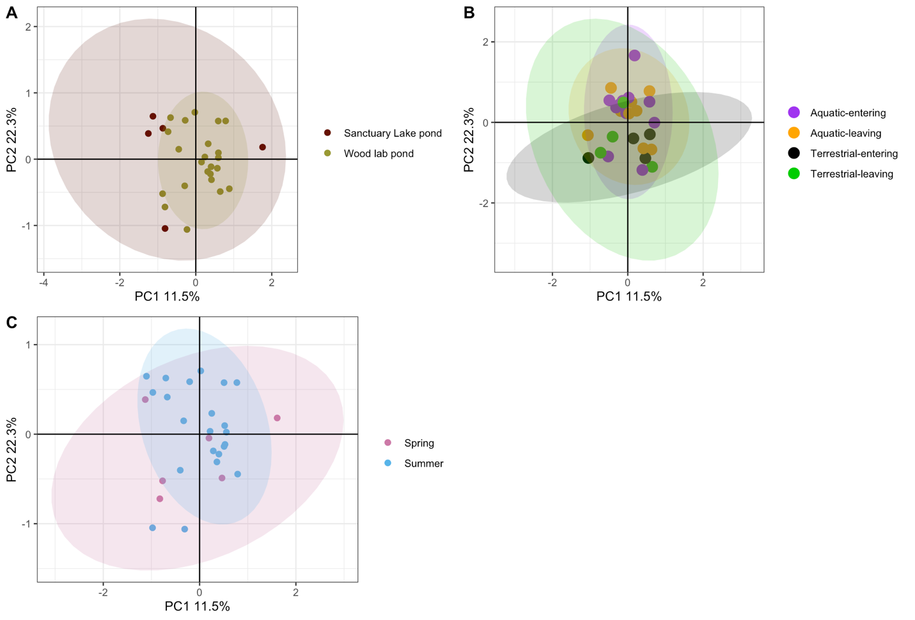

Figure S2. Scatter plots of PC1 versus PC2 showing variance (A) among Bd haplotypes by pond, (B) by direction of animal movement (entering vs. leaving the pond) and hibernation type (aquatic vs. terrestrial), and (C) by season (spring vs. summer). The shaded ovals represent 95% confidence intervals.

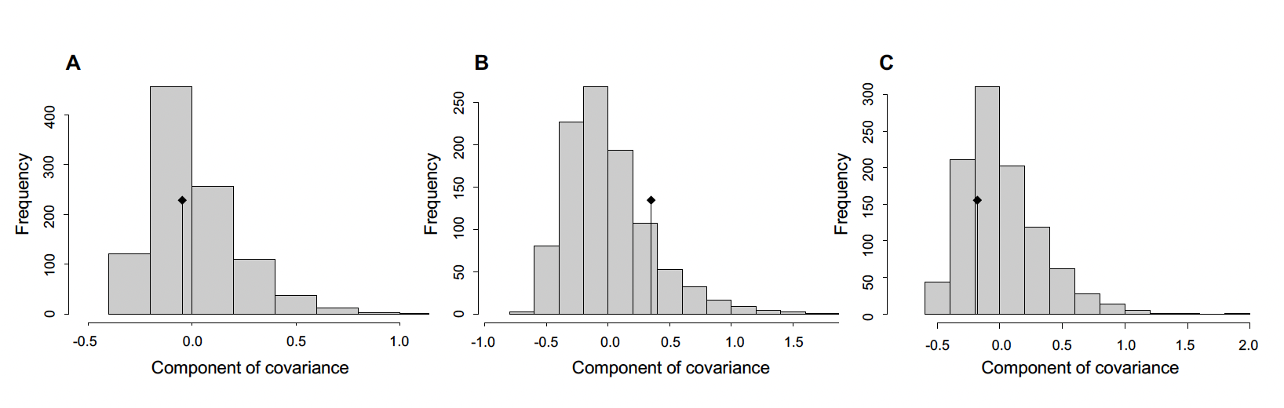

Figure S3. Results from AMOVAs testing the relative importance of (A) animal movement (leaving vs, coming to the pond), (B) pond (Sanctuary Lake pond vs. Wood Lab pond), and (C) season (spring vs. summer) in explaining Bd genetic variance. Each histogram displays components of covariances calculated by randomly permuting the sample matrices 999 times using the rand.test function in the R package ade4. The black dot indicates the empirical component of covariance calculated from the original dataset. None of the p-values are statistically significant (α = 0.05).

Supplemental Tables

Table S1. Field site names, locations, and pond types the year indicates the ponds that were only sampled in 2019.
Pond Code | Pond Name | Coordinates | Pond Type
1 | Wood Lab (fenced 2019) | 41.569722 N -80.452500 W | Ephemeral
2 | RV (2019) | 41.691933 N -80.500450 W | Permanent
3 | Sanctuary Lake (fenced 2019) | 41.644136 N -80.429444 W | Ephemeral
4 | Cow Pit (2019) | 41.672083 N -80.513067 W | Permanent
5 | Tuttle | 41.638883 N -80.495116 W | Permanent
6 | Beaver | 41.665167 N -80.514650 W | Permanent
7 | David's pond | 41.621208 N -80.469131 W | Permanent
8 | Phelps | 41.690883 N -80.512467 W | Ephemeral
9 | Church | 41.650494 N -80.423694 W | Ephemeral
10 | Blackjack | 41.665733 N -80.511781 W | Ephemeral

Table S2. Proportion of Bd-positive captures (followed by number Bd-positive / total swabs) by species and pond. Pond codes follow Table S1.
Species | Pond 1 | Pond 2 |  |  | Pond 3 |  | Pond 4 | Pond 5 |  | Pond 6 |  | Pond 7 |  | Pond 8 |  | Pond 9 |  | Pond 10
Rana pipiens | 0.000  (0/1) | - |  |  | 0.310 (103/332) |  | 0.730 (19/26) | 0.800 (4/5) |  | - |  | 0.806 (25/31) |  | 1.000  (1/1) |  | 0.500 (1/2) |  | -
Rana clamitans | 0.722 (179/248) | 0.593 (127/214) |  |  | 0.474 (9/19) |  | 0.609 (67/110) | 0.261 (43/165) |  | 0.551 (70/127) |  | 0.267 (4/15) |  | 0.364 (4/11) |  | 0.745 (35/47) |  | 0.290  (27/94)
Rana sylvatica | 0.193 (71/367) | 0.060 (1/16) |  |  | - |  | - | - |  | 0  (0/15) |  | - |  | 0.467 (7/15) |  | 0.500  (1/2) |  | 0.154  (2/13)
Rana catesbeiana | 0.667  (2/3) | 0.702 (59/84) |  |  | 0.250  (1/4) |  | 0.765 (127/166) | 0.372 (73/196) |  | 0.583 (7/12) |  | 0.365 (65/178) |  | 0.583 (7/12) |  | 0.729 (43/59) |  | 0.409  (9/22)
Pseudacris crucifer | 0.254 (15/59) | 0.134 (19/142) |  |  | 0.322 (29/90) |  | 0.159 (7/44) | 0.333 (1/3) |  | 0.095 (2/21) |  | 0.160 (13/81) |  | 0.227 (5/22) |  | 0.296 (8/27) |  | 0.161  (9/56)
Plethodon cinereus | 0.071 (1/14) | - |  |  | 0  (0/2) |  | 0  (0/1) | - |  | 0.063 (1/16) |  | - |  | - |  | - |  | 0.333  (1/3)
Hyla versicolor | 0  (0/5) | 0.104 (7/67) |  |  | 0.169 (10/59) |  | 0  (0/3) | 0.143 (1/7) |  | 0  (0/5) |  | 0.444 (20/45) |  | 0.191 (13/68) |  | 0.077 (2/13) |  | 0.205  (9/44)
Anaxyrus americanus | 0.444  (4/9) | 0  (0/7) |  |  | 0.269 (56/208) |  | 0.143 (1/7) | - |  | 0  (0/11) |  | 0.200  (1/5) |  | 0.231 (3/13) |  | 0  (0/3) |  | 0.500  (1/2)
Ambystoma maculatum | 0.214 (15/70) | 0.067 (1/15) |  |  | - |  | - | - |  | - |  | - |  | - |  | - |  | -
Ambystoma jeffersonianum | - | - |  |  | - |  | - | - |  | - |  | - |  | 0  (0/1) |  | - |  | -
Notophthalmus viridescens | 0.500  (1/2) |  | 0.600 (15/25) | - |  | 0.400  (2/5) |  |  | - |  | - | - | - |  | - |  | 0  (0/2)
Hemidactylium scutatum | 0  (0/1) |  | - | - |  | - |  |  | - |  | - | - | - |  | - |  | 0.500  (1/2)

Table S3. Output from a generalized additive model (GAM) of the probability of Bd infection (yes/no) over time (in Julian days). Pond type (ephemeral vs. permanent) and Julian day were included as factors and species, site and year were included as random effects.
 | Estimate | Standard error | z value | p-value
Intercept | -1.242 | 0.509 | -2.441 | 0.015
Pond type (permanent) | - 0.070 | 0.384 | -0.183 | 0.855
Approx. significance of smooth terms:
 | Estimated df | Reference df | Chi squared | p-value
Julian day * Pond type (ephemeral) | 11.484 | 13.75 | 243.93 | < 0.001
Julian day * Pond type (permanent) | 15.899 | 17.660 | 295.97 | < 0.001
Species | 8.698 | 9.0 | 900 | < 0.001
Site | 7.609 | 8.0 | 515.48 | < 0.001
Year | 1.854 | 2.0 | 66.88 | < 0.001
R-squared (adjusted) | 0.26
Deviance explained | 20.7
Residual maximum likelihood (REML) | 2760.3
Scale estimate | 1.000
N | 5033

Table S4. Output from a GAM of Bd load (in log (DNA copies + 1)) over time (in Julian days). Pond type (ephemeral vs. permanent) and Julian day are factors and species, site, and year are random effects.
 | Estimate |  | Standard error | t value | p-value
Intercept | 2.961 |  | 0.247 | 12.010 | < 0.001
Pond type (permanent) | -0.017 |  | 0.141 | -0.117 | 0.907
Approx. significance of smooth terms:
 | Estimated df |  | Reference df | F | p-value
Julian day * Pond type (ephemeral) | 1.965 |  | 2.457 | 6.500 | 0.001
Julian day * Pond type (permanent) | 7.681 |  | 9.355 | 13.244 | < 0.001
Year | 8.816 |  | 12 | 10.784 | < 0.001
Site code | 6.443 |  | 8.000 | 19.812 | < 0.001
Species code | 8.247 |  | 9.000 | 55.547 | < 0.001
R-squared (adjusted) |  | 0.189
Deviance explained |  | 20.0
Residual maximum likelihood (REML) |  | 2921.5
Scale estimate |  | 1.197
N |  | 1909

Table S5. Output from a GAM of the probability of Bd infection (yes/no) as a function of body temperature. Pond type (ephemeral vs. permanent) and Julian day are factors and species, site, and year are random effects.
 | Estimate |  | Standard error | z value | p-value
Intercept | -1.121 |  | 0.457 | -2.456 | 0.014
Pond type (permanent) | 0.005 |  | 0.345 | 0.015 | 0.988
Approx. significance of smooth terms:
 | Estimated df |  | Reference df | Chi squared | p-value
Body temperature*Pond type (ephemeral) | 5.846 |  | 7.333 | 91.260 | < 0.001
Body temperature*Pond type (permanent) | 6.598 |  | 8.313 | 128.716 | < 0.001
Year | 0.288 |  | 2.000 | 0.619 | 0.235
Site code | 7.537 |  | 8.000 | 1217.206 | < 0.001
Species code | 8.668 |  | 9.000 | 1057.136 | < 0.001
R-squared (adjusted) |  | 0.206
Deviance explained |  | 16.4
Residual maximum likelihood (REML) |  | 2517.8
Scale estimate |  | 1.000
N |  | 4378

Table S6. Output from a GAM of Bd load (in log (DNA copies + 1) as a function of body temperature. Pond type (ephemeral vs. permanent) and Julian day are factors and species, site, and year are random effects.
 | Estimate |  | Standard error | t value | p-value
Intercept | 2.950 |  | 0.243 | 12.148 | < 0.001
Pond type (permanent) | 0.008 |  | 0.133 | 0.063 | 0.950
Approx. significance of smooth terms:
 | Estimated df |  | Reference df | F | p-value
Julian day *Pond type (ephemeral) | 2.843 |  | 3.656 | 5.609 | < 0.001
Julian day * Pond type (permanent) | 4.377 |  | 5.581 | 16.811 | < 0.001
Species code | 8.198 |  | 9.000 | 40.181 | < 0.001
Site code | 6.125 |  | 8.000 | 10.115 | 0.002
Year | 0.010 |  | 2.000 | 0.004 | 0.453
R-squared (adjusted) |  | 0.181
Deviance explained |  | 19.1
Residual maximum likelihood (REML) |  | 2639.2
Scale estimate |  | 1.204
N |  | 1724

Table S7. Proportion of eDNA samples where Bd was detected and Bd DNA concentration (including only samples where Bd was detected) by season and pond type.
 | Mean (range) Bd eDNA concentration  [log (DNA copies +1)/L] |  | Proportion of samples (detected/total) containing Bd eDNA |  | Ponds where eDNA was  sampled vs. detected
Season | Ephemeral | Permanent | Ephemeral | Permanent | 2018 | 2019
Winter | - | - | 0 (0/4) | - | 2 | 3
Spring | 3.046  (1.842- 4.063) | 3.284  (1.531- 5.376) | 0.33 (6/18) | 0.50 (8/16) | 1,2,3,4,5,6,7,8,9,10 | 1,2,3,4
Summer | 3.337  (2.558-4.334) | 3.515  (2.736-4.524) | 0.33 (3/9) | 0.36 (4/11) | 2,4,5,6,8,9,10 | 1,2,3,4
Fall | 3.233 | - | 0.25 (1/4) | 0.00 (0/6) | 1,2,5,6,8 | 1,2,3,4

Table S8. Output from a generalized linear mixed model (with a binomial distribution) of the probability of Bd infection (yes/no) across the two life stages (tadpoles vs. post-metamorphic) and pond type (ephemeral vs. permanent). Because of unequal variances when all species were included, we only included four species for which we had sufficient sampling (Rana catesbeiana, to which the other three are compared, R. clamitans, R. sylvatica, and Pseudacris crucifer). Coefficient estimates and standard errors (in parentheses) are shown for each factor.
 | Dependent variable:
 | Bd infection
Life stage (tadpole) | -1.646*** (-2.514, -0.778)
 | t = -3.718
 | p < 0.001
Pond type (permanent) | -0.172 (-0.931, 0.588)
 | t = -0.443
 | p = 0.658
Species (Rana clamitans) | -0.272** (-0.466, -0.079)
 | t = -2.759
 | p = 0.006
Species (Rana sylvatica) | -2.231*** (-2.575, -1.886)
 | t = -12.706
 | p < 0.001
Species (Pseudacris crucifer) | -1.592*** (-1.838, -1.346)
 | t = -12.681
 | p < 0.001
Life stage (tadpole) * Pond type (permanent) | -0.918 (-2.038, 0.201)
 | t = -1.608
 | p = 0.108
Constant | 0.367 (-0.188, 0.923)
 | t = 1.296
 | p = 0.195
Observations | 3578
Log Likelihood | -2096.306
Akaike Information Criterion | 4208.612
Bayesian Information Criterion | 4258.073
Table S9. Output from a linear mixed model of Bd load on infected animals across the two hibernation types (permanent pond vs. terrestrial) in the two fenced ponds. Coefficient estimates and their standard errors (in parentheses) are shown for each factor.
 | Dependent variable:
 | Bd load in log (DNA copies + 1)
Hibernation type (aquatic vs. terrestrial) | 1.901 (0.701, 3.102)
 | t = -3.103
 | p = 0.003
Pond (Wood Lab vs. Sanctuary Lake) | 0.146 (-0.227, 0.518)
 | t = -1.839
 | p = 0.069
Hibernation type * Pond | -0.621 (-1.246, 0.004)
 | t = 1.949
 | p = 0.054
Constant | 2.546 (1.781, 3.312)
 | t = 6.519
 | p < 0.001
Observations | 114
Log Likelihood | -196.505
Akaike Information Criterion | 405.011
Bayesian Information Criterion | 421.213

Table S10. Output from a generalized linear mixed model (with a binomial distribution) of the probability of Bd infection (yes/no) across the two hibernation types in the two fenced ponds. Coefficient estimates and their standard errors (in parentheses) are shown for each factor.
 | Dependent variable:
 | Bd infection (yes/no)
Hibernation type (aquatic vs. terrestrial) | -3.574 (2.446, 4.702)
 | z = -6.212
 | p < 0.001
Pond (Wood Lab vs. Sanctuary Lake) | 0.197 (-0.112, 0.506)
 | z = -4.111
 | p < 0.001
Hibernation type * Pond | -1.184 (-1.747, -0.621)
 | z = 4.122
 | p < 0.001
Constant | -1.489 (-2.095, -0.882)
 | z = -4.813
 | p < 0.001
Observations | 332
Log Likelihood | -187.078
Akaike Information Criterion | 384.156
Bayesian Information Criterion | 403.256

Table S11. Output from a generalized least squares linear mixed model (GLS LMM) of Bd load on infected animals across the two hibernation types (permanent pond vs. terrestrial) and among animals entering vs. leaving the two fenced ponds. Coefficient estimates and their standard errors (in parentheses) are shown for each factor.

 | Dependent variable:
 | Bd load in log (DNA copies + 1)
Hibernation type (aquatic vs. terrestrial) | -0.817 (0.436, 1.199)
 | t = -4.097
 | p < 0.001
Movement direction (entering vs. leaving pond) | 0.313 (-0.119, 0.663)
 | t = 1.296
 | p = 0.196
Hibernation type * Movement direction | 0.014 (-0.536, 0.622)
 | t = 0.0933
 | p = 0.9257
Constant | 3.383 (2.325, 2.828)
 | t = 17.01
 | p < 0.001
Observations | 295
Log Likelihood | -486.652
Akaike Information Criterion | 985.304
Bayesian Information Criterion | 1007.344

Table S12. Output from a generalized linear mixed model (with a binomial distribution) of the probability of Bd infection (yes/no) across the two hibernation types (permanent pond vs. terrestrial) for animals entering vs. leaving the two fenced ponds. Coefficient estimates and their standard errors (in parentheses) are shown for each factor.
 | Dependent variable:
 | Bd infection (yes/no)
Hibernation type (pond vs. terrestrial) | 1.288 (0.823, 1.753)
 | z = 5.433
 | p = 0.00000
Movement direction (entering vs. leaving pond) | -0.112 (-0.488, 0.264)
 | z = 0.323
 | p = 0.7466
Hibernation type * Movement direction | 0.201 (-0.468, 0.871)
 | z = 0.590
 | p = 0.555
Constant | -0.949 (-1.260, -0.639)
 | z = -5.987
 | p < 0.001
Observations | 824
Log Likelihood | -500.697
Akaike Information Criterion | 1011.394
Bayesian Information Criterion | 1034.958

Table S13. Output from a generalized linear model (with a binomial distribution and logit link function) of the relationship between Fluidigm sequencing result (yes/no on useable haplotype data) and Bd load on the swab sample (as estimated using qPCR). Coefficient estimates and their standard errors (in parentheses) are shown for each factor.
 | Dependent variable:
 | Usable haplotype data (yes/no)
Bd load (in log (DNA copies + 1)) | 0.004 (-0.010, 0.019)
 | t = 0.603
 | p = 0.547
Constant | -1.250 (-2.148, -0.352)
 | t = -2.727
 | p = 0.007
Observations | 105
Log Likelihood | -60.708
Akaike Information Criterion | 125.416
Residual Deviance | 121.416 (df = 103)
Null Deviance | 121.782 (df = 104)

Table S14. Results from AMOVAs testing the relative importance of direction of movement (entering vs. leaving), pond (Sanctuary Lake vs. Wood Lab), and season (spring vs. summer) in explaining Bd genetic variance.
Comparison | Sample Sizes | % variation between comparison groups | % variation within samples | p-value
Movement direction | Leaving = 13  Entering =15 | -0.66% | 100.66% | 0.553
Pond | Wood Lab = 23  Sanctuary Lake = 5 | 4.81% | 95.19% | 0.163
Season | Summer = 22  Spring = 6 | -2.60% | 102.60% | 0.678

