Climate Dynamics
Supporting Information for
Does El Niño affect MJO-AR connections over the North Pacific and associated North American precipitation?
Laís G. Fernandes ¹∗, and Paul Loikith ¹
¹ Department of Geography, Portland State University, Portland, OR, United States

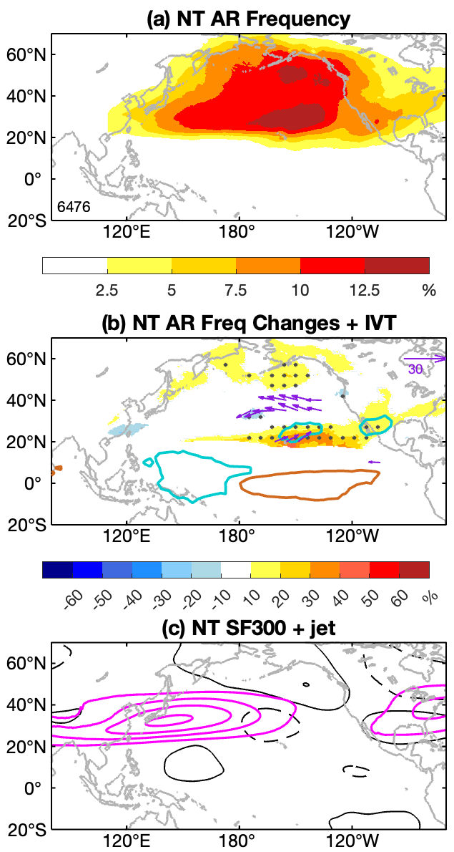
Fig. S1 Same as Figure 2, but for neutral ENSO years

∗Corresponding author address: Department of Geography, PSU, 1825 SW Broadway Portland, OR 97201. E-mail: lais.fernandes@pdx.edu

