Supplemental material
Repeatability of measurements
Repeatability of measurements is important to prevent conflation of variation in measurement with differences between species. For this reason, the length and width of 40 eggs and the length of 12 right hind tibias were measured twice at different time points and compared via t-test. The average difference between the two measurements of the same egg was 0.00265 mm with the average egg length sit at 0.1158, or a 2.29% difference (correlation between measurements: r = 0.90). The average difference in egg width was 0.00255 mm with an average egg width of 0.0886, or a 2.88% difference (correlation measurements: r = 0.91). For body size, the difference in tibia length measurements was 0.0158 mm on an average tibia length of 1.122, or a 1.41% difference (correlation measurements: r = 0.90).
Table S1. Geographic location of collection Belonocnema sites
Species (host plant) | Site | Latitude | Longitude
B. fossoria (Q. geminata) | Archbold Biological Station (ABS) | 27.1846 | -81.3521
 | Lake Lizzie (LL) | 28.2276 | -81.1788
 | Jonathan Dickinson State Park (JDSP) | 27.0261 | -80.1091
 | Ochlockonee, FL (OCH) | 30.0063 | -84.4881
B. treatae (Q. virginiana) | Alva | 26.7092 | -81.6154
 | Lake Griffin State Park (LGSP) | 28.8647 | -81.8934
 | Kissimmee River (KRE) | 27.3780 | -81.0968
 | Okeechobee (Okee) | 27.2440 | -80.8168
 | High Springs (HS) | 29.8436 | -82.6316

Table S2. Number of B. fossoria and B. treatae collected from each site, as well as the number of eggs and wings measured
Wasp species | Location | Number collected | Number of individuals measured | Egg measurements | Wing measurements
B. fossoria | ABS | 20 | 15 | 14 | 11
 | JDSP | 52 | 30 | 30 | 26
 | LL | 174 | 30 | 29 | 28
 | OCH | 61 | 30 | 29 | 29
Total B. fossoria |  | 307 | 105 | 102 | 94
B. treatae | Alva | 3 | 2 | 2 | 2
 | HS | 55 | 30 | 30 | 30
 | KRE | 55 | 30 | 29 | 30
 | LGSP | 71 | 33 | 29 | 31
 | Okee | 3 | 2 | 2 | 2
Total B. treatae |  | 187 | 97 | 92 | 95

Table S3. Number of individuals of B. fossoria and B. treatae reared from natal and non-natal host plants from reciprocal transplant experiment
Gall wasp species | Host plant |  | Number of individuals measured
B. fossoria | Q. geminata | 54
 | Q. virginiana | 31
B. treatae | Q. geminata | 16
 | Q. virginiana | 62

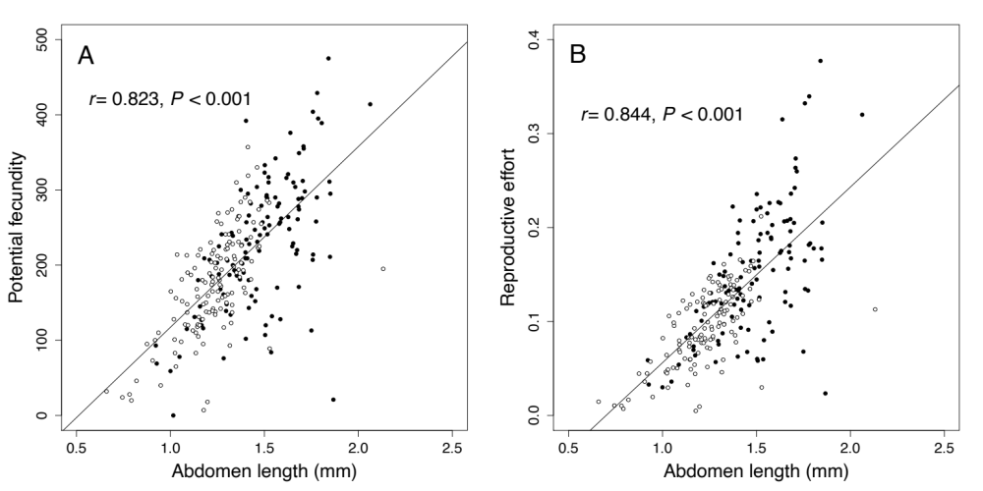
Figure S1. Correlation between abdomen length and (A) potential fecundity (measured as the total number of eggs per individual), and (B) reproductive effort, calculated as the product of fecundity (number of eggs) and egg volume, among natural collected individuals. Filled and open circles stand for individuals from B. fossoria and B. treatae, respectively. Total number of individuals of B. fossoria and B. treatae used are 126 and 143.

