Supplementary Materials

Molecular mechanisms in metal oxide nanoparticle Tryptophan interactions
Alexandra Nefedova,ª Fredric G. Svensson,^{b} Alexander S. Vanetsev,ª* Peter Agback,^{b} Tatiana Agback,^{b} Lars Kloo,^{c} Tanel Tätte,ª Angela Ivask,^{d} Gulaim A. Seisenbaeva,^{b} Vadim G. Kessler^{b}*
ª Institute of Physics, University of Tartu, W.Ostwaldi 1, 50411 Tartu, Estonia. alexander.vanetsev@ut.ee
^{b} Department of Solid State Physics, Ångström Laboratory, Uppsala University, Box 35, SE-75103 Uppsala, Sweden
^{c} Department of Molecular Science, BioCenter, Swedish University of Agricultural Sciences, Box 7015, 75007 Uppsala, Sweden. vadim.kessler@slu.se
d Applied Physical Chemistry, KTH Royal Institute of Technology, Teknikringen 30, SE-100 44 Stockholm, Sweden.
^{e} Institute of Molecular and Cell Biology, University of Tartu, Riia 23, 51010 Tartu, Estonia.

Fig S1. Titration of 0.5mM Trp with Captigel (A), TiBALD (B), Ce(-)(C) and Ce(+)(D). The following colours of curves obtained at different ration of NP/Tript were used. (A), (B) Trp: Captigel/or TiBALD: 0.5mM: 0mM (black); 0.5mM:0.031mM (blue); 0.5mM:0.0625mM (red); 0.5mM:0.125mM (green); 0.5mM:0.250mM (light green);) 0.5mM:0.5mM (light blue); 0.5mM:1.0mM (ros). (C), (D) Trp: Ce(-)(C)/or Ce(+)(D): 0.5mM: 0mM (black); 0.5mM:0.0005mM (blue); 0.5mM:0.001mM (red); 0.5mM:0.002mM (green); 0.5mM:0.005mM (light green); 0.5mM:0.007mM (light blue).

Fig S2. Normalized intensities (I/Iº) of H6 proton resonance of Trp at 7.728 ppm vs to the ratio (R) of Trp: TiO₂-I (blue line) and Trp: TiO₂-II (black line) mixtures

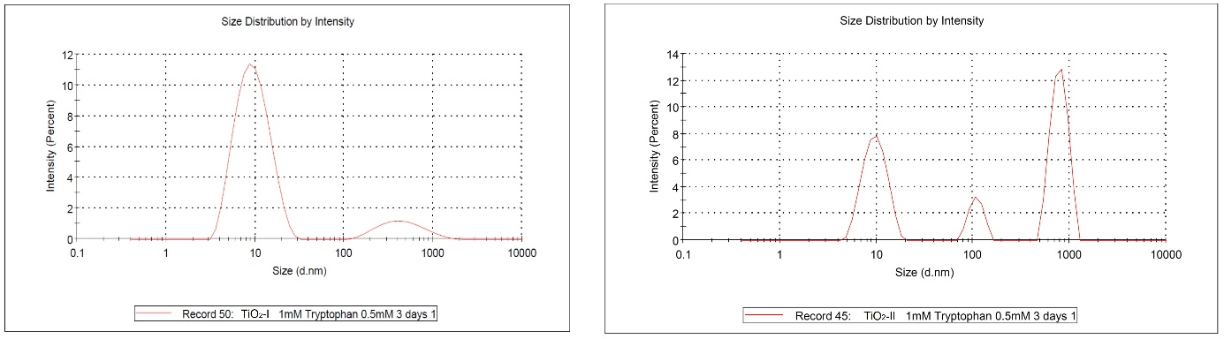
Fig S3. Particle size distribution by DLS after 72 h of storage for Trp solutions containing TiO₂-I (left) and TiO₂-II (right).

Fig S4. NMR spectra with assignment of the oxidized product of Trp obtained in mixture with Ce(-)(C) NP. Superposition of the HMBC (blue) and HSQC( red, black) spectra are presented in the aromatic 8.0-6.5ppm (A) and aliphatic (C) regions. 1H spectrum is in the regions (B) and (D), respectively. Assignment and numbering was shown according structure on panel (A).

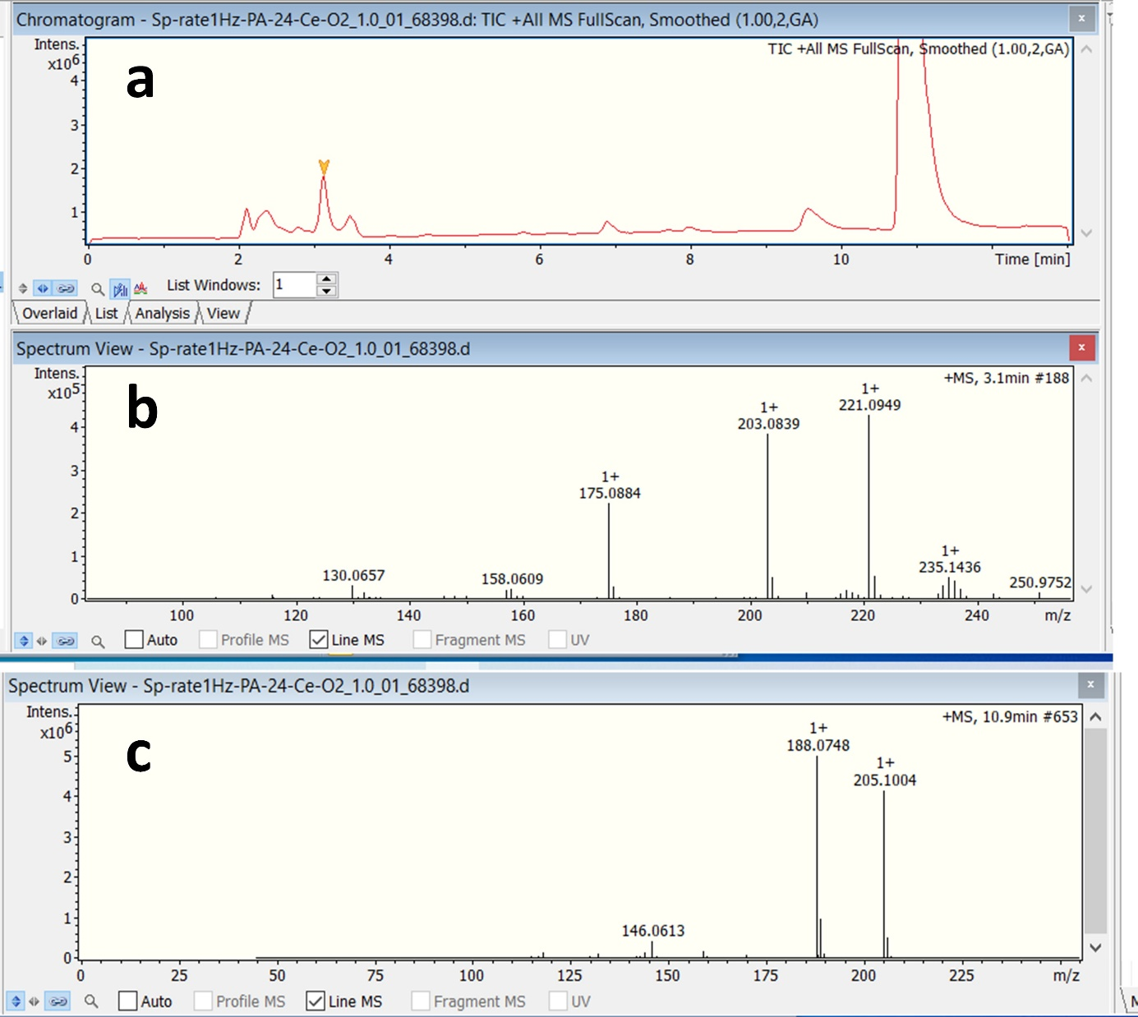
Fig S5. Total Ion Current (TIC) chromatogram from a Bruker’s Maxis Impact Q-TOF mass spectrometer obtained after an HPLC-MS analysis of the sample using a Hypercarb (4.6x100mm) HPLC column (a); Mass spectrum of the peak at Rt. 3.1 min. i.e that of a mono-oxy compound (b); Mass spectrum of the peak at Rt. 10.9 min that of unreacted Tryptophan for comparison (c).

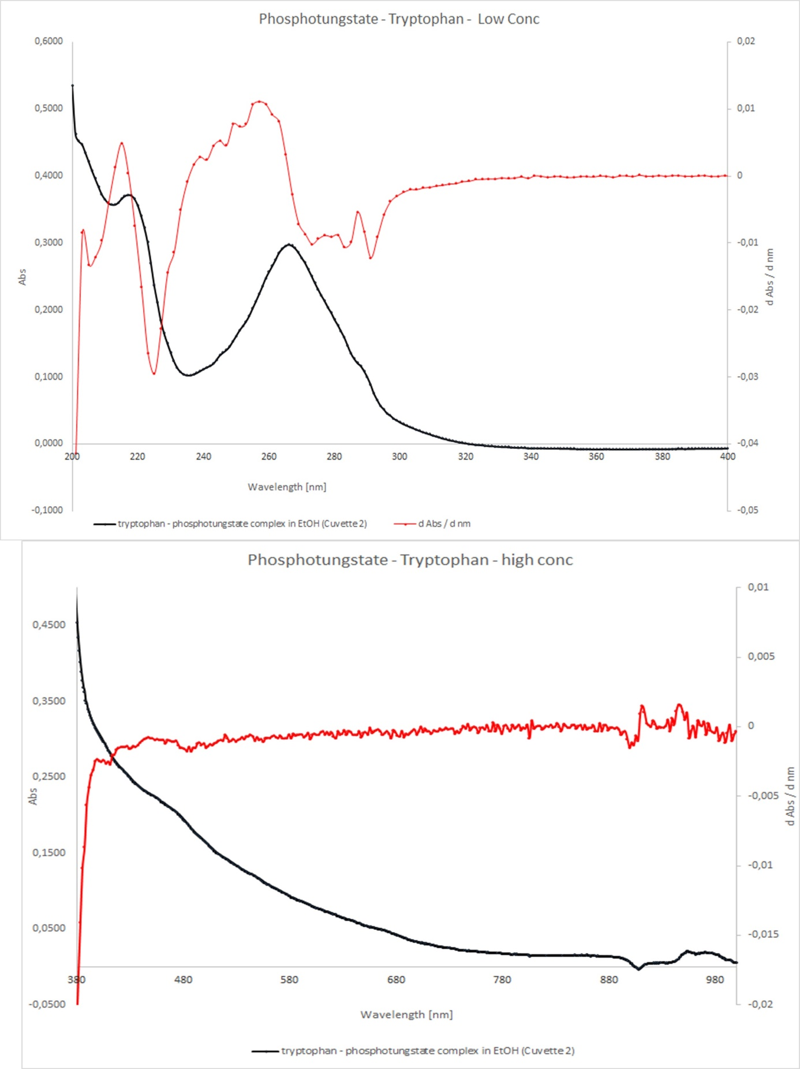
Fig S6. UV-Vis spectra of the EtOH:H₂O = 1:1 solutions of (HTrp)₃PW₁₂O₄₀⋅5H₂O.

Fig. S7 Assignment of the ¹H and ¹³C chemical shifts of Trp in complex (HTrp)₃PW₁₂O₄₀⋅5H₂O.
In panel (A) the superposition of the one bond ¹H-¹³C correlation, HSQC (red), and 2, 3 ¹H-¹³C bonds correlation, HMBC(blue), spectra dissolved in dmso_{d6} are presented with ¹³C projection (left) with assignment. In panel (B) and (C) 1D ¹H spectra of Trp in complex (HTrp)₃PW₁₂O₄₀⋅5H₂O and free form are presented respectively. In HMBC spectrum one bond ¹H-¹³C coupling is not suppressed.

Fig. S8 ¹H expended spectra in aromatic region (A) 8.05-7.65 (B) 6.9-4.9 ppm of the Trp:NP complex exposed to UV light filtered in in dmso_{d6} solution.
(black) Trypt: bare TiO₂;(blue), Trypt: TiO2-I, (red) and Trypt: TiO2-II. There are signals of oxidation products after UV irradiation in solution of Trypt: bare-TiO₂ but not Trypt: TiO₂-I or Trypt: TiO₂-II.

Table TS1
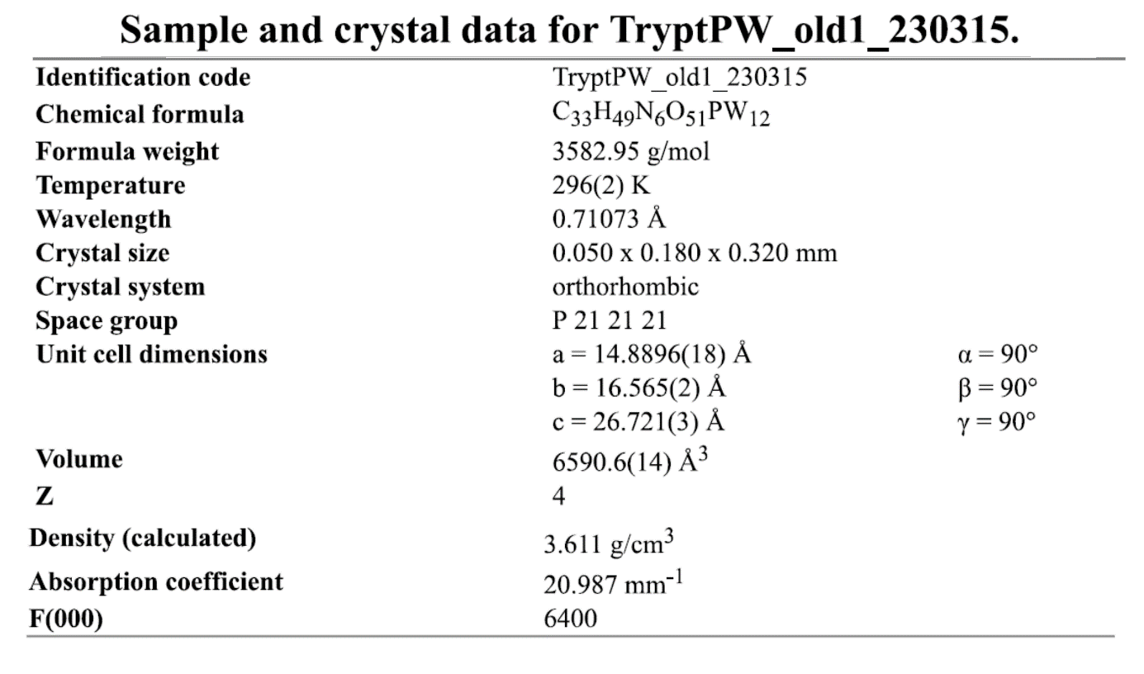

Table TS2
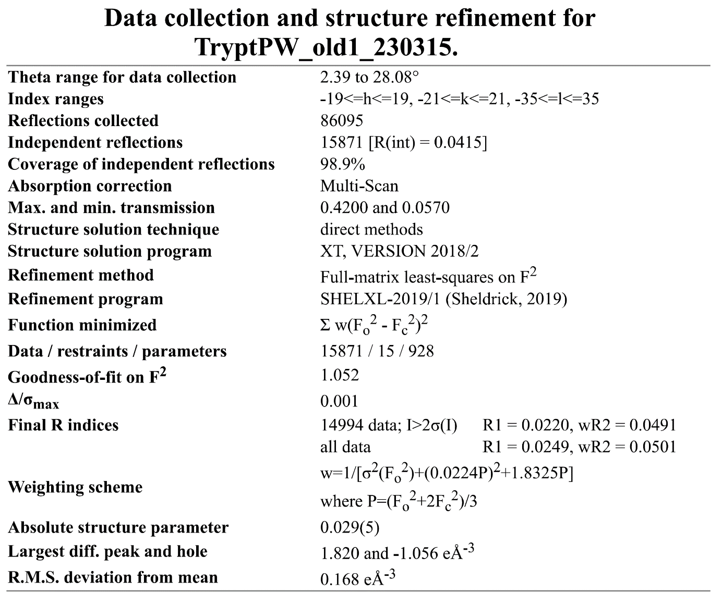

Table TS3. Key energies for the species involved in the reactions (1)-(3), in electron volts (eV).
Species | HOMO* / eV | LUMO* / eV | E_{tot} / eV
W₁₂PO₄₀³⁻, C1 | -3.032 | +4.215 | -113265.42
W₁₂PO₄₀³⁻, T | -3.032 | +4.215 | -113265.42
W₁₂PO₄₀³⁻(aq), C1 | -9.849 | -2.583 | -113275.81
HW₁₂PO₄₀²⁻, C1 | -5.648 | +1.597 | -113281.19
HW₁₂PO₄₀³⁻(aq), C1 | -10.103 | -2.856 | -113286.43
W₁₂PO₄₀⁴⁻ | +2.892/-0.142 | +7.135/+7.177 | -113261.58
HW₁₂PO₄₀³⁻ | -0.426/-2.939 | +4.335/+4.334 | -113280.31
HW₁₂PO₄₀³⁻(aq) | -6.589/-9.638 | -2.317/-2.295 | -113290.87
TRP | -7.136 | +0.467 | -18672.74
TRP⁺ | -11.621/-12.111 | -4.251/-7.350 | -18665.46
TRP⁺(aq) | -8.484/-9.079 | -0.953/-4.100 | -18667.49
HTRP⁺ | -10.686 | -3.622 | -18682.81
HTRP⁺(aq) | -7.527 | +0.111 | -18685.22
HTRP²⁺ | -15.507/-15.912 | -7.907/-11.094 | -18671.89
*The HOMOs/LUMOs with two values correspond to doublet ground states with alpha and beta electron energies given separately.

