Supporting Information

Portable visual and electrochemical detection of hydrogen peroxide release from living cells based on dual functional Pt-Ni hydrogels

Guanglei Li^{1,2}, Yao Chen¹, Fei Liu¹, Wenhua Bi¹, Chenxin Wang¹, Danfeng Lu³ and Dan Wen^{1*}

Correspondence: Dan Wen (dan.wen@nwpu.edu.cn, ORCID: 0000-0001-6879-7982)
¹State Key Laboratory of Solidification Processing, School of Materials Science and Engineering, NPU and Shaanxi Joint Laboratory of Graphene, Xi’an, 710072, P. R. China.
²Interdisciplinary Research Center of Biology & Catalysis, School of Life Sciences, Northwestern Polytechnical University (NPU), Xi'an, 710072, P. R. China.
³Faculty of Printing, Packaging Engineering, and Digital Media Technology, Xi’an University of Technology, Xi’an, 710048, P. R. China.
These authors contributed equally: Guanglei Li, Yao Chen, Fei Liu.

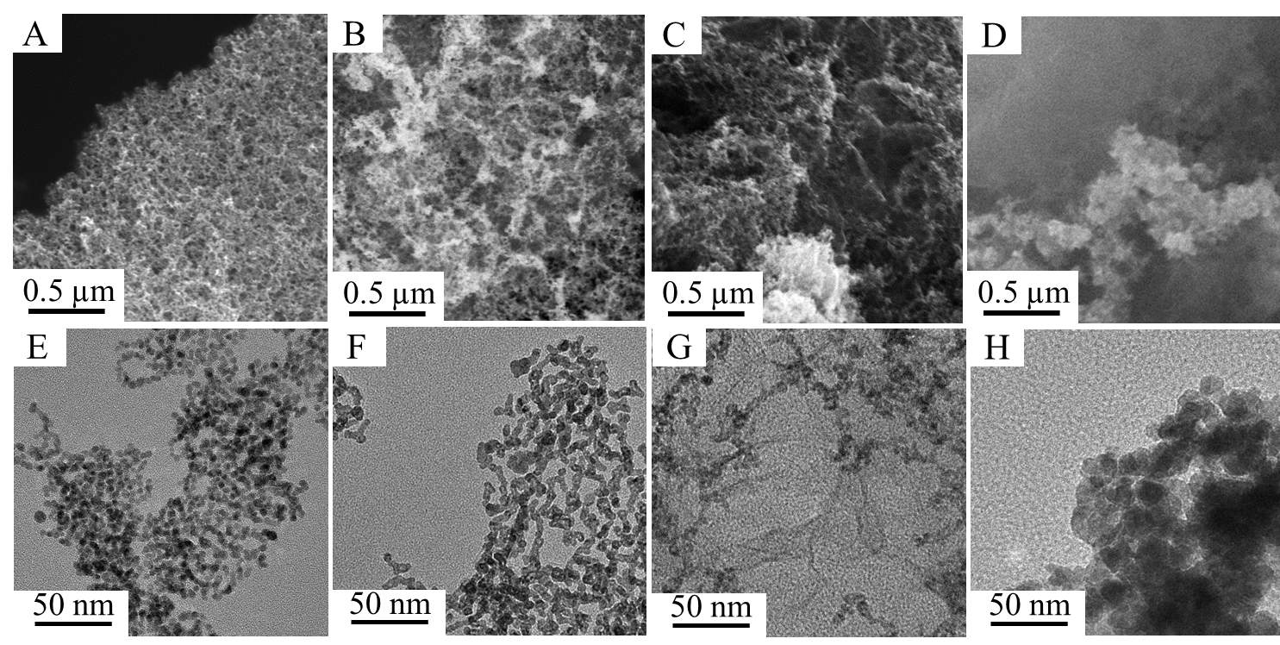
Fig. S1 The scanning electron microscopy (SEM) image of the (A) pure Pt, (B) PtNi, (C) PtNi₅ and (D) pure Ni hydrogels. The transmission electron microscopy (TEM) images of the (E) pure Pt, (F) PtNi, (G) PtNi₅ and (H) pure Ni hydrogels.

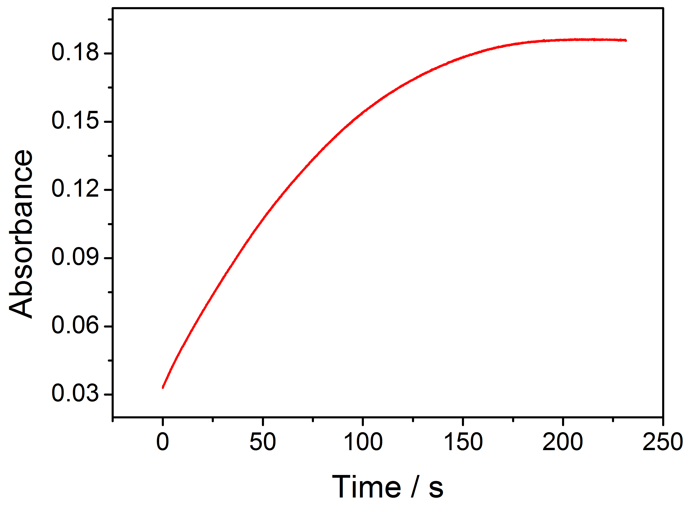
Fig. S2 Time-dependent absorbance at 652 nm measured from the reaction solutions containing 0.5 mM hydrogen peroxide (H₂O₂), 0.5 mM 3,3,5,5-tetramethylbenzidine (TMB), and 0.05 μg mL⁻¹ PtNi₃ hydrogel in 0.1 M phosphate buffer solution (PBS) (pH 5.0) at room temperature.
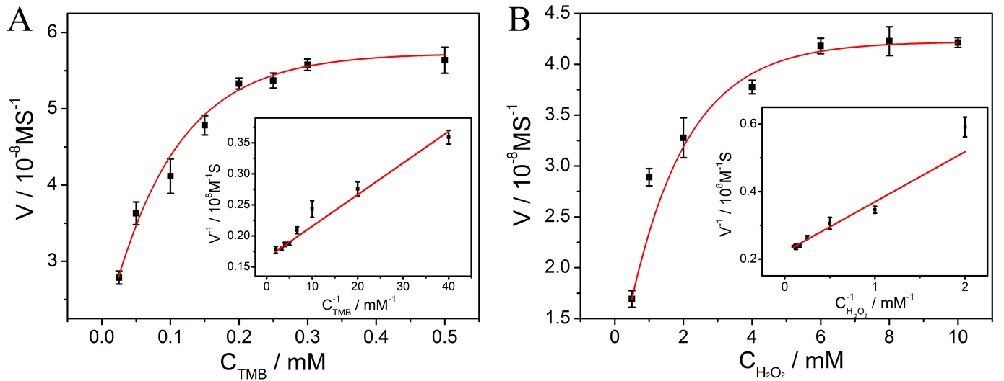
Fig. S3 Lineweaver-Burk curves and double-reciprocal diagrams of the initial reaction rates of the PtNi₃ hydrogel for the (A) TMB and (B) H₂O₂.

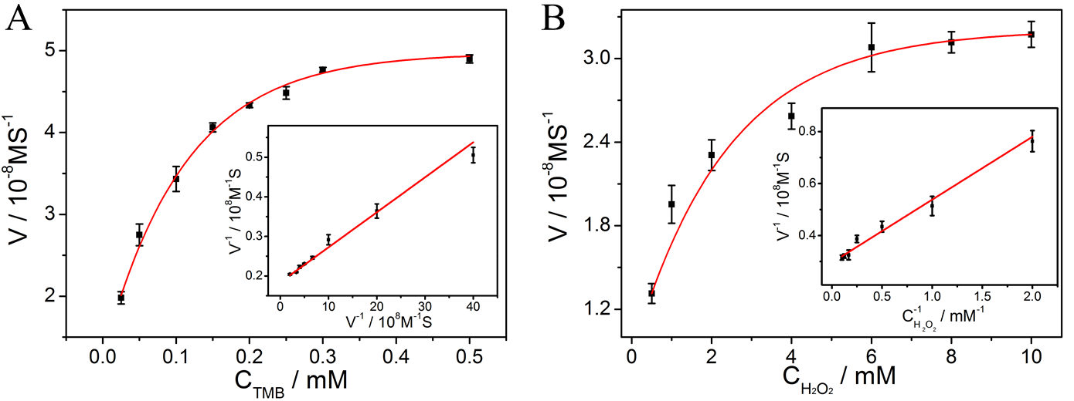
Fig. S4 Lineweaver-Burk curves and double-reciprocal diagrams of the initial reaction rates of the PtNi hydrogel for the (A) TMB and (B) H₂O₂.

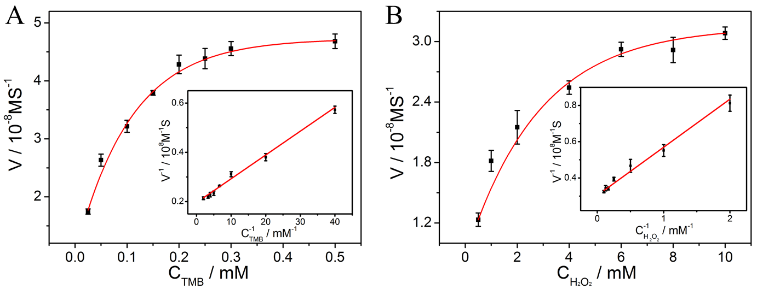
Fig. S5 Lineweaver-Burk curves and double-reciprocal diagrams of the initial reaction rates of the PtNi₅ hydrogel for the (A) TMB and (B) H₂O₂.

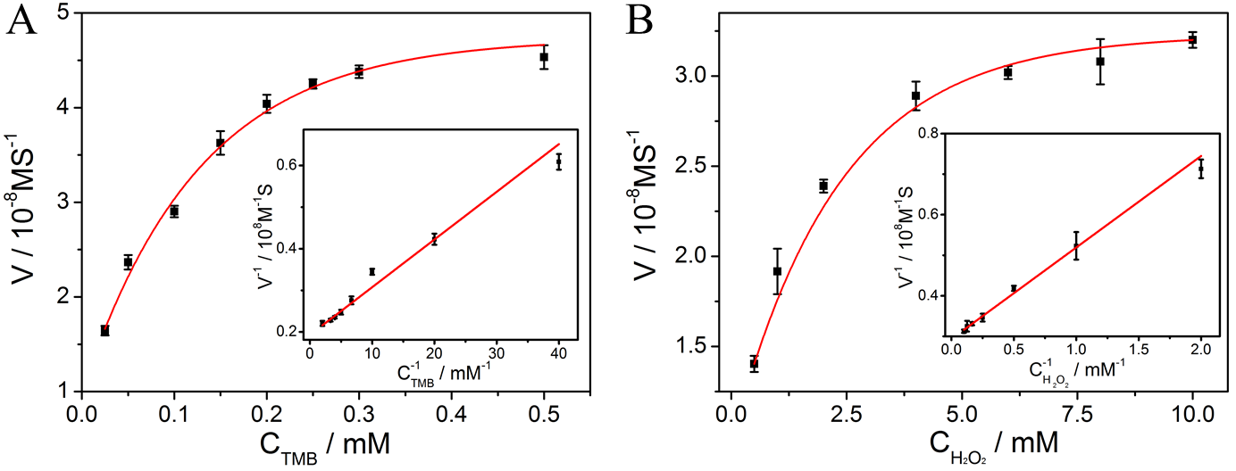
Fig. S6 Lineweaver-Burk curves and double-reciprocal diagrams of the initial reaction rates of the Pt hydrogel for the (A) TMB and (B) H₂O₂.

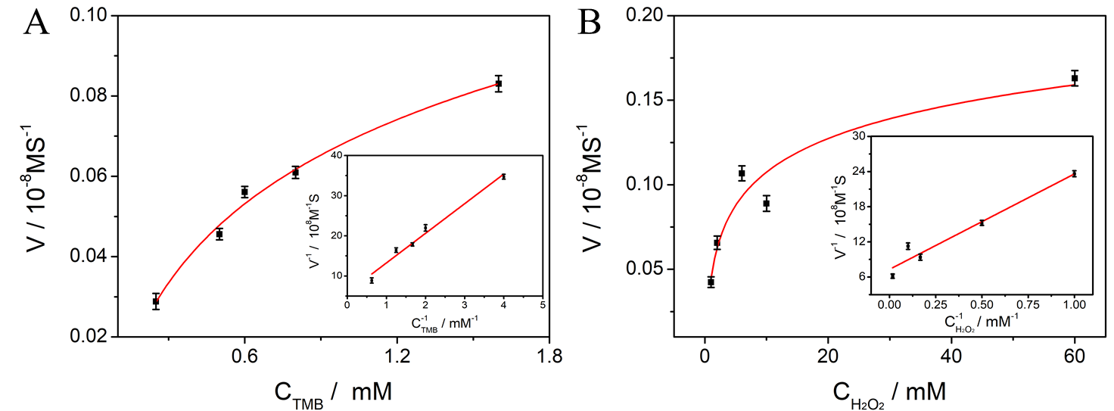
Fig. S7 Lineweaver-Burk curves and double-reciprocal diagrams of the initial reaction rates of the Ni hydrogel for the (A) TMB and (B) H₂O₂.

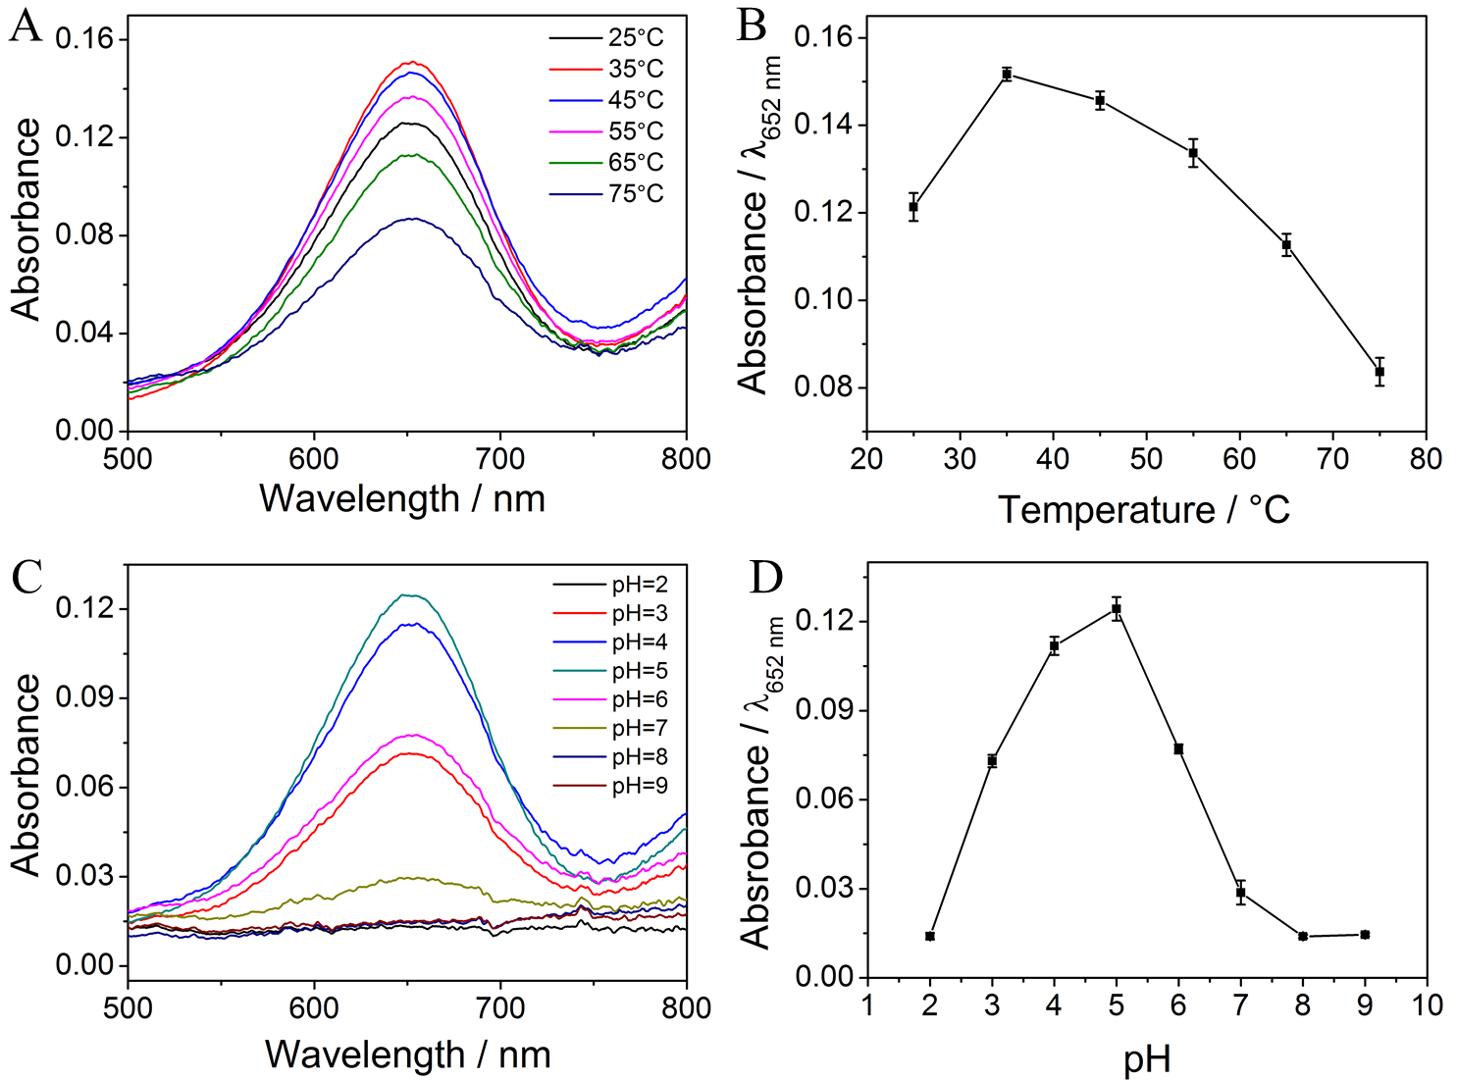
Fig. S8 UV-vis absorption spectra of the PtNi₃ hydrogel at (A-B) a temperature gradient of 25-75 ℃ and (C-D) a pH range of 2-9 in the presence of 0.5 mM TMB and 0.2 mM H₂O₂.
Table S1: Comparison of the kinetic parameters of the PtNi_{x}, pure Pt, Ni hydrogels and other artificial/natural enzymes.
Samples | K_{m} (mM) |  | V_{max} (10⁻⁸ Ms⁻¹) |  | K_{cat} (s⁻¹) |  | Ref.
Samples | TMB | H₂O₂ | TMB | H₂O₂ | TMB | H₂O₂ | Ref.
PtNi₃ hydrogel | 0.031 | 0.67 | 6.08 | 4.52 | 4.50×10⁴ | 3.35×10⁴ | This work
PtNi hydrogel | 0.048 | 0.818 | 5.43 | 3.37 | 2.76×10⁴ | 1.71×10⁴ | This work
PtNi₅ hydrogel | 0.049 | 0.873 | 5.10 | 3.28 | 2.37×10⁴ | 1.29×10⁴ | This work
Pt hydrogel | 0.059 | 0.904 | 5.18 | 3.40 | 2.54×10⁴ | 1.87×10⁴ | This work
Ni hydrogel | 1.26 | 2.23 | 0.17 | 0.14 | 2.02×10³ | 1.62×10³ | This work
Pd@Pt core-frame | 0.43 | 14 | 5.10 | 9.0 | 7.20×10⁻³ | 1.30×10⁻² | 1
Pt/hBNNSs | 0.21 | 9.2 | / | / | / | / | 2
Pt nanodendrites | 0.81 | 6.90 | 12 | 9.90 | 1.70×10⁻² | 1.40×10⁻² | 1
Fe-N-C SAzymes | 3.6 | 12 | 116 | 35.6 | 0.78 | 0.24 | 3
Fe-AL-E | 20.10 | 58.0 | 5.43 | 1.12 | 8.83×10⁻⁵ | 1.82×10⁻⁵ | 4
Pd cubes | 0.054 | 700 | 9.7 | 6.5 | 6.9×10⁴ | 4.6×10⁴ | 5
Mo_{SA}-N₃-C | 0.79 | / | / | 37 | 4.0×10⁴ | / | 6
HRP | 0.43 | 3.70 | 10.0 | 8.71 | 4.0×10³ | 3.48×10³ | 7

Table S2: The comparison of the sensing performances between the as-prepared colorimetric H₂O₂ sensor and the others recently reported in the literatures.
Sensing material | Linearity  range | Limit of detection | Long-term stability (signal retention) | Ref.
PtNi_{(1:3)} hydrogel | 0.1 μM-10 mM | 0.03 μM | 60 days | This work
Pt nanoclusters | 0-200 μM | 0.46 μM | 1 months | 8
B, N-PdRu aerogel | 10 μM-2 mM | 6 μM | / | 9
Fe-AL | 10-100 mM | 54 μM | / | 10
Fe_{0.8}Ni_{0.2}S₂ | 1.25-12.5 μM | 0.77 μM | / | 11
MSA/Cu NCs | 1 μM-1 mM | 0.5 μM | 10 months | 12
PtNPs/Cu-TCPP(Fe) | 2-100 μM | 0.357 μM | / | 13
Fe/CuSn(OH)₆ | 30-1000 μM | 9.49 μM | 11 days | 14
cysteine/I⁻/Au NPs | 0-80 μM | 2 μM | / | 15

Table S3: The measured R, G, B values at different concentrations of H₂O₂.
H₂O₂ (μM) | B/(R+G+B)
0 | 0.33433
0.5 | 0.33448
5 | 0.33645
50 | 0.34439
100 | 0.35086
500 | 0.39023
1000 | 0.44915

Supplemental References
- Wu, R. F. et al. Adv. Funct. Mater. 28, 1801484 (2018).
- Ivanova, M. N. et al. ACS Appl. Mater. Inter. 11, 22102-22112 (2019).
- Jiao, L. et al. Anal. Chem. 91, 11994-11999 (2019).
- Li, L. J. et al. ACS Sustain. Chem. Eng. 9, 12833-12843 (2021).
- Xia, X. H. et al. ACS Nano 9, 9994-10004 (2015).
- Wang, Y. et al. Chem 7, 436-449 (2021).
- Gao, L. et al. Nat. Nanotechnol. 22, 577-583 (2007).
- Jin, L. H. et al. ACS Appl. Mater. Inter. 9, 10027-10033 (2017).
- Zeng, Y. T. et al. ACS Appl. Mater. Inter. 13, 36816-36823 (2021).
- Li, L. J. et al. ACS Sustain. Chem. Eng. 9, 12833-12843 (2021).
- Zhang, C. Y. & Nan, Z. D. J. Phys. Chem. C 126, 4355-4364 (2022).
- Du, Y. B., Fang, J., Wang, H. L. & Yang, Y. ACS Appl. Mater. Inter.9, 11035-11044 (2017).
- Chen, H. Y. et al. ACS Appl. Mater. Inter. 10, 24108-24115 (2018).
- Liu, H. et al. ACS Sustainable Chem. Eng. 6, 14383-14393 (2018).
- Wang, F., Liu, X. Q., Lu, C. H. & Willner, I. ACS Nano 7, 7278-7286 (2013).

