Supplementary Information

Assessing PM_{2.5} in a Protected Ecosystem in the South Atlantic under Massive Port Activities - Evidence of High Concentrations and Multiple Sources

Bruno Martins Gurgatz*, Luiza Natalino, Julia Stefany Chagas Albrecht, Camila Arielle Bufato Moreira, Marina Reback Garcia, Emerson Joucoski, Ricardo Henrique Moreton Godoi, César C. Martins*, Rodrigo Arantes Reis.

* Corresponding authors: brunogurgatz@gmail.com (B.M. Gurgatz)
ccmart@ufpr.br (C.C. Martins)

Table S1. Spearman correlation matrix for daily fine particulate matter (PM_{2.5}), Black Carbon (BC), Brown Carbon (BrC), precipitation (Precip), temperature (Temp.), relative humidity (RH), wind speed (WS), Ships and Trucks.
Spearman's Correlations
Variable |  |  |  | PM_{2.5} |  | BC |  | BrC |  | Precip. |  | Temp. |  |  | RH |  |  | WS |  |  | Ships |  |  | Trucks
PM_{2.5} |  | Spearman's (ρ) |  | —
 |  | p-value |  | —
BC |  | Spearman's (ρ) |  | 0.534 | *** | —
 |  | p-value |  | <0.001 |  | —
BrC |  | Spearman's (ρ) |  | 0.544 | *** | 0.988 | *** | —
 |  | p-value |  | <0.001 |  | <0.001 |  | —
Precip. |  | Spearman's (ρ) |  | -0.238 | *** | -0.220 | *** | -0.213 | *** | —
 |  | p-value |  | <0.001 |  | <0.001 |  | <0.001 |  | —
Temp. |  | Spearman's (ρ) |  | 0.183 | ** | -0.122 | * | -0.104 |  | 0.166 | ** | —
 |  | p-value |  | 0.001 |  | 0.032 |  | 0.070 |  | 0.003 |  | —
RH |  | Spearman's (ρ) |  | -0.236 | *** | -0.010 |  | -0.047 |  | 0.379 | *** | -0.349 | *** | —
 |  | p-value |  | <0.001 |  | 0.864 |  | 0.416 |  | <0.001 |  | <0.001 |  | —
WS |  | Spearman's (ρ) |  | -0.016 |  | -0.068 |  | -0.055 |  | 0.171 | ** | 0.240 | *** | -0.265 |  | *** | —
 |  | p-value |  | 0.779 |  | 0.219 |  | 0.319 |  | 0.002 |  | <0.001 |  | <0.001 |  |  | —
Ships |  | Spearman's (ρ) |  | 0.166 | ** | 0.168 | ** | 0.159 | ** | -0.261 | *** | -0.053 |  | -0.162 |  | ** | -0.075 |  |  | —
 |  | p-value |  | 0.003 |  | 0.003 |  | 0.005 |  | <0.001 |  | 0.367 |  | 0.005 |  |  | 0.187 |  |  | —
Trucks |  | Spearman's (ρ) |  | 0.160 | ** | 0.257 | *** | 0.242 | *** | -0.160 | ** | -0.185 | ** | 0.031 |  |  | -0.171 |  | ** | 0.090 |  |  | —
 |  | p-value |  | 0.004 |  | <0.001 |  | <0.001 |  | 0.004 |  | 0.001 |  | 0.597 |  |  | 0.002 |  |  | 0.111 |  |  | —
* p < 0.05, ** p < 0.01, *** p < 0.001
Shapiro-Wilk Test for Multivariate Normality: 0.332, p < 0.001 (non-parametric)

Table S2. Averaged concentration of ionizable species extracted from PM_{2.5} samples and analyzed by Ion Chromatography.

 | Average [ng g⁻³] | Max. [ng g⁻³] | N
Cl⁻ | 96 ± 13 | 1272 | 94
NO₃⁻ | 137 ± 12 | 475 | 84
SO₄²⁻ | 2292 ± 275 | 7489 | 105
PO₄³⁻ | 245 ± 26 | 3151 | 104
Na⁺ | 207 ± 16 | 952 | 104
NH₄⁺ | 418 ± 16 | 2042 | 88
K⁺ | 128 ± 8.9 | 739 | 104
Mg²⁺ | 29 ± 2.3 | 251 | 105
Ca²⁺ | 138 ± 15 | 834 | 104

Figure S1: Positive Matrix Factorization (PMF) profiles for soluble ions.

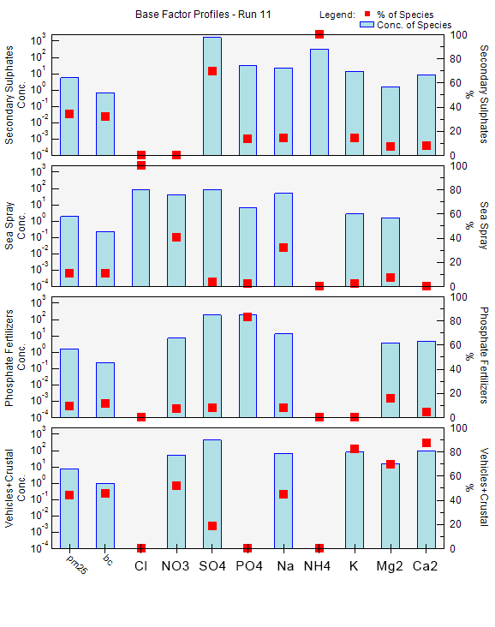

Figure S2. Positive Matrix Factorization (PMF) profiles for trace and major metals.
