Infection control with antimicrobial solid-state ZnO nanoparticles on silk fibroin gauze
Daniela Vieira¹, Cat-Thy Dang², Rachel Monk¹, Samuel Angel¹, Alexis Marion², Uwe Gbureck³, Edward Harvey⁴, Geraldine Merle^{2*}
¹Surgical and Interventional Sciences Division, Faculty of Medicine, McGill University, Montreal, QC H3A 2B2, Canada
²Department of Chemical Engineering, École Polytechnique de Montréal, Montreal, QC H3T 1J4, Canada
³Department for Functional Materials in Medicine and Dentistry, University of Würzburg, Würzburg 97070, Germany
⁴Department of Surgery, Faculty of Medicine, McGill University, Montreal, QC H3A 0C5, Canada

* Corresponding Author: geraldine.merle@polymtl.ca

Supporting information
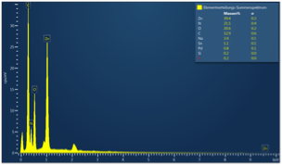
Figure S1. EDS spectrum of ZnO-SF silk fibroin gauze
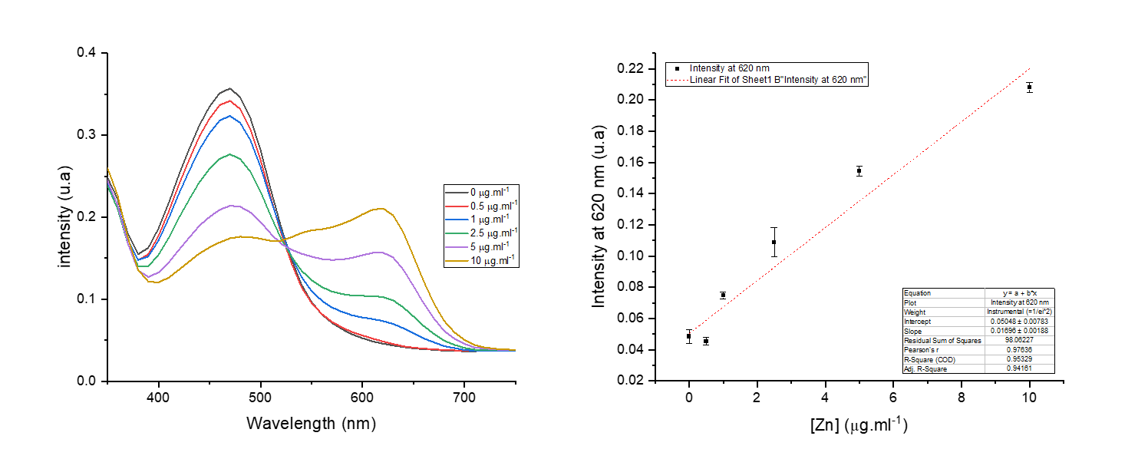
Figure S2. Standard curve for zinc ions release measurement

