Extraterrestrial mining – A novel method for extracting minerals and metals from asteroids
Rodolfo Marin Rivera^{a*}, Philip Bird^{b}, Gawen Jenkin^{b}, Andrew P. Abbottª

ª School of Chemistry, University of Leicester, Leicester, LE1 7RH
^{b} School of Geography, Geology and the Environment, LE1 7RH
^{c} School of Physics and Astronomy, LE1 7RH
* Corresponding author. Email address: rmr26@le.ac.uk

Supplementary information
(a) | (b)
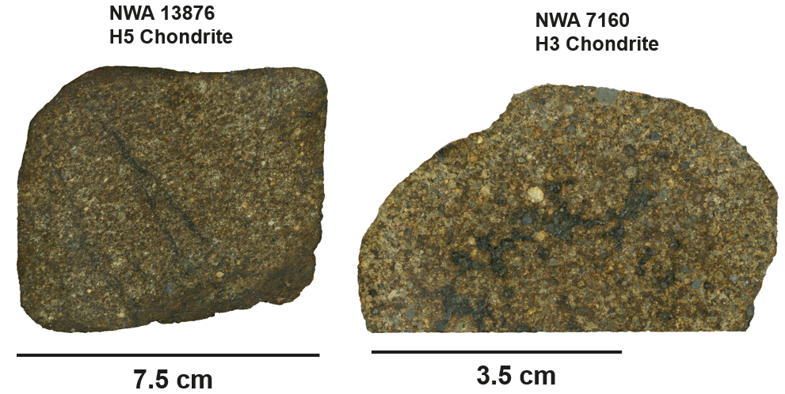
(c)
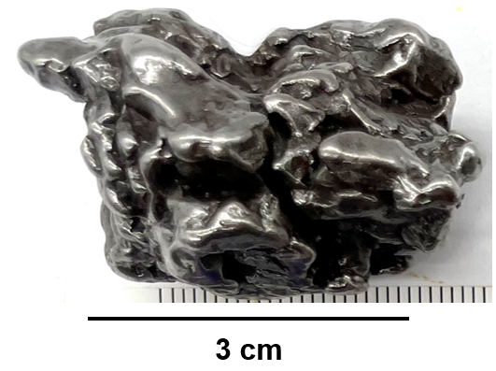
Figure S1. Meteorite proxies of metal-rich asteroids. (a) H5 chondrite NWA 13876, (b) H3 chondrite NWA 7160, and (c) Campo del Cielo iron meteorite.

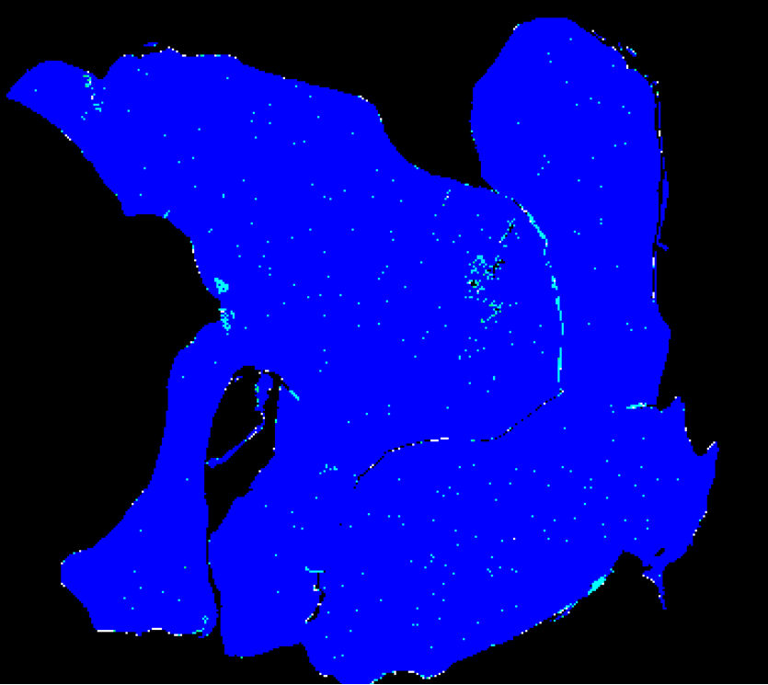 | 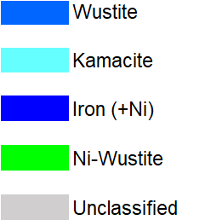
Figure S2. Mineral phase distribution based on automated SEM-EDX analysis of the Campo del Cielo meteorite.

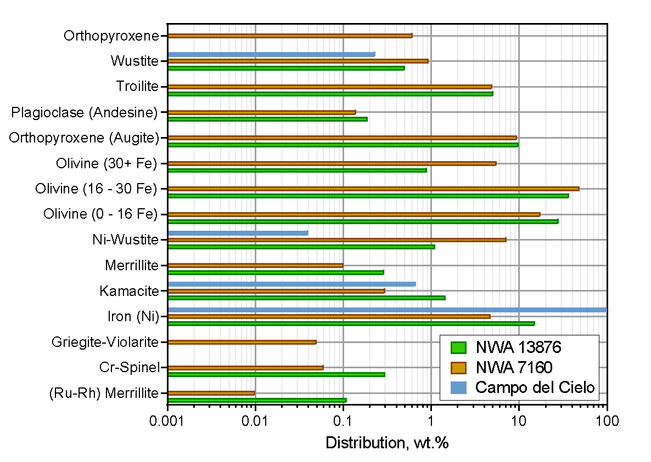
Figure S3. Mineral phase distribution based on automated SEM-EDX analysis of meteorites NWA 13876, NWA 7160 and Campo del Cielo.

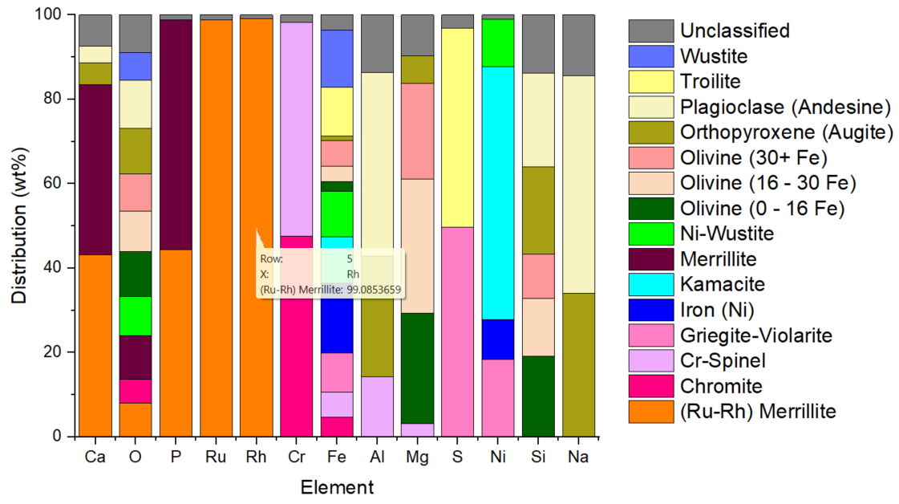
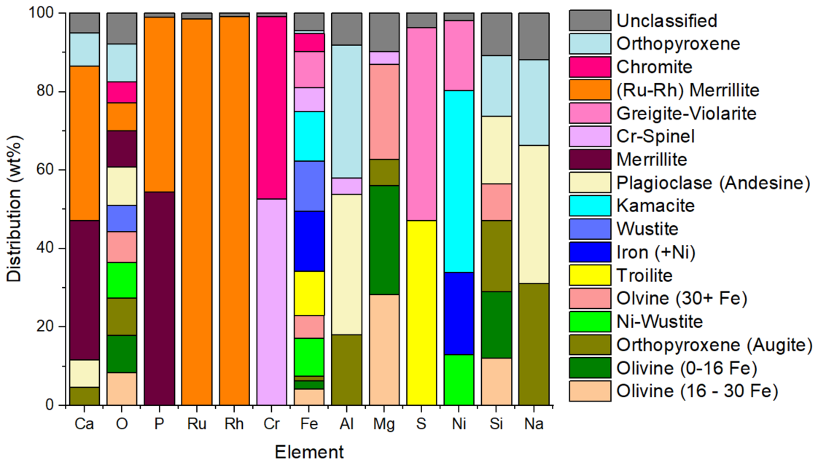
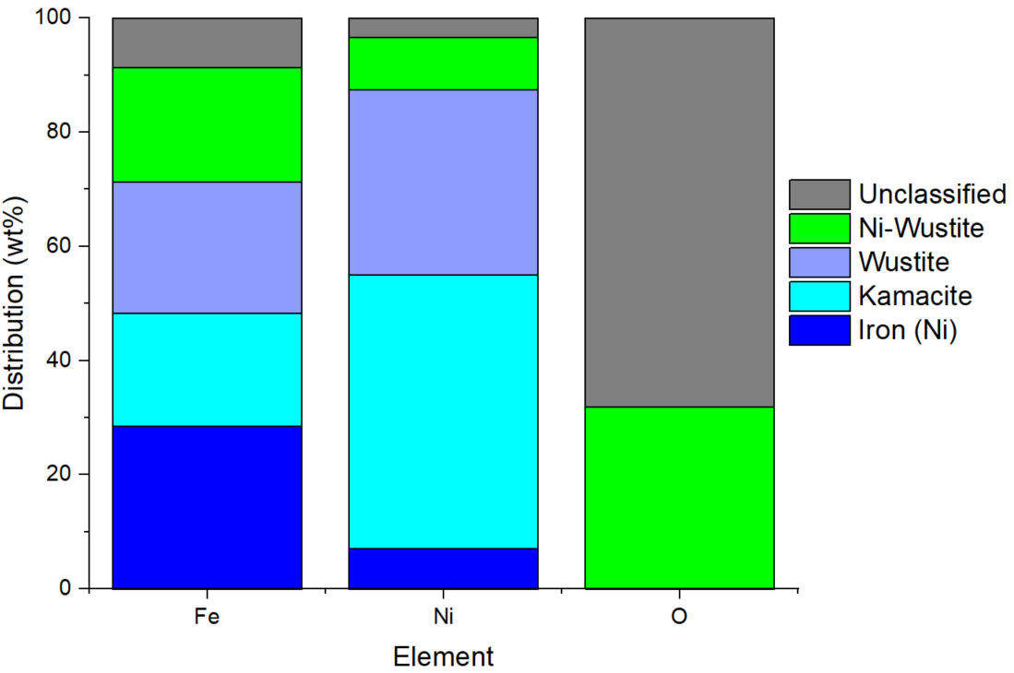
Figure S4. Element distribution in different mineral phases found in meteorites (a) NWA 13876, (b) NWA 7160 and (c) Campo del Cielo.

Table S1. Element distribution in meteorite NWA 13876.
Mineral | Ca | O | P | Ru | Rh | Cr | Fe | Al | Mg | S | Ni | Si | Na | K | Others
(Ru-Rh) Merrillite | 46.1 | 27.5 | 17.0 | 6.3 | 3.3
Chromite |  | 19.3 |  |  |  | 54.6 | 26.3
Cr-Spinel |  |  |  |  |  | 58.3 | 34.1 | 5.0 | 2.6
Griegite-Violarite |  |  |  |  |  |  | 52.7 |  |  | 35.8 | 11.4
Iron (Ni) |  |  |  |  |  |  | 94.1 |  |  |  | 5.9
Kamacite |  |  |  |  |  |  | 62.7 |  |  |  | 37.3
Merrillite | 43.2 | 36.1 | 20.7
Ni-Wustite |  | 31.7 |  |  |  |  | 61.3 |  |  |  | 7.0
Olivine  (0 - 16 Fe) |  | 36.7 |  |  |  |  | 13.1 |  | 21.7 |  |  | 28.5
Olivine  (16 - 30 Fe) |  | 32.9 |  |  |  |  | 20.5 |  | 26.3 |  |  | 20.4
Olivine  (30+ Fe) |  | 30.4 |  |  |  |  | 35.2 |  | 18.8 |  |  | 15.6
Orthopyroxene (Augite) | 5.6 | 37.2 |  |  |  |  | 5.6 | 10.0 | 5.4 |  |  | 30.6 | 5.5
Plagioclase (Andesine) | 4.1 | 39.1 |  |  |  |  | 0.0 | 15.2 |  |  |  | 33.2 | 8.4
Troilite |  |  |  |  |  |  | 66.2 |  |  | 33.8
Wustite |  | 22.9 |  |  |  |  | 77.1
Unclassified | 7.97 | 30.45 | 0.45 | 0.07 | 0.03 | 2.08 | 20.17 | 4.79 | 7.99 | 2.28 | 0.68 | 20.42 | 2.33 | 0.15 | 0.1

Table S2. Element distribution in meteorite NWA 7160.
Mineral | Ca | O | P | Ru | Rh | Cr | Fe | Al | Mg | S | Ni | Si | Na | K | Others
Olivine  (16 - 30 Fe) |  | 32.4 |  |  |  |  | 24.3 |  | 22.8 |  |  | 20.4
Olivine  (0-16 Fe) |  | 37.0 |  |  |  |  | 11.6 |  | 22.6 |  |  | 28.8
Orthopyroxene (Augite) | 5.6 | 36.9 |  |  |  |  | 6.9 | 8.9 | 5.4 |  |  | 30.9 | 5.5
Ni-Wustite |  | 35.8 |  |  |  |  | 56.8 |  |  |  | 7.4
Olvine  (30+ Fe) |  | 30.7 |  |  |  |  | 33.6 |  | 19.6 |  |  | 16.1
Troilite |  |  |  |  |  |  | 65.4 |  |  | 34.6
Iron (+Ni) |  |  |  |  |  |  | 88.0 |  |  |  | 12.0
Wustite |  | 25.7 |  |  |  |  | 74.3
Kamacite |  |  |  |  |  |  | 73.5 |  |  |  | 26.5
Plagioclase (Andesine) | 8.7 | 38.3 |  |  |  |  | 0.0 | 17.7 |  |  |  | 29.1 | 6.2
Merrillite | 43.6 | 35.7 | 20.6
Cr-Spinel |  |  |  |  |  | 60.1 | 35.2 | 2.1 | 2.6
Greigite-Violarite |  |  |  |  |  |  | 53.6 |  |  | 36.1 | 10.3
(Ru-Rh) Merrillite | 48.1 | 27.7 | 16.9 | 4.8 | 2.5
Chromite |  | 20.8 |  |  |  | 52.9 | 26.3
Orthopyroxene | 10.5 | 38.1 |  |  |  |  | 4.5 | 16.8 |  |  |  | 26.3 | 3.9
Unclassified | 6.1 | 30.3 | 0.4 | 0.1 | 0.02 | 1.0 | 25.7 | 4.0 | 7.9 | 2.7 | 1.1 | 18.4 | 2.1 | 0.1 | 0.1

Table S3. Element distribution in meteorite Campo del Cielo.
Mineral | Ca | O | P | Ru | Rh | Cr | Fe | Al | Mg | S | Ni | Si | Na | Ge | Others
Iron (+Ni) |  |  |  |  |  |  | 94.9 |  |  |  | 5.1
Kamacite |  |  |  |  |  |  | 65.6 |  |  |  | 34.4
Wustite |  |  |  |  |  |  | 76.7 |  |  |  | 23.3
Ni-Wustite |  | 26.6 |  |  |  |  | 66.8 |  |  |  | 6.6
Unclassified | 0.23 | 56.9 | 0.8 | 0.5 | 0.06 | 0.06 | 28.8 | 1.2 | 0.31 | 0.21 | 2.5 | 6.1 | 0.58 | 0.24 | 1.9

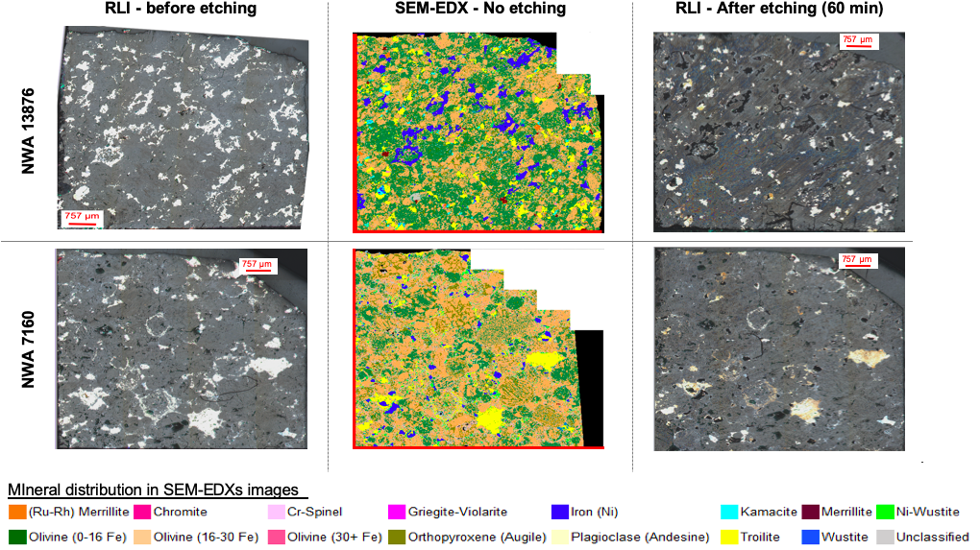
Figure S5. Reflected light images of meteorites NWA 13876 and NWA 7160 before and after 60 min of chemical etching with 0.1 mol dm ^{̶ 3} of iodine as oxidising agent in ChCl: 2EG eutectic solvent. The distribution of minerals is depicted in the corresponding SEM-EDX images.

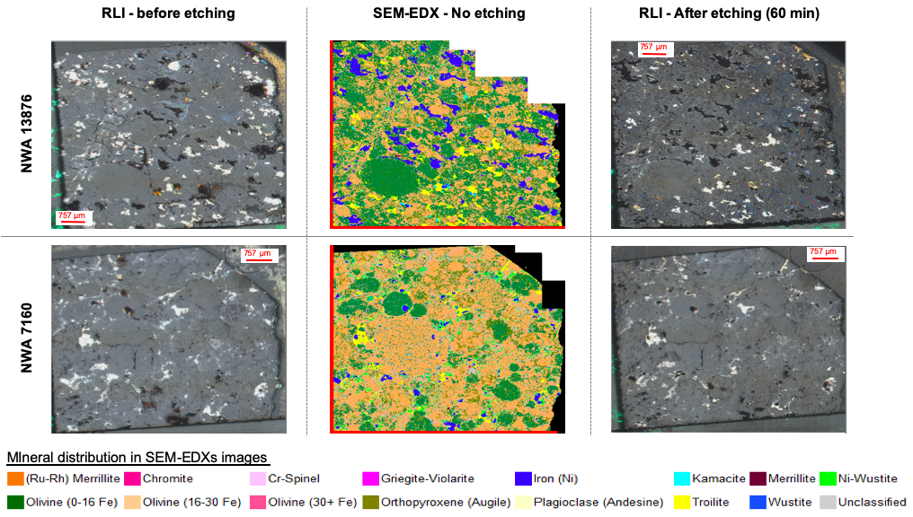
Figure S6. Reflected light images of meteorites NWA 13876 and NWA 7160 before and after 60 min of chemical etching with 0.1 mol dm ^{̶ 3} of FeCl₃ as oxidising agent in ChCl: 2EG eutectic solvent. The distribution of minerals is depicted in the corresponding SEM-EDX images.

