Supporting Information

Universal capability of 3-ketosteroid Δ¹-dehydrogenases to catalyze Δ¹-dehydrogenation of C17- substituted steroids

Patrycja Wójcik¹, Michał Glanowski¹, Agnieszka M. Wojtkiewicz¹, Ali Rohman^{2,3,4}, Maciej Szaleniec¹*

*Correspondence: maciej.szaleniec@ikifp.edu.pl
¹ Jerzy Haber Institute of Catalysis and Surface Chemistry Polish Academy of Sciences, Niezapominajek 8, PL30239 Krakow, Poland
² Department of Chemistry, Faculty of Science and Technology, Universitas Airlangga, Surabaya 60115, Indonesia
³ Laboratory of Proteomics, Research Center for Bio-Molecule Engineering (BIOME), Universitas Airlangga, Surabaya 60115, Indonesia
⁴ Laboratory of Biophysical Chemistry, University of Groningen, 9747 AG Groningen, The Netherlands
Results
Theoretical prediction of substrate specificity
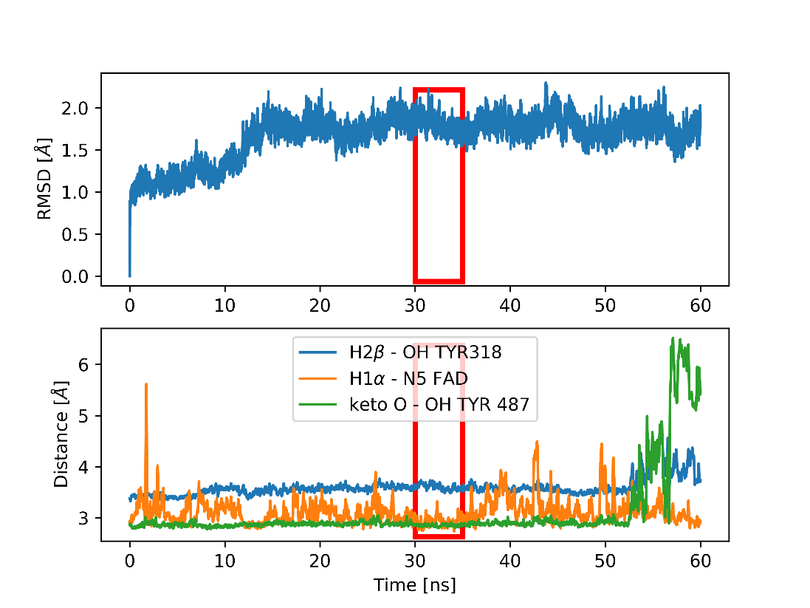
Fig. S1 Root Mean Square Deviation (top graph) and selected distances (bottom graph, smoothed by moving average) during MD simulation for androst-4-en-3,17-dione. Fragment of trajectory selected for MMPBSA calculations is marked with red rectangles.

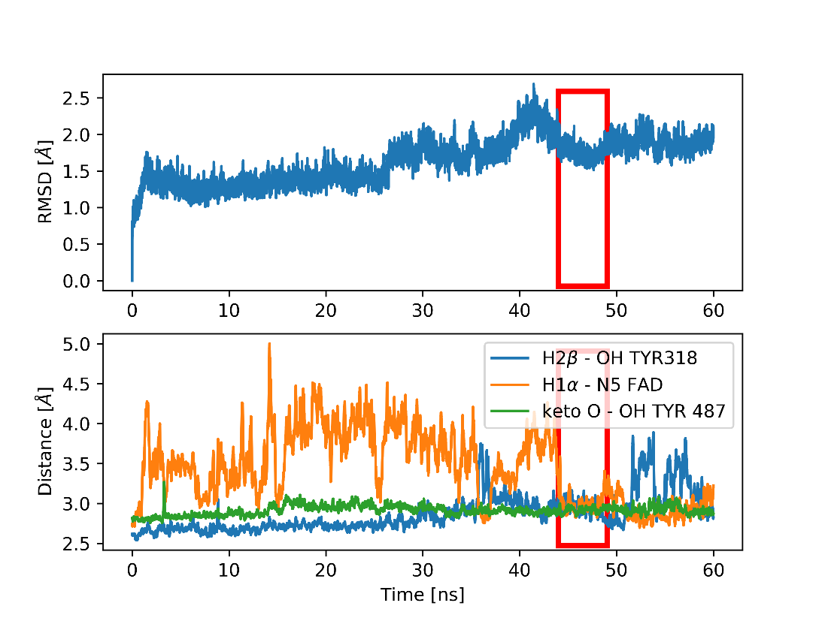
Fig. S2 Root Mean Square Deviation (top graph) and selected distances (bottom graph, smoothed by moving average) during MD simulation for cholest-4-en-3-one. Fragment of trajectory selected for MMPBSA calculations is marked with red rectangles.
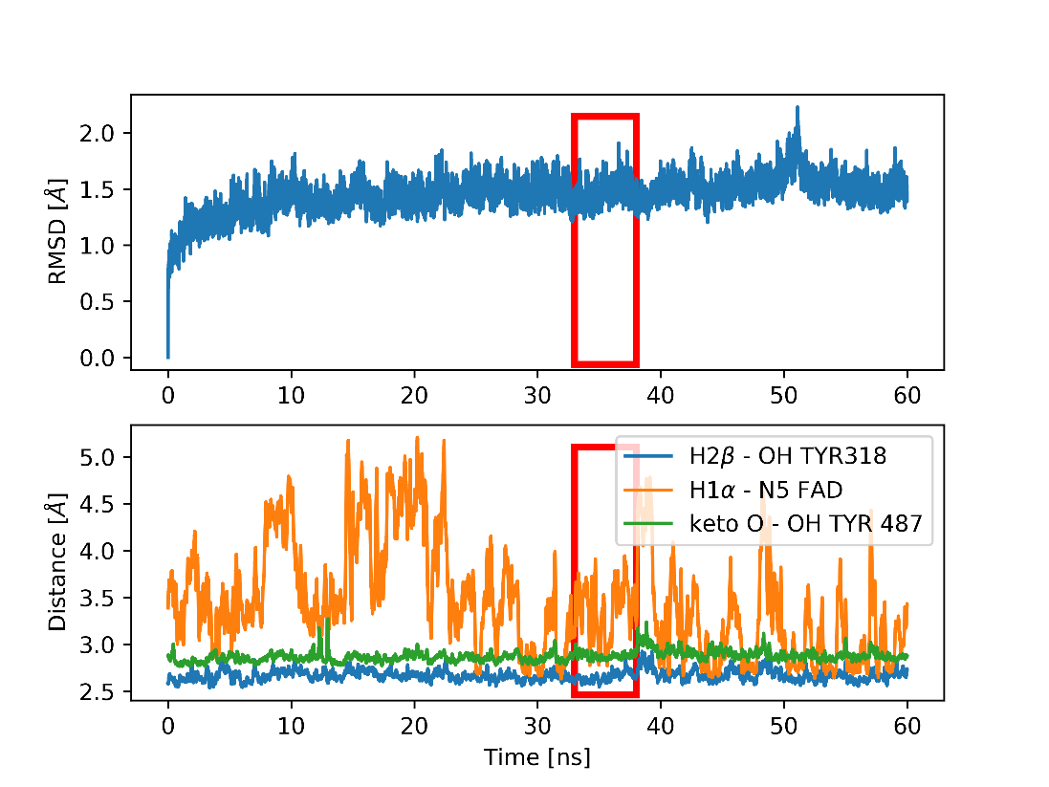
Fig. S3 Root Mean Square Deviation (top graph) and selected distances (bottom graph, smoothed by moving average) during MD simulation for diosgenone. Fragment of trajectory selected for MMPBSA calculations is marked with red rectangles.

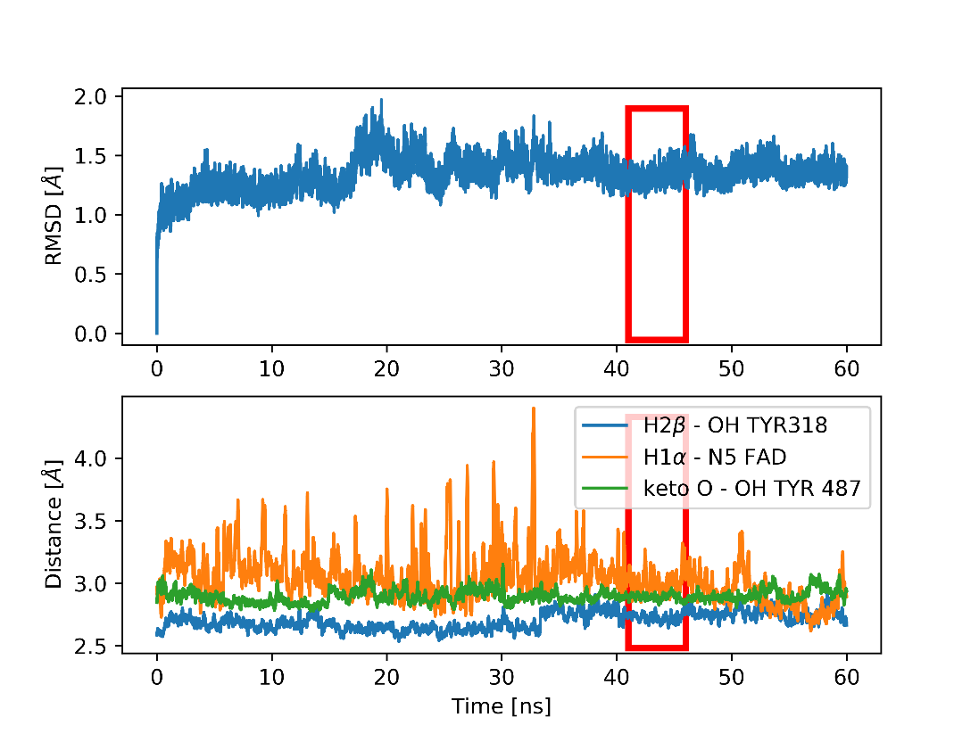
Fig. S4 Root Mean Square Deviation (top graph) and selected distances (bottom graph, smoothed by moving average) during MD simulation for androstanolone. Fragment of trajectory selected for MMPBSA calculations is marked with red rectangles.
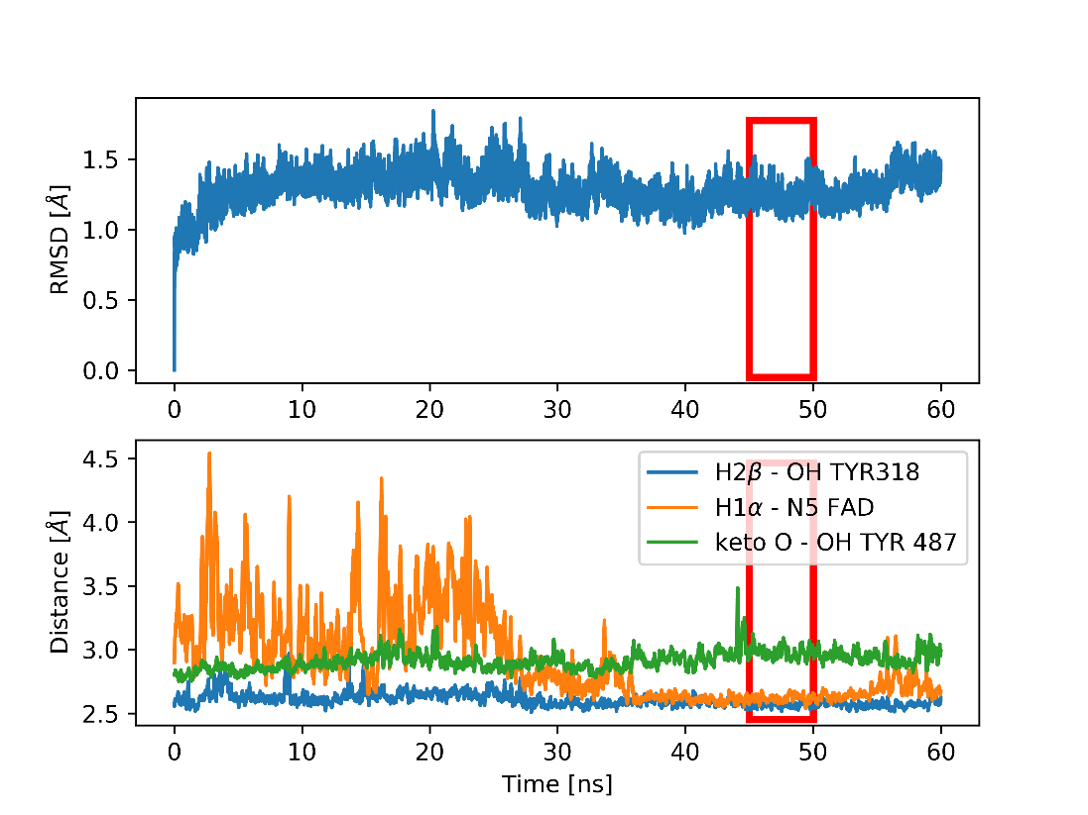
Fig. S5 Root Mean Square Deviation (top graph) and selected distances (bottom graph, smoothed by moving average) during MD simulation for progesterone. Fragment of trajectory selected for MMPBSA calculations is marked with red rectangles.

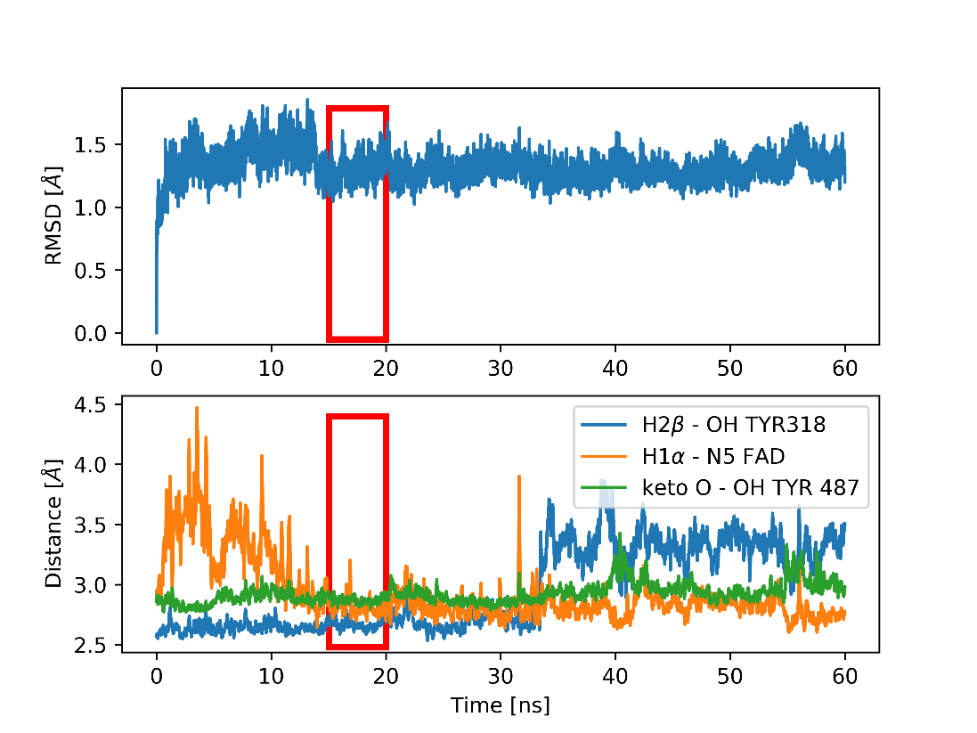
Fig. S6 Root Mean Square Deviation (top graph) and selected distances (bottom graph, smoothed by moving average) during MD simulation for testosterone propionate. Fragment of trajectory selected for MMPBSA calculations is marked with red rectangles.
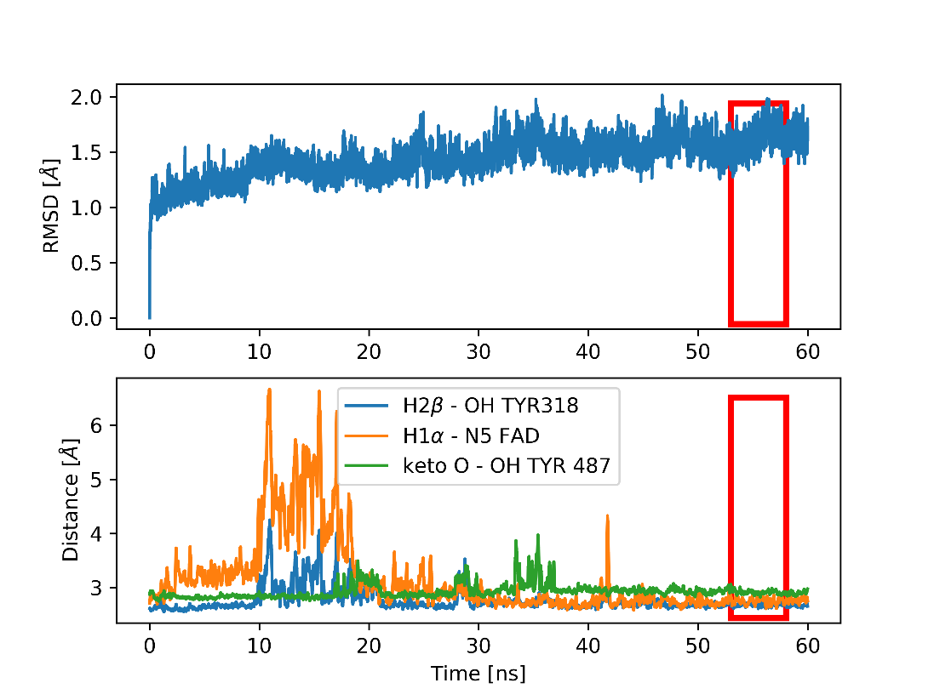
Fig. S7 Root Mean Square Deviation (top graph) and selected distances (bottom graph, smoothed by moving average) during MD simulation for 6-dehydrotestosterone acetate. Fragment of trajectory selected for MMPBSA calculations is marked with red rectangles.

HBC/steroid inclusion complex formation
Table S1 Fit parameters and statistics of phase solubility diagrams of steroids in the solution of HBC and 2% EGME at 30°C
 | Substrate
Parameter | Androst-4-en-3,17-dione (1) | Cholest-4-en-3-one (2)
Equation | y = ax + b | y = ax² + bx + c
a | 0.52661 ± 0.00859 | 0.00035 ± 0.00001
b | 0.14420 ± 0.00714* | 0.00611 ± 0.00081
c | - | 0.00478 ± 0.00054*
R² | 0.99869 | 0.9989
Adj. R² | 0.99843 | 0.99835
* measured values

Table S2 Percentage of cholest-4-en-3-one forms dependent on initial substrate concentration; S - cholest-4-en-3-one, HBC – 2-hydroxypropyl-β-cyclodextrin
[S]_{t} [μM] | % [S] | % [S(HBC)] | % [S(HBC)₂]
5 | 2.87 | 53.21 | 43.93
10 | 2.87 | 53.22 | 43.91
20 | 2.87 | 53.24 | 43.89
30 | 2.88 | 53.26 | 43.86
40 | 2.88 | 53.28 | 43.84
50 | 2.88 | 53.30 | 43.81
60 | 2.89 | 53.32 | 43.79
70 | 2.89 | 53.35 | 43.76
80 | 2.90 | 53.37 | 43.74
100 | 2.90 | 53.41 | 43.69

AcmBs native substrate
Table S3 Fit statistics of the AcmB Ping-Pong bi bi (non-sequential) mechanism
 | Substrate
Parameter | Androst-4-en-3.17-dione (1) | Cholest-4-en-3-one (2)
Reduced χ² | 32.77842 | 11.68547
R² | 0.99318 | 0.9749
Adj. R² | 0.99309 | 0.97464
AICc | 546.15167 | 484.35427

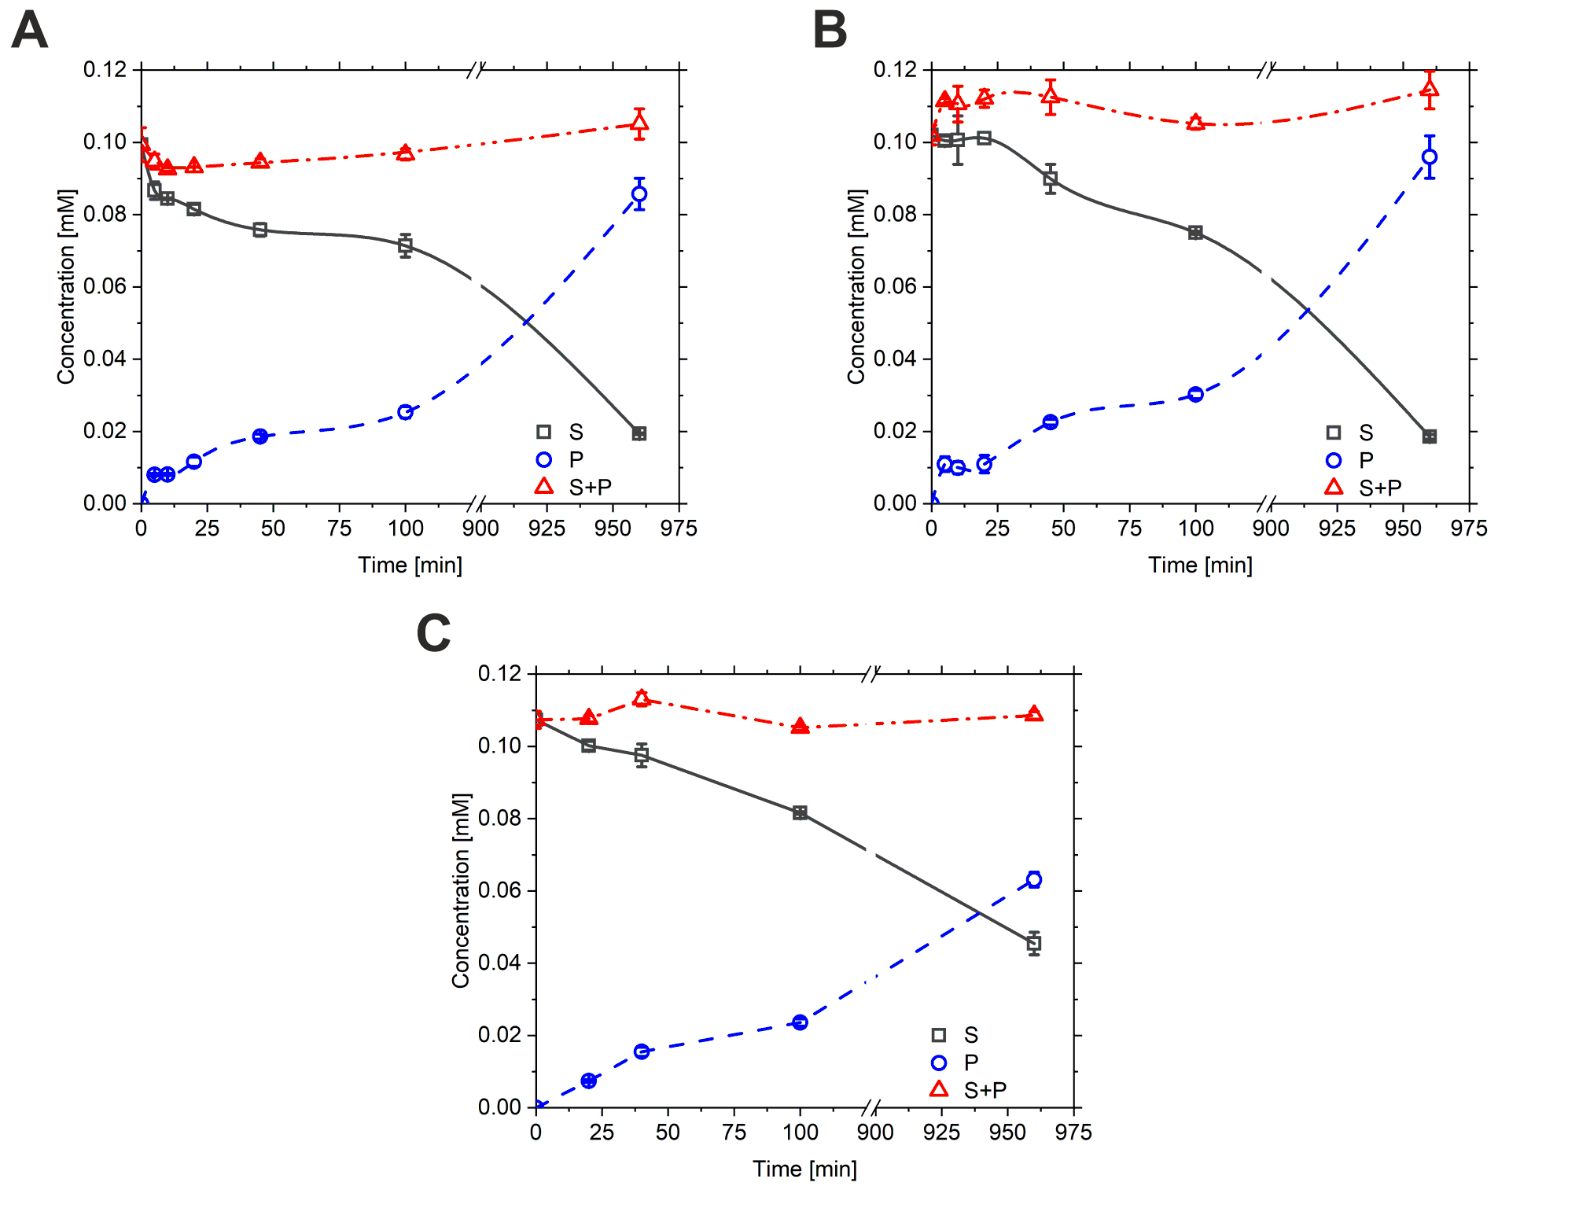
Fig. S8 Progress of the 1.2-dehydrogenation of 0.1 mM AD (A) and cholest-4-en-3-one (B) with 6.55 nM AcmB2 and 0.1 mM diosgenone (C) with 65.5 nM AcmB2 in the presence of 0.15 mM DCPIP in 50 mM Thris-HCl buffer pH 8.0. S – substrate; P – product.

KSTD1 substrate spectrum
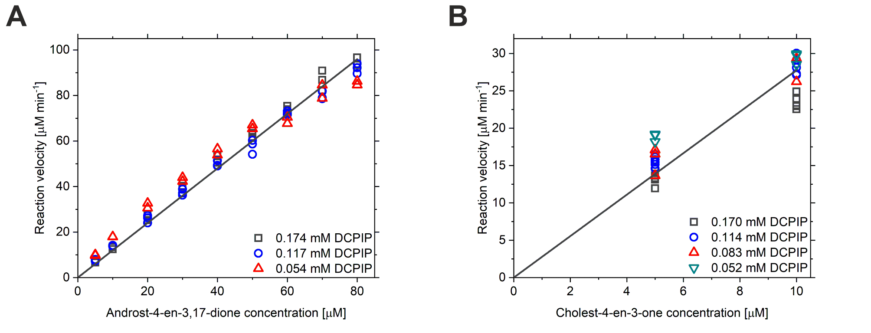
Fig. S9 Results of steady-state kinetics for dehydrogenation reaction of androst-4-en-3.17-dione (A) and cholest-4-en-3-one (B) calatyzed by AcmB. Reaction velocities were measured in 0.1 M K₂HPO₄/KH₂PO₄ buffer pH 6.5 with 2% HBC. 2% EGME. 0.052 – 0.174 mM DCPIP. 5 – 80 μM steroids and 0.30 μM of AcmB at 30°C.

Table S4 Fit parameters and statistics of AcmB and KSTD1 steady-state kinetics results
 |  | Substrate
 | Parameter | Androst-4-en-3.17-dione (1) | Cholest-4-en-3-one (2)
KSTD1 | Equation | y = ax + b | y = ax + b
KSTD1 | a | 1.18924 ± 0.00672 | 0.10844 ± 0.000668728
KSTD1 | b | 0 | 0
KSTD1 | R² | 0.99755 | 0.99704
KSTD1 | Adj. R² | 0.99751 | 0.997
AcmB | Equation | y = ax + b | y = ax + b
AcmB | a | 1.19954 ± 0.0107 | 2.77637 ± 0.05598
AcmB | b | 0 | 0
AcmB | R² | 0.99368 | 0.98597
AcmB | Adj. R² | 0.9936 | 0.98557

