Supplementary Information for:
Reconciling ice core CO2 and land-use change following New World-Old World contact
King, A.C.F. et al.

Table S1: Summary information of each ice core CO₂ record and spline parameters.
 | Ice Core CO₂ |  |  |  |  | Spline
 | Timespan  (yr CE) | Accumulation  (cm water eq. yr) | Sample resolution (yrs)  [1450-1650 CE] | Sample  Error  (ppm) | Age distribution  (yrs) | Timespan  (yr CE) | Data spacing  (yrs) | Cut-off frequency  (yrs) | Smoothing parameter | Av. Std deviation  (ppm)
Skytrain | 1688 - 1454 | 13.5 | 7.55  [7.69] | 1.0 | ~ 27 | 1950 - 50 | 1 | 50 | 2e-3 | 0.60
Law Dome | 2006 - 13.3 | 60 | 7.97  [15.38] | 1.1 | 8 | 1900 - 750 | 1 | 50 | 3e-3 | 0.85
WAIS Divide | 1939 - 732 | 19.8 | 7.74  [6.66] | 0.8 | 19 | 1685 - 1455 | 1 | 50 | 1.3e-3 | 0.40
 |  |  |  |  | Compilation | 1950 - 50 | 1 | 100 | 8e-5 | 0.41

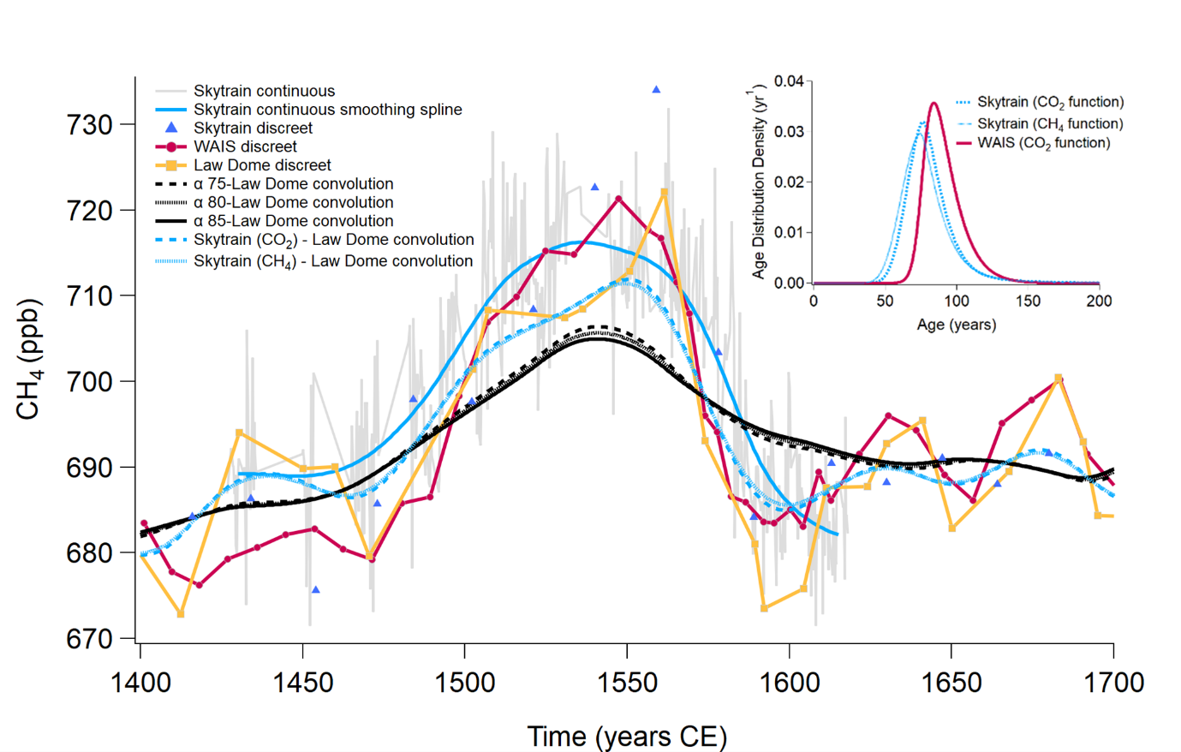

Figure S1: CH₄ convolution experiments (See Figure 3, main text) with a comparison convolution using a Skytrain firn filter generated using CH₄ diffusivity parameters rather than CO₂ diffusivity parameters (inset figure top right). The figure shows the effect of the changes in diffusivity parameter on both the firn filter output and the subsequent convolutions are negligeable. Also shown are the Skytrain continuous CH₄ at 30-second averages, and previous discreet CH₄ measurements ¹.

Quantifying the mismatch between the data and the artificially smoothed CH4 timeseries

To compare the CH₄ records we choose two representative windows: between 1480 and 1500 CE when CH₄ is increasing and 1560 and 1580 CE when CH₄ is decreasing. In the Skytrain ice core record, CH₄ first increases at 5.02 ppb/decade followed by a decrease of -6.39 ppb/decade in good agreement with the minimal, firn model-based smoothing (+4.61 ppb/decade and -6.18 ppb, respectively). In contrast, our three artificially enhanced smoothing filters clearly do not recreate the Skytrain record; decadal rates of change are greatly reduced. From 1480 to 1500 CE the rates are between 2.5 to 2.8 ppb/decade and between 1560 and 1580 CE range from -2.8 to -3.4 ppb/decade, around half of that of the rates observed in Skytrain record.

Late pre-Industrial atmospheric CO₂ compilation

We present a new synthesis of atmospheric CO₂ data from 1350 to 1800 CE. A previous compilation presented a spline record of CO₂ through this time-period as part of a complete 156 kyr smoothed CO₂ history ² (Figure S2). The spline includes both the WAIS Divide and Law Dome records but adjusted the WAIS Divide data by -3.13 ppm to match the lower-offset Law Dome absolute values. With Skytrain absolute values sitting between both Law Dome and WAIS Divide, and with evidence that Law Dome values may be too low in specific areas, we instead adjust the Law Dome and WAIS Divide datasets to their average offsets to the Skytrain record, +1.36 ppm and -1.28 ppm respectively. For the Law Dome offset calculation, the three data points of the ‘1610 minimum’ were removed so as not to introduce a low bias. When all three data sets are combined and smoothed with a 100-yr cut-off spline, the atmospheric CO₂ history shows a maximum CO₂ value of 284.4 ± 0.3 ppm at 1532 CE, declining to a minimum CO₂ value of 277.6 ± 0.2 ppm at 1673, with a decadal rate of decline in CO₂ of 0.5 ppm (Table 1). The preceding ‘baseline’ CO₂ is 281.5 ± 0.3 ppm at 1448 CE. The centennial scale CO₂ variability is highly comparable to the previous compilation, but the absolute values remain uncertain. Thus, we can be confident in the relative changes in climate model simulations forced by this compilation or previous compilations that excluded the ‘1610 minimum’.

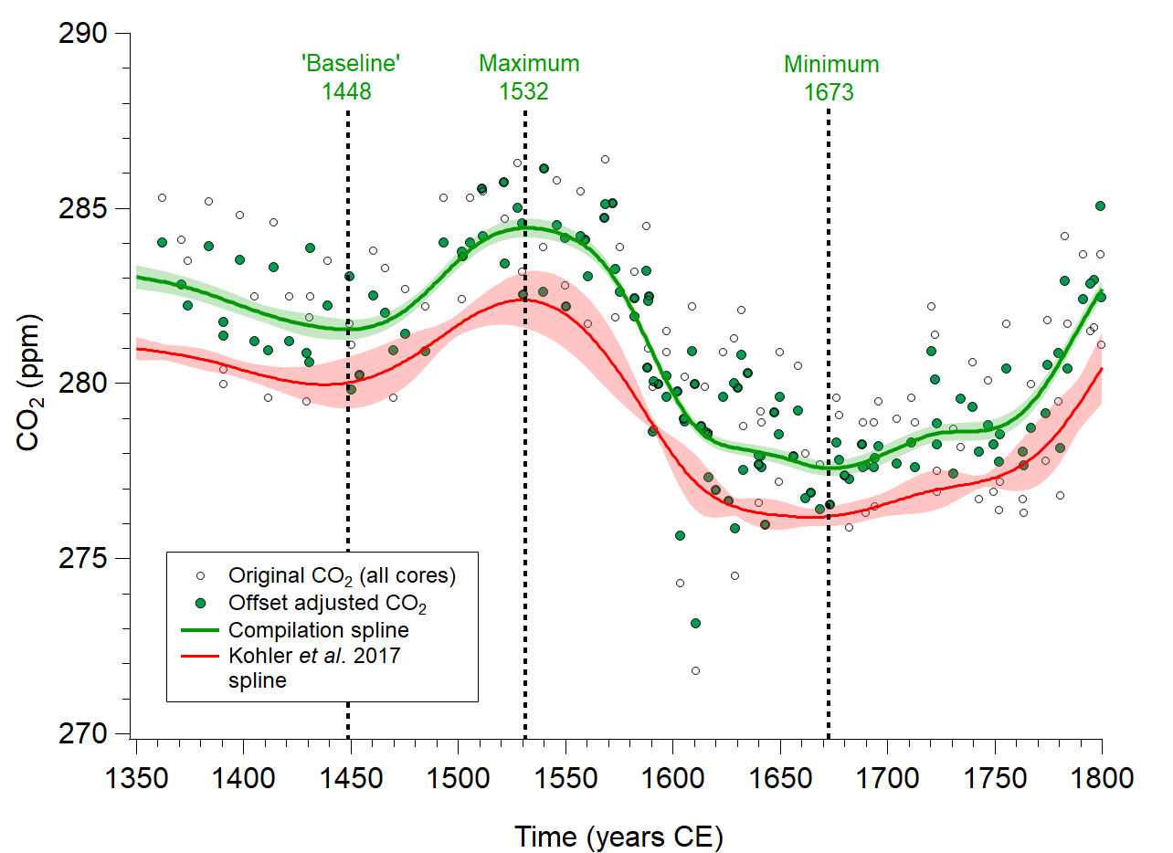

Figure S2: A compilation smoothing spline including the new Skytrain CO₂ record, shown comparative to a previously published spline using Law Dome and WAIS Divide only (red line) ². The spline (green line) is generated from a compilation of all three CO₂ datasets (original records, open circles), but with Law Dome and WAIS Divide values adjusted to account for their respective average offset to Skytrain (adjusted compilation records, green circles).

References

1. Hoffmann, H. M. et al. The ST22 chronology for the Skytrain Ice Rise ice core - Part 1: A stratigraphic chronology of the last 2000 years. Climate of the Past 18, 1831–1847 (2022).
2. Köhler, P. et al. A 156 kyr smoothed history of the atmospheric greenhouse gases CO2, CH4, and N2O and their radiative forcing. Earth Syst Sci Data 9, (2017).

