Supplementary
Supplementary Table 1: Parameters and results for thermal blood brain barrier opening threshold estimation
animal No | peak pulse power P_{P} (W) | average pulse power P_{M} (W) | pulse width PW (s) | pulse energy E_{P} (J) | duty cycle (%) | frequency (Hz) | no. of pulses | duration (s) | energy E (J) | max. temperature (ºC) | Evans' Blue extravasation | ROI
1 | 10,2 | 0,0255 | 0,00005 | 0,00051 | 0,25 | 50 | 30000 | 600 | 15,3 | 42,7 | Yes | 3
2 | 10,2 | 0,0765 | 0,00015 | 0,00153 | 0,75 | 50 | 15000 | 300 | 22,95 | 57,8 | Yes | 1
2 | 10,2 | 0,0357 | 0,00007 | 0,000714 | 0,35 | 50 | 30000 | 600 | 21,42 | 46,1 | Yes | 2
3 | 10,2 | 0,00765 | 0,000015 | 0,000153 | 0,075 | 50 | 15000 | 300 | 2,295 | 38,7 | No | 1
3 | 10,2 | 0,0612 | 0,00012 | 0,001224 | 0,6 | 50 | 30000 | 600 | 36,72 | 53,7 | Yes | 2
3 | 10,2 | 0,051 | 0,0001 | 0,00102 | 0,5 | 50 | 3000 | 60 | 3,06 | 45,9 | Yes | 3
3 | 10,2 | 0,0408 | 0,00008 | 0,000816 | 0,4 | 50 | 9000 | 180 | 7,344 | 45 | Yes | 4
4 | 10,2 | 0,03315 | 0,000065 | 0,000663 | 0,325 | 50 | 15000 | 300 | 9,945 | 43,1 | Yes | 2
4 | 10,2 | 0,0357 | 0,00007 | 0,000714 | 0,35 | 50 | 15000 | 300 | 10,71 | 43,6 | Yes | 3
5 | 10,2 | 0,102 | 0,0002 | 0,00204 | 1 | 50 | 1000 | 20 | 2,04 | 62,8 | Yes | 2
5 | 10,2 | 0,102 | 0,0002 | 0,00204 | 1 | 50 | 1500 | 30 | 3,06 | 64,7 | Yes | 3
6 | 10,2 | 0,1275 | 0,00025 | 0,00255 | 1,25 | 50 | 1500 | 30 | 3,825 | 69,8 | Yes | 1
6 | 10,2 | 0,0357 | 0,00007 | 0,000714 | 0,35 | 50 | 1500 | 30 | 1,071 | 44,5 | Yes | 2
6 | 10,2 | 0,0306 | 0,00006 | 0,000612 | 0,3 | 50 | 3000 | 60 | 1,836 | 44,4 | Yes | 3
7 | 7,8 | 0,0234 | 0,00006 | 0,000468 | 0,3 | 50 | 3000 | 60 | 1,404 | 41,9 | No | 1
7 | 7,8 | 0,0585 | 0,00015 | 0,00117 | 0,75 | 50 | 3000 | 60 | 3,51 | 50,3 | Yes | 2
7 | 7,8 | 0,0468 | 0,00012 | 0,000936 | 0,6 | 50 | 3000 | 60 | 2,808 | 50,6 | Yes | 3
7 | 7,8 | 0,0195 | 0,00005 | 0,00039 | 0,25 | 50 | 3000 | 60 | 1,17 | 39,5 | No | 4
8 | 7,8 | 0,0234 | 0,00006 | 0,000468 | 0,3 | 50 | 3000 | 60 | 1,404 | 41,2 | No | 2
8 | 7,8 | 0,078 | 0,0002 | 0,00156 | 1 | 50 | 3000 | 60 | 4,68 | 52,4 | Yes | 3
8 | 7,8 | 0,0273 | 0,00007 | 0,000546 | 0,35 | 50 | 15000 | 300 | 8,19 | 41,8 | Yes | 4
9 | 7,8 | 0,0741 | 0,00019 | 0,001482 | 0,95 | 50 | 3000 | 60 | 4,446 | 50,7 | Yes | 1
9 | 7,8 | 0,0195 | 0,00005 | 0,00039 | 0,25 | 50 | 3000 | 60 | 1,17 | 40,2 | No | 2

Table S1: Summary of the IR laser parameters and thermal camera measured maximal tissue temperature for each animal and respective ROI used for EB extravasation experiments.
Supplementary figure S1: Thermal threshold estimation of Blood-Brain Barrier opening based on Evans’ Blue extravasation
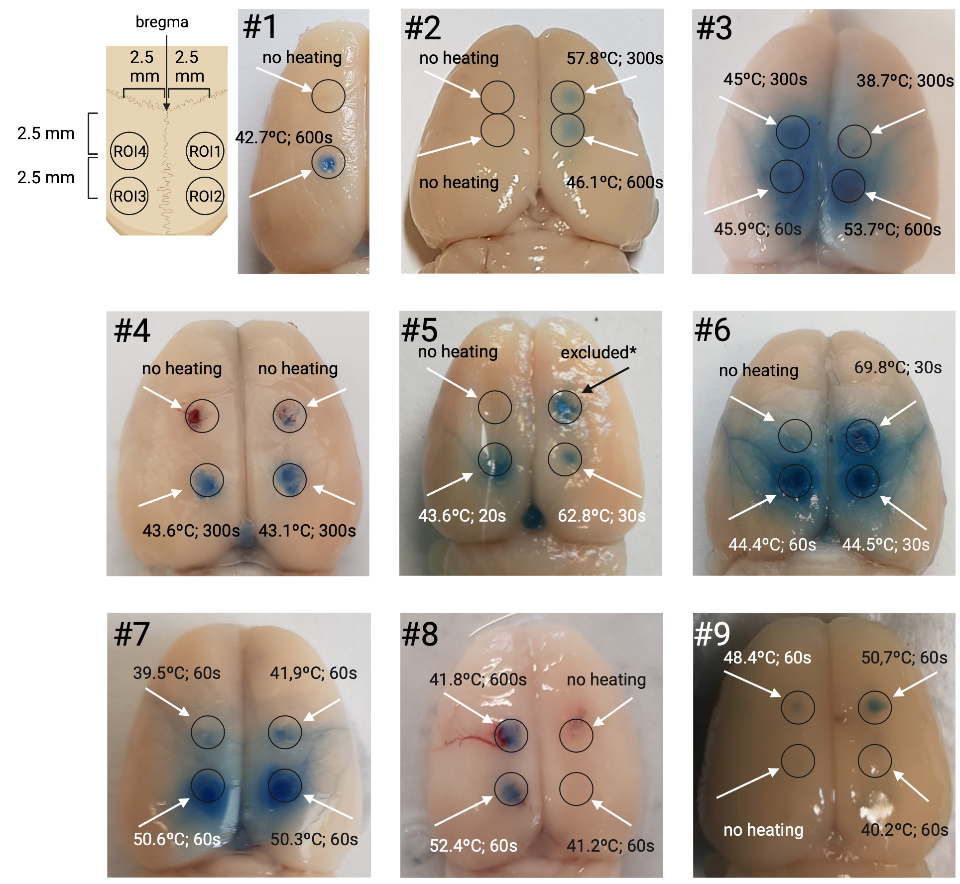
Supplementary figure S1: Evans’ Blue extravasation as response to different thermal dosages. EB extravasation was determined by unambiguous discoloration of the targeted tissue. For each animal, 4 burr holes were drilled at the same location of the skull. No heating (no laser) or low thermal dosages and consequently no discoloration at the respective sites served as control. ROI1 (upper right) of animal #5 has been excluded from analysis because thermal camera data was not obtained.

Supplementary figure S2: Experimental set up for IR laser calibration using a thermal camera
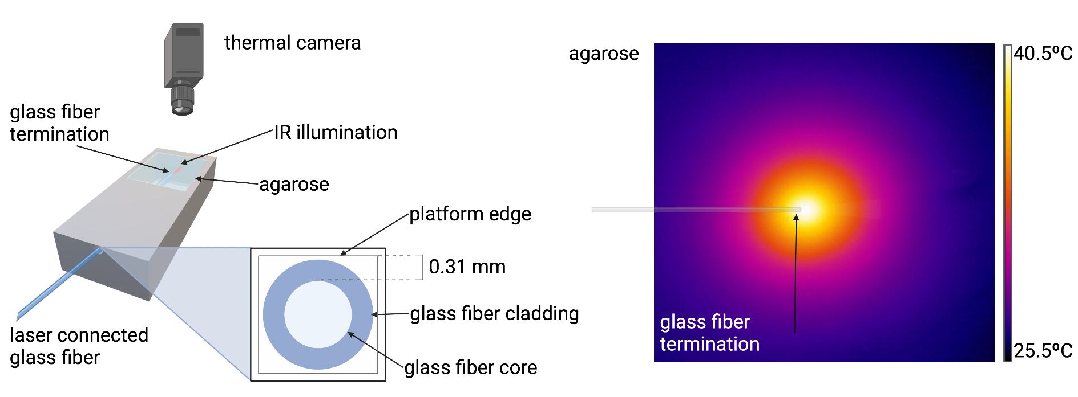
Supplementary figure S2: Thermal camera measured temperature calibration of IR illumination: A laser connected glass fiber was guided into a pool of agarose (0.6%) with a defined distance of the edge of the glass fiber termination to the agarose surface (left). For simplicity, only one distance of the agarose surface to the horizontal edge of the glass fiber is shown. For calibration however, a total of 7 distances corresponding to 0.31, 0.81 1.47, 1.97, 2.63, 3.13, 4.29 mm were used. The agarose temperature profile was measured at different duty cycles by a thermal camera positioned perpendicular to the agarose surface. An exemplary screenshot of the thermal camera measured temperature during IR heating (duty cycle = 10%) at 180 s of heating is shown on the right.

Supplementary figure S3: MR generated heating maps for two different wavelengths: λ = 1470 nm and λ = 980 nm

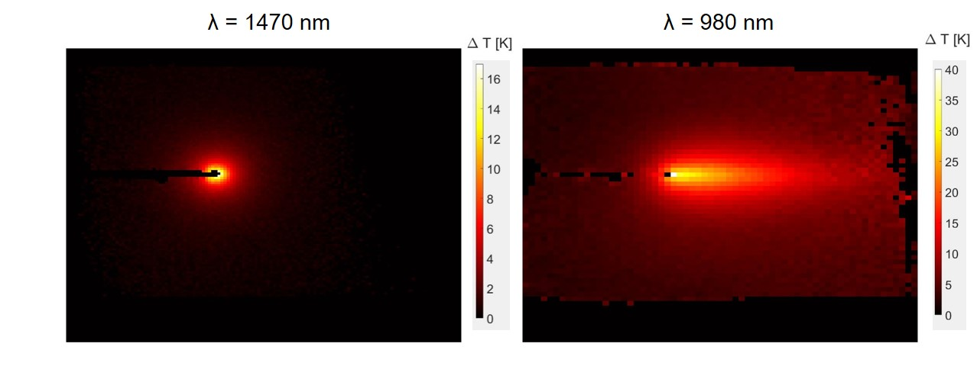
Supplementary figure S3: Representative MR-thermometry heating maps for λ = 1470 nm (DC: 10%, P_{peak} = 500 mW, τ = 1 µs, laser on 10 min.14s, E_{tot} = 30.7 J) and 980 nm (DC: 75%, P_{peak} = 500 mW, τ = 1 µs, laser on 2min.33s, E_{tot} = 57.375 J)) are shown. The heating for 1470 nm is highly localized, almost referring to a heating tip. 980 nm in contrast shows a much higher spatial heat distribution and therefore impact on tissue, almost resulting in a heating torch.

Supplementary text S1: DCE post-processing
The steady-state signal of an RF-spoiled FLASH sequence without influence of the CA is given by equation S1
$$S\left(t\right)=S_{0}*\frac{sinθ * \left(1 - E_{1}\right)}{\left(1 - cosθ * E_{1}\right)}*E_{2}^{*}$$
where
$E_{1}=e^{-TR/T_{1}}$ and $E_{2}^{*}=e^{-TE/T_{2}^{*}}$
In strong T₁ weighted images which is the case here, E₂* can be considered ≈ 1.
Taking the CA effects on T₁ over time into account go back to the fact that T₁ becomes T₁(t) in equation S1. The time dependent relaxation rate r₁(t) needed to obtain the voxel concentration (see Equation 2) can therefore be calculated by solving equation S1 for 1/T₁:
$$r_{1}\left(t\right)=-\frac{ln \frac{\left(\frac{S(t)}{S_{0}} - sinθ\right)}{\left(\frac{S(t)}{S_{0}} * cosθ - sinθ\right)}}{TR}$$

