Annex1.
- Overall survival Null model
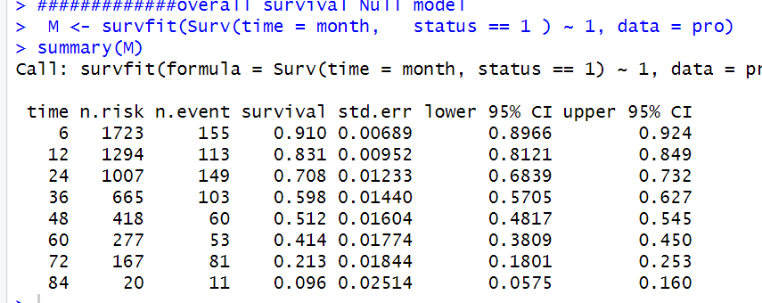
- Overall survival model by sex
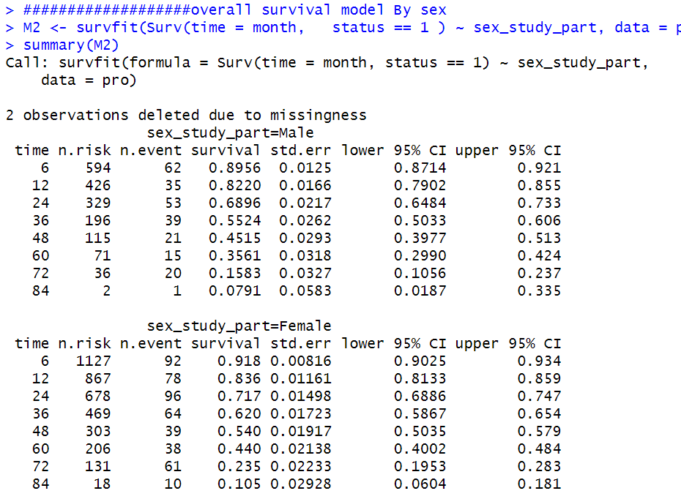
######################cox regression
m1<-coxph(Surv(start,stop,status) ~ age2 + wt0 + sex + anemia_0 + tb02+cd4_cat+ OI_cat, data = pro, subset = c(reg =="1a->1e"))
m1<-coxph(Surv(start,stop,status) ~ age2 + wt0 + sex + anemia_0 + tb02+cd4_cat+ OI_cat, data = pro, subset = c(reg =="1c->1d"))

m1<-coxph(Surv(start,stop,status) ~ age2 + wt0 + sex + anemia_0 + tb02+cd4_cat+ OI_cat, data = pro, subset = c(reg =="1e->1f"))

m1<-coxph(Surv(start,stop,status) ~ age2 + wt0 + sex + anemia_0 + tb02+cd4_cat+ OI_cat, data = pro, subset = c(reg =="1f->1e"))
####################transition probability
library(msm)
library(mstate)
library(dynpred)
library(mstate)
library(mstate)
library(dynpred)
library(survival)
library(survminer)
library(foreign)
library(ggplot2)
library(rms)
library(pec)
library(xfun)
library(Hmisc)
library(prodlim)
library(mstate)
pro<-read.dta("C:/Users/hp/Desktop/Mnuscript one and two 642023/newdata2.dta")
####################transition probability
head(pro)
table(pro$reg0)
M2 <- survfit(Surv(time= followuptime, status ) ~ 1, data = pro)
summary(M2)
plot(M2)
ggsurvplot(M2, data = pro, risk.table = TRUE, xlab="Time in month", lwd=3, linetype = c(1,2,3,4,5,6), pval = TRUE, ylab = c("probability"))
#####################figure 6
M2 <- survfit(Surv(time = month, status == 1 ) ~ initialstate, da = pro)
summary(M2)
plot(M2)
ggsurvplot(M2, data = pro, linetype = c(1,2,3,4,5,6,7,8,9), pval = TRUE, ylab = c("staying probability"))

M3 <- survfit(Surv(followuptime, status) ~ sex, data = pro)
summary(M3)
plot(M3)
ggsurvplot(M3, data = pro, risk.table = TRUE, xlab="Time in month", lwd=3, linetype = c(1,2,3,4,5,6), pval = TRUE, ylab = c("probability"))

ggsurvplot(M3, data = pro, linetype = c(1,2,3,4,5,6,7,8,9), pval = TRUE, ylab = c("staying probability"))

#########
pro<-read.dta("C:/Users/hp/Desktop/working data/work_22.dta")
head(pro)
M4 <- survfit(Surv(month, status) ~ substitute, data = pro)

M4 <- survfit(Surv(time = month, status == 1 ) ~ reg0, da = pro)
summary(M4)
plot(M4)
ggsurvplot(M4, data = pro, risk.table = TRUE, xlab="Time in month", lwd=2, linetype = c(1,2,3,4,5,6), pval = TRUE, ylab = c("probability"))

M5 <- survfit(Surv(time = month, status == 1 ) ~ reg, da = pro)
summary(M5)
plot(M5)
ggsurvplot(M5, data = pro, risk.table = TRUE, xlab="Time in month", lwd=1, linetype = c(1,2,3,4,5,6, 7,8,9), pval = TRUE, ylab = c("probability"))# Prediction

summary(m1)
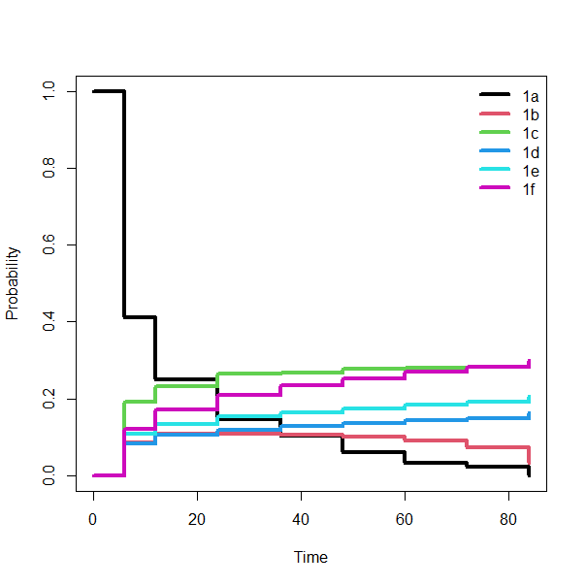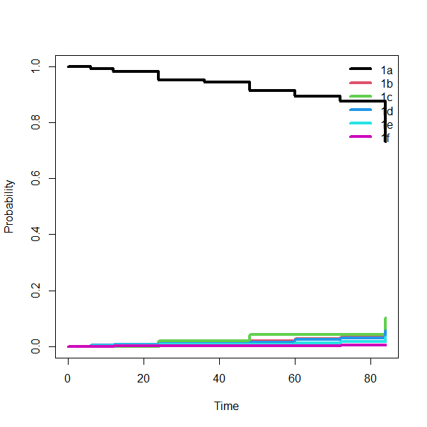
No treatment modification Treatment modification
Figure 1 follow up time 0
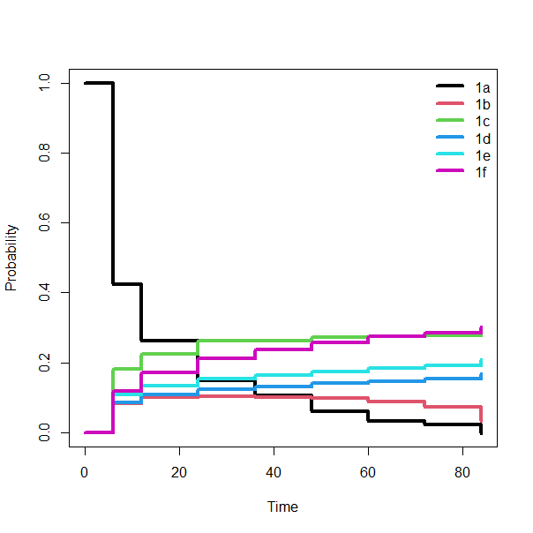 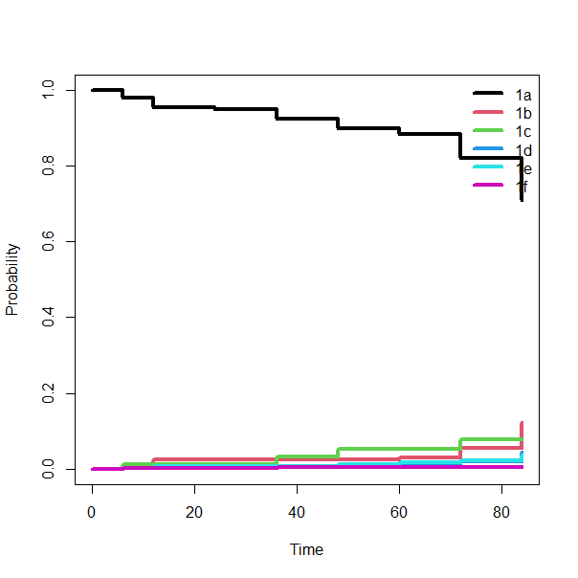 Figure 1 follow up time 0

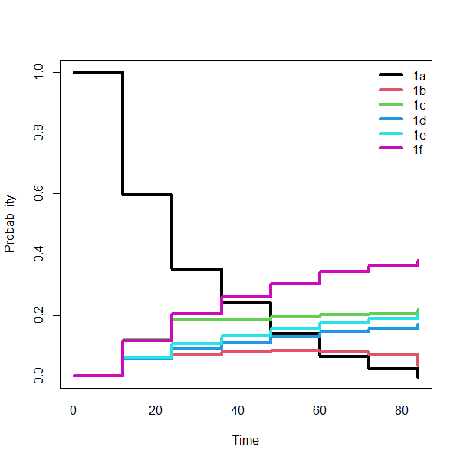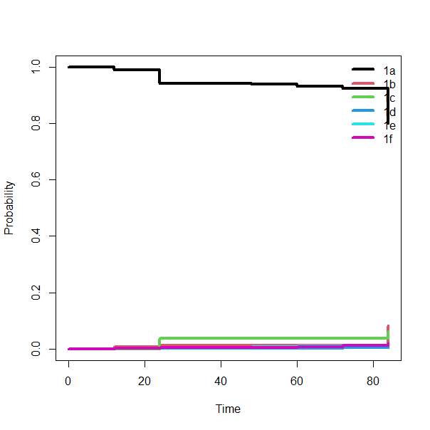
Figure 3 follow up time 12

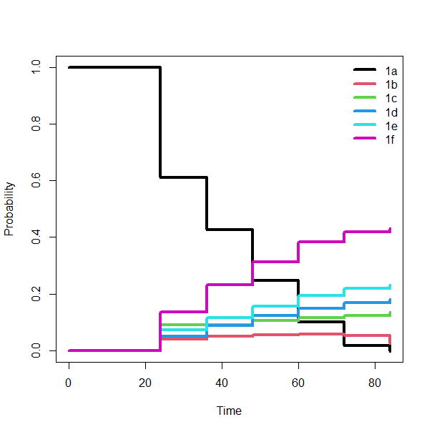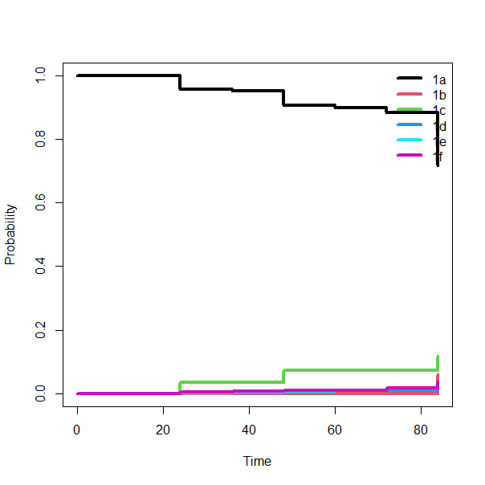
Figure 4 follow up time 24
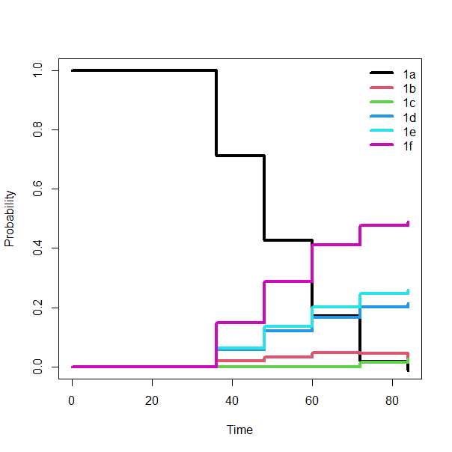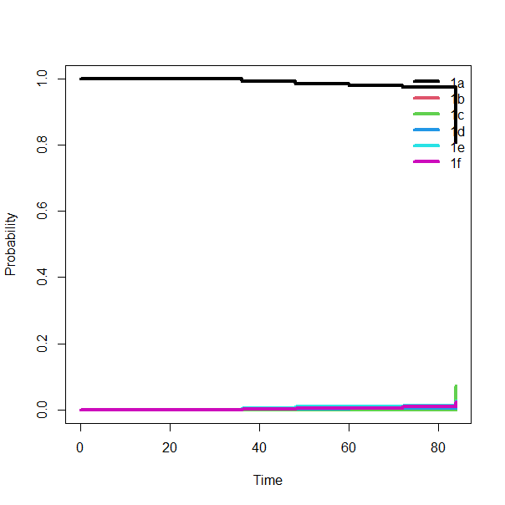
Figure 5 follow up time 36
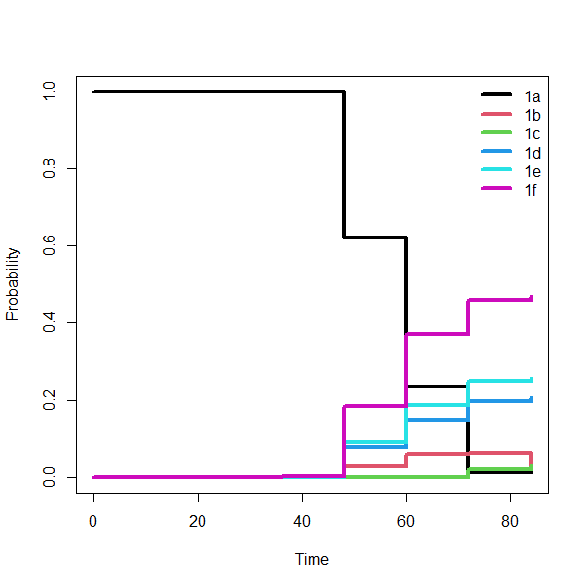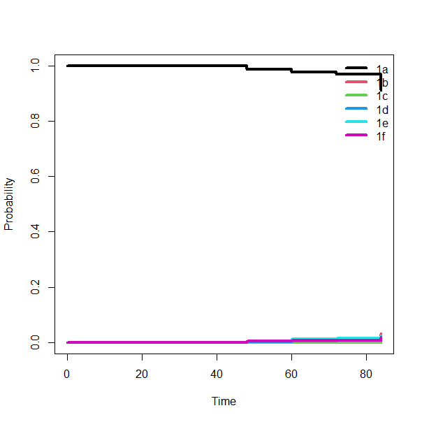
Figure 5 follow up time 48

