Supplementary Materials for

Heat-induced maternal effects shapes avian eggshell traits and embryo development and phenotype in high incubation temperatures

Authors: Alexander J. Hoffman, Leslie Dees, Haruka Wada
Correspondence to: ajh0077@auburn.edu

This file includes:

Methods – details on animal diet and husbandry and specific statistical models used.
Supplemental Table S1
Supplemental Figure S2

Other Supplementary Materials for this manuscript include the following:

Data files
- “Embryo Data for Hoffman et al” (.csv file)
- “Eggshell Data for Hoffman et al” (.csv file)

Supplementary Materials and Methods

- Animal diet and husbandry
Experimental females used in this experiment were obtained from our captive colony of zebra finches (Taeniopygia guttata) at Auburn University. The 32 pairs were housed in individual cages (38.10 cm Width x 45.72 cm Depth x 45.72 cm Height) where they received ad libitum mixed seeds (Kaytee Supreme (finch), Chilton, WI), water, grit, and cuttlefish bone. A nest box (19.5x14.5x14.5 cm) containing shredded paper covered with irradiated hay (SunSations® Timothy Hay, Vitakraft Sun Seed, Weston, OH) was attached to each individual cage, and pairs were sprayed with water twice per day in order to encourage the onset of breeding behavior. On the day eggs hatched, the down feathers of the birds were trimmed into recognizable patterns to allow for individual identification. Every day each pair received one tablespoon of egg mixture (hard-boiled chicken egg, white bread, and cornmeal) to supplement their diet until the oldest nestling reached 5 days post-hatch (DPH). From that point on, pairs were then given two tablespoons per day until the youngest nestling was 35 DPH and had reached nutritional independence. Pairs were also given a vitamin supplement (Wild Harvest, Blacksburg, VA) and chopped spinach once per week. Upon reaching 10 DPH, nestlings were temporarily removed from the nest to be weighed and given unique ID bands. Juveniles were separated from their parents at 39-43 DPH and kept with other juveniles until the start of treatment.

(i) Statistical analyses
Egg mass and heart rate
Linear mixed-effects models (LMM) were used to analyze effects on all egg mass, heart rate, and hatchling mass variables. To test the effect of maternal treatment on initial egg mass (mass on the day egg was laid and prior to incubation treatment), we used a model with juvenile treatment, adult treatment, and lay order (the sequential order in which the egg was laid for each female) as fixed factors, as well as a juvenile*adult treatment interaction term. Incubation treatment was not included in this egg mass analysis, as the initial egg mass was taken before being placed in the incubator. The change in egg mass over the first ~77% of embryonic incubation was analyzed using a model with a categorical “dummy coded” treatment variable representing the four combinations of juvenile and incubation treatment as a fixed factor, as well as the embryonic heart rates at both ~30% and ~77% of embryonic development included as fixed factors. The dummy coded variable represents the four distinct maternal treatment groups resulting from the 2x2 factorial design (Control-Control, Control-Heat, Heat-Control, Heat-Heat), and allows for easy pairwise comparisons. The relationship between the change in egg mass and heart rate at ~77% of embryonic development was also determined using a model which included juvenile, adult, and incubation treatment as fixed factors, as well as the two and three way interaction terms. The effect of maternal and incubation treatments on embryonic heart rates at ~77% development was analyzed using juvenile, adult, and incubation treatment, as well as the two and three way interaction terms, and initial egg mass as fixed factors. The relationship between incubation time and heart rate at ~77% embryonic development was determined using a model which included juvenile, adult, and incubation treatment, as well as the two and three way interaction terms, and heart rate as a fixed factors.
Embryonic development time and hatchling organ mass
The effect of maternal juvenile and incubation treatments on embryonic development time was analyzed using an LMM which included the categorical treatment variable representing the four combinations of juvenile and incubation treatment as a fixed factor, as well as the embryonic heart rate at ~77% of embryonic development included as a fixed factor. Pectoralis mass was analyzed using a LMM with the juvenile*incubation categorical treatment variable (see above), hatchling body mass, and incubation time as fixed factors. The effect of maternal and incubation treatments on body (total hatchling mass prior to euthanization) mass of hatchlings was analyzed using a LMM which included juvenile, adult, and incubation treatment as fixed effects, their two and three way interaction terms, initial egg mass, incubation time, and embryonic heart rate at ~77% of embryonic development as fixed factors. The model examining the effects of treatments on hatchling residual yolk (the mass of yolk internalized from egg stores that are present at hatch) and heart mass included juvenile, adult, and incubation treatment, their two and three way interaction terms, as well as hatchling total body mass as a fixed factors.
Eggshell characteristics
We used LMMs for all models to determine the effect of maternal and incubation treatments on eggshell characteristics. The difference in eggshell pore density between embryos that lived and died was analyzed using a model which included juvenile, adult, and incubation treatment, as well as the two and three way interaction terms, survival (whether the embryo died during development or successfully hatched), and initial egg mass as fixed factors. The difference in average eggshell thickness between embryos that lived and died was analyzed using a model with survival and lay order as fixed factors. To determine the relationship between eggshell thickness and stage of embryonic mortality (categorical group of estimated point of death), we again used a LMM with mortality time and egg mass as fixed factors. Pore density in relation to embryonic mortality time and incubation temperature was analyzed using a model with mortality time, incubation treatment, and egg mass as fixed factors, as well as a mortality time*incubation treatment interaction term. We analyzed the effect of maternal treatment on egg pore density using a model with treatment and egg mass as fixed factors.
Embryo survival
The effect of maternal and incubation treatment on embryo survival was analyzed using a Cox proportional hazard model, with the term full treatment – a variable that is the maternal juvenile, maternal adult, and incubation treatments “dummy coded” together – and egg mass as fixed factors. The dummy coded variable represents the eight distinct treatment groups resulting from the combinations of maternal juvenile, maternal adult, and incubation treatments.

Supplementary table

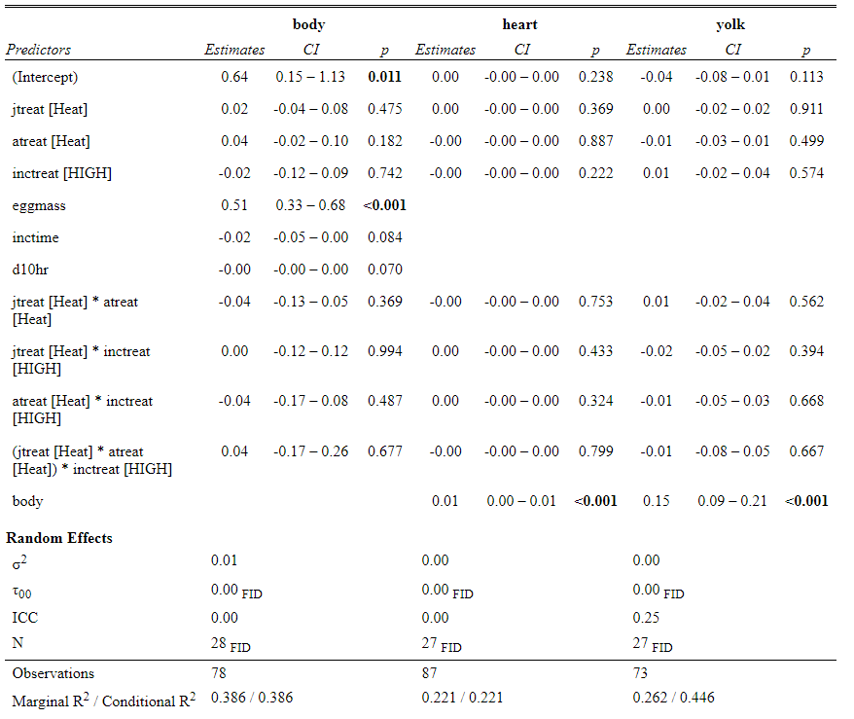

Supplemental Table S1. The statistical output of LMMs used to analyze the effect of maternal and incubation treatment on hatchling total body mass (g), heart mass (g), and residual yolk mass (g).

Supplementary Figure S2
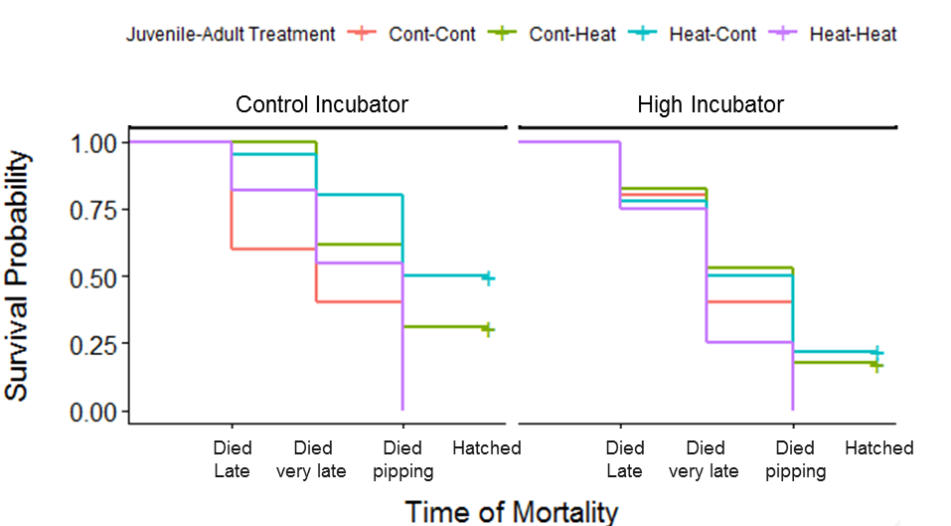

Fig. S2| Embryonic survival in relation to maternal treatment at each incubation temperature. Survival probabilities of embryos at different points in embryonic development, grouped by the respective thermal treatments received by their mothers. The x-axis denotes the estimated developmental stage (very early, early, mid, late, very late, and pipping) at which mortality occurred. The left side of the graph shows embryonic survival at the control incubation temperature (37.2°C) while the right shows survival at the high incubation temperature (38.5°C). In the legend, the first word denotes the treatment the mothers received as juveniles (control or mild heat) and the second word denotes which treatment they received as adults (control or high heat).

