Supplementary figure legends
FigureS1 Identification of human vascular smooth muscle cells. HSMCs stained with α-SMA were used to identify the contractile properties. Scale bar=100 µm.
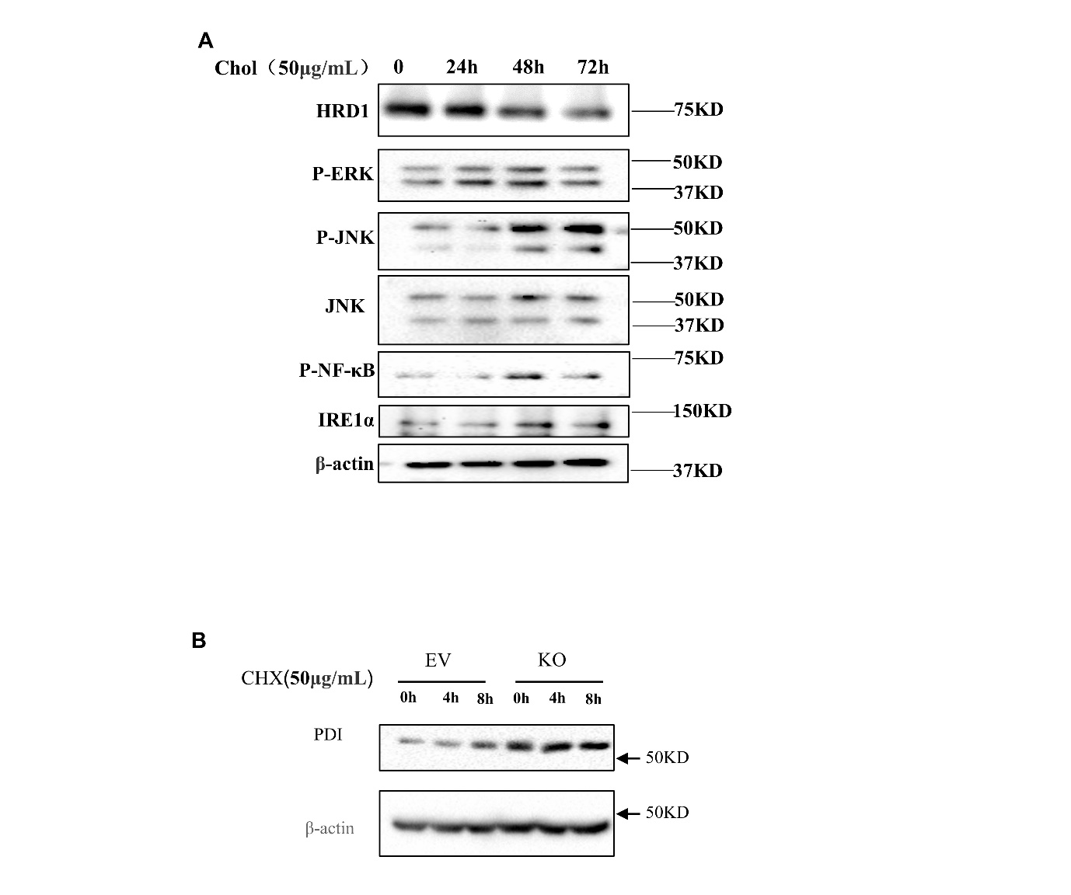
Figure S2 Cholesterol induces inflammatory responses in VSMCs and PDI is a substrate of HRD1. A, MVSMCs were treated with 50μg/mL for different time, the HRD1, P-ERK, P-JNK/JNK, P-NF-κB, IRE1α expression were analyzed; B, Empty vector transfected cells and HRD1-KO cells were treated with 50μg/mL cycloheximide(CHX), PDI didn’t degrade after HRD1 knockout.
Figure S3 Transwell assay of the HSMCs induced by PDGF-BB. A, HSMCs with or without HRD1 KO were treated with or without PGDF-BB (20ng/mL) for 24h, the chambers were stained with 0.1% crystal violet, scale bar=500 μm. B, Statistical analysis of A,) n=3, t-test, * P<0.05, ** P<0.01, *** P<0.001.

