Prevention and therapy of orchestra musicians’ playing-related musculoskeletal disorders with transcranial direct current stimulation:
a pilot study.
Supplementary information

Figures
Figure 1: Medical imaging protocol with acquisition types and durations.
Figure 2: Percentile ranks achieved by participant 1 in the TOL-F. (TOL-F = Tower of London – Freiburg Version)
Figure 3: Percentile ranks achieved by participant 2 in the TOL-F. (TOL-F = Tower of London – Freiburg Version)
Figure 4: Percentile ranks with CIs achieved by participant 1 in the INHIB. (INHIB = Response Inhibition, CI = Confidence Interval)
Figure 5: Percentile ranks with CIs achieved by participant 2 in the INHIB. (INHIB = Response Inhibition, CI = Confidence Interval)
Figure 6: Task-based BOLD fMRI scans of participant 1.
Figure 7: DTI Tractography of participant 1.
Figure 8: DTI Tractography of participant 2.
Figure 9: Wrist angle for two plays.
Figure 10: Elbow angle for two plays.
Figure 11: Shoulder angle for two plays.
Figure 12: Absolute deviation for the wrist-, elbow-, and shoulder angle.
Figure 13: 3D motion capture model reconstruction (front view).

Tables
Table 1: Study tasks completed by each participant. (tDCS = transcranial Direct Current Stimulation, MI = Medical Imaging)
Table 2: Number of participants and total time (minutes) per study task.
Table 3: Absolute frequency of issues with tDCS and the physiotherapeutic exercises.
Table 4: Answers to the "tDCS safety questionnaire" statements.
Table 5: Distances (cm) achieved by participant 1 in the mUQYBT. (mUQYBT = modified Upper Quarter Y-Balance Test)
Table 6: Distances (cm) achieved by participant 2 in the mUQYBT. (mUQYBT = modified Upper Quarter Y-Balance Test)
Table 7: Distances (cm) achieved by participant 3 in the mUQYBT. (mUQYBT = modified Upper Quarter Y-Balance Test)
Table 8: Mean distances (cm) per arm and arm length in the mUQYBT. (mUQYBT = modified Upper Quarter Y-Balance Test)
Table 9: Number of repetitions achieved in the CKCUEST. (CKCUEST = Closed Kinetic Chain Upper Extremity Speed Test)
Table 10: Number of repetitions achieved in the one-arm line hopping test. (Participant 3 did not do this test because of a ganglion in his right wrist.)
Table 11: QuickDASH module scores. (QuickDASH = Quick Disabilities of the Arm, Shoulder and Hand Questionnaire, PAM = Performing Arts Medicine)
Table 12: VLT scores of both participants. (VLT = Verbal Learning Test, PR = Percentile Rank, CI = Confidence Interval, s = seconds)
Table 13: NVLT scores of both participants. (NVLT = Non-Verbal Learning Test, PR = Percentile Rank, CI = Confidence Interval, s = seconds)
Table 14: TMT scores of both participants. (TMT = Trail Making Test, CI = Confidence Interval, s = seconds)
Table 15: TOL-F scores of both participants. (TOL-F = Tower of London – Freiburg Version, PR = Percentile Rank)
Table 16: INHIB scores of both participants. (INHIB = Response Inhibition, CI = Confidence Interval, s = seconds)
Table 17: Sample of raw data acquired through 3D Motion capture.

Figures
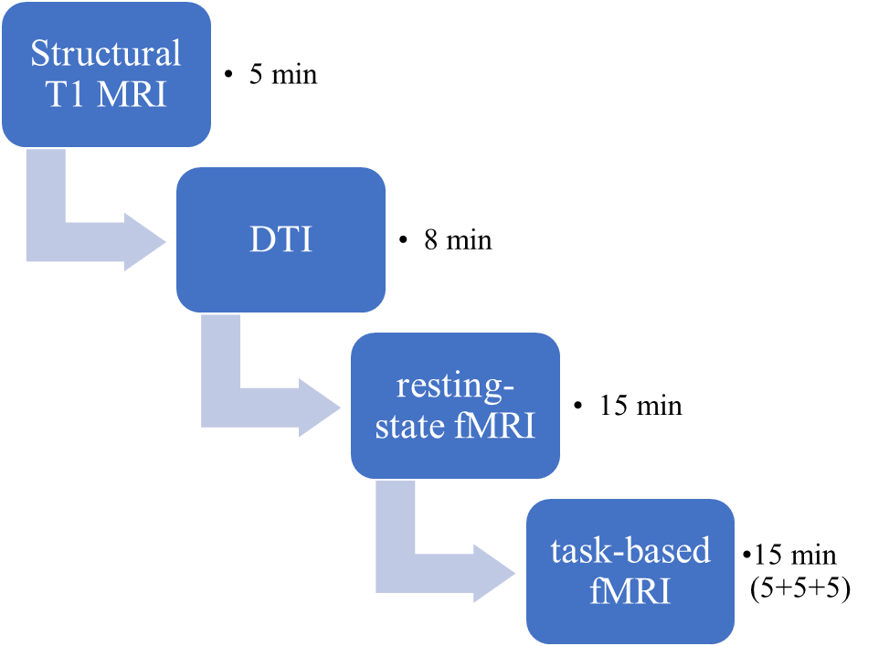
Figure 1: Medical imaging protocol with acquisition types and durations.

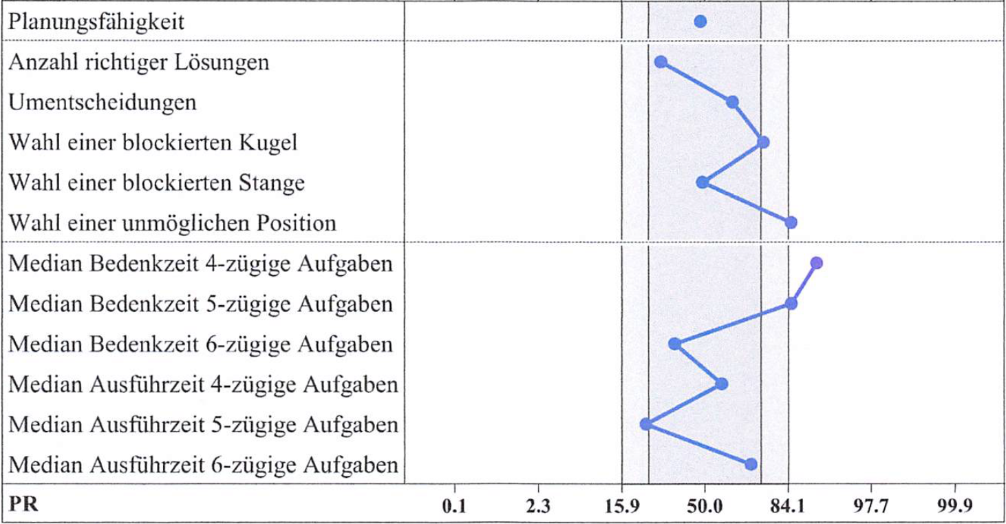
Figure 2: Percentile ranks achieved by participant 1 in the TOL-F. (TOL-F = Tower of London – Freiburg Version)

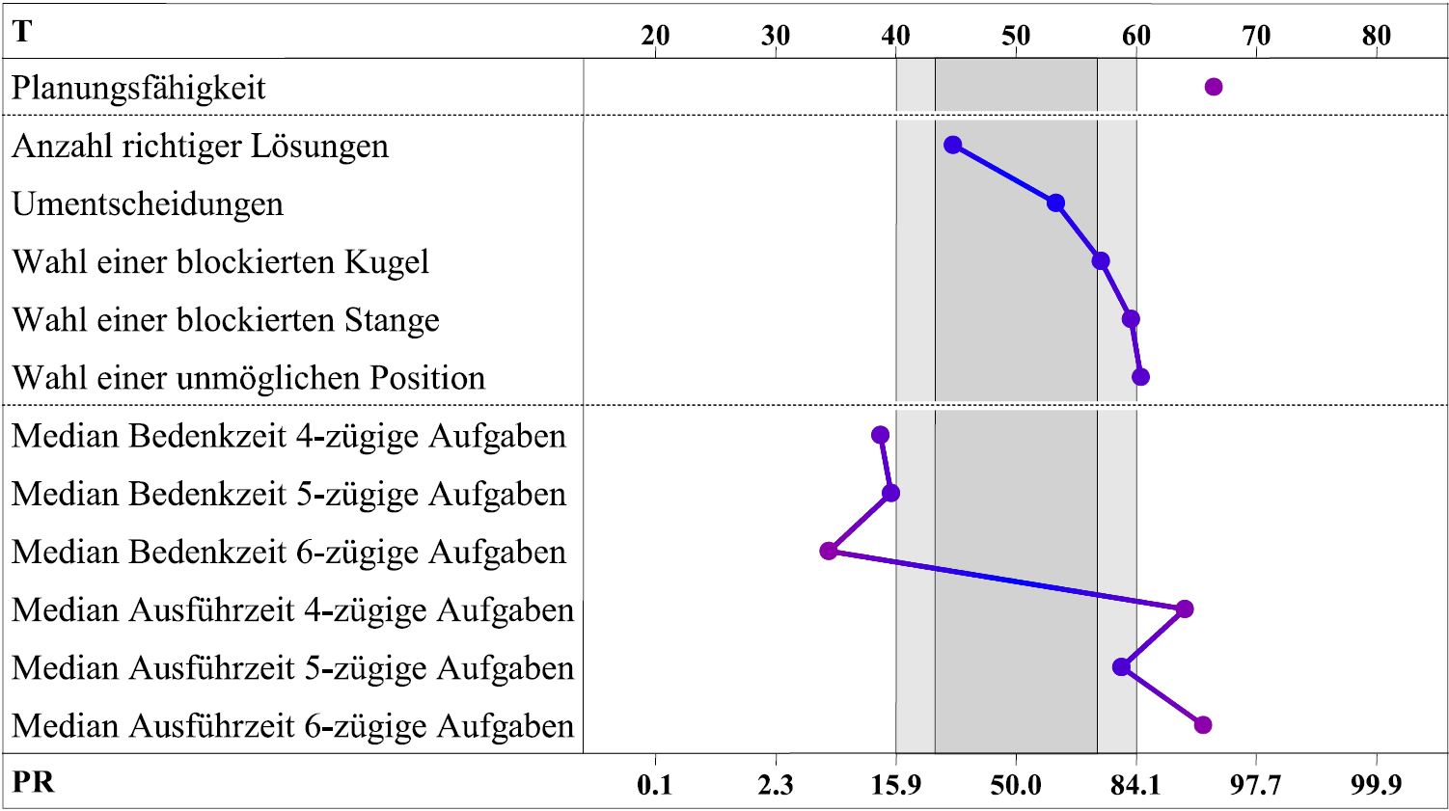
Figure 3: Percentile ranks achieved by participant 2 in the TOL-F. (TOL-F = Tower of London – Freiburg Version)

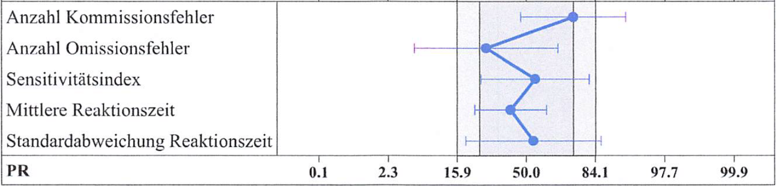
Figure 4: Percentile ranks with CIs achieved by participant 1 in the INHIB. (INHIB = Response Inhibition, CI = Confidence Interval)

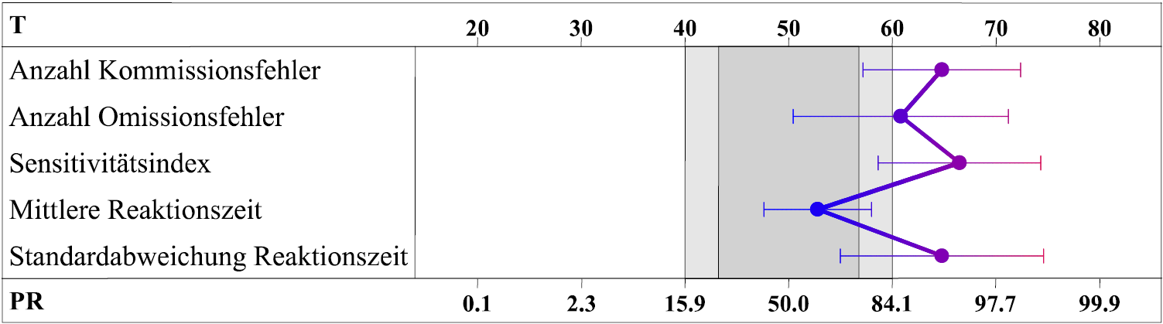
Figure 5: Percentile ranks with CIs achieved by participant 2 in the INHIB. (INHIB = Response Inhibition, CI = Confidence Interval)

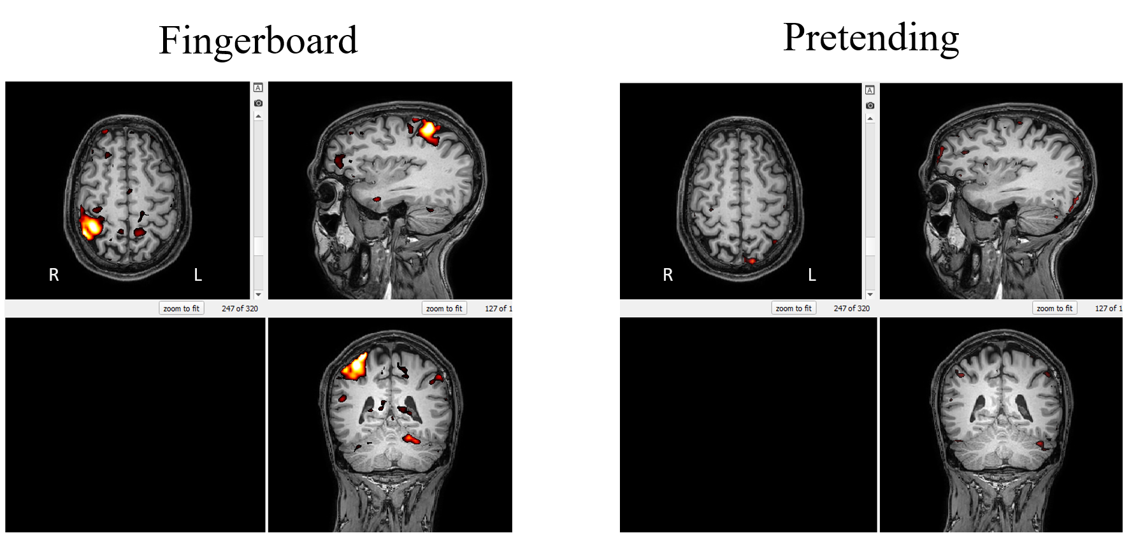
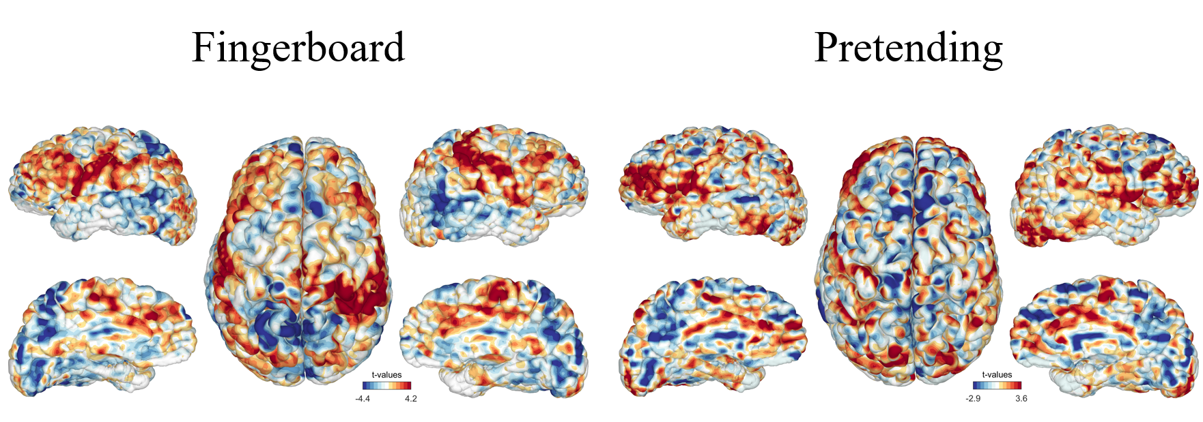
Figure 6: Task-based BOLD fMRI scans of participant 1.

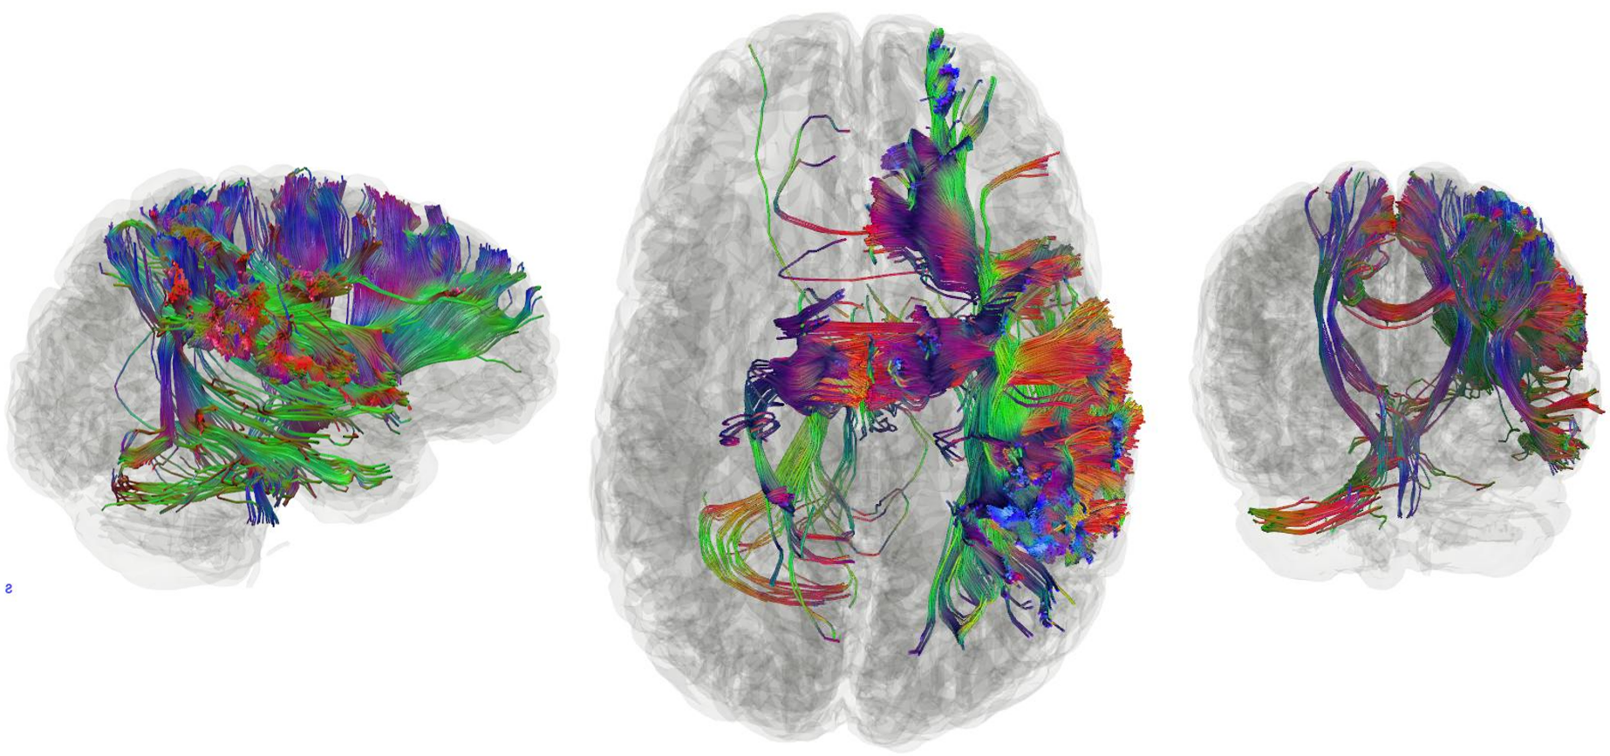
Figure 7: DTI Tractography of participant 1.

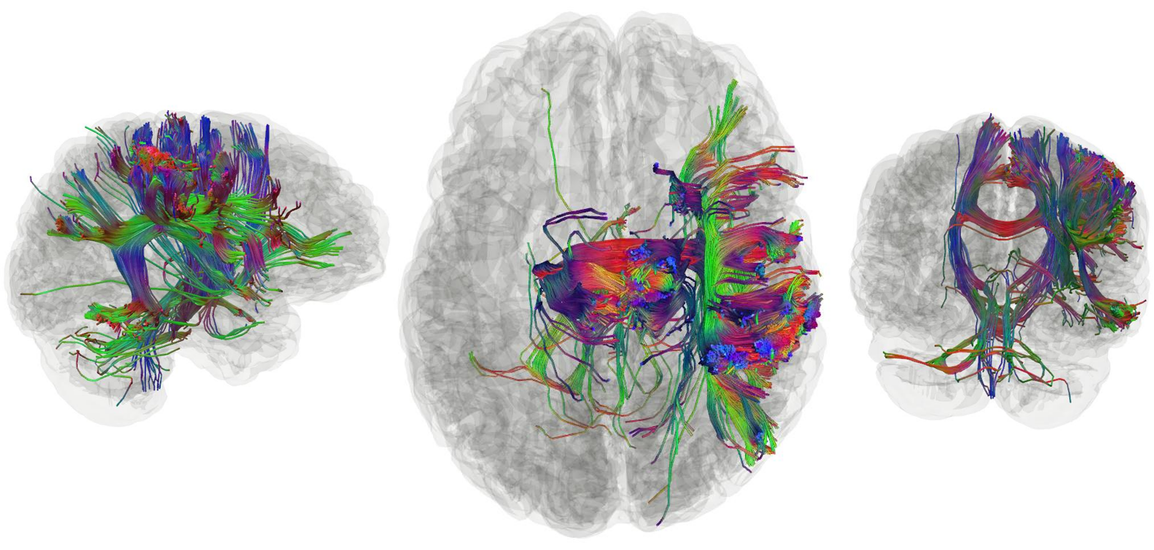
Figure 8: DTI Tractography of participant 2.

Figure 9: Wrist angle for two plays.

Figure 10: Elbow angle for two plays.

Figure 11: Shoulder angle for two plays.

Figure 12: Absolute deviation for the wrist-, elbow-, and shoulder angle.

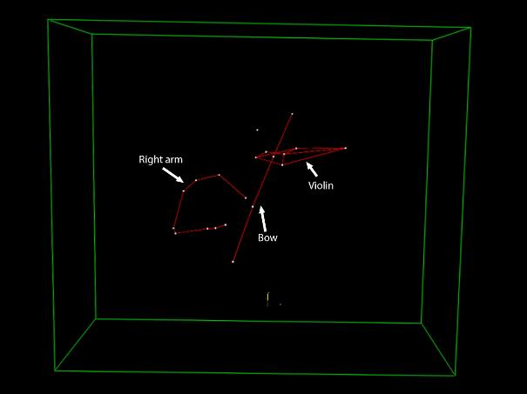
Figure 13: 3D motion capture model reconstruction (front view).

Tables
Participant No. | tDCS | Physio | Coaching | MI | Motion | No. of tasks
1 |  |  |  | Yes |  | 1
2 |  |  |  | Yes |  | 1
3 |  |  |  |  | Yes | 1
4 | Yes |  |  |  |  | 1
5 |  | Yes |  |  |  | 1
6 | Yes | Yes | Yes |  |  | 3
7 |  | Yes | Yes |  |  | 2
Table 1: Study tasks completed by each participant. (tDCS = transcranial Direct Current Stimulation, MI = Medical Imaging)

Study task | No. enrolled | No. completed | Time / participant
tDCS with Halo Sport 2 | 2 | 2 | 100
Physiotherapy | 3 | 3 | 110-125
Coaching | 2 | 2 | 60
Medical Imaging | 2 | 2 | 45
Motion capture | 1 | 1 | 30
Table 2: Number of participants and total time (minutes) per study task.

Issue | Participant 1 | Participant 2 | Total
Connectivity | 2 | 1 | 3
Moisture | 1 | 0 | 1
Falling off | 1 | 0 | 1
Tingling / Burning | 3 | 0 | 3
Table 3: Absolute frequency of issues with tDCS and the physiotherapeutic exercises.

Short statement | Participant 1 | Participant 2
“I had trouble with setup/handling of the device.” | Yes | No
“I had adverse effects when using Halo Sport 2.” | Yes | No
“I had adverse effects during the therapy.” | Yes | No
“Adverse effects were an impairment in daily life.” | No | No
“The symptoms of a disease I had became worse.” | No | No
Table 4: Answers to the "tDCS safety questionnaire" statements.

 | Lateral |  | Superior |  | Inferior
 | right arm | left arm | right arm | left arm | right arm | left arm
First try | 103 | 95 | 68 | 59 | 101 | 97
Second try | 104 | 98 | 63 | 62 | 103 | 101
Third try | 103 | 95 | 61 | 65 | 103 | 107
Mean ± SD | 103 | 96 | 64 | 62 | 102 | 102
Table 5: Distances (cm) achieved by participant 1 in the mUQYBT. (mUQYBT = modified Upper Quarter Y-Balance Test)

 | Lateral |  | Superior |  | Inferior
 | right arm | left arm | right arm | left arm | right arm | left arm
First try | 95 | 93 | 65 | 62 | 74 | 74
Second try | 102 | 101 | 58 | 63 | 72 | 72
Third try | 107 | 103 | 62 | 64 | 75 | 75
Mean ± SD | 101 | 99 | 62 | 63 | 74 | 74
Table 6: Distances (cm) achieved by participant 2 in the mUQYBT. (mUQYBT = modified Upper Quarter Y-Balance Test)

 | Lateral |  | Superior |  | Inferior
 | right arm | left arm | right arm | left arm | right arm | left arm
First try | 111 | 97 | 59 | 55 | 97 | 88
Second try | 111 | 106 | 60 | 54 | 101 | 82
Third try | 110 | 107 | 56 | 82 | 98 | 80
Mean | 111 | 103 | 58 | 64 | 99 | 83
Table 7: Distances (cm) achieved by participant 3 in the mUQYBT. (mUQYBT = modified Upper Quarter Y-Balance Test)

 | Right arm | Left arm | Arm length
Participant 1 | 107 | 103 | 84
Participant 2 | 88 | 87 | 91
Participant 3 | 106 | 99 | 97
Table 8: Mean distances (cm) per arm and arm length in the mUQYBT. (mUQYBT = modified Upper Quarter Y-Balance Test)

 | Participant 1 | Participant 2 | Participant 3
First try | 13 | 8 | 10
Second try | 16 | 9 | 11
Third try | 18 | 10 | 12
Mean | 16 | 9 | 11
Table 9: Number of repetitions achieved in the CKCUEST. (CKCUEST = Closed Kinetic Chain Upper Extremity Speed Test)

 | Participant 1 | Participant 2 | Participant 3
Right arm | 41 | 25 | n.a.
Left arm | 52 | 22 | n.a.
Mean | 47 | 10 | n.a.
Table 10: Number of repetitions achieved in the one-arm line hopping test. (Participant 3 did not do this test because of a ganglion in his right wrist.)

 | Participant 1 | Participant 2 | Participant 3
Main module score | 9.1 | 0 | 0
Work module score | 6.3 | 0 | 12.5
PAM module score | 6.3 | 0 | 12.5
Table 11: QuickDASH module scores. (QuickDASH = Quick Disabilities of the Arm, Shoulder and Hand Questionnaire, PAM = Performing Arts Medicine)

 | Participant 1 |  | Participant 2
 | Sum | PR (95% CI) | Sum | PR (95% CI)
Correct YES-responses | 40 | 89 (73-96) | 39 | 66 (42-84)
Incorrect YES-responses | 21 | 10 (2-27) | 16 | 24 (8-50)
Difference of correct minus incorrect YES-responses | 19 | 21 (8-42) | 23 | 33 (16-58)
Median of the reaction time for correct YES-responses (s) | 0.65 |  | 0.97
Median of the reaction time for incorrect YES-responses (s) | 0.84 |  | 1.49
Total working time (min:sec) | 01:50 |  | 02:08
Frainlness index | 0.00 |  | 0.06
Table 12: VLT scores of both participants. (VLT = Verbal Learning Test, PR = Percentile Rank, CI = Confidence Interval, s = seconds)

 | Participant 1 |  | Participant 2
 | Sum | PR (95% CI) | Sum | PR (95% CI)
Correct YES-responses | 33 | 49 (24-76) | 32 | 43 (18-69)
Incorrect YES-responses | 8 | 72 (50-88) | 10 | 66 (42-84)
Difference of correct minus incorrect YES-responses | 25 | 82 (54-96) | 22 | 71 (42-92)
Total working time (min:sec) | 02:00 |  | 04:11
Frailness index | 0.25 |  | 0.13
Table 13: NVLT scores of both participants. (NVLT = Non-Verbal Learning Test, PR = Percentile Rank, CI = Confidence Interval, s = seconds)

 | Participant 1 |  | Participant 2
 | Value | PR (95% CI) | Value | PR (95% CI)
Working time part A (s) | 17.34 | 20 (10-38) | 9.08 | 100 (99-100)
Working time part B (s) | 20.68 | 63 (38-82) | 15.30 | 97 (90-99)
Working time part A corrected (s) | 17.34 | 19 | 9.08 | 100
Working time part B corrected (s) | 19.67 | 69 | 15.30 | 96
Errors part A | 0 | 52 | 0 | 52
Errors part B | 1 | 31 | 0 | 72
Time difference B-A (s) | 3.34 | 86 | 6.22 | 62
Time quotient B/A | 1.19 | 89 (66-98) | 1.69 | 30 (10-62)
Table 14: TMT scores of both participants. (TMT = Trail Making Test, CI = Confidence Interval, s = seconds)

 | Participant 1 |  | Participant 2
 | Value | PR | Value | PR
Planning ability | 16 | 48 | 21 | 95
Number of correctly solved items | 23 | 30 | 23 | 30
Number of reversed decisions | 4 | 63 | 4 | 63
Number of blocked balls selected | 0 | 76 | 0 | 76
Number of blocked rods selected | 2 | 49 | 0 | 83
Number of impossible positions selected | 0 | 85 | 0 | 85
Median planning time of 4-action tasks | 2.5 | 91 | 7.6 | 13
Median planning time of 5-action tasks | 4.2 | 85 | 12.4 | 15
Median planning time of 6-action tasks | 9.5 | 36 | 18.0 | 6
Median execution time of 4-action tasks | 4.9 | 58 | 3.9 | 92
Median execution time of 5-action tasks | 12.2 | 24 | 5.8 | 81
Median execution time of 6-action tasks | 9.5 | 71 | 6.5 | 94
Table 15: TOL-F scores of both participants. (TOL-F = Tower of London – Freiburg Version, PR = Percentile Rank)

 | Participant 1 |  | Participant 2
 | Value | PR (95% CI) | Value | PR (95% CI)
Commission errors | 5 | 75 (46-93) | 2 | 93 (76-99)
Omission errors | 3 | 28 (5-66) | 0 | 86 (54-98)
Sensitivity index | 3.430 | 55 (24-82) | 4.310 | 95 (79-99)
Mean reaction time (s) | 0.272 | 41 (24-62) | 0.253 | 61 (42-79)
Standard deviation of mean reaction time (s) | 0.078 | 54 (18-86) | 0.042 | 93 (69-99)
Total working time | 01:51 |  | 01:46
Table 16: INHIB scores of both participants. (INHIB = Response Inhibition, CI = Confidence Interval, s = seconds)

Wrist angle (°)
Time (s) | Play 1 | Play 2 | Mean absolute deviation (°)
0 | 0.053 | 0.034 | 0.019
0.008 | 0.002 | 0.02 | 0.018
0.017 | -0.05 | -0.07 | 0.016
0.025 | -0.03 | -0.13 | 0.095
0.033 | -0.03 | -0.11 | 0.082
0.042 | -0.04 | -0.09 | 0.047
0.05 | -0.06 | -0.15 | 0.093
0.058 | -0.06 | -0.16 | 0.094
0.067 | -0.08 | -0.16 | 0.076
0.075 | -0.12 | -0.19 | 0.071
0.083 | -0.15 | -0.21 | 0.063
0.092 | -0.15 | -0.23 | 0.083
0.1 | -0.19 | -0.29 | 0.106
0.108 | -0.23 | -0.33 | 0.097
0.117 | -0.26 | -0.32 | 0.053
0.125 | -0.31 | -0.25 | 0.057
0.133 | -0.37 | -0.26 | 0.105
0.142 | -0.41 | -0.24 | 0.169
0.15 | -0.49 | -0.27 | 0.22
Table 17: Sample of raw data acquired through 3D Motion capture.

