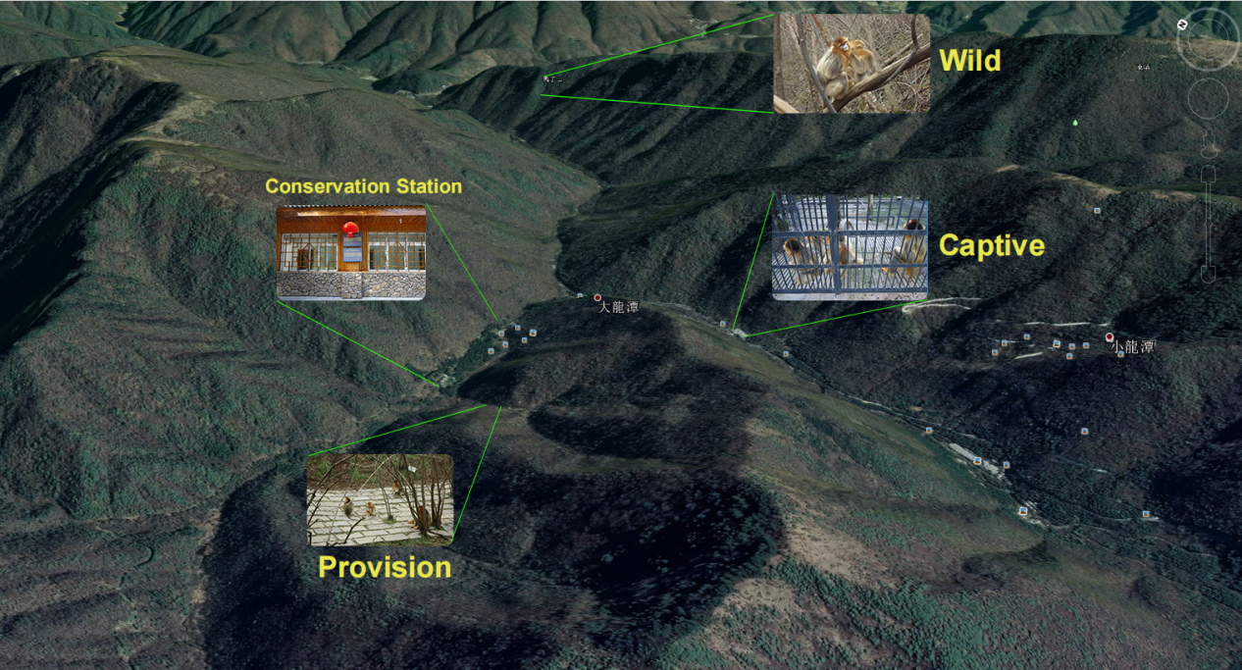Figure S1. Sampling spots of this study. The google map shows the sampling sites of the wild (W), provision (P), and captive (C) golden snub-nosed monkey in Shennonjia National Park, as well as the position of the conservation station .

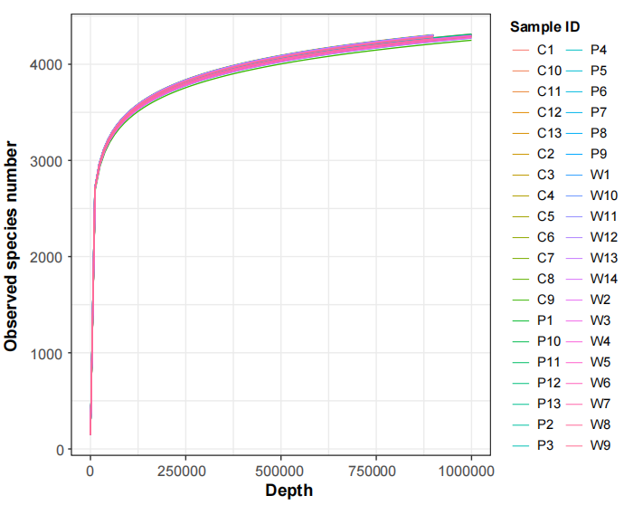
Figure S2. Rarefaction analysis based on observed species.
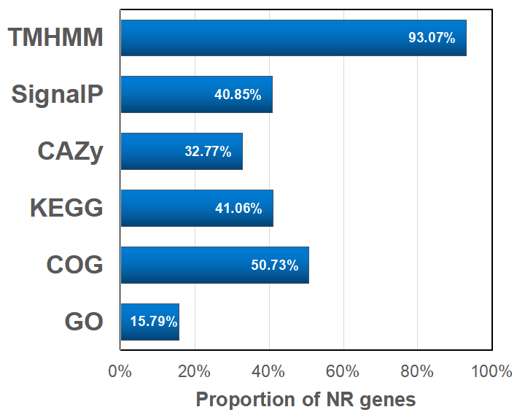
Figure S3. Statistics of functional annotation for the gut microbial reference gene catalog.

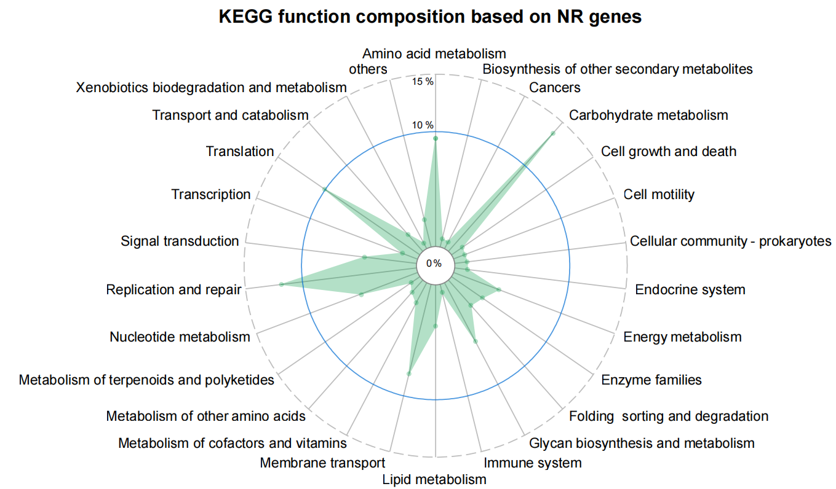
Figure S4. KEGG function composition based on NR genes from the golden snub-nosed monkey gut microbial reference gene catalog.

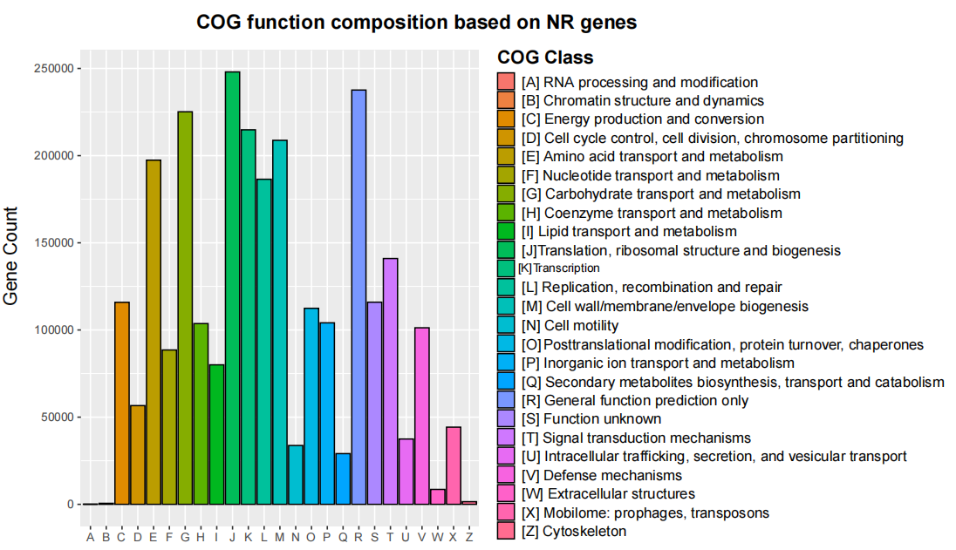
Figure S5. COG function composition based on NR genes from the golden snub-nosed monkey gut microbial reference gene catalog.

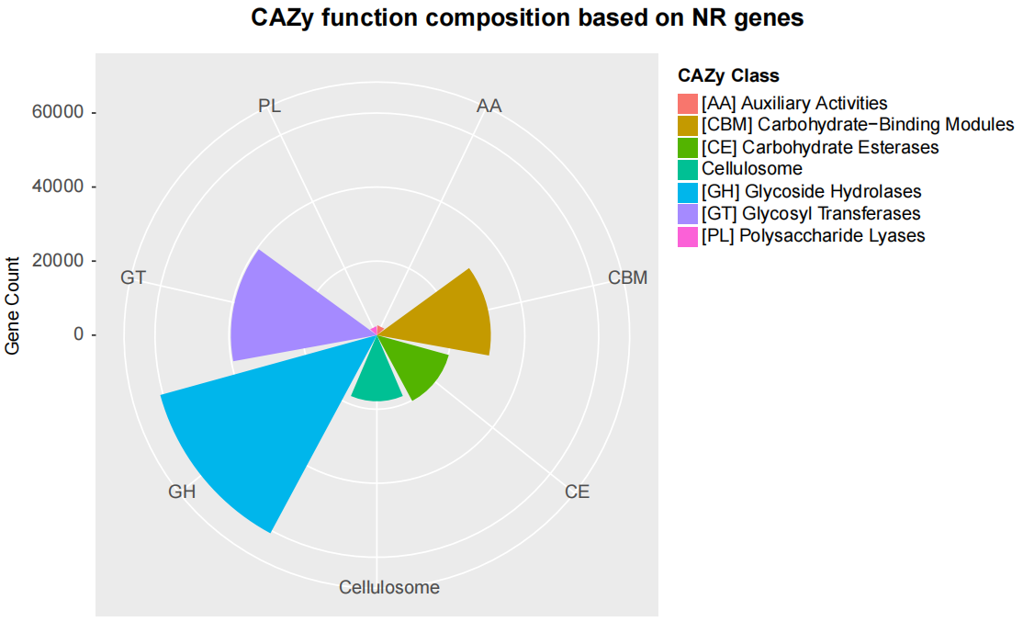
Figure S6. CAZy function composition based on NR genes from the golden snub-nosed monkey gut microbial reference gene catalog.
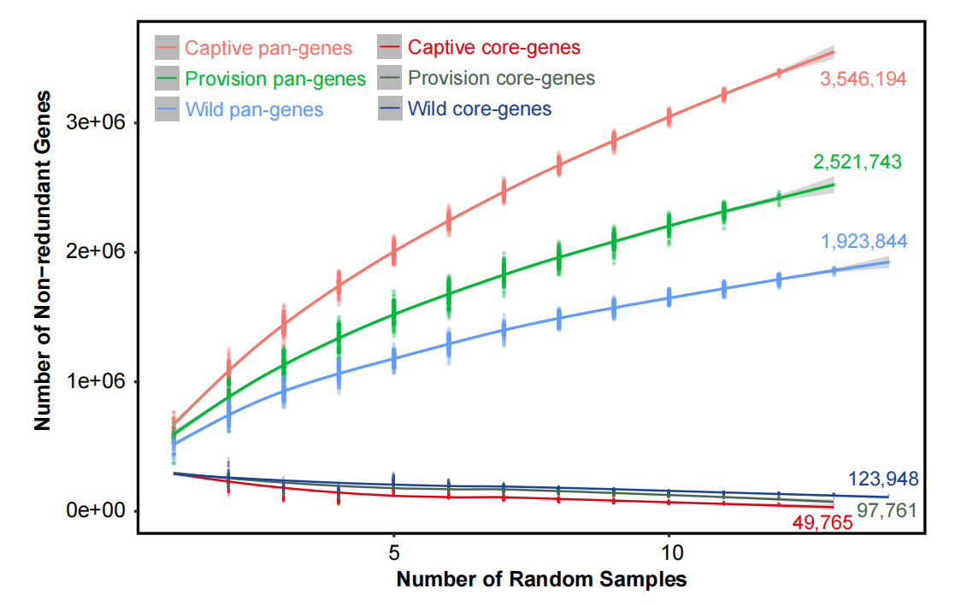
Figure S7. Rarefaction analysis of pan-genes and core-genes on the Captive, Provision and Wild golden snub-nosed monkey gut microbiome.

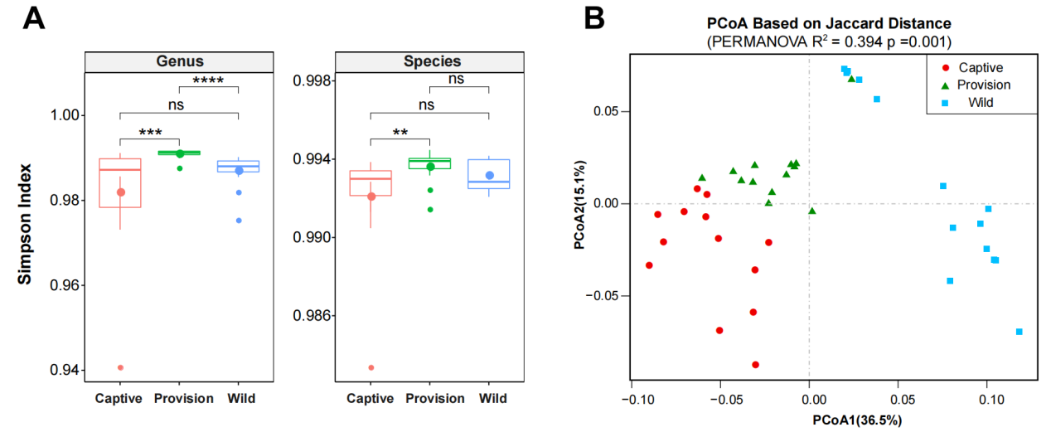
Figure S8. Gut microbial community diversity variation in the Captive, Provision and Wild group. (A) Alpha-diversity indices (Simpson) in the Captive, Provision and Wild group. (B) Differences in golden snub-nosed monkey gut microbiome beta-diversity associated with the Captive, Provision and Wild. PCoA based on Jaccard distance. The statistical significance between groups was assessed by Mann Whitney U test. PCoA, principal coordinates analysis; PERMANOVA, permutational multivariate analysis of variance.

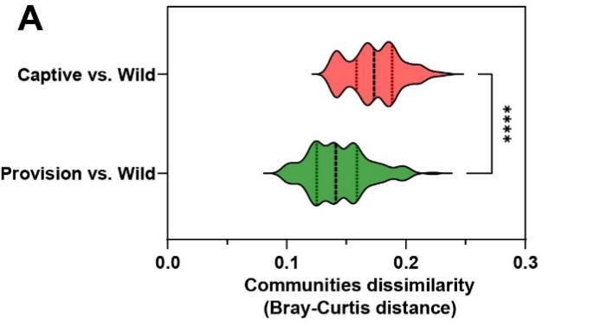
Figure S9. Beta-diversity between the Wild and Captive group and beta-diversity between the Wild and Provision group . The statistical significance between groups was assessed by Mann Whitney U test.

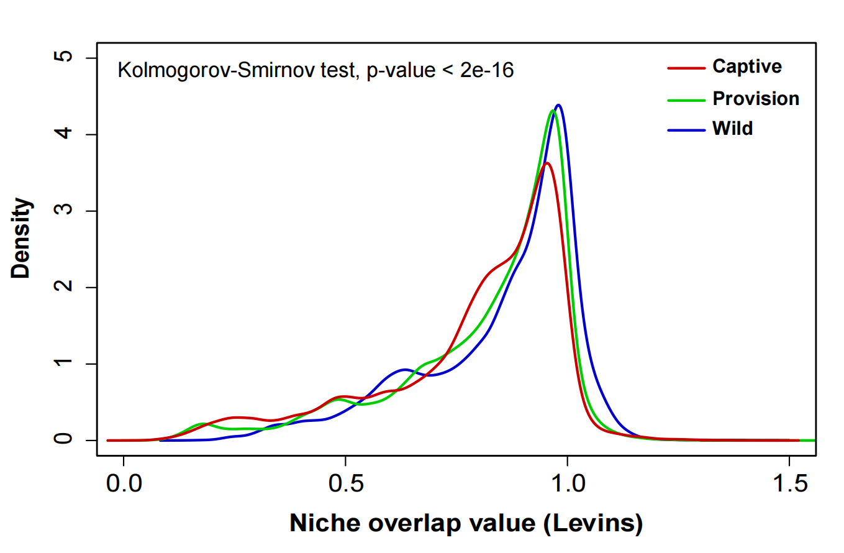
Figure S10. Gut microbial community niche overlap analysis among the Captive, Provision and Wild golden snub-nosed monkey. The statistical significance among groups was assessed by Kolmogorov-Smirnov test.

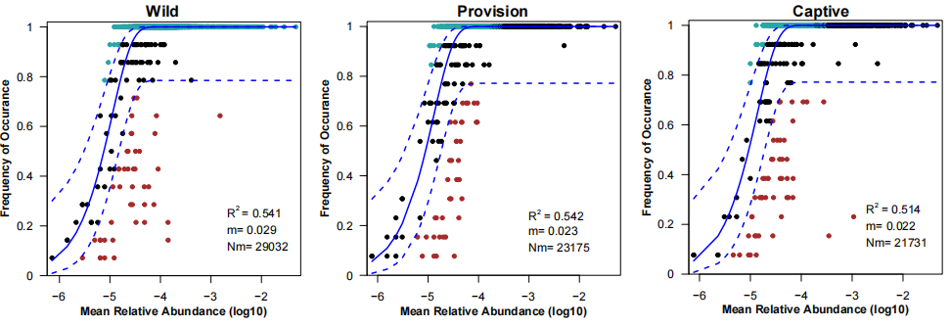Figure S11. Fit of the neutral community model (NCM) of community assembly. The predicted occurrence frequencies for Captive, Provision and Wild representing microbial communities from Captive, Provision and Wild golden snub-nosed monkey, respectively. The solid blue lines indicate the best fit to the NCM as in Sloan et al., and the dashed blue lines represent 95% confidence intervals around the model prediction. Species that occur more or less frequently than predicted by the NCM are shown in different colors. Nm indicates the metacommunity size times immigration, R² indicates the fit to this model.

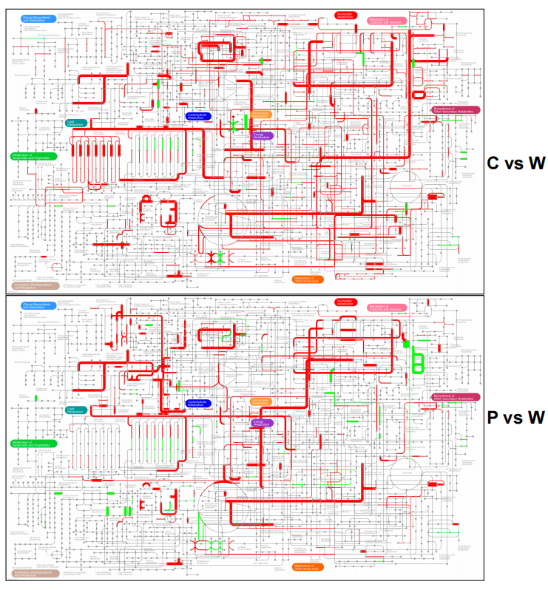
Figure S12. Metabolic pathways analysis based on the KEGG functional differences among the wild (W), provision (P), and captive (C) golden snub-nosed monkey. A pairwise comparison of pathway networks was conducted to screen the significantly regulated metabolic pathways, and IPATH3 was used for visualization. The red lines represent the up-regulated pathways, and the green lines represent the down-regulated pathways, while the gray lines represent the pathways with no difference between groups.
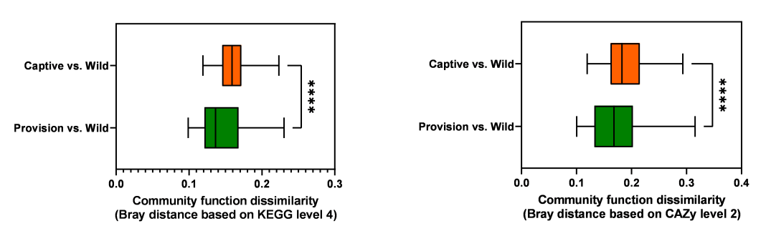
Figure S13. Box plots of beta-diversity between the Wild and Captive groups and beta-diversity between Wild and Provision. The statistical significance between groups was assessed by Mann Whitney U test.

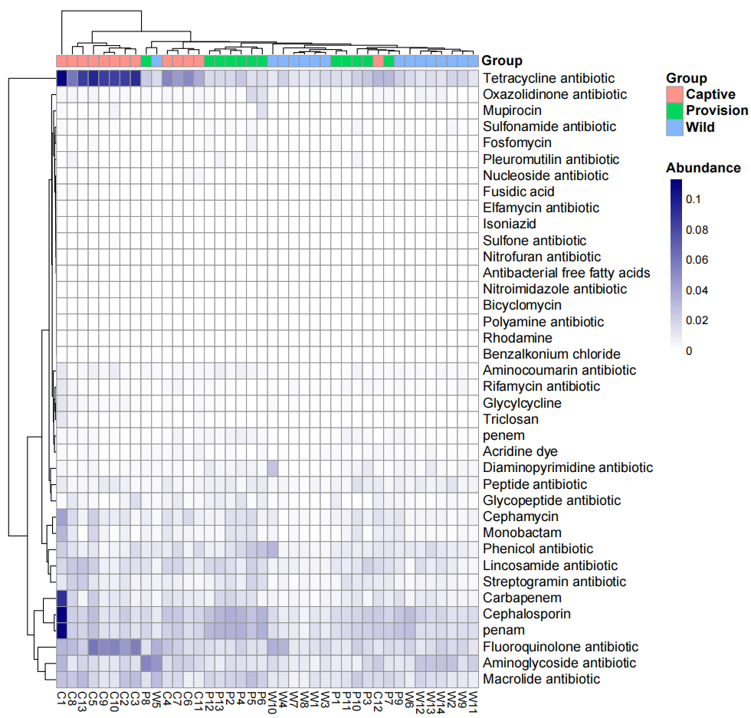
Figure S14. Antibiotic resistance gene analysis of the gut microbiota in the Wild, Provision and Captive golden snub-nosed monkey. The abscissa of the heat map represents the sample, and the ordinate represents the type of ARGs.
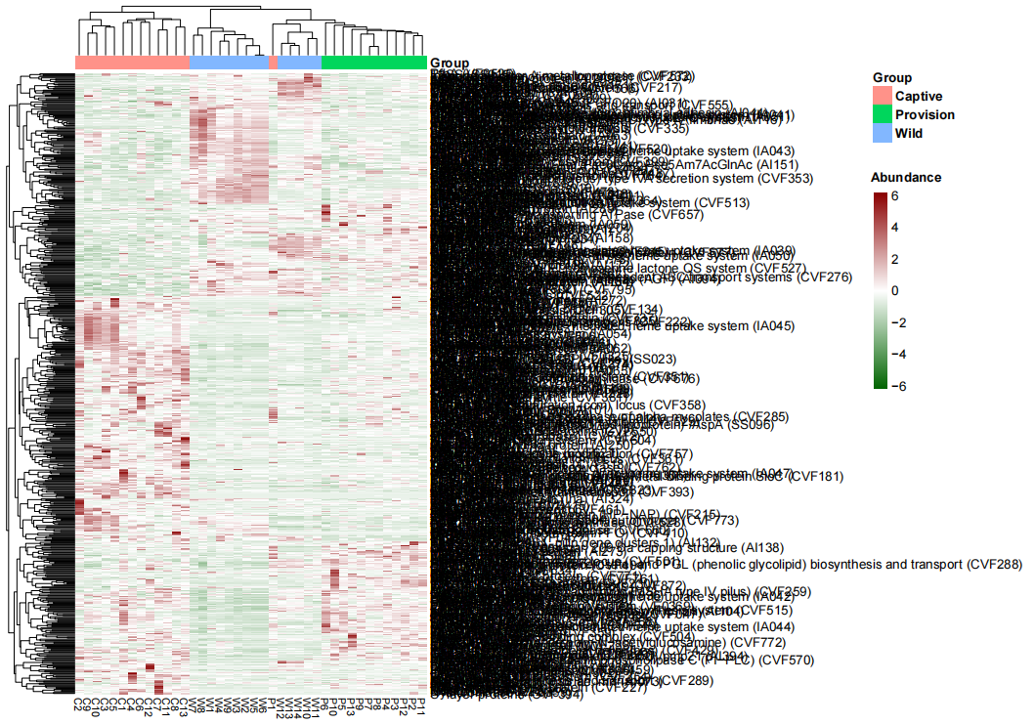
Figure S15. Virulence factor analysis of the gut microbiota in the Wild, Provision and Captive golden snub-nosed monkey. The abscissa of the heat map represents the sample, and the ordinate represents the class of VFs.
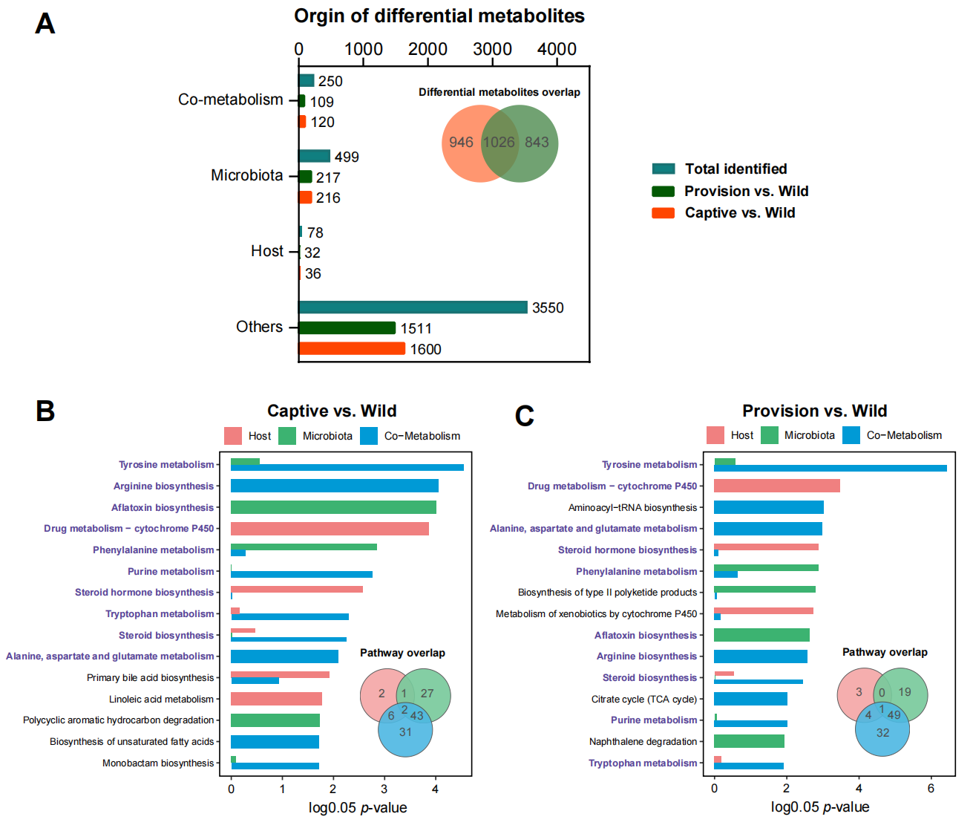
Figure S16. Origin-based differential metabolites analyses. (A) Orgin statistic of differential metabolites. (B-C) Origin-based MPEA based on differential metabolites from Captive vs. Wild and Provision vs. Wild. MPEA, metabolic pathway enrichment analysis. The enrichment significance was assessed by Hypergeometric test. Pathways colored purple represents the shared pathways in (B) and (C).
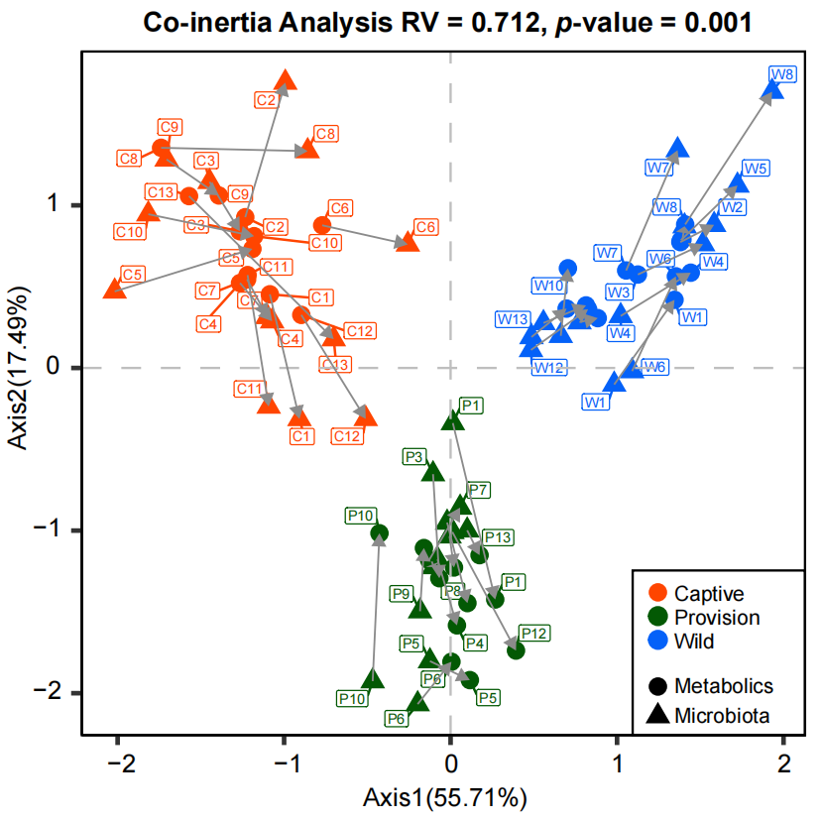
Figure S17. Co-inertia analysis illustrating the correlation between fecal metabolites and microbial species based on NMDS (Bray-Curtis) results of metabolites abundances and species abundances.

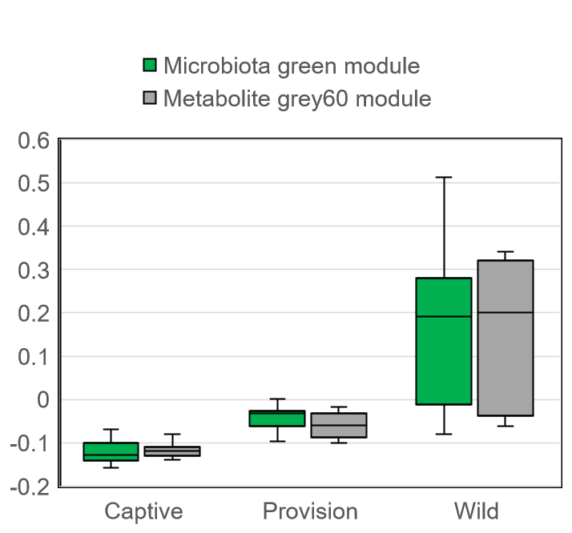
Figure S18. Eigengene value distribution of the correlated microbiota and metabolite module.

