Supplemental material

Supplementary Figure 1: MS/MS spectrum for IPA in ELIPA
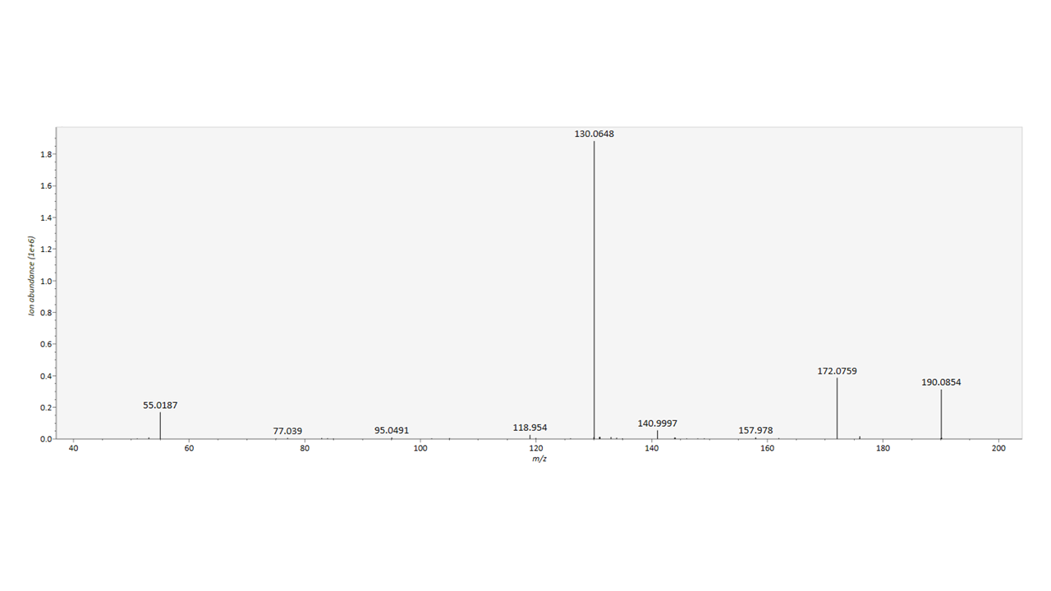

Supplementary Table 1. Prevalence of impaired fasting glucose (≥5.6 nmol/L) (KOBS, n=121)
 | Males  (n = 36) | Females  (n = 85) | P-value ª
Baseline, % (n) | 86 (30) | 66 (56) | 0.078
1 year, % (n) | 57 (17) | 25 (21) | 0.042
Improved fasting glucose level, % (n) | 30 (9) | 48 (27) | 0.045
ª Chi-squared test.
Statistically significant differences are in bold.

Supplementary Table 2. IPA concentrations during the first year after obesity surgery in females (KOBS, n=85)
 | Females ≤ 48.7 years (n = 43) |  | Females > 48.7 years (n = 42) |  | Effect-Age | Time | Time x Age
 | Baseline | 1 year | Baseline | 1 year | Effect-Age | Time | Time x Age
IPA, ng/dL ª | 64.0 (40.9 – 123.3) | 93.0 (53.0 – 126.1) | 81.1 (49.4 – 116.1) | 84.1 (56.4 – 150.4) | 0.149 | 0.009 | 0.362
Generalized Estimating Equation. Data are shown as IQR as indicated.

Supplementary Table 3. The interaction of sex with the changes in BMI, glucose, insulin or HOMA-IR on the change of IPA after obesity surgery (KOBS, n=121)
Clinical variables | IPA fold change (dependent variable)
Clinical variables | Adjusted R² | P-value ª
Δ BMI | -0.015 | 0.850
Δ fasting glucose | -0.025 | 0.962
Δ fasting insulin | 0.171 | <0.001
Δ HOMA-IR | -0.016 | 0.779
IPA fold change: 1 year to baseline ratio.
Δ : 1 year minus baseline.
ª for the the interaction of the sex with each of the changes in the variables of interest (independent variables) on the changes in IPA, adjusted for baseline values, using UNIANOVA.

