Supplementary Information for LanDis: The Disease Landscape Explorer

Note 1: Quantifying similarities between diseases
A few measures have been developed to systematically quantify the similarity between pairs of diseases (1-6). van Driel et al. (1) proposed a text-mining analysis of OMIM, whereby diseases are classified based on features retrieved from the Clinical Synopsis field in OMIM. The authors use a subset of MeSH to build a feature vector for each disease. These vectors are then compared to obtain a measure of the similarity between diseases. Robinson et al. (2) proposed and built the Human Phenotype Ontology, a manually curated ontology that contains terms for the description of phenotypic abnormalities for diseases in OMIM. The similarity between diseases is then computed using an information based measure between sets of terms representing diseases on the ontology. Zhou et al. (3) mine PubMed, extracting the MeSH terms associated to each publication and analyse the co-occurrence of a symptom term (terms in the C23 ontology in MeSH) and a disease term (terms in the C01-C26, except for the C22 and C23 ontologies in MeSH). This co-occurrence is compiled into a feature vector that characterises each disease based the frequency of its symptoms across PubMed. Similarity between every disease is obtained by computing the cosine of the angle between the feature vectors and then conserving only those statistically significant scores. The work of Park et al. (4) builds on the premise that diseases whose proteins share a common subcellular localisation are phenotypically related. Similarity between two diseases is determined by an association score between diseases based on the cellular co-localisation of their disease proteins. Cheng et al. (5) calculate disease similarity using disease-related gene sets in a weighted network of human gene function. Next semantic similarity is devised to calculate disease similarity using the relationship between two diseases from Disease Ontology. Both types of similarities are then integrated to measure disease similarity. Hoehndorf et al. (6) use several ontologies to retrieve the co-occurrence of various phenotypes, which they combine with known disease genes from OMIM, the significance of such co-ocurrences is then ranked using several metrics to build a similarity score based on the simSIC measure. Finally, Caniza et al. (7) compare the MeSH terms used to annotate the publications relevant to a pair of diseases. Semantic similarity measures on the MeSH ontology itself are used to determine the similarity between a pair of diseases.

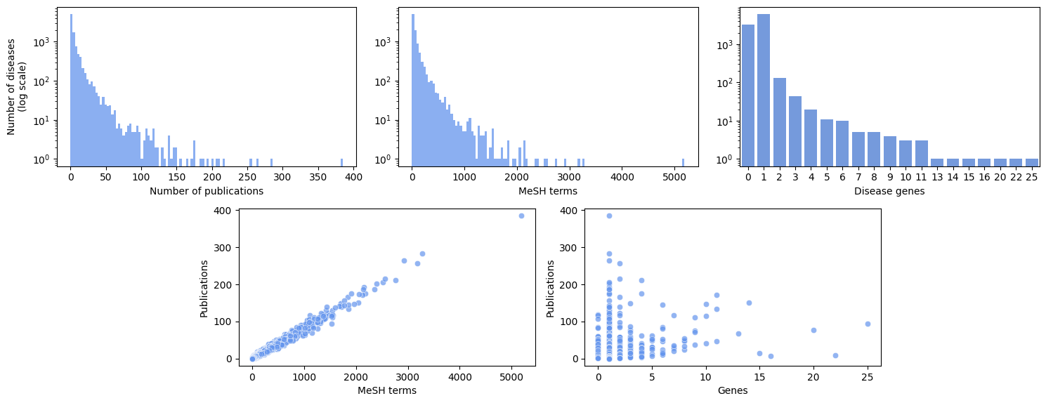
Supplementary Figure 1: Information used by LANDIS. (Top left) Number of publications associated to OMIM diseases. On average, diseases have 8.1 references (standard deviation 16.1). (Top middle) Number of MeSH terms associated to OMIM diseases. The average number of MeSH terms is 100.3 (standard deviation 197.4). (Top right) Number of disease genes per OMIM disease. On average, diseases have 0.7 genes (standard deviation 0.84). (Bottom Left) Diseases with many references tend to be annotated with many MeSH terms (0.99 correlation). (Bottom Right) Many publications do not necessarily imply many known disease genes (0.29 correlation). In the scatter plots each dot corresponds to a disease.

References
1. Van Driel MA, Bruggeman J, Vriend G, Brunner HG, Leunissen JA. A text-mining analysis of the human phenome. European journal of human genetics: EJHG. 2006;14(5):535.
2. Robinson PN, Mundlos S. The Human Phenotype Ontology. Clinical Genetics. 2010;77(6):525-34.
3. Zhou X, Menche J, Barabási A-L, Sharma A. Human symptoms–disease network. Nature communications. 2014;5:4212.
4. Park S, Yang JS, Shin YE, Park J, Jang SK, Kim S. Protein localization as a principal feature of the etiology and comorbidity of genetic diseases. Molecular systems biology. 2011;7(1):494.
5. Cheng L, Li J, Ju P, Peng J, Wang Y. SemFunSim: a new method for measuring disease similarity by integrating semantic and gene functional association. PLoS ONE. 2014;9, e99415.
6. Hoehndorf R, Schofield PN, Gkoutos GV. Analysis of the human diseasome using phenotype similarity between common, genetic, and infectious diseases. Scientific Reports. 2015;5:10888.
7. Caniza H, Romero AE, Paccanaro A. A network medicine approach to quantify distance between hereditary disease modules on the interactome. Scientific reports. 2015;5.

