Supplementary material

Impact of vaccination on the association of COVID-19 with arterial and venous vascular diseases: an OpenSAFELY cohort study using linked electronic health records

Supplementary methods

Further details of statistical analyses
If there were two events or fewer at any level of a potential confounder, the confounder was excluded from the analysis, after levels were aggregated when feasible. To make computations feasible, if the sample size was above four million, the datasets analysed included all individuals with the outcome event or who had COVID-19 during follow up, and a randomly selected subset of those without either the outcome or COVID-19 (“non-exposed controls”). The number of non-exposed controls sampled was based on the number of outcome events: 20 per event for less than 100,000 events, 10 per event for 100,000-500,000 events and 5 per event for >500,000 events. Analyses used inverse probability weights to account for this random sampling, and confidence intervals were derived using robust standard errors. All models were stratified by region, to account for between-region variation.

Absolute excess risks of any ATE and any VTE after COVID-19 were derived. The average daily incidence of each outcome before or without COVID-19 over the whole follow-up period was calculated, separately in subgroups defined by age group and sex. The incidence on each day after COVID-19 was derived by multiplying the daily incidence by the maximally adjusted HR for that day. Using a life table approach, age- and sex-specific cumulative risks over time, with and without COVID-19, were calculated, subtracting the latter from the former to get absolute excess risks over time after COVID-19 versus before or without COVID-19. The overall absolute excess risk was estimated using a weighted sum of the age- and sex-specific excess risks, weighted by the proportions of individuals in age and sex strata in the pre-vaccination cohort.

Individuals with missing age, sex, or deprivation are excluded from the analysis. We included a missing category for ethnicity. All other covariates are defined using the presence versus absence of specific codes, so have no identifiable missing values.

Further details on Information governance and ethical approval
NHS England is the data controller for OpenSAFELY-TPP; TPP is the data processor; all study authors using OpenSAFELY have the approval of NHS England. This implementation of OpenSAFELY is hosted within the TPP environment which is accredited to the ISO 27001 information security standard and is NHS IG Toolkit compliant (https://digital.nhs.uk/data-and-information/looking-after-information/data-security-and-information-governance/data-security-and-protection-toolkit).

Patient data has been pseudonymised for analysis and linkage using industry standard cryptographic hashing techniques; all pseudonymised datasets transmitted for linkage onto OpenSAFELY are encrypted; access to the platform is via a virtual private network (VPN) connection, restricted to a small group of researchers; the researchers hold contracts with NHS England and only access the platform to initiate database queries and statistical models; all database activity is logged; only aggregate statistical outputs leave the platform environment following best practice for anonymisation of results such as statistical disclosure control for low cell counts (https://digital.nhs.uk/data-and-information/information-standards/information-standards-and-data-collections-including-extractions/publications-and-notifications/standards-and-collections/isb1523-anonymisation-standard-for-publishing-health-and-social-care-data).

The OpenSAFELY research platform adheres to the obligations of the UK General Data Protection Regulation (GDPR) and the Data Protection Act 2018. In March 2020, the Secretary of State for Health and Social Care used powers under the UK Health Service (Control of Patient Information) Regulations 2002 (COPI) to require organisations to process confidential patient information for the purposes of protecting public health, providing healthcare services to the public and monitoring and managing the COVID-19 outbreak and incidents of exposure; this sets aside the requirement for patient consent (https://web.archive.org/web/20200421171727/https://www.gov.uk/government/publications/covid-19-notification-to-gps-and-nhs-england-to-share-information). This was extended in November 2022 for the NHS England OpenSAFELY COVID-19 research platform (https://www.gov.uk/government/publications/coronavirus-covid-19-notification-to-organisations-to-share-information/coronavirus-covid-19-notice-under-regulation-34-of-the-health-service-control-of-patient-information-regulations-2002). In some cases of data sharing, the common law duty of confidence is met using, for example, patient consent or support from the Health Research Authority Confidentiality Advisory Group (https://www.hra.nhs.uk/about-us/committees-and-services/confidentiality-advisory-group/).

Taken together, these provide the legal bases to link patient datasets on the OpenSAFELY platform. GP practices, from which the primary care data are obtained, are required to share relevant health information to support the public health response to the pandemic, and have been informed of the OpenSAFELY analytics platform.

Table S1: Patients’ medical characteristics in the pre-vaccination, vaccinated and unvaccinated cohorts.
Medical characteristics |  | Pre-vaccination cohort  (Jan 1 2020 to Dec 14 2021) |  | Vaccinated cohort  (June 1 to Dec 14 2021) |  | Unvaccinated cohort  (June 1 to Dec 14 2021)
 |  | N (%) | COVID-19 diagnoses | N (%) | COVID-19 diagnoses | N (%) | COVID-19 diagnoses
All |  | 18,210,937 | 1,150,299 | 13,572,399 | 844,235 | 3,161,485 | 162,103
GP Consultations (in the past year) | 0 | 4,906,049 (26.9%) | 234,801 | 3,075,265 (22.7%) | 179,977 | 1,690,642 (53.5%) | 48,712
GP Consultations (in the past year) | 1-6 | 6,781,543 (37.2%) | 449,009 | 5,323,075 (39.2%) | 348,135 | 883,709 (28.0%) | 62,336
GP Consultations (in the past year) | 6+ | 6,523,345 (35.8%) | 466,489 | 5,174,059 (38.1%) | 316,123 | 587,134 (18.6%) | 51,055
Medical history | All stroke | 311,346 (1.7%) | 24,611 | 283,203 (2.1%) | 10,458 | 15,462 (0.5%) | 895
Medical history | Acute myocardial infarction | 456,481 (2.5%) | 32,026 | 415,066 (3.1%) | 16,543 | 21,582 (0.7%) | 1,227
Medical history | Angina | 692,590 (3.8%) | 46,663 | 617,970 (4.6%) | 23,980 | 26,441 (0.8%) | 1,542
Medical history | Anticoagulation medications | 628,605 (3.5%) | 43,127 | 581,792 (4.3%) | 23,227 | 25,599 (0.8%) | 1,759
Medical history | Antiplatelet medications | 2,054,670 (11.3%) | 133,027 | 1,790,224 (13.2%) | 75,605 | 108,586 (3.4%) | 7,691
Medical history | Cancer | 5,386,384 (29.6%) | 383,659 | 4,655,704 (34.3%) | 355,899 | 607,492 (19.2%) | 55,519
Medical history | Chronic kidney disease | 1,141,709 (6.3%) | 83,607 | 1,033,251 (7.6%) | 37,977 | 47,182 (1.5%) | 2,936
Medical history | Chronic obstructive pulmonary disease | 594,413 (3.3%) | 39,513 | 527,658 (3.9%) | 20,667 | 28,676 (0.9%) | 1,508
Medical history | Combined oral contraceptive pill | 2,954,192 (16.2%) | 248,502 | 2,246,588 (16.6%) | 217,402 | 419,921 (13.3%) | 39,365
Medical history | Dementia | 225,378 (1.2%) | 37,763 | 172,881 (1.3%) | 6,468 | 6,114 (0.2%) | 370
Medical history | Depression | 5,172,199 (28.4%) | 354,812 | 4,165,697 (30.7%) | 278,033 | 708,913 (22.4%) | 52,714
Medical history | Diabetes | 1,610,598 (8.8%) | 121,394 | 1,445,448 (10.6%) | 77,798 | 120,772 (3.8%) | 9,231
Medical history | Healthcare worker | 537,203 (2.9%) | 73,071 | 455,039 (3.4%) | 36,732 | 19,241 (0.6%) | 2,286
Medical history | Heart failure | 378,673 (2.1%) | 32,434 | 354,450 (2.6%) | 13,831 | 15,036 (0.5%) | 928
Medical history | Hormone replacement therapy | 1,337,186 (7.3%) | 70,349 | 1,256,529 (9.3%) | 64,618 | 53,901 (1.7%) | 3,615
Medical history | Hypertension | 6,041,285 (33.2%) | 382,420 | 5,275,579 (38.9%) | 272,594 | 461,334 (14.6%) | 32,891
Medical history | Lipid medications | 2,676,353 (14.7%) | 157,176 | 2,323,764 (17.1%) | 88,785 | 97,534 (3.1%) | 4,975
Medical history | Liver disease | 131,402 (0.7%) | 8,563 | 113,791 (0.8%) | 5,664 | 16,124 (0.5%) | 828
Medical history | Obesity | 4,466,692 (24.5%) | 330,552 | 3,758,457 (27.7%) | 258,746 | 477,224 (15.1%) | 37,389
Medical history | Other arterial embolism | 120,783 (0.7%) | 8,724 | 132,299 (1.0%) | 5,705 | 7,790 (0.2%) | 467
Medical history | Venous thromboembolism | 312,998 (1.7%) | 22,110 | 286,893 (2.1%) | 14,660 | 26,636 (0.8%) | 2,043

Table S2: Adjusted hazard ratios (95% CI) comparing the incidence of arterial thrombotic, venous thrombotic, and other vascular events after COVID-19 with the incidence before or without COVID-19, in the pre-vaccination, vaccinated and unvaccinated cohorts, overall and according to COVID-19 severity. Hazard ratios for hospitalised and non-hospitalised COVID-19 are maximally adjusted.
 |  | Weeks since COVID-19 | Pre-vaccination cohort | Vaccinated cohort | Unvaccinated cohort
Arterial thrombotic events
Acute myocardial infarction | All, age/sex/region adjusted | 1-4 | 12.7 (12.1-13.4) | 4.49 (4.14-4.88) | 17.4 (14.5-20.9)
Acute myocardial infarction | All, age/sex/region adjusted | 5-28 | 1.49 (1.40-1.58) | 1.07 (0.95-1.20) | 2.12 (1.46-3.07)
Acute myocardial infarction | All, age/sex/region adjusted | 29-52 | 1.31 (1.23-1.39) | - | -
Acute myocardial infarction | All, age/sex/region adjusted | 53-102 | 1.59 (1.44-1.75) | - | -
Acute myocardial infarction | Hospitalised COVID-19 | 1-4 | 22.1 (20.4-23.9) | 14.0 (12.0-16.4) | 27.8 (21.4-36.1)
Acute myocardial infarction | Hospitalised COVID-19 | 5-28 | 1.64 (1.44-1.87) | 1.25 (0.85-1.84) | 1.54 (0.69-3.45)
Acute myocardial infarction | Hospitalised COVID-19 | 29-52 | 1.30 (1.12-1.52) | - | -
Acute myocardial infarction | Hospitalised COVID-19 | 53-102 | 1.43 (1.18-1.72) | - | -
Acute myocardial infarction | Non-hospitalised COVID-19 | 1-4 | 8.39 (7.88-8.93) | 3.50 (3.18-3.86) | 8.55 (6.62-11.0)
Acute myocardial infarction | Non-hospitalised COVID-19 | 5-28 | 1.24 (1.17-1.33) | 1.03 (0.90-1.16) | 1.62 (1.07-2.46)
Acute myocardial infarction | Non-hospitalised COVID-19 | 29-52 | 1.12 (1.04-1.20) | - | -
Acute myocardial infarction | Non-hospitalised COVID-19 | 53-102 | 1.25 (1.12-1.40) | - | -
Ischaemic stroke | All, age/sex/region adjusted | 1-4 | 15.4 (14.7-16.1) | 5.47 (5.07-5.90) | 22.2 (18.7-26.5)
Ischaemic stroke | All, age/sex/region adjusted | 5-28 | 1.64 (1.55-1.73) | 1.14 (1.02-1.29) | 1.73 (1.11-2.67)
Ischaemic stroke | All, age/sex/region adjusted | 29-52 | 1.26 (1.18-1.35) | - | -
Ischaemic stroke | All, age/sex/region adjusted | 53-102 | 1.48 (1.34-1.62) | - | -
Ischaemic stroke | Hospitalised COVID-19 | 1-4 | 18.0 (16.5-19.7) | 10.1 (8.50-12.1) | 28.7 (22.0-37.3)
Ischaemic stroke | Hospitalised COVID-19 | 5-28 | 1.92 (1.69-2.17) | 2.11 (1.57-2.84) | 1.60 (0.71-3.61)
Ischaemic stroke | Hospitalised COVID-19 | 29-52 | 1.31 (1.12-1.53) | - | -
Ischaemic stroke | Hospitalised COVID-19 | 53-102 | 1.25 (1.03-1.52) | - | -
Ischaemic stroke | Non-hospitalised COVID-19 | 1-4 | 11.7 (11.1-12.4) | 4.67 (4.30-5.09) | 12.4 (9.88-15.7)
Ischaemic stroke | Non-hospitalised COVID-19 | 5-28 | 1.31 (1.23-1.40) | 0.99 (0.87-1.13) | 1.19 (0.70-2.02)
Ischaemic stroke | Non-hospitalised COVID-19 | 29-52 | 1.04 (0.97-1.12) | - | -
Ischaemic stroke | Non-hospitalised COVID-19 | 53-102 | 1.13 (1.01-1.26) | - | -
Venous thrombotic events
Pulmonary embolism | All, age/sex/region adjusted | 1-4 | 58.6 (56.6-60.8) | 15.3 (14.3-16.4) | 167.5 (148.9-188.4)
Pulmonary embolism | All, age/sex/region adjusted | 5-28 | 2.22 (2.08-2.37) | 1.88 (1.64-2.15) | 5.66 (4.09-7.82)
Pulmonary embolism | All, age/sex/region adjusted | 29-52 | 1.13 (1.03-1.24) | - | -
Pulmonary embolism | All, age/sex/region adjusted | 53-102 | 1.32 (1.14-1.52) | - | -
Pulmonary embolism | Hospitalised COVID-19 | 1-4 | 252.1 (240.5-264.3) | 127.4 (115.9-140.1) | 833.0 (717.3-967.5)
Pulmonary embolism | Hospitalised COVID-19 | 5-28 | 5.74 (5.12-6.45) | 8.32 (6.50-10.7) | 15.2 (9.41-24.6)
Pulmonary embolism | Hospitalised COVID-19 | 29-52 | 1.58 (1.27-1.97) | - | -
Pulmonary embolism | Hospitalised COVID-19 | 53-102 | 1.49 (1.12-1.99) | - | -
Pulmonary embolism | Non-hospitalised COVID-19 | 1-4 | 22.1 (20.9-23.4) | 5.90 (5.31-6.56) | 29.0 (24.1-34.9)
Pulmonary embolism | Non-hospitalised COVID-19 | 5-28 | 1.53 (1.42-1.66) | 1.31 (1.12-1.54) | 2.48 (1.63-3.79)
Pulmonary embolism | Non-hospitalised COVID-19 | 29-52 | 0.96 (0.87-1.06) | - | -
Pulmonary embolism | Non-hospitalised COVID-19 | 53-102 | 1.04 (0.89-1.23) | - | -
Deep vein thrombosis | All, age/sex/region adjusted | 1-4 | 12.8 (12.0-13.5) | 3.61 (3.23-4.04) | 12.1 (10.0-14.6)
Deep vein thrombosis | All, age/sex/region adjusted | 5-28 | 1.95 (1.83-2.07) | 1.56 (1.38-1.77) | 2.29 (1.64-3.18)
Deep vein thrombosis | All, age/sex/region adjusted | 29-52 | 1.28 (1.18-1.38) | - | -
Deep vein thrombosis | All, age/sex/region adjusted | 53-102 | 1.53 (1.35-1.74) | - | -
Deep vein thrombosis | Hospitalised COVID-19 | 1-4 | 35.4 (32.0-39.0) | 17.1 (13.8-21.1) | 46.1 (22.7-93.7)
Deep vein thrombosis | Hospitalised COVID-19 | 5-28 | 3.61 (3.16-4.12) | 3.55 (2.50-5.05) | 2.34 (0.32-17.2)
Deep vein thrombosis | Hospitalised COVID-19 | 29-52 | 1.34 (1.07-1.67) | - | -
Deep vein thrombosis | Hospitalised COVID-19 | 53-102 | 1.29 (0.96-1.74) | - | -
Deep vein thrombosis | Non-hospitalised COVID-19 | 1-4 | 7.79 (7.22-8.42) | 2.55 (2.24-2.91) | 5.44 (4.21-7.02)
Deep vein thrombosis | Non-hospitalised COVID-19 | 5-28 | 1.54 (1.44-1.65) | 1.35 (1.18-1.54) | 1.07 (0.70-1.63)
Deep vein thrombosis | Non-hospitalised COVID-19 | 29-52 | 1.14 (1.05-1.24) | - | -
Deep vein thrombosis | Non-hospitalised COVID-19 | 53-102 | 1.27 (1.10-1.46) | - | -
Other cardiovascular events
Heart failure | All, age/sex/region adjusted | 1-4 | 18.6 (18.1-19.0) | 5.92 (5.70-6.15) | 21.5 (19.3-24.0)
Heart failure | All, age/sex/region adjusted | 5-28 | 1.61 (1.56-1.67) | 1.17 (1.10-1.24) | 2.28 (1.80-2.90)
Heart failure | All, age/sex/region adjusted | 29-52 | 1.25 (1.20-1.30) | - | -
Heart failure | All, age/sex/region adjusted | 53-102 | 1.26 (1.19-1.34) | - | -
Heart failure | Hospitalised COVID-19 | 1-4 | 46.8 (44.7-49.0) | 27.7 (25.9-29.8) | 46.6 (39.5-55.0)
Heart failure | Hospitalised COVID-19 | 5-28 | 2.29 (2.11-2.47) | 2.02 (1.71-2.39) | 2.77 (1.75-4.40)
Heart failure | Hospitalised COVID-19 | 29-52 | 1.29 (1.16-1.44) | - | -
Heart failure | Hospitalised COVID-19 | 53-102 | 1.12 (0.98-1.29) | - | -
Heart failure | Non-hospitalised COVID-19 | 1-4 | 9.55 (9.20-9.92) | 3.21 (3.04-3.38) | 6.21 (5.06-7.63)
Heart failure | Non-hospitalised COVID-19 | 5-28 | 1.28 (1.23-1.33) | 1.05 (0.98-1.12) | 1.57 (1.18-2.11)
Heart failure | Non-hospitalised COVID-19 | 29-52 | 1.06 (1.01-1.11) | - | -
Heart failure | Non-hospitalised COVID-19 | 53-102 | 1.02 (0.95-1.10) | - | -
Angina | All, age/sex/region adjusted | 1-4 | 11.8 (11.4-12.2) | 4.14 (3.93-4.36) | 18.2 (15.8-21.0)
Angina | All, age/sex/region adjusted | 5-28 | 1.39 (1.33-1.45) | 1.20 (1.12-1.29) | 1.82 (1.32-2.51)
Angina | All, age/sex/region adjusted | 29-52 | 1.26 (1.21-1.32) | - | -
Angina | All, age/sex/region adjusted | 53-102 | 1.40 (1.31-1.51) | - | -
Angina | Hospitalised COVID-19 | 1-4 | 32.6 (31.0-34.3) | 23.5 (21.7-25.5) | 37.4 (31.2-44.8)
Angina | Hospitalised COVID-19 | 5-28 | 1.24 (1.11-1.38) | 1.25 (0.97-1.60) | 1.33 (0.66-2.71)
Angina | Hospitalised COVID-19 | 29-52 | 1.05 (0.93-1.20) | - | -
Angina | Hospitalised COVID-19 | 53-102 | 1.17 (1.00-1.37) | - | -
Angina | Non-hospitalised COVID-19 | 1-4 | 5.24 (4.97-5.53) | 2.03 (1.89-2.19) | 4.79 (3.68-6.22)
Angina | Non-hospitalised COVID-19 | 5-28 | 1.22 (1.16-1.27) | 1.11 (1.03-1.19) | 1.33 (0.93-1.91)
Angina | Non-hospitalised COVID-19 | 29-52 | 1.11 (1.06-1.17) | - | -
Angina | Non-hospitalised COVID-19 | 53-102 | 1.16 (1.07-1.25) | - | -
Transient ischaemic attack | All, age/sex/region adjusted | 1-4 | 4.20 (3.71-4.76) | 2.14 (1.79-2.54) | †
Transient ischaemic attack | All, age/sex/region adjusted | 5-28 | 1.34 (1.22-1.46) | 1.21 (1.02-1.43) | †
Transient ischaemic attack | All, age/sex/region adjusted | 29-52 | 1.22 (1.10-1.34) | - | -
Transient ischaemic attack | All, age/sex/region adjusted | 53-102 | 1.26 (1.08-1.46) | - | -
Transient ischaemic attack | Hospitalised COVID-19 | 1-4 | 5.72 (4.50-7.28) | † | †
Transient ischaemic attack | Hospitalised COVID-19 | 5-28 | 1.34 (1.07-1.68) | † | †
Transient ischaemic attack | Hospitalised COVID-19 | 29-52 | 1.38 (1.09-1.74) | - | -
Transient ischaemic attack | Hospitalised COVID-19 | 53-102 | 0.95 (0.67-1.35) | - | -
Transient ischaemic attack | Non-hospitalised COVID-19 | 1-4 | 3.43 (2.97-3.96) | 1.78 (1.46-2.16) | †
Transient ischaemic attack | Non-hospitalised COVID-19 | 5-28 | 1.21 (1.10-1.34) | 1.07 (0.90-1.29) | †
Transient ischaemic attack | Non-hospitalised COVID-19 | 29-52 | 1.08 (0.97-1.20) | - | -
Transient ischaemic attack | Non-hospitalised COVID-19 | 53-102 | 1.15 (0.97-1.36) | - | -
Subarachnoid haemorrhage and haemorrhagic stroke | All, age/sex/region adjusted | 1-4 | 17.7 (16.1-19.5) | 6.20 (5.22-7.35) | †
Subarachnoid haemorrhage and haemorrhagic stroke | All, age/sex/region adjusted | 5-28 | 1.60 (1.41-1.82) | 1.23 (0.94-1.62) | †
Subarachnoid haemorrhage and haemorrhagic stroke | All, age/sex/region adjusted | 29-52 | 1.46 (1.26-1.68) | - | -
Subarachnoid haemorrhage and haemorrhagic stroke | All, age/sex/region adjusted | 53-102 | 1.69 (1.37-2.10) | - | -
Subarachnoid haemorrhage and haemorrhagic stroke | Hospitalised COVID-19 | 1-4 | 25.3 (21.1-30.3) | † | †
Subarachnoid haemorrhage and haemorrhagic stroke | Hospitalised COVID-19 | 5-28 | 2.05 (1.53-2.73) | † | †
Subarachnoid haemorrhage and haemorrhagic stroke | Hospitalised COVID-19 | 29-52 | 1.62 (1.15-2.30) | - | -
Subarachnoid haemorrhage and haemorrhagic stroke | Hospitalised COVID-19 | 53-102 | 1.57 (1.01-2.43) | - | -
Subarachnoid haemorrhage and haemorrhagic stroke | Non-hospitalised COVID-19 | 1-4 | 13.9 (12.5-15.5) | 5.59 (4.66-6.71) | †
Subarachnoid haemorrhage and haemorrhagic stroke | Non-hospitalised COVID-19 | 5-28 | 1.35 (1.18-1.56) | 1.12 (0.84-1.50) | †
Subarachnoid haemorrhage and haemorrhagic stroke | Non-hospitalised COVID-19 | 29-52 | 1.27 (1.09-1.48) | - | -
Subarachnoid haemorrhage and haemorrhagic stroke | Non-hospitalised COVID-19 | 53-102 | 1.37 (1.07-1.75) | - | -
† Insufficient events for estimation

Table S3: Adjusted hazard ratios (95% CI) comparing the incidence of arterial thrombotic and venous thrombotic events after COVID-19 with the incidence before or without COVID-19, in the unvaccinated cohort, overall and according to COVID-19 severity. Comparing results from the main analysis and to results where censoring at vaccination was removed.

 | Weeks since COVID-19 | Unvaccinated cohort | Unvaccinated cohort without censoring at vaccination
All arterial thrombotic events
All, age/sex/region adjusted | 1-4 | 21.4 (19.0-24.1) | 19.3 (17.2-21.6)
All, age/sex/region adjusted | 5-8 | 1.94 (1.47-2.57) | 1.74 (1.34-2.26)
All, maximally adjusted | 1-4 | 17.2 (15.3-19.4) | 15.9 (14.2-17.8)
All, maximally adjusted | 5-8 | 1.55 (1.17-2.05) | 1.44 (1.11-1.87)
Hospitalised COVID-19 | 1-4 | 32.8 (27.5-39.2) | 31.0 (26.1-36.9)
Hospitalised COVID-19 | 5-8 | 1.56 (0.88-2.78) | 1.58 (0.94-2.64)
Non-hospitalised COVID-19 | 1-4 | 10.9 (9.27-12.9) | 10.1 (8.65-11.8)
Non-hospitalised COVID-19 | 5-8 | 1.45 (1.06-2.00) | 1.30 (0.97-1.76)
All venous thrombotic events
All, age/sex/region adjusted | 1-4 | 56.8 (52.3-61.8) | 50.0 (46.1-54.2)
All, age/sex/region adjusted | 5-8 | 3.21 (2.55-4.05) | 2.84 (2.28-3.53)
All, maximally adjusted | 1-4 | 45.4 (41.7-49.4) | 40.7 (37.5-44.2)
All, maximally adjusted | 5-8 | 2.44 (1.94-3.07) | 2.17 (1.74-2.69)
Hospitalised COVID-19 | 1-4 | 303 (269-341) | 286 (255-321)
Hospitalised COVID-19 | 5-8 | 7.58 (5.12-11.2) | 6.43 (4.38-9.44)
Non-hospitalised COVID-19 | 1-4 | 12.0 (10.3-13.9) | 11.0 (9.51-12.6)
Non-hospitalised COVID-19 | 5-8 | 1.63 (1.22-2.17) | 1.54 (1.19-2.01)

Table S4: Number of events and maximally adjusted hazard ratios (aHR) comparing the incidence of arterial and venous thrombotic events after COVID-19 with the incidence before or without COVID-19, separately for the day of COVID-19 diagnosis (day 0) and the rest of weeks 1-4 after COVID-19 diagnosis (days 1-27), in the pre-vaccination, vaccinated and unvaccinated cohorts, overall and according to COVID-19 severity.

 | Days since COVID-19 | Pre-vaccination cohort |  | Vaccinated cohort |  | Unvaccinated cohort
 | Days since COVID-19 | Number of events | aHR (95% CI) | Number of events | aHR (95% CI) | Number of events | aHR (95% CI)
Arterial thrombotic events
All | 0 | 2618 | 200 (192-208) | 790 | 71.8 (66.9-77.0) | 165 | 199 (169-233)
All | 1-27 | 1333 | 4.40 (4.16-4.65) | 548 | 2.09 (1.92-2.28) | 149 | 8.53 (7.20-10.1)
Hospitalised COVID-19 | 0 | 636 | 228 (211-247) | 147 | 123 (105-145) | 68 | 290 (224-374)
Hospitalised COVID-19 | 1-27 | 667 | 12.1 (11.2-13.1) | 184 | 7.44 (6.41-8.63) | 89 | 19.6 (15.6-24.5)
Non-hospitalised COVID-19 | 0 | 1982 | 194 (185-203) | 643 | 63.7 (58.9-68.9) | 97 | 152 (124-188)
Non-hospitalised COVID-19 | 1-27 | 666 | 2.70 (2.50-2.92) | 364 | 1.53 (1.38-1.69) | 60 | 4.35 (3.36-5.64)
Venous thrombotic events
All | 0 | 2274 | 312 (299-326) | 516 | 72.3 (66.2-79.0) | 310 | 383 (337-435)
All | 1-27 | 2982 | 16.6 (15.9-17.2) | 799 | 4.87 (4.53-5.23) | 527 | 29.6 (26.7-32.9)
Hospitalised COVID-19 | 0 | 1061 | 982 (920-1048) | 214 | 436 (379-501) | 230 | 2427 (2064-2853)
Hospitalised COVID-19 | 1-27 | 2047 | 88.5 (84.1-93.2) | 468 | 46.7 (42.2-51.6) | 401 | 200 (175-229)
Non-hospitalised COVID-19 | 0 | 1213 | 196 (185-208) | 302 | 45.5 (40.6-51.0) | 80 | 107 (85.1-135)
Non-hospitalised COVID-19 | 1-27 | 935 | 5.99 (5.61-6.40) | 331 | 2.13 (1.91-2.38) | 126 | 7.64 (6.34-9.20)

Table S5: Maximally adjusted hazard ratios (95% CI) comparing the incidence of arterial thrombotic events after COVID-19 with the incidence before or without COVID-19, in the pre-vaccination, vaccinated and unvaccinated cohorts, by subgroup.
Subgroup |  | Weeks since COVID-19 | Pre-vaccination cohort | Vaccinated cohort | Unvaccinated cohort
Age group | 18-39 | 1-4 | 6.37 (4.99-8.12) | † | †
Age group | 18-39 | 5-28 | 1.21 (0.98-1.50) | † | †
Age group | 18-39 | 29-52 | 1.07 (0.85-1.34) | - | -
Age group | 18-39 | 53-102 | 1.03 (0.64-1.64) | - | -
Age group | 40-59 | 1-4 | 8.62 (7.98-9.30) | 2.35 (2.05-2.71) | 12.8 (10.5-15.6)
Age group | 40-59 | 5-28 | 1.19 (1.10-1.29) | 0.83 (0.70-0.98) | 1.12 (0.72-1.76)
Age group | 40-59 | 29-52 | 1.12 (1.03-1.22) | - | -
Age group | 40-59 | 53-102 | 1.30 (1.12-1.51) | - | -
Age group | 60-79 | 1-4 | 15.9 (15.1-16.6) | 4.84 (4.47-5.24) | 25.3 (21.1-30.4)
Age group | 60-79 | 5-28 | 1.42 (1.34-1.51) | 1.11 (0.99-1.25) | 1.44 (0.85-2.45)
Age group | 60-79 | 29-52 | 1.12 (1.04-1.20) | - | -
Age group | 60-79 | 53-102 | 1.33 (1.19-1.47) | - | -
Age group | 80-110 | 1-4 | 13.0 (12.2-13.8) | 8.73 (7.99-9.54) | †
Age group | 80-110 | 5-28 | 1.42 (1.32-1.54) | 1.19 (1.00-1.41) | †
Age group | 80-110 | 29-52 | 1.07 (0.97-1.18) | - | -
Age group | 80-110 | 53-102 | 1.06 (0.94-1.19) | - | -
Sex | Female | 1-4 | 11.2 (10.6-11.9) | 4.94 (4.53-5.39) | 13.4 (10.9-16.3)
Sex | Female | 5-28 | 1.08 (1.00-1.16) | 1.02 (0.89-1.16) | 2.21 (1.55-3.16)
Sex | Female | 29-52 | 1.34 (1.26-1.43) | - | -
Sex | Female | 53-102 | 1.09 (0.98-1.21) | - | -
Sex | Male | 1-4 | 13.5 (12.9-14.1) | 4.78 (4.45-5.13) | 18.6 (16.0-21.6)
Sex | Male | 5-28 | 1.36 (1.29-1.43) | 1.10 (0.99-1.23) | 0.95 (0.60-1.49)
Sex | Male | 29-52 | 1.14 (1.08-1.21) | - | -
Sex | Male | 53-102 | 1.31 (1.20-1.44) | - | -
Ethnicity | White | 1-4 | 12.5 (12.1-13.0) | 4.89 (4.61-5.18) | 15.0 (13.1-17.2)
Ethnicity | White | 5-28 | 1.37 (1.31-1.43) | 1.09 (1.00-1.19) | 1.49 (1.09-2.03)
Ethnicity | White | 29-52 | 1.14 (1.09-1.20) | - | -
Ethnicity | White | 53-102 | 1.21 (1.13-1.31) | - | -
Ethnicity | Black | 1-4 | 15.5 (12.4-19.3) | † | †
Ethnicity | Black | 5-28 | 1.13 (0.83-1.54) | † | †
Ethnicity | Black | 29-52 | 0.91 (0.64-1.30) | - | -
Ethnicity | Black | 53-102 | 1.19 (0.75-1.88) | - | -
Ethnicity | South Asian | 1-4 | 12.9 (11.6-14.4) | 4.52 (3.56-5.73) | -
Ethnicity | South Asian | 5-28 | 1.23 (1.08-1.40) | 0.83 (0.57-1.22) | -
Ethnicity | South Asian | 29-52 | 1.00 (0.87-1.16) | - | -
Ethnicity | South Asian | 53-102 | 1.19 (0.95-1.48) | - | -
Ethnicity | Other Ethnic Groups | 1-4 | 12.9 (9.58-17.2) | † | †
Ethnicity | Other Ethnic Groups | 5-28 | 1.44 (1.01-2.07) | † | †
Ethnicity | Other Ethnic Groups | 29-52 | 0.90 (0.57-1.42) | - | -
Ethnicity | Other Ethnic Groups | 53-102 | 1.02 (0.52-1.96) | - | -
Ethnicity | Mixed | 1-4 | 16.9 (11.9-23.9) | † | †
Ethnicity | Mixed | 5-28 | 1.96 (1.29-2.99) | † | †
Ethnicity | Mixed | 29-52 | 0.80 (0.41-1.55) | - | -
Ethnicity | Mixed | 53-102 | 2.02 (1.00-4.09) | - | -
Prior history of event | Yes | 1-4 | 10.5 (9.88-11.2) | 4.73 (4.28-5.22) | 8.58 (6.48-11.4)
Prior history of event | Yes | 5-28 | 1.30 (1.20-1.40) | 1.06 (0.91-1.23) | 0.65 (0.31-1.37)
Prior history of event | Yes | 29-52 | 1.13 (1.03-1.23) | - | -
Prior history of event | Yes | 53-102 | 1.24 (1.11-1.39) | - | -
Prior history of event | No | 1-4 | 13.7 (13.1-14.2) | 5.08 (4.76-5.43) | 21.2 (18.5-24.2)
Prior history of event | No | 5-28 | 1.39 (1.32-1.46) | 1.09 (0.99-1.21) | 1.91 (1.41-2.59)
Prior history of event | No | 29-52 | 1.13 (1.07-1.19) | - | -
Prior history of event | No | 53-102 | 1.23 (1.13-1.33) | - | -
† insufficient events for estimation
Table S6: Maximally adjusted hazard ratios (95% CI) comparing the incidence of venous thrombotic events after COVID-19 with the incidence before or without COVID-19, in the pre-vaccination, vaccinated and unvaccinated cohorts, by subgroup.
Subgroup |  | Weeks since COVID-19 | Pre-vaccination cohort | Vaccinated cohort | Unvaccinated cohort
Age group | 18-39 | 1-4 | 15.2 (13.7-16.9) | 2.83 (2.14-3.75) | 18.7 (15.7-22.3)
Age group | 18-39 | 5-8 | 1.44 (1.28-1.63) | 1.50 (1.13-1.99) | 1.41 (0.90-2.21)
Age group | 18-39 | 29-52 | 1.08 (0.94-1.25) | - | -
Age group | 18-39 | 53-102 | 1.29 (0.98-1.70) | - | -
Age group | 40-59 | 1-4 | 29.2 (27.7-30.8) | 5.11 (4.57-5.71) | 54.7 (48.2-62.1)
Age group | 40-59 | 5-8 | 1.65 (1.53-1.79) | 1.19 (1.00-1.40) | 2.52 (1.80-3.54)
Age group | 40-59 | 29-52 | 1.01 (0.91-1.11) | - | -
Age group | 40-59 | 53-102 | 1.14 (0.94-1.36) | - | -
Age group | 60-79 | 1-4 | 39.6 (37.9-41.5) | 10.0 (9.24-10.8) | 94.8 (79.6-113.0)
Age group | 60-79 | 5-8 | 2.35 (2.19-2.52) | 1.75 (1.53-2.01) | 3.78 (2.30-6.20)
Age group | 60-79 | 29-52 | 1.17 (1.06-1.29) | - | -
Age group | 60-79 | 53-102 | 1.31 (1.13-1.53) | - | -
Age group | 80-110 | 1-4 | 22.5 (20.7-24.4) | 14.1 (12.5-16.0) | †
Age group | 80-110 | 5-8 | 2.07 (1.85-2.31) | 1.94 (1.54-2.45) | †
Age group | 80-110 | 29-52 | 1.18 (1.01-1.38) | - | -
Age group | 80-110 | 53-102 | 1.09 (0.89-1.32) | - | -
Sex | Female | 1-4 | 20.7 (19.8-21.7) | 6.01 (5.49-6.57) | 25.5 (22.2-29.2)
Sex | Female | 5-8 | 1.75 (1.64-1.86) | 1.45 (1.28-1.65) | 2.15 (1.56-2.97)
Sex | Female | 29-52 | 1.12 (1.03-1.21) | - | -
Sex | Female | 53-102 | 1.15 (1.01-1.31) | - | -
Sex | Male | 1-4 | 36.1 (34.7-37.6) | 9.41 (8.74-10.1) | 69.7 (62.3-78.1)
Sex | Male | 5-8 | 1.99 (1.87-2.12) | 1.59 (1.40-1.80) | 2.55 (1.81-3.58)
Sex | Male | 29-52 | 1.06 (0.97-1.15) | - | -
Sex | Male | 53-102 | 1.24 (1.07-1.42) | - | -
Ethnicity | White | 1-4 | 25.7 (24.8-26.5) | 7.65 (7.21-8.11) | 37.5 (34.0-41.3)
Ethnicity | White | 5-8 | 1.86 (1.77-1.95) | 1.55 (1.41-1.70) | 2.27 (1.76-2.93)
Ethnicity | White | 29-52 | 1.09 (1.03-1.16) | - | -
Ethnicity | White | 53-102 | 1.18 (1.07-1.31) | - | -
Ethnicity | Black | 1-4 | 48.7 (41.7-56.8) | † | 76.9 (34.4-172.1)
Ethnicity | Black | 5-8 | 1.88 (1.42-2.50) | † | 3.32 (0.39-28.6)
Ethnicity | Black | 29-52 | 0.80 (0.53-1.21) | - | -
Ethnicity | Black | 53-102 | 1.80 (1.14-2.85) | - | -
Ethnicity | South Asian | 1-4 | 46.0 (41.1-51.4) | † | 81.7 (58.0-115.1)
Ethnicity | South Asian | 5-8 | 1.90 (1.58-2.28) | † | †
Ethnicity | South Asian | 29-52 | 1.13 (0.90-1.43) | - | -
Ethnicity | South Asian | 53-102 | 1.43 (0.99-2.07) | - | -
Ethnicity | Other Ethnic Groups | 1-4 | 66.7 (52.6-84.7) | † | †
Ethnicity | Other Ethnic Groups | 5-8 | 1.34 (0.8-2.26) | † | †
Ethnicity | Other Ethnic Groups | 29-52 | 2.98 (2.06-4.31) | - | -
Ethnicity | Other Ethnic Groups | 53-102 | 0.52 (0.13-2.11) | - | -
Ethnicity | Mixed | 1-4 | 36.3 (27.0-48.8) | † | †
Ethnicity | Mixed | 5-8 | 1.25 (0.73-2.13) | † | †
Ethnicity | Mixed | 29-52 | 1.22 (0.71-2.09) | - | -
Ethnicity | Mixed | 53-102 | † | - | -
Prior history of event | Yes | 1-4 | 12.6 (11.4-13.8) | 4.06 (3.48-4.74) | 6.86 (5.12-9.20)
Prior history of event | Yes | 5-8 | 1.47 (1.31-1.65) | 1.27 (1.04-1.55) | 1.24 (0.77-1.99)
Prior history of event | Yes | 29-52 | 1.01 (0.87-1.18) | - | -
Prior history of event | Yes | 53-102 | 1.20 (0.96-1.50) | - | -
Prior history of event | No | 1-4 | 32.3 (31.3-33.3) | 8.94 (8.40-9.50) | 65.8 (60.0-72.2)
Prior history of event | No | 5-8 | 1.97 (1.88-2.07) | 1.61 (1.46-1.78) | 2.83 (2.17-3.69)
Prior history of event | No | 29-52 | 1.11 (1.05-1.19) | - | -
Prior history of event | No | 53-102 | 1.20 (1.08-1.34) | - | -
† insufficient events for estimation
Table S7: Estimated excess events at 28 weeks for pre-vaccination, vaccinated and unvaccinated cohorts

Outcome |  | Pre-vaccination cohort | Vaccinated cohort | Unvaccinated cohort
Arterial thrombotic events | Total excess events | 4,546 | 1,491 | 374
Arterial thrombotic events | Total post exposure follow-up (years) | 522,421 | 158,306 | 25,578
Arterial thrombotic events | Excess events per 100,000 COVID-19 diagnosis | 642 | 229 | 718
Venous thrombotic events | Total excess events | 6,360 | 1,991 | 1,083
Venous thrombotic events | Total post exposure follow-up (years) | 522,573 | 158,379 | 25,472
Venous thrombotic events | Excess events per 100,000 COVID-19 diagnosis | 797 | 270 | 1094

Table S8: List of Covariates

The following potential confounders were defined using the most recent data prior to the study start date:

Confounder | Type | Definition | Data sources
Sex* | Categorical | Male, Female | Primary care (see: https://docs.opensafely.org/study-def-variables/#cohortextractor.patients.sex)
Age | Continuous | Modelled as age in years using a restricted cubic spline with 3 knots at the 10th, 50th and 90th percentiles | All
Ethnicity | Categorical | 1: White  2: Mixed  3: South Asian  4: Black  5: Other  6: Missing/Unknown | All
Deprivation | Categorical | Index of Multiple Deprivation 2019 quintiles | Index of Multiple Deprivation 2019
Region | Categorical | East  East Midlands  London  North East  North West  South East  South West  West Midlands  Yorkshire/Humber | Primary care
Patient-GP contact | Continuous | Number of primary care contacts in the year prior to index date | Primary care
Smoking status | Categorial | N: Never smoker  E: Ex-smoker  S: Current smoker  M: Missing/Unknown | Primary care
Obesity | Binary | 1 if BMI>=30 or coded diagnosis for obesity; 0 otherwise | Primary care, HES APC
Acute myocardial infarction | Binary | 1 if diagnosis present; 0 otherwise | Primary care, HES APC
All stroke | Binary | 1 if diagnosis present; 0 otherwise | Primary care, HES APC
Other arterial embolism | Binary | 1 if diagnosis present; 0 otherwise | Primary care, HES APC
Venous thromboembolism events | Binary | 1 if diagnosis present; 0 otherwise | Primary care, HES APC
Heart failure | Binary | 1 if diagnosis present; 0 otherwise | Primary care, HES APC
Angina | Binary | 1 if diagnosis present; 0 otherwise | Primary care, HES APC
Dementia | Binary | 1 if diagnosis present; 0 otherwise | Primary care, HES APC
Liver disease | Binary | 1 if diagnosis present; 0 otherwise | Primary care, HES APC
Chronic kidney disease | Binary | 1 if diagnosis present; 0 otherwise | Primary care, HES APC
Cancer | Binary | 1 if diagnosis present; 0 otherwise | Primary care, HES APC
Hypertension | Binary | 1 if diagnosis or prescription present; 0 otherwise | Primary care, HES APC
Diabetes | Binary | 1 if diagnosis or prescription present; 0 otherwise | Primary care, HES APC
Depression | Binary | 1 if diagnosis present; 0 otherwise | Primary care, HES APC
Chronic obstructive pulmonary disease | Binary | 1 if diagnosis present; 0 otherwise | Primary care, HES APC
Lipid lowering medications | Binary | 1 if prescription present; 0 otherwise | Primary care
Antiplatelet medications | Binary | 1 if prescription present; 0 otherwise | Primary care
Anticoagulation medications | Binary | 1 if prescription present; 0 otherwise | Primary care
Combined oral contraceptive pill | Binary | 1 if prescription present; 0 otherwise | Primary care
Hormone replacement therapy | Binary | 1 if prescription present; 0 otherwise | Primary care
Healthcare worker* | Binary | 1 if healthcare worker; 0 otherwise | NHS England COVID-19 data store (see: https://docs.opensafely.org/study-def-variables/#cohortextractor.patients.with_healthcare_worker_flag_on_covid_vaccine_record)
Care home resident | Binary | 1 if care home resident; 0 otherwise | Address matching CQC database (see: https://docs.opensafely.org/study-def-variables/#cohortextractor.patients.care_home_status_as_of)
* These variables are derived once per patient without a date specification so are an exception to ‘most recent data prior to the study start date’

Figure S1: Maximally adjusted hazard ratios and 95% CIs comparing the incidence of arterial thrombotic events after COVID-19 with the incidence before or without COVID-19, in the pre-vaccination, vaccinated and unvaccinated cohorts, overall and by COVID-19 severity. Sensitivity analysis with events identified through primary diagnosis only. Points are plotted at the median time of the outcome event within each follow up period in each cohort.

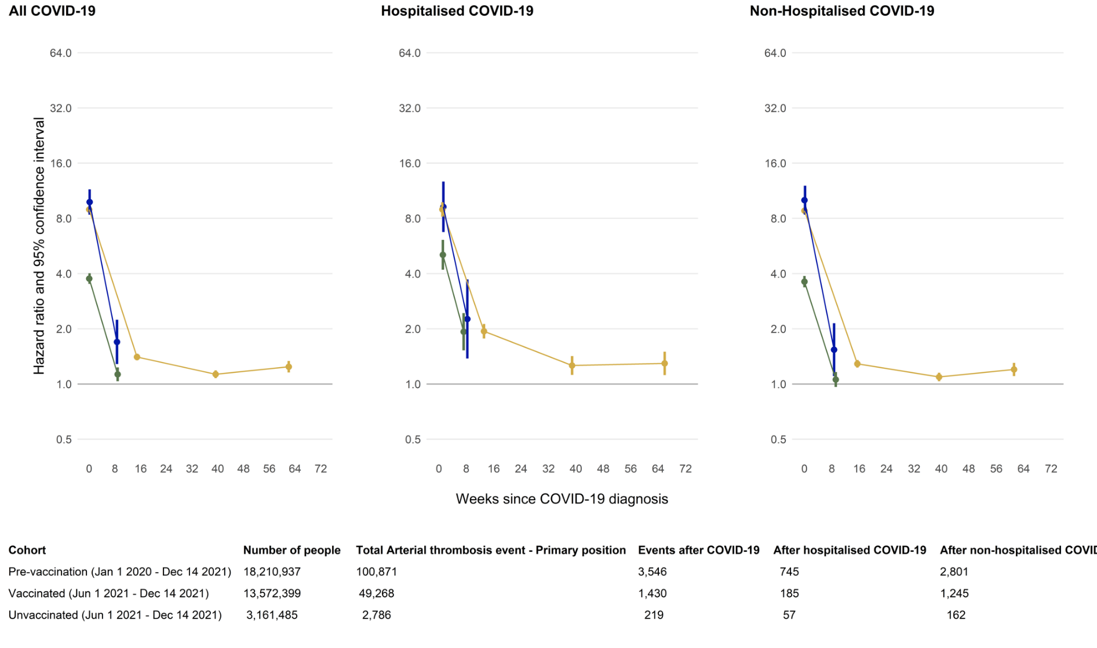

Figure S2: Maximally adjusted hazard ratios and 95% CIs comparing the incidence of venous thrombotic events after COVID-19 with the incidence before or without COVID-19, in the pre-vaccination, vaccinated and unvaccinated cohorts, overall and by COVID-19 severity. Sensitivity analysis with events identified through primary diagnosis only. Points are plotted at the median time of the outcome event within each follow up period in each cohort.

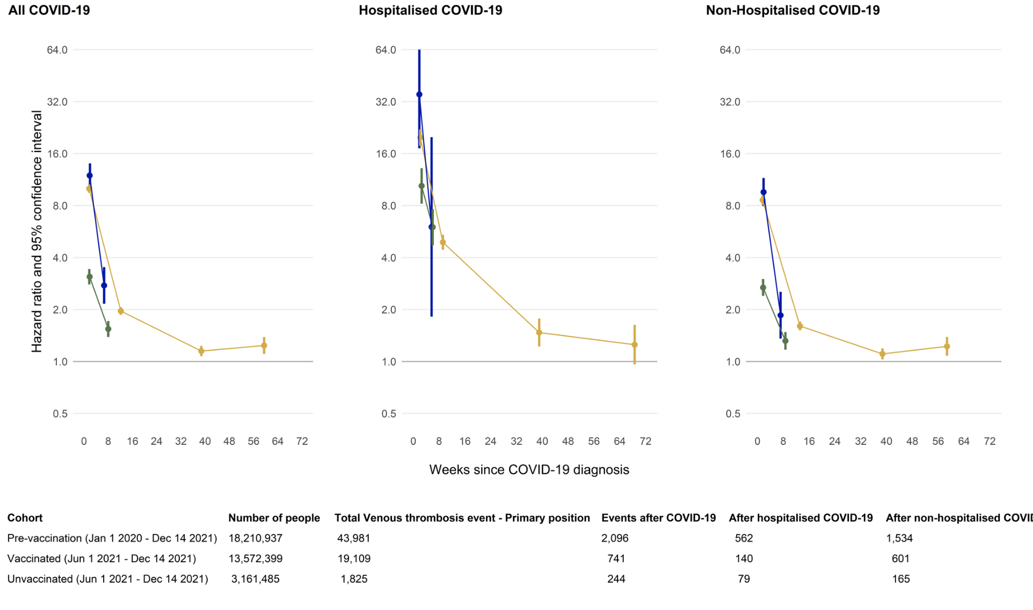
Figure S3: Maximally adjusted hazard ratios and 95% CIs comparing the incidence of arterial thrombotic events after COVID-19 with the incidence before or without COVID-19, in the pre-vaccination, vaccinated and unvaccinated cohorts, by subgroup. Points are plotted at the median time of the outcome event within each follow up period in each cohort.
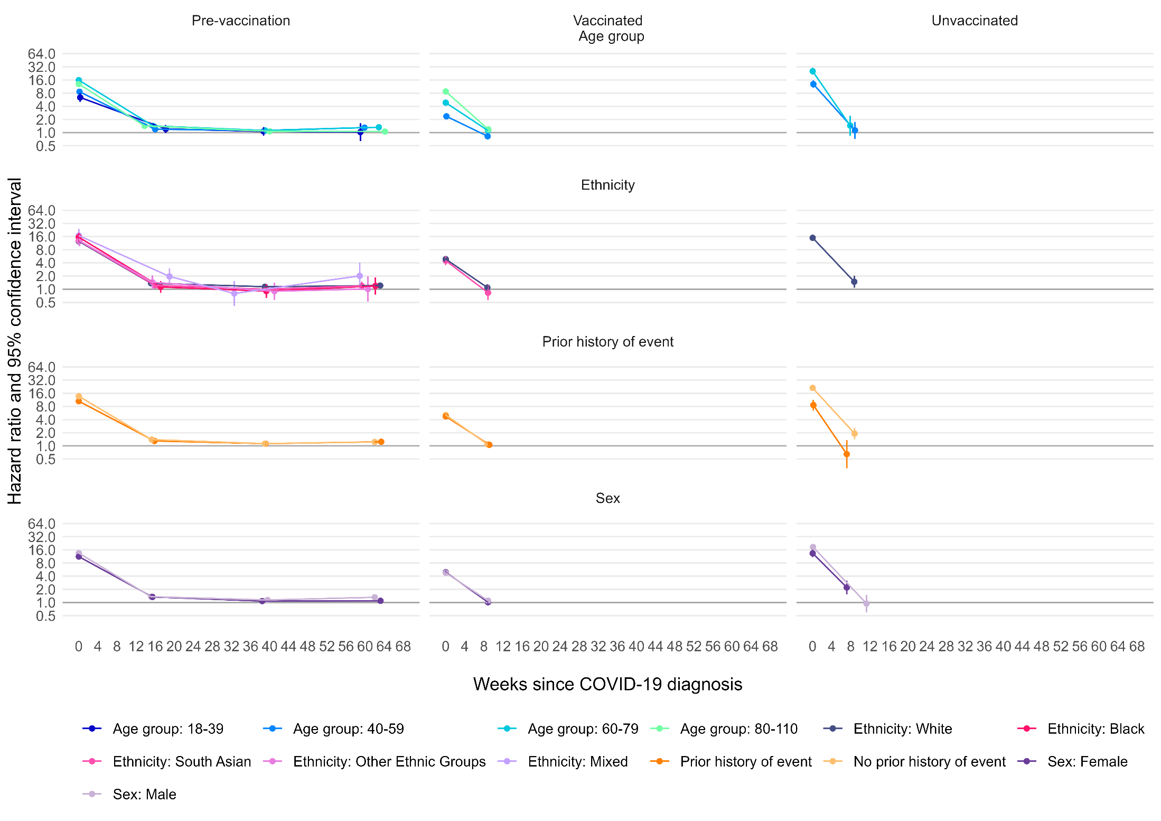
Figure S4: Maximally adjusted hazard ratios and 95% CIs comparing the incidence of venous thrombotic events after COVID-19 with the incidence before or without COVID-19, in the pre-vaccination, vaccinated and unvaccinated cohorts, by subgroup. Points are plotted at the median time of the outcome event within each follow up period in each cohort.
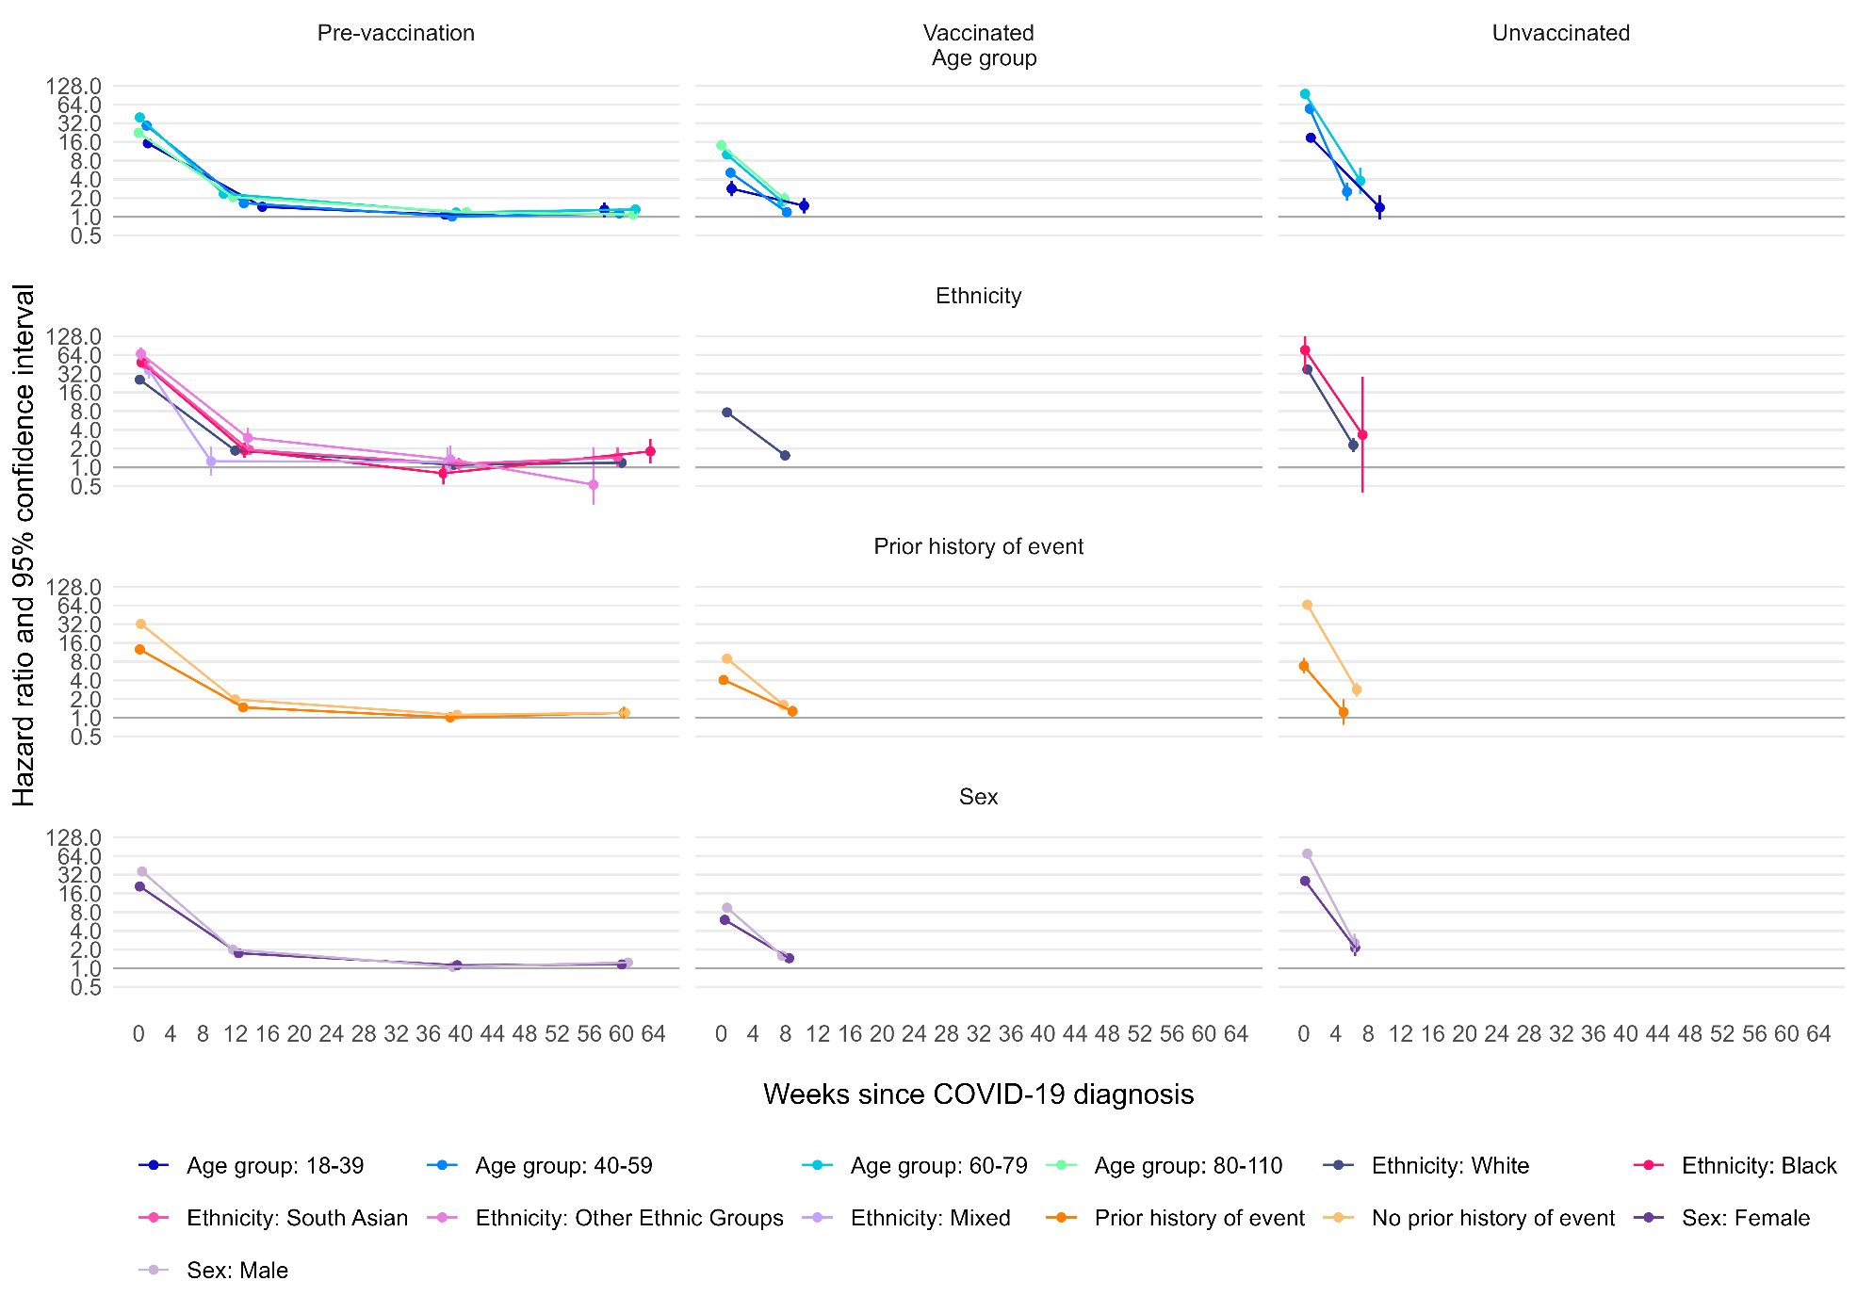

Figure S5: Estimated absolute increase in risk of arterial thrombotic and venous thrombotic events over time since diagnosis of COVID-19, compared with no COVID-19 diagnosis, in the pre-vaccination, vaccinated and unvaccinated cohorts. Increases in risks were estimated within age groups, and the estimated overall increase in risk is the average of these, weighted according to the proportions in each age group in the pre-vaccination cohort.
