Supplementary information
The climate-development nexus in coastal Bangladesh to 2050
Attila N. Lázár, Robert J. Nicholls, Craig W. Hutton, Andres Payo, Helen Adams, Anisul Haque, Derek Clarke, Mashfiqus Salehin, Alistair Hunt, Andrew Allan, W. Neil Adger, M. Munsur Rahman

Table of Content
Figure S1: Overview of the Delta Dynamic Integrated Emulator Model (ΔDIEM) showing scenarios/look-up tables and dynamic calculations and the associated model/method 2
Figure S2: Summary of household livelihood composition of coastal Bangladesh 2
Figure S3: Flood inundation area maps for 2041-2050 (decadal mean, % union area) 3
Figure S4: Soil salinity maps for 2041-2050 (decadal mean, dS/m) 3
Figure S5: Rice produce maps for 2041-2050 (decadal mean, tons/union/year) 3
Figure S6: Income inequality maps for 2041-2050 (decadal mean, GINI coefficient - %) 4
Figure S7: Poverty maps for 2041-2050 (decadal mean, Cost of Basic Needs method, Upper poverty line - % population) 4
Figure S8: GDP/capita maps for 2041-2050 (decadal mean, BDT/month) 4
Figure S9: Total population maps for 2041-2050 (decadal mean, thousand) 5
Figure S10: Sensitivity of the inundated area output to different drivers within the Positive and Negative world scenarios at mid-Century 5
Figure S11: Sensitivity of the soil salinity output to different drivers within the Positive and Negative world scenarios at mid-Century 5
Figure S12: Sensitivity of the rice productivity output to different drivers within the Positive and Negative world scenarios at mid-Century 6
Figure S13: Sensitivity of the income inequality (GINI coefficient) output to different drivers within the Positive and Negative world scenarios at mid-Century 6
Figure S14: Sensitivity of the Cost of Basic Needs (Upper Poverty Line)-based poverty rate output to different drivers within the Positive and Negative world scenarios at mid-Century 6
Figure S15: Sensitivity of the GDP/capita output to different drivers within the Positive and Negative world scenarios at mid-Century 7

Table S1: Input scenarios 8-10
Table S2: List of scenario runs 11-12
Table S3: List of randomly selected, simulated cyclones (strengths, tracks and landfall dates) 13-14

References 15
Figures and Tables supporting the manuscript findings

Figure S1: Overview of the Delta Dynamic Integrated Emulator Model (ΔDIEM) showing scenarios/look-up tables and dynamic calculations and the associated model/method.

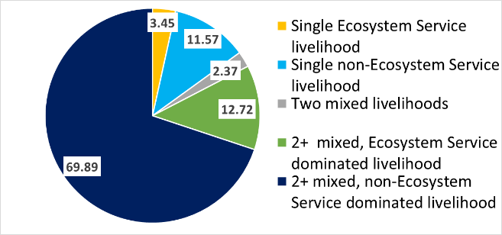
Figure S2: Summary of household livelihood composition of coastal Bangladesh. Total number of interviewed households: 1478 (consistent across all three seasons). Data source: the ESPA Deltas household survey ¹.

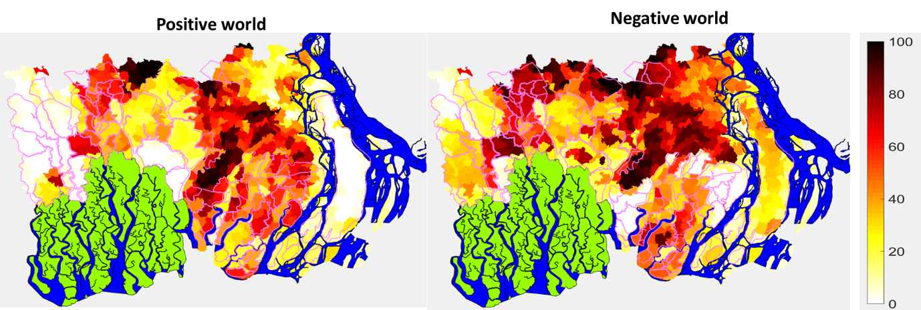
Figure S3: Flood inundation area maps for 2041-2050 (decadal mean, % union area). Shaded colours show the output variable value. Purple lines show the polder boundaries. Green areas are the Sundarbans forest. Blue areas are significant river channels.

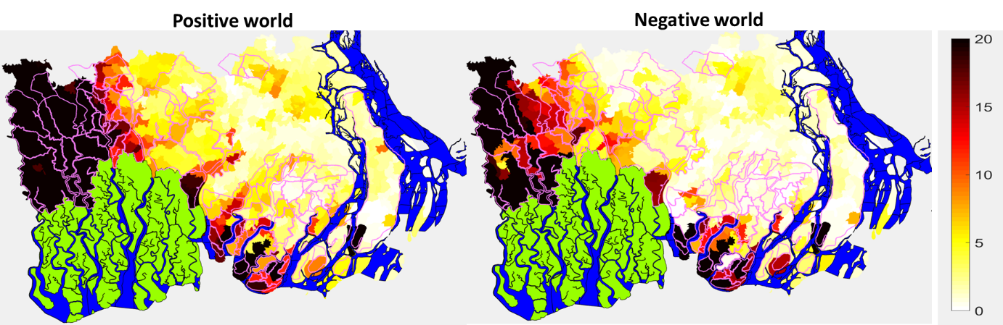
Figure S4: Soil salinity maps for 2041-2050 (decadal mean, dS/m). Shaded colours show the output variable value. Purple lines show the polder boundaries. Green areas are the Sundarbans forest. Blue areas are significant river channels.

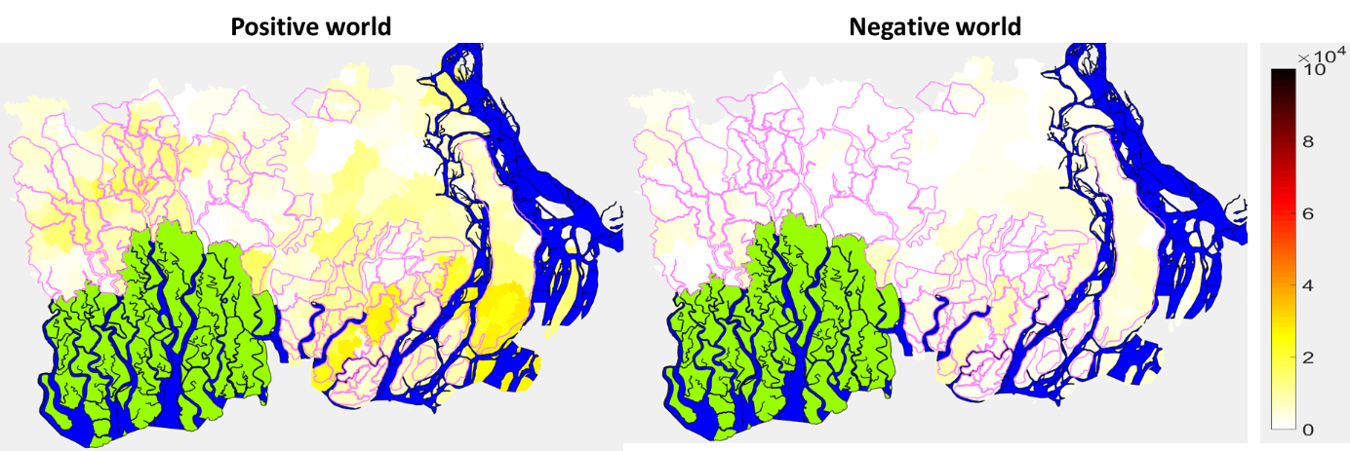
Figure S5: Rice produce maps for 2041-2050 (decadal mean, tons/union/year). Shaded colours show the output variable value. Purple lines show the polder boundaries. Green areas are the Sundarbans forest. Blue areas are significant river channels.
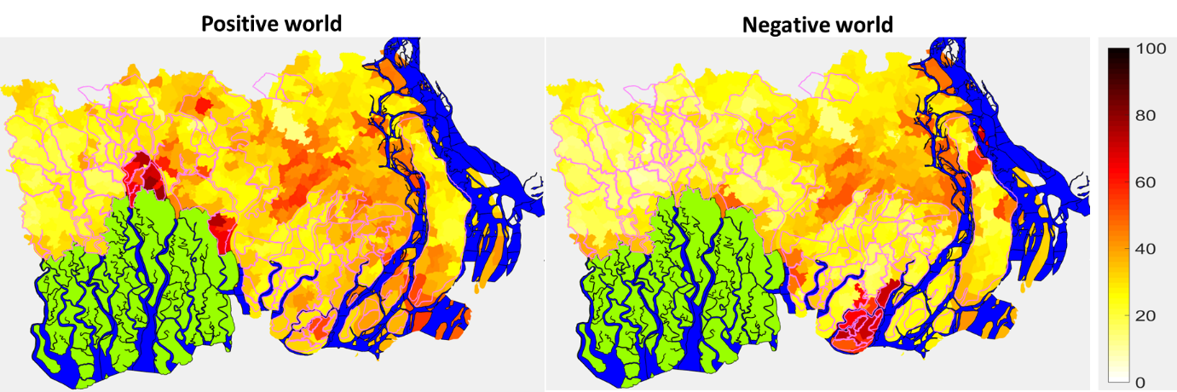
Figure S6: Income inequality maps for 2041-2050 (decadal mean, GINI coefficient - %). Shaded colours show the output variable value. Purple lines show the polder boundaries. Green areas are the Sundarbans forest. Blue areas are significant river channels.
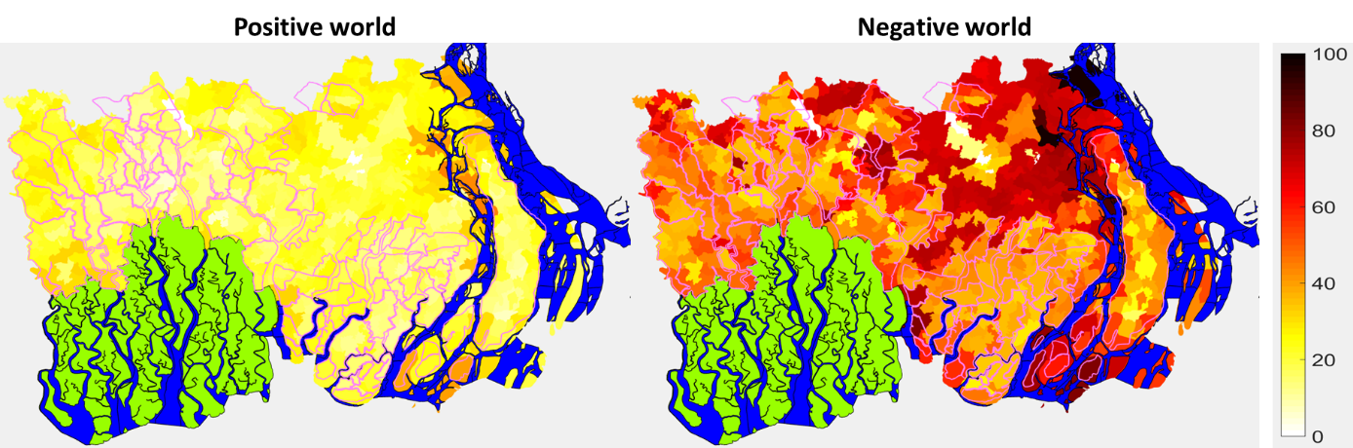
Figure S7: Poverty maps for 2041-2050 (decadal mean, Cost of Basic Needs method, Upper poverty line - % population). Shaded colours show the output variable value. Purple lines show the polder boundaries. Green areas are the Sundarbans forest. Blue areas are significant river channels.
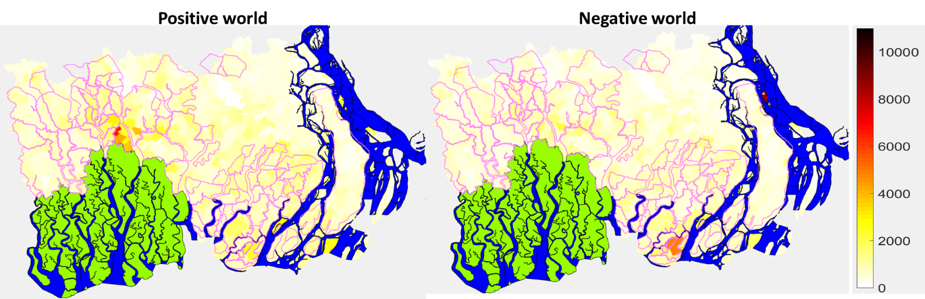
Figure S8: GDP/capita maps for 2041-2050 (decadal mean, BDT/month). Shaded colours show the output variable value. Purple lines show the polder boundaries. Green areas are the Sundarbans forest. Blue areas are significant river channels.
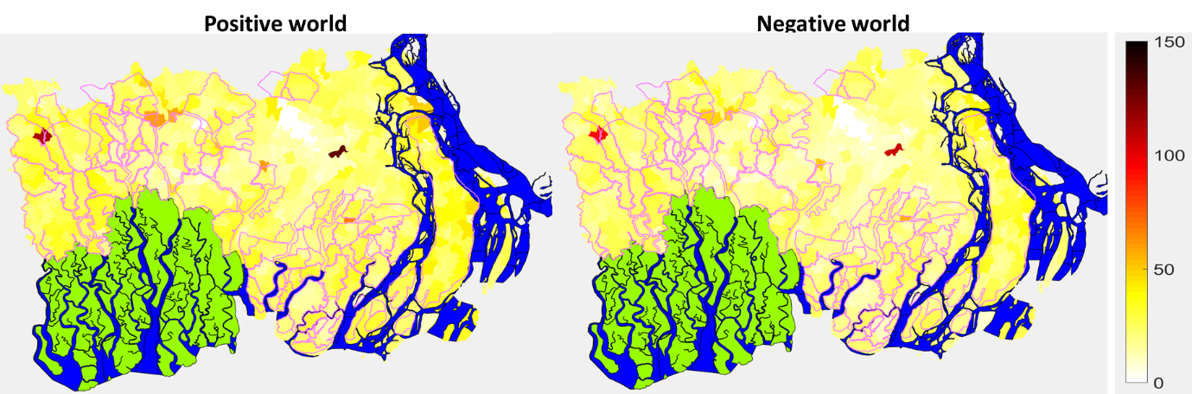
Figure S9: Total population maps for 2041-2050 (decadal mean, thousand). Please note that population of large cities (Barisal and Khulna) are not shown. Shaded colours show the output variable value. Purple lines show the polder boundaries. Green areas are the Sundarbans forest. Blue areas are significant river channels.

Figure S10: Sensitivity of the inundated area output to different drivers within the Positive and Negative world scenarios at mid-Century. The calculation compares the baseline results (2005-15) with the mid-century (2041-50) results. The decadal (annual) minimum, mean and maximum values were calculated first for the two periods. The ‘actual change’ blue bar shows the expected mean decadal change in inundated area compared to the baseline (km², also expressed as a percentage value: e.g. +13% increase compared to baseline). The red line enables the visual comparison of the blue bar with the error bars. The error bars show the change in the decadal minimum, mean and maximum as a result of changing just one driver, e.g. the sea level rise, and keeping all other drivers constant. (Abbreviations: ‘actual’: decadal mean change compared to baseline, ‘PTRO’: precipitation, temperature and runoff linked to different climate scenarios, ‘rSLR’: relative sea level rise, ‘Cyc’: cyclone frequency, ‘Pold’: polder maintenance, ‘Pop’: population size, ‘Econ’: economic changes at household level such as selling price of crops, cost of food, etc., ‘LC’: land cover, ‘FP’: farming practices)

Figure S11: Sensitivity of the soil salinity output to different drivers within the Positive and Negative world scenarios at mid-Century. The ‘actual change’ blue bar shows the expected mean decadal change in inundated area compared to the baseline (km², also expressed as a percentage value: e.g. +13% increase compared to baseline). The red line enables the visual comparison of the blue bar with the error bars. The error bars show the change in the decadal minimum, mean and maximum as a result of changing just one driver, e.g. the sea level rise, and keeping all other drivers constant. (Abbreviations: ‘actual’: decadal mean change compared to baseline, ‘PTRO’: precipitation, temperature and runoff linked to different climate scenarios, ‘rSLR’: relative sea level rise, ‘Cyc’: cyclone frequency, ‘Pold’: polder maintenance, ‘Pop’: population size, ‘Econ’: economic changes at household level such as selling price of crops, cost of food, etc., ‘LC’: land cover, ‘FP’: farming practices)
Figure S12: Sensitivity of the rice productivity output to different drivers within the Positive and Negative world scenarios at mid-Century. The ‘actual change’ blue bar shows the expected mean decadal change in inundated area compared to the baseline (km², also expressed as a percentage value: e.g. +13% increase compared to baseline). The red line enables the visual comparison of the blue bar with the error bars. The error bars show the change in the decadal minimum, mean and maximum as a result of changing just one driver, e.g. the sea level rise, and keeping all other drivers constant. (Abbreviations: ‘actual’: decadal mean change compared to baseline, ‘PTRO’: precipitation, temperature and runoff linked to different climate scenarios, ‘rSLR’: relative sea level rise, ‘Cyc’: cyclone frequency, ‘Pold’: polder maintenance, ‘Pop’: population size, ‘Econ’: economic changes at household level such as selling price of crops, cost of food, etc., ‘LC’: land cover, ‘FP’: farming practices)

Figure S13: Sensitivity of the income inequality (GINI coefficient) output to different drivers within the Positive and Negative world scenarios at mid-Century. The ‘actual change’ blue bar shows the expected mean decadal change in inundated area compared to the baseline (km², also expressed as a percentage value: e.g. +13% increase compared to baseline). The red line enables the visual comparison of the blue bar with the error bars. The error bars show the change in the decadal minimum, mean and maximum as a result of changing just one driver, e.g. the sea level rise, and keeping all other drivers constant. (Abbreviations: ‘actual’: decadal mean change compared to baseline, ‘PTRO’: precipitation, temperature and runoff linked to different climate scenarios, ‘rSLR’: relative sea level rise, ‘Cyc’: cyclone frequency, ‘Pold’: polder maintenance, ‘Pop’: population size, ‘Econ’: economic changes at household level such as selling price of crops, cost of food, etc., ‘LC’: land cover, ‘FP’: farming practices)

Figure S14: Sensitivity of the Cost of Basic Needs (Upper Poverty Line)-based poverty rate output to different drivers within the Positive and Negative world scenarios at mid-Century. The ‘actual change’ blue bar shows the expected mean decadal change in inundated area compared to the baseline (km², also expressed as a percentage value: e.g. +13% increase compared to baseline). The red line enables the visual comparison of the blue bar with the error bars. The error bars show the change in the decadal minimum, mean and maximum as a result of changing just one driver, e.g. the sea level rise, and keeping all other drivers constant. (Abbreviations: ‘actual’: decadal mean change compared to baseline, ‘PTRO’: precipitation, temperature and runoff linked to different climate scenarios, ‘rSLR’: relative sea level rise, ‘Cyc’: cyclone frequency, ‘Pold’: polder maintenance, ‘Pop’: population size, ‘Econ’: economic changes at household level such as selling price of crops, cost of food, etc., ‘LC’: land cover, ‘FP’: farming practices)

Figure S15: Sensitivity of the GDP/capita output to different drivers within the Positive and Negative world scenarios at mid-Century. The ‘actual change’ blue bar shows the expected mean decadal change in inundated area compared to the baseline (km², also expressed as a percentage value: e.g. +13% increase compared to baseline). The red line enables the visual comparison of the blue bar with the error bars. The error bars show the change in the decadal minimum, mean and maximum as a result of changing just one driver, e.g. the sea level rise, and keeping all other drivers constant. (Abbreviations: ‘actual’: decadal mean change compared to baseline, ‘PTRO’: precipitation, temperature and runoff linked to different climate scenarios, ‘rSLR’: relative sea level rise, ‘Cyc’: cyclone frequency, ‘Pold’: polder maintenance, ‘Pop’: population size, ‘Econ’: economic changes at household level such as selling price of crops, cost of food, etc., ‘LC’: land cover, ‘FP’: farming practices)
Table S1: Input scenarios
This paper builds extensively on the scenario narratives of the ESPA Deltas project ²⁻⁴. Thirty-six basic simulations were run by using all combinations of the following climate, sea-level rise, polder maintenance and socio-economic development input scenarios. The simulations started in 1985 and run until 2050. We used the 1985-2004 period as a spin-up period to allow the model to settle. The 2005-2014 period was used as the baseline and the analysis focused on 2015-2050. Changes presented are therefore between 2005-2014 and 2050.
Climate: The UK MetOffice HadRM3/PRECIS Regional Climate Model scenarios (SRES A1B which is in the range of RCP 6.0 to RCP 8.5) ⁵ are used for the precipitation, air temperature and potential evapotranspiration inputs of ΔDIEM. In this application, the following three climate time series are used:
- the Q8 ensemble member of the Hadley RCM (compared to mean of 2000-2015: +1.78ºC temperature increase, +1.51ºC in monsoon period, +2.22ºC in dry season period; -23% annual precipitation, -20% total monsoon rain, -53% total dry season rainfall) – used in the “Positive World” in Table 1;
- the Q16 ensemble member of the Hadley RCM (compared to mean of 2000-2015: +1.89ºC temperature increase, +1.45ºC in monsoon period, +2.51ºC in dry season period; -4% annual precipitation, -2% total monsoon rain, -16% total dry season rainfall) – used in the “Negative World” in Table 1;
- a time series, where ‘no climate change’ occurs (the Q8 scenario’s 2001-2010 climate and run-off data is looped throughout the simulation period).
 | 2000-15 |  |  | 2040-55 |  |  | Change
 | Annual | Dry season | Monsoon | Annual | Dry season | Monsoon | Annual | Dry season | Monsoon
Q8 | Temperature (ºC) |  |  |  |  |  | Absolute change (ºC)
Min | 25.08 | 20.76 | 27.62 | 26.58 | 22.57 | 28.73 | 1.50 | 1.81 | 1.11
Mean | 26.15 | 22.02 | 28.39 | 27.93 | 24.23 | 29.90 | 1.78 | 2.22 | 1.51
Max | 26.91 | 23.48 | 29.52 | 28.88 | 25.60 | 31.17 | 1.97 | 2.12 | 1.66
St dev | 0.47 | 0.72 | 0.49 | 0.64 | 0.82 | 0.71 | 0.17 | 0.10 | 0.22
Q16 | Temperature (ºC) |  |  |  |  |  | Absolute change (ºC)
Min | 26.96 | 22.71 | 28.87 | 28.58 | 25.01 | 30.38 | 1.62 | 2.31 | 1.51
Mean | 27.43 | 23.43 | 29.76 | 29.33 | 25.95 | 31.21 | 1.89 | 2.51 | 1.45
Max | 28.76 | 24.55 | 31.39 | 30.23 | 27.35 | 32.05 | 1.48 | 2.80 | 0.67
St dev | 0.47 | 0.46 | 0.63 | 0.42 | 0.73 | 0.38 | -0.05 | 0.27 | -0.25
Q8 | Precipitation (mm) |  |  |  |  |  | Percent change
Min | 1,453 | 34 | 1,075 | 1,290 | 30 | 1,054 | -11.20 | -10.97 | -1.90
Mean | 2,099 | 215 | 1,672 | 1,623 | 100 | 1,345 | -22.69 | -53.18 | -19.57
Max | 2,769 | 632 | 1,972 | 2,146 | 250 | 1,949 | -22.51 | -60.40 | -1.16
St dev | 363 | 153 | 268 | 271 | 62 | 251 | -25.43 | -59.56 | -6.13
Q16 | Precipitation (mm) |  |  |  |  |  | Percent change
Min | 897 | 26 | 835 | 1,205 | 14 | 954 | 34.35 | -45.00 | 14.19
Mean | 1,623 | 88 | 1,433 | 1,566 | 74 | 1,405 | -3.50 | -16.18 | -1.94
Max | 2,408 | 164 | 2,324 | 2,305 | 174 | 2,148 | -4.25 | 5.77 | -7.57
St dev | 421 | 41 | 397 | 320 | 53 | 349 | -24.07 | 28.91 | -12.20
Note: Dry season: Nov-Mar; Monsoon Jun-Oct
Looking beyond 2050 to 2100, these climate trends continue, and the Positive World becomes moderately drier and the Negative World becomes warmer and wetter with more extremes.
Sea-level rise projections are based on the Fifth Assessment Report of the Intergovernmental Panel on Climate Change ⁶:
- low SLR: 26cm in 2050 + a uniform subsidence of 2.5mm/year (relative SLR: 38.5cm);
- high SLR: 61cm in 2050 + a uniform subsidence of 2.5mm/year (relative SLR: 73.5cm).
The high SLR scenario comprises a high impact, low likelihood (i.e., high-end) SLR scenario ⁷.
Cyclone frequencies are calculated from Alam and Dominey-Howes ⁸. Based on the recorded cyclones for the period of 1916-2009, the SIDR-type cyclones (140+ km/h wind speed) are expected with a return frequency of 0.4 cyclone per decade, whereas AILA-type cyclones (80-140 km/h wind speed) has a return period of 4.2 per decade. The cyclone tracks were grouped into five landfall categories: Meghna, Sundabans, West Bengal, Bhola and Barguna/Patuakhali. Where cyclone tracks were available, it was also visually checked against the NOAAA database (https://www.coast.noaa.gov/hurricanes/). Future cyclones years, cyclone strengths and landfall locations, were randomly selected based on the return periods for three scenario cases (Table S2):
- cyclones occur with the observed frequency, magnitude and landfall locations in the future;
- cyclone frequency increases (+50%);
- cyclone frequency decreases (-50%).
Embankment maintenance scenarios were uniformly applied to the embankments around all the polders of the study area:
- maintain existing embankment heights (at design height) and current drainage infrastructure within each polder;
- embankments are not maintained and deteriorate, losing effective height (-3cm / year) and exposing the area within the polder to a greater chance of inundation.
Socio-economic development of coastal Bangladesh was characterised as More sustainable (MS), Business as Usual (BAU) and Less Sustainable (LS) scenarios within the ESPA Deltas project ^{3,4}. These scenarios combine demographic changes, land cover and land use changes, and economic changes. Each of these aspects are summarised below.
- Population size based on the 2011 CENSUS is ca. 14 million ⁹. In this application three stylised scenarios are tested based on Szabo, et al. ¹⁰:
- MS: population size is constant at 14 million;
- BAU: population size is constant at 14 million until 2030 and then gradually decline to 12.85 million by 2050;
- LS: the population gradually declines from today to 11.2 million by 2050.

- Plausible economic development trends were identified by Hunt ¹¹. He also approximated the effect of these trends on the coastal households (wages, market price, food cost, livelihood costs, wages, etc.):
- MS – More Sustainable (Fast growth): Manufacturing and services: 87% by 2050 (2.5%/yr); Agriculture: 45% by 2050 (1.3%/yr); Household expenses: 45% by 2050 (1.3%/yr); Wages: 70% by 2050 (2%/yr).
- BAU – Business As Usual: Manufacturing and services 45% by 2050 (1.3%/yr); Agriculture: 24% by 2050, Household expenses: 24% by 2050, Wages: 24% by 2050 (0.62%/yr).
- LS – Less Sustainable (Slow growth): Manufacturing and services 24% by 2050 (0.62%/yr); Agriculture: 0% by 2050, Household expenses: 0% by 2050, Wages: 0% by 2050.

- Land cover changes are assumed based on stakeholder scenario narratives about the future. The 2010 land cover observation ¹² is modified with the following percentage changes:
- MS – More Sustainable: agriculture area slightly decreases (-5%) to increase mangrove area. Sundarbans loses 5% area to aquaculture and agriculture. The land zoning proposal of the Ministry of Agriculture is promoted and 30% of land cover area is converted accordingly ¹³.
- BAU – Business As Usual: 10% of Sundarbans area and 5% of other mangrove areas are converted to agriculture and aquaculture.
- LS – Less Sustainable: 20 % of Sundarbans area and 10% of other mangrove areas are converted to agriculture and aquaculture. Agriculture area is reduced by 20% if salinity is high (>12 dS/m) and by 10% if salinity is moderately high (8-12 dS/m).

- Farming practice scenarios follow the observed patterns:
- MS – More Sustainable: Current cropping patterns continue with improved varieties. New crop types increase production (+20%). Salinity tolerance of rice increases from 6 dS/m (2015) to 13 dS/m (2050).
- BAU – Business As Usual: Current cropping patterns continue with current crop varieties.
- LS – Less Sustainable: Traditional crop types and cropping patterns are assumed with neither yield (0%) nor salinity tolerance (6 dS/m) improvements.
The one-at-a-time (i.e. local) sensitivity analysis of the Positive and Negative world scenarios varied every input type one-by-one (keeping all other inputs the same).

Table S2: List of scenario runs (LS: Less Sustainable, BAU: Business As Usual, MS: More Sustainable; No CC: no climate change)
No | Scen ID | Climate | Cyclones | SLR | Polders | Population | Economy | Land Cover | Farming | Figure
1 | 1a | Q8 | yes | low | maintained | LS | LS | LS | LS | Fig2
2 | 2a | Q8 | yes | low | maintained | BAU | BAU | BAU | BAU | Fig2
3 | 3a | Q8 | yes | low | maintained | MS | MS | MS | MS | Fig2,3,4
4 | 4a | Q8 | yes | low | deteriorated | LS | LS | LS | LS | Fig2
5 | 5a | Q8 | yes | low | deteriorated | BAU | BAU | BAU | BAU | Fig2
6 | 6a | Q8 | yes | low | deteriorated | MS | MS | MS | MS | Fig2
7 | 7a | Q8 | yes | high | maintained | LS | LS | LS | LS | Fig2
8 | 8a | Q8 | yes | high | maintained | BAU | BAU | BAU | BAU | Fig2
9 | 9a | Q8 | yes | high | maintained | MS | MS | MS | MS | Fig2
10 | 10a | Q8 | yes | high | deteriorated | LS | LS | LS | LS | Fig2
11 | 11a | Q8 | yes | high | deteriorated | BAU | BAU | BAU | BAU | Fig2
12 | 12a | Q8 | yes | high | deteriorated | MS | MS | MS | MS | Fig2
13 | 1b | Q16 | yes | low | maintained | LS | LS | LS | LS | Fig2
14 | 2b | Q16 | yes | low | maintained | BAU | BAU | BAU | BAU | Fig2
15 | 3b | Q16 | yes | low | maintained | MS | MS | MS | MS | Fig2
16 | 4b | Q16 | yes | low | deteriorated | LS | LS | LS | LS | Fig2
17 | 5b | Q16 | yes | low | deteriorated | BAU | BAU | BAU | BAU | Fig2
18 | 6b | Q16 | yes | low | deteriorated | MS | MS | MS | MS | Fig2
19 | 7b | Q16 | yes | high | maintained | LS | LS | LS | LS | Fig2
20 | 8b | Q16 | yes | high | maintained | BAU | BAU | BAU | BAU | Fig2
21 | 9b | Q16 | yes | high | maintained | MS | MS | MS | MS | Fig2
22 | 10b | Q16 | yes | high | deteriorated | LS | LS | LS | LS | Fig2,3,4
23 | 11b | Q16 | yes | high | deteriorated | BAU | BAU | BAU | BAU | Fig2
24 | 12b | Q16 | yes | high | deteriorated | MS | MS | MS | MS | Fig2
25 | 1c | No CC | yes | low | maintained | LS | LS | LS | LS | Fig2
26 | 2c | No CC | yes | low | maintained | BAU | BAU | BAU | BAU | Fig2
27 | 3c | No CC | yes | low | maintained | MS | MS | MS | MS | Fig2
28 | 4c | No CC | yes | low | deteriorated | LS | LS | LS | LS | Fig2
29 | 5c | No CC | yes | low | deteriorated | BAU | BAU | BAU | BAU | Fig2
30 | 6c | No CC | yes | low | deteriorated | MS | MS | MS | MS | Fig2
31 | 7c | No CC | yes | high | maintained | LS | LS | LS | LS | Fig2
32 | 8c | No CC | yes | high | maintained | BAU | BAU | BAU | BAU | Fig2
33 | 9c | No CC | yes | high | maintained | MS | MS | MS | MS | Fig2
34 | 10c | No CC | yes | high | deteriorated | LS | LS | LS | LS | Fig2
35 | 11c | No CC | yes | high | deteriorated | BAU | BAU | BAU | BAU | Fig2
36 | 12c | No CC | yes | high | deteriorated | MS | MS | MS | MS | Fig2
37 | 3a_1 | Q8 | yes | low | maintained | BAU | MS | MS | MS | Fig3,4
38 | 3a_2 | Q8 | yes | low | maintained | LS | MS | MS | MS | Fig3,4
39 | 3a_3 | Q8 | yes | low | maintained | MS | BAU | MS | MS | Fig3,4
40 | 3a_4 | Q8 | yes | low | maintained | MS | LS | MS | MS | Fig3,4
41 | 3a_5 | Q8 | yes | low | maintained | MS | MS | BAU | MS | Fig3,4
42 | 3a_6 | Q8 | yes | low | maintained | MS | MS | LS | MS | Fig3,4
43 | 3a_7 | Q8 | yes | low | maintained | MS | MS | MS | BAU | Fig3,4
44 | 3a_8 | Q8 | yes | low | maintained | MS | MS | MS | LS | Fig3,4
45 | 3a_9 | Q8 | yes + 50% | low | maintained | MS | MS | MS | MS | Fig3,4
46 | 3a_10 | Q8 | yes - 50% | low | maintained | MS | MS | MS | MS | Fig3,4
47 | 10b_1 | Q16 | yes | high | deteriorating | BAU | LS | LS | LS | Fig3,4
48 | 10b_2 | Q16 | yes | high | deteriorating | MS | LS | LS | LS | Fig3,4
49 | 10b_3 | Q16 | yes | high | deteriorating | LS | BAU | LS | LS | Fig3,4
50 | 10b_4 | Q16 | yes | high | deteriorating | LS | MS | LS | LS | Fig3,4
51 | 10b_5 | Q16 | yes | high | deteriorating | LS | LS | BAU | LS | Fig3,4
52 | 10b_6 | Q16 | yes | high | deteriorating | LS | LS | MS | LS | Fig3,4
53 | 10b_7 | Q16 | yes | high | deteriorating | LS | LS | LS | BAU | Fig3,4
54 | 10b_8 | Q16 | yes | high | deteriorating | LS | LS | LS | MS | Fig3,4
55 | 10b_9 | Q16 | yes + 50% | high | deteriorating | LS | LS | LS | LS | Fig3,4
56 | 10b_10 | Q16 | yes - 50% | high | deteriorating | LS | LS | LS | LS | Fig3,4
57 | 2a_2 | Q8 | yes | low | maintained | MS | BAU | BAU | BAU
58 | 2a_4 | Q8 | yes | low | maintained | BAU | MS | BAU | BAU
59 | 2a_8 | Q8 | yes | low | maintained | BAU | BAU | BAU | MS
60 | 11b_2 | Q16 | yes | high | deteriorating | MS | BAU | BAU | BAU
61 | 11b_4 | Q16 | yes | high | deteriorating | BAU | MS | BAU | BAU
62 | 11b_8 | Q16 | yes | high | deteriorating | BAU | BAU | BAU | MS

Table S3: List of randomly selected, simulated cyclones (strengths, tracks and landfall dates)

Strength: Aila; Track: Barguna/Patuakhali (historic track)
cyclones occur with the observed frequency, magnitude and landfall locations: 23/05/2009, 23/10/2026, 23/11/2028
cyclone frequency increases (+50%): 23/05/2009, 23/05/2016, 23/11/2049
cyclone frequency decreases (-50%): 23/05/2009, 23/05/2025

Strength: Aila; Track: Bhola
cyclones occur with the observed frequency, magnitude and landfall locations: 23/09/2035, 23/10/2048
cyclone frequency increases (+50%): 23/10/2012, 23/10/2017, 23/11/2020, 23/11/2043
cyclone frequency decreases (-50%): 23/05/2045

Strength: Aila; Track: Meghna
cyclones occur with the observed frequency, magnitude and landfall locations:23/05/2031, 23/05/2046
cyclone frequency increases (+50%): 23/11/2021, 23/04/2025
cyclone frequency decreases (-50%): 23/05/2048

Strength: Aila; Track: Sundarbans
cyclones occur with the observed frequency, magnitude and landfall locations: 23/11/2013, 23/05/2016, 23/05/2019, 23/05/2041, 23/11/2044, 23/10/2050
cyclone frequency increases (+50%): 23/11/2011, 23/10/2018, 23/05/2031, 23/05/2036, 23/09/2038, 23/05/2041, 23/05/2042, 23/08/2043, 23/05/2045
cyclone frequency decreases (-50%): 23/09/2012, 23/05/2027, 23/08/2031

Strength: Aila; Track: West Bengal
cyclones occur with the observed frequency, magnitude and landfall locations: 23/05/2024, 23/05/2025, 23/11/2027, 23/10/2047
cyclone frequency increases (+50%): 11/05/2020, 11/05/2024, 11/05/2030, 11/11/2034, 11/05/2040, 11/11/2042
cyclone frequency decreases (-50%): 23/11/2015, 11/11/2036

Strength: Sidr (historic track)
cyclones occur with the observed frequency, magnitude and landfall locations: 11/11/2007
cyclone frequency increases (+50%): 11/11/2007, 23/05/2014, 23/10/2016
cyclone frequency decreases (-50%): 11/11/2007, 23/11/2037

Strength: Sidr; Track: Bhola
cyclones occur with the observed frequency, magnitude and landfall locations: none
cyclone frequency increases (+50%): 23/05/2038
cyclone frequency decreases (-50%): none

Strength: Sidr; Track: Sundarbans
cyclones occur with the observed frequency, magnitude and landfall locations: 11/10/2029
cyclone frequency increases (+50%): 23/05/2021, 23/06/2022
cyclone frequency decreases (-50%): 23/09/2049

References
1 Adams, H. & Adger, W. N. (UK Data Service ReShare, 2016).
2 Allan, A. & Barbour, E. Building Scenarios for Ecosystem Services and Poverty Alleviation - the ESPA Deltas Approach, ESPA Deltas Working Paper, available at http://www.espadelta.net. (2015).
3 Allan, A., Lim, M. & Barbour, E. J. in Ecosystem Services For Well-Being In Deltas: Integrated Assessment For Policy Analysis (eds J. R. Nicholls et al.) (Palgrave, ISBN 978-3-319-71092-1, 2018).
4 Allan, A. A. et al. Developing socio-ecological scenarios: A participatory process for engaging stakeholders. Science of The Total Environment 807, 150512 (2022). https://doi.org:10.1016/j.scitotenv.2021.150512
5 Caesar, J., Janes, T., Lindsay, A. & Bhaskaran, B. Temperature and precipitation projections over Bangladesh and the upstream Ganges, Brahmaputra and Meghna systems. Environmental Science: Processes & Impacts 17, 1047-1056 (2015). https://doi.org:10.1039/C4EM00650J
6 Church, J. A. et al. Sea level change. (Cambridge, United Kingdom and New York, NY, USA: Cambridge University Press, 2013).
7 Nicholls, R. J. et al. Integrating new sea-level scenarios into coastal risk and adaptation assessments: An ongoing process. WIREs Climate Change 12, e706 (2021). https://doi.org:https://doi.org/10.1002/wcc.706
8 Alam, E. & Dominey-Howes, D. A new catalogue of tropical cyclones of the northern Bay of Bengal and the distribution and effects of selected landfalling events in Bangladesh. International Journal of Climatology 35, 801-835 (2015). https://doi.org:10.1002/joc.4035
9 BBS, SID & MP. Population and Housing Census 2011. Socio-economic and demographic report. (Bangladesh Bureau of Statistics, Statistics and Informatics Division, Ministry of Planning 2012).
10 Szabo, S., Begum, D., Ahmad, S., Matthews, Z. & Streatfield, P. K. Scenarios of population change in the coastal Ganges Brahmaputra Delta (2011-2051). Asia-Pacific Population Journal 30, 51-72 (2016). https://doi.org:10.18356/35479cd3-en
11 Hunt, A. in Ecosystem Services For Well-Being In Deltas: Integrated Assessment For Policy Analysis (eds J. R. Nicholls et al.) (Palgrave, ISBN 978-3-319-71092-1, 2018).
12 Mukhopadhyay, A. et al. in Ecosystem Services For Well-Being In Deltas: Integrated Assessment For Policy Analysis (eds J. R. Nicholls et al.) (Palgrave, ISBN 978-3-319-71092-1, 2018).
13 MA & FAO. Master Plan for Agriculture Development In the Southern Region of Bangladesh. (Ministry of Agriculture of the Government of the People's Republic of Bangladesh, Food and Agriculture Organisation of the United Antions, 2013).

