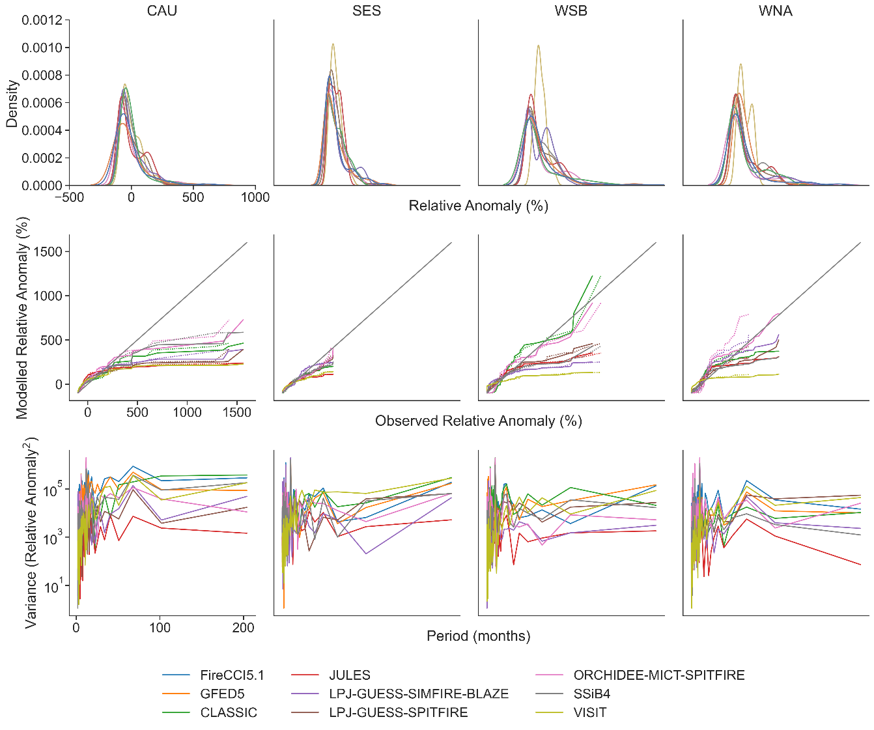
Extended Data Figure 1 | Model validation for 4 selected regions. Distribution of models and observations for probability distribution (top row), quantile-quantile plots (middle row) and power spectra (bottom row). All show relative anomaly compared to observations. In the QQ plots, models are plotted in colours against GFED5 (dotted lines) and Fire CCI5.1 (solid lines).

Extended Data Table 1: Global benchmarking for the ranked and annual NME scores used in the model weighing. Global NME scores are heavily skewed towards models that represent the African savannahs well. The lower the NME, the better a model performs.
 |  | CLASSIC | JULES | LPJ-GUESS-SIMFIRE-BLAZE | LPJ-GUESS-SPITFIRE | ORCHIDEE-MICT-SPITFIRE | SSiB4 | VISIT
FireCCI5.1 | NME₃ Ranked | 0.85 | 0.92 | 0.8 | 0.94 | 1.41 | 0.54 | 1.21
FireCCI5.1 | NME₃ Annual | 0.71 | 0.85 | 1.08 | 1.26 | 1.66 | 0.78 | 1.58
GFED5 | NME₃ Ranked | 0.87 | 0.94 | 0.91 | 1.17 | 1.49 | 0.73 | 1.26
GFED5 | NME₃ Annual | 0.73 | 0.92 | 0.94 | 1.4 | 1.83 | 0.73 | 1.52

