Global burned area increasingly explained by climate change
Authors: Chantelle Burton^{1*} and Seppe Lampe^{2*}, Douglas I. Kelley³, Wim Thiery², Stijn Hantson⁴, Nikos Christidis¹, Lukas Gudmundsson⁵, Matthew Forrest⁶, Eleanor Burke¹, Jinfeng Chang⁷, Huilin Huang⁸, Akihiko Ito⁹, Sian Kou-Giesbrecht¹⁰, Gitta Lasslop⁶, Wei Li¹¹, Lars Nieradzik¹², Fang Li¹³, Yang Chen¹⁴, Jim Randerson¹⁴, Christopher P.O. Reyer¹⁵ & Matthias Mengel¹⁵

Affiliations:
¹ Met Office Hadley Centre, Fitzroy Road, Exeter, EX1 3PB, UK
² Vrije Universiteit Brussel, Department of Water and Climate, Brussels, Belgium
³ UK Centre for Ecology and Hydrology, Wallingford, OX10 8BB, UK
⁴ Faculty of Natural Sciences, Universidad del Rosario, Bogotá, Colombia
⁵ Institute for Atmospheric and Climate Science, Department of Environmental Systems Science, ETH, Zurich, Zurich, Switzerland
⁶ Senckenberg Biodiversity and Climate Research Centre, 60325 Frankfurt am Main, Germany
⁷ College of Environmental and Resource Sciences, Zhejiang University, Hangzhou, China
⁸ Pacific Northwest National Laboratory, Richland, WA, 99354, USA
⁹ National Institute for Environmental Studies (NIES), 16-2 Onogawa, Tsukuba, Ibaraki, 305-8506, Japan
¹⁰ Canadian Centre for Climate Modelling and Analysis, Environment and Climate Change Canada, Victoria, BC, Canada
¹¹ Department of Earth System Science, Ministry of Education Key Laboratory for Earth System Modeling, Institute for Global Change Studies, Tsinghua University, Beijing, China
¹² Department of Physical Geography and Ecosystem Science, Lund University, Sweden
¹³ International Center for Climate and Environment Sciences, Institute of Atmospheric Physics, Chinese Academy of Sciences, Beijing 100029, China
¹⁴ Department of Earth System Science, University of California, Irvine, CA 92697, USA
¹⁵ Potsdam Institute for Climate Impact Research, Member of the Leibniz Association, Potsdam, Germany
* equally contributed to this work

Supplementary Information

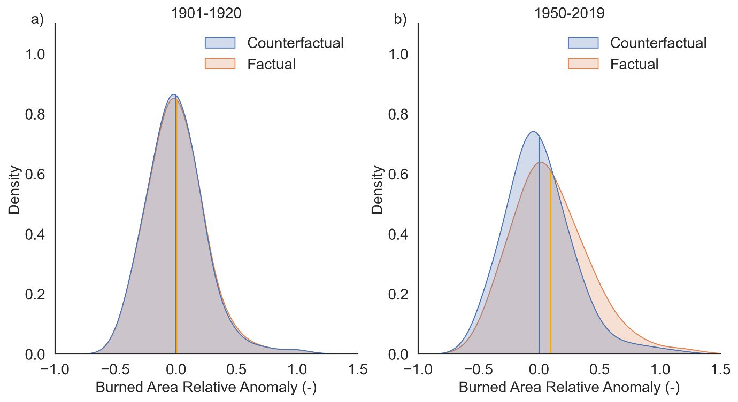
Figure S1 | Global Probability Density Functions. a) Test to show no significant change in the early industrial (1901-1920) period; b) change in the distributions over the period 1950-2019.

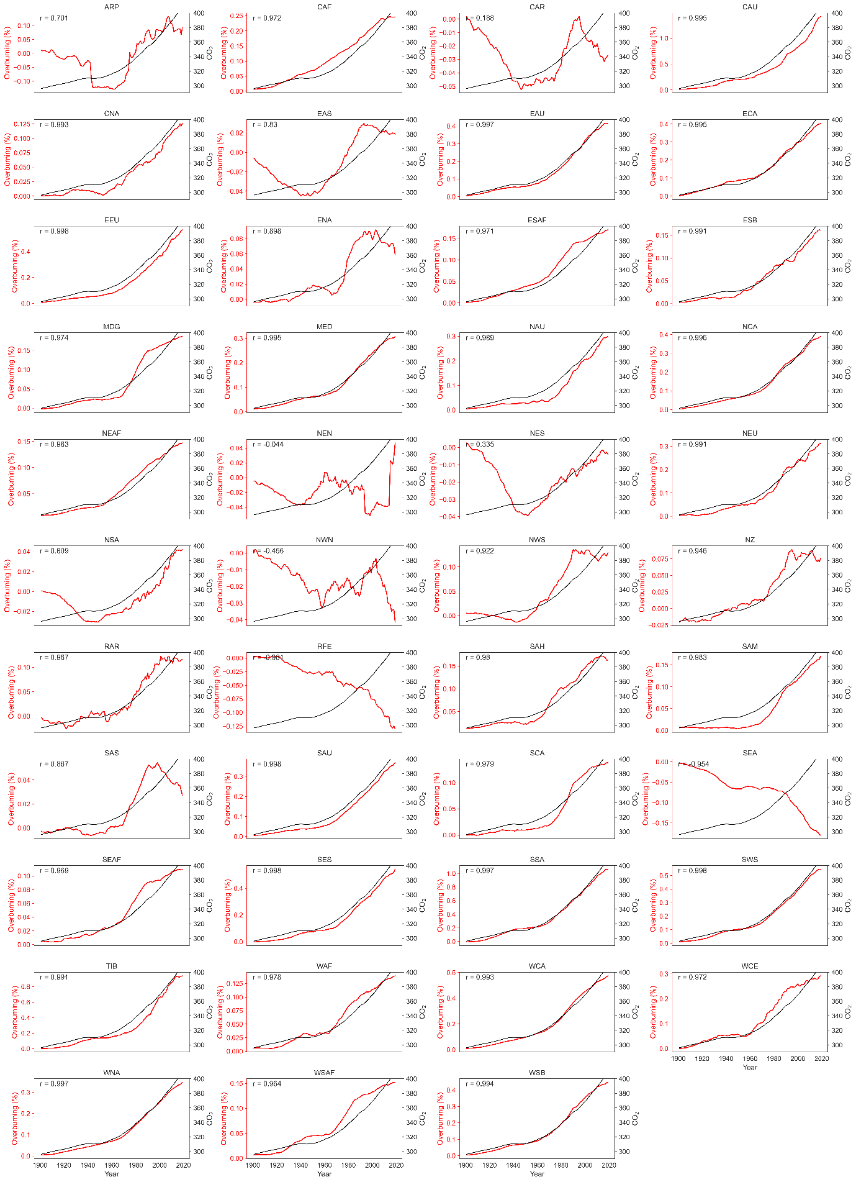
Figure S2 | Regional overburning trends compared to global atmospheric CO₂.
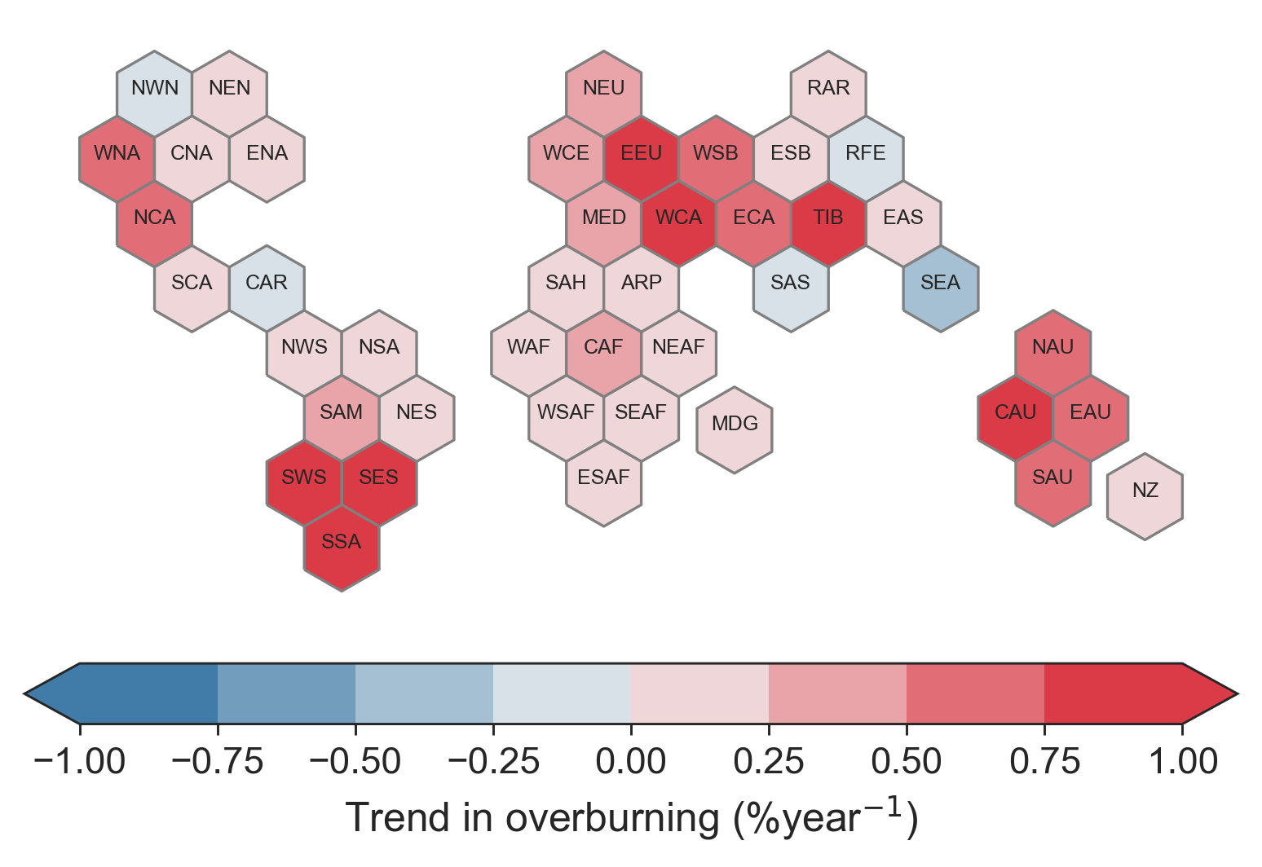
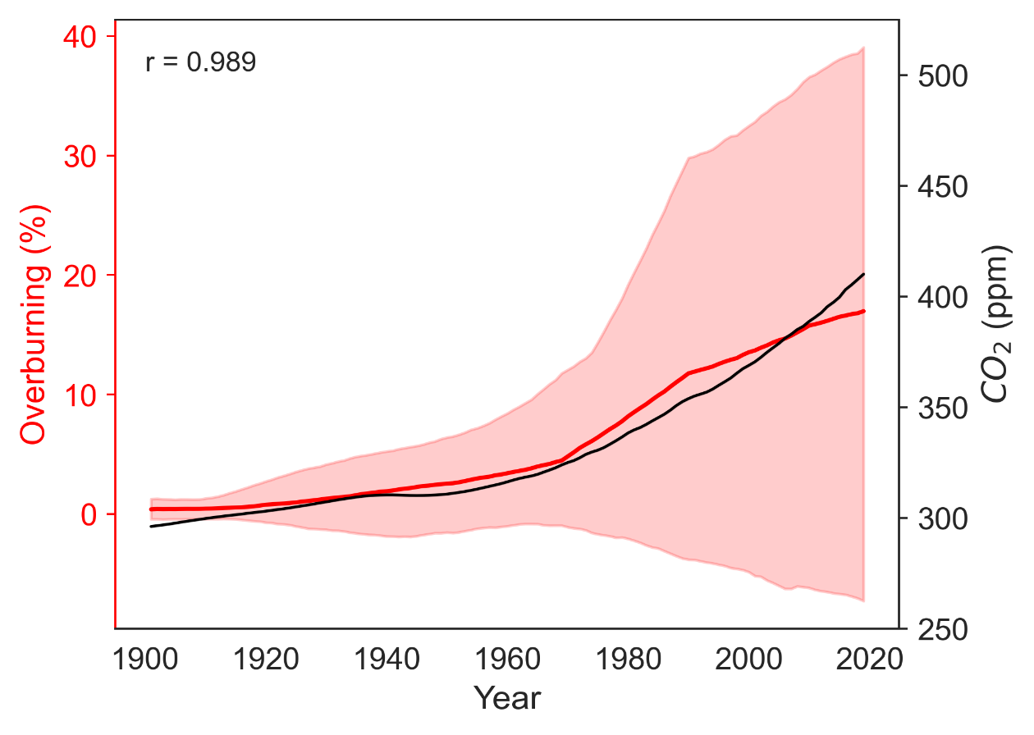
Figure S3 | The 1980-2019 trend in overburning per IPCC region. This depicts the speed by which the effects of climate change are affecting each region.
Figure S4 | Global overburning. The negative part of the uncertainty band is caused by LPJ-GUESS-SPITFIRE having a positive trend in the counterfactual experiment. In LPJ-GUESS-SPITFIRE, pastures are represented as ordinary (highly-flammable) grasslands. Throughout he 20th century, there has been an increase in pasture area. However, in reality these are heavily managed by human activity and do not burn as frequently as grasslands.
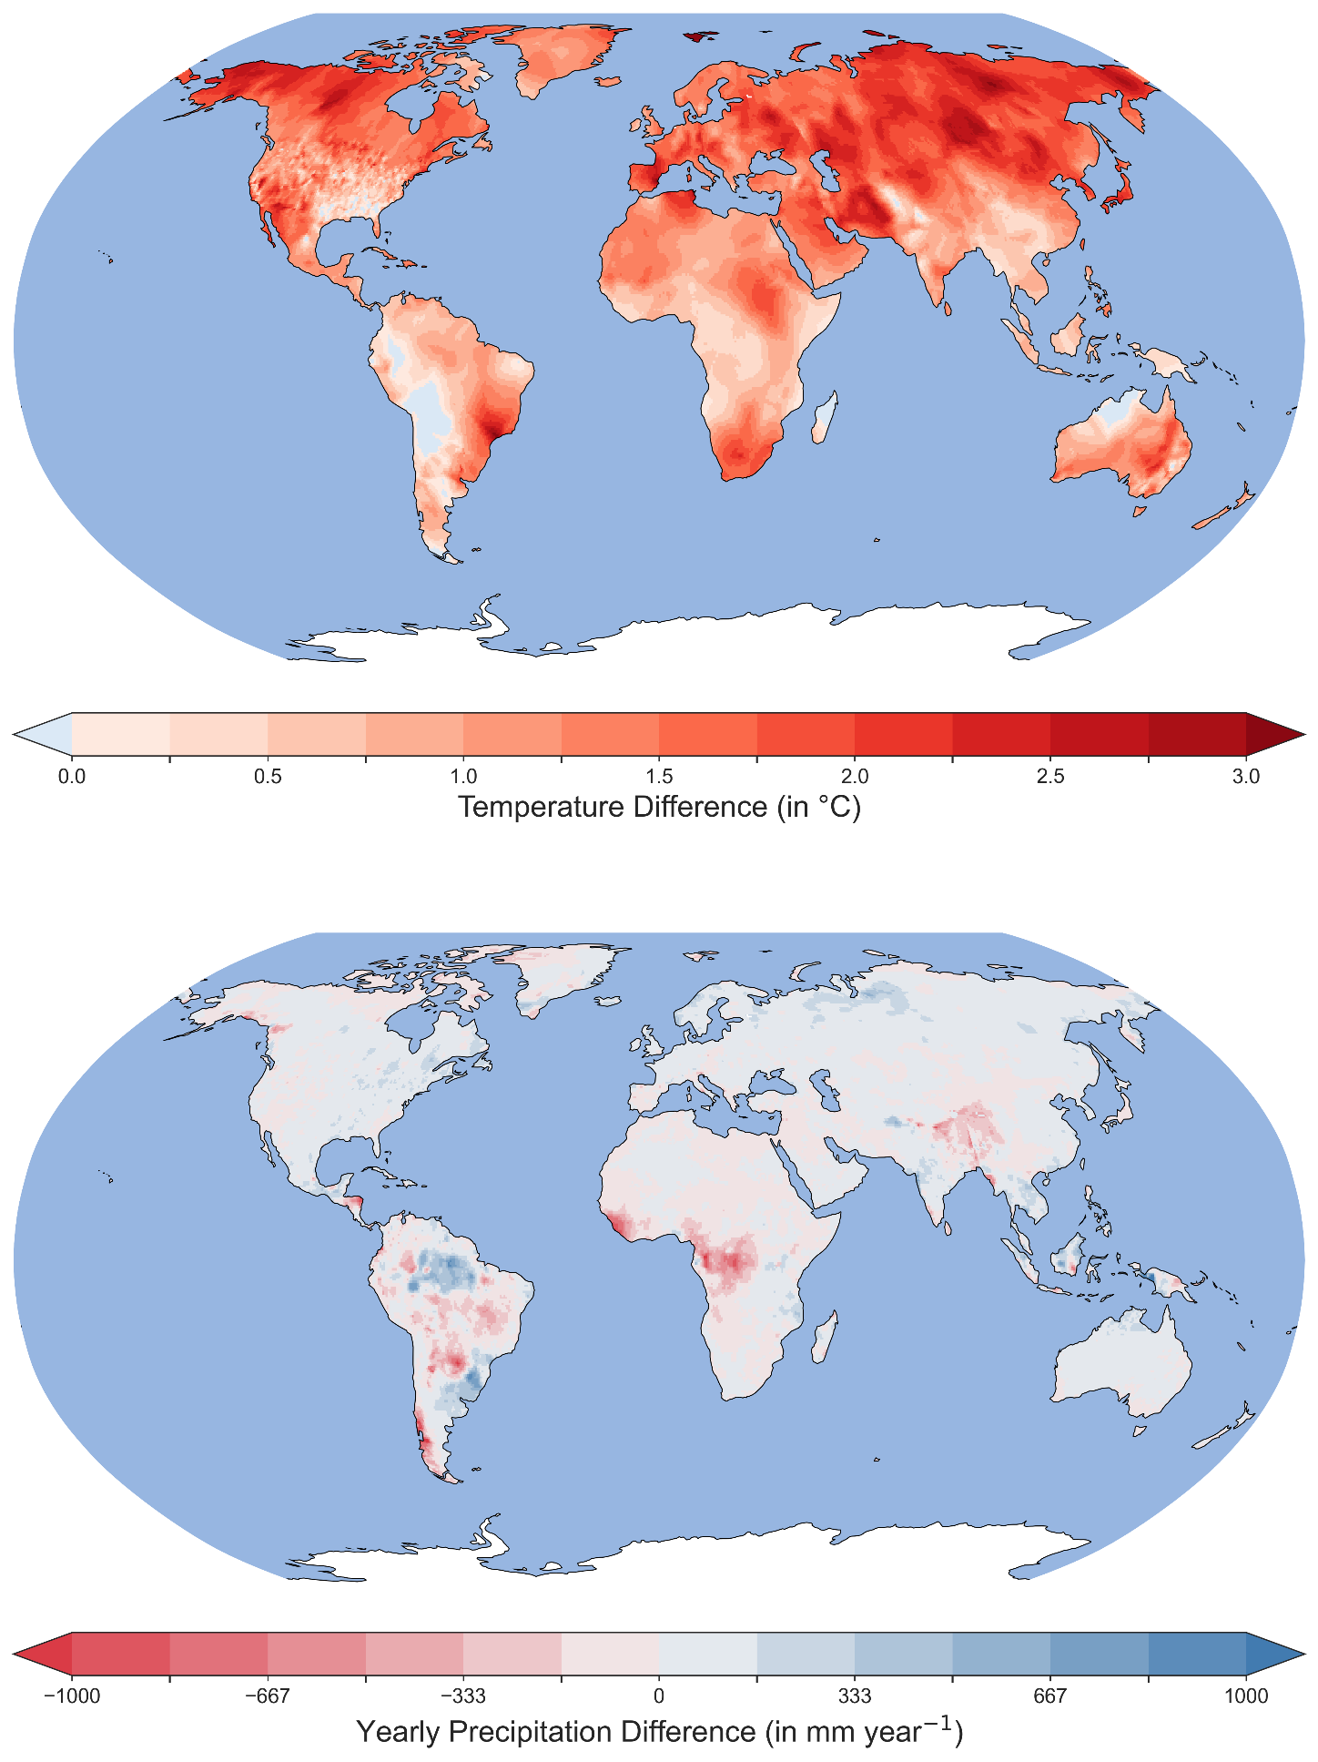
Figure S5 | Difference in temperature (top) and precipitation between the factual and counterfactual driving data for the 2003-2019 period.

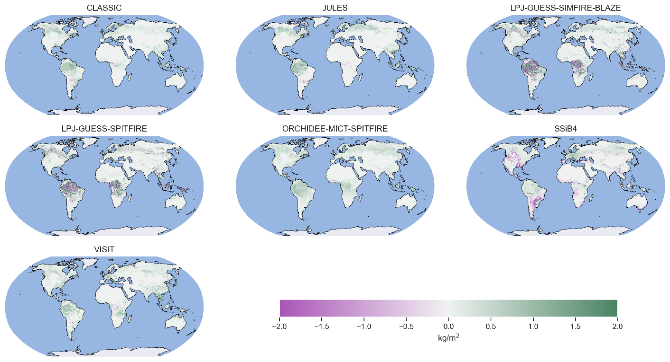
Figure S6 | Change in Vegetation due to climate change 2003-2019 (Factual – Counterfactual).

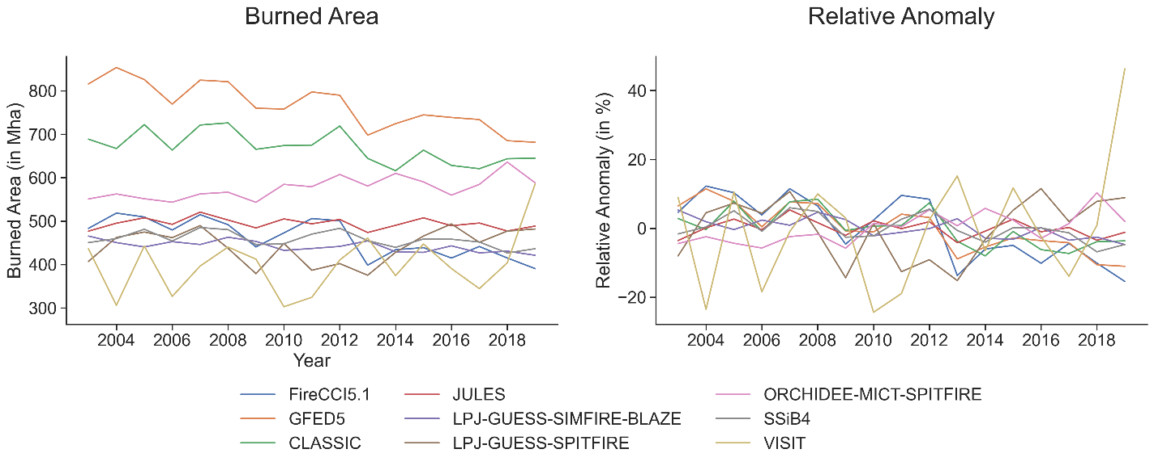
Figure S7 | Annual burned area and relative anomaly for observations and models.

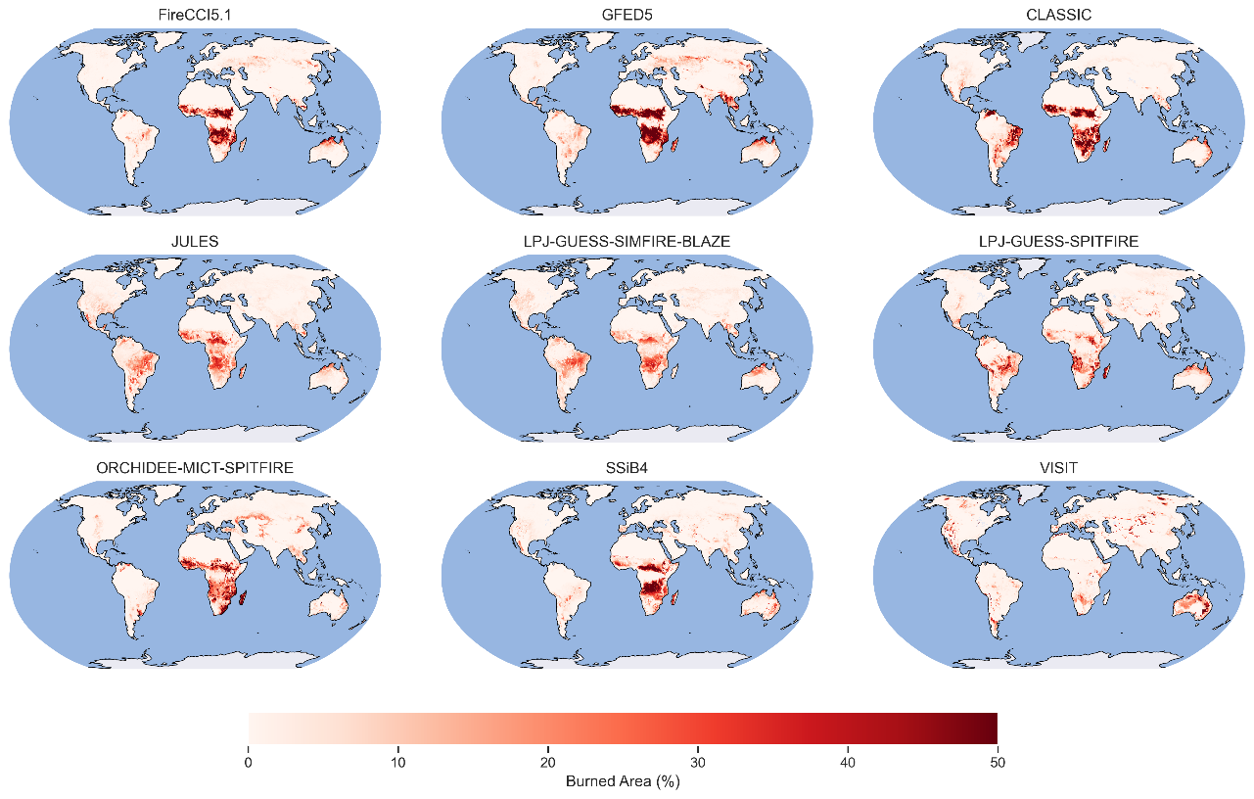
Figure S8 | Average annual burned area percentage for observations and each model, 2003-2019.

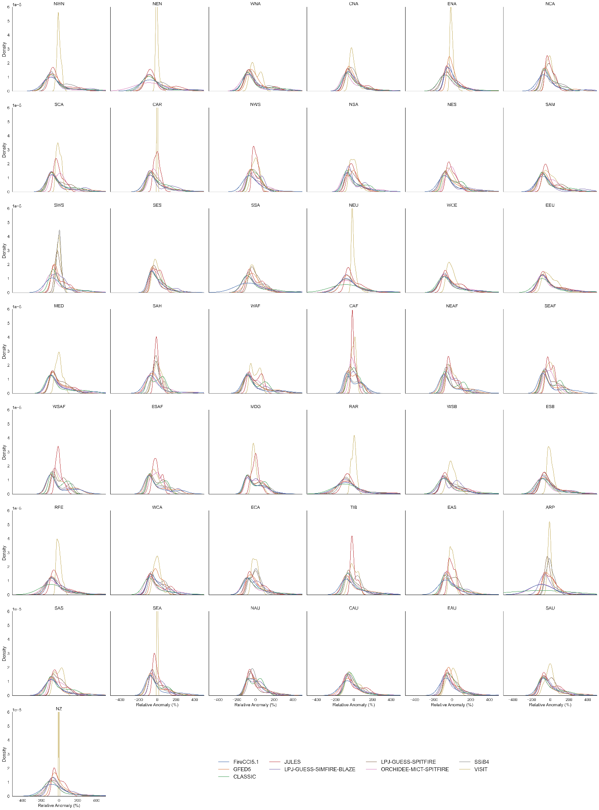
Figure S9 | Monthly regional total burned area Probability Density Function (PDF) for each model compared to observations for all IPCC regions, relative anomaly 2003-2019, with VISIT.
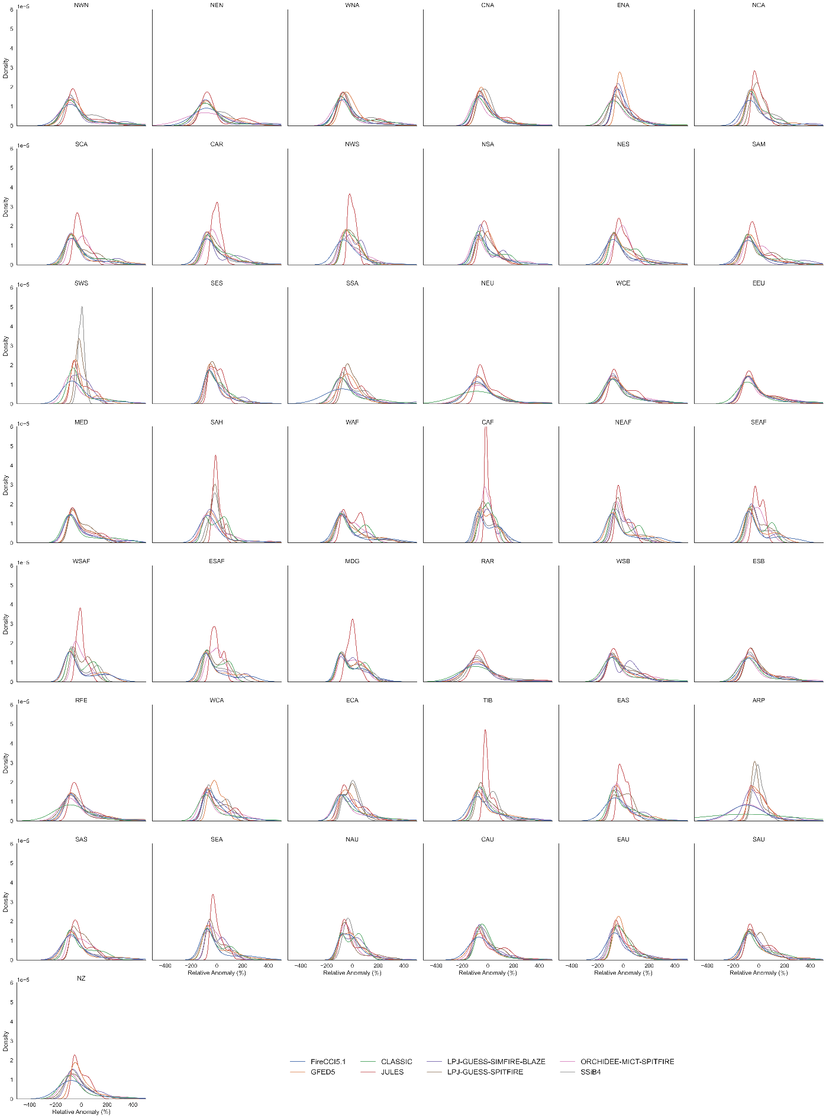
Figure S10 | Same as Figure S9 but without VISIT.

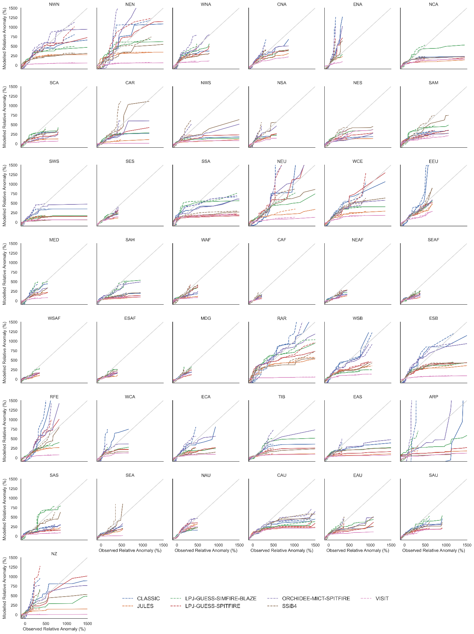
Figure S11 | Monthly total burned area QQ analysis for each model compared to observations for all IPCC regions, relative anomaly, 2003-2019. Models are plotted in colours against GFED5 (dotted lines) and Fire CCI5.1 (solid lines).

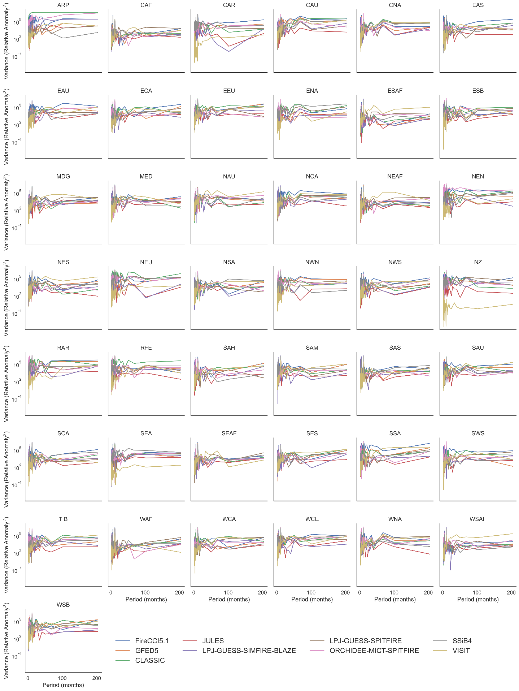
Figure S12 | Monthly regional total burned area power spectra analysis for models and observations, for all IPCC regions, relative anomaly 2003-2019.

Table S1: Percentage change in global mean burned area, Probability Ratio (PR), and significant difference in the global distributions shown in Error! Reference source not found. and Figure S2 using a KS test (all statistic values are significant at P<0.05).

 | Change in Mean (%) | PR | KS Statistic
1901-1920 | 0.47 | 1.02 | 0.02
1950-2019 | 9.46 | 1.27 | 0.13
2003-2019 | 16.43 | 1.43 | 0.19
DHF | -15.83 | 0.47 | 0.35
All forcing | -3.72 | 0.84 | 0.17

Table S2: Columns left to right: Region abbreviation; Region full name (from IPCC regions. Note that PAC (Pacific Small Islands) and GIC (Greenland / Iceland have been removed from this analysis compared to the original IPCC AR6 report); Change in mean burned area (BA) due to climate change (%) ordered highest to lowest regionally after Global; Change in mean BA due to Direct Human Forcing (%); Change in mean BA due to All forcings; Probability Ratio due to climate change; Trend in overburning for the 1980-2019 period along with the standard error (SE).
Region (abbrv.) | IPCC AR6 Region Full Name | Mean Change CC (%) | Mean Change DHF (%) | Mean Change All (%) | PR due to climate change | 1980-2019 Overburning trend  (%year⁻¹ ± 1SE)
Global |  | 16.43 | -15.83 | -3.72 | 1.43 | 0.22 ± 0.03
CAU | Central Australia | 125.09 | -8.12 | 89.64 | 1.56 | 2.49 ± 0.46
SSA | Southern South America | 102.15 | 55.43 | 211.14 | 1.33 | 1.68 ± 0.23
TIB | Tibetan Plateau | 93.20 | -38.15 | 0.18 | 1.54 | 1.94 ± 0.34
WCA | Western Central Asia | 54.03 | 64.85 | 189.73 | 1.27 | 0.82 ± 0.07
SWS | South-Western South America | 51.92 | 25.50 | 90.57 | 1.38 | 0.87 ± 0.09
EEU | Eastern Europe | 51.60 | 20.25 | 91.50 | 1.19 | 0.98 ± 0.15
SES | South-Eastern South America | 50.06 | -26.35 | 0.34 | 1.37 | 0.89 ± 0.15
WSB | West Siberia | 43.26 | 31.73 | 97.87 | 1.26 | 0.67 ± 0.08
EAU | Eastern Australia | 40.61 | 12.34 | 65.82 | 1.33 | 0.69 ± 0.07
ECA | East Central Asia | 38.27 | 12.99 | 60.83 | 1.40 | 0.58 ± 0.07
NCA | Northern Central America | 37.80 | -20.49 | 7.11 | 1.29 | 0.57 ± 0.10
SAU | Southern Australia | 34.35 | -12.71 | 18.09 | 1.23 | 0.62 ± 0.06
WNA | Western North America | 32.90 | 40.12 | 94.71 | 1.16 | 0.53 ± 0.05
MED | Mediterranean | 29.68 | -6.08 | 14.87 | 1.17 | 0.46 ± 0.03
NEU | Northern Europe | 28.69 | -4.77 | 12.39 | 1.23 | 0.45 ± 0.13
NAU | Northern Australia | 28.39 | 29.54 | 63.26 | 1.21 | 0.55 ± 0.12
WCE | Western and Central Europe | 27.97 | -8.27 | 17.37 | 1.19 | 0.28 ± 0.07
CAF | Central Africa | 24.76 | -9.14 | 13.01 | 1.32 | 0.30 ± 0.05
MDG | Madagascar | 17.81 | 106.49 | 138.34 | 1.08 | 0.20 ± 0.04
SAH | Sahara | 17.25 | 2.49 | 17.67 | 1.31 | 0.21 ± 0.05
ESAF | East Southern Africa | 16.17 | -3.18 | 10.82 | 1.07 | 0.16 ± 0.03
SAM | South American Monsoon | 15.63 | 6.93 | 19.10 | 1.02 | 0.28 ± 0.05
ESB | East Siberia | 15.49 | -9.72 | 3.81 | 1.05 | 0.23 ± 0.03
WSAF | West Southern Africa | 14.79 | 17.51 | 31.17 | 1.11 | 0.12 ± 0.04
NEAF | North Eastern Africa | 14.22 | -15.15 | -4.93 | 1.10 | 0.17 ± 0.04
SCA | Southern Central America | 13.63 | -25.76 | -11.77 | 1.05 | 0.22 ± 0.06
WAF | Western Africa | 13.46 | -43.70 | -36.32 | 1.01 | 0.14 ± 0.04
NWS | North-Western South America | 12.36 | 19.39 | 30.21 | 1.11 | 0.07 ± 0.04
RAR | Russian Arctic | 12.27 | -14.13 | -4.08 | 0.95 | 0.18 ± 0.07
CNA | Central North America | 11.71 | 63.06 | 95.74 | 1.15 | 0.22 ± 0.04
SEAF | South Eastern Africa | 10.86 | -21.77 | -13.93 | 1.08 | 0.10 ± 0.04
ARP | Arabian Peninsula | 8.37 | 10.11 | 53.03 | 1.14 | 0.15 ± 0.08
NZ | New Zealand | 7.90 | 100.08 | 123.71 | 1.04 | 0.08 ± 0.05
ENA | Eastern North America | 7.07 | -28.91 | -27.28 | 1.03 | 0.00 ± 0.05
NSA | Northern South America | 4.31 | 14.82 | 16.67 | 0.92 | 0.15 ± 0.09
SAS | South Asia | 3.72 | -55.70 | -54.35 | 1.01 | -0.01 ± 0.02
EAS | East Asia | 1.87 | -44.60 | -43.13 | 0.99 | 0.02 ± 0.02
NES | North-Eastern South America | -0.12 | -12.16 | -14.13 | 0.92 | 0.04 ± 0.04
NWN | North-Western North America | -2.83 | -20.58 | -23.29 | 1.06 | -0.03 ± 0.05
CAR | Caribbean | -2.92 | -49.72 | -50.97 | 0.94 | -0.03 ± 0.03
NEN | North-Eastern North America | -3.64 | -24.28 | -30.93 | 1.00 | 0.04 ± 0.07
RFE | Russian Far East | -10.48 | -26.72 | -32.18 | 0.81 | -0.22 ± 0.06
SEA | South East Asia | -16.87 | -52.25 | -59.19 | 0.72 | -0.33 ± 0.05
Table S3: Pearson correlation between regional fire drivers and the regional overburning (Equation 3). CO₂ values represents global mean atmospheric CO₂. Temperature and Precipitation are the regional differences between the obsclim and counterclim of the input data (gswp3-w5e5,) and carbon vegetation is the regional weighted difference between the carbon vegetation of the factual and counterfactual simulations. Note that some regions have little overburning (or even very small underburning), correlation does not give any indication of the strength of change in overburning nor does it imply causation.
Region | CO₂ | Temperature | Precipitation | Carbon Vegetation
ARP | 0.701 | 0.574 | 0.468 | 0.581
CAF | 0.972 | 0.982 | -0.967 | 0.864
CAR | 0.188 | 0.022 | -0.200 | 0.194
CAU | 0.995 | 0.973 | 0.849 | 0.975
CNA | 0.993 | 0.953 | 0.935 | 0.939
EAS | 0.830 | 0.740 | 0.746 | 0.815
EAU | 0.997 | 0.973 | 0.686 | 0.967
ECA | 0.995 | 0.987 | -0.402 | 0.851
EEU | 0.998 | 0.965 | 0.968 | 0.993
ENA | 0.898 | 0.898 | 0.893 | 0.875
ESAF | 0.971 | 0.969 | 0.777 | 0.979
ESB | 0.991 | 0.964 | 0.964 | 0.985
MDG | 0.974 | 0.951 | 0.832 | 0.977
MED | 0.995 | 0.979 | -0.750 | 0.976
NAU | 0.989 | 0.952 | 0.900 | 0.988
NCA | 0.996 | 0.978 | 0.961 | 0.973
NEAF | 0.983 | 0.968 | -0.486 | 0.973
NEN | -0.044 | -0.090 | -0.066 | -0.030
NES | 0.335 | 0.130 | -0.214 | 0.245
NEU | 0.991 | 0.972 | 0.967 | 0.984
NSA | 0.809 | 0.676 | 0.673 | 0.803
NWN | -0.456 | -0.565 | 0.446 | -0.495
NWS | 0.922 | 0.882 | -0.829 | 0.919
NZ | 0.946 | 0.950 | 0.740 | 0.935
RAR | 0.967 | 0.948 | 0.955 | 0.951
RFE | -0.981 | -0.982 | -0.977 | -0.988
SAH | 0.980 | 0.950 | -0.551 | 0.903
SAM | 0.983 | 0.934 | -0.920 | 0.967
SAS | 0.867 | 0.834 | 0.625 | 0.859
SAU | 0.998 | 0.967 | 0.307 | 0.975
SCA | 0.979 | 0.945 | -0.011 | 0.965
SEA | -0.954 | -0.980 | -0.965 | -0.965
SEAF | 0.969 | 0.956 | 0.850 | 0.970
SES | 0.998 | 0.978 | 0.607 | 0.601
SSA | 0.997 | 0.986 | -0.953 | 0.952
SWS | 0.998 | 0.984 | -0.976 | 0.992
TIB | 0.991 | 0.969 | -0.905 | 0.988
WAF | 0.978 | 0.974 | -0.932 | 0.967
WCA | 0.993 | 0.977 | 0.916 | 0.961
WCE | 0.972 | 0.961 | 0.938 | 0.967
WNA | 0.997 | 0.978 | 0.412 | 0.934
WSAF | 0.964 | 0.972 | -0.746 | 0.892
WSB | 0.994 | 0.978 | 0.974 | 0.987

Table S4: Global spatial NME scores of the seven models.
 |  | CLASSIC | JULES | LPJ-GUESS-SIMFIRE-BLAZE | LPJ-GUESS-SPITFIRE | ORCHIDEE-MICT-SPITFIRE | SSiB4 | VISIT
FireCCI5.1 | NME₁ | 0.89 | 0.78 | 0.78 | 0.84 | 0.90 | 0.65 | 1.17
FireCCI5.1 | NME₃ | 0.74 | 0.77 | 0.79 | 0.82 | 0.80 | 0.65 | 1.06
GFED5 | NME₁ | 0.71 | 0.69 | 0.72 | 0.77 | 0.73 | 0.62 | 1.03
GFED5 | NME₃ | 0.77 | 0.77 | 0.83 | 0.88 | 0.82 | 0.73 | 1.14

Table S5: Temporal NME₃ scores of the seven fire models compared to the FireCCI5.1 randomly resampled reference model.
 | Reference |  | CLASSIC |  | JULES |  | LPJ-GUESS-SIMFIRE-BLAZE |  | LPJ-GUESS-SPITFIRE |  | ORCHIDEE-MICT-SPITFIRE |  | SSiB4 |  | VISIT
NME  Region | Rank. | Ann. | Rank. | Ann. | Rank. | Ann. | Rank. | Ann. | Rank. | Ann. | Rank. | Ann. | Rank. | Ann. | Rank. | Ann.
NWN | 1.22 | 1.54 | 0.67 | 1.58 | 0.59 | 1.2 | 0.56 | 1.34 | 0.52 | 0.93 | 0.67 | 1.7 | 0.8 | 0.83 | 1.38 | 1.34
NEN | 1.22 | 1.58 | 0.8 | 1.2 | 0.61 | 1.2 | 0.7 | 1.66 | 0.69 | 1.37 | 0.89 | 1.26 | 0.82 | 1.32 | 1.22 | 1.59
WNA | 1.4 | 1.38 | 0.53 | 0.48 | 0.65 | 0.69 | 0.65 | 1.05 | 0.65 | 0.73 | 0.68 | 0.79 | 0.56 | 0.66 | 1.15 | 1.15
CNA | 1.25 | 1.04 | 1.29 | 1.19 | 1.45 | 1.06 | 1 | 1.78 | 1.41 | 1.17 | 1.44 | 1.26 | 1.25 | 1.27 | 1.4 | 1.34
ENA | 1.47 | 1.56 | 1.37 | 0.78 | 1.49 | 0.73 | 1.32 | 1.25 | 1.34 | 0.82 | 1.53 | 1.29 | 0.87 | 0.63 | 1.39 | 0.76
NCA | 1.24 | 1.2 | 0.75 | 0.79 | 0.91 | 1.5 | 0.6 | 1.31 | 1.1 | 1.37 | 0.88 | 1.45 | 0.76 | 0.79 | 1.09 | 0.77
SCA | 1.21 | 1.33 | 0.39 | 0.88 | 0.64 | 1.26 | 0.43 | 1 | 0.6 | 1.11 | 0.83 | 1.5 | 0.48 | 1.05 | 0.8 | 1.17
CAR | 1.22 | 1.33 | 0.63 | 1.13 | 1.34 | 1.39 | 0.65 | 1.63 | 0.83 | 1.09 | 1.07 | 1.43 | 0.58 | 0.74 | 1.55 | 1.73
NWS | 1.25 | 1.57 | 0.94 | 1.09 | 1.04 | 1.43 | 0.97 | 1.42 | 1.19 | 1.12 | 0.85 | 1.65 | 1.11 | 0.87 | 1.3 | 0.9
NSA | 1.47 | 1.27 | 0.46 | 1.24 | 1.25 | 1.56 | 0.7 | 0.99 | 0.81 | 1.6 | 0.59 | 1.63 | 0.72 | 1.06 | 1.35 | 1.32
NES | 1.24 | 1.38 | 0.62 | 0.62 | 0.62 | 0.73 | 0.53 | 1.83 | 0.92 | 0.78 | 1.18 | 0.89 | 0.36 | 0.8 | 0.95 | 1.11
SAM | 1.25 | 1.48 | 0.51 | 0.5 | 0.51 | 0.81 | 0.43 | 1.58 | 0.78 | 0.73 | 0.86 | 0.94 | 0.32 | 0.62 | 0.91 | 1.36
SWS | 1.2 | 1.38 | 1.01 | 1.37 | 1.11 | 1.47 | 1.39 | 1.62 | 1.44 | 1.72 | 1.08 | 1.41 | 1.57 | 1.44 | 1.52 | 1.62
SES | 1.33 | 1.24 | 0.73 | 1 | 1.23 | 0.82 | 0.68 | 1.06 | 0.92 | 1.05 | 1.17 | 0.96 | 0.92 | 0.99 | 1.15 | 0.95
SSA | 1.22 | 0.95 | 1.02 | 1.3 | 1.08 | 1.44 | 0.91 | 1.39 | 1.23 | 1.03 | 0.96 | 1.08 | 1.06 | 0.95 | 1.43 | 1.53
NEU | 1.2 | 1.21 | 1.13 | 0.92 | 1.07 | 0.97 | 1.13 | 1.01 | 1.01 | 1.13 | 1.16 | 0.98 | 0.85 | 1.03 | 1.21 | 1.11
WCE | 1.37 | 1.45 | 0.92 | 1.53 | 1.02 | 1.49 | 0.64 | 1.41 | 1.06 | 1.11 | 0.99 | 1.73 | 0.85 | 1.28 | 1.28 | 1.46
EEU | 1.21 | 1.37 | 0.79 | 1.59 | 0.83 | 1.76 | 0.72 | 1.26 | 0.74 | 1.02 | 0.8 | 1.17 | 0.79 | 1.59 | 1.22 | 1.59
MED | 1.28 | 1.38 | 0.44 | 0.9 | 0.65 | 1.07 | 0.4 | 1.54 | 0.84 | 1.37 | 0.7 | 1.36 | 0.56 | 0.96 | 1 | 1.22
SAH | 1.28 | 1.59 | 1.45 | 1.49 | 0.81 | 1.54 | 0.87 | 1.45 | 0.8 | 1.54 | 1.21 | 1.39 | 0.66 | 1.21 | 1.46 | 1.73
WAF | 1.19 | 1.39 | 0.88 | 0.65 | 0.83 | 0.58 | 0.38 | 1 | 0.54 | 1.1 | 1 | 1.69 | 0.42 | 1.04 | 0.98 | 1.47
CAF | 1.24 | 1.44 | 1.14 | 0.58 | 1.42 | 0.74 | 0.45 | 0.83 | 0.92 | 0.97 | 1.44 | 1.71 | 0.62 | 1.01 | 1.08 | 0.66
NEAF | 1.15 | 1.3 | 0.75 | 0.93 | 0.62 | 0.67 | 0.54 | 1.46 | 0.57 | 1.09 | 0.7 | 1.43 | 0.54 | 0.71 | 1.08 | 1.35
SEAF | 1.27 | 1.61 | 0.64 | 0.57 | 0.77 | 0.47 | 0.31 | 0.99 | 0.55 | 0.99 | 0.88 | 1.07 | 0.58 | 0.36 | 1.15 | 1.21
WSAF | 1.2 | 0.98 | 0.4 | 0.77 | 0.98 | 1.3 | 0.25 | 1.29 | 0.72 | 1.66 | 1.3 | 1.27 | 0.28 | 1.27 | 1.1 | 1.62
ESAF | 1.17 | 0.93 | 0.5 | 0.97 | 0.82 | 0.68 | 0.23 | 1.33 | 0.78 | 1.26 | 1.17 | 1.09 | 0.4 | 0.89 | 0.99 | 1.45
MDG | 1.33 | 1.42 | 0.34 | 1.04 | 0.97 | 1.09 | 0.68 | 1.42 | 0.67 | 1.5 | 0.71 | 1.46 | 0.53 | 1.35 | 1.08 | 1.48
RAR | 1.21 | 1.13 | 0.79 | 1.01 | 0.81 | 0.97 | 0.71 | 1.03 | 0.76 | 0.63 | 0.75 | 0.88 | 0.97 | 0.83 | 1.46 | 1.13
WSB | 1.31 | 1.62 | 1.02 | 0.76 | 0.89 | 1.14 | 0.84 | 1.27 | 0.85 | 1.2 | 1 | 0.73 | 0.77 | 0.77 | 1.41 | 0.89
ESB | 1.32 | 1.18 | 0.95 | 1.24 | 1.12 | 1.29 | 0.74 | 1.78 | 1.11 | 1.34 | 1.26 | 1.5 | 0.63 | 1.09 | 1.46 | 0.98
RFE | 1.26 | 1.05 | 1.15 | 0.95 | 1.16 | 0.83 | 0.96 | 1.57 | 1.24 | 1.01 | 1.21 | 1.03 | 0.75 | 0.94 | 1.32 | 1.19
WCA | 1.35 | 1.57 | 0.72 | 1.43 | 0.57 | 1.52 | 0.86 | 1.13 | 0.66 | 1.05 | 0.68 | 1.75 | 0.65 | 1.09 | 1.27 | 1.73
ECA | 1.31 | 1.23 | 1.06 | 1.41 | 1.17 | 1.66 | 1.09 | 1.15 | 1.15 | 1.26 | 1.16 | 1.39 | 1.08 | 0.91 | 1.38 | 1.43
TIB | 1.27 | 1.51 | 0.96 | 1.05 | 0.86 | 1.36 | 0.96 | 1.4 | 1.06 | 1.3 | 1.23 | 0.95 | 1.1 | 1.72 | 1.29 | 1.36
EAS | 1.37 | 1.65 | 1.2 | 0.96 | 1.25 | 1.1 | 0.9 | 0.99 | 1.33 | 1.76 | 1.12 | 1.39 | 1.14 | 0.86 | 1.29 | 1.26
ARP | 1.05 | 1.33 | 1.14 | 1.27 | 1.41 | 1 | 1.26 | 1.28 | 1.37 | 1.44 | 1.2 | 1.4 | 1.42 | 1.76 | 1.42 | 1.27
SAS | 1.22 | 1.23 | 0.65 | 1.56 | 0.73 | 1.37 | 0.4 | 1.65 | 0.92 | 1.6 | 0.89 | 1.7 | 0.61 | 1.6 | 1 | 1.14
SEA | 1.22 | 1.59 | 0.56 | 0.64 | 0.85 | 0.57 | 0.82 | 0.89 | 0.53 | 0.69 | 1.03 | 1.08 | 0.97 | 0.85 | 1.09 | 0.86
NAU | 1.42 | 1.39 | 0.62 | 1.17 | 1.23 | 0.75 | 0.74 | 1.48 | 1.06 | 1.1 | 1.06 | 1.07 | 0.9 | 1.06 | 1.27 | 1.74
CAU | 1.32 | 1.44 | 0.85 | 0.76 | 1.1 | 1.25 | 1.06 | 1.61 | 1.02 | 1.03 | 0.98 | 0.64 | 1.23 | 0.71 | 1.46 | 1.67
EAU | 1.26 | 1.35 | 0.87 | 0.92 | 0.9 | 0.96 | 0.87 | 1.41 | 0.97 | 1.07 | 0.83 | 0.67 | 0.83 | 1.04 | 1.35 | 1.33
SAU | 1.41 | 1.16 | 0.91 | 1.29 | 1.04 | 1.16 | 1.08 | 1.37 | 1.13 | 1.3 | 1.04 | 1.48 | 1.16 | 1.23 | 1.28 | 1.18
NZ | 1.21 | 0.92 | 0.99 | 1.06 | 1.18 | 1.07 | 1.3 | 1.36 | 1.13 | 1.2 | 1.01 | 1.07 | 1.17 | 1.39 | 1.46 | 1.22

Table S6: Temporal NME₃ scores of the 7 fire models compared to the GFED5 randomly resampled null model.
 | Reference |  | CLASSIC |  | JULES |  | LPJ-GUESS-SIMFIRE-BLAZE |  | LPJ-GUESS-SPITFIRE |  | ORCHIDEE-MICT-SPITFIRE |  | SSiB4 |  | VISIT
NME  Region | Rank. | Ann. | Rank. | Ann. | Rank. | Ann. | Rank. | Ann. | Rank. | Ann. | Rank. | Ann. | Rank. | Ann. | Rank. | Ann.
NWN | 1.28 | 1.24 | 0.77 | 1.65 | 0.61 | 1.29 | 0.62 | 1.31 | 0.51 | 0.98 | 0.78 | 1.73 | 0.73 | 0.93 | 1.46 | 1.37
NEN | 1.32 | 1.48 | 1.08 | 1.17 | 0.89 | 1.04 | 1.01 | 1.63 | 1 | 1.31 | 1.24 | 1.27 | 0.74 | 1.36 | 1.32 | 1.63
WNA | 1.35 | 1.09 | 0.67 | 0.56 | 0.79 | 0.73 | 0.79 | 1.16 | 0.76 | 0.79 | 0.85 | 0.78 | 0.67 | 0.72 | 1.2 | 1.14
CNA | 1.38 | 1.48 | 1.3 | 1.23 | 1.38 | 0.97 | 0.95 | 1.72 | 1.4 | 1.25 | 1.44 | 1.21 | 1.24 | 1.23 | 1.41 | 1.46
ENA | 1.33 | 1.55 | 1.47 | 0.92 | 1.52 | 0.64 | 1.38 | 1.12 | 1.4 | 0.94 | 1.57 | 1.24 | 1.02 | 0.74 | 1.47 | 0.84
NCA | 1.24 | 1.66 | 0.59 | 0.65 | 0.93 | 1.34 | 0.46 | 1.39 | 0.92 | 1.23 | 0.77 | 1.26 | 0.52 | 0.69 | 1 | 0.82
SCA | 1.15 | 1.27 | 0.4 | 0.65 | 0.49 | 1.16 | 0.24 | 1.19 | 0.65 | 1.03 | 0.79 | 1.48 | 0.49 | 0.94 | 0.78 | 1.16
CAR | 1.3 | 1.63 | 0.48 | 1.01 | 1.34 | 1.36 | 0.48 | 1.54 | 0.74 | 1.04 | 1.02 | 1.38 | 0.59 | 0.86 | 1.46 | 1.73
NWS | 1.3 | 1.49 | 0.71 | 0.98 | 0.61 | 1.27 | 0.62 | 1.47 | 1.25 | 1.16 | 1.1 | 1.52 | 0.83 | 0.79 | 1.11 | 1.02
NSA | 1.44 | 1.32 | 0.6 | 1.08 | 1.13 | 1.49 | 0.88 | 1.04 | 0.96 | 1.38 | 0.82 | 1.47 | 0.88 | 1.24 | 1.2 | 1.29
NES | 1.27 | 1.32 | 0.58 | 0.68 | 0.57 | 0.74 | 0.52 | 1.74 | 1.1 | 0.89 | 1.08 | 0.68 | 0.42 | 1.06 | 0.95 | 1.28
SAM | 1.2 | 1.19 | 0.51 | 0.71 | 0.41 | 1.02 | 0.48 | 1.55 | 0.79 | 0.81 | 0.75 | 0.69 | 0.32 | 0.9 | 0.85 | 1.46
SWS | 1.28 | 1.49 | 1.27 | 1.24 | 1.3 | 1.25 | 1.43 | 1.69 | 1.34 | 1.76 | 1.32 | 1.37 | 1.65 | 1.35 | 1.47 | 1.6
SES | 1.28 | 1.71 | 0.79 | 0.97 | 1.4 | 0.87 | 0.5 | 0.92 | 0.83 | 1.11 | 1.32 | 0.79 | 0.96 | 0.99 | 1.1 | 0.9
SSA | 1.4 | 1.23 | 1.1 | 1.39 | 1 | 1.42 | 1.06 | 1.34 | 1.12 | 1.04 | 0.97 | 1.04 | 0.97 | 0.98 | 1.39 | 1.48
NEU | 1.35 | 1.43 | 1.17 | 1.09 | 0.92 | 1 | 1.1 | 1 | 1 | 1.33 | 1.15 | 1.09 | 0.75 | 1.36 | 1.16 | 1.33
WCE | 1.33 | 0.76 | 1.12 | 1.57 | 1.12 | 1.54 | 0.85 | 1.47 | 1.15 | 1.21 | 1.16 | 1.78 | 1.05 | 1.31 | 1.38 | 1.55
EEU | 1.37 | 1.4 | 0.98 | 1.65 | 0.92 | 1.83 | 0.83 | 1.23 | 0.88 | 1.14 | 0.93 | 1.25 | 0.92 | 1.64 | 1.36 | 1.58
MED | 1.24 | 1.47 | 0.56 | 1.01 | 0.72 | 1.23 | 0.52 | 1.61 | 0.84 | 1.39 | 0.79 | 1.51 | 0.63 | 1.12 | 0.98 | 1.33
SAH | 1.36 | 1.45 | 1.35 | 1.47 | 0.8 | 1.49 | 0.86 | 1.48 | 0.82 | 1.38 | 1.26 | 1.35 | 0.64 | 0.99 | 1.39 | 1.72
WAF | 1.23 | 1.11 | 0.61 | 0.5 | 0.57 | 0.5 | 0.53 | 0.91 | 0.5 | 1.25 | 0.88 | 1.71 | 0.28 | 0.93 | 0.72 | 1.44
CAF | 1.33 | 1.43 | 1.02 | 0.73 | 1.37 | 0.78 | 0.52 | 0.95 | 0.99 | 0.98 | 1.56 | 1.56 | 0.54 | 0.78 | 0.98 | 0.61
NEAF | 1.22 | 1.55 | 0.67 | 0.77 | 0.54 | 0.59 | 0.5 | 1.59 | 0.56 | 0.83 | 0.63 | 1.29 | 0.53 | 0.76 | 1.04 | 1.16
SEAF | 1.23 | 1.23 | 0.45 | 0.4 | 0.59 | 0.37 | 0.42 | 1.08 | 0.44 | 0.82 | 0.83 | 0.88 | 0.38 | 0.44 | 1.05 | 1.17
WSAF | 1.26 | 1.55 | 0.34 | 1.01 | 0.95 | 1.71 | 0.21 | 1.35 | 0.68 | 1.58 | 1.27 | 1.54 | 0.23 | 1.44 | 1.07 | 1.23
ESAF | 1.23 | 1.39 | 0.37 | 0.65 | 0.69 | 0.66 | 0.2 | 1.39 | 0.74 | 1.14 | 1.09 | 1 | 0.28 | 0.7 | 0.95 | 1.21
MDG | 1.28 | 1.32 | 0.33 | 1.29 | 0.67 | 1.26 | 0.48 | 1.47 | 0.7 | 1.43 | 0.72 | 1.22 | 0.37 | 1.17 | 0.97 | 1.42
RAR | 1.22 | 1.6 | 0.75 | 1.09 | 0.6 | 0.91 | 0.64 | 1.11 | 0.54 | 0.55 | 0.59 | 0.75 | 0.73 | 0.72 | 1.45 | 1.12
WSB | 1.42 | 1.56 | 1.18 | 0.78 | 1.04 | 1.33 | 0.93 | 1.19 | 1.01 | 1.35 | 1.15 | 0.89 | 0.93 | 0.81 | 1.46 | 0.87
ESB | 1.36 | 1.06 | 1.02 | 1.23 | 1.1 | 1.22 | 0.7 | 1.77 | 1.12 | 1.27 | 1.29 | 1.4 | 0.61 | 1.08 | 1.42 | 0.92
RFE | 1.25 | 1.11 | 1.11 | 0.78 | 1.08 | 0.91 | 0.89 | 1.51 | 1.18 | 1 | 1.15 | 0.87 | 0.73 | 0.87 | 1.29 | 0.99
WCA | 1.38 | 1.15 | 1.32 | 1.48 | 1.16 | 1.34 | 1.05 | 1.13 | 1.08 | 1.03 | 1.2 | 1.63 | 1.14 | 1.13 | 1.44 | 1.74
ECA | 1.44 | 1.8 | 1.32 | 1.14 | 1.34 | 0.96 | 1.16 | 1.02 | 1.37 | 1 | 1.44 | 1.09 | 1.08 | 1.46 | 1.39 | 1.36
TIB | 1.27 | 1.43 | 0.92 | 1.01 | 1.07 | 1.22 | 1 | 1.43 | 0.87 | 1.38 | 1.34 | 0.9 | 1.11 | 1.3 | 1.2 | 0.89
EAS | 1.32 | 1.2 | 0.71 | 0.95 | 1.11 | 1.03 | 0.62 | 1.36 | 1.06 | 1.37 | 1.4 | 1.39 | 0.59 | 1.03 | 1.07 | 1
ARP | 1.42 | 1.03 | 1.51 | 1.35 | 1.4 | 1.33 | 1.2 | 0.87 | 1.6 | 1.75 | 1.49 | 1.22 | 1.28 | 1.47 | 1.43 | 1.31
SAS | 1.21 | 1.23 | 0.49 | 1.07 | 0.57 | 0.89 | 0.33 | 1.4 | 0.84 | 1.64 | 0.8 | 1.78 | 0.45 | 1.09 | 0.93 | 1.46
SEA | 1.33 | 1.48 | 0.35 | 0.51 | 0.51 | 0.41 | 0.8 | 0.94 | 0.48 | 0.73 | 0.79 | 0.8 | 0.8 | 0.71 | 0.82 | 0.61
NAU | 1.32 | 1.22 | 0.6 | 1.22 | 1.21 | 0.75 | 0.7 | 1.49 | 1.03 | 1.1 | 1.03 | 1.05 | 0.85 | 0.99 | 1.29 | 1.74
CAU | 1.31 | 1.18 | 0.9 | 1.03 | 1.03 | 1.17 | 0.98 | 1.63 | 0.96 | 1.11 | 0.89 | 0.68 | 1.21 | 0.84 | 1.45 | 1.74
EAU | 1.44 | 1.53 | 0.97 | 1.13 | 0.95 | 1.16 | 0.83 | 1.65 | 1.01 | 0.95 | 0.98 | 0.99 | 0.82 | 1.08 | 1.27 | 1.4
SAU | 1.26 | 1.18 | 1.15 | 1.42 | 1.29 | 0.98 | 1.27 | 1.61 | 1.24 | 1.12 | 1.3 | 1.55 | 1.4 | 0.96 | 1.29 | 1.42
NZ | 1.36 | 1.58 | 1.37 | 1.05 | 1.32 | 0.82 | 1.53 | 1.5 | 1.19 | 1.03 | 1.28 | 1 | 1.31 | 1.09 | 1.4 | 1.3

Table S7: Model weights.
Model  Region | CLASSIC | JULES | LPJ-GUESS-SIMFIRE-BLAZE | LPJ-GUESS-SPITFIRE | ORCHIDEE-MICT-SPITFIRE | SSiB4 | VISIT
ARP | 0.148 | 0.161 | 0.211 | 0.095 | 0.144 | 0.109 | 0.133
CAF | 0.157 | 0.112 | 0.221 | 0.117 | 0.036 | 0.194 | 0.164
CAR | 0.219 | 0.064 | 0.18 | 0.159 | 0.089 | 0.249 | 0.039
CAU | 0.193 | 0.116 | 0.095 | 0.143 | 0.236 | 0.169 | 0.049
CNA | 0.148 | 0.172 | 0.157 | 0.135 | 0.128 | 0.150 | 0.109
EAS | 0.184 | 0.125 | 0.193 | 0.083 | 0.085 | 0.210 | 0.119
EAU | 0.155 | 0.147 | 0.122 | 0.144 | 0.193 | 0.165 | 0.074
ECA | 0.138 | 0.137 | 0.173 | 0.149 | 0.130 | 0.175 | 0.098
EEU | 0.130 | 0.123 | 0.181 | 0.193 | 0.164 | 0.136 | 0.072
ENA | 0.139 | 0.174 | 0.093 | 0.137 | 0.072 | 0.234 | 0.150
ESAF | 0.191 | 0.147 | 0.217 | 0.094 | 0.07 | 0.216 | 0.065
ESB | 0.139 | 0.118 | 0.166 | 0.113 | 0.083 | 0.253 | 0.129
MDG | 0.236 | 0.116 | 0.146 | 0.120 | 0.120 | 0.191 | 0.072
MED | 0.208 | 0.142 | 0.177 | 0.100 | 0.113 | 0.173 | 0.086
NAU | 0.206 | 0.165 | 0.154 | 0.126 | 0.130 | 0.161 | 0.057
NCA | 0.204 | 0.089 | 0.171 | 0.085 | 0.106 | 0.210 | 0.134
NEAF | 0.142 | 0.200 | 0.133 | 0.157 | 0.110 | 0.190 | 0.067
NEN | 0.150 | 0.202 | 0.134 | 0.157 | 0.122 | 0.165 | 0.071
NES | 0.192 | 0.180 | 0.127 | 0.108 | 0.106 | 0.207 | 0.081
NEU | 0.14 | 0.164 | 0.143 | 0.131 | 0.134 | 0.178 | 0.108
NSA | 0.235 | 0.074 | 0.179 | 0.117 | 0.155 | 0.160 | 0.080
NWN | 0.120 | 0.165 | 0.163 | 0.217 | 0.115 | 0.167 | 0.054
NWS | 0.177 | 0.152 | 0.150 | 0.103 | 0.103 | 0.186 | 0.130
NZ | 0.167 | 0.179 | 0.089 | 0.156 | 0.174 | 0.130 | 0.104
RAR | 0.124 | 0.147 | 0.138 | 0.214 | 0.170 | 0.148 | 0.058
RFE | 0.156 | 0.155 | 0.112 | 0.122 | 0.135 | 0.215 | 0.104
SAH | 0.077 | 0.170 | 0.157 | 0.172 | 0.101 | 0.262 | 0.062
SAM | 0.191 | 0.162 | 0.127 | 0.122 | 0.115 | 0.216 | 0.067
SAS | 0.168 | 0.163 | 0.221 | 0.088 | 0.090 | 0.177 | 0.093
SAU | 0.159 | 0.177 | 0.119 | 0.148 | 0.119 | 0.157 | 0.122
SCA | 0.21 | 0.131 | 0.198 | 0.127 | 0.078 | 0.162 | 0.095
SEA | 0.212 | 0.189 | 0.104 | 0.177 | 0.094 | 0.111 | 0.113
SEAF | 0.183 | 0.176 | 0.156 | 0.137 | 0.083 | 0.213 | 0.052
SES | 0.166 | 0.119 | 0.208 | 0.133 | 0.119 | 0.134 | 0.122
SSA | 0.130 | 0.126 | 0.142 | 0.154 | 0.183 | 0.191 | 0.075
SWS | 0.206 | 0.182 | 0.110 | 0.106 | 0.176 | 0.116 | 0.103
TIB | 0.184 | 0.148 | 0.132 | 0.142 | 0.154 | 0.108 | 0.132
WAF | 0.171 | 0.185 | 0.172 | 0.140 | 0.058 | 0.199 | 0.075
WCA | 0.127 | 0.162 | 0.155 | 0.192 | 0.125 | 0.180 | 0.06
WCE | 0.133 | 0.125 | 0.214 | 0.157 | 0.111 | 0.171 | 0.089
WNA | 0.212 | 0.154 | 0.112 | 0.148 | 0.136 | 0.175 | 0.063
WSAF | 0.229 | 0.070 | 0.248 | 0.101 | 0.049 | 0.239 | 0.063
WSB | 0.163 | 0.116 | 0.129 | 0.120 | 0.160 | 0.197 | 0.115

