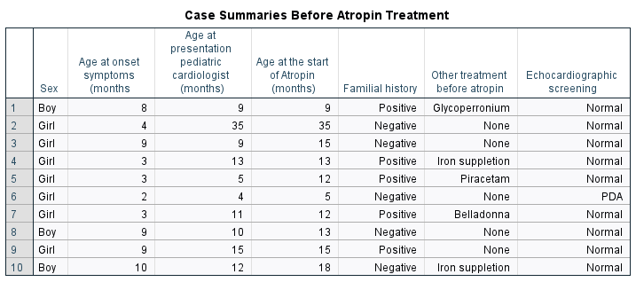
Table 1. Case summaries before atropine treatment

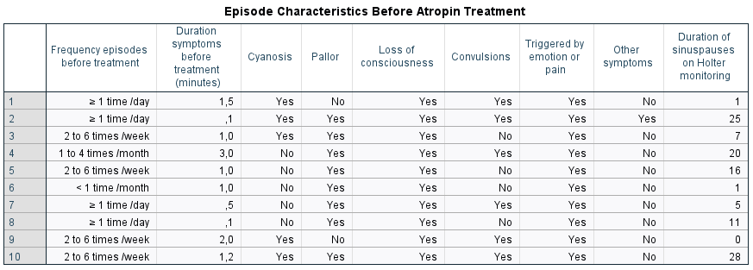
Table 2. Episode characteristics before atropine treatment
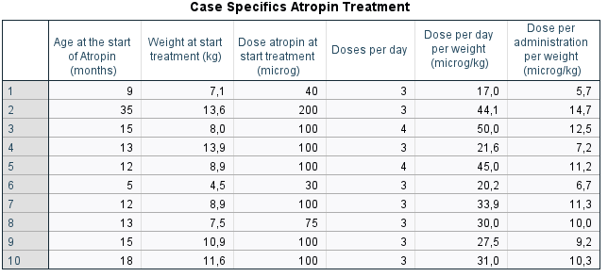
Table 3. Case specifics Atropine Treatment
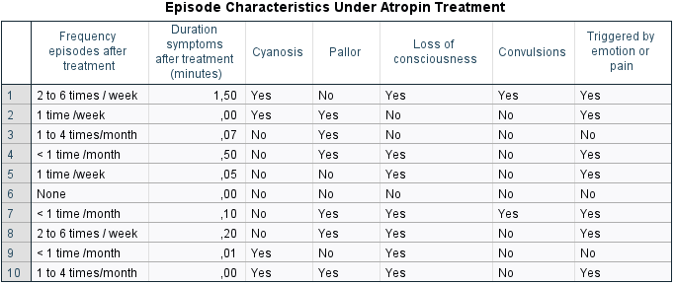
Table 4. Episode characteristics under atropine treatment

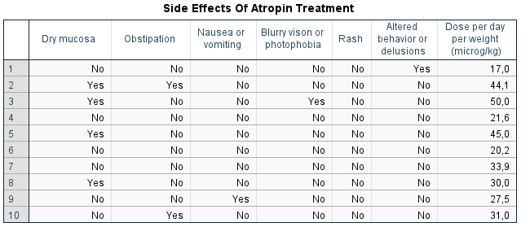
Table 5. Side effects and daily atropine dose.

