All original, full-length gels and blot images
Fig. 1. Plasma membrane (PM) enrichment detected using western blotting
The primary images for Figure 1
1) Na⁺-K⁺-ATPase: from left to right, the protein lanes are marker, and homogenate, total membrane, and plasma membrane from U937 cells, and U1 cells, respectively.
Replicate 1
Replicate 2
Replicate 3
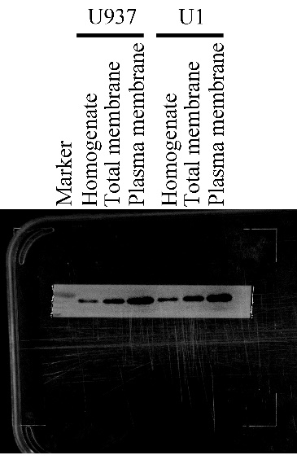

2) Prohibitin: from left to right, the protein lanes are marker, and homogenate, total membrane, and plasma membrane from U937 cells, and U1 cells, respectively.
Replicate 1
Replicate 2
Replicate 3
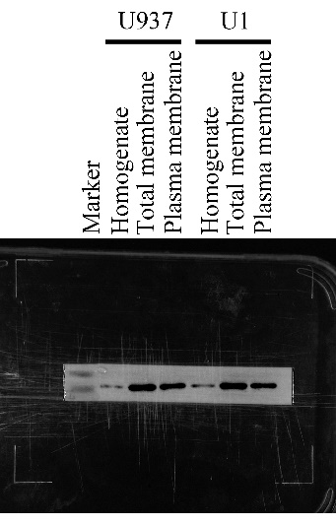

3) β-Actin: from left to right, the protein lanes are marker, and homogenate, total membrane, and plasma membrane from U937 cells, and U1 cells, respectively.
Replicate 1
Replicate 2
Replicate 3
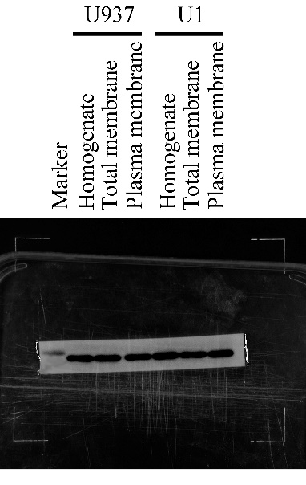

Fig. 4. Detection of the differentially expressed proteins using western blotting
The primary images for Figure 4
Positive was a mix from HepG2, U87, MCF-7 and Hela cells.
Total, TM and PM were protein samples from homogenate, total membrane and plasma membrane, respectively. Comment: In replicate 1, the markers were not completely saved, therefore, we cannot label them now.
CD55
Replicate 1
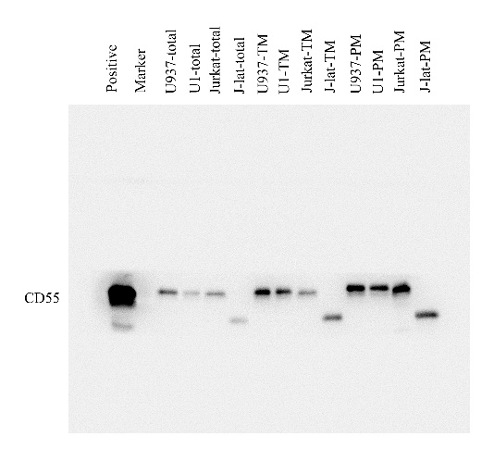
Replicate 2
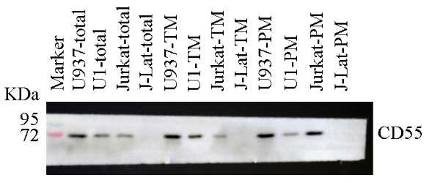
Replicate 3
CD47
Replicate 2
Replicate 3
ITGA6
Replicate 2
Replicate 3
LAMP2
Replicate 1
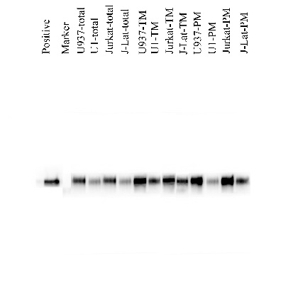
Replicate 2
Replicate 3
β-actin
Replicate 2
Replicate 3

Fig. 7. Assessment of the effect of panobinostat and hydroxychloroquine on LAMP2 protein expression
The primary images with three replicates for Figure 7
A. In U937 and U1 cells
The LAMP2 protein level after panobinostat and hydroxychloroquine treatment in replicate 1 and 2. P and H represent panobinostat and hydroxychloroquine respectively. Comment: the protein levels in U1 are too low to distinguish the difference, therefore we re-examed LAMP2 in U1 cells.

Time-dependence of LAMP2 only used for U937 analysis.
Replicate 1
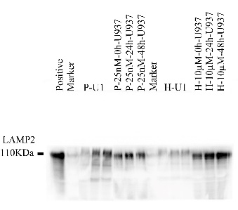
Replicate 2
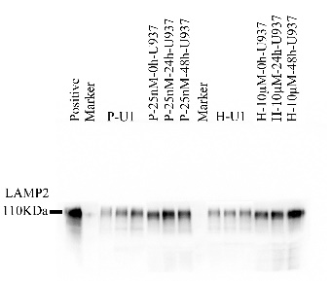
Concentration-dependence of LAMP2 only used for U937 analysis
Replicate 1
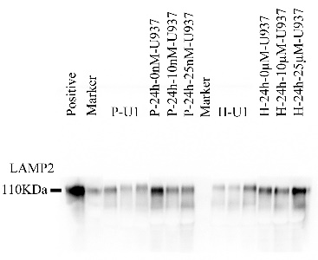
Replicate 2
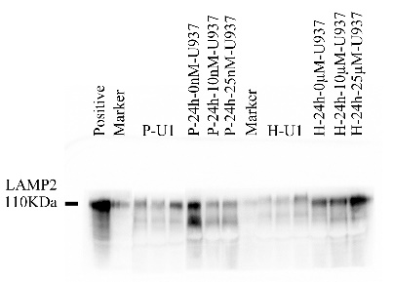
GAPDH
Time-dependence for GAPDH for LAMP2 analysis
Replicate 1
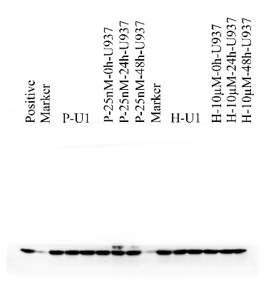
Replicate 2
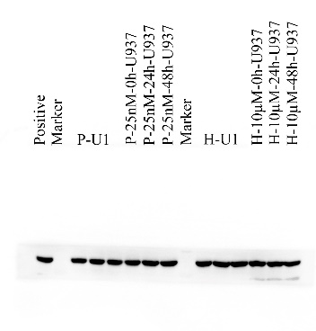
Concentration-dependence for GAPDH for LAMP2 analysis
Replicate 1
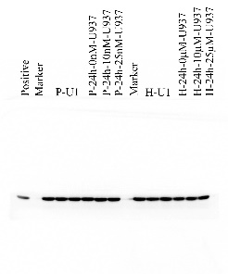
Replicate 2
B. U1 cells
Concentration and time-dependence of LAMP2 in U1 cells
LAMP2
Replicate 1
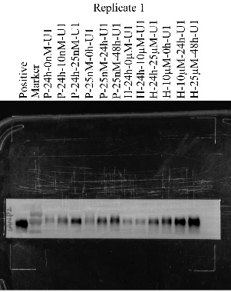
Replicate 2
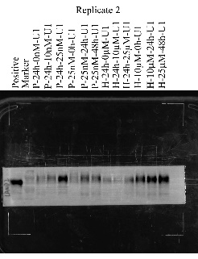
GAPDH
Replicate 1
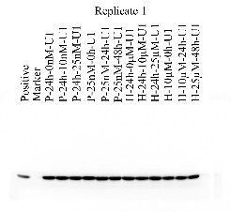
Replicate 2
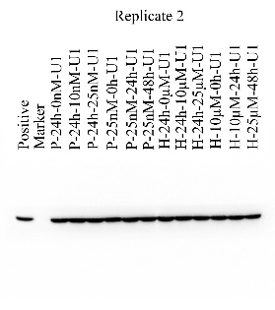
C. In U937 or U1 cells
To clearly show the time-dependence and concentration-dependence in U937 and U1 for panobinostat (P) or hydroxychloroquine (H) treatment, all kinds of proteins from U1 or U937 were singly loaded in one gel in the replicate 3.
LAMP2
In U937 cells
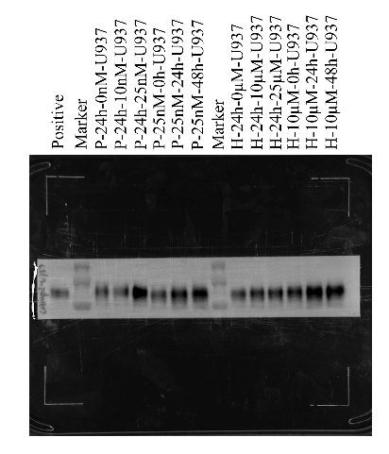
In U1 cells
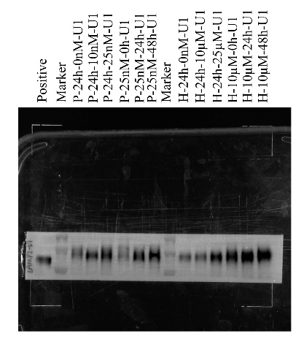

β-actin
In U937
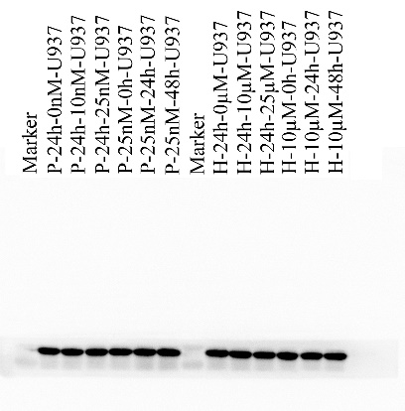

In U1 cells
