Supplemental Figure 1. Metagenomic sequencing data used for the analysis. Plots show the abundance (x-axis, as count) and the prevalence (y-axis, as percentage of all samples) of each read in 13 different phyla.
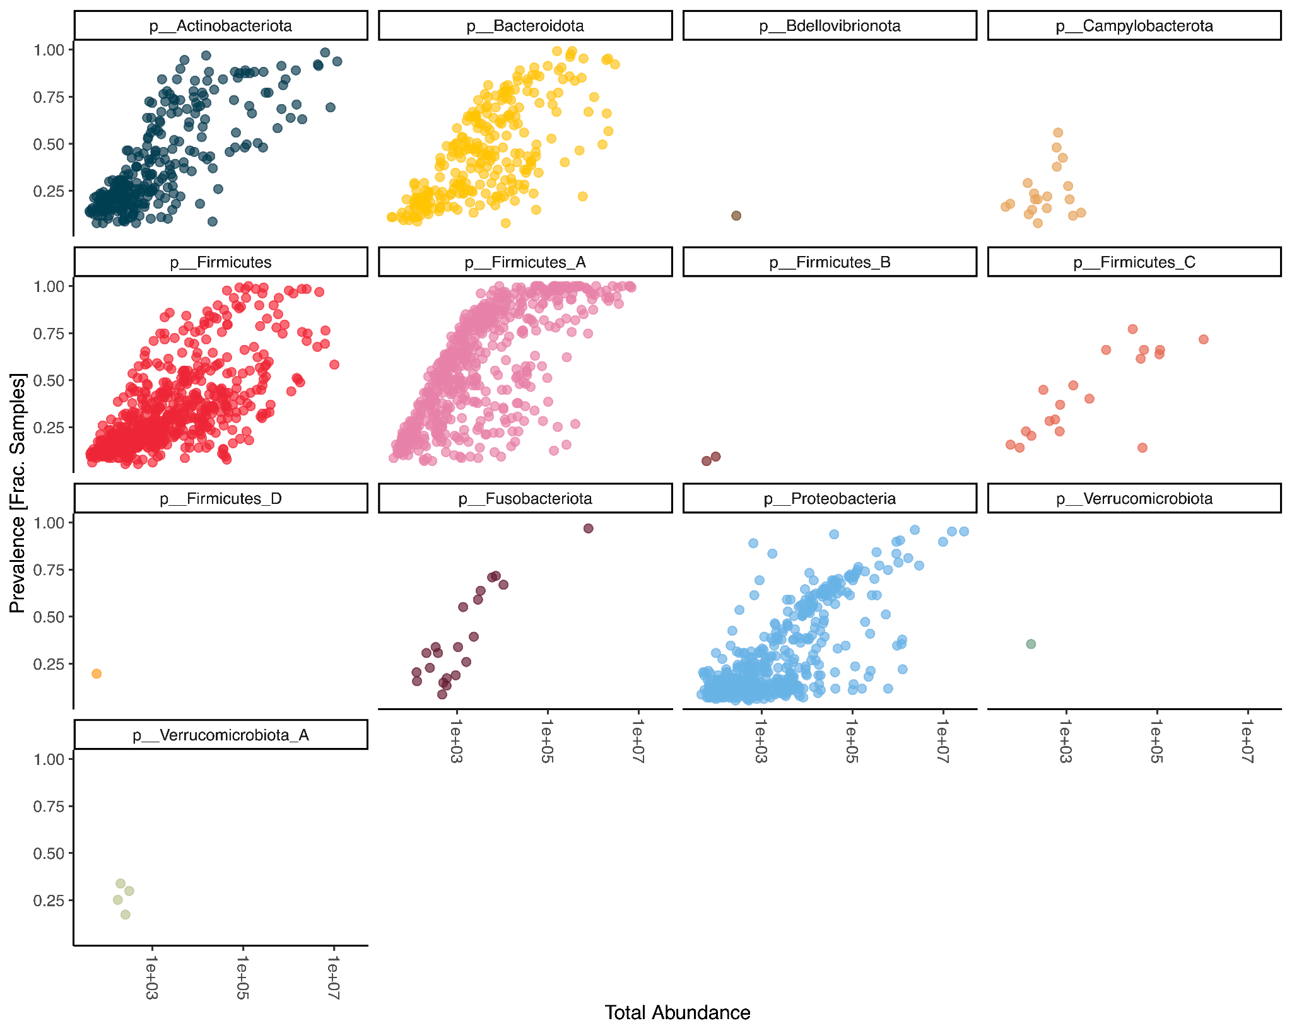
Supplemental Figure 2. Eigenvalues of the first 25 PCoA axes for the taxa level.
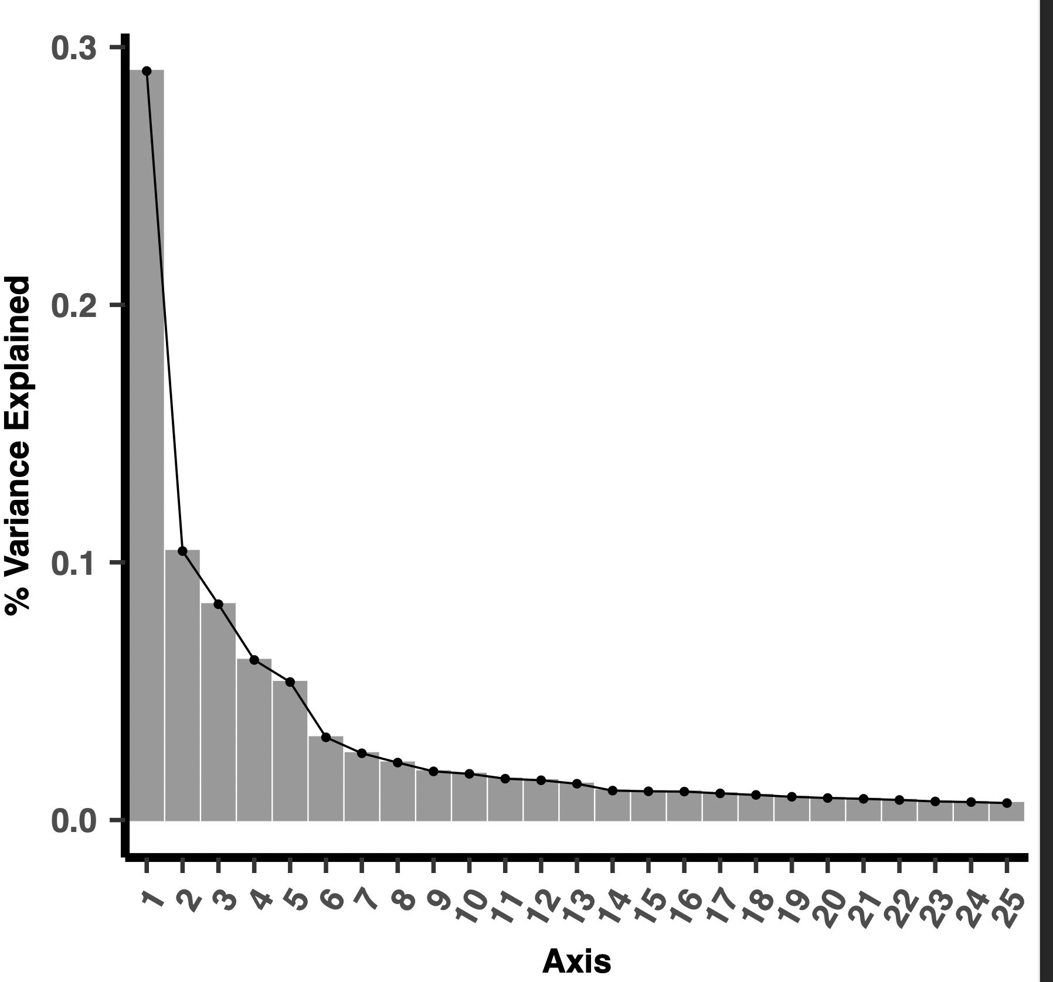
Supplemental Figure 3. Scores along the PCoA axes 1-5 of the species data in (A) fresh and (B) kibble diet samples. P values for pairwise comparisons were adjusted with Benjamini-Hochberg correction.
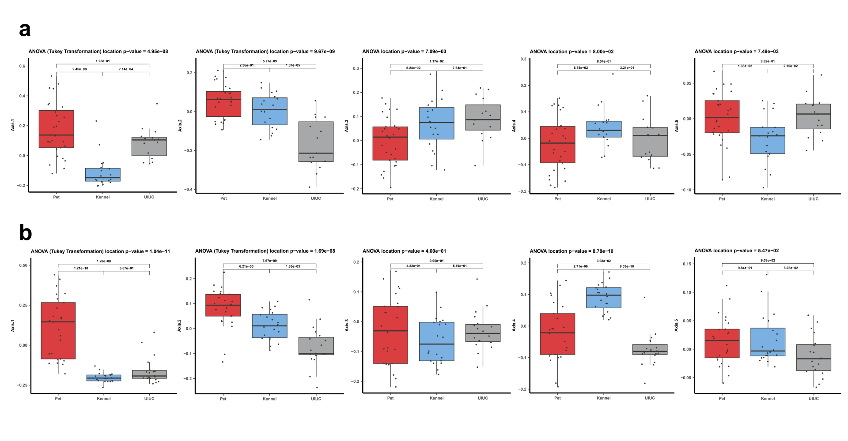

Supplemental Figure 4. Pairwise discriminant taxa in dogs fed a fresh diet. The discriminant taxa were identified with Linear discriminant analysis Effect Size (LEfSe) and further filtered with generalized linear models testing for differences in log10 read counts of taxa among cohorts. (A) LEfSe cladogram displaying filtered discriminant taxa. (B) LEfSe barplot of effect sizes of filtered discriminant taxa restricted to those with a linear Discriminant Analysis score > 3.0. Each bar represents a taxonomic feature and is colored according to the phylum for which the taxonomic feature belongs.
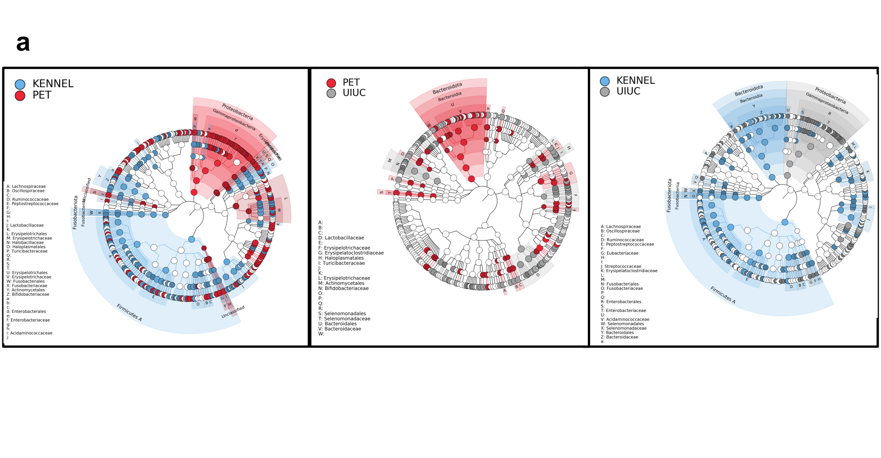

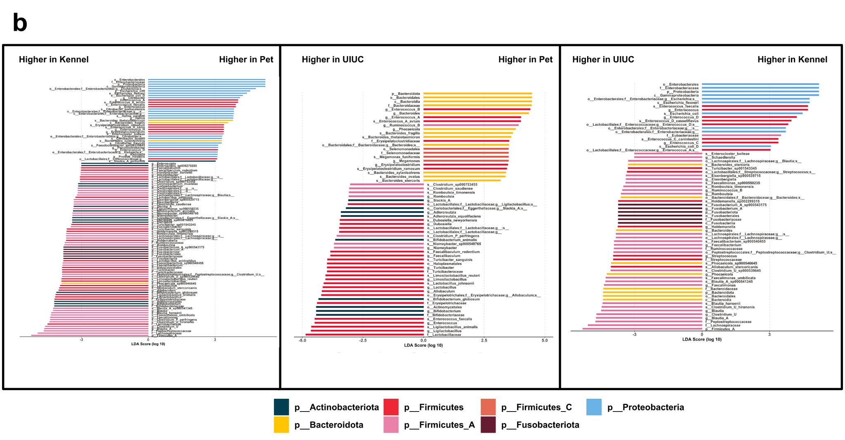

Supplemental Figure 5. Pairwise discriminant taxa in dogs fed a kibble diet. The discriminant taxa were identified with Linear discriminant analysis Effect Size (LEfSe) and further filtered with generalized linear models testing for differences in log10 read counts of taxa among cohorts. (A) LEfSe cladogram displaying filtered discriminant taxa. (B) LEfSe barplot of effect sizes of filtered discriminant taxa restricted to those with a linear Discriminant Analysis score > 3.0. Each bar represents a taxonomic feature and is colored according to the phylum for which the taxonomic feature belongs.
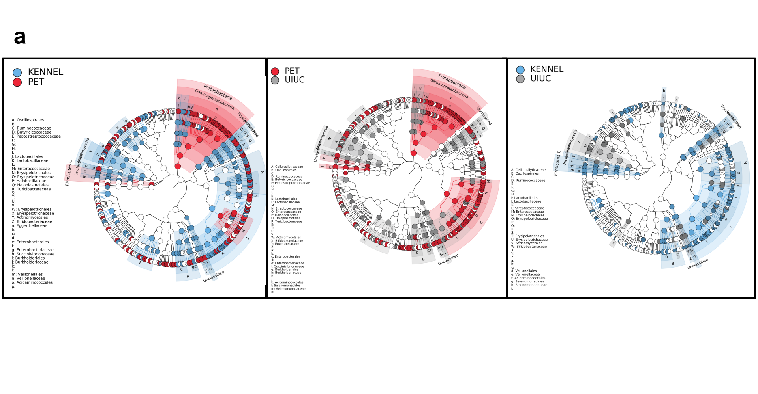

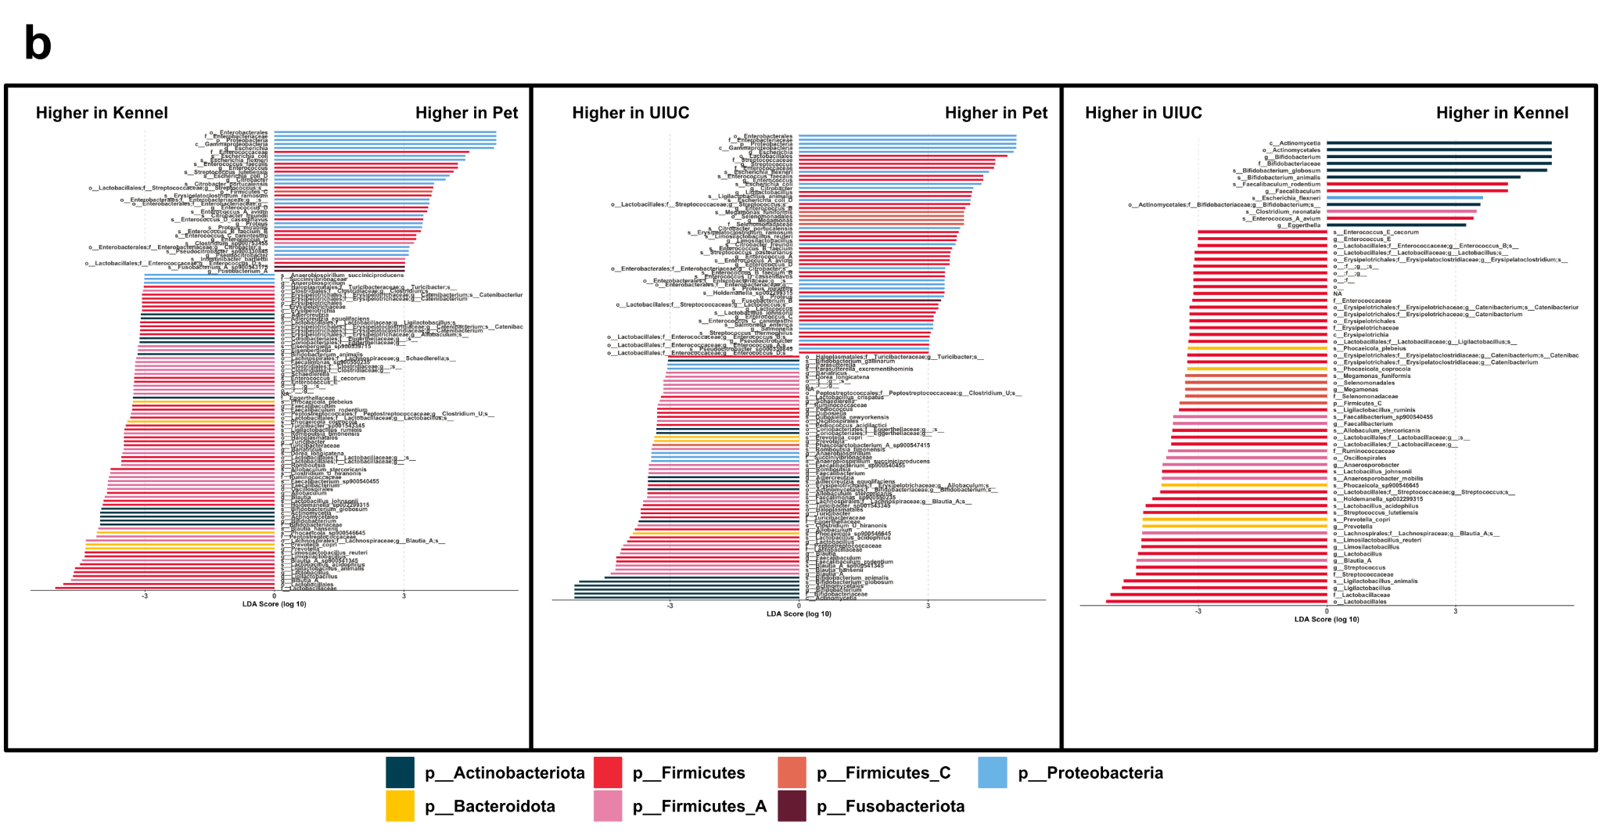

Supplemental Figure 6. Eigenvalues of the first 25 PCoA axes for the pathway data.
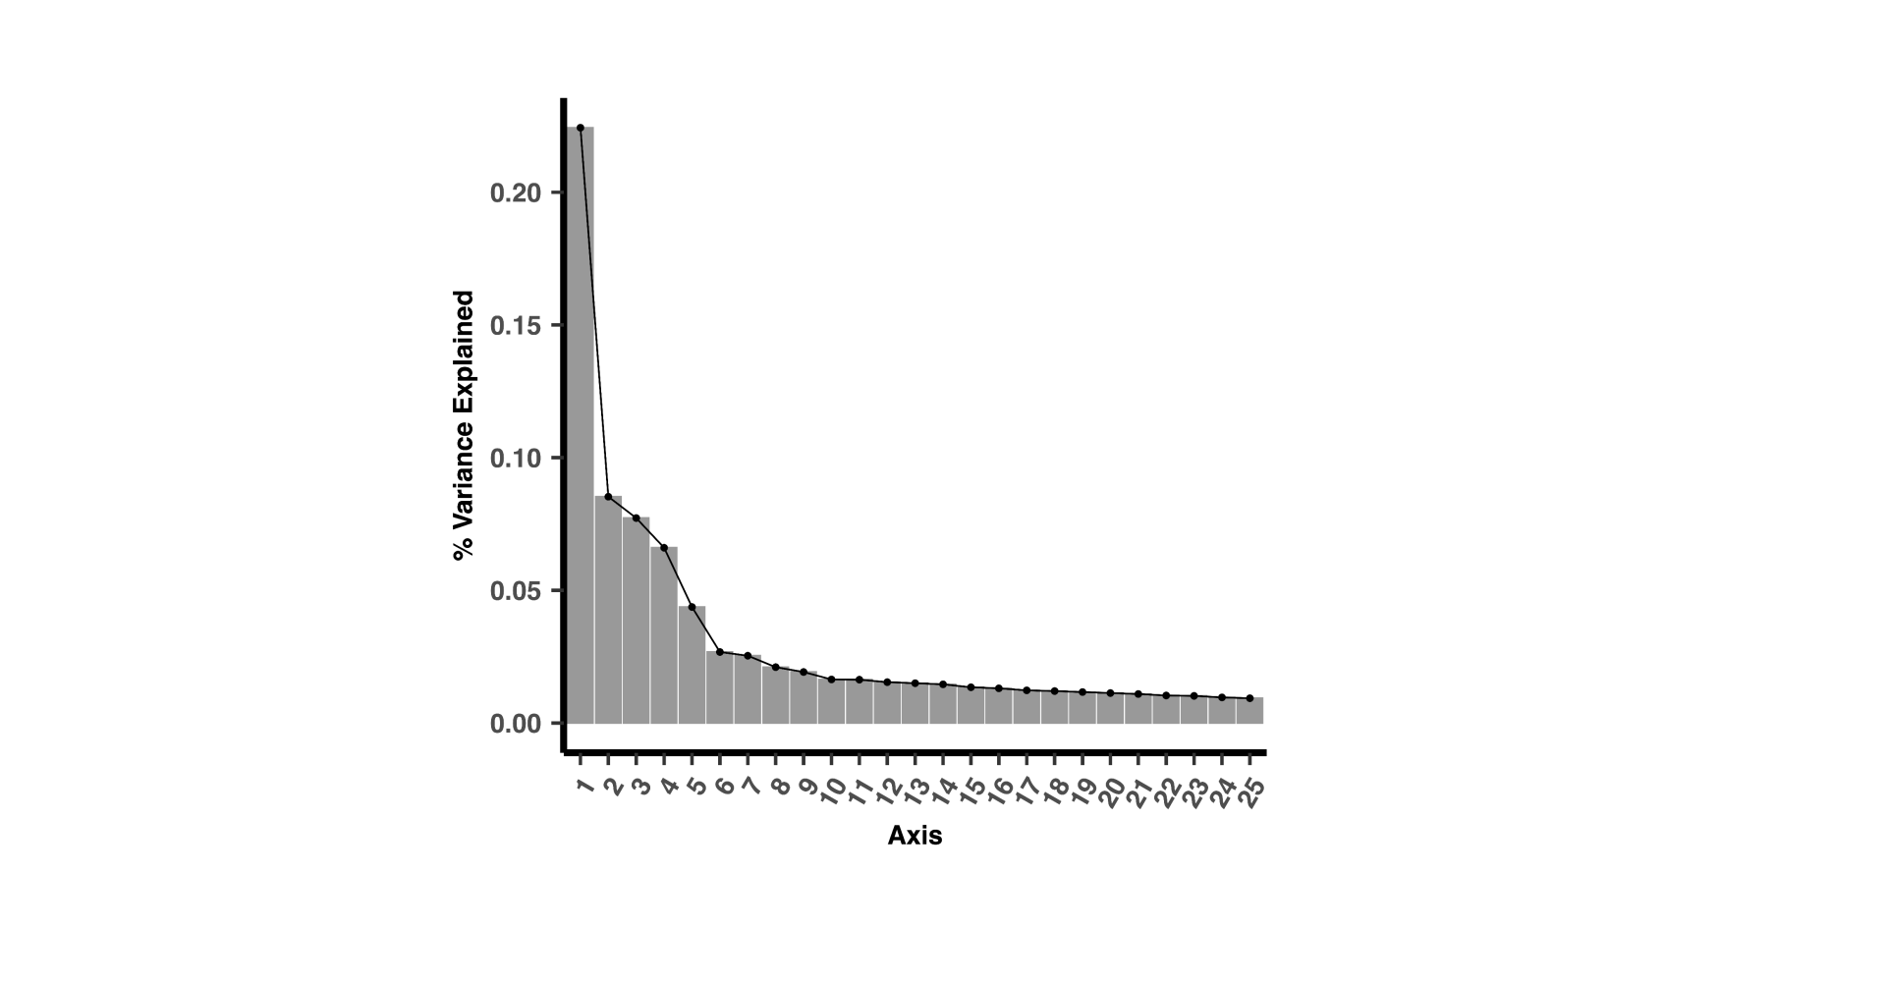

Supplemental Figure 7. Scores along the PCoA axes 1-4 of the KEGG pathway data in (A) fresh and (B) kibble diet samples. P values for pairwise comparisons were adjusted with Benjamini-Hochberg correction.
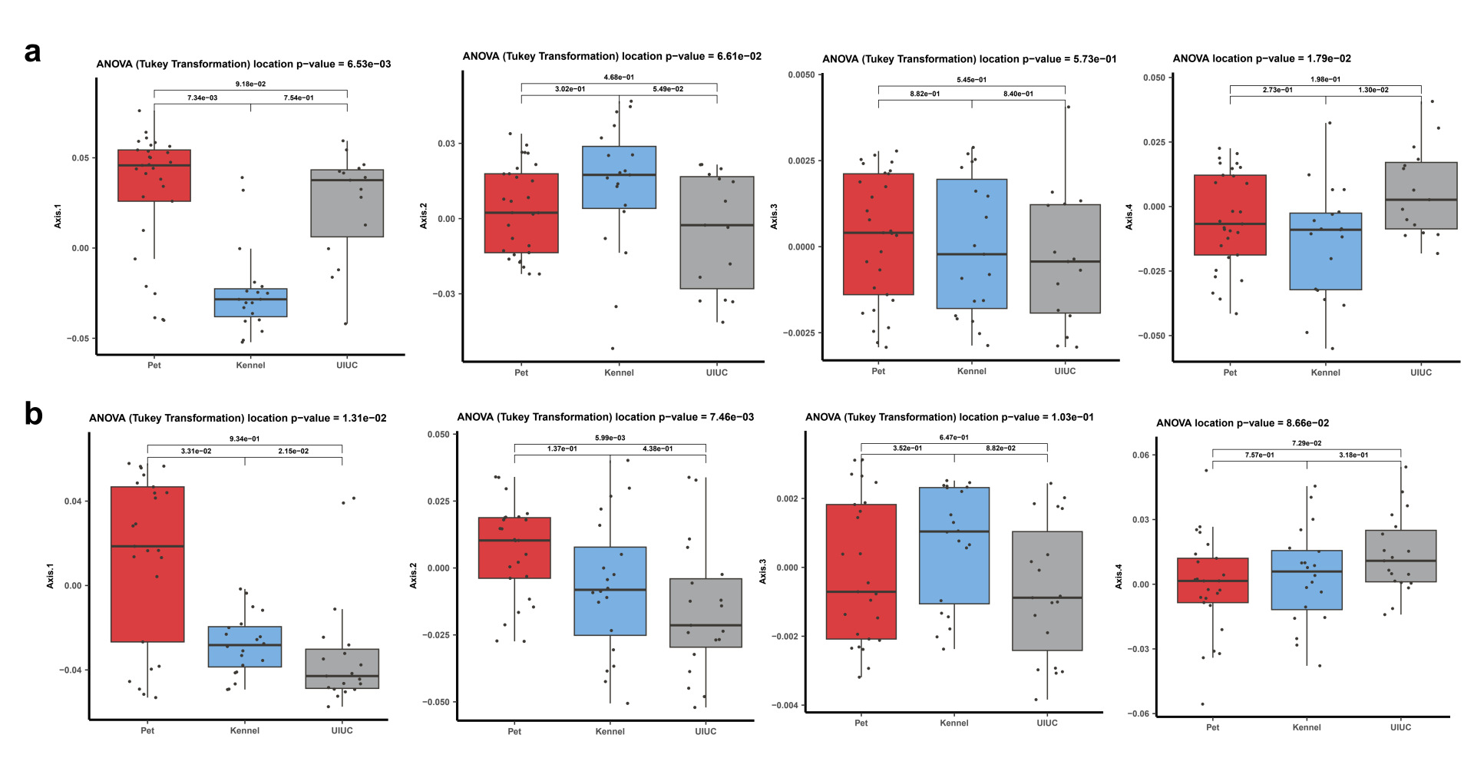

Supplemental Figure 8. Pairwise discriminant KEGG pathways. The discriminant KEGG pathways were identified with Linear discriminant analysis Effect Size (LEfSe) and further filtered with generalized linear models testing for differences in log10 read counts of taxa among cohorts while controlling for diet. (A) LEfSe cladogram displaying filtered discriminant KEGG pathways. (B) LEfSe barplot of effect sizes of filtered discriminant KEGG pathways. Each bar represents a KEGG pathway feature and is colored according to the KEGG Level 1 pathway for which the pathway feature belongs.
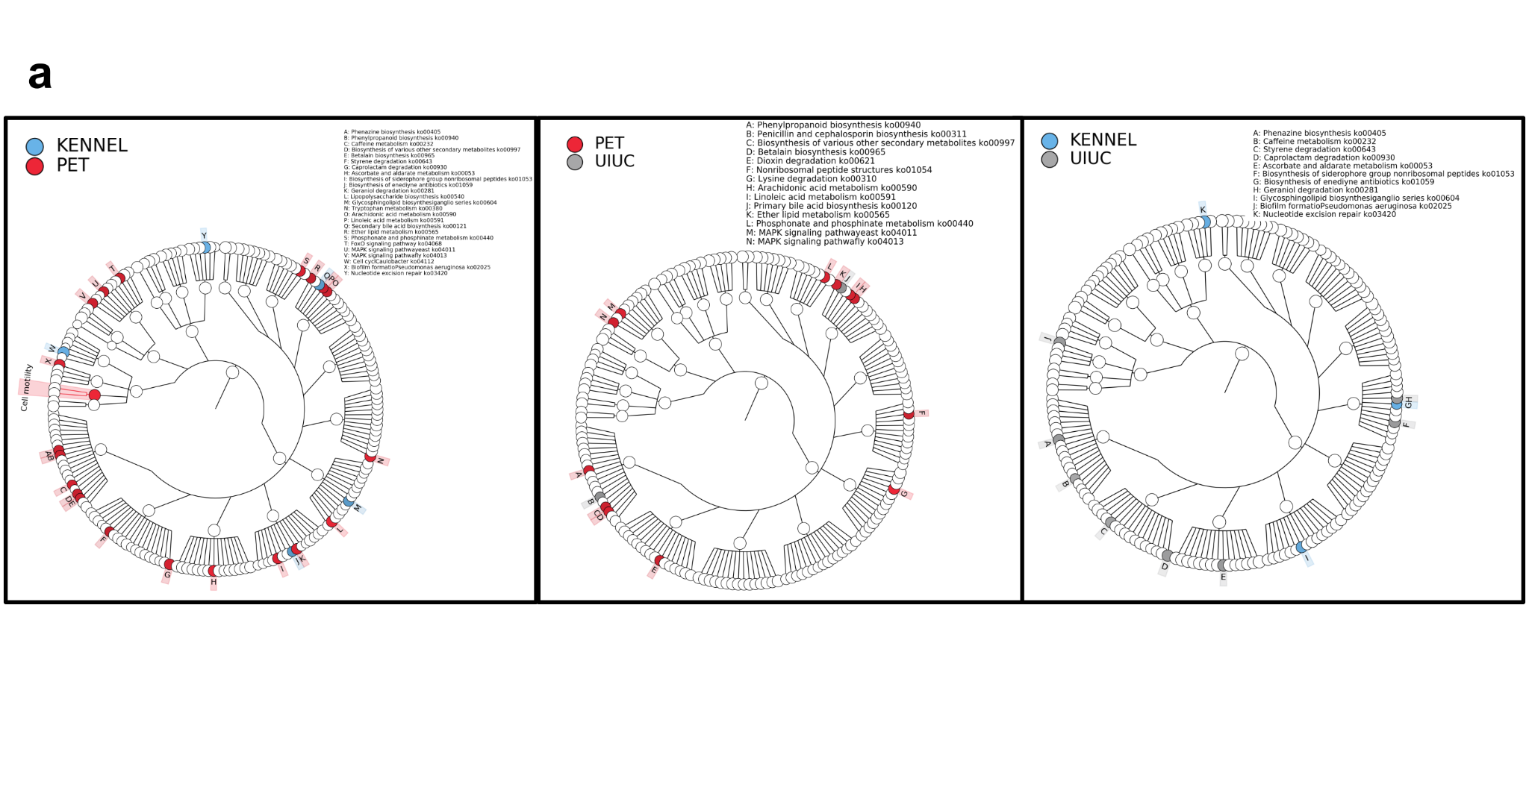

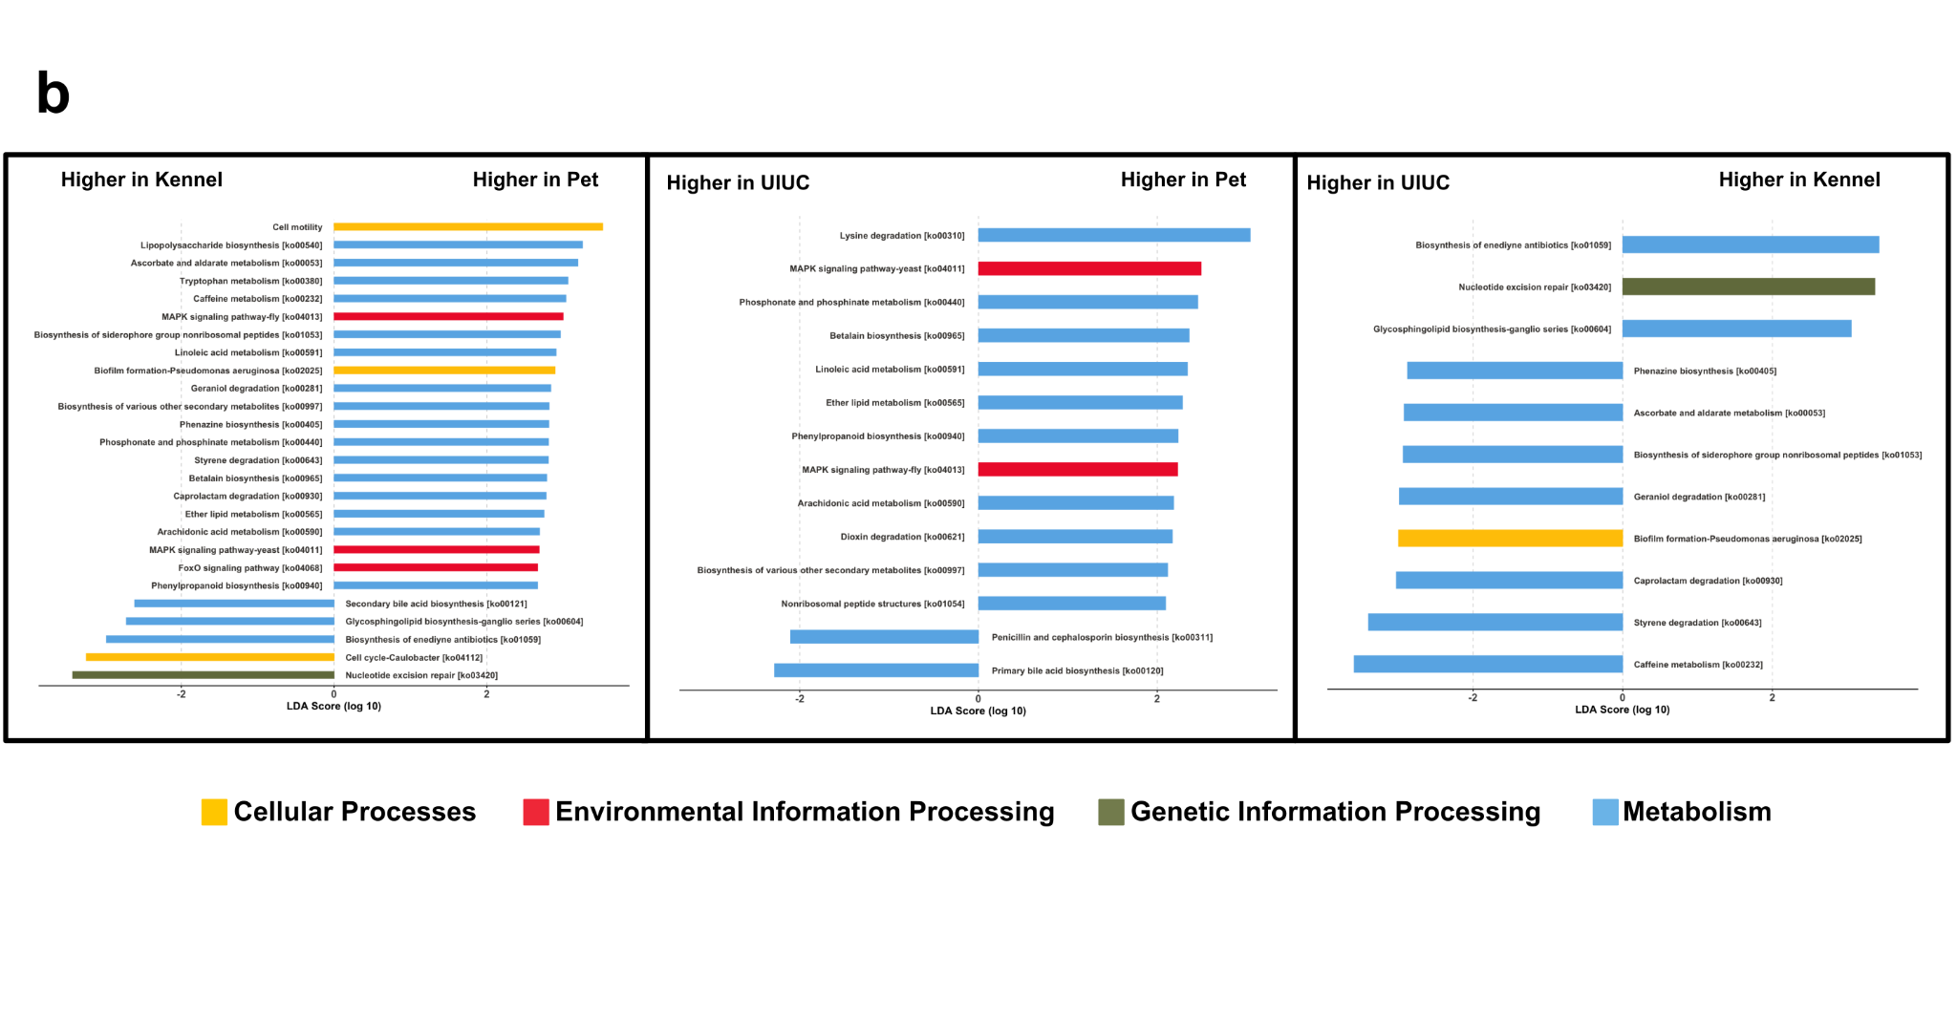

Supplemental Figure 9. Pairwise discriminant KEGG pathways in dogs fed a fresh diet. The discriminant KEGG pathways were identified with Linear discriminant analysis Effect Size (LEfSe) and further filtered with generalized linear models testing for differences in log10 read counts of taxa among cohorts. (A) LEfSe cladogram displaying filtered discriminant KEGG pathways. (B) LEfSe barplot of effect sizes of filtered discriminant KEGG pathways. Each bar represents a KEGG pathway feature and is colored according to the KEGG Level 1 pathway for which the pathway feature belongs.
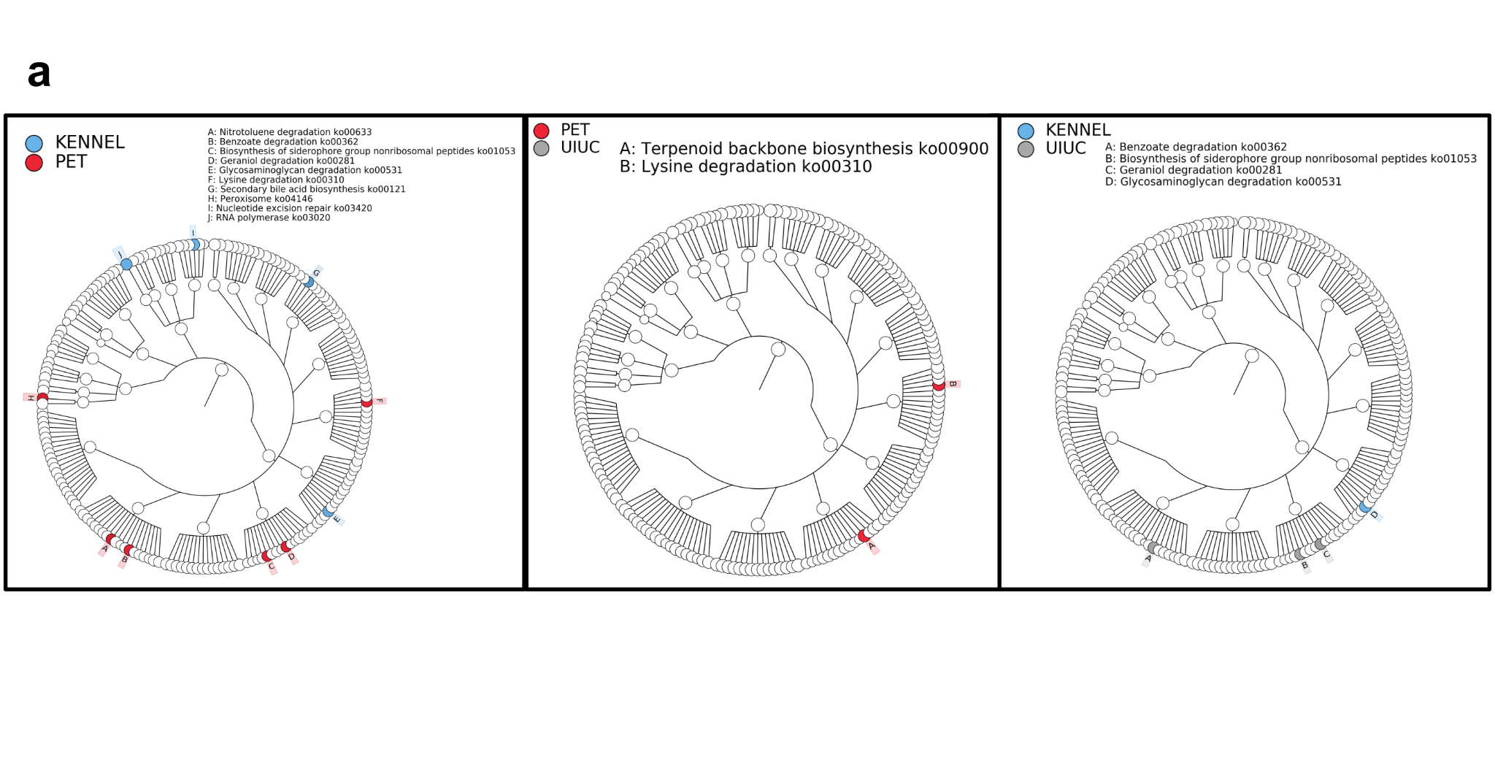

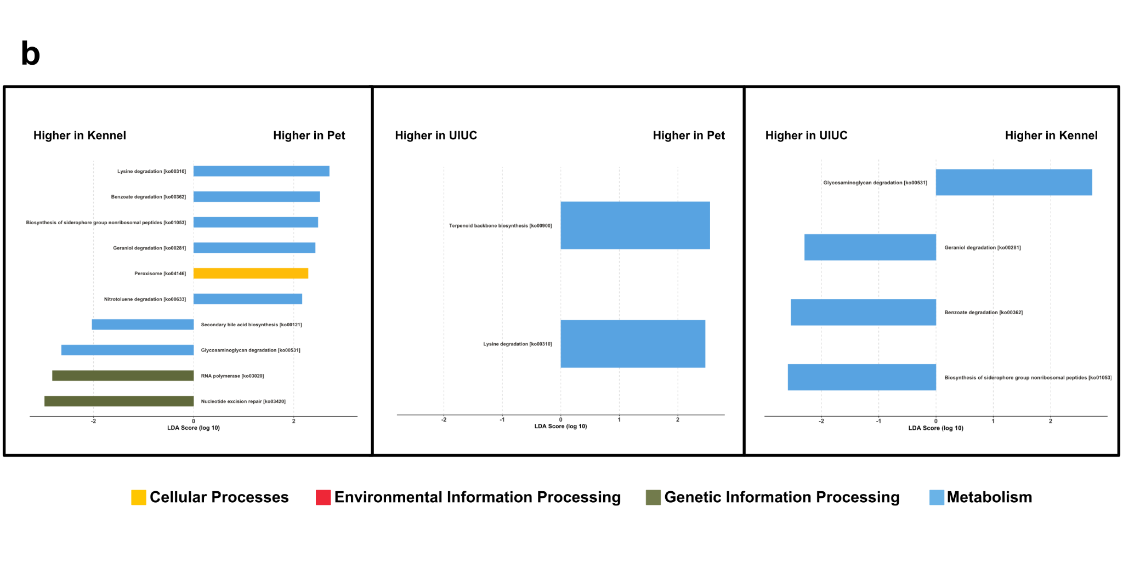

Supplemental Figure 10. Pairwise discriminant KEGG pathways in dogs fed a kibble diet. The discriminant KEGG pathways were identified with Linear discriminant analysis Effect Size (LEfSe) and further filtered with generalized linear models testing for differences in log10 read counts of taxa among cohorts. (A) LEfSe cladogram displaying filtered discriminant KEGG pathways. (B) LEfSe barplot of effect sizes of filtered discriminant KEGG pathways. Each bar represents a KEGG pathway feature and is colored according to the KEGG Level 1 pathway for which the pathway feature belongs.
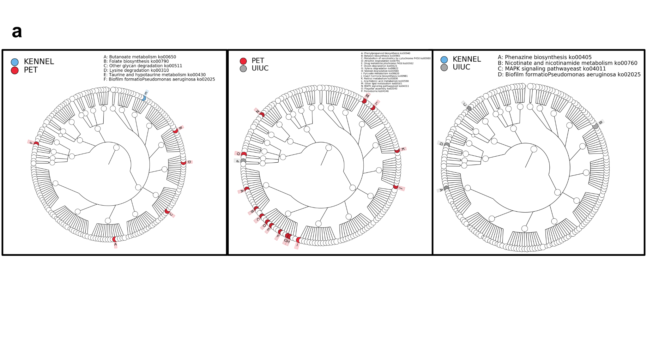

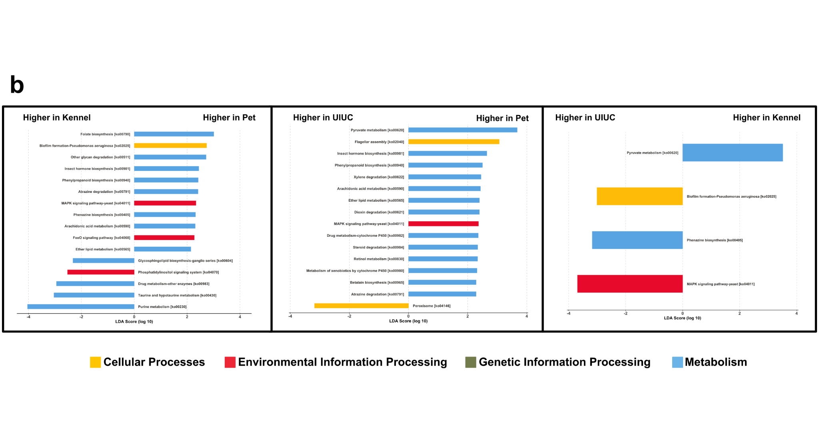

Supplemental Figure 11. Rarefaction curves at the species level. Each point represent the average value at each rarefied depth, and the lines represent standard error of the mean.
