Supplementary material

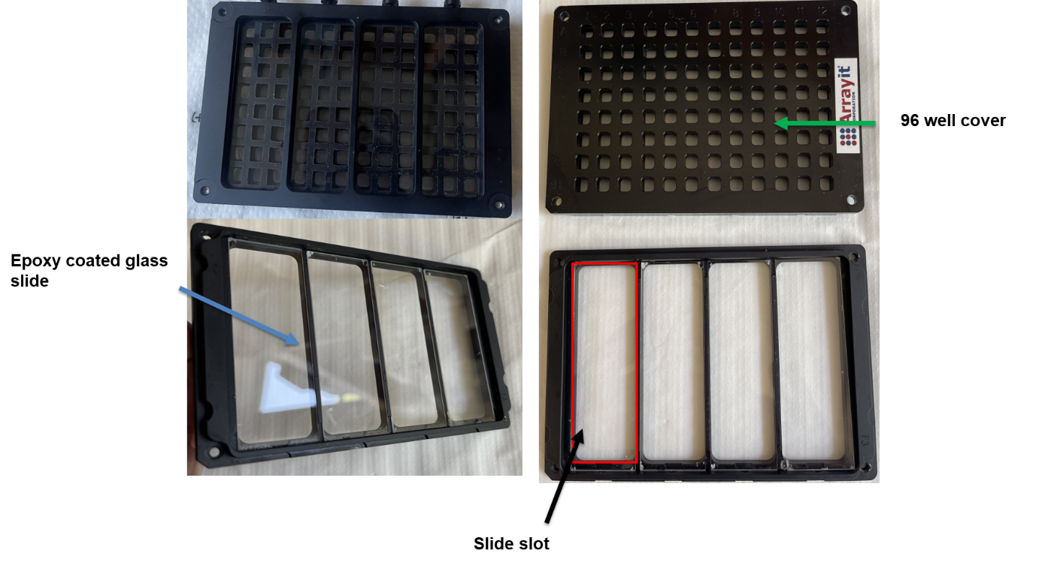

Supplementary Figure S1: An image of the 96 well hybridization cassette. The epoxy-coated glass slide indicated with the blue arrow was clamped into one of the cassette slots (indicated in red), this was to form a 96 well plate (see green arrow) with an epoxy glass slide base in which the HIV and TB antigen-antibody reactions were performed.

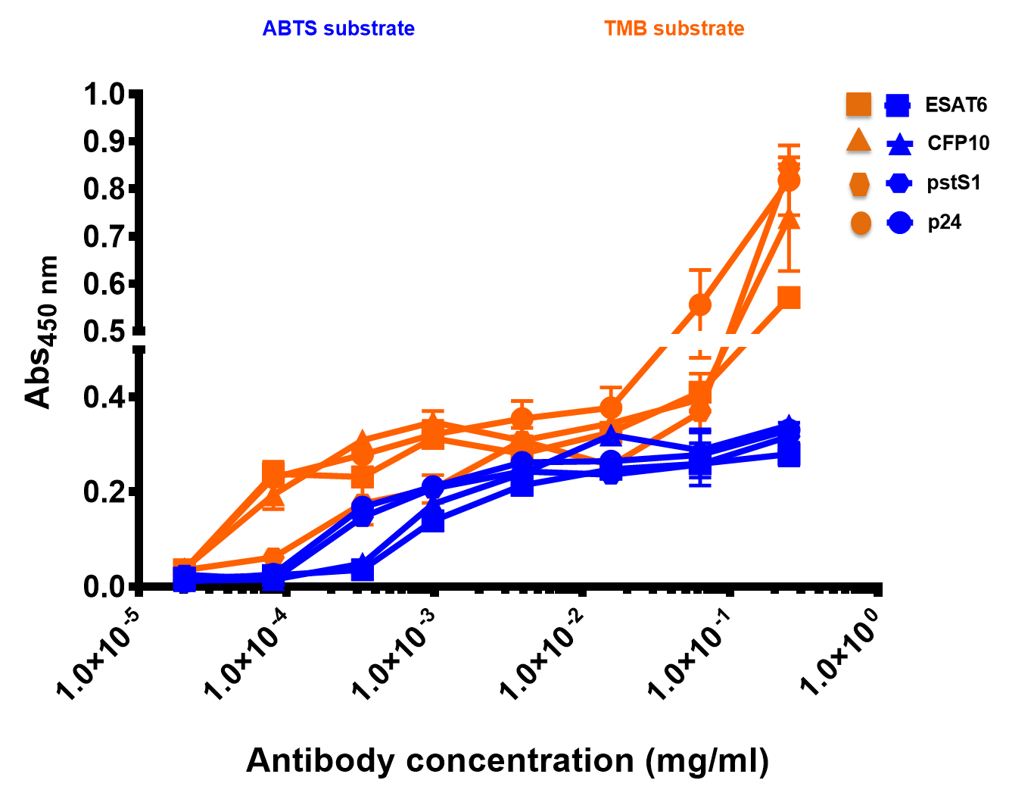

Supplementary Figure S2: Evaluation of the sensitivity of the antigen-antibody interaction in PBS . The anti-p24, anti-CFP10, anti-ESAT6 and anti-pstS1 primary antibodies were serially diluted in PBS and mixed to form a cocktail and incubated with immobilized antigens in the 96 well high-binding plates. Colorimetric detection was achieved using secondary antibodies conjugated to HRP, with ABTS or TMB as substrate. Data represent the mean of three independent experiments and error bars are standards deviation.

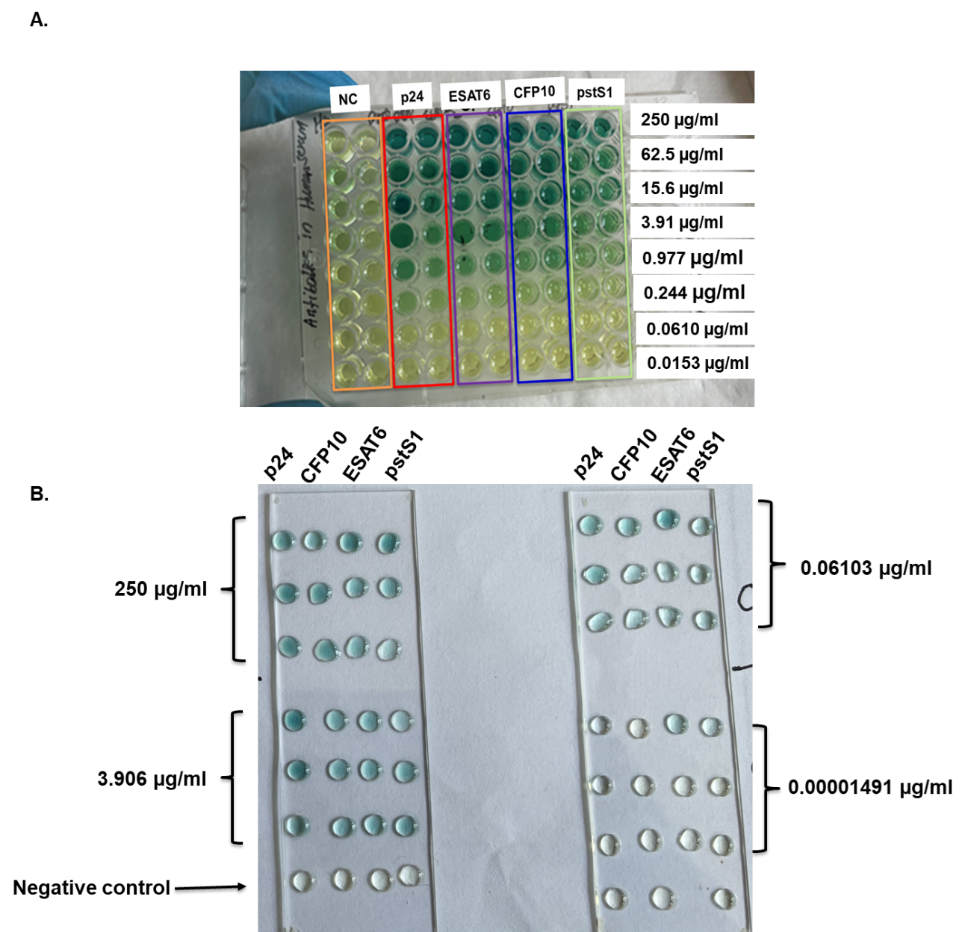

Supplementary Figure S3: Evaulation of the sensitivity of the HIV and TB antigen-antibody immunoassay by visual inspection. HIV-1 p24, M.tb CFP10, ESAT6 and pstS1 primary antibodies diluted in human serum were incubated with their corresponding antigens on either the 96 well high-binding plate (A) or epoxy-coated glass slides (B), and the dtection of the colour change reaction was done by visual inspection.

Supplementary Table S1: Head-to-head comparison of the limits of detection obtained on the epoxy-coated glass slides and high-binding plates using the ABTS substrate
Protein name | Limit of detection oh HIV and TB primary antibodies in human serum (ng/ml)
Protein name | ABTS substrate
Protein name | Epoxy slides | High-binding plates
HIV-1 p24 | 0.954 | 325.5
M.tb CFP10 | 0.954 | 976.5
M.tb ESAT6 | 0.954 | 81.38
M.tb pstS1 | 61.03 | 325.5

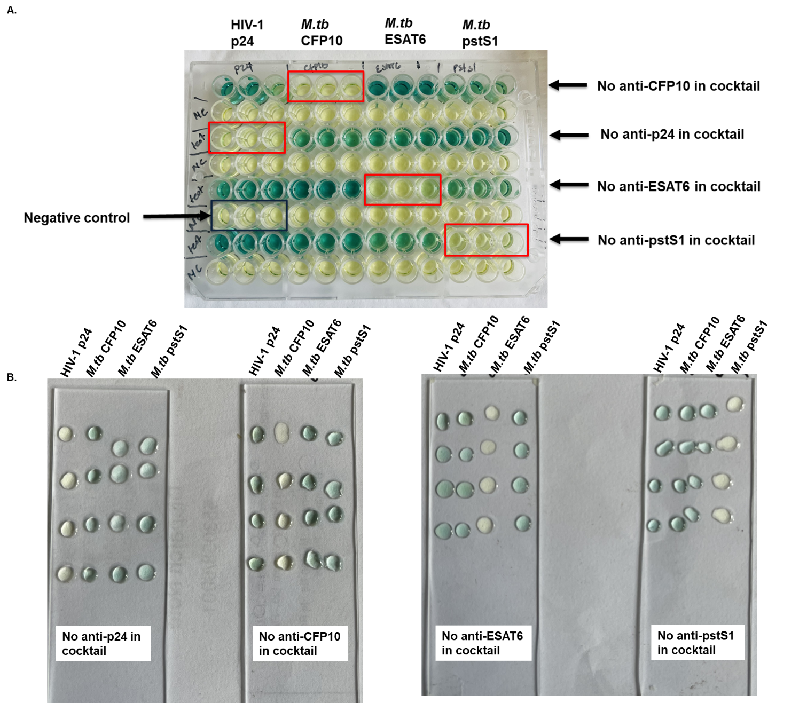

Supplementary Figure S4: Evaluation of the multiplex HIV and TB immunoassay specificity by visual inspection. The anti-p24, anti-CFP10, anti-ESAT6 and anti-pstS1 primary antibodies were diluted in human serum and mixed into a cocktail missing one primary antibody at a time, (A) in 96 well high-binding plates, and (B) on epoxy-coated microarray slides. The images represent three experiments performed on separate days. They were done in triplicates for the high-binding plates and quadruplicates for the epoxy-coated slides.

