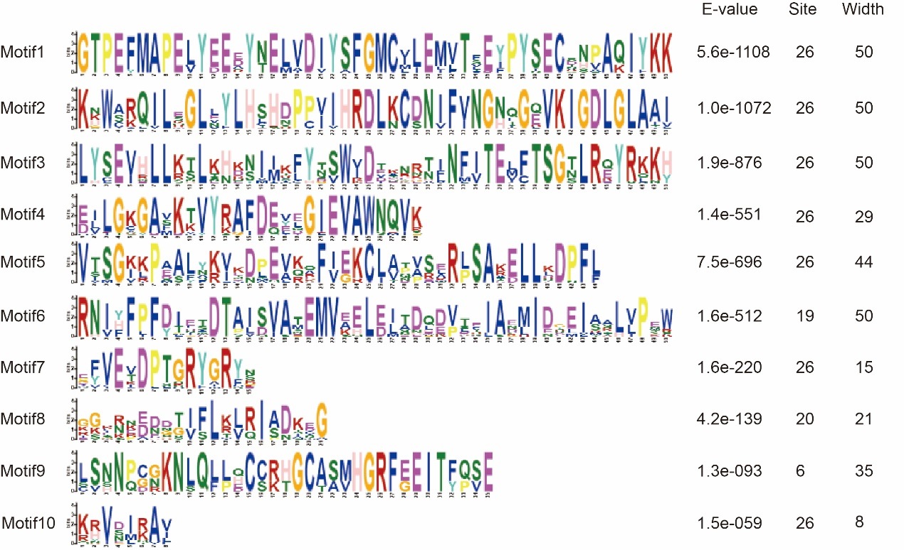
Figure S1 Graphical representation of conserved motif amino acids

Figure S2 The proportion of various cis-elements

