Supplementary Information
Sea cucumber viscera contains novel non-holostane-type glycoside toxins that possess a putative chemical defense function
Yanfang Liu ^{a,c,1}, Zhen Lu ^{a,1}, Zhi Yan ^{a,b}, Ainuo Lin ^{a,c}, Shaoshuai Han ^{a,d}, Yaxi Li ^{a,c}, Xiao Yang ^{a,c}, Xiaodong Li ª, Xiuli Yin ª, Ranran Zhang ^{a,c}, and Ke Li ^{a,}*
¹These authors contributed equally to this work.
*Correspondence: kli@yic.ac.cn; Tel.: +86-535-210-9286
Table of content
Fig. S1 High resolution mass spectra of compound 1 on negative mode 2
Fig. S2 High resolution mass spectra of compound 1 on positive mode 3
Fig. S3 ESI-MS/MS of compound 1 on negative mode 4
Fig. S4 ¹H NMR spectrum of compound 1 in methanol-d₄ 5
Fig. S5 1D TOCSY spectrum of compound 1 with anomeric H-1′ (δ_{H} 4.40) was irradiated 5
Fig. S6 1D TOCSY spectrum of compound 1 with anomeric H-1′′ (δ_{H} 4.66) was irradiated 6
Fig. S7 ¹³C NMR spectrum of compound 1 in methanol-d₄ 6
Fig. S8 DEPT spectra of compound 1 7
Fig. S9 ¹H-¹H COSY spectra of compound 1 7
Fig. S10 HSQC spectra of compound 1 8
Fig. S11 HMBC spectra of compound 1 8
Fig. S12 NOESY spectra of compound 1 9
Fig. S13 High resolution mass spectra of compound 2 on negative mode 10
Fig. S14 High resolution mass spectra of compound 2 on positive mode 11
Fig. S15 ESI-MS/MS of compound 2 on negative mode 12
Fig. S16 ¹H NMR spectrum of compound 2 in pyridine-d₅ 13
Fig. S17 1D TOCSY spectrum of compound 2 with anomeric H-1′ (δ_{H} 4.85) was irradiated 13
Fig. S18 1D TOCSY spectrum of compound 2 with anomeric H-1′′ (δ_{H} 5.26) was irradiated 14
Fig. S19 ¹³C NMR spectrum of compound 2 in pyridine-d₅ 14
Fig. S20 DEPT spectra of compound 2 15
Fig. S21 ¹H-¹H COSY spectra of compound 2 15
Fig. S22 HSQC spectra of compound 2 16
Fig. S23 HMBC spectra of compound 2 16
Fig. S24 NOESY spectra of compound 2 17
Fig. S25 96 h-LC50 Probit analysis of Compound 1 18
Fig. S26 96 h-EC50 analysis of Compound 2 18
Table S1. Mortality rates (%) of zebrafish embryos exposed to compound 1 and 2 (n = 3) 19
Table S2. Hatching rates (%) of zebrafish embryos exposed to compound 1 and 2 (n = 3) 19
Table S3. Malformation rates (%) of zebrafish embryos exposed to compound 1 and 2 (n = 3) 20
Table S4. Total body length (mm) of at 96 hpf after exposure with different concentrations of compound 1 and 2 (n = 9) 20

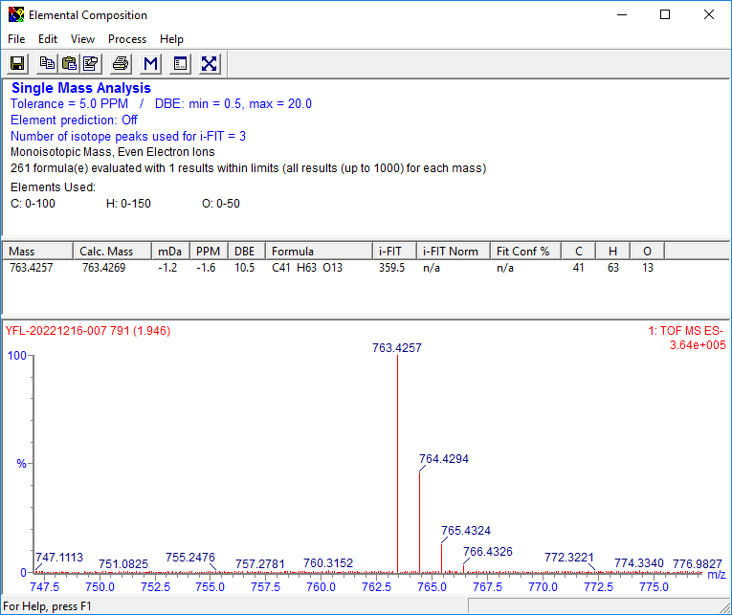

Fig. S1 High resolution mass spectra of compound 1 on negative mode

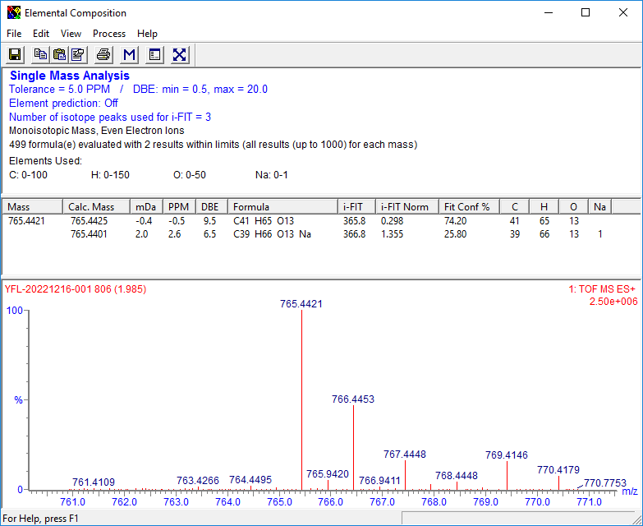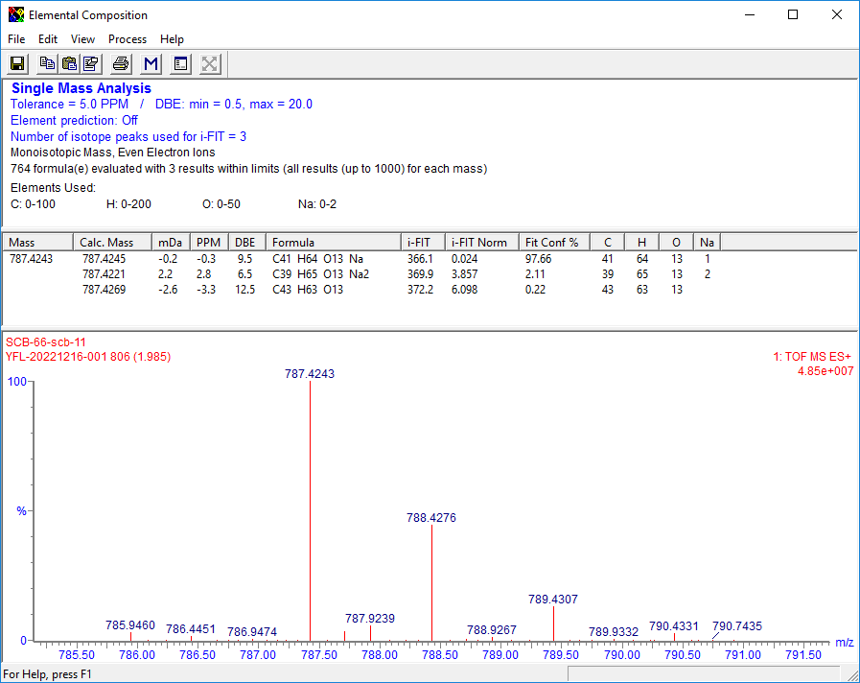

Fig. S2 High resolution mass spectra of compound 1 on positive mode

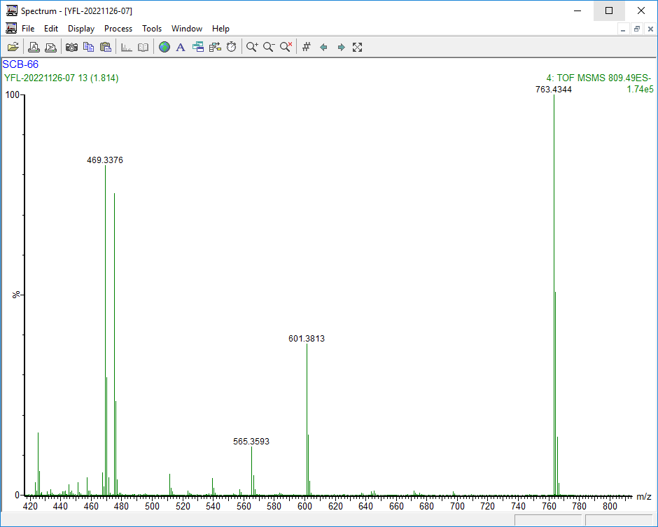
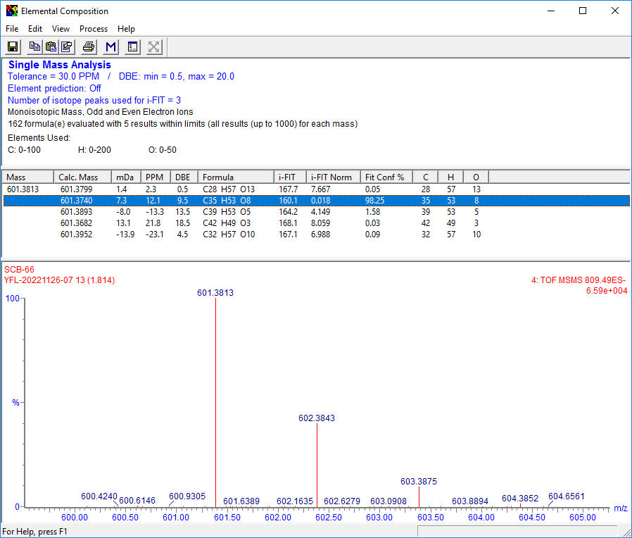
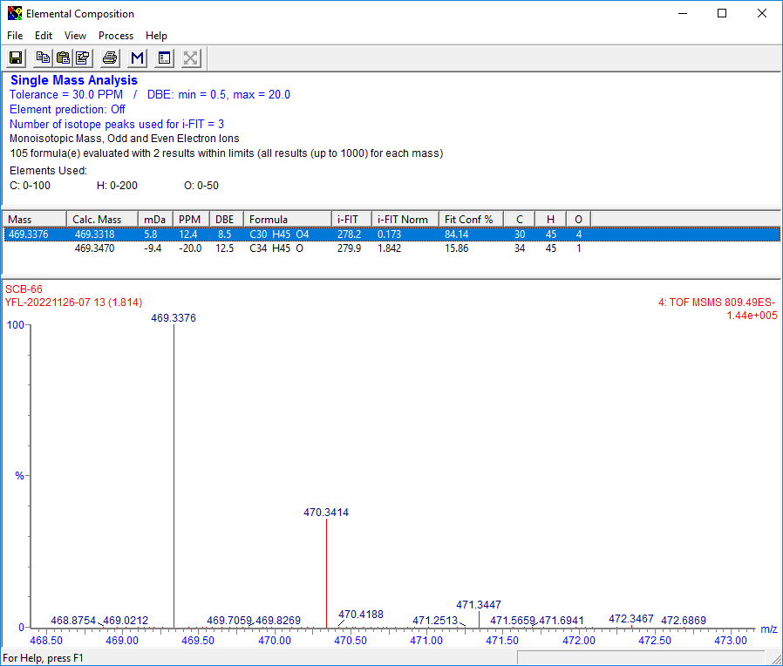

Fig. S3 ESI-MS/MS of compound 1 on negative mode

Fig. S4 ¹H NMR spectrum of compound 1 in methanol-d₄

Fig. S5 1D TOCSY spectrum of compound 1 with anomeric H-1′ (δ_{H} 4.40) was irradiated

Fig. S6 1D TOCSY spectrum of compound 1 with anomeric H-1′′ (δ_{H} 4.66) was irradiated

Fig. S7 ¹³C NMR spectrum of compound 1 in methanol-d₄

Fig. S8 DEPT spectra of compound 1

Fig. S9 ¹H-¹H COSY spectra of compound 1

Fig. S10 HSQC spectra of compound 1

Fig. S11 HMBC spectra of compound 1

Fig. S12 NOESY spectra of compound 1
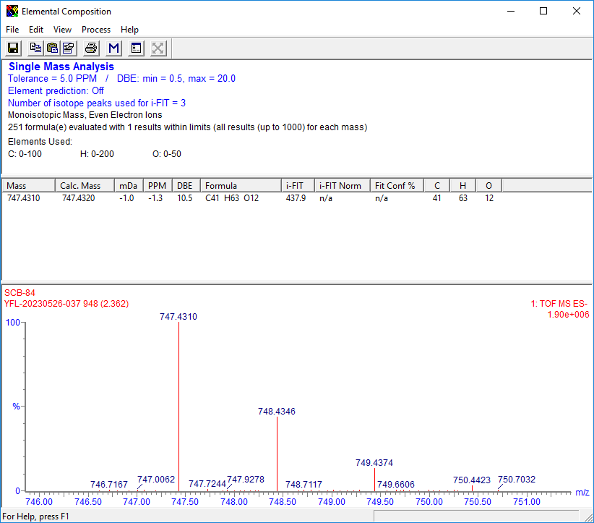

Fig. S13 High resolution mass spectra of compound 2 on negative mode

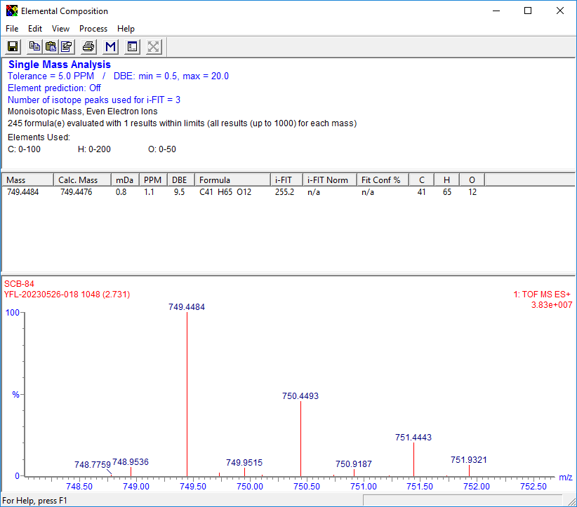
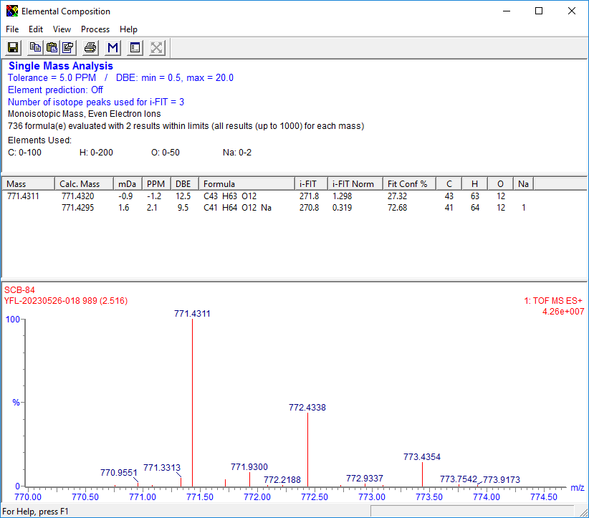

Fig. S14 High resolution mass spectra of compound 2 on positive mode

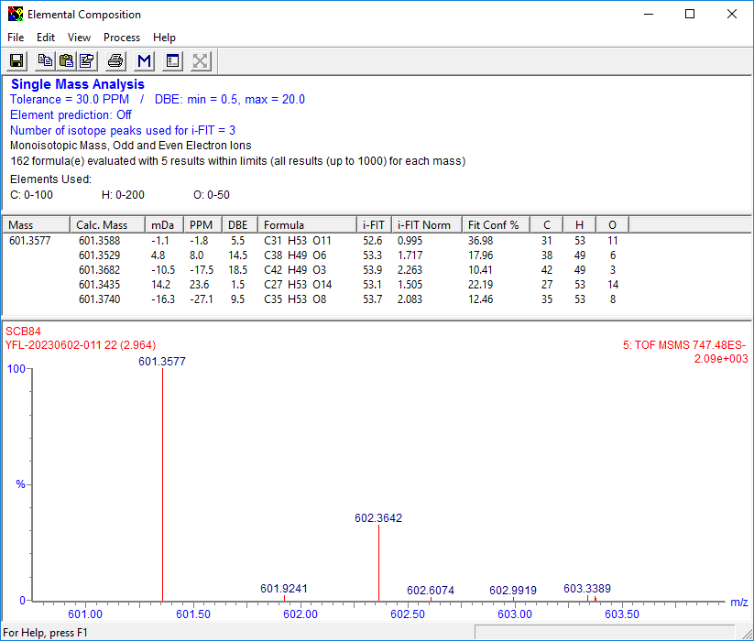
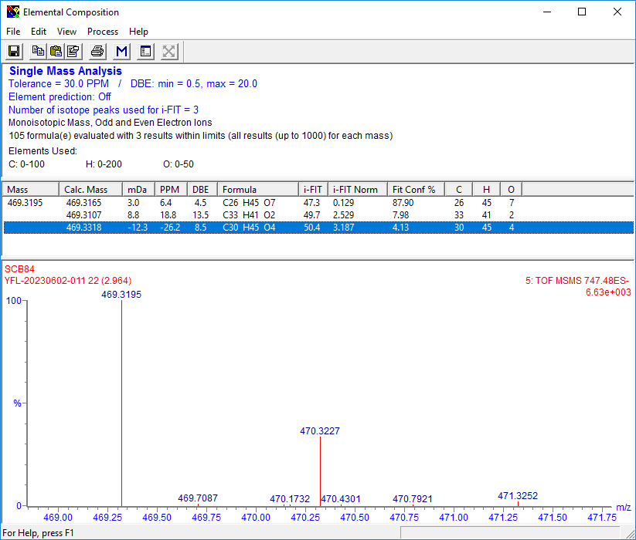
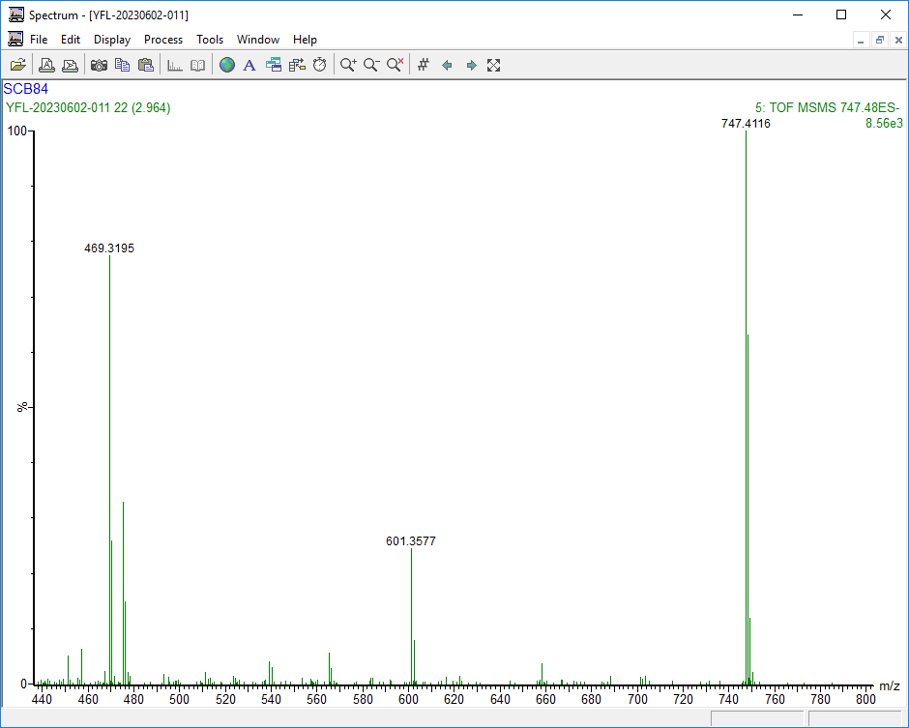

Fig. S15 ESI-MS/MS of compound 2 on negative mode

Fig. S16 ¹H NMR spectrum of compound 2 in pyridine-d₅

Fig. S17 1D TOCSY spectrum of compound 2 with anomeric H-1′ (δ_{H} 4.85) was irradiated

Fig. S18 1D TOCSY spectrum of compound 2 with anomeric H-1′′ (δ_{H} 5.26) was irradiated

Fig. S19 ¹³C NMR spectrum of compound 2 in pyridine-d₅

Fig. S20 DEPT spectra of compound 2

Fig. S21 ¹H-¹H COSY spectra of compound 2

Fig. S22 HSQC spectra of compound 2

Fig. S23 HMBC spectra of compound 2

Fig. S24 NOESY spectra of compound 2

Fig. S25 96 h-LC50 Probit analysis of Compound 1

Fig. S26 96 h-EC50 analysis of Compound 2

Table S1. Mortality rates (%) of zebrafish embryos exposed to compound 1 and 2 (n = 3)
Compound | Concentration  (μM) | Time point (hpf)
Compound | Concentration  (μM) | 12 | 24 | 48 | 72 | 96
1 | 0 | 0 | 0 | 0 | 0 | 0
1 | 20 | 0 | 0 | 6.67 ± 5.77 | 6.67 ± 5.77 | 20 ± 0
1 | 25 | 10 ± 0 | 26.67 ± 5.77 | 26.67 ± 5.77 | 26.67 ± 5.77 | 33.33 ± 5.77
1 | 30 | 6.67 ± 5.77 | 13.33 ± 5.77 | 16.67 ± 5.77 | 23.33 ± 5.77 | 26.67 ± 5.77
1 | 35 | 6.67 ± 5.77 | 23.33 ± 5.77 | 26.67 ± 5.77 | 30 ± 0 | 40 ± 10
1 | 40 | 10 ± 0 | 30 ± 10 | 36.67 ± 5.77 | 46.67 ± 5.77 | 53.33 ± 5.77
2 | 0 | 0 | 0 | 0 | 0 | 0
2 | 10 | 0 | 0 | 0 | 0 | 0
2 | 50 | 0 | 0 | 0 | 0 | 0
2 | 100 | 0 | 0 | 0 | 0 | 0
2 | 200 | 0 | 0 | 3.33 ± 5.77 | 3.33 ± 5.77 | 3.33 ± 5.77
2 | 300 | 0 | 3.33 ± 5.77 | 3.33 ± 5.77 | 3.33 ± 5.77 | 3.33 ± 5.77

Table S2. Hatching rates (%) of zebrafish embryos exposed to compound 1 and 2 (n = 3)
Compound | Concentration  (μM) | Time point (hpf)
Compound | Concentration  (μM) | 12 | 24 | 48 | 72
1 | 0 | 43.33 ± 5.77 | 93.33 ± 5.77 | 100 | 100
1 | 20 | 30 ± 0 | 90 ± 0 | 93.33 ± 5.77 | 93.33 ± 5.77
1 | 25 | 33.33 ± 5.77 | 53.33 ± 11.55 | 56.67 ± 5.77 | 56.67 ± 5.77
1 | 30 | 20 ± 0 | 80 ± 10 | 86.67 ± 5.77 | 86.67 ± 5.77
1 | 35 | 23.33 ± 5.77 | 56.67 ± 5.77 | 60 ± 10 | 60 ± 10
1 | 40 | 20 ± 10 | 40 ± 10 | 46.67 ± 5.77 | 46.67 ± 5.77
2 | 0 | 6.67 ± 5.77 | 86.67 ± 5.77 | 100 | 100
2 | 10 | 10 ± 0 | 83.33 ± 11.55 | 96.67 ± 5.77 | 100
2 | 50 | 13.33 ± 5.77 | 73.33 ± 5.77 | 86.67 ± 5.77 | 100
2 | 100 | 6.67 ± 5.77 | 73.33 ± 5.77 | 93.33 ± 5.77 | 100
2 | 200 | 23.33 ± 5.77 | 66.67 ± 5.77 | 83.33 ± 5.77 | 96.67 ± 5.77
2 | 300 | 3.33 ± 5.77 | 56.67 ± 5.77 | 93.33 ± 5.77 | 96.67 ± 5.77

Table S3. Malformation rates (%) of zebrafish embryos exposed to compound 1 and 2 (n = 3)
Compound | Concentration  (μM) | Time point (hpf)
Compound | Concentration  (μM) | 12 | 24 | 48 | 72 | 96
1 | 0 | 0 | 0 | 0 | 0 | 0
1 | 20 | 0 | 23.33 ± 5.77 | 23.33 ± 5.77 | 30 ± 10 | 36.67 ± 5.77
1 | 25 | 0 | 13.33 ± 5.77 | 16.67 ± 5.77 | 23.33 ± 5.77 | 26.67 ± 5.77
1 | 30 | 0 | 10 ± 0 | 10 ± 0 | 23.33 ± 5.77 | 23.33 ± 5.77
1 | 35 | 0 | 13.33 ± 5.77 | 13.33 ± 5.77 | 26.67 ± 5.77 | 26.67 ± 5.77
1 | 40 | 0 | 10 ± 0 | 10 ± 0 | 20 ± 10 | 20 ± 10
2 | 0 | 0 | 0 | 0 | 0 | 0
2 | 10 | 0 | 0 | 0 | 0 | 0
2 | 50 | 0 | 0 | 0 | 26.67 ± 5.77 | 30 ± 0
2 | 100 | 0 | 0 | 6.67 ± 5.77 | 33.33 ± 5.77 | 40 ± 0
2 | 200 | 0 | 0 | 6.67 ± 5.77 | 43.33 ± 5.77 | 46.67 ± 5.77
2 | 300 | 0 | 0 | 13.33 ± 5.77 | 53.33 ± 5.77 | 56.67 ± 5.77

Table S4. Total body length (mm) of at 96 hpf after exposure with different concentrations of compound 1 and 2 (n = 9)
Compound | Concentration (μM) | Total body length of at 96 hpf (mm)
1 | 0 | 3.82 ± 0.16
1 | 20 | 3.53 ± 0.14
1 | 25 | 3.59 ± 0.12
1 | 30 | 3.53 ± 0.16
1 | 35 | 3.61 ± 0.14
1 | 40 | 3.53 ± 0.18
2 | 0 | 4.22 ± 0.09
2 | 10 | 4.17 ± 0.07
2 | 50 | 4.06 ± 0.14
2 | 100 | 4.07 ± 0.10
2 | 200 | 4.04 ± 0.09
2 | 300 | 3.99 ± 0.19

