Supplementary Materials

Results

Descriptive data

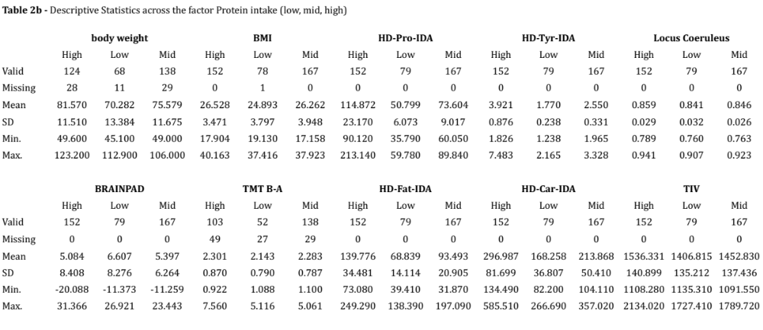

VBM – Tyrosine additional control analyses: 4th ventricle and Pons mask
As reported in table 3b, repeating the same model including the 4th ventricle as covariate, the results were reduced in spatial extent for all five neuromodulatory subcortical nuclei, suggesting that the regional level of ventricle enlargement might affect the integrity of the neuromodulator‘s seeds. Specifically for P<0.01 the LC cluster was reduced from 129 to 78 voxels, of which 34 survived p<0.001. Similarly, LC-tyrosine BF was also reduced at BF₁₀ 10798.29 from the previous BF₁₀ 14050.14. Similar effects were observed for the other ROIs as well. The LC results can be visually observed in figure 2b in the supplementary materials.

As final control procedure, this last model was repeated without isolating the LC region, but considering the whole Pons using a Pons binary mask. The results arising from this analysis outlined, as a primary cluster related to tyrosine intake, a bilateral group of voxels overlapping the previously published LC atlases and masks as shown in figure 2c in the supplementary materials. For P<0.01 threshold, the most significant cluster relating to HD-Tyr-IDA overlapped the LC region extending for 133 bilateral voxels. When the statistical threshold was increased to P<0.001, the LC cluster was reduced to 41 voxels. Other smaller clusters of voxels were scattered throughout the Pons. This final control procedure indicates an association between dietary tyrosine intake and the LC. For both, when the opposite relationships were tested, no relevant results were observed.

Figure 2b - Below the LC findings are shown in comparison with the spatial resolution of the previously published LC MRI masks and atlases. From an axial and coronal point of views, the VBM LC-Tyrosine cluster is displayed on a 3D LC reconstruction of the “omni-comprehensive” LC mask by Plini et al. 2021

LC-Tyrosine 4th ventricle covaried

Table 3b

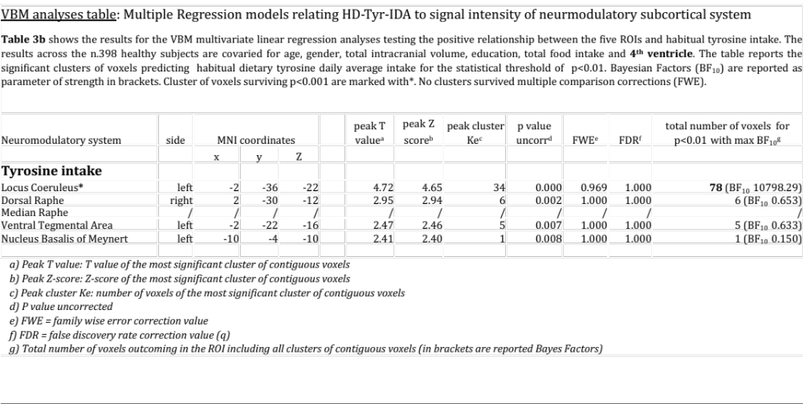

Tyrosine and the Pons mask

Figure 2c

VBM - Tyrosine time point 2 on 291 participants
The exploratory analyses investigating the possible relationship between HD-Tyr-IDA at time point one and LC integrity taken at time point two 3 years later, revealed that habitual tyrosine intake reported 3 years earlier related to LC signal intensity. However, the magnitude and the cluster extent was dramatically reduced. As reported in table 3c in the supplementary materials, for the statistical threshold of P<0.01 35 LC voxels related to dietary tyrosine intake (BF₁₀ 1.96 – anecdotal evidence). Only 12 voxels of the LC survived to P<0.001 and disappeared when more conservative statistical thresholds were applied. Figure 2d in the supplementary materials display the spatial extent of the LC cluster.

Figure 2d - Below the LC findings are shown in comparison with the spatial resolution of the previously published LC MRI masks and atlases. From an axial and coronal point of views, the VBM LC-Tyrosine cluster (at time point 2) is displayed on a 3D LC reconstruction of the “omni-comprehensive” LC mask by Plini et al. 2021

Table 3c

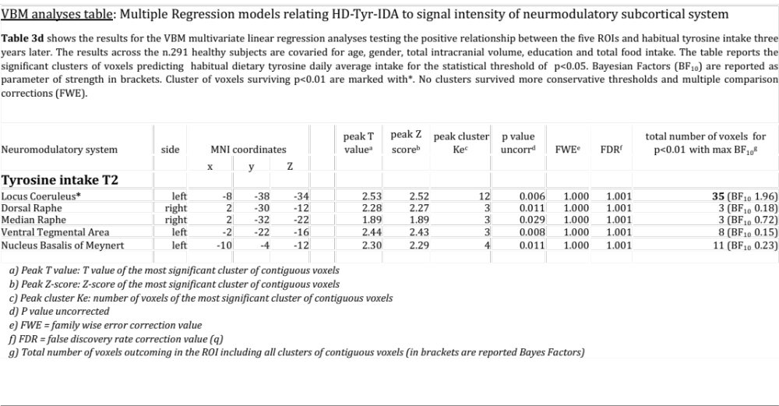

VBM – Tyrosine and Bayesian modelling
By testing the other neuromodulator seeds, negligible or no results arose, indicating a predominant sensitivity of the LC to tyrosine intake in contrast to the other main neuromodulatory subcortical nuclei. In the same way, no results emerged when the opposite relationships for the five ROIs were tested.
When examining the five ROIs simultaneously in the same Bayesian multiple regression model, the combined effect of LC + VTA (BF₁₀ 231041.046) resulted in the strongest model related to tyrosine intake, and the relationship between tyrosine and VTA emerged (BF_{inclusion} 4.710), but the disproportionate involvement of LC-NA system was predominant (BF_{inclusion} 792.331 - for details refer to table 4). Furthermore, when in the model was additionally controlled for participants’ BMI, body weight, height, waist circumference and the 4th ventricle, the same pattern of findings was obtained. Noticeably, the LC+VTA effect increased to BF₁₀ to 349682.325 and the LC BF_{inclusion} doubled to 1412.285 while the VTA raised to 40.732. For further details refer to table 4b in the supplementary materials.
Lastly, both at visual inspection and with formal analyses, the LC-tyrosine relationship showed the same trajectory and the same pattern in both young and old populations (for further details please refer to table 4c and 4d and figure 2e in the supplementary materials). This result is consistent with the findings by Kühn and colleagues (2017), where no differences in the relationship between Tyrosine and cognitive functions were found in young and older participants.

Table 4b
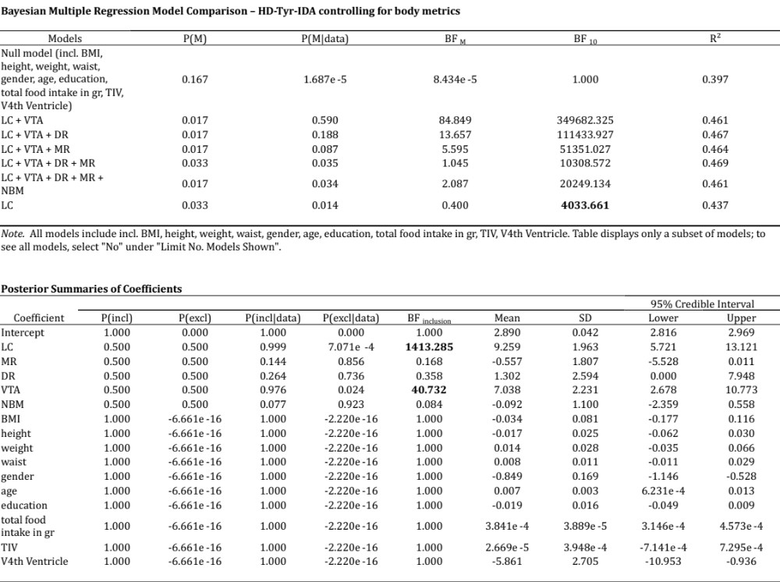

Table 4c

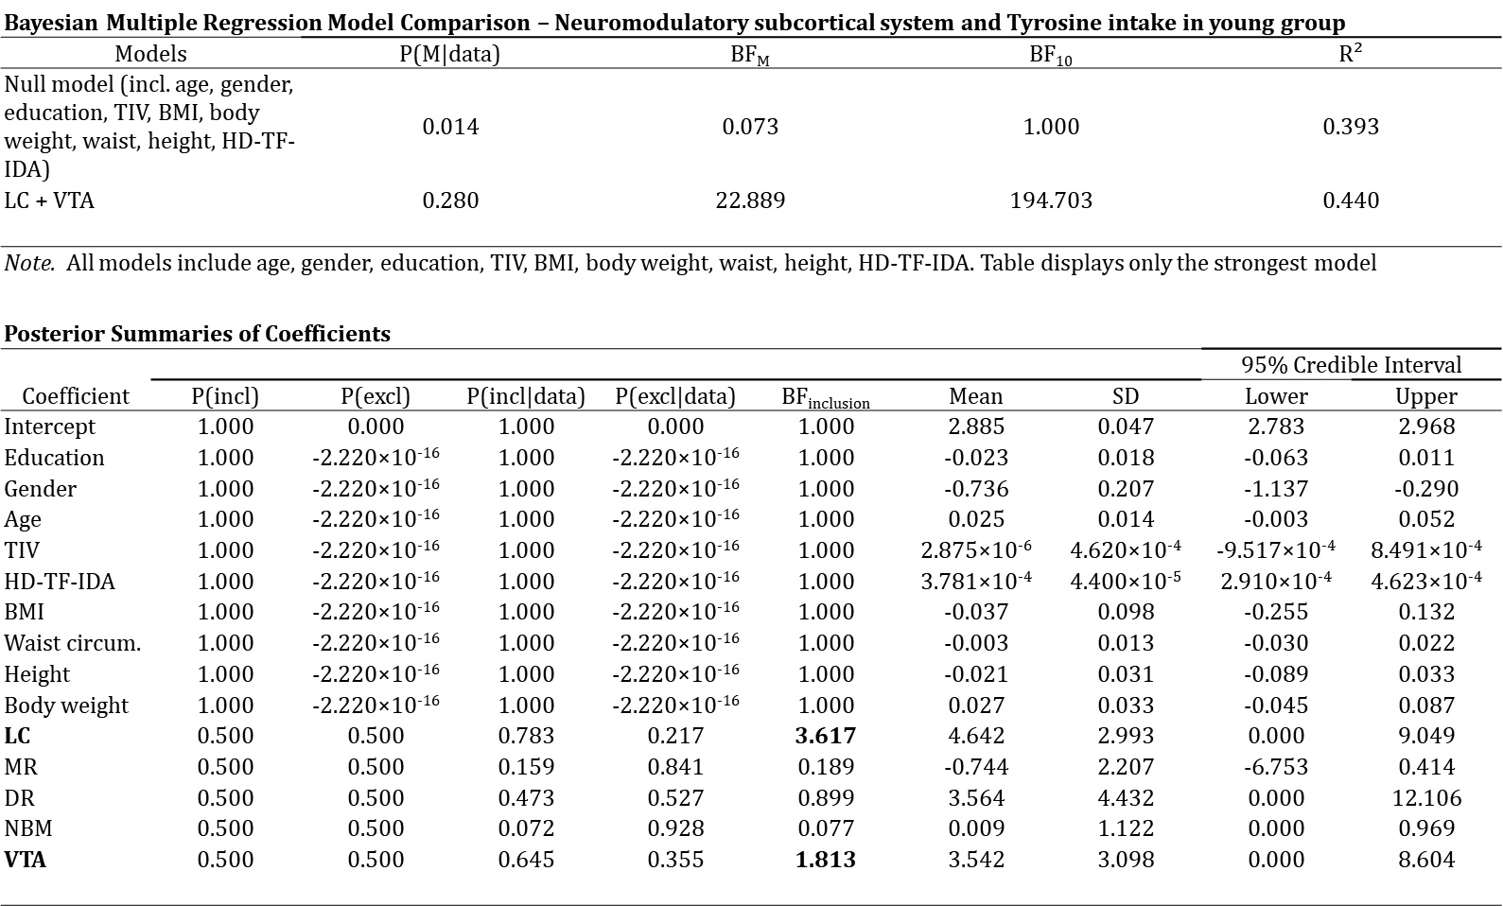

Table 4d

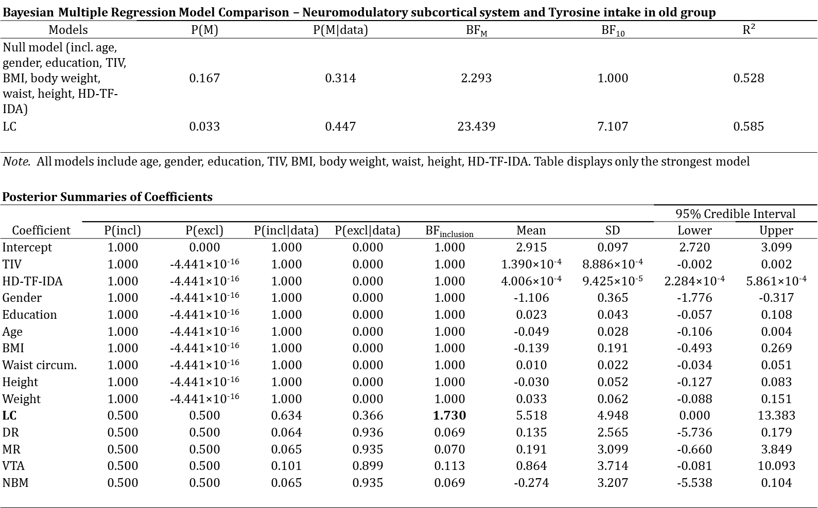

Figure 2e
In addition, table 4e reports the multiple regression model for the association between LC and Tyrosine including a multicollinearity check with variance inflation factors which are all acceptable (VIF below 2.5). This is reassuring that the data are not susceptible to variance inflation due multiple covariates and that the performed regression models are stable after checking for multicollinearity.

Table 4e

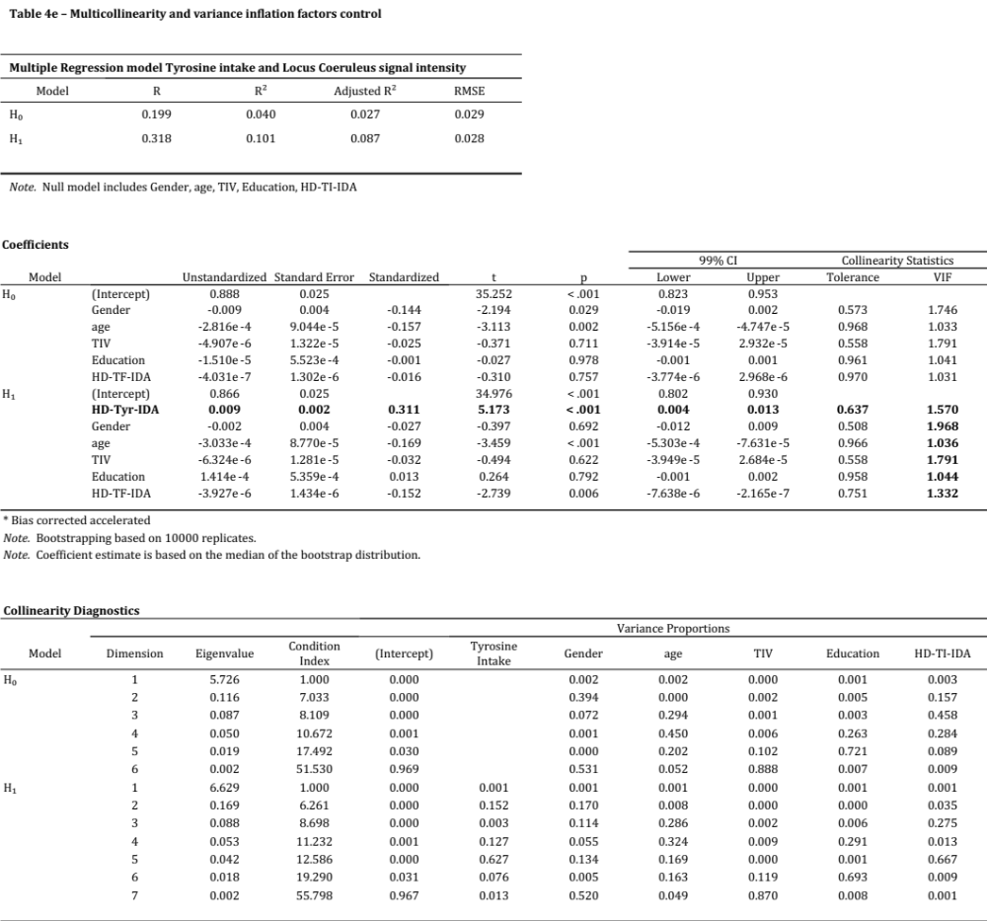

Univariate analyses LC-Tyrosine relationship

Figure 2f – screenshots comparing univariate VBM vs multivariate VBM

from CAT12 / SPM output

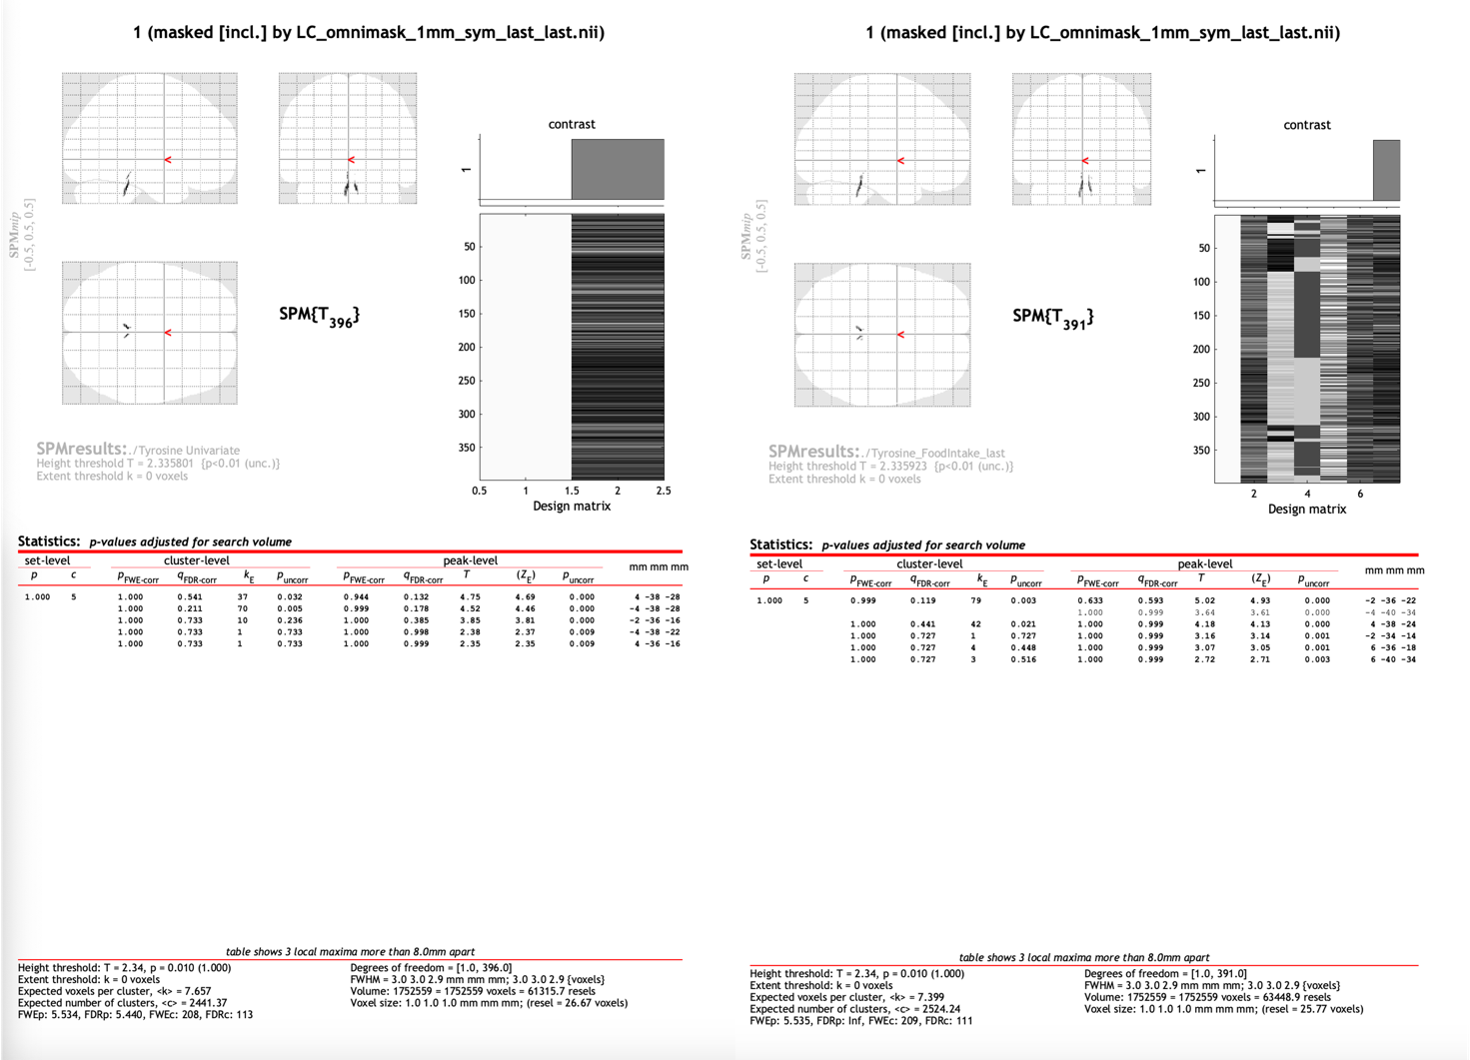

Figure 2g – Bayesian correlation LC-Tyrosine relationship

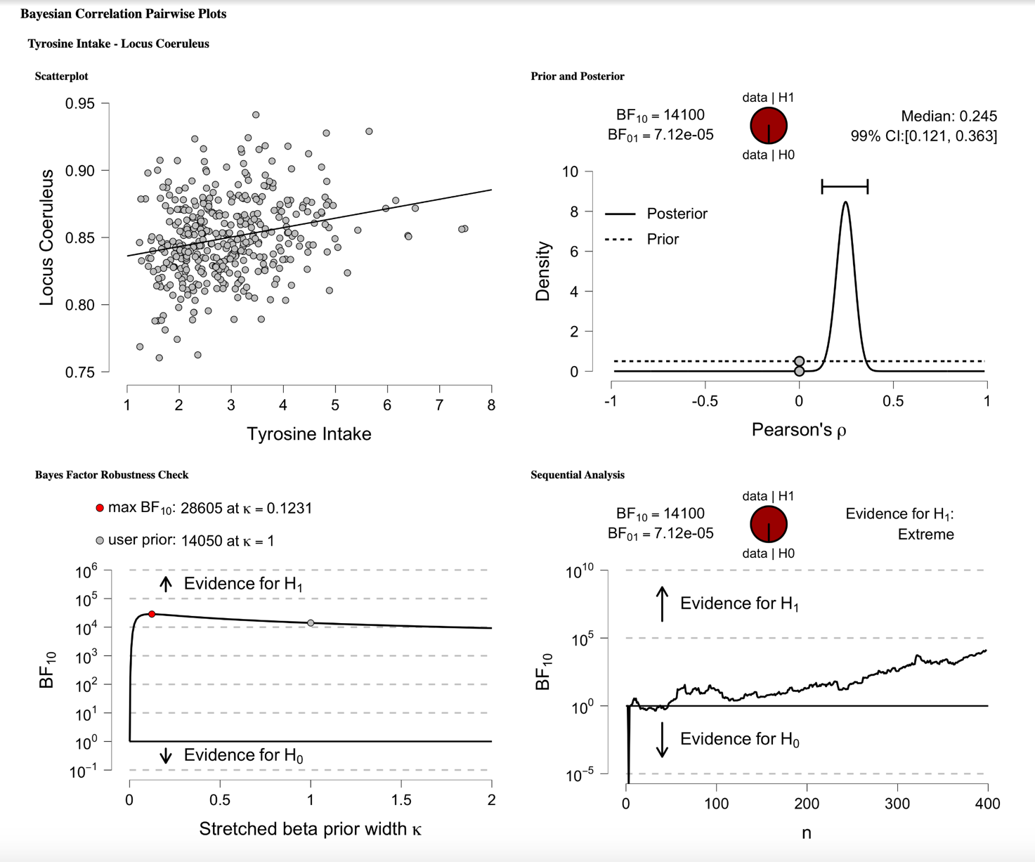

Table 4f

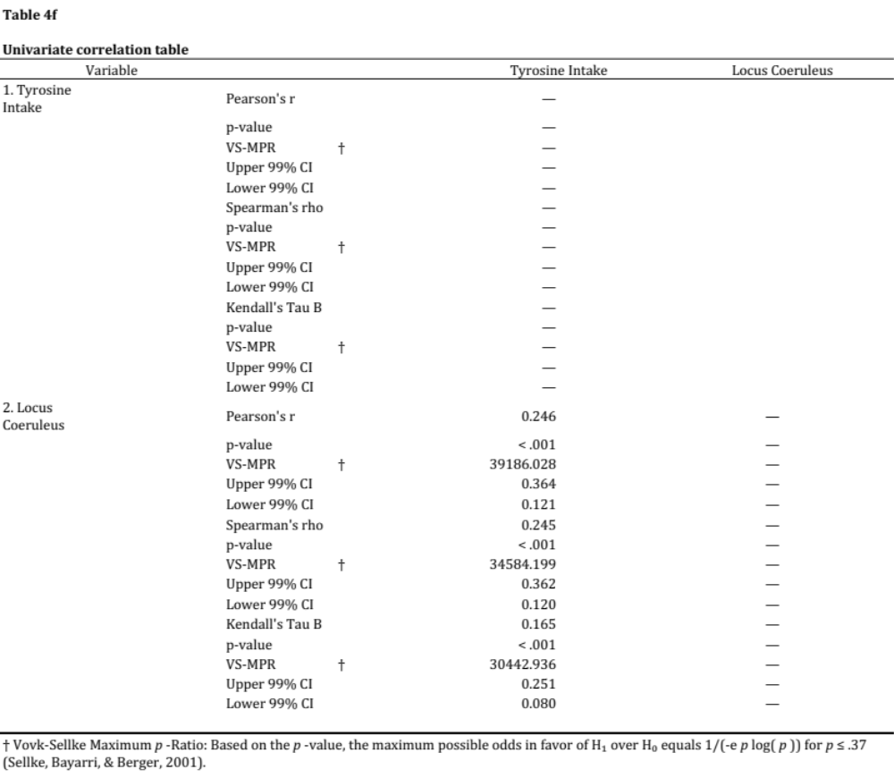

Figure 2h

Protein intake: visual modelling and ANCOVAs
ANCOVAs on the three groups of protein intake (low, mid and high) revealed that TIV, BMI and body weight did not significantly differ across different level of dietary protein intake (HD-Pro-IDA), tables are not reported for the sake of brevity. On the other hand, HD-Tyr-IDA and LC MRI signal intensity significantly differs across the three groups while controlling for age, gender, education, TIV, HD-TF-IDA, BMI and body weight. Namely, individuals reporting eating in average more protein on daily basis (1.4gr~ of protein per kg of body weight – kg/bw), shown significantly higher tyrosine intake (HD-Tyr-IDA) and greater LC integrity when compared to individuals eating mid (1gr~ kg/bw) and low (0.7gr~ kg/bw) levels. For greater details please refer to figure 3b (protein intake visual modelling) and to table 5b and 5c in the supplementary materials.

Figure 3b – reports the relationship between tyrosine intake and Locus Coeruleus signal intensity across levels of habitual protein intake displayed for individual body weight. individuals reporting eating in average more protein on daily basis (1.4gr~ of protein per kg of body weight – kg/bw – Tyrosine: 3.9gr~), shown significantly higher tyrosine intake (HD-Tyr-IDA) and greater LC integrity when compared to individuals eating mid (1gr~ kg/bw - Tyrosine: 2.5gr~ ) and low (0.7gr~ kg/bw - Tyrosine: 1.5gr~) levels. Body weight, BMI index and TIV do not significantly differ across the 3 levels of habitual dietary protein intake (low, mid, high). Habitual Tyrosine intake and Locus Coeruleus integrity significantly differ across the 3 levels (ANCOVAs P.bonf P<0.001 with effect size above 0.8 – controlling for age, gender, education TIV, total food intake, BMI, body weight and 4th ventricle volume).

Table 5b – ANCOVA protein intake level and Locus Coeruleus signal intensity variation

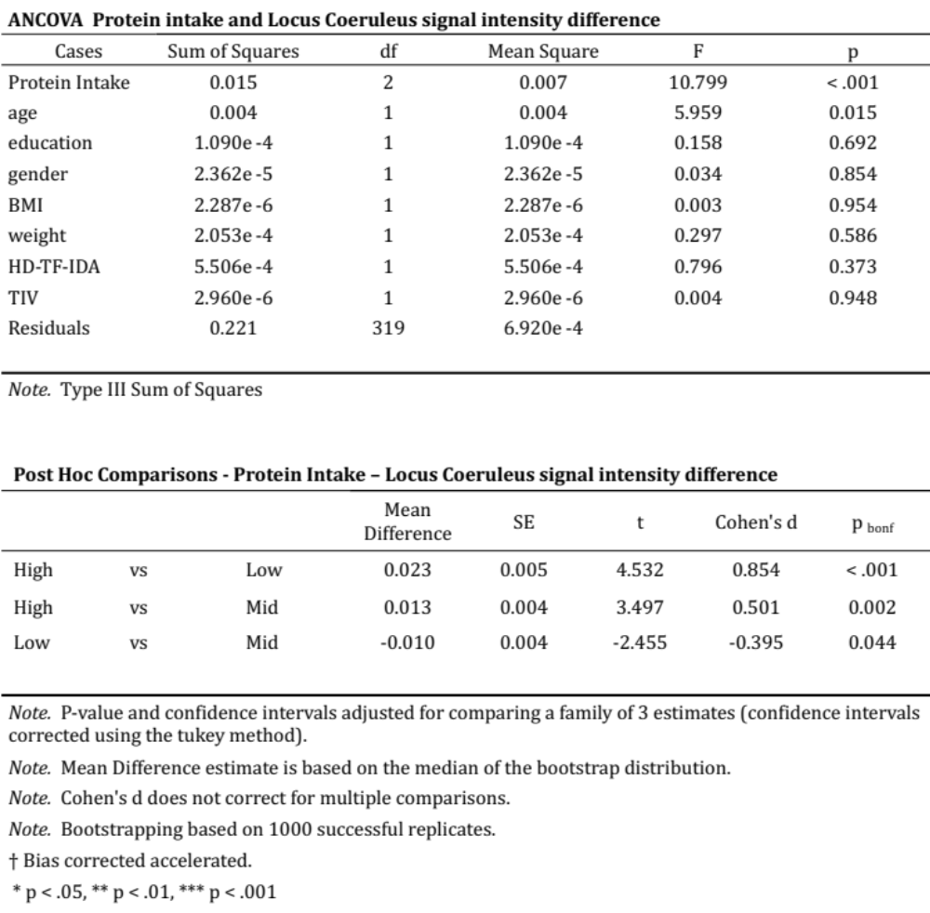

Table 5c – ANCOVA protein intake level and Tyrosine intake variation

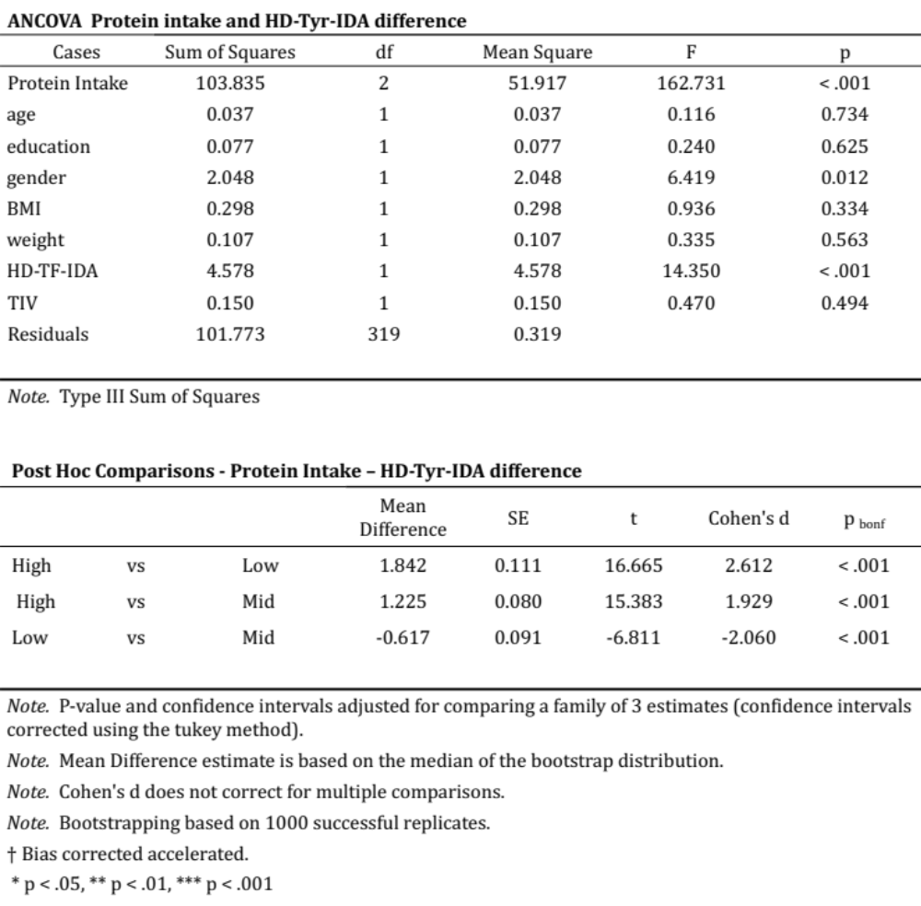

Protein intake and TIV

Methods
Another multiple regression model was built entering TIV as dependent variable and HD-Fat-IDA, HD-Car-IDA, HD-Pro-IDA as predictors. This model aimed to examine which macro-nutrients contributed the most to total brain mass in order to better gauge the relationship between tyrosine and protein intake. To corroborate this model, an additional ANCOVA was performed to test whether different level of protein intake related to overall brain volume. Then, TIV was treated as dependent variable and HD-Pro-IDA was treated as independent factor divided in three levels, low-intake, mid-intake, high-intake.

Results
The multiple regression model revealed that protein intake was the strongest predictor of TIV (BF₁₀ 8.12), followed by fat intake (BF₁₀ 6.57) and tyrosine intake (BF₁₀ 5.44), suggesting that greater amino-acid intake (including tyrosine) have a predominant role in relationship to total brain mass.
In the same vein, the ANCOVA showed that individuals reporting high-level of protein intake had greater TIV in comparison to individuals with mid- and low protein intake, who showed lower total brain mass.
However, when the effect of gender was added into the model, this association disappeared, suggesting that the combined variability of lower protein intake in females together with smaller TIV can act as a major confounder even when controlling for body metrics.
Higher protein intake can reflect greater body weight such as in males and therefore also greater brain mass. For further details refer to table 5d and 5e and figure 3c and figure 3d in the supplementary materials.

Table 5d – Bayesian Multiple regression model on TIV and macronutrients intake

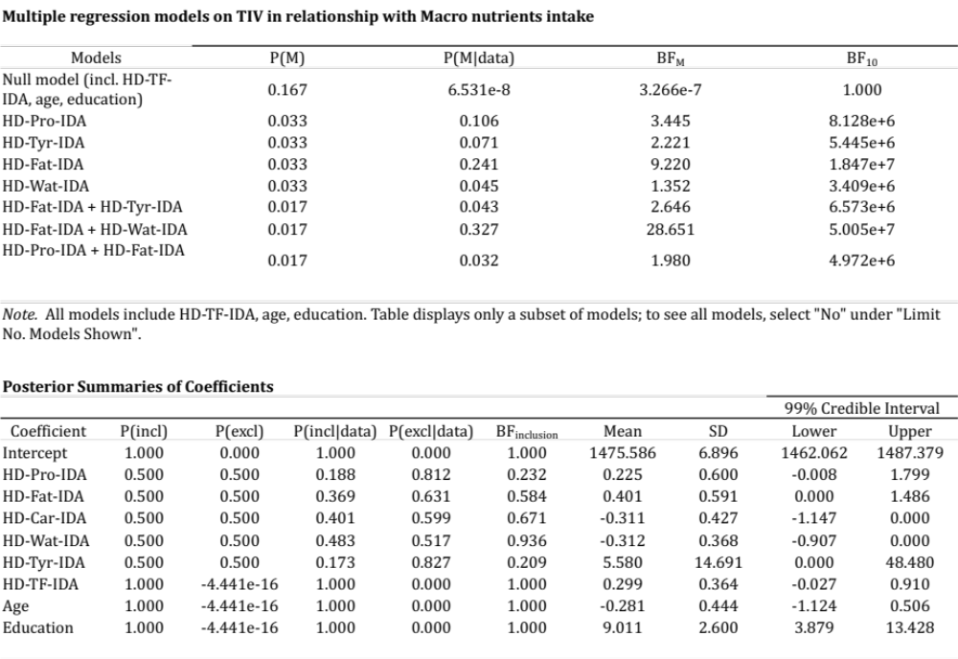
Table 5e – ANCOVA protein intake level and TIV variation. Significant differences between TIV and protein intake arises only when controlling for total food intake (HD-TF-IDA). When the model is further controlled for gender, and body metrics any significant difference disappears.

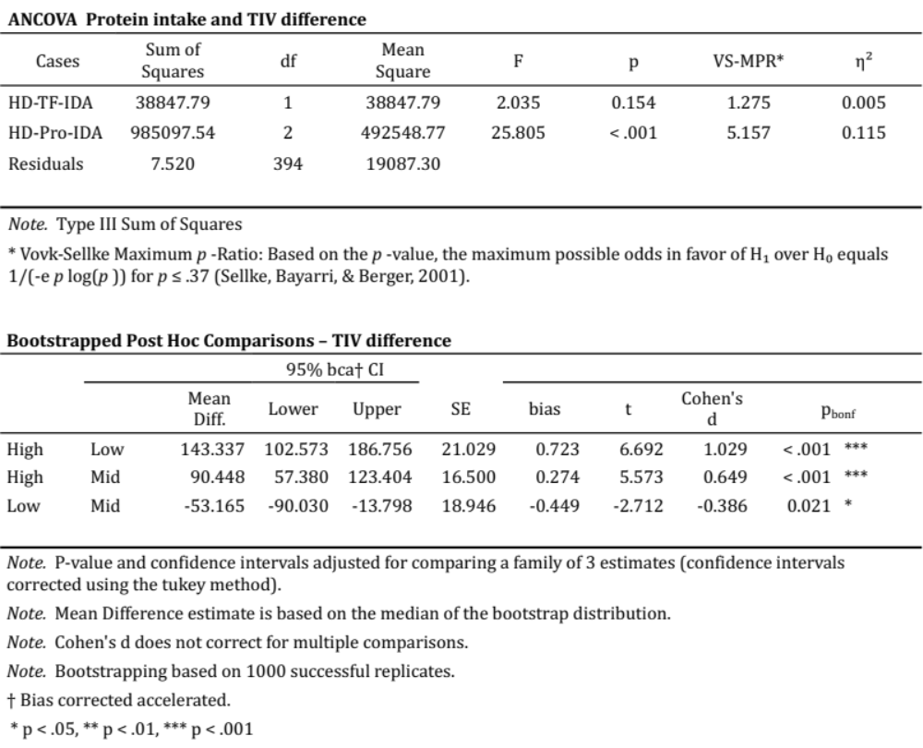

Figure 3c – different protein intake between males and females

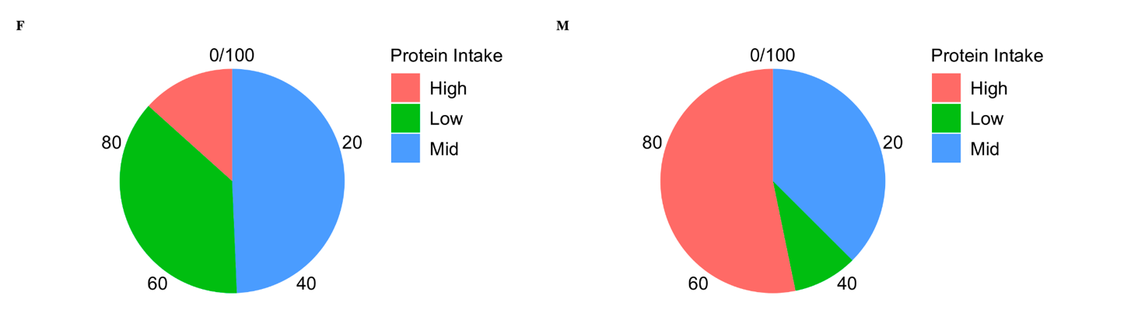

Figure 3d – TIV variation between levels of protein intake for males and females

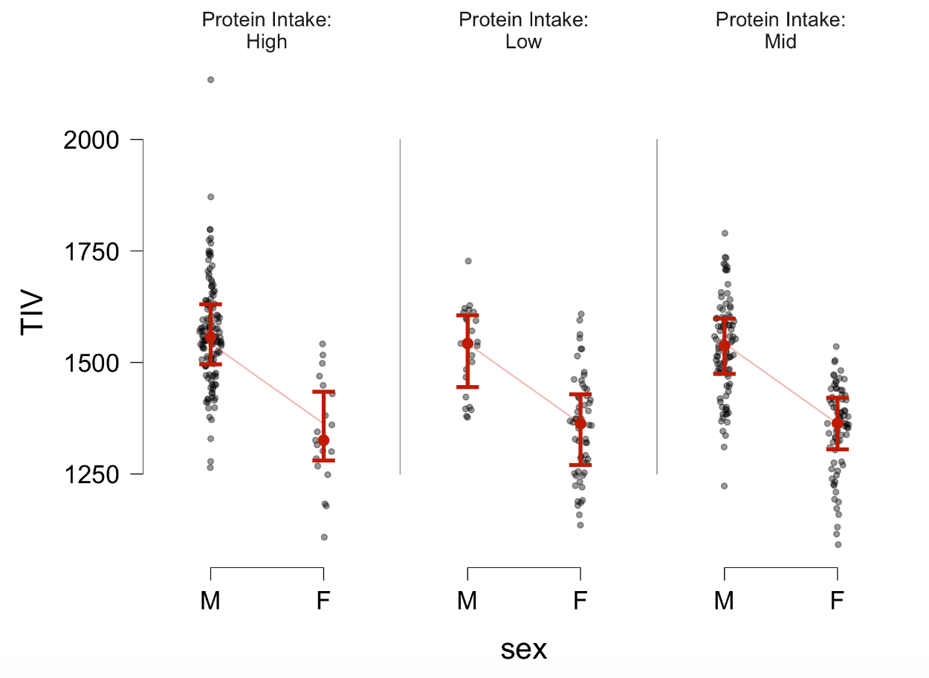

VBM – control analyses on macro-nutrients and Bayesian modelling
No relevant associations emerged for HD-Car-IDA and HD-Wat-IDA (table 5f supplementary materials). In contrast, significant associations between LC signal intensity and HD-Pro-IDA and HD-Fat-IDA emerged. Specifically for P<0.01 141 LC voxels distributed bilaterally related to protein intake and 51 LC voxels related to fat intake. When the statistical threshold was increased to P<0.001 both clusters were reduced to 57 and 11 voxels respectively. The associations between LC and protein and fat were weaker than the associations between LC and tyrosine, suggesting that LC-tyrosine findings appear to be more specific in relationship to LC in comparison with the main macro-nutrients. LC-Tyrosine (BF₁₀ 14050.14), LC-HD-Pro-IDA (BF₁₀ 6926.05), LC-HD-Fat-IDA (BF₁₀ 483.20). When testing for opposite relationships, no or negligible associations emerged for all four macro-nutrients. All significant clusters were below 10 voxels in size and did not survive a p<0.001 threshold.
Furthermore, when the macro-nutrients were tested simultaneously in the same Bayesian multiple regression model (controlling for age, gender, education, TIV, HD-TF-IDA4th ventricle, HD-TF-IDA, BMI, weight, height, and waist circumference), HD-Tyr-IDA (BF₁₀ 2445.069; R² 0.108) was the strongest variable related to LC followed by HD-Pro-IDA (BF₁₀ 1763.069; R² 0.106). Weaker associations were found for the other variables (for further detail see table 5g in the supplementary materials). This outlines the tight interdependence between protein intake and tyrosine which in this sample are highly related (Pearson's r 0.979*** - BF₁₀ 2.809e+268).

Table 5f

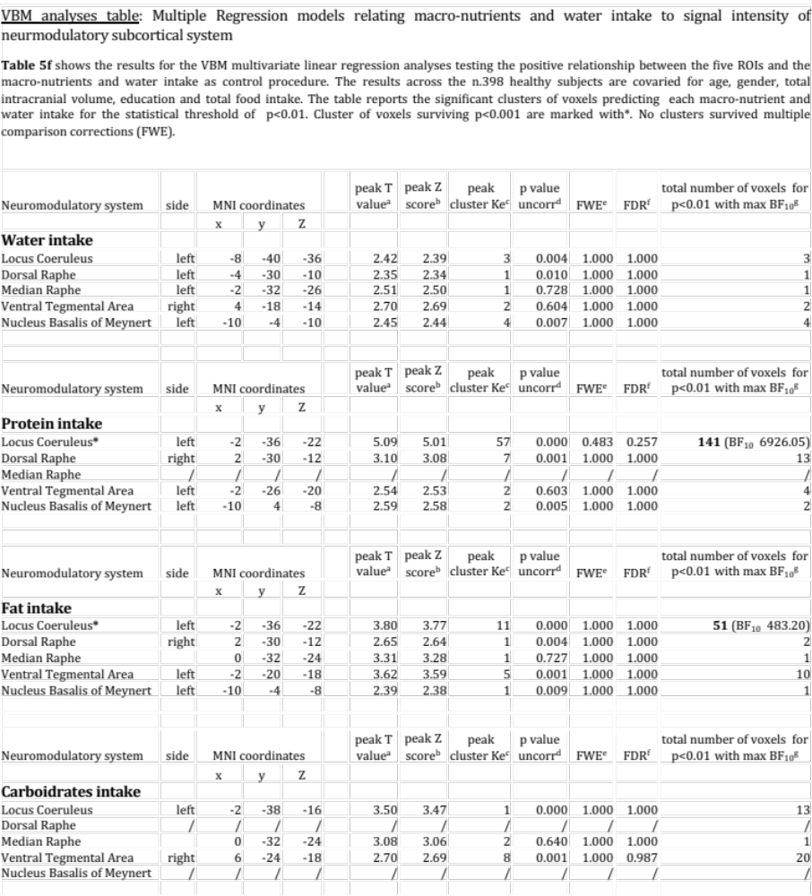

Table 5g

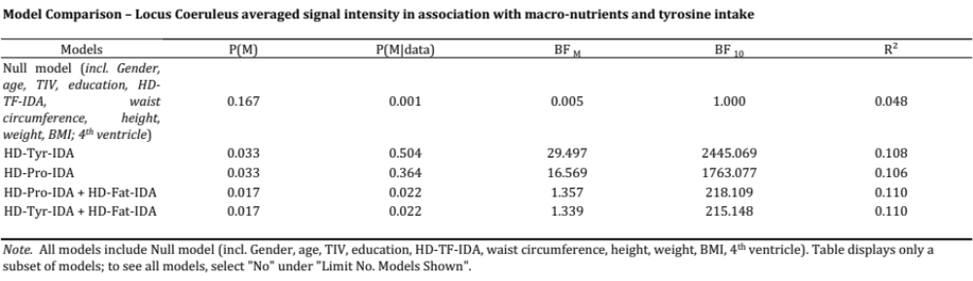

VBM – BrainPAD and Bayesian modelling
The relationship between brain maintenance and the five neuromodulators’ seeds revealed a disproportionate relationship between LC integrity and lower BrainPAD scores in comparison with the other nuclei. The significant portion of these LC findings overlap with the core of previously published LC atlases and masks (Keren et al. 2009 & 2015; Tona et al. 2017; Betts et al. 2017; Dahl et al. 2019; Liu et al. 2019; Rong Ye et al. 2020; Dahl et al. 2021; García-Gomar et al. 2022). Better brain maintenance was related to an LC cluster of 201 voxels distributed bilaterally (P<0.01 - BF₁₀ 5.44 - in table 8 in the supplementary materials). Figure 5 (in the supplementary materials) shows the spatial extent of the LC results in comparison with the previously published LC atlases and masks. The second strongest relationship was observed within the DR region showing a cluster of 49 voxels (BF₁₀ 0.12). Both LC and DR clusters were reduced in spatial extent when the statistical threshold was increased to P<0.001 and did not survive more conservative approaches. 31 voxels (BF₁₀ 11.2) within the NBM region also related with better brain maintenance. However, when the opposite relationships were tested, while for the other neuromodulatory seeds no significant clusters emerged, an NBM cluster of 30 voxels mostly right lateralised related in the opposite direction, namely accelerated GM aging, greater BrainPAD scores. However, this cluster did not survive more stringent statistical thresholds. When the five ROIs were considered together within the same Bayesian multiple regression model (table 8b), the primary involvement of the LC-NA system in brain maintenance was confirmed (BF₁₀ 28.56). As observed in Plini et al. 2021, this was followed by the DR (BF₁₀ 11.45). In addition, the combined effect of LC + DR was the third model related to BrainPAD (BF₁₀ 22.46). The other ROIs showed weaker associations, for further details refer to table 11 in the supplementary materials.

Table 8

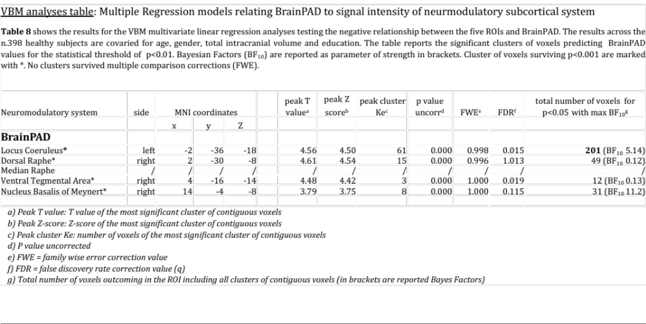

Figure 5 - The upper portion of the figure shows the Bayesian sequential analyses plot and the bayes factor robustness evidence in support to H1 (the negative relationship between biological brain maintenance - BrainPAD - and Locus Coeruleus MRI signal intensity. The right portion of the figure shows the scatterplot across n.398 healthy young subjects (age range 25-81) for P<0.001 threshold. The results are corrected for age, gender, education and total intracranial volume. The significant LC cluster of voxels (in blue) is shown on a coronal 3D reconstruction of the brain. Greater LC signal intensity is related with reduced brain aging, namely lesser years than chronological age, while lower LC signal intensity is related with accelerated years of brain aging. Below on the left, the LC findings are shown in comparison with the spatial resolution of the previously published LC MRI masks and atlases. From an axial and coronal point of views, the VBM LC-BrainPAD cluster is displayed on a 3D LC reconstruction of the “omni-comprehensive” LC mask by Plini et al. 2021.

Table 8b
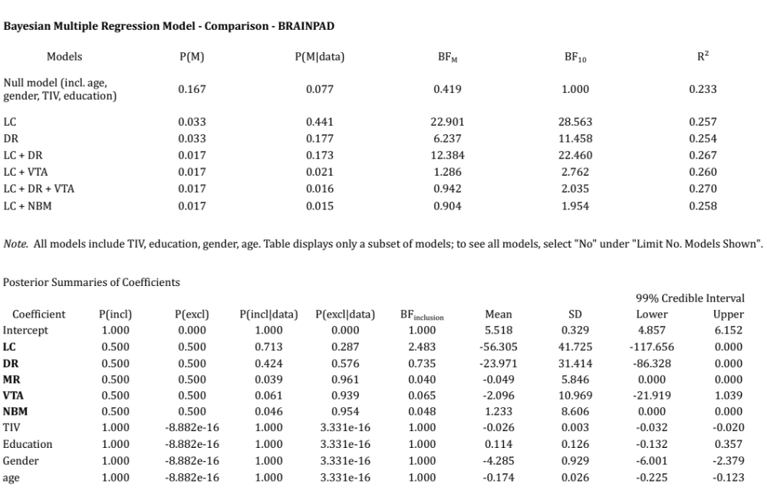

Code for calculating the percentage overlaps between the LC-Tyrosine findings and the previously published LC atlases and masks.
To calculate statistics of overlap of all LC atlases, a script was written in python, utilising the nibabel toolbox (https://doi.org/ 10.5281/zenodo.7633628; see below). All images were registered to an MNI template, co-occurring voxels were counted, and this number was divided by the total number of voxels of the LC-tyrosine cluster.

import numpy as np
import nibabel as nib
import os
import matplotlib.pyplot as plt
#working dir
os.chdir("/Users/joanne/Desktop/Emanuele/masks_for_dice_test")
# list of lists to store results:
listResults = []
# set probability threshold
thresh = 0
# Emanuele's reference mask (tyrosine cluster *** do also the omni-mask
'COR_Plini et al. 2021.nii' specificity and sensitivity)
img = nib.load('LC-Tyrosine.nii')
header = img.header
print("LC-Tyrosine.nii")
print("reference image dimensions: ", header.get_data_shape())
image_data = img.get_fdata()
image_data_flat = image_data.flatten() # convert to 1-dim array
nzInd = np.where(image_data_flat>thresh)[0]
denom = len(nzInd)
# Comparison image (get % of overlap with reference mask)
maskNameFiles = ['COR_Betts et al. 2017.nii', 'COR_Dahl et al. 2019.nii',
'COR_Dahl et al. 2021.nii', \
'COR_Garcia-Gomez et al. 2022.nii', 'COR_Keren et al.
2099.nii', 'COR_LC-Tyrosine_0001.nii', \
'COR_Liu et al. 2019.nii', 'COR_Plini et al. 2021.nii',
'COR_Rong Ye et al. 2020.nii', \
'COR_Tona et al. 2017.nii']
for maskName in maskNameFiles:
imgcomp = nib.load(maskName)
header = imgcomp.header
print(maskName)
print("comparison Image dimensions: ", header.get_data_shape())
imagecomp_data = imgcomp.get_fdata()
imagecomp_data_flat = imagecomp_data.flatten() # convert to 1-dim
array
nzIndcomp = np.where(imagecomp_data_flat>thresh)[0]
numVoxComp = len(nzIndcomp)
#testing co-registrated images for errant values due to coregistration process
plt.plot(imagecomp_data_flat)
plt.ylabel('some numbers')
plt.show()
# calculate overlap (common voxels / reference voxels)
commonVoxels = np.in1d(nzInd, nzIndcomp)
# print(commonVoxels)
commonVoxels = np.where(commonVoxels)[0]
print("Common Voxels: ", commonVoxels)
commonVoxels = len(commonVoxels)
print("number of Common Voxels: ", commonVoxels)
print("reference Voxels: ", denom)
overlapPercent = commonVoxels/denom*100
print("Percent Overlap: ", overlapPercent, "percent.")
# store 'maskName'commonVoxels' and 'overlapPercent' in dict
# Insert data into dictionary
overlapPercent = round(overlapPercent,2)
# dictResults[str(n)] = [maskName, commonVoxels, overlapPercent]
print(maskName, commonVoxels, overlapPercent, numVoxComp)
outList = [maskName, commonVoxels, overlapPercent, numVoxComp]
listResults.append(outList)
import tabulate
col_names = ["mask Name", "voxels", "percent Overlap", "mask Voxels"]
print (listResults)
print(tabulate.tabulate(listResults, headers=col_names))

