Table 1 – abbreviations: TIV – total intracranial volume; BrainPAD – brain predicted age difference; LC – Locus Coeruleus; DR – Dorsal Raphe; MR – Median Raphe; VTA – Ventral Tegmental Area; NBM- Nucleus Basalis of Meynert. Abbreviations for neuropsychological tests: MMSE – Mini Mental Examination State; Trail-A – Trail Making Test Part A; Trail-B – Trail Making Test part B; Trail B-A- Trail Making Test part B minus part A; SU – Spatial Update (working memory); PP – Practical Problem solving (fluid intelligence); RAVLT recall 1 and 2 - Rey Auditory Verbal Learning Test.

Table 2 – abbreviations: HD-Tyr-IDA – habitual dietary tyrosine intake on daily average; HD-TF-IDA - habitual total food intake on daily average; HD-Pro-IDA - habitual dietary protein intake on daily average HD-Fat-IDA - habitual dietary fat intake on daily average; HD-Car-IDA - habitual dietary carbohydrates intake on daily average; HD-Wat-IDA - habitual dietary water intake on daily average.

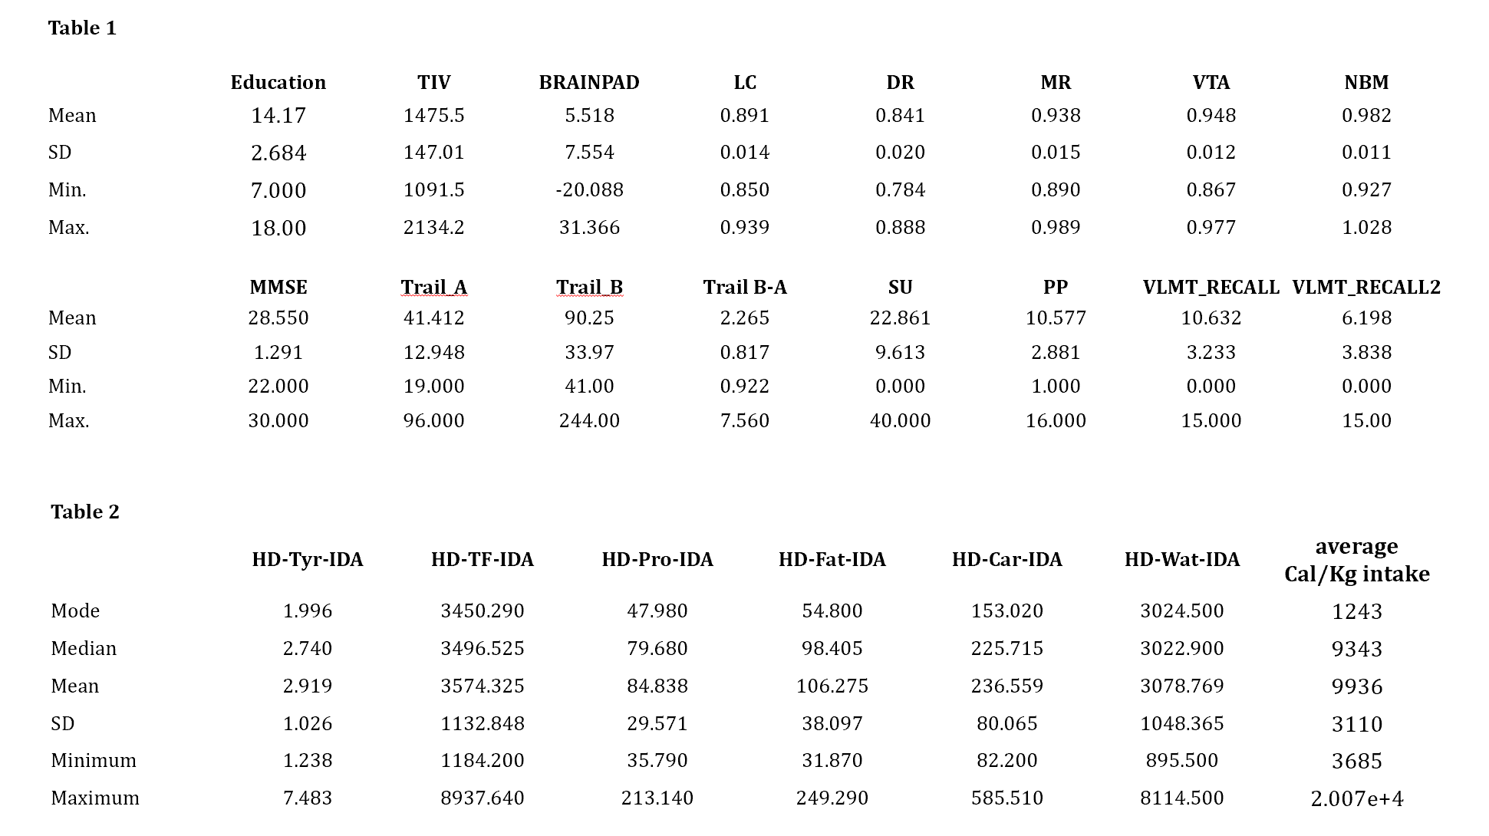

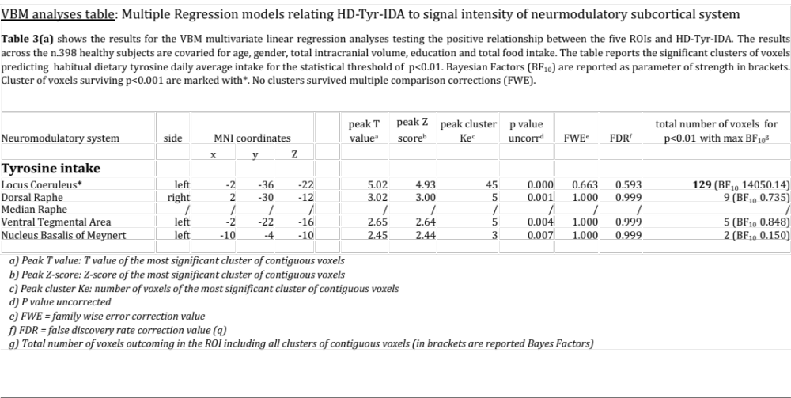

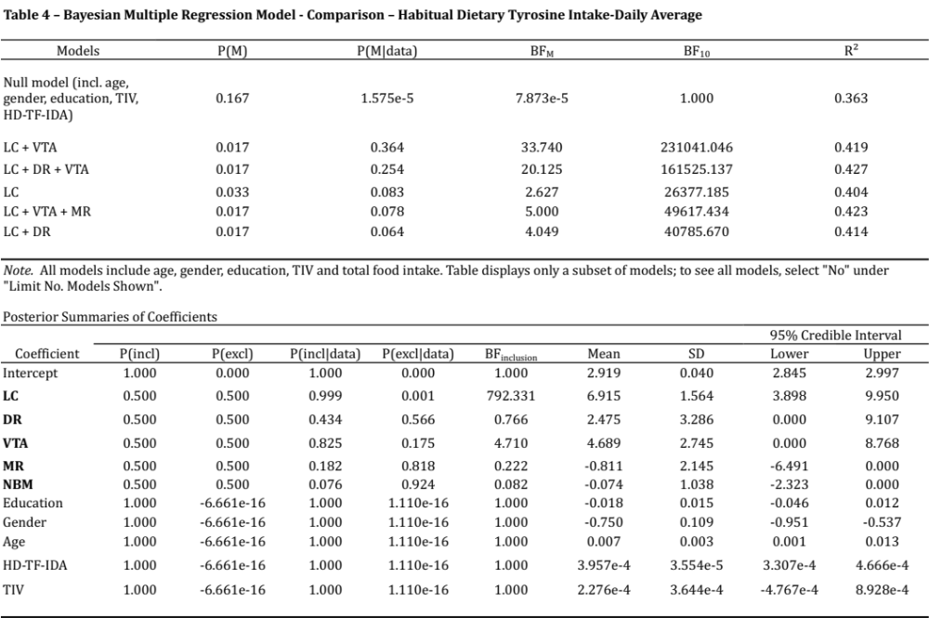

Table 5 reporting the main effect of tyrosine levels intake in grams (below 2gr, medium intake between 2 and 3gr, medium high between 3 and 4gr, and high intake above 4gr) and the Locus Coeruleus average signal intensity for each level of intake. Main effect and significant differences are observed across levels, the more significant are observed between low and high intake (Bonferroni corrected P<0.001)

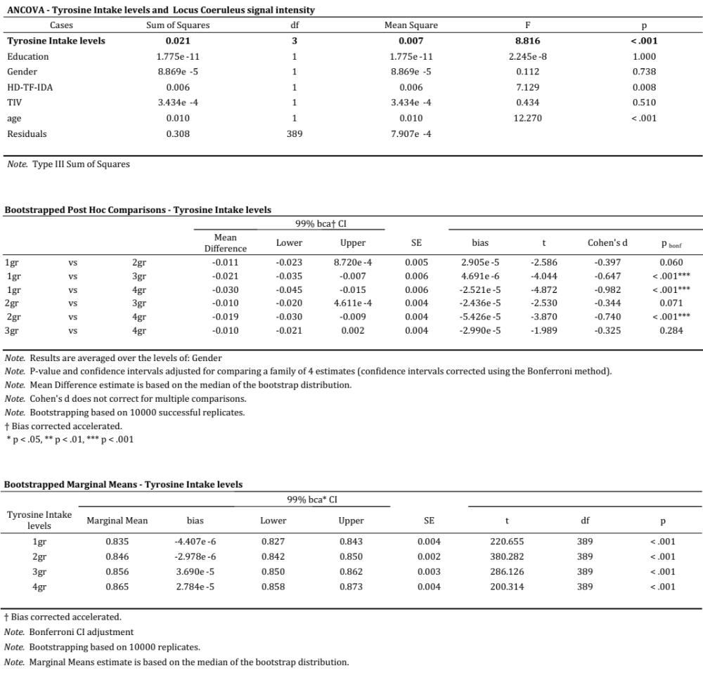

Table 6 – reports results of the mediation analyses treating the 5ROIs as parallel mediators between tyrosine intake and TMT B-A. By covaring for age, gender, education, TIV and HD-TF-IDA, only the LC significantly mediated the relationship between dietary tyrosine intake and TMT B-A.

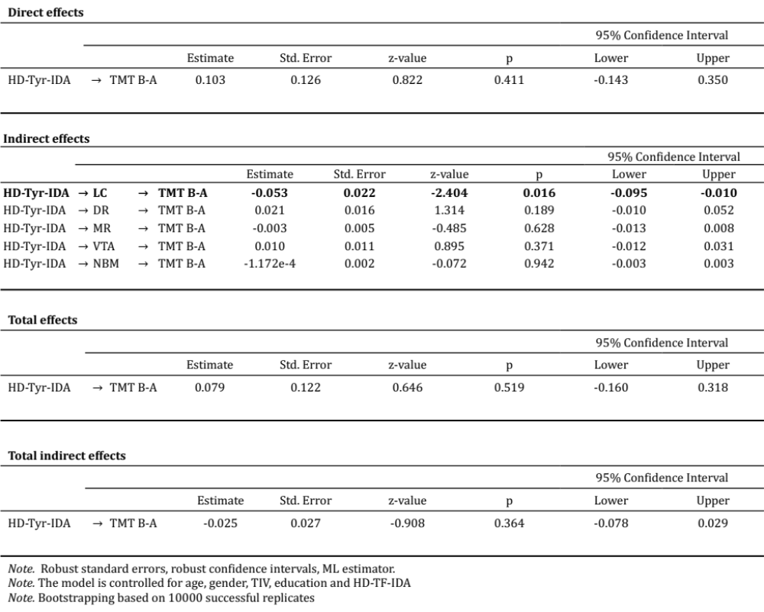

Table 7 - reports results of the mediation analyses treating the 5ROIs as parallel mediators between tyrosine intake and BrainPAD. As shown in the table, by covaring for age, gender, education, TIV and HD-TF-IDA only the LC significantly mediated the relationship between dietary tyrosine intake and BrainPAD

