Supporting information

Rotenone nanoparticles based on mesoporous silica to improve the stability, translocation and insecticidal activity of rotenone
Wangjin Xu, Dianjing Shen, Xiaojun Chen*, Ming Zhao, Tianle Fan, Qinchao Wu, Zhiyuan Meng, Jiajia Cui

College of Plant Protection, Yangzhou University/Joint International Research Laboratory of Agriculture & Agri-Product Safety (Yangzhou University), Jiangsu Yangzhou, 225009, People’s Republic of China.

Correspondence author: Xiaojun Chen, Professor, E-mail: cxj@yzu.edu.cn
The table of contents
Fig S1. Preparation of mesoporous silica nanoparticles (MSNs).
Fig S2. Application site of Rot@MSNs and sampling position of tomato plants.
Fig S3. TEM images of Rot@MSNs.
Fig S4. XRD pattern of Rotenone, MSNs and Rot@MSNs.
Table S1. Rotenone drug loading rate
Table S2. Transfer factors of rotenone in tomato plants treated with Rot@MSNs and ME.
Table S3. Degradation kinetic of rotenone on the tomato leaves.

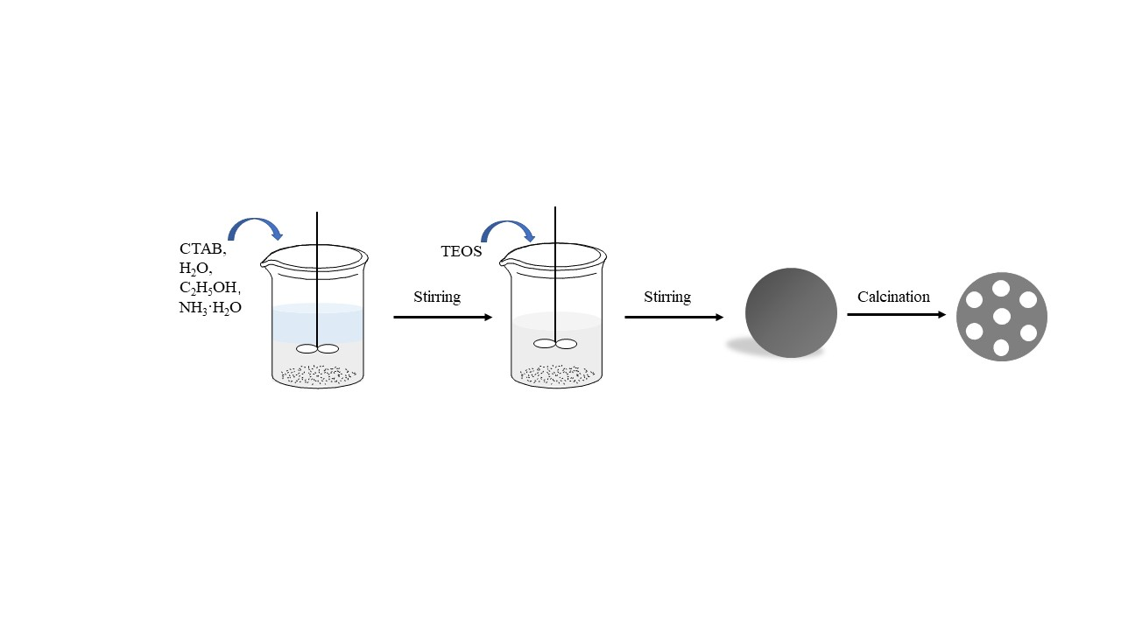
Fig S1. Preparation of mesoporous silica nanoparticles (MSNs).

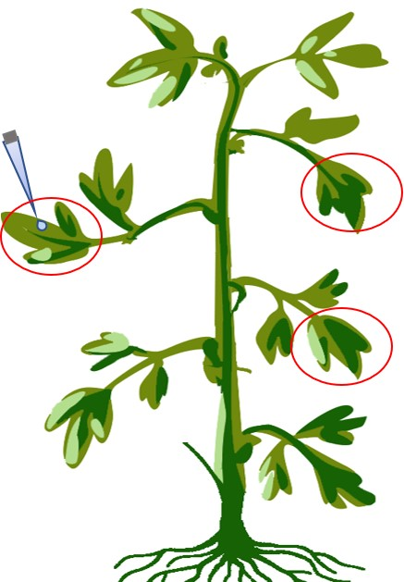
Fig S2. Application site of Rot@MSNs and sampling position of tomato plants.

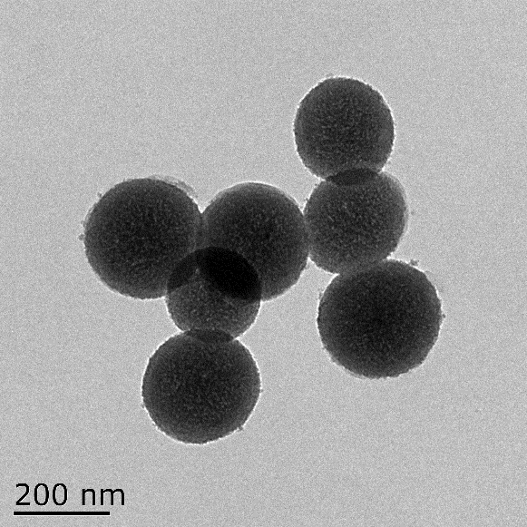 | 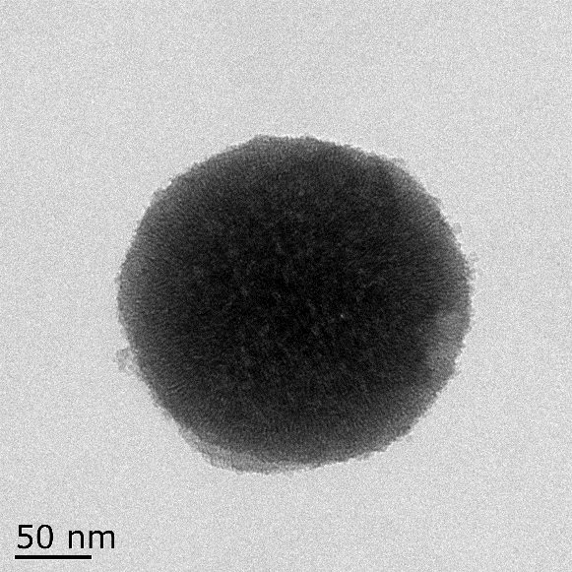
Fig S3. TEM images of Rot@MSNs

Fig S4. XRD pattern of Rotenone, MSNs and Rot@MSNs.

Table S1. Rotenone drug loading rate
Treatment | Rotenone quality（mg） | Drug loading rate（%）
Treatment 1 | 3.341 | 33.41
Treatment 2 | 3.318 | 33.18
Treatment 3 | 3.319 | 33.19
Average value | 3.326 | 33.26±0.13

Table S2. Transfer factors of rotenone in tomato plants treated with Rot@MSNs and ME
Treatment times | Rot@MSN |  | ME
Treatment times | TF_{Upper} | TF_{Lower} | TF_{Upper} | TF_{Lower}
2 h | 0.0124 d | 0.0018 d | 0.1071 b | 0.0344 cd
1 d | 0.0049 d | 0.0042 d | 0.0325 d | 0.0079 d
5 d | 0.0051 d | 0.0020 d | 0 | 0
10 d | 0.0615 c | 0.1633 a | 0 | 0
14 d | 0.1347 b | 0.1384 ab | 0 | 0
TF_{Average} | 0.0437 | 0.0619 | 0.0279 | 0.0085
*Means with the same letter are not significantly different (Duncan’s multiple range test, p≤0.05, n=3).
Table S3. Degradation kinetic of rotenone on the tomato leaves
Treatments | Rot@MSNs | ME
24 | 13.5235 ±1.1348 | 11.4452 ± 1.1124
48 | 11.0842 ± 0.9213 | 7.2024 ± 0.9388
72 | 9.8816 ± 0.4382 | 5.7114 ± 0.6722
96 | 7.9932 ± 0.5673 | 4.0132± 0.5228
192 | 3.7268 ± 0.2397 | 1.1924± 0.2453
Degradation kinetic equation | C_{t}=16.4712e^{-0.0077t} | C_{t}=14.5813e^{-0.0132t}
Half-life T_{1/2} (h) | 90.01 | 52.51

