Supplementary Materials for

Radiative Forcing Bias Calculation Based on COSMO (Core-Shell Mie model Optimization) and AERONET data
Pravash Tiwari et al.
*Corresponding author. Email: jasonbc@alum.mit.edu

This Supplementary file includes:

Figs. S1 to S3
Tables S1 to S4

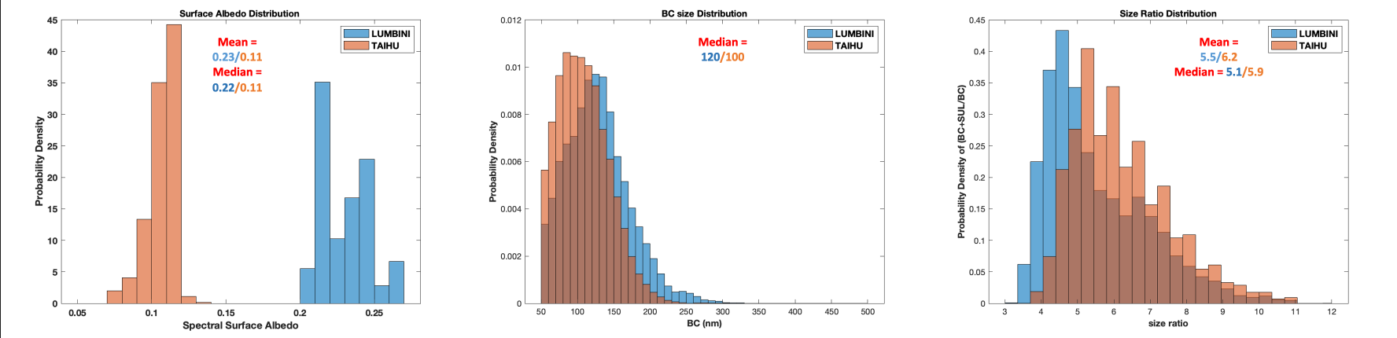

Fig. S1. PDF of surface albedo, BC size and total size to BC ratio over Lumbini and Taihu

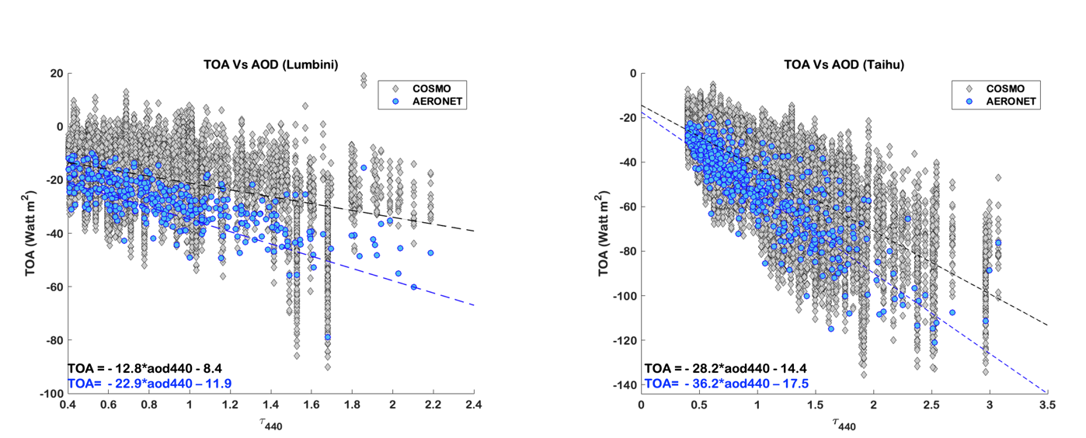Fig. S2. TOA Vs AOD for AERONET and COSMO RF.

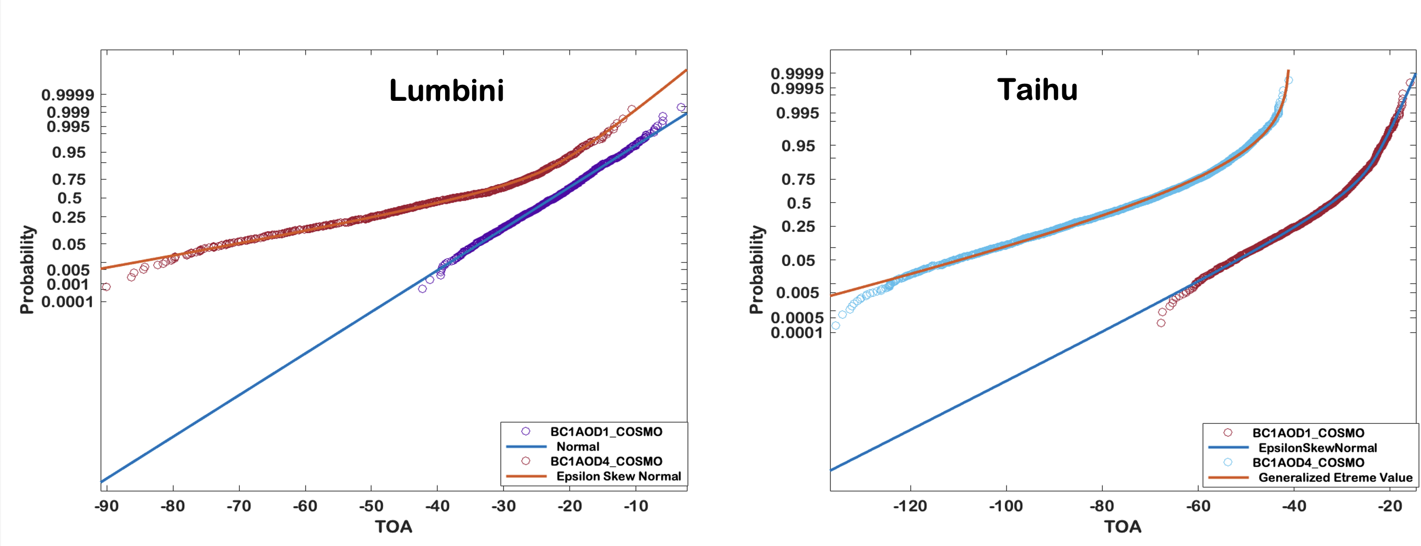

Fig. S3. The small size BC cores denoted by BC1 at two different AOD conditions (clean (AOD1) represented by purple circle for and polluted (AOD4) represented by red circle in case of Lumbini (left panel) are best fitted by normal and Epsilon Skew normal fitting. While over Taihu (right panel) these are represented by brown circles (clean (AOD1)) which are best fitted in Epsilon skew normal distribution and light blue circles (polluted (AOD4)) which is best fitted under Generalized extreme value distribution. This supports the evidence that TOA forcing for yield a non-normal distribution with multi-modality, depending upon size, AOD and mixing state.

Table S1.
(10th to 90th) Percentile comparison of TOA across different AOD condition for AERONET and COSMO.

Percentile | Clean | Fairly polluted | Moderately polluted | polluted | Extremely polluted | Clean | Fairly polluted | Moderately polluted | polluted | Extremely polluted
10 | -27.1 | -28.4 | -29.5 | -46.1 | -60.4 | -29.4 | -31.7 | -38.9 | -60.2 | -78.9
20 | -23.2 | -23.5 | -24.5 | -36.6 | -49.1 | -29.2 | -30.7 | -34.4 | -55.5 | -78.9
30 | -20.5 | -20.7 | -21.0 | -30.6 | -42.7 | -29.2 | -29.9 | -34.4 | -44.2 | -78.9
40 | -18.4 | -18.4 | -18.4 | -26.7 | -36.6 | -29.0 | -29.3 | -32.9 | -41.1 | -78.9
50 | -16.4 | -16.6 | -16.0 | -23.6 | -32.6 | -25.3 | -26.8 | -31.0 | -38.1 | -78.9
60 | -14.4 | -14.7 | -13.9 | -20.9 | -29.5 | -24.1 | -26.5 | -29.6 | -36.2 | -52.9
70 | -12.3 | -12.7 | -11.5 | -18.4 | -25.7 | -23.2 | -25.3 | -27.7 | -34.9 | -45.7
80 | -9.8 | -10.1 | -8.9 | -15.4 | -22.4 | -19.7 | -23.6 | -25.5 | -33.3 | -40.8
90 | -6.4 | -6.7 | -5.2 | -11.3 | -17.6 | -16.2 | -20.6 | -22.9 | -28.1 | -40.7
 | COSMO-TOA |  |  |  |  | AERONET-TOA
 | Lumbini
Percentile | Clean | Fairly polluted | Moderately polluted | polluted | Extremely polluted | Clean | Fairly polluted | Moderately polluted | polluted | Extremely polluted
10 | -41.6 | -51.5 | -70.0 | -91.0 | -104.9 | -45.6 | -57.6 | -83.8 | -108.0 | -114.7
20 | -36.3 | -45.9 | -61.3 | -79.9 | -94.4 | -42.9 | -52.9 | -75.3 | -100.1 | -113.4
30 | -32.8 | -41.8 | -55.4 | -72.3 | -87.0 | -40.9 | -50.4 | -71.6 | -88.5 | -111.2
40 | -30.0 | -38.5 | -51.2 | -66.3 | -81.2 | -38.1 | -47.5 | -66.4 | -79.7 | -111.2
50 | -27.9 | -36.0 | -47.5 | -61.3 | -75.6 | -36.6 | -45.5 | -62.3 | -76.8 | -107.1
60 | -25.9 | -33.9 | -44.2 | -56.9 | -70.8 | -33.1 | -45.1 | -61.3 | -74.1 | -102.4
70 | -23.9 | -31.6 | -41.0 | -52.8 | -66.6 | -30.7 | -42.7 | -58.1 | -71.0 | -99.7
80 | -21.9 | -29.2 | -37.3 | -48.5 | -60.7 | -29.2 | -40.2 | -52.6 | -66.1 | -90.2
90 | -19.2 | -26.1 | -32.5 | -43.1 | -53.0 | -27.8 | -36.2 | -47.0 | -56.9 | -76.3
 | COSMO-TOA |  |  |  |  | AERONET-TOA
 | Taihu

Table S2.
(10th, 30th, 50th, 70th and 90th) Change in ATM forcing across varying BC sizes and mixing state conditions. This suggest that the per-particle lensing effect of absorption enhancement increases the net absorption when the BC sizes are relatively small (<=120nm)

10th | 30th | 50th | 70th | 90th | BC size | Coating Conditions | 10th | 30th | 50th | 70th | 90th
33.3 | 38.5 | 48.4 | 56.3 | 64.8 | Small | Barely coated | 18.0 | 24.7 | 30.4 | 38.1 | 57.7
23.6 | 34.8 | 43.1 | 50.0 | 68.2 | Small | Moderately coated | 16.0 | 24.1 | 32.1 | 44.1 | 64.0
14.4 | 20.0 | 26.2 | 35.8 | 61.1 | Small | Substantially coated | 13.9 | 20.8 | 28.0 | 37.3 | 53.0
4.0 | 7.3 | 11.2 | 15.2 | 25.4 | Small | Heavily coated | 3.6 | 7.7 | 11.5 | 17.3 | 28.6
2.1 | 3.8 | 5.4 | 7.8 | 13.6 | Small | Extremely Heavily coated | 1.8 | 3.6 | 5.2 | 8.1 | 12.3
38.9 | 49.5 | 61.7 | 70.5 | 84.2 | Medium | Barely coated | 27.8 | 38.4 | 47.5 | 62.2 | 90.0
36.0 | 52.1 | 63.2 | 75.0 | 94.8 | Medium | Moderately coated | 24.5 | 33.8 | 41.7 | 54.6 | 74.2
13.1 | 19.6 | 29.4 | 41.2 | 57.7 | Medium | Substantially coated | 12.6 | 18.3 | 23.9 | 30.8 | 46.3
5.2 | 8.4 | 10.9 | 13.6 | 24.6 | Medium | Heavily coated | 5.0 | 8.0 | 10.6 | 14.7 | 21.9
2.7 | 4.3 | 5.3 | 8.2 | 12.3 | Medium | Extremely Heavily coated | 2.6 | 4.5 | 5.8 | 8.7 | 13.6
45.5 | 58.3 | 71.0 | 85.9 | 110.0 | Moderately Big | Barely coated | 31.7 | 41.8 | 51 | 62.8 | 87.7
23.1 | 34.0 | 43.7 | 56.3 | 72.9 | Moderately Big | Moderately coated | 18.3 | 24.6 | 30.3 | 37 | 49.4
14.9 | 19.2 | 25.6 | 36.4 | 46.0 | Moderately Big | Substantially coated | 11.3 | 16.3 | 21.4 | 27.9 | 37.8
9.6 | 12.7 | 15.1 | 19.2 | 35.2 | Moderately Big | Heavily coated | 6.73 | 11.1 | 14.4 | 20.4 | 28.31
NA | NA | NA | NA | NA | Moderately Big | Extremely Heavily coated | NA | NA | NA | NA | NA
34.1 | 49.9 | 60.5 | 68.8 | 88.6 | Big | Barely coated | 24.1 | 30.4 | 36.7 | 46.3 | 67.4
24.7 | 34.6 | 43.2 | 50.4 | 60.3 | Big | Moderately coated | 18.0 | 25.3 | 30.8 | 39.2 | 49.3
19.3 | 23.2 | 31.7 | 44.3 | 52.9 | Big | Substantially coated | 12.9 | 18.2 | 23.4 | 32.2 | 41.7
NA | NA | NA | NA | NA | Big | Heavily coated | NA | NA | NA | NA | NA
NA | NA | NA | NA | NA | Big | Extremely Heavily coated | NA | NA | NA | NA | NA
30.8 | 42.7 | 54.0 | 66.5 | 74.7 | Extremely Big | Barely coated | 27.1 | 32.9 | 38.8 | 46.0 | 68.8
27.7 | 45.6 | 59.3 | 65.0 | 70.6 | Extremely Big | Moderately coated | 23.8 | 29.5 | 33.1 | 37.7 | 54.8
NA | NA | NA | NA | NA | Extremely Big | Substantially coated | NA | NA | NA | NA | NA
NA | NA | NA | NA | NA | Extremely Big | Heavily coated | NA | NA | NA | NA | NA
NA | NA | NA | NA | NA | Extremely Big | Extremely Heavily coated | NA | NA | NA | NA | NA
LUMBINI |  |  |  |  |  |  | Taihu

Table S3.
Performance metrics and scaled coefficients of Multiple Regression Linear Model
Models | RMSE | MGE | R-square
TOA~AOD | 7.5 | 5.5 | 0.55 | Lumbini
TOA~AOD+BC+ratio | 5.7 | 4.0 | 0.74 | Lumbini
TOA~AOD | 10.3 | 7.5 | 0.69 | Taihu
TOA~AOD+BC+ratio | 10.1 | 7.0 | 0.72 | Taihu
 | BC | ratio | AOD
Mean | 122.9 | 5.5 | 0.85 | Lumbini
Coeff | -0.01 | -3.47 | -23.9 | Lumbini
Scaled Coeff. | -1.23 | -19.08 | -20.31
Mean | 104 | 6.2 | 1.07 | Taihu
Coeff | -0.02 | -1.53 | -35.8 | Taihu
Scaled Coeff. | -2.08 | -9.49 | -38.3

Table S4.
Percentile values of AOD at 440nm, BC core size (nm) and total size to BC ratio for Lumbini and Taihu

Percentile | 25th | 50th | 75th | 95th
AOD (440nm) | 0.6/0.68 | 0.75/1.01 | 1.03/1.38 | 1.61/1.95
BC (nm) | 90/80 | 120/100 | 150/130 | 200/170
Ratio | 4.4/5.2 | 5.1/5.9 | 6.4/7.0 | 8.3/8.7
Lumbini Taihu

