Monatshefte für Chemie - Chemical Monthly

Supplementary Information

The synthesis of disubstituted 4-methyl-N,N-dipropylbenzenamine derivatives bearing identical azolethione(thiol) moieties as antioxidant agents
Ingrida Tumosienė¹ ● Ilona Jonuškienė¹ ● Sergey Belyakov² ● Kristina Kantminienė³
____
Kristina Kantminienė
kristina.kantminiene@ktu.lt
¹ Department of Organic Chemistry, Kaunas University of Technology, Radvilėnų pl. 19, 50254 Kaunas, Lithuania
² Laboratory of Physical Organic Chemistry, Latvian Institute of Organic Synthesis, Aizkraukles 21, 1006 Riga, Latvia
³ Department of Physical and Inorganic Chemistry, Kaunas University of Technology, Radvilėnų pl. 19, 50254 Kaunas, Lithuania

Fig. S1. ¹H NMR (400 MHz, DMSO-d₆) spectrum of 3
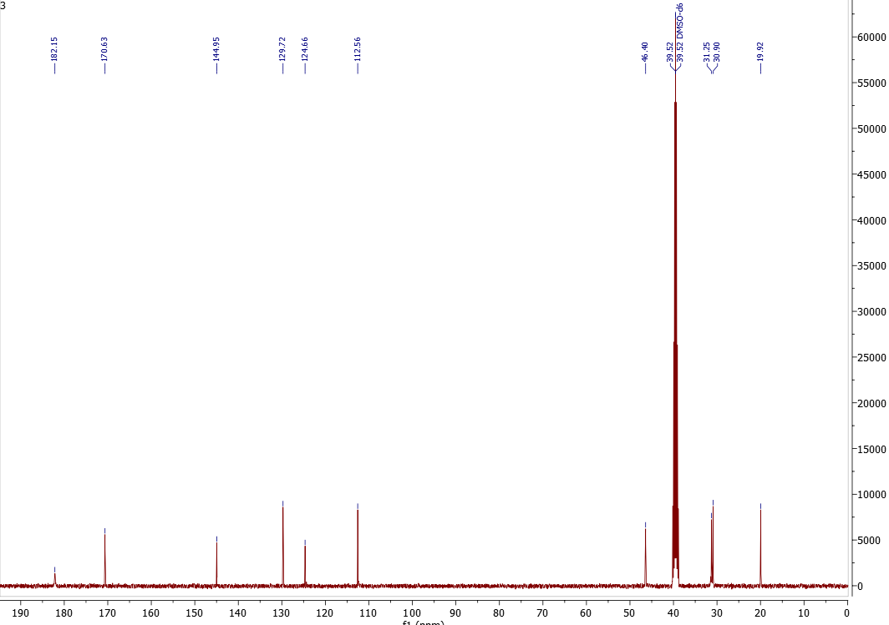
Fig. S2. ¹³C NMR (101 MHz, DMSO-d₆) spectrum of 3
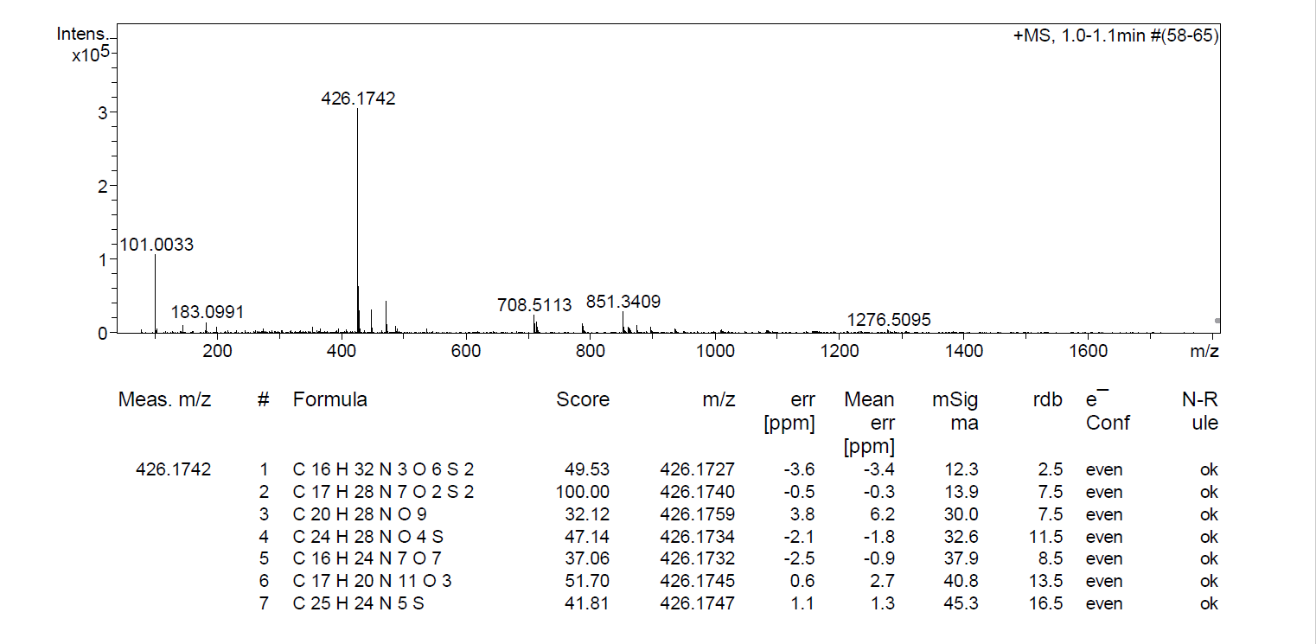
Fig. S3. HRMS spectrum of 3
Fig. S4. ¹H NMR (400 MHz, DMSO-d₆) spectrum of 5
Fig. S5. ¹³C NMR (101 MHz, DMSO-d₆) spectrum of 5
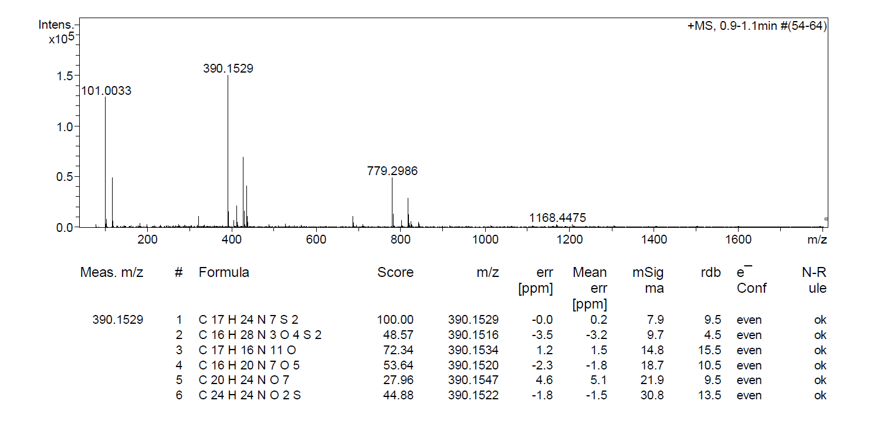
Fig. S6. HRMS spectrum of 5
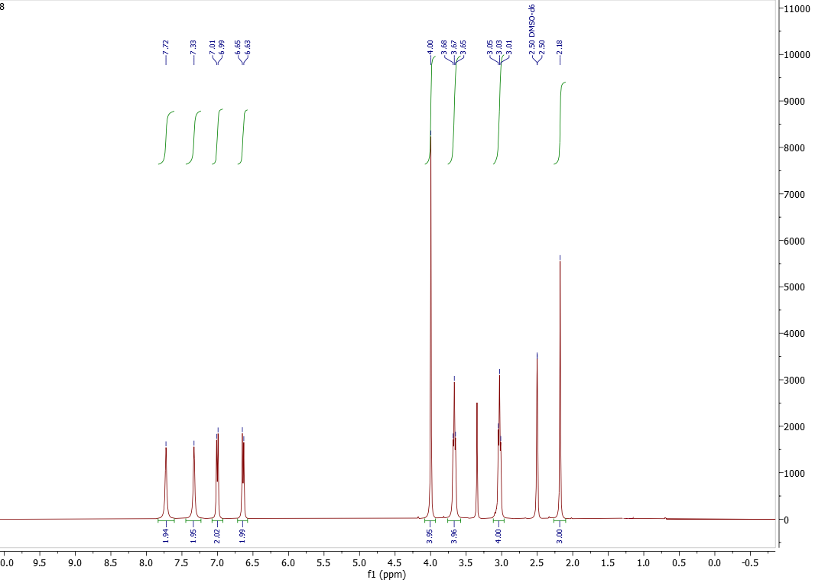
Fig. S7. ¹H NMR (400 MHz, DMSO-d₆) spectrum of 8
Fig. S8. ¹³C NMR (101 MHz, DMSO-d₆) spectrum of 8
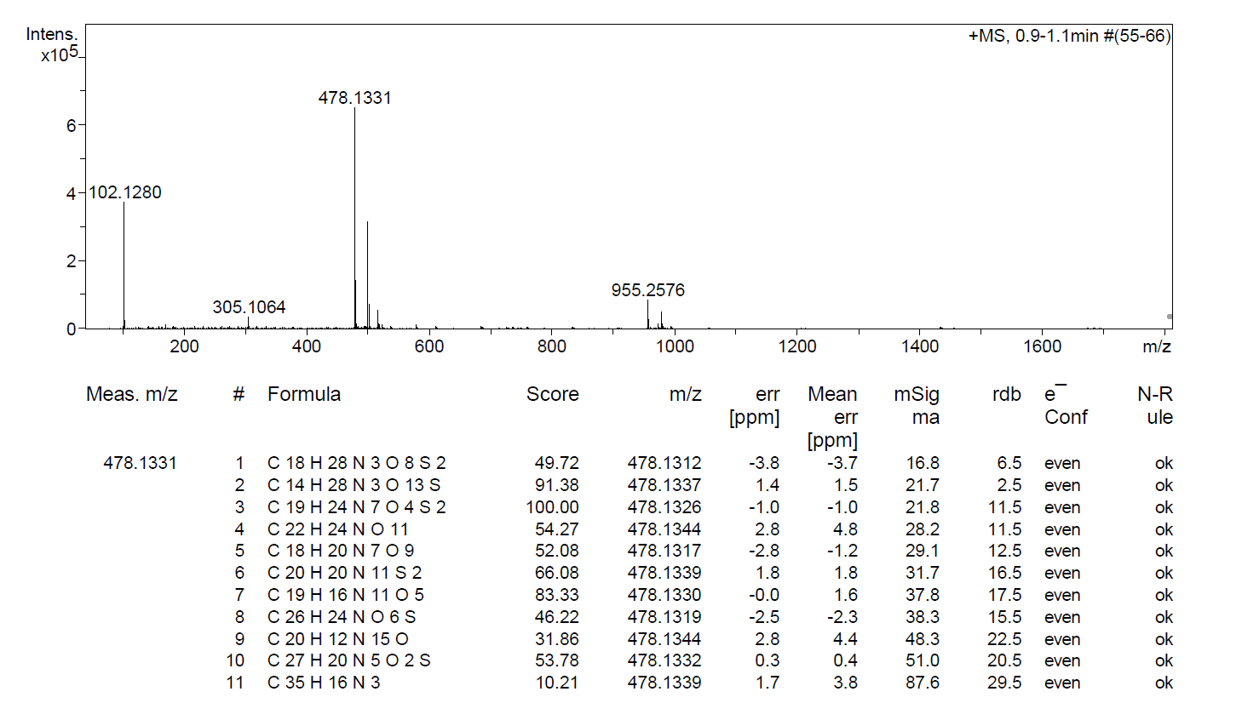
Fig. S9. HRMS spectrum of 8
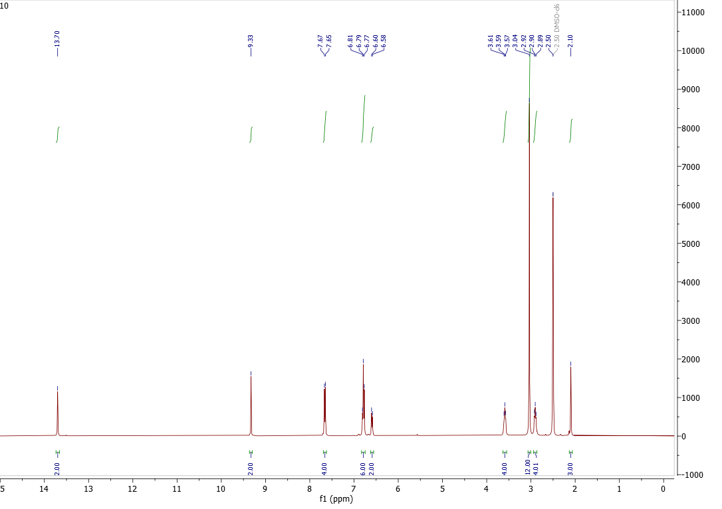
Fig. S10. ¹H NMR (400 MHz, DMSO-d₆) spectrum of 10
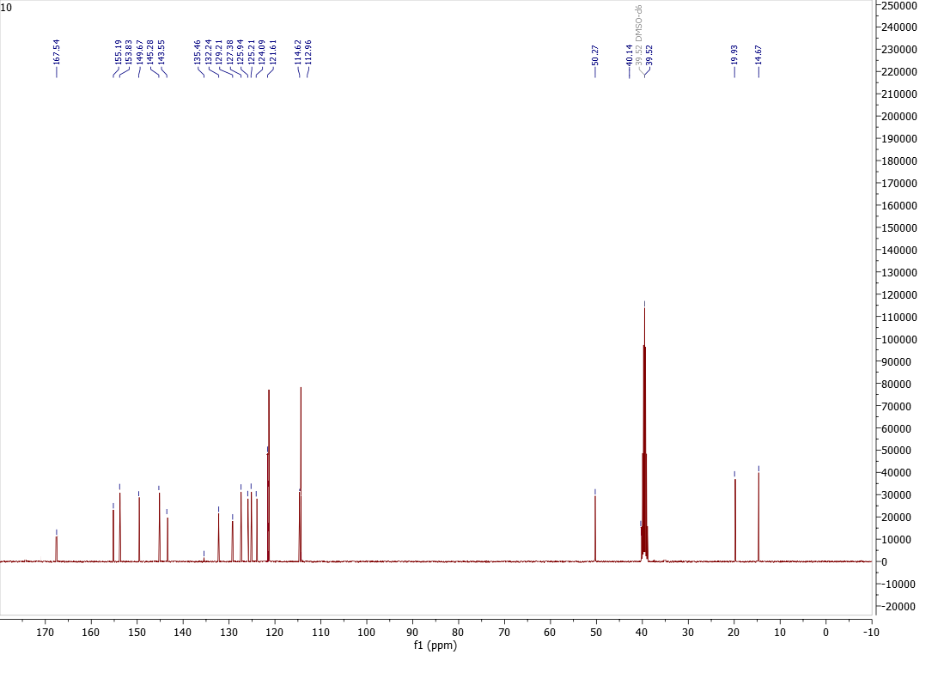
Fig. S11. ¹³C NMR (101 MHz, DMSO-d₆) spectrum of 10

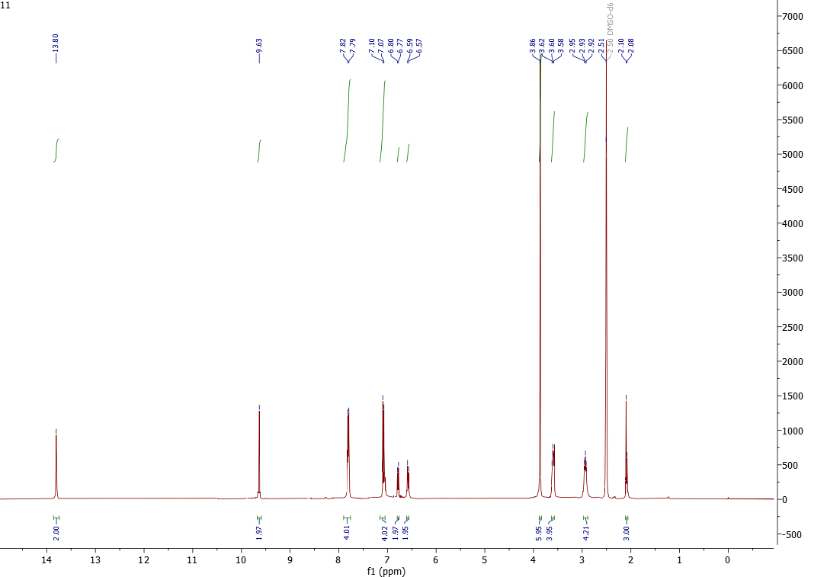
Fig. S12. ¹H NMR (400 MHz, DMSO-d₆) spectrum of 11
Fig. S13. ¹³C NMR (101 MHz, DMSO-d₆) spectrum of 11

Fig. S14. ¹H NMR (400 MHz, DMSO-d₆) spectrum of 12

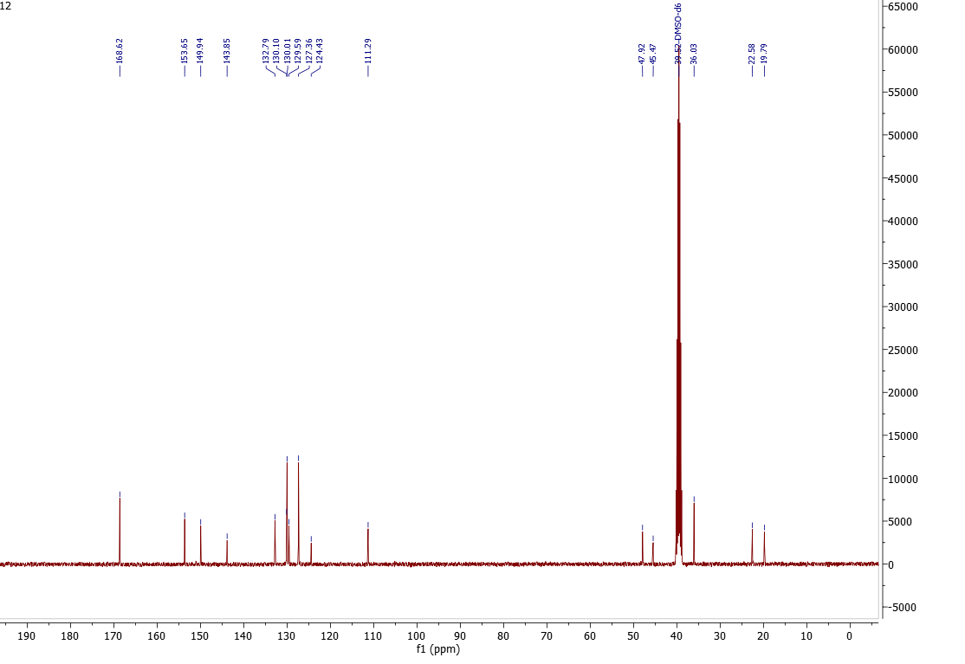
Fig. S15. ¹³C NMR (101 MHz, DMSO-d₆) spectrum of 12
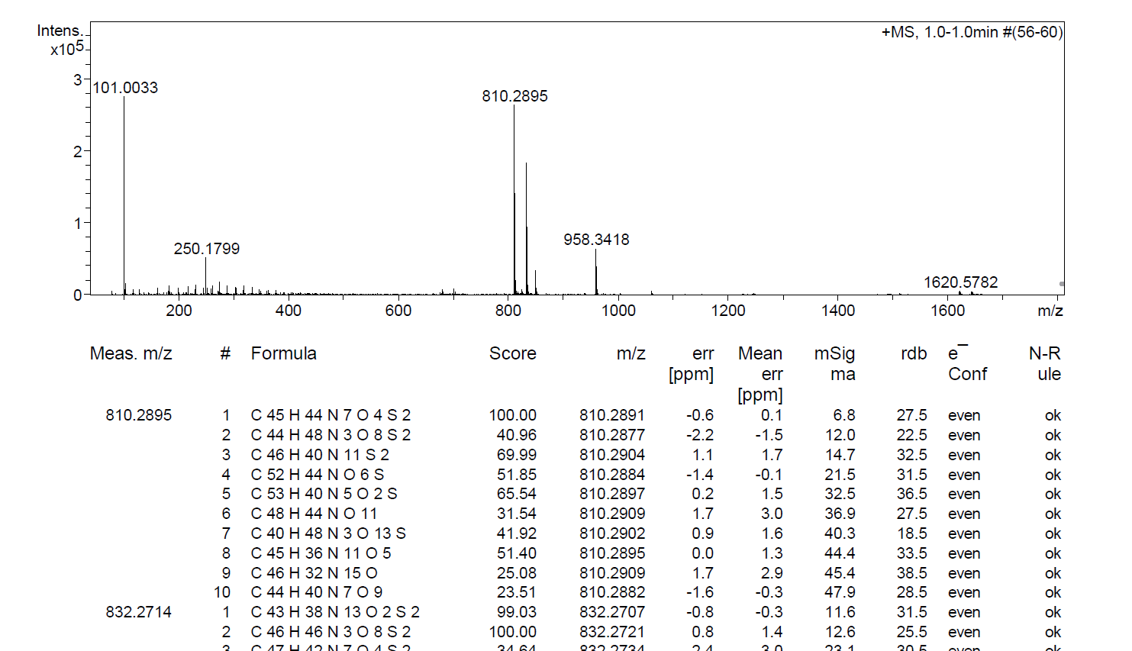
Fig. S16. HRMS spectrum of 12
Fig. S17. ¹H NMR (400 MHz, DMSO-d₆) spectrum of 13
Fig. S18. ¹³C NMR (101 MHz, DMSO-d₆) spectrum of 13
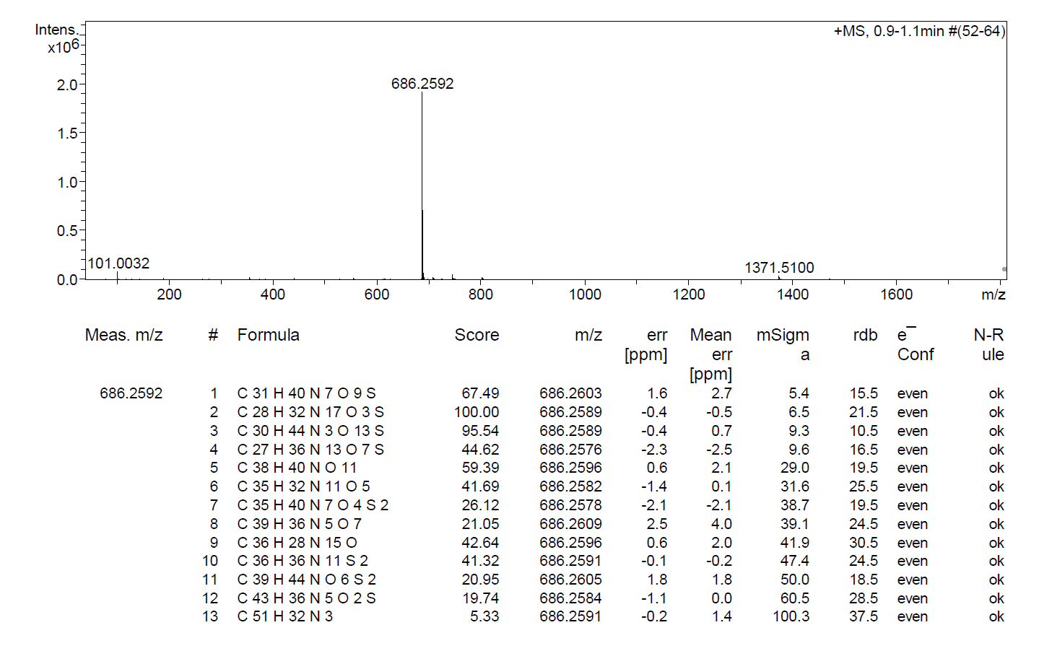
Fig. S19. HRMS spectrum of 13
Fig. S20. ¹H NMR (400 MHz, DMSO-d₆) spectrum of 14
Fig. S21. ¹³C NMR (101 MHz, DMSO-d₆) spectrum of 14
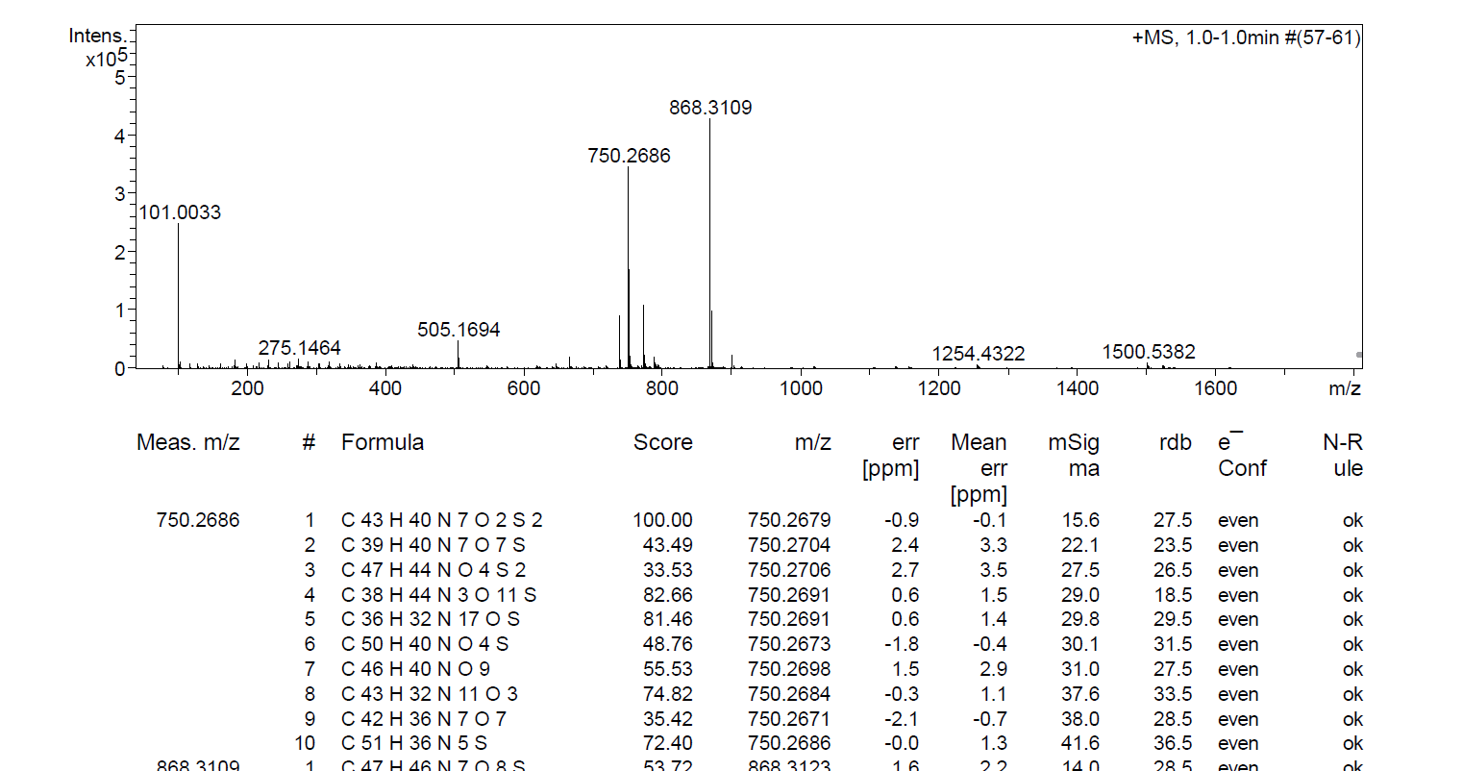
Fig. S22. HRMS spectrum of 14
Fig. S23. ¹H NMR (400 MHz, DMSO-d₆) spectrum of 15
Fig. S24. ¹³C NMR (101 MHz, DMSO-d₆) spectrum of 15
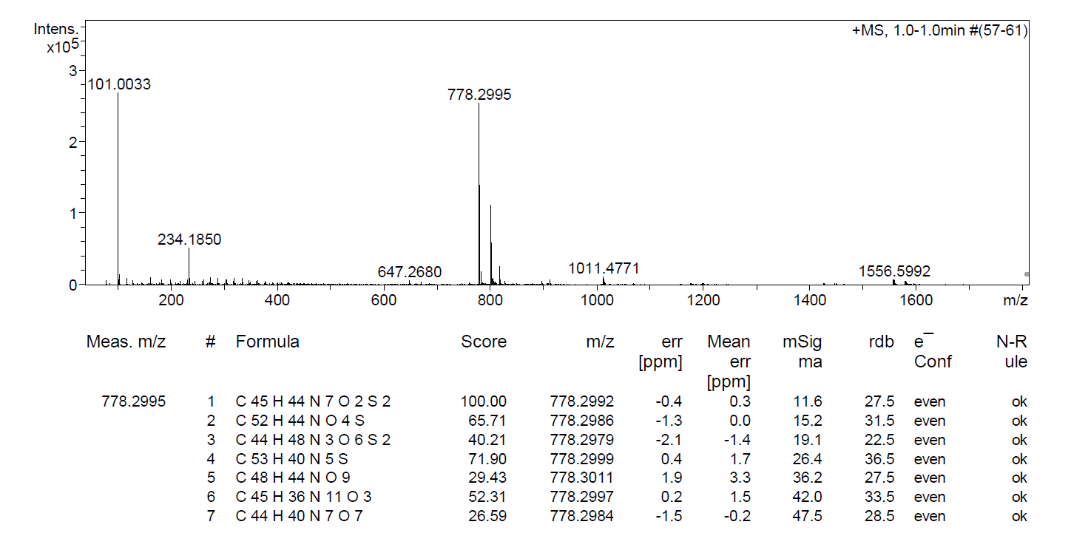
Fig. S25. HRMS spectrum of 15
Fig. S26. ¹H NMR (400 MHz, DMSO-d₆) spectrum of 16
Fig. S27. ¹³C NMR (101 MHz, DMSO-d₆) spectrum of 16
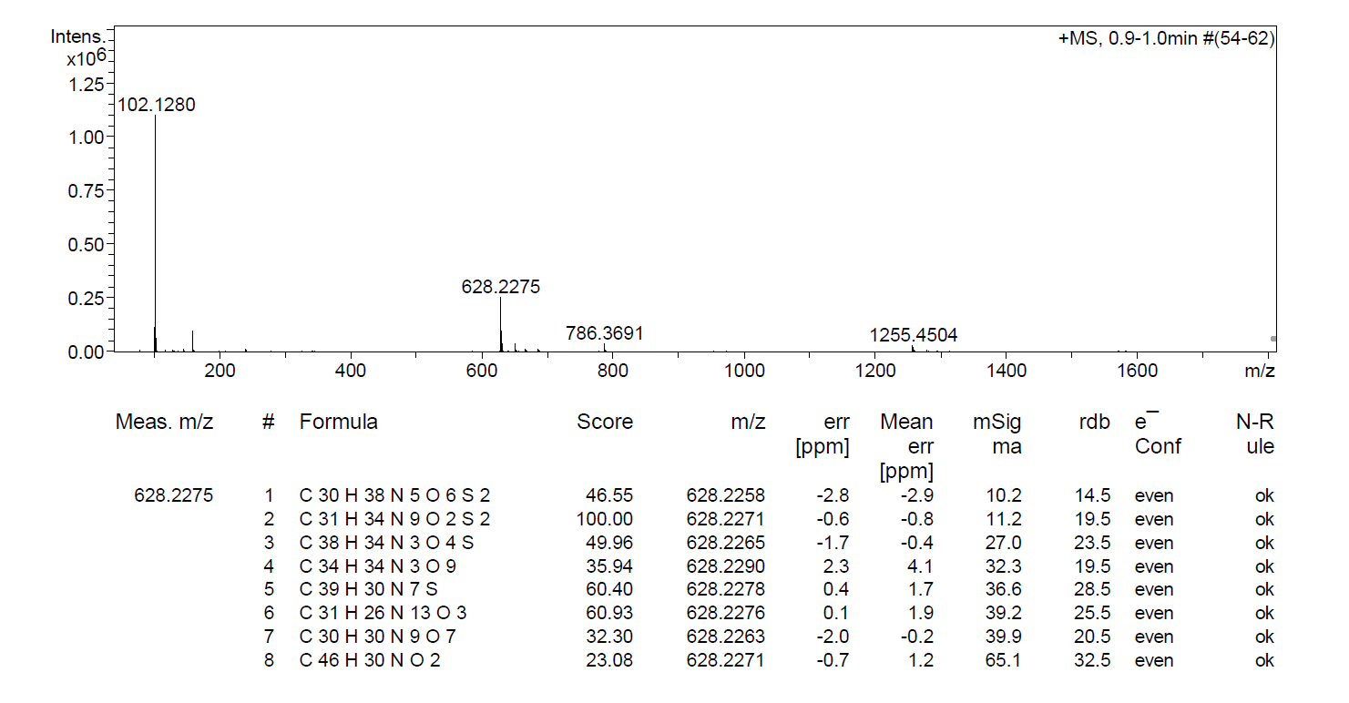
Fig. S28. HRMS spectrum of 16
Fig. S29. ¹H NMR (400 MHz, DMSO-d₆) spectrum of 17
Fig. S30. ¹³C NMR (101 MHz, DMSO-d₆) spectrum of 17
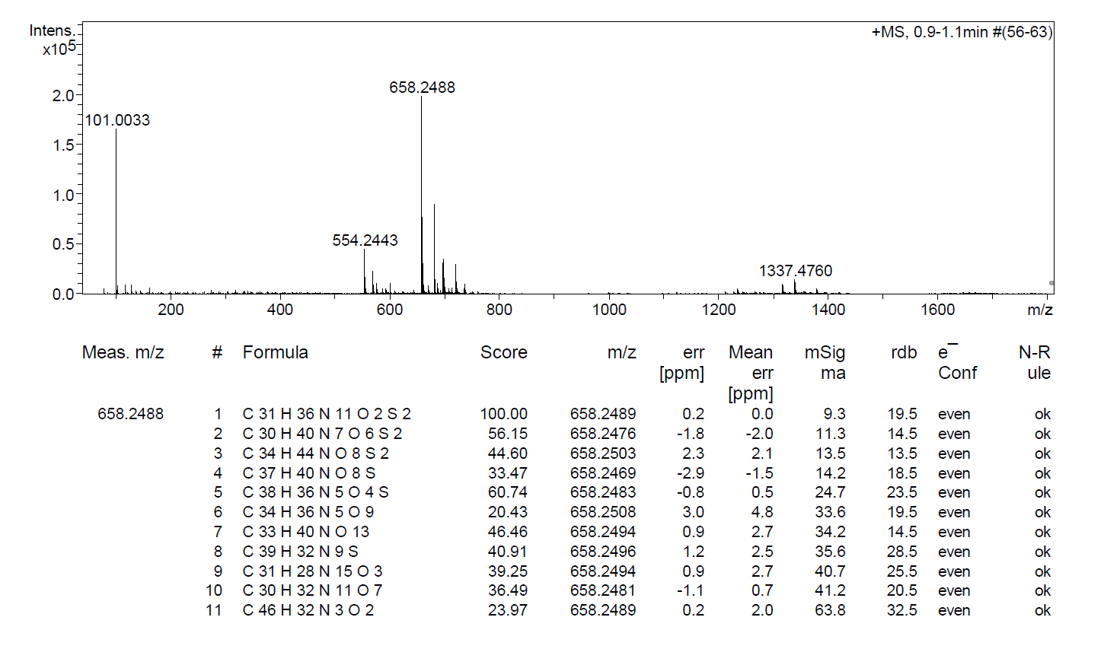
Fig. S31. HRMS spectrum of 17
Fig. S32. ¹H NMR (400 MHz, DMSO-d₆) spectrum of 18
Fig. S33. ¹³C NMR (101 MHz, DMSO-d₆) spectrum of 18
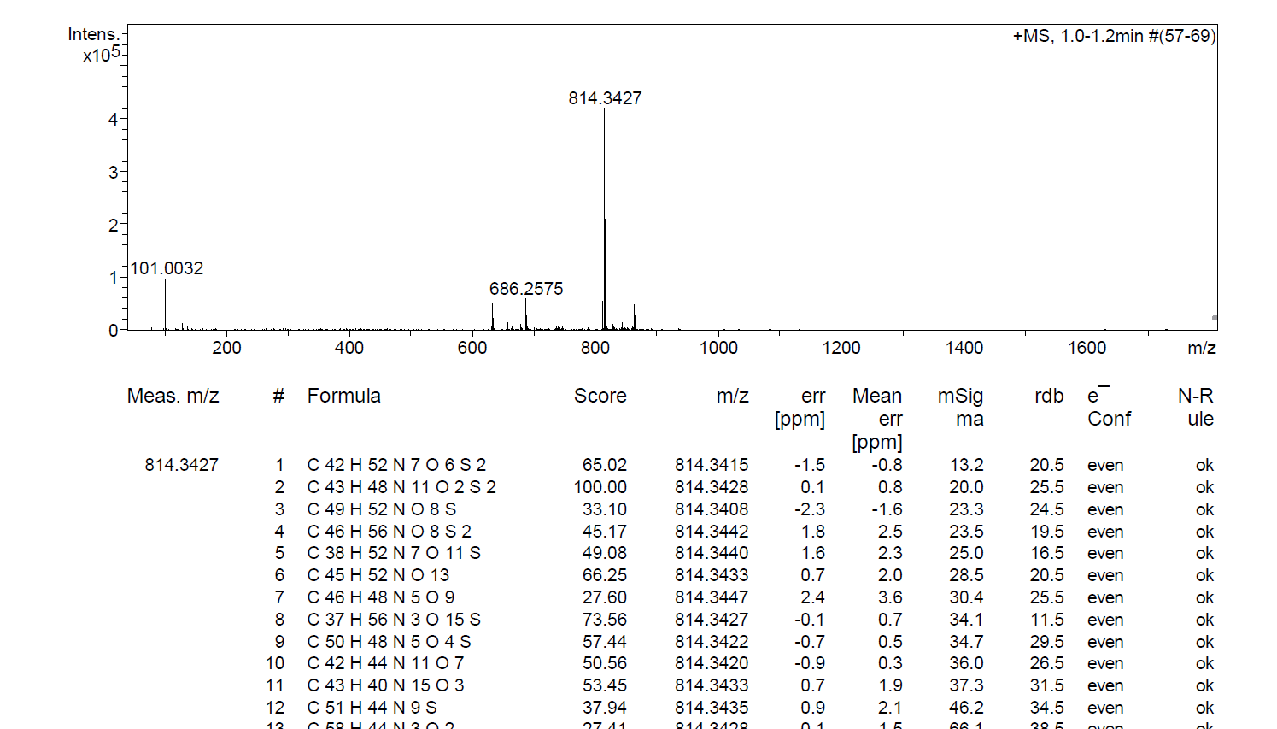
Fig. S34. HRMS spectrum of 18

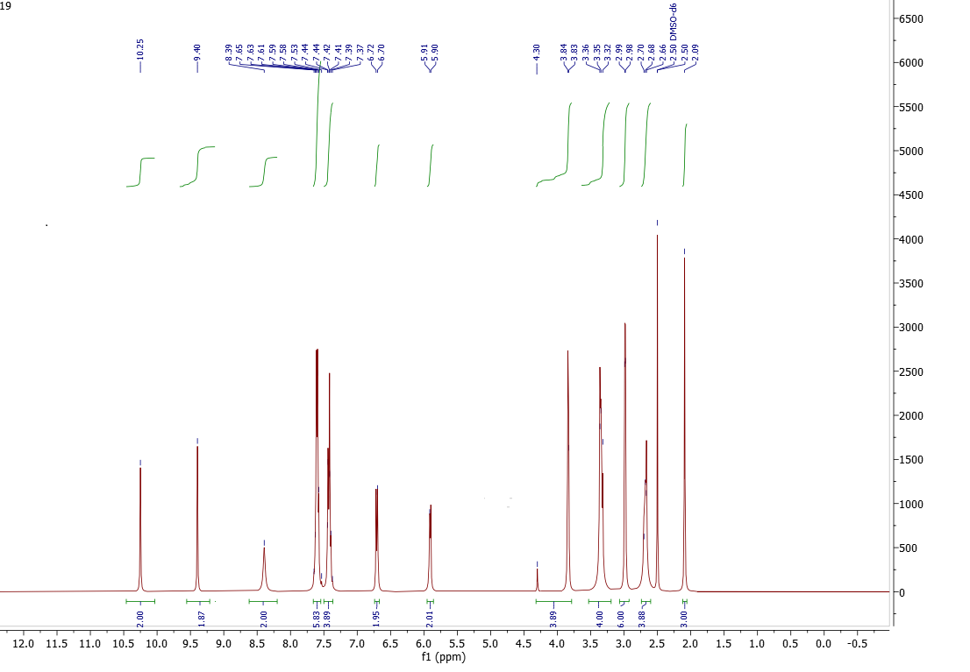
Fig. S35. ¹H NMR (400 MHz, DMSO-d₆) spectrum of 19
Fig. S36. ¹³C NMR (101 MHz, DMSO-d₆) spectrum of 19
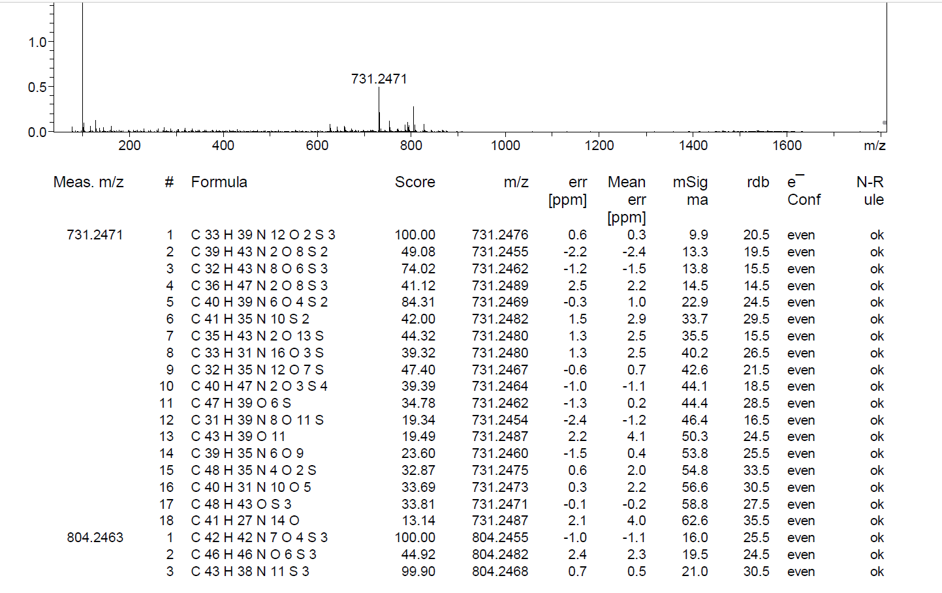
Fig. S37. HRMS spectrum of 19
Fig. S38. ¹H NMR (400 MHz, DMSO-d₆) spectrum of 20
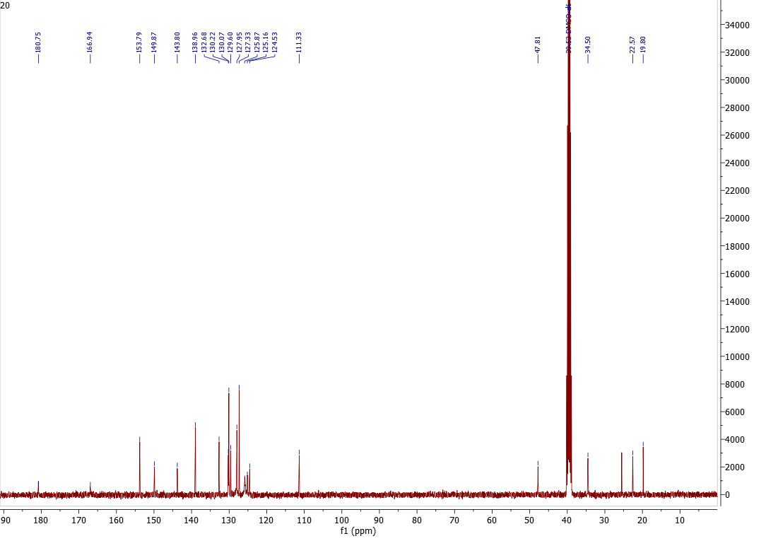
Fig. S39. ¹³C NMR (101 MHz, DMSO-d₆) spectrum of 20
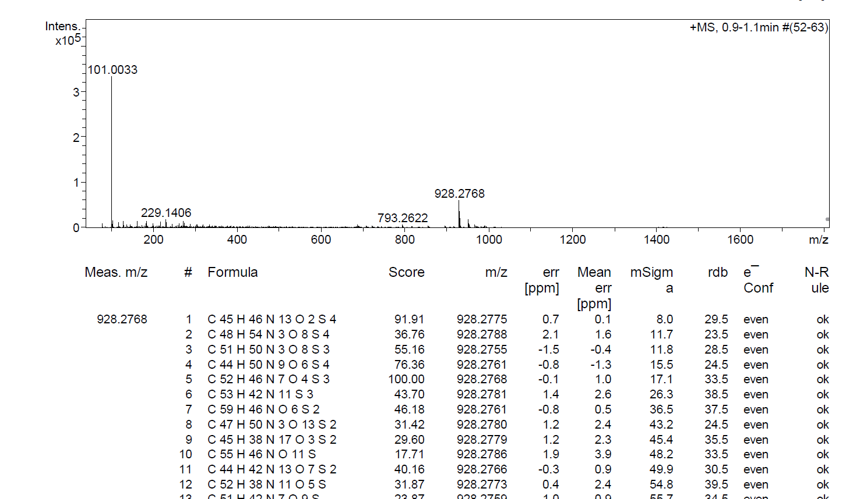
Fig. S40. HRMS spectrum of 20
Fig. S41. ¹H NMR (400 MHz, DMSO-d₆) spectrum of 21
Fig. S42. ¹³C NMR (101 MHz, DMSO-d₆) spectrum of 21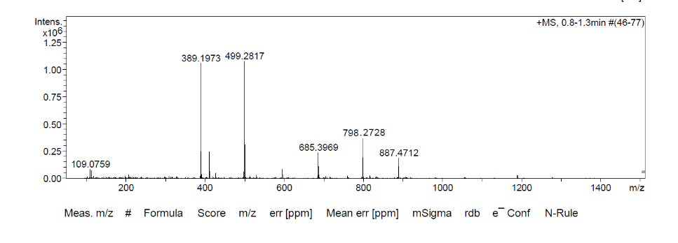
Fig. S43. HRMS spectrum of 21

Fig. S44. ¹H NMR (400 MHz, DMSO-d₆) spectrum of 22
Fig. S45. ¹³C NMR (101 MHz, DMSO-d₆) spectrum of 22
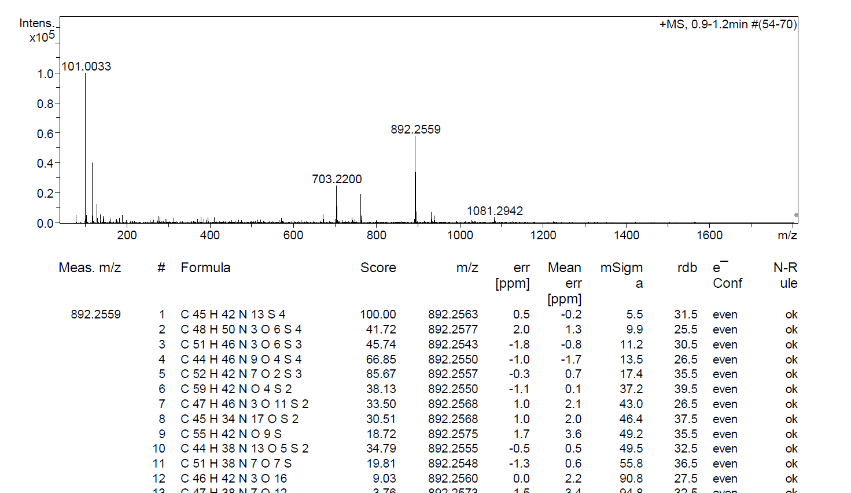
Fig. S46. HRMS spectrum of 22
Fig. S47. ¹H NMR (400 MHz, DMSO-d₆) spectrum of 23
Fig. S48. ¹³C NMR (101 MHz, DMSO-d₆) spectrum of 23
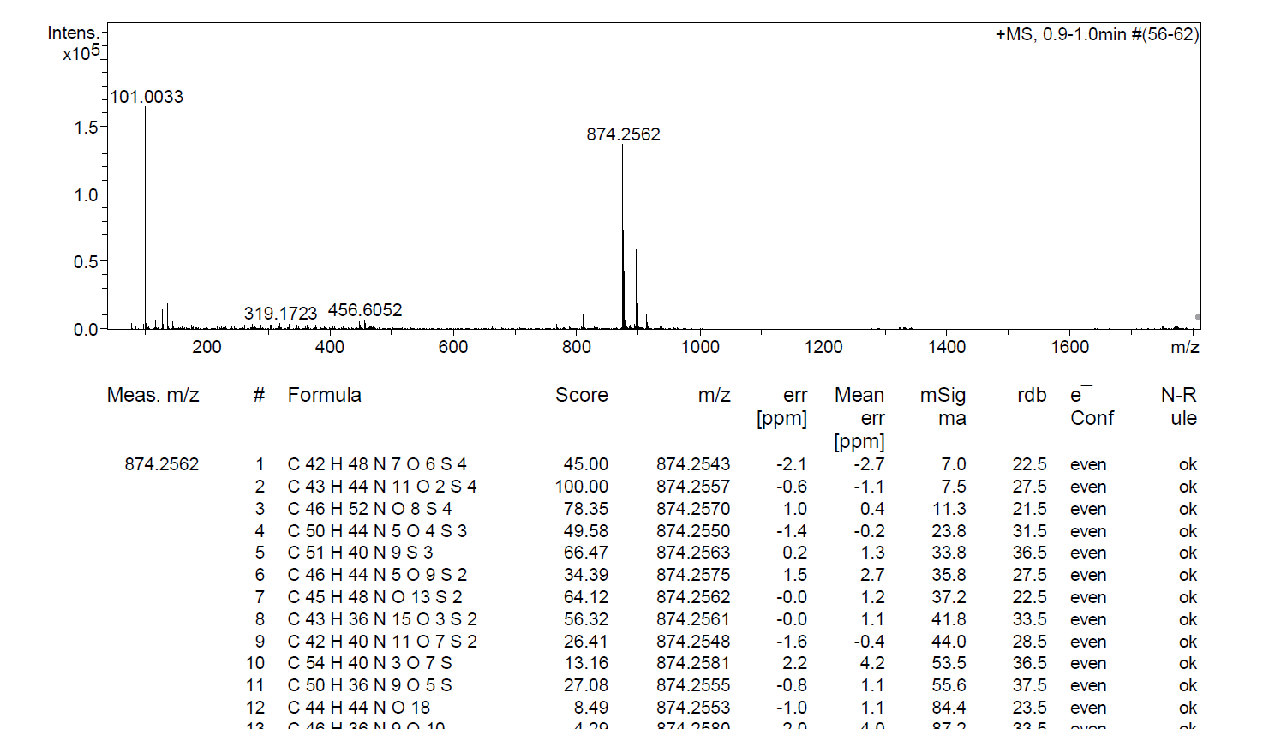
Fig. S49. HRMS spectrum of 23
Fig. S50. ¹H NMR (400 MHz, DMSO-d₆) spectrum of 24
Fig. S51. ¹³C NMR (101 MHz, DMSO-d₆) spectrum of 24
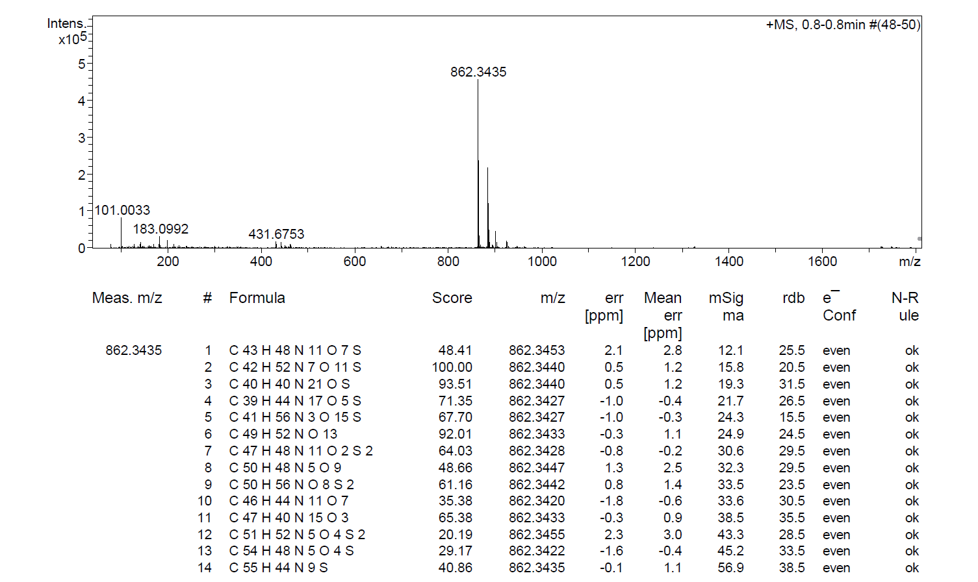
Fig. S52. HRMS spectrum of 24
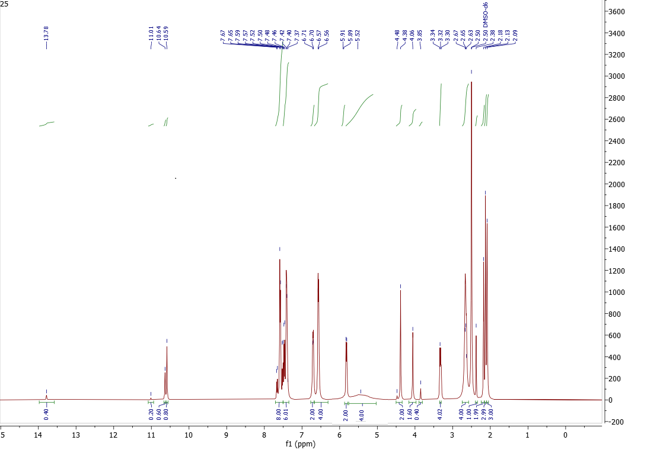
Fig. S53. ¹H NMR (400 MHz, DMSO-d₆) spectrum of 25
Fig. S54. ¹³C NMR (101 MHz, DMSO-d₆) spectrum of 25
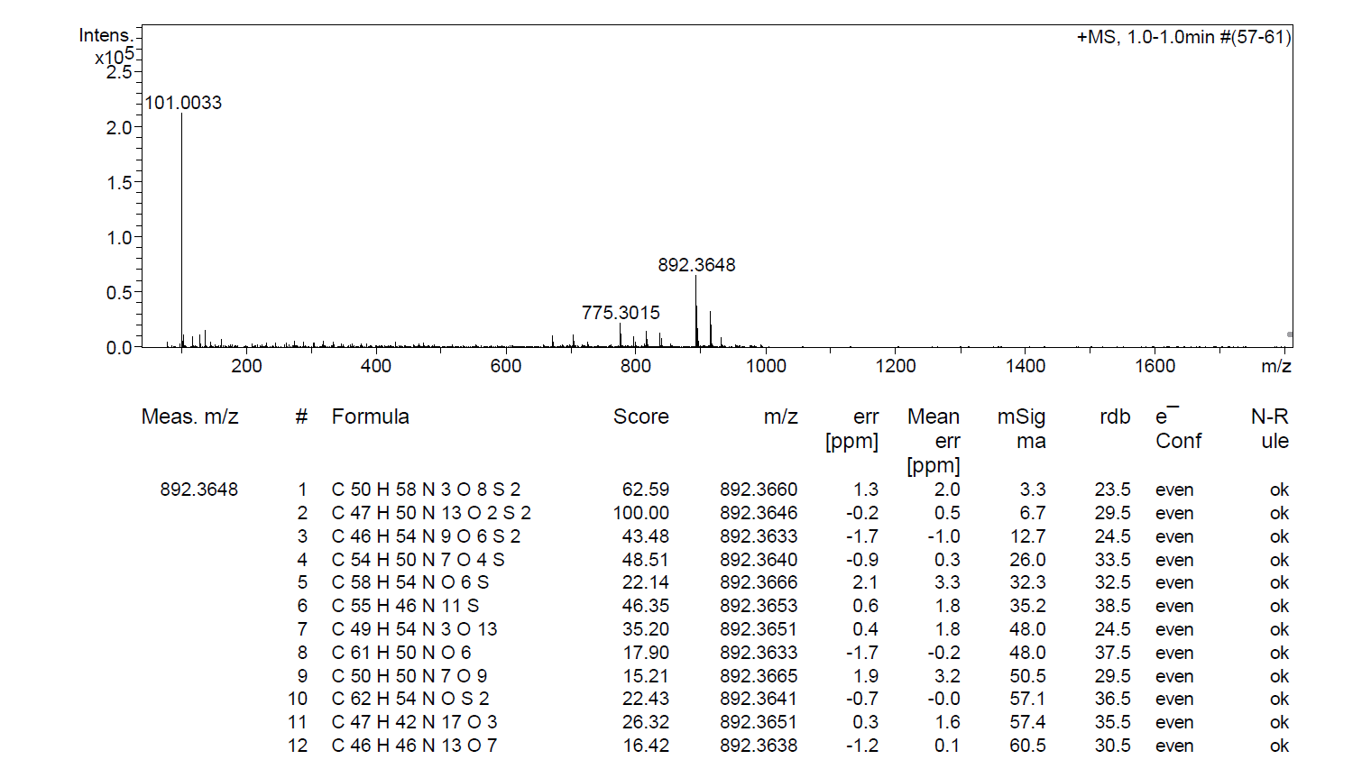
Fig. S55. HRMS spectrum of 25
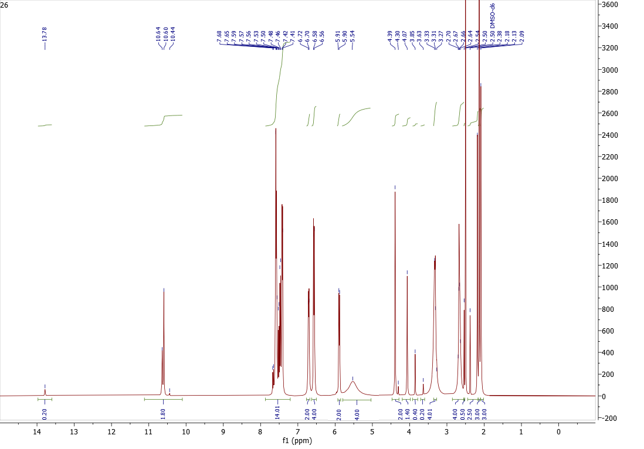
Fig. S56. ¹H NMR (400 MHz, DMSO-d₆) spectrum of 26
Fig. S57. ¹³C NMR (101 MHz, DMSO-d₆) spectrum of 26
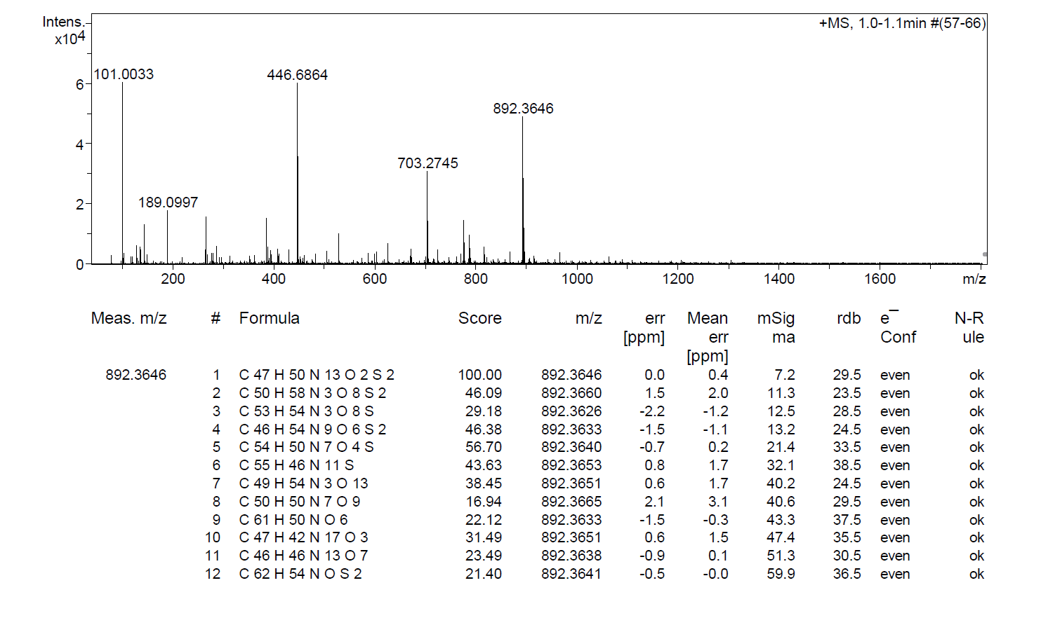
Fig. S58. HRMS spectrum of 26
Fig. S59. ¹H NMR (400 MHz, DMSO-d₆) spectrum of 27
Fig. S60. ¹³C NMR (101 MHz, DMSO-d₆) spectrum of 27
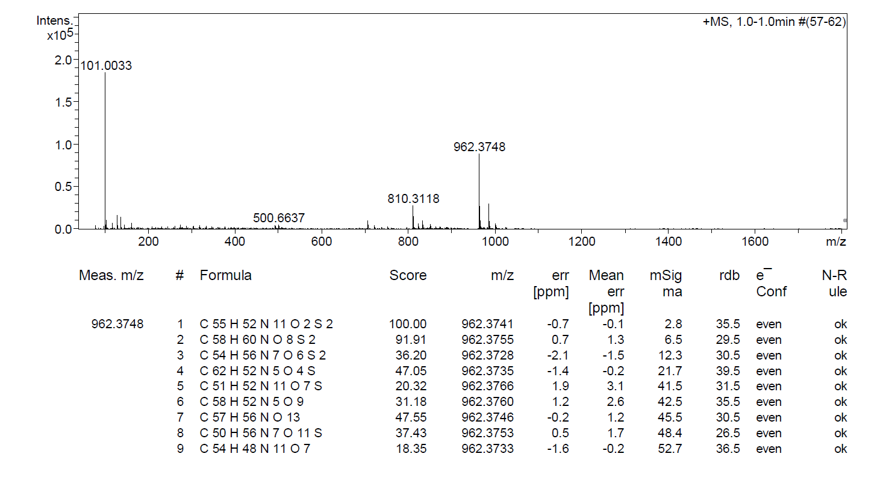
Fig. S61. HRMS spectrum of 27

