Supplementary Information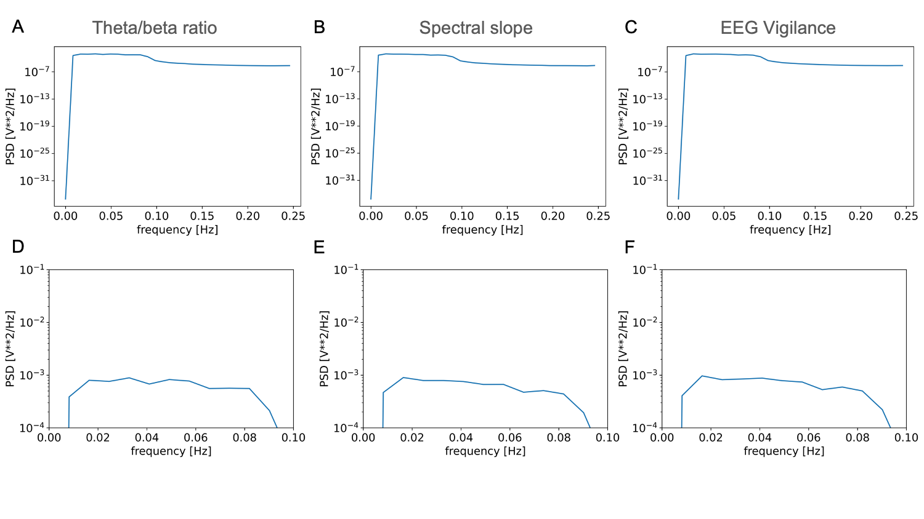
Supplementary Figure 1. Periodograms of correlation values between EEG metrics and BOLD ROIs. A-C) Periodograms of correlation values across time lags between -64s to 64s for theta/beta ratio, spectral slope, and EEG vigilance, respectively. D-E) Zoomed in periodogram for better visualizing the plateau around 0.01 Hz to 0.09 Hz.
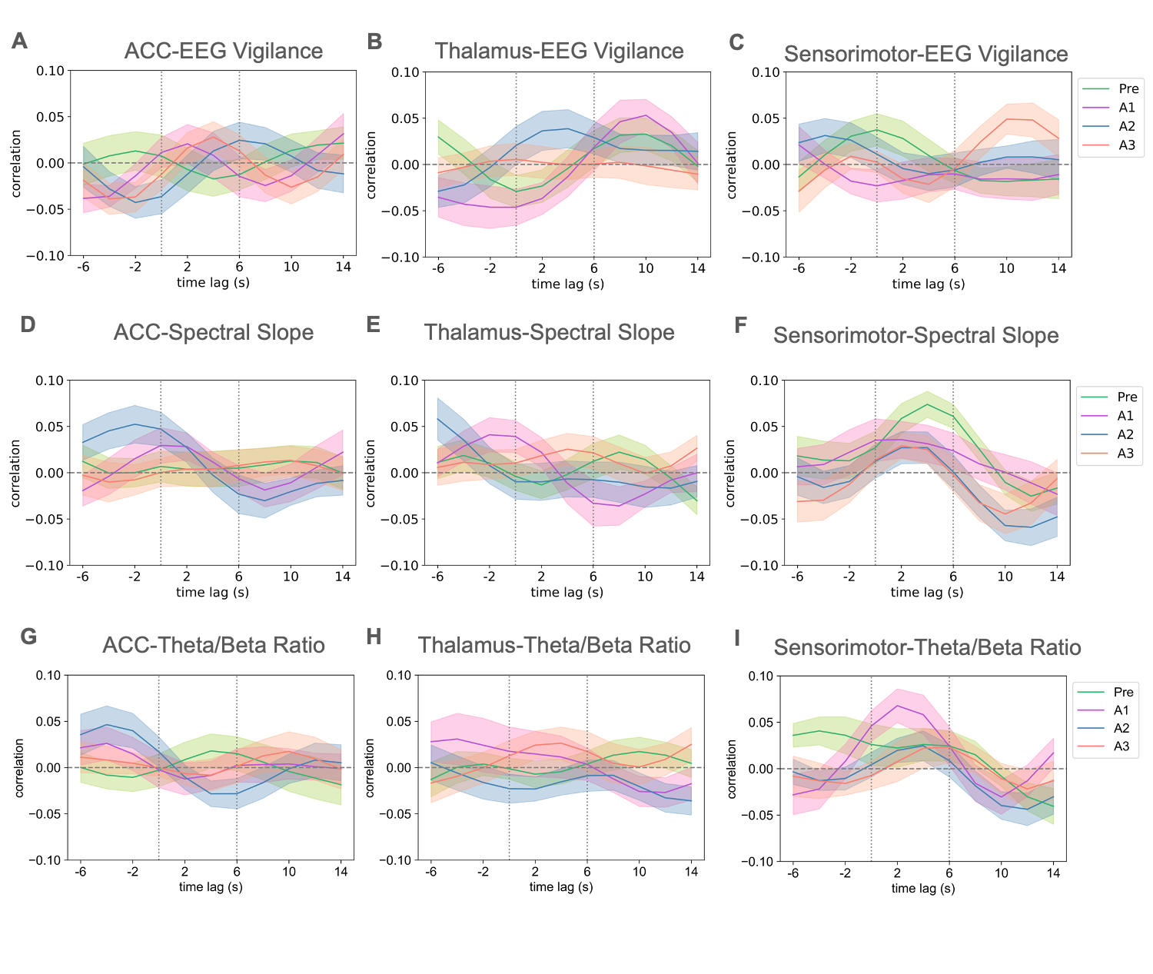
Supplementary Figure 2. Cross correlation between EEG metrics and BOLD ROIs.
A-C) Cross correlation values between EEG-vigilance and BOLD ROIs. D-F) Cross correlation values between spectral slope and BOLD ROIs.

