Supplementary Figure5B.
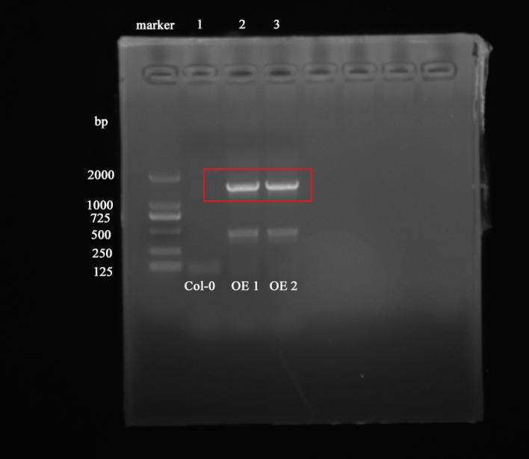
In-gel electrophoresis detection of PhCYP724B1 expression from the leaves of Arabidopsis Col-0 plants and PhCYP724B1-overexpressing transgenic plants.
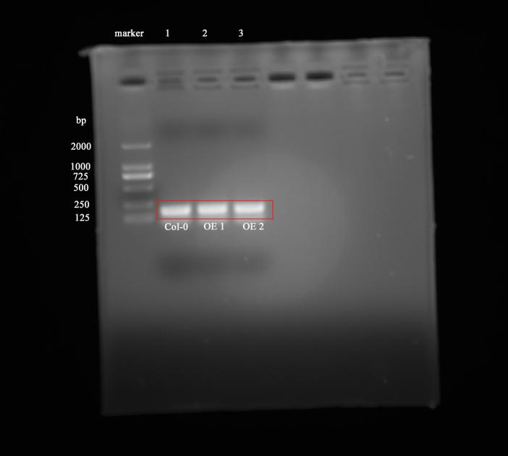
In-gel electrophoresis detection of Tubulin expression from the leaves of Arabidopsis Col-0 plants and PhCYP724B1-overexpressing transgenic plants.

