Biopolymer-assisted enzyme-induced carbonate precipitation for Cu-contaminated loess remediation

Yi-Xin Xie^{1,3}, Wen-Chieh Cheng^{2,3*}, Lin Wang^{1,3}, Zhong-Fei Xue^{1,3}, and Yin-Long Xu^{3,4}

¹PhD student, School of Civil Engineering, Xi’an University of Architecture and Technology, Xi’an 710055, China. Email: xieyixin@xauat.edu.cn (Y.-X. Xie), wanglin@xauat.edu.cn (L. Wang), xuezhongfei@xauat.edu.cn (Z.-F. Xue)
²Professor, School of Civil Engineering, Xi’an University of Architecture and Technology, Xi’an 710055, China. *Corresponding author, email: w-c.cheng@xauat.edu.cn (W.-C. Cheng)
³Shaanxi Key Laboratory of Geotechnical and Underground Space Engineering (XAUAT), Xi’an 710055, China
⁴Graduate student, School of Civil Engineering, Xi’an University of Architecture and Technology, Xi’an 710055, China. Email: xylh@xauat.edu.cn (Y.-L. Xu)

These Supplemental files include
7 Pages
2 Figures
3 Tables
Figure and Table Legends
Figure S1 a Urease extraction and preparation of chitosan colloid; b Test tube experiments; c Soil column tests
Figure S2 Particle-size distribution curve for the loess soil
Table S1 Scheme applied to the test tube experiments
Table S2 Physical and mechanical properties of the loess soil
Table S3 Scheme applied to the one-dimensional soil column tests
Figure S1 a Urease extraction and preparation of chitosan colloid b Test tube experiments c Soil column tests
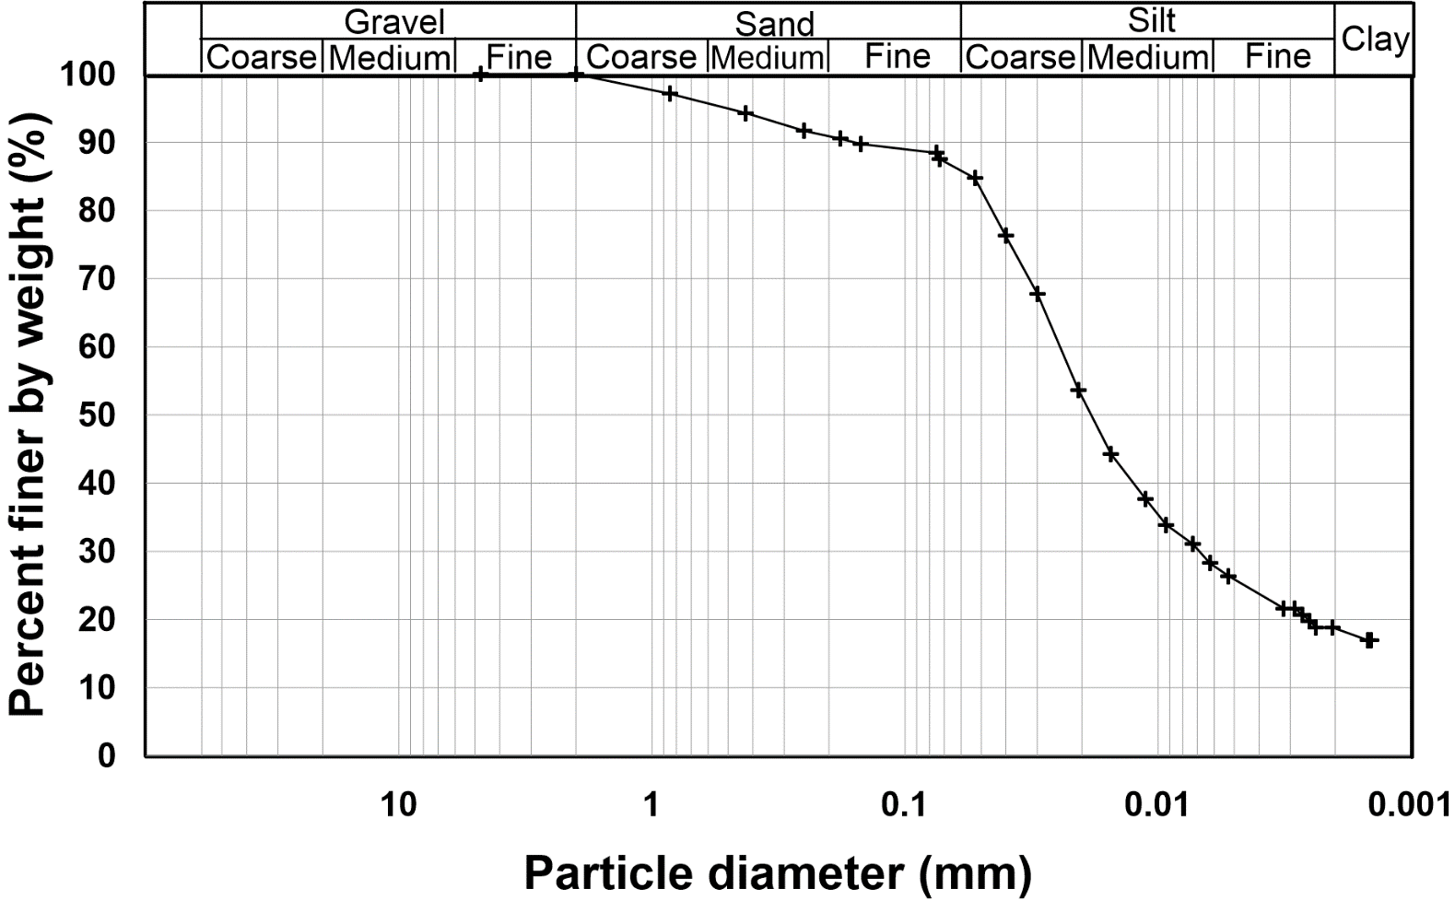
Figure S2 Particle-size distribution curve for the loess soil
Table S1 Scheme applied to the test tube experiments
 | Concentration (mM) |  |  | Concentration (g/L)
 | Cu(NO₃)₂ | Urea | CaCl₂ | Urease | Chitosan
1 | 5-50 | 500 | 0 | 3 | 0
2 | 5-50 | 500 | 0 | 3 | 2
3 | 5-50 | 500 | 0 | 3 | 4
4 | 5-50 | 500 | 250 | 3 | 2
5 | 5-50 | 500 | 250 | 3 | 4

Table S2 Physical and mechanical properties of the loess soil
ω_{L}/% | ω_{P}/% | I_{P} | ω_{n}/% | ρ_{dmax}/g·cm⁻³ | G_{s} | USCS symbol
24.4 | 14.2 | 10.2 | 17.25 | 1.745 | 2.66 | CL
Note: ω_{L} = liquid limit; ω_{P} = plastic limit; I_{P} = plastic index; ω_{n} = natural moisture content; G_{s} = specific gravity; USCS = Unified Soil Classification System

Table S3. Scheme applied to the one-dimensional soil column tests.
 | Group  ID | Cu²⁺ concentration  /mg·kg⁻¹ | UC2 concentration  /mM | UC1 concentration  /g·L⁻¹
Control group | CG | 500 | 0 | 0
Control group | CG | 2000 | 0 | 0
Control group | CG | 4000 | 0 | 0
Test group 1 | TG2 | 500 | 1000/500 | 10/2
Test group 1 | TG2 | 2000 | 1000/500 | 10/2
Test group 1 | TG2 | 4000 | 1000/500 | 10/2
Test group 2 | TG4 | 500 | 1000/500 | 10/4
Test group 2 | TG4 | 2000 | 1000/500 | 10/4
Test group 2 | TG4 | 4000 | 1000/500 | 10/4
Note: UC1 = Urease and chitosan colloid; UC2 = Urea and CaCl₂

