Table of Contents
Supplementary Figure 1. High resolution transmission electron spectroscopy image of Pt/CeO₂-rod catalyst……………………………………………………………………………………………………...3
Supplementary Figure 2. High resolution transmission electron spectroscopy image of Pt/CeO₂-cube catalyst……………………………………………………………………………………………………...3
Supplementary Figure 3. High resolution transmission electron spectroscopy image of Pt/CeO₂-rod catalyst……………………………………………………………………………………………………...3
Supplementary Figure 4. Thermodynamic modeling and catalytic activity of the WGSR on Pt/CeO₂ catalysts…………………………………………………………………………………………………......4
Supplementary Figure 5. In situ ambient-pressure X-ray photoelectron spectra of Pt/CeO₂ catalysts………………………………………………………………………………………………….....4
Supplementary Figure 6. Pt 4f spectra of Pt/CeO₂ catalysts under different conditions………....…........5
Supplementary Figure 7. Oxidation state change of Pt on Pt/CeO₂ catalysts under different conditions…………………………………………………………………………………………………...6
Supplementary Figure 8. Oxidation state change of Pt on Pt/CeO₂-oct catalyst after O₂ pretreatment using 320 eV photon energy ……………………………………………………………………………….7
Supplementary Figure 9. CO adsorption on metallic Pt on Pt/CeO₂-oct catalyst in the presence of CO. 320 eV photon energy was applied to investigate the surface information……………………………………..8
Supplementary Figure 10. Ce 3d spectra of Pt/CeO₂ catalysts under different conditions………............9
Supplementary Figure 11. Oxidation state change of Ce on Pt/CeO₂ catalysts under different conditions……………………………………………………………………………………………..…...10
Supplementary Figure 12. O 1s spectra of Pt/CeO₂ catalysts under different conditions……..….…......11
Supplementary Figure 13. Oxidation state change of O on Pt/CeO₂ catalysts under different conditions…………………………………………………………………………………………...……..12
Supplementary Table 1-3. Surface composition changes on Pt/CeO₂ catalysts under different conditions……………………………………………………………………………………………….....13
Supplementary Table 4-6. Fitting parameters used for XPS peak fitting…………………………….....14
Supplementary Figure 14 -15. In situ transmission infrared spectroscopy……………………………...15
Supplementary Figure 16. In situ environmental transmission electron microscopy of Pt/CeO₂-rod catalyst…………………………………………………………………………………………………….17
Supplementary Figure 17. In situ environmental transmission electron microscopy of Pt/CeO₂-cube catalyst…………………………………………………………………………………………………….18
Supplementary Figure 18. In situ environmental transmission electron microscopy of Pt/CeO₂-oct catalyst…………………………………………………………………………………………………….19
Supplementary Figure 19-20. Comparison of Pt/CeO₂-rod catalyst before and after exposing to reactants ………….………………………………………………………………………………………………….20
Supplementary References…...………………………………………………………………………….21

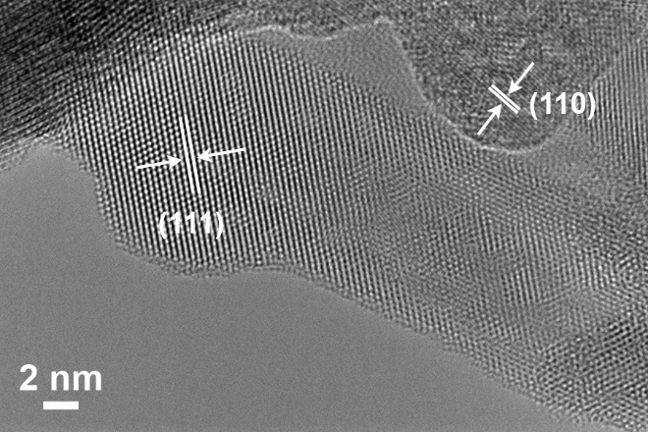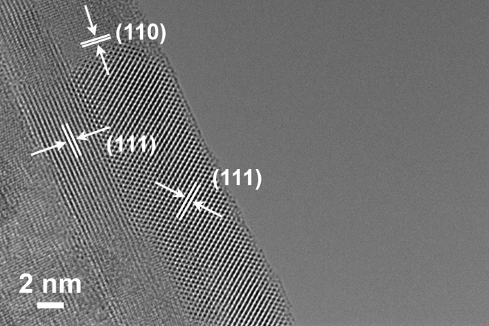
Supplementary Figure 1. High resolution transmission electron spectroscopy image of Pt/CeO₂-rod catalyst.

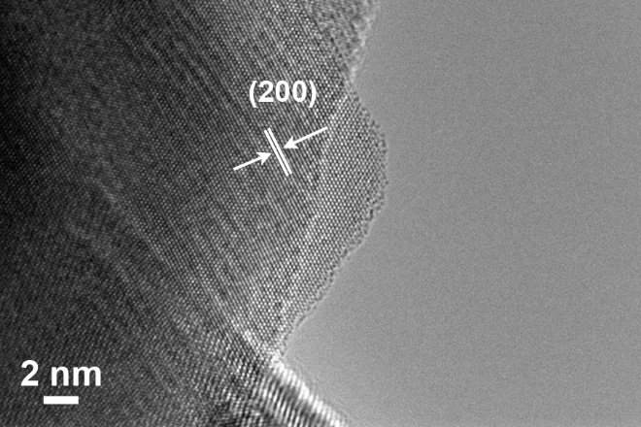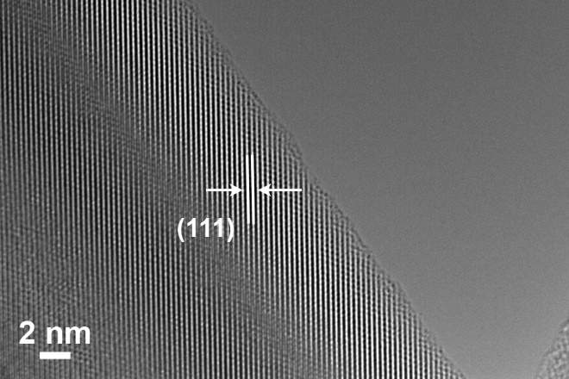
Supplementary Figure 2. High resolution transmission electron spectroscopy image of Pt/CeO₂-cube catalyst.

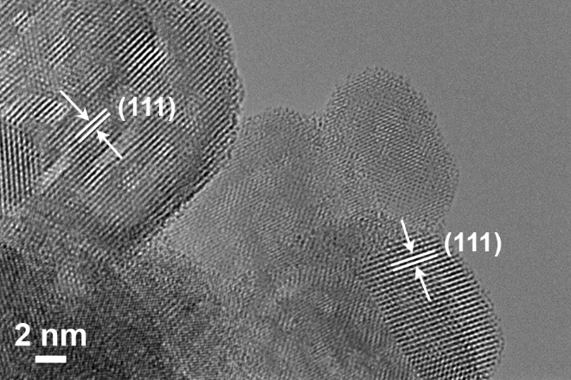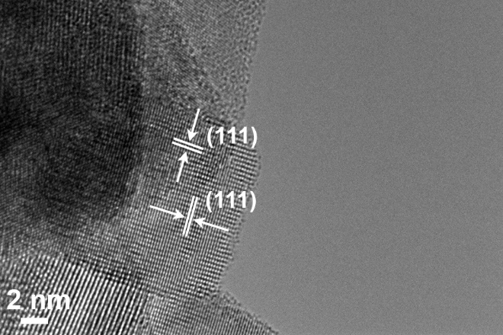
Supplementary Figure 3. High resolution transmission electron spectroscopy image of Pt/CeO₂-oct catalyst.

Supplementary Figure 4. (a) Thermodynamic modeling of WGSR in a Gibbs reactor in ASPEN with a stream of CO and H₂O (1: 2). (B) CO conversion of the WGSR on CeO₂ supported Pt catalysts. Reaction conditions: 50 mg catalyst was pretreated at 400 °C under 50 ml/min O₂ flow for 60 min, followed by 15 vol% H₂/Ar flow with a flow rate of 100 ml/min for 60 min at 300 °C. The catalyst was cooled down to room temperature under 50 ml/min Ar flow. Then, a stream of 1 vol% CO and 2 vol% H₂O balanced with Ar was introduced into the system with a flow rate of 157 ml/min, given a space velocity of 188,400 ml/g_{cat}/h.

Supplementary Figure 5. In situ ambient-pressure X-ray photoelectron spectroscopy. Survey spectra of (a) Pt/CeO₂-rod, (b) Pt/CeO₂-cube, and (c) Pt/CeO₂-oct catalysts under different conditions.

Supplementary Figure 6. In situ ambient-pressure X-ray photoelectron spectroscopy. (a) Pt 4f spectra of Pt/CeO₂-rod catalyst under different conditions; (b) Pt 4f spectra of Pt/CeO₂-cube catalyst under different conditions; (c) Pt 4f spectra of Pt/CeO₂-oct catalyst under different conditions; Photon energy of 1100 eV was applied.

Supplementary Figure 7. (a) oxidation state change of Pt on Pt/CeO₂-rod catalyst under different conditions; (b) oxidation state change of Pt on Pt/CeO₂-cube catalyst under different conditions; (c) oxidation state change of Pt on Pt/CeO₂-oct catalyst under different conditions.

Supplementary Figure 8. Pt 4f core level spectra for Pt/CeO₂-oct catalyst after O₂ pretreatment for 30 min. 320 eV photon energy was applied to investigate the surface Pt species.

Under UHV conditions, both Pt²⁺ and Pt⁴⁺ are observed with a ratio of Pt⁴⁺/Pt²⁺ = 0.036. Pt²⁺ have peaks located at 73.0 and 76.4 eV, while Pt⁴⁺ have peaks located at 74.9 and 78.3 eV. After O₂ pretreatment, the surface Pt remains oxidized. The Pt⁴⁺/Pt²⁺ ratio increases from 0.036 to 0.082.
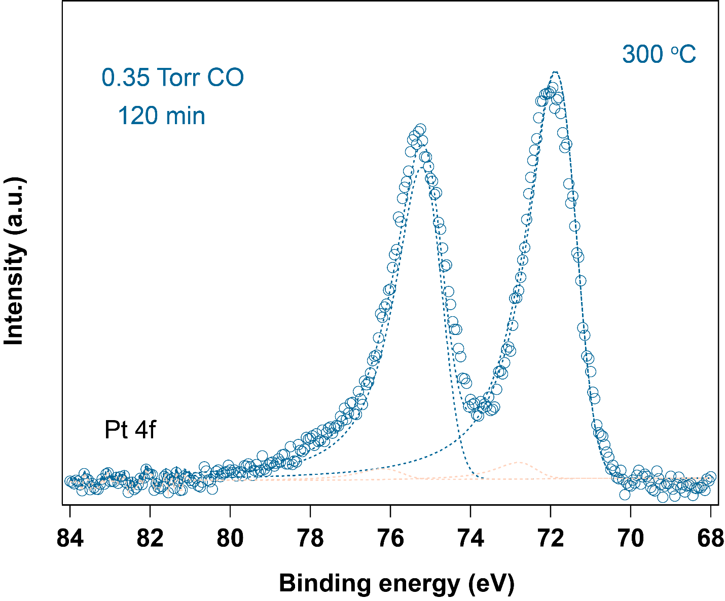
Supplementary Figure 9. CO adsorption on metallic Pt on Pt/CeO₂-oct catalyst in the presence of CO. 320 eV photon energy was applied to investigate the surface information. The peaks located at 71.4 and 74.8 eV correspond to Pt⁰, while CO adsorption on Pt⁰ is reflected by peaks located at 72.4 and 75.8 eV.

Supplementary Figure 10. In situ ambient-pressure X-ray photoelectron spectroscopy. (a) Ce 3d spectra of Pt/CeO₂-rod catalyst under different conditions; (b) Ce 3d spectra of Pt/CeO₂-cube catalyst under different conditions; (c) Ce 3d spectra of Pt/CeO₂-oct catalyst under different conditions; Photon energy of 1100 eV was applied. The solid peaks represent the Ce⁴⁺.

Supplementary Figure 11. (a) oxidation state change of Ce on Pt/CeO₂-rod catalyst under different conditions; (b) oxidation state change of Ce on Pt/CeO₂-cube catalyst under different conditions; (c) oxidation state change of Ce on Pt/CeO₂-oct catalyst under different conditions.

For peak deconvolution of Ce 3d spectra of Pt/CeO₂ catalysts, the binding energies of 880.6 eV (Ce 3d_{5/2}, ν₀), 885.0 eV (v’), 899.2 eV (Ce 3d_{3/2}, μ₀), and 903.3 eV (μ’) are referring to Ce³⁺, while binding energies of 882.6 eV (Ce 3d_{5/2}, ν), 888.2 eV (ν”), 898.5 eV (ν’”), 901.2 eV (Ce 3d_{3/2}, μ), 907.4 (μ”) and 916.9 eV (μ’”) represent Ce⁴⁺.¹⁻⁴ The percentage of each oxidation sate of Ce was calculated by comparing the total peak areas of Ce³⁺ to the total peak areas of Ce³⁺ and Ce⁴⁺:
$${Ce}^{3+}\left(\%\right)=\frac{v_{0}+v^{'}+μ_{0}+μ^{'}}{v_{0}+v^{'}+μ_{0}+μ^{'}+v+v^{"}+v^{'''}+μ+μ^{"}+μ^{'''}}$$

Supplementary Figure 12. In situ ambient-pressure X-ray photoelectron spectroscopy. (a) O 1s spectra of Pt/CeO₂-rod catalyst under different conditions; (b) O 1s spectra of Pt/CeO₂-cube catalyst under different conditions; (c) O 1s spectra of Pt/CeO₂-oct catalyst under different conditions; Photon energy of 1100 eV was applied. For all the samples, surface oxygen species contain lattice O at 529.5 eV, hydroxyl (OH) group at 531.0 eV and adsorbed oxygen species at 532.5 eV.^{2, 5-7}
Supplementary Figure 13. (a) oxidation state change of O on Pt/CeO₂-rod catalyst under different conditions; (b) oxidation state change of O on Pt/CeO₂-cube catalyst under different conditions; (c) oxidation state change of O on Pt/CeO₂-oct catalyst under different conditions.
Supplementary Table 1. Percentage of Pt⁰ on Pt/CeO₂ catalysts under different conditions
Conditions | Pt/CeO₂-rod | Pt/CeO₂-cube | Pt/CeO₂-oct
After O₂ pretreatment for 30 min | 0 | 31 | 18
After H₂ pretreatment for 30 min | 18 | 41 | 95
In the presence of CO for 60 min | 31 | 72 | 98
In the presence of CO and H₂O for 60 min | 70 | 87 | 100

Supplementary Table 2. Percentage of Ce³⁺ on Pt/CeO₂ catalysts under different conditions
Conditions | Pt/CeO₂-rod | Pt/CeO₂-cube | Pt/CeO₂-oct
After O₂ pretreatment for 30 min | 12 | 18 | 11
After H₂ pretreatment for 30 min | 33 | 25 | 43
In the presence of CO for 60 min | 33 | 38 | 42
In the presence of CO and H₂O for 60 min | 37 | 38 | 42

Supplementary Table 3. Change of OH group/lattice O on Pt/CeO₂ catalysts under different conditions
Conditions | Pt/CeO₂-rod | Pt/CeO₂-cube | Pt/CeO₂-oct
After O₂ pretreatment for 30 min | 0.25 | 0.03 | 0
After H₂ pretreatment for 30 min | 0.41 | 0.21 | 0.17
In the presence of CO for 60 min | 0.05 | 0.19 | 0.15
In the presence of CO and H₂O for 60 min | 0.33 | 0.45 | 0.35

Supplementary Table 4. Parameters used for XPS fitting of Pt4f
Component | Position (eV) | FWHM | Lineshape
Pt⁰ | 71.4 | 1.0 ± 0.2 | LA(1.2,85,70)
Pt⁰ | 74.8 | 1.0 ± 0.2 | LA(1.2,85,70)
Pt²⁺ | 73.0 | 1.0 ± 0.2 | GL(30)
Pt²⁺ | 76.4 | 1.0 ± 0.2 | GL(30)
Pt⁴⁺ | 74.9 | 1.4 ± 0.2 | GL(30)
Pt⁴⁺ | 78.3 | 1.4 ± 0.2 | GL(30)
CO-Pt⁰ | 72.4 | 1.0 ± 0.2 | LA(1.2,85,70)
CO-Pt⁰ | 75.8 | 1.0 ± 0.2 | LA(1.2,85,70)

Supplementary Table 5. Parameters used for XPS fitting of O1s
Component | Position (eV) | FWHM | Lineshape
Lattice O | 529.5 | 1.5 ± 0.2 | GL(30)
OH group | 531.0 | 1.5 ± 0.2 | GL(30)
Chemisorbed O species | 532.5 | 1.7 ± 0.2 | GL(30)

Supplementary Table 6. Parameters used for XPS fitting of Ce3d
Component | Position (eV) | FWHM | Lineshape
Ce⁴⁺ (ν) | 882.6 | 1.8 ± 0.2 | GL(30)
Ce⁴⁺ (ν”) | 889.1 | 4.5 ± 0.2 | GL(30)
Ce⁴⁺ (ν’”) | 898.5 | 1.8 ± 0.2 | GL(30)
Ce⁴⁺ (μ) | 900.9 | 1.5 ± 0.2 | GL(30)
Ce⁴⁺ (μ”) | 907.7 | 5.5 ± 0.2 | GL(30)
Ce⁴⁺ (μ’”) | 916.9 | 2.4 ± 0.2 | GL(30)
Ce³⁺ (ν₀) | 880.8 | 3.0 ± 0.2 | GL(30)
Ce³⁺ (ν’) | 884.4 | 3.0 ± 0.2 | GL(30)
Ce³⁺ (μ₀) | 899.3 | 1.0 ± 0.2 | GL(30)
Ce³⁺ (μ’) | 902.3 | 3.0 ± 0.2 | GL(30)

Supplementary Figure 14. In situ transmission infrared (TIR) spectroscopy. (a) In situ TIR spectra of Pt/CeO₂-rod catalyst under different conditions; (b) In situ TIR spectra of Pt/CeO₂-cube catalyst under different conditions; (c) In situ TIR spectra of Pt/CeO₂-oct catalyst under different conditions; (d) Normalized peak areas of different species on Pt/CeO₂-rod catalyst under different conditions; The catalyst was pretreated under 0.4 Torr O₂ at 400 °C for 30 min, followed by pretreatment under 0.4 Torr O₂ at 300 °C for 30 min. Then, the spectrum of catalyst collected at 300 °C under vacuum conditions was used as background before introducing CO and H₂O into the system.

Supplementary Figure 15. In situ transmission infrared (TIR) spectroscopy. (a) In situ TIR spectra of Pt/CeO₂-rod catalyst under different conditions; (b) In situ TIR spectra of Pt/CeO₂-cube catalyst under different conditions; (c) In situ TIR spectra of Pt/CeO₂-oct catalyst under different conditions; (d) Normalized peak areas of different species on Pt/CeO₂-rod catalyst under different conditions; (e) Normalized peak areas of different species on Pt/CeO₂-cube catalyst under different conditions; (f) Normalized peak areas of different species on Pt/CeO₂-oct catalyst under different conditions. The catalyst was pretreated under 0.40 Torr O₂ at 400 °C for 30 min, followed by pretreatment under 0.40 Torr H₂ at 300 °C for 30 min. Then, the spectrum of catalyst collected at 300 °C under vacuum conditions was used as background before introducing 0.05 Torr CO. After 60 min, 0.10 Torr H₂O was introduced into the system. The full spectra (4000-1000 cm⁻¹) are shown in supplementary Figure 10. The normalization of peak areas was calculated by comparing the peak areas of each species with that of 3 min spectra. It should be noted that the in situ TIR experiments were performed in a sealed chamber, the pressure of CO and H₂O change with time.
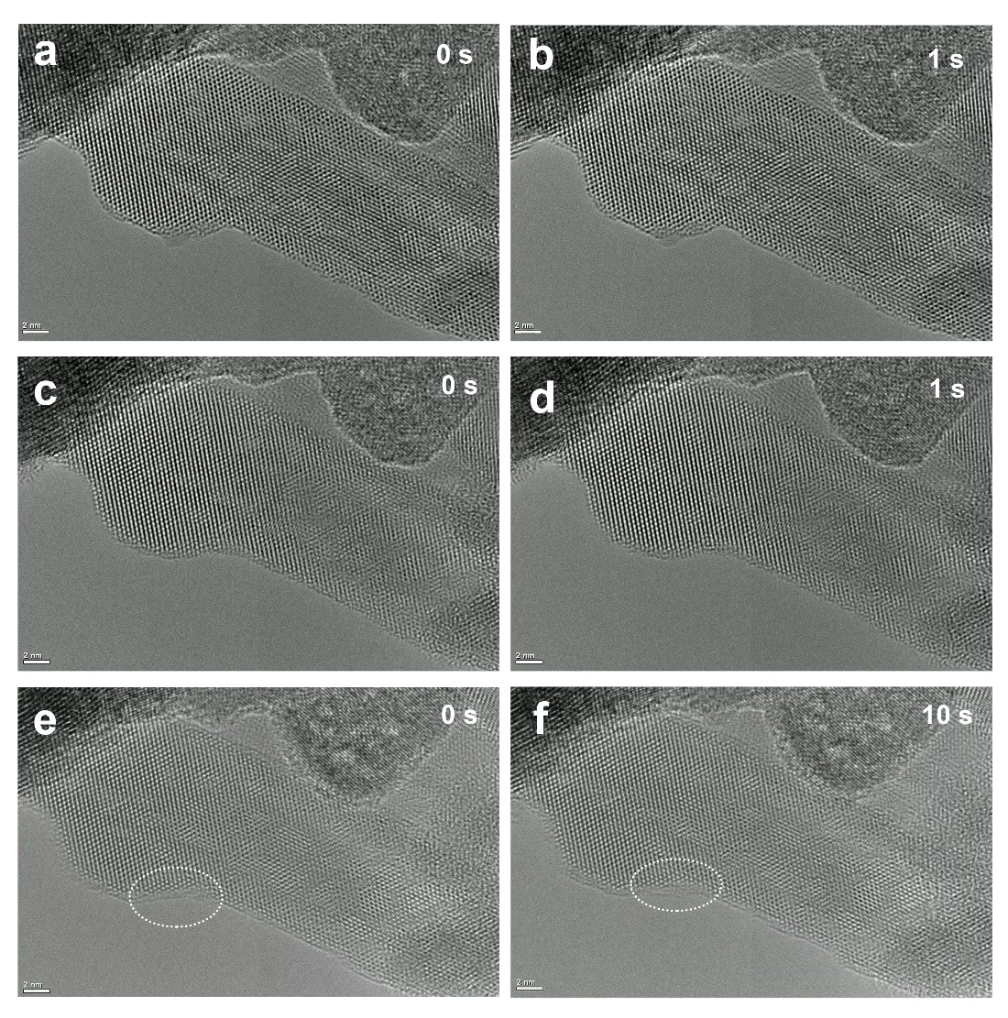
Supplementary Figure 16. In situ ETEM images of Pt/CeO₂-rod catalyst. (a and b) snapshots of catalyst after 0.40 Torr O₂ pretreatment at 400 °C for 30 min. (c and d) snapshots of catalyst after 0.40 Torr H₂ pretreatment at 400 °C for 30 min. (e and f) snapshots of catalyst under reaction conditions with 0.10 Torr CO and 0.20 Torr H₂O at 300 °C. The snapshots were selected when the structural reconstruction occurred. Therefore, the 0 s and 10 s do not represent starting time and 10 s of the reaction. The supplementary movies 1-9 show the dynamics of active sites on Pt/CeO₂ catalysts under different conditions.

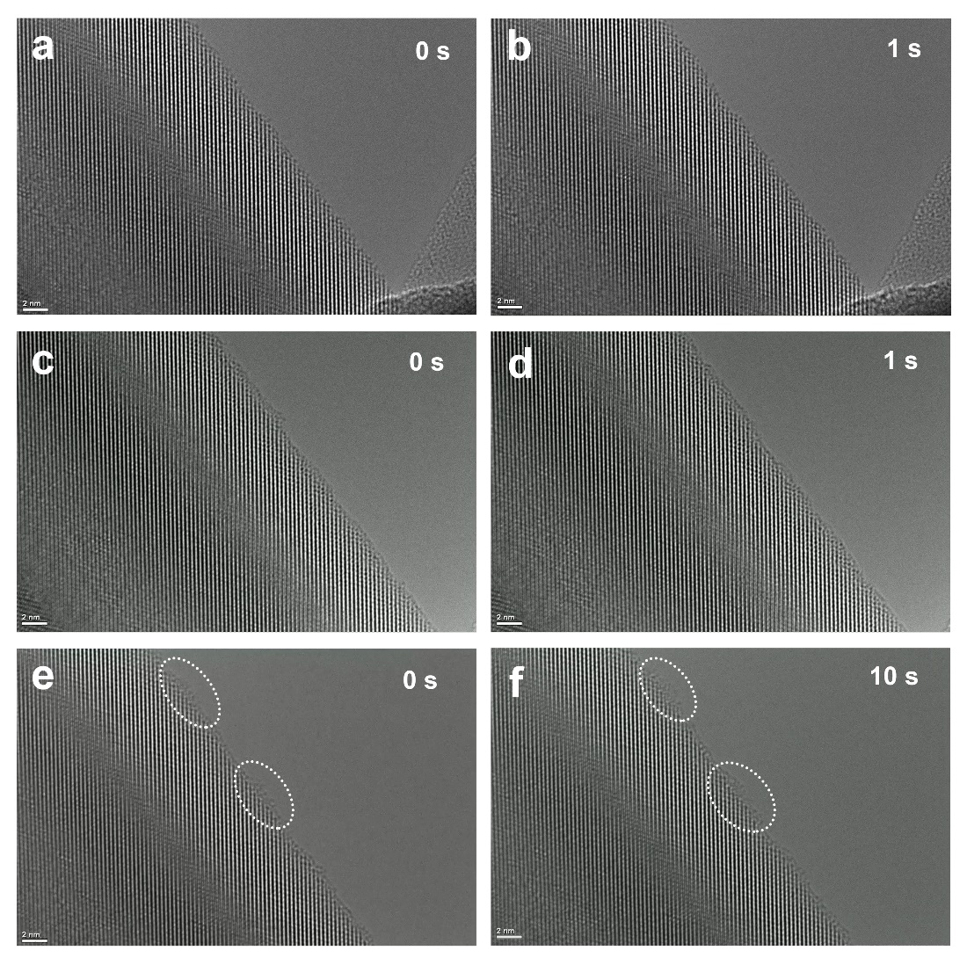
Supplementary Figure 17. In situ ETEM images of Pt/CeO₂-cube catalyst. (a and b) snapshots of catalyst after 0.40 Torr O₂ pretreatment at 400 °C for 30 min. (c and d) snapshots of catalyst after 0.40 Torr H₂ pretreatment at 400 °C for 30 min. (e and f) snapshots of catalyst under reaction conditions with 0.10 Torr CO and 0.20 Torr H₂O at 300 °C. The snapshots were selected when the structural reconstruction occurred. Therefore, the 0 s and 10 s do not represent starting time and 10 s of the reaction. The supplementary movies 1-9 show the dynamics of active sites on Pt/CeO₂ catalysts under different conditions.

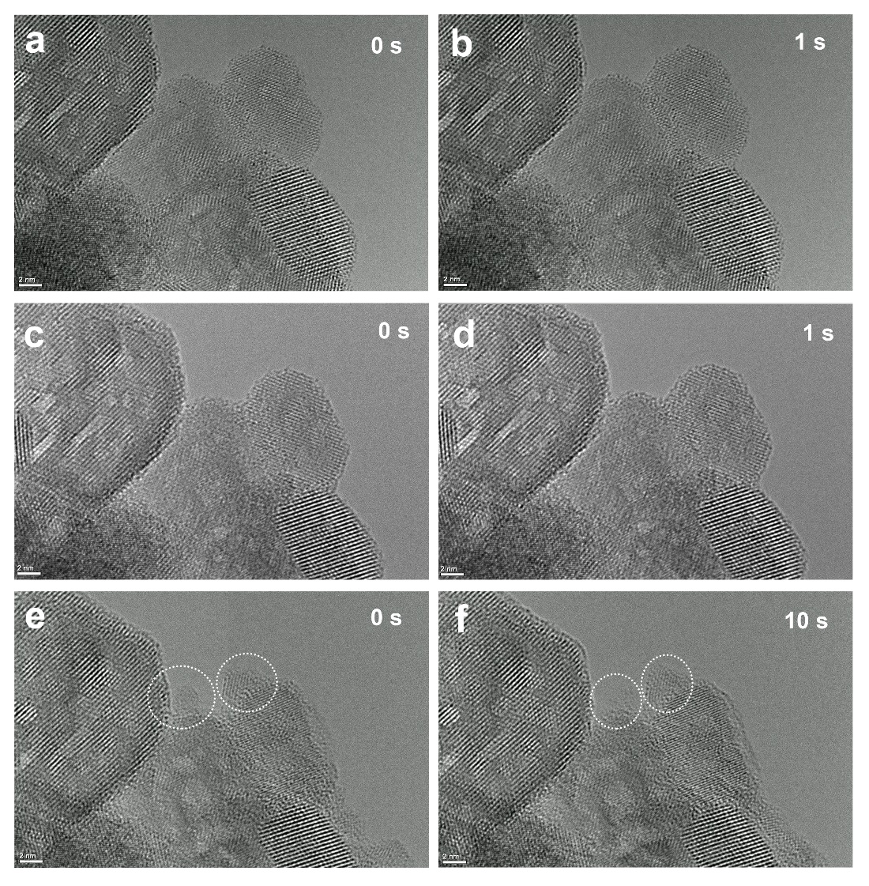
Supplementary Figure 18. In situ ETEM images of Pt/CeO₂-oct catalyst. (a and b) snapshots of catalyst after 0.40 Torr O₂ pretreatment at 400 °C for 30 min. (c and d) snapshots of catalyst after 0.40 Torr H₂ pretreatment at 400 °C for 30 min. (e and f) snapshots of catalyst under reaction conditions with 0.10 Torr CO and 0.20 Torr H₂O at 300 °C. The snapshots were selected when the structural reconstruction occurred. Therefore, the 0 s and 10 s do not represent starting time and 10 s of the reaction. The supplementary movies 1-9 show the dynamics of active sites on Pt/CeO₂ catalysts under different conditions.

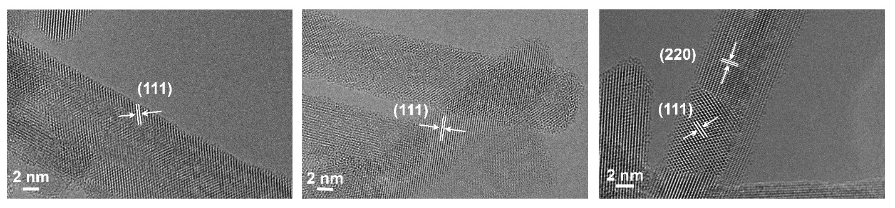
Supplementary Figure 19. In situ ETEM images of Pt/CeO₂-rod catalyst after 0.40 Torr O₂ pretreatment at 400 °C for 30 min, followed by 0.40 Torr H₂ pretreatment at 300 °C for 30 min.

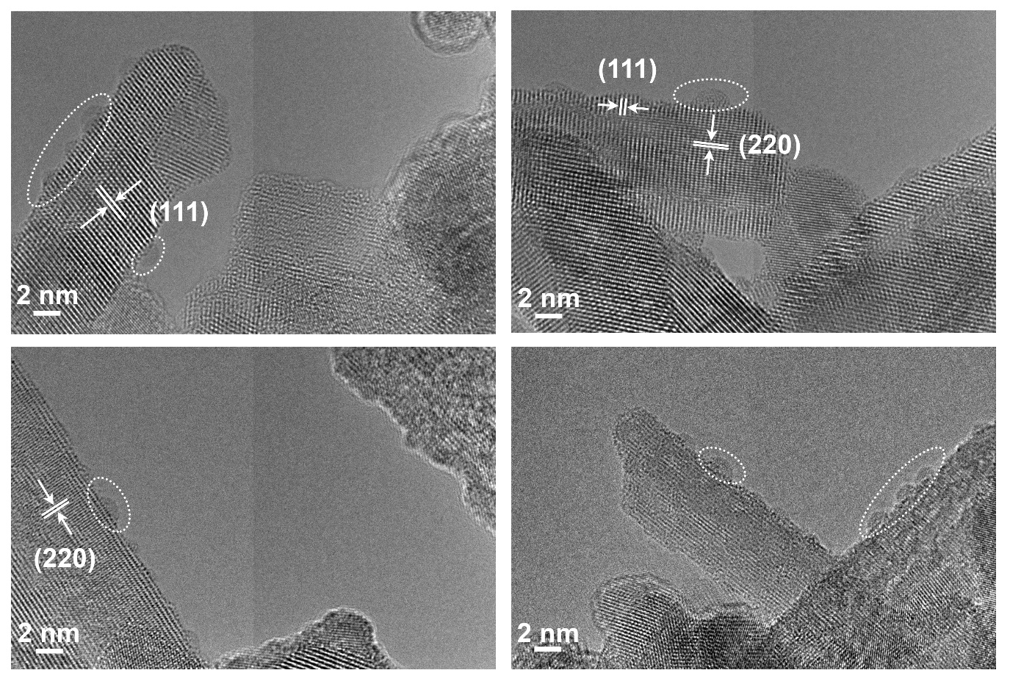
Supplementary Figure 20. In situ ETEM images of Pt/CeO₂-rod catalyst after exposing to 0.10 Torr CO and 0.20 Torr H₂O at 300 °C for 90 min with electron beam off.

References
1. Luches, P.; Pagliuca, F.; Valeri, S.; Boscherini, F., Structure of ultrathin CeO2 films on Pt (111) by polarization-dependent X-ray absorption fine structure. The Journal of Physical Chemistry C 2013, 117 (2), 1030-1036.
2. Bruix, A.; Rodriguez, J. A.; Ramírez, P. J.; Senanayake, S. D.; Evans, J.; Park, J. B.; Stacchiola, D.; Liu, P.; Hrbek, J.; Illas, F., A new type of strong metal–support interaction and the production of H2 through the transformation of water on Pt/CeO2 (111) and Pt/CeO x/TiO2 (110) catalysts. Journal of the American Chemical Society 2012, 134 (21), 8968-8974.
3. Zhang, F.; Gutiérrez, R. A.; Lustemberg, P. G.; Liu, Z.; Rui, N.; Wu, T.; Ramírez, P. J.; Xu, W.; Idriss, H.; Ganduglia-Pirovano, M. V., Metal–support interactions and C1 chemistry: transforming Pt-CeO2 into a highly active and stable catalyst for the conversion of carbon dioxide and methane. ACS catalysis 2021, 11 (3), 1613-1623.
4. Li, Y.; Kottwitz, M.; Vincent, J. L.; Enright, M. J.; Liu, Z.; Zhang, L.; Huang, J.; Senanayake, S. D.; Yang, W.-C. D.; Crozier, P. A., Dynamic structure of active sites in ceria-supported Pt catalysts for the water gas shift reaction. Nature communications 2021, 12 (1), 1-9.
5. Carrasco, J.; López‐Durán, D.; Liu, Z.; Duchoň, T.; Evans, J.; Senanayake, S. D.; Crumlin, E. J.; Matolín, V.; Rodríguez, J. A.; Ganduglia‐Pirovano, M. V., In situ and theoretical studies for the dissociation of water on an active Ni/CeO2 catalyst: Importance of Strong Metal–Support Interactions for the Cleavage of O–H Bonds. Angewandte Chemie International Edition 2015, 54 (13), 3917-3921.
6. Yang, C.; Yu, X.; Heißler, S.; Nefedov, A.; Colussi, S.; Llorca, J.; Trovarelli, A.; Wang, Y.; Wöll, C., Surface faceting and reconstruction of ceria nanoparticles. Angewandte Chemie International Edition 2017, 56 (1), 375-379.
7. Stadnichenko, A. I.; Muravev, V. V.; Koscheev, S. V.; Zaikovskii, V. I.; Aleksandrov, H. A.; Neyman, K. M.; Boronin, A. I., Study of active surface centers of Pt/CeO2 catalysts prepared using radio-frequency plasma sputtering technique. Surface Science 2019, 679, 273-283.

