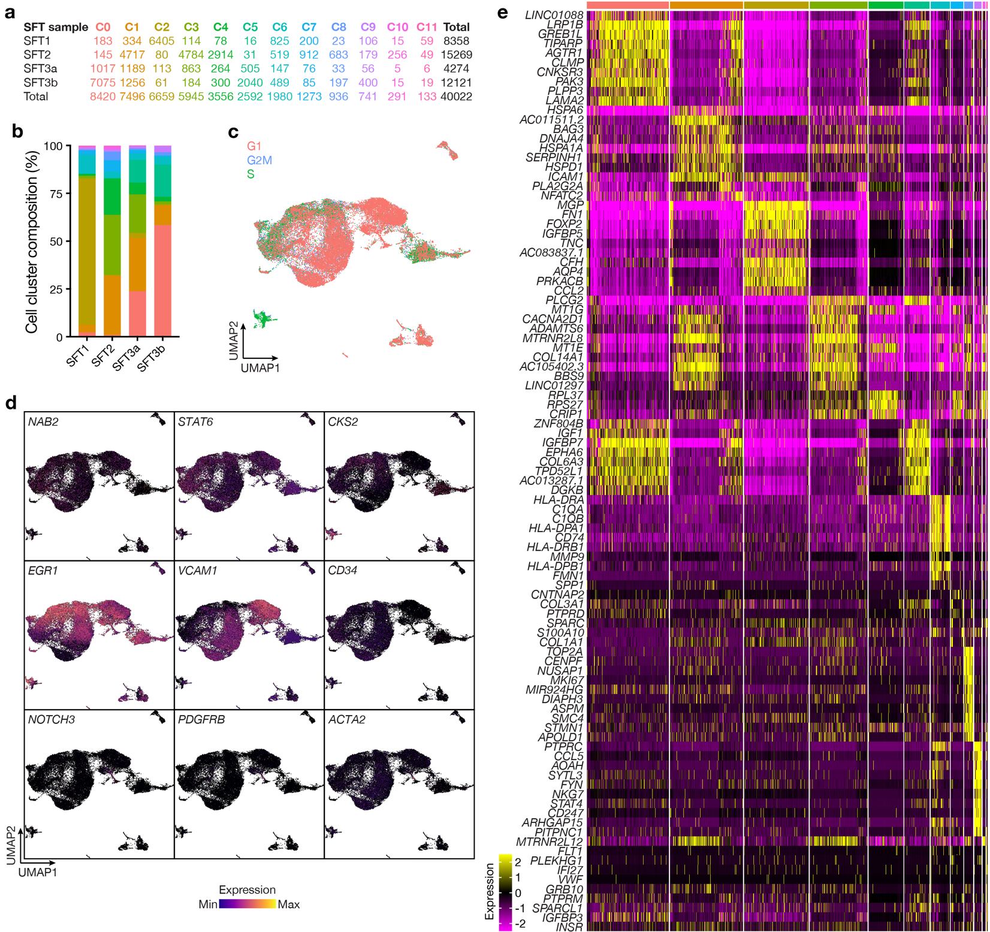Extended Data Fig. 1. Meningeal solitary fibrous tumor single-cell RNA sequencing. a, Single-cell counts across UMAP clusters from SFT samples analyzed using single-cell RNA sequencing. b, Stacked bar plots showing the distribution of SFT single-cell RNA sequencing clusters across biological replicates. Colors as in a. c, UMAP showing single-cell RNA sequencing cell cycle analysis across SFT samples. d, Feature plots showing differentially expressed genes across UMAP clusters from SFT samples analyzed using single-cell RNA sequencing. e, Heatmap showing differentially expressed genes across UMAP clusters from SFT samples analyzed using single-cell RNA sequencing.
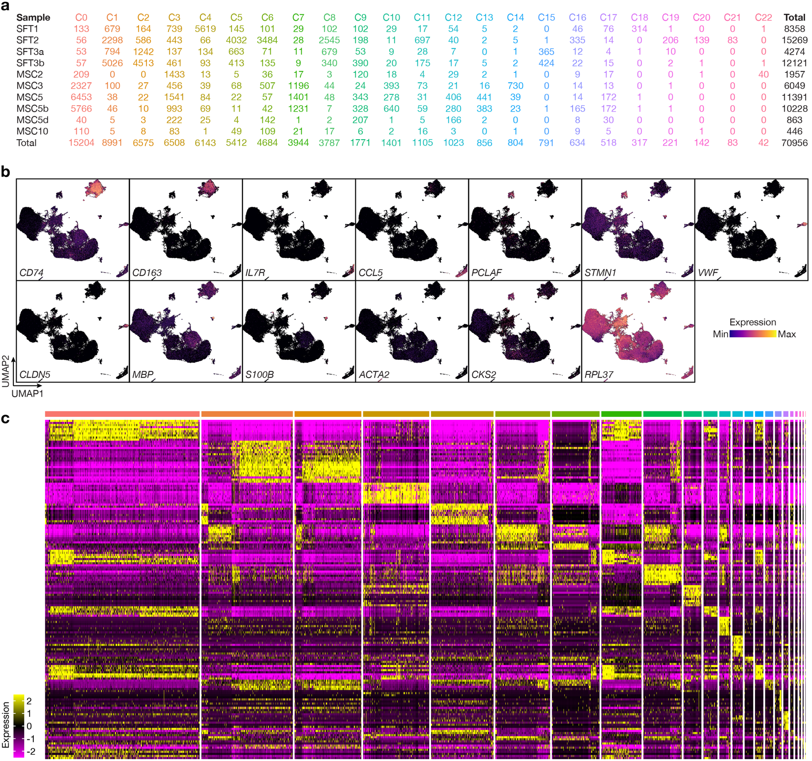Extended Data Fig. 2. Single-cell RNA sequencing of meningeal solitary fibrous tumors and meningiomas. a, Single-cell counts across UMAP clusters from SFT and meningioma (MSC) samples analyzed using single-cell RNA sequencing. b, Feature plots showing differentially expressed genes across UMAP clusters from SFT and meningioma samples analyzed using single-cell RNA sequencing. c, Heatmap showing differentially expressed genes across UMAP clusters from SFT and meningioma samples analyzed using single-cell RNA sequencing.
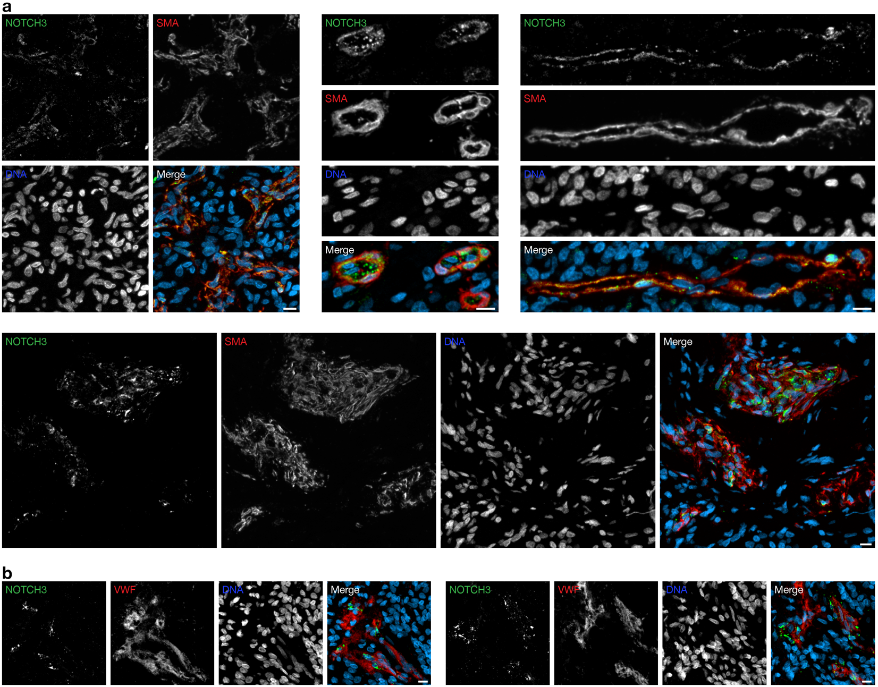Extended Data Fig. 3. Meningeal solitary fibrous tumor immunofluorescence microscopy for NOTCH3 and vascular cell markers. a, b, NOTCH3 expression is restricted to the perivascular niche and colocalizes with mural cells marked by SMA but not with endothelial cells marked by VWF in SFTs. Representative of n=3 biological replicates. Scale bars, 10µm.
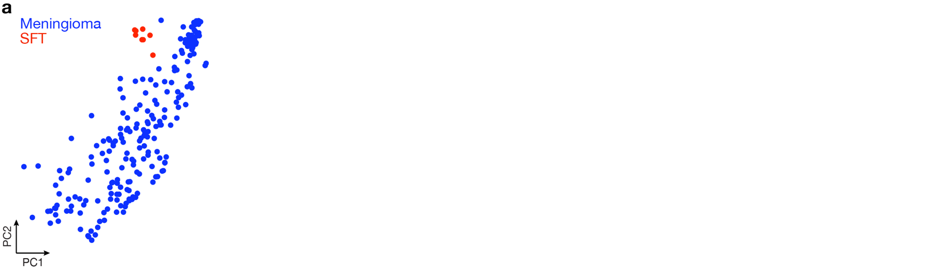Extended Data Fig. 4. DNA methylation profiling of meningeal solitary fibrous tumors and meningiomas. a, Principal component (PC) analysis of DNA methylation profiles from meningiomas (n=213) or solitary fibrous tumors that were analyzed using spatial RNA sequencing (n=8).
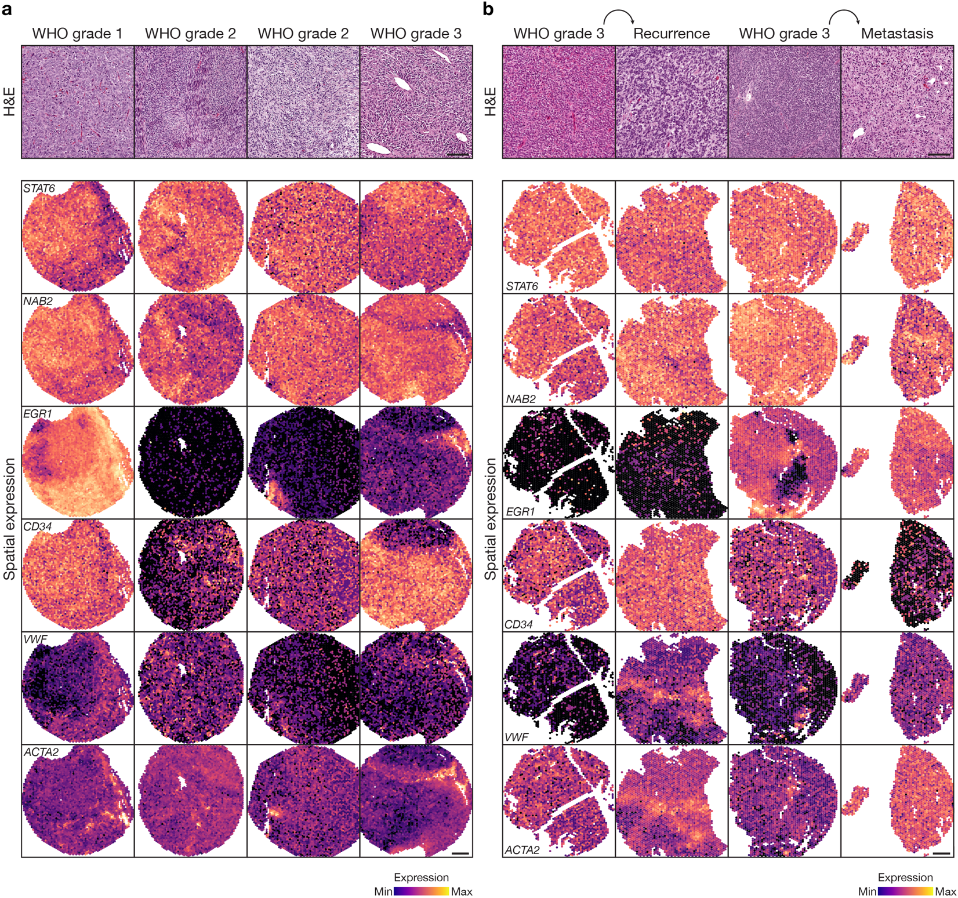Extended Data Fig. 5. Meningeal solitary fibrous tumor spatial RNA sequencing. a, High-magnification H&E images (top) and spatial expression of genes (bottom) in SFT samples analyzed using spatial RNA sequencing across WHO histological grades. Scale bars, 10µm (top) and 100µm (bottom). b, High-magnification H&E images (top) and spatial expression of genes (bottom) in SFT samples analyzed using spatial RNA sequencing across patient-matched pairs of primary/recurrent or intracranial/metastatic samples. Scale bars, 10µm (top) and 100µm (bottom).
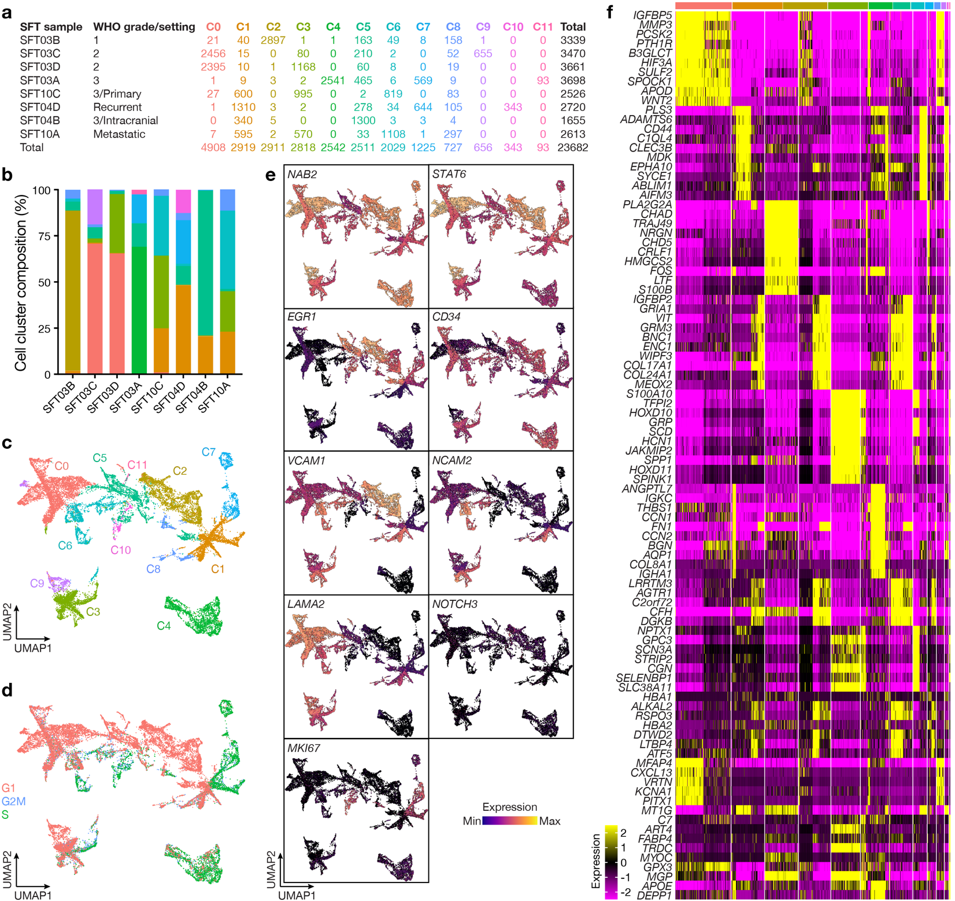Extended Data Fig. 6. Meningeal solitary fibrous tumor spatial RNA sequencing uniform manifold approximation and projection analysis. a, Spatial transcriptome counts across UMAP clusters from SFT samples analyzed using spatial RNA sequencing. b, Stacked bar plots showing the distribution of SFT spatial RNA sequencing clusters across biological replicates. Colors as in a. c, Spatial RNA sequencing UMAP of 23,682 transcriptomes from SFT samples. d, UMAP showing spatial RNA sequencing cell cycle analysis across SFT samples. e, Feature plots showing differentially expressed genes across UMAP clusters from SFT samples analyzed using spatial RNA sequencing. f, Heatmap showing differentially expressed genes across UMAP clusters from SFT samples analyzed using spatial RNA sequencing.

