Appendix A. Final AAHL-Adult Functional Health Literacy Assessment

The correct answers are italicized and scored 1. Incorrect responses are scored 0.

# | VARIABLE NAME | QUESTION | SCORES: ANSWER CHOICES
1 | FHLD2  Numerical calculation | 5ml=1 teaspoon  10ml = ____ | 0: 1 tablespoon  0: 1 teaspoon  1: 2 teaspoons  0: 2 tablespoons
2 | FHLD3  Reading comprehension | An unhealthy blood pressure reading for an adult is above 120/80. Which of these is an unhealthy blood pressure reading? | 0: 115/70  0: 120/78  0: 96/64  1: 150/97
Use the table and legend below to answer the next two questions.
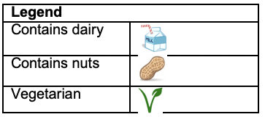
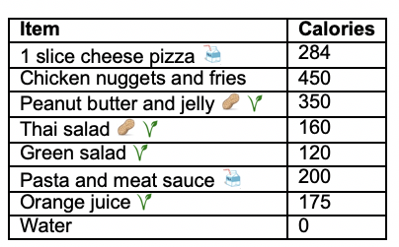

3 | FHLD5  Reading comprehension, Numerical calculation | Sean can only eat up to 500 calories at lunch time. Which of the following contains too many calories to be Sean’s lunch? | 0: Cheese pizza and orange juice  1: Peanut butter and jelly and orange juice  0: Chicken nuggets and fries, and water  0: Pasta and meat sauce, green salad, and orange juice
4 | FHLD6  Reading charts, numerical calculation | Jared is allergic to dairy and nuts. He can eat up to 200 calories at lunch. Which of the following meals can he eat for lunch? | 0: ½ serving chicken nuggets and fries  0: Pasta and meat sauce  0: Thai salad  1: Green salad
Use the label below to answer the next three questions.
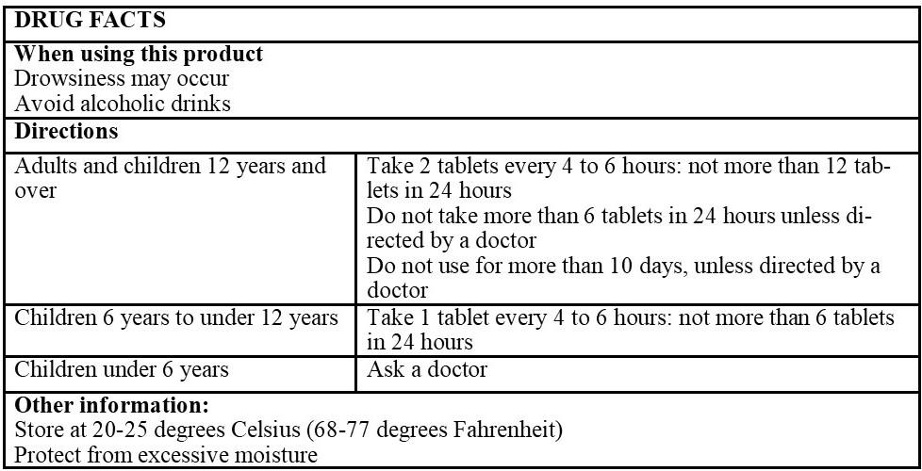

5 | FHLD9  Reading charts, reading comprehension | How many tablets can a 12-year-old take at once? | 0: 1  1: 2  0: 3  0: 4
6 | FHLD10  Reading comprehension | Where should this medication be stored? | 1: Refrigerator  0: Medicine cabinet  0: Kitchen cupboard  0: Oven
7 | FHLD11  Reading comprehension, applying health information | What activity would an individual be allowed to do after taking this medication? | 1: Take a nap  0: Drive a car  0: Cook a hot meal  0: Babysit young children

