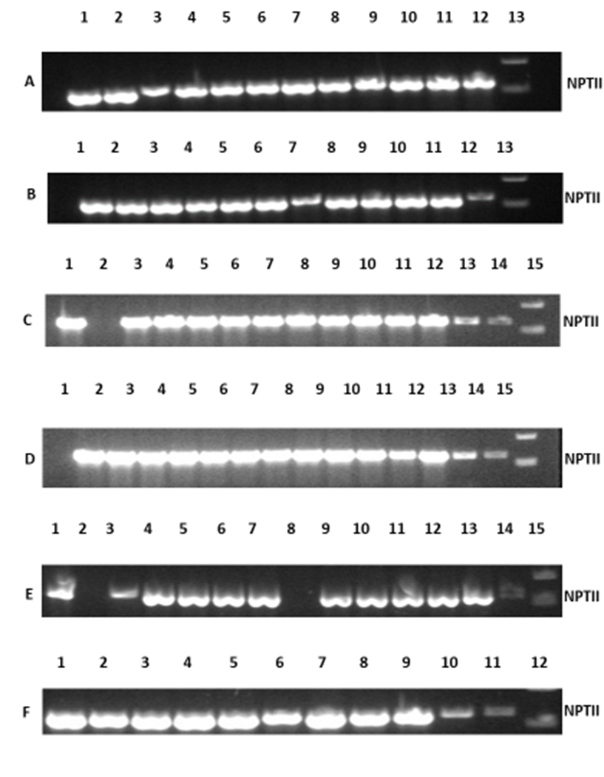

Screening of transgenic Carrizo lines for NPTII by PCR and agarose gel electrophoreses. (A-F) The presence of NPTII selectable marker gene.

- 1-12= Transgenic Carrizo FT3L1 propagated via shoot in vitro; 13=1kb Ladder.
- 1-3= Transgenic Carrizo FT3L1 (two-year-old); 4-12= Transgenic Carrizo FT3L1 propagated via seeds in vitro; 13=1kb Ladder.
- 1= Transgenic Carrizo FT3L2 (two-year- old); 2= Wild type Carrizo, 3-14= Transgenic Carrizo FT3L2 propagated via shoot in vitro; 15= 1kb Ladder.
- 1-14= Transgenic Carrizo FT3L3 propagated via shoot in vitro, 15= 1kb Ladder.
- 1 transgenic Carrizo FT3L3 (two-year- old); 2= Wild type Carrizo, 3-7= Transgenic Carrizo FT3L1 propagated via shoot in vitro; 8= Wild type Carrizo; 9-13: Transgenic Carrizo FT3L3 propagated via seeds in vitro; 14: Wild type Carrizo; 15= 1kb Ladder.
- 1-5= transgenic Carrizo FT3L4 (~15-month- old); 6-10= Transgenic Carrizo FT3L4 propagated via seeds in vitro; 11= Water; 12= 1kb Ladder.

1 2 3 4 5 6 7
1=1 kb Ladder
2= FT3L1
3= FT3L2
4= FT3L3
5= FT3L4
6= Wild type Carrizo
7= 1 kb Ladder.
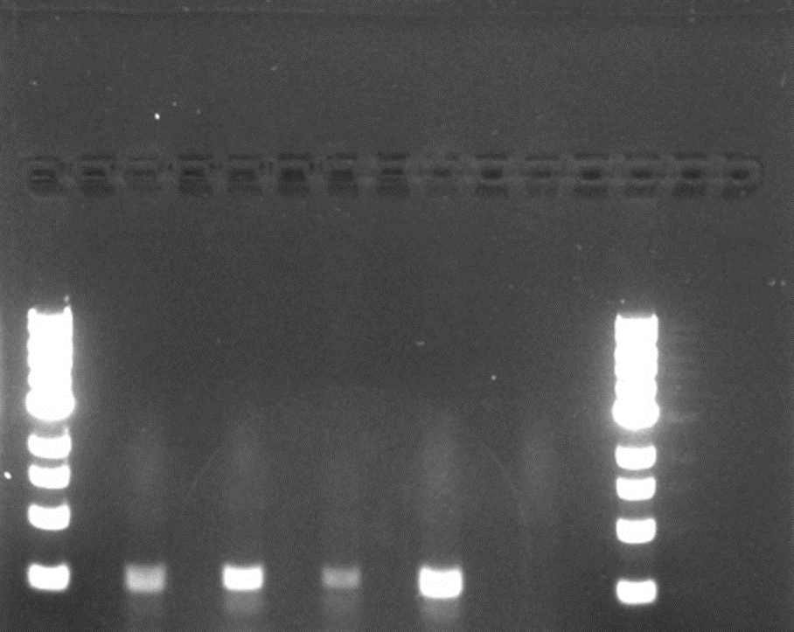
Screening of transgenic Carrizo lines for FT3 by PCR and agarose gel electrophoreses.
FT3

