Supplementary Materials
Table of Contents
A. Methods 2
A1. Participant Recruitment and Eligibility 2
A2. Participant Demographics 3
A3. EEG Videos 4
A4. EEG Data Quality Checks 5
A5. Resampling Data During Microstate Analysis 6
A6. Split-Half Segments 7
A7. Software Versions 8
B. Results 9
B1. Descriptive Statistics of Microstate Temporal Properties 9
B2. Descriptive Statistics of Microstate Transition Probabilities 10
B3. Backfitting Details 11
B4. Topographic Stability with Varying Data Durations and Number of Participants 12
B5. Linear Mixed-Effects Models (with outliers removed) 13
B6. Linear Mixed-Effects Models (without outliers removed) 13
B7. Split-Half Reliability of Temporal Properties (with and without outliers removed) 13
B8. Split-Half Reliability of Transition Probabilities (with and without outliers removed) 13
B9. Stability and Split-Half Reliability of Neural Sources 13
B10. Neural Sources of Microstates 14

A. Methods

A1. Participant Recruitment and Eligibility

Participants were part of a larger study investigating how maternal experiences of bias and discrimination affect maternal mental and physical health during and after pregnancy and, subsequently, postnatal child development. Data collection for the parent study is in progress. The parent study is currently collecting questionnaire measures of discrimination, maternal and infant mental health, social connectedness, and child development from mothers during each trimester of pregnancy and when children are approximately 6-, 9-, and 24-months of age. At 6- and 9-months of age, mother-infant dyads participate in lab visits where resting-state EEG is recorded from infants and dyadic head-mounted eye-tracking during naturalistic play is recorded from infants and mothers. Although infants were to be seen at 6- and 9-months for EEG, some were seen at 5- or 7-months for their 6-month visit and at 7- or 10-months for their 9-month visit due to scheduling constraints or illness.
Participants were recruited through Project Hope 1000 (ClinicalTrials.gov Identifier: NCT04417283), social media posts and advertisements, the Research Participant at Duke Database maintained by the Human Subjects Coordinator for the Department of Psychology and Neuroscience at Duke, the Duke Behavioral Research participant pool, and the Perinatal Psychiatry Behavioral Health Team directed by Dr. Andrea Diaz Stransky. Inclusion criteria included maternal age of at least 18 years at time of consent, ability to understand English, and singleton gestation less than 24 weeks. Exclusionary criteria included non-viable pregnancy, maternal medical condition in the opinion of investigators that would place the mother at unacceptable risk of injury or confound data interpretation, infant congenital, genetic, or neurologic disorder, and infant birth before 34 weeks of gestation.
At the time of data analyses for the current manuscript, EEG data from 60 infants was recorded. Infants had EEG data at either their 6-month or 9-month visits, or at both visits, resulting in 99 sessions from 60 infants. Sessions that did not result in at least five minutes of clean, artifact-free data after preprocessing were removed, resulting in 79 EEG sessions from 55 infants. In order for each infant to be represented only once in the final data set, for each infant that had EEG at both their 6- and 9-month visits, we kept the EEG recording that was closest in date to when the infant was exactly 6- or 9-months-old. After removing 24 EEG sessions, each of the 55 infants had one EEG session at either their 6- or 9-month visit. The final set of EEG sessions from the 55 infants were collected between February 24, 2022 and April 25, 2023.

A2. Participant Demographics

 | Mean (SD) | Range
Age (months) | 7.89 (1.53) | 5.98 – 10.42
Income-to-Needs Ratio * | 3.95 (1.07) | 1.25 – 5.74
 | n | Percent (%)
Biological Sex
Females | 28 | 50.91%
Males | 27 | 49.09%
Race
White | 41 | 74.55%
Multiracial | 8 | 14.55%
Black or African American | 4 | 7.27%
Asian | 1 | 1.82%
Other | 1 | 1.82%
Native Hawaiian or Other Pacific Islander | 0 | 0%
Ethnicity
Not Hispanic or Latino | 49 | 89.09%
Hispanic or Latino | 6 | 10.91%
Maternal Education
Some Grade School | 0 | 0%
Completed Grade School | 0 | 0%
Some High School | 1 | 1.82%
High School Diploma | 1 | 1.82%
Some College or 2-Year Degree | 1 | 1.82%
4-Year College Degree | 16 | 29.09%
Some School Beyond College | 1 | 1.82%
Professional or Graduate Degree | 35 | 63.64%
Note. The Income-to-Needs Ratio (ITN) was calculated by dividing total family income by a poverty threshold determined by the United States Census Bureau, which considered the year assessed and household family size. Two participants did not have ITN information available (i.e., they refused to respond).

A3. EEG Videos

Videos were purchased from https://wayokids.com/. Snippets from their Hey Bear Sensory collection were used. Additional information is available upon request.

A4. EEG Data Quality Checks

Participants were only included in analyses if they met quality checks.

Criteria included:
- Bad Channels
  - Number of bad channels must not exceed 15 (approximately 15% of 105 total channels).
  - Visualization of bad channels must not show clusters of bad channels.
- Artifact Subspace Reconstruction (ASR)
  - Data length after ASR must exceed 60 seconds.
- Independent Component Analysis (ICA)
  - Visualization of decomposition must appear “normal” and “appropriate.”
  - Visualization of flagged components must appear eye- or muscle-related.
  - Retained variance after removal of flagged components must exceed 50%.
- Channel Power Spectra
  - Visualization of channel power spectra must appear “normal” and “appropriate.”
- Data Duration
  - At least five minutes or 300 seconds of clean, artifact-free data must be available.

Descriptive statistics of resting-state EEG data quality metrics for n = 55 sample of infants.
 | Number of Channels Removed and Interpolated | File Length in Seconds After ASR | Number of Independent Components Rejected | Percent Variance Retained After Removal of Independent Components | File Length in Seconds After Preprocessing
Mean | 5.40 | 461.35 | 3.73 | 87.70 | 630.18
SD | 3.46 | 144.20 | 2.72 | 6.93 | 150.87
Minimum | 0 | 178.72 | 0 | 68.46 | 326
Maximum | 12 | 784.13 | 12 | 100 | 856
Note. ASR = Artifact Subspace Reconstruction. SD = standard deviation.

A5. Resampling Data During Microstate Analysis

Number of Subsamples Entered in Cartool

Stage 1:
- 1 Minute: 50 Epochs, of 2000[TF], Covering 99.9% Data
- 2 Minutes: 50 Epochs, of 4000[TF], Covering 99.9% Data
- 3 Minutes: 50 Epochs, of 6000[TF], Covering 99.9% Data
- 4 Minutes: 50 Epochs, of 8000[TF], Covering 99.9% Data
- 5 Minutes: 50 Epochs, of 10000[TF], Covering 99.9% Data

Stage 2:
- 1 Minute: 100 Epochs, of 1000[TF], Covering 99.8% Data
- 2 Minutes: 100 Epochs, of 1000[TF], Covering 99.9% Data
- 3 Minutes: 100 Epochs, of 1000[TF], Covering 99.9% Data
- 4 Minutes: 100 Epochs, of 1000[TF], Covering 99.9% Data
- 5 Minutes: 100 Epochs, of 1000[TF], Covering 99.9% Data

A6. Split-Half Segments

 | Segments and Range of Time Frames they Represent
Data Duration | 1 | 2 | 3 | 4 | 5 | 6
1 Minute | 0-2499 | 2500-4999 | 5000-7499 | 7500-9999 | 10000-12499 | 12500-14999
2 Minutes | 0-4999 | 5000-9999 | 10000-14999 | 15000-19999 | 20000-24999 | 25000-29999
3 Minutes | 0-7499 | 7500-14999 | 15000-22499 | 22500-29999 | 30000-37499 | 37500-44999
4 Minutes | 0-9999 | 10000-19999 | 20000-29999 | 30000-39999 | 40000-49999 | 50000-59999
5 Minutes | 0-12499 | 12500-24999 | 25000-37499 | 37500-49999 | 50000-62499 | 62500-74999

* Each time frame represents 4 ms of data.

Equal Segments
- One-minute: Six, 10-second segments
- Two-minutes: Six, 20-second segments
- Three-minutes: Six, 30-second segments
- Four-minutes: Six, 40-second segments
- Five-minutes: Six, 50-second segments

Even segments (2, 4, 6) were combined, and odd segments (1, 3, 5) were combined, resulting in two files for each participant.

A7. Software Versions

E-Prime Version 2.0.10.356

NetStation Acquisition Version 5.4.2 (r29917)

MATLAB Version R2022a

EEGLAB Version 2021.0
- CleanLine Version 2.00
- clean_rawdata Version 2.7
- ICLabel Version 1.4
- TBT Version 2.6.1
- firfilt Version 2.6
- MFFMatlabIO Version 4.0

Cartool Version 4.11/7658

AFNI Version 22.1.10

R Version 4.2.2
- lme4 Version 1.133
- lmerTest Version 3.1-3
- emmeans Version 1.8.3
- MASS Version 7.3-58.1
- splithalfr Version 2.2.0

B. Results

B1. Descriptive Statistics of Microstate Temporal Properties

GEV

 | Microstate 1 | Microstate 2 | Microstate 3 | Microstate 4 | Microstate 5
1 Minute | .07 (.03) | .08 (.03) | .26 (.06) | .08 (.03) | .08 (.03)
2 Minutes | .07 (.02) | .08 (.04) | .26 (.06) | .08 (.03) | .08 (.03)
3 Minutes | .07 (.02) | .08 (.03) | .26 (.06) | .09 (.04) | .07 (.02)
4 Minutes | .07 (.02) | .07 (.03) | .25 (.06) | .09 (.04) | .07 (.02)
5 Minutes | .06 (.02) | .07 (.03) | .25 (.06) | .09 (.03) | .07 (.02)
Note. Presented as mean (standard deviation).

Duration

 | Microstate 1 | Microstate 2 | Microstate 3 | Microstate 4 | Microstate 5
1 Minute | 86.00 (7.38) | 86.95 (7.15) | 112.29 (10.07) | 91.01 (9.68) | 90.48 (7.24)
2 Minutes | 86.16 (6.35) | 86.97 (7.11) | 112.10 (8.52) | 91.59 (8.84) | 90.79 (6.87)
3 Minutes | 86.15 (5.56) | 87.57 (6.84) | 112.48 (8.56) | 92.95 (8.88) | 90.05 (6.05)
4 Minutes | 86.73 (5.36) | 88.11 (6.57) | 113.56 (8.29) | 93.66 (8.61) | 91.41 (6.06)
5 Minutes | 86.48 (5.49) | 87.82 (6.51) | 112.90 (7.92) | 94.01 (8.57) | 91.43 (6.36)
Note. Presented as mean (standard deviation).

Coverage

 | Microstate 1 | Microstate 2 | Microstate 3 | Microstate 4 | Microstate 5
1 Minute | 16.21 (3.68) | 16.61 (4.00) | 33.69 (3.89) | 16.63 (4.13) | 16.86 (3.52)
2 Minutes | 16.46 (3.28) | 16.35 (3.84) | 33.65 (4.02) | 16.67 (4.00) | 16.88 (3.66)
3 Minutes | 15.91 (3.20) | 16.79 (3.64) | 33.50 (3.98) | 17.50 (4.13) | 16.31 (3.62)
4 Minutes | 15.66 (3.20) | 16.61 (3.43) | 33.52 (3.95) | 17.56 (4.15) | 16.65 (3.45)
5 Minutes | 15.62 (3.18) | 16.52 (3.40) | 33.13 (3.77) | 17.99 (4.00) | 16.74 (3.48)
Note. Presented as mean (standard deviation).

Occurrence

 | Microstate 1 | Microstate 2 | Microstate 3 | Microstate 4 | Microstate 5
1 Minute | 1.64 (0.28) | 1.66 (0.33) | 2.50 (0.25) | 1.57 (0.27) | 1.61 (0.28)
2 Minutes | 1.66 (0.24) | 1.63 (0.27) | 2.49 (0.22) | 1.56 (0.29) | 1.61 (0.29)
3 Minutes | 1.61 (0.25) | 1.66 (0.26) | 2.47 (0.20) | 1.60 (0.28) | 1.57 (0.30)
4 Minutes | 1.57 (0.25) | 1.63 (0.25) | 2.44 (0.20) | 1.59 (0.27) | 1.57 (0.28)
5 Minutes | 1.58 (0.25) | 1.63 (0.25) | 2.44 (0.20) | 1.63 (0.26) | 1.58 (0.28)
Note. Presented as mean (standard deviation).

B2. Descriptive Statistics of Microstate Transition Probabilities

 | From1-To2 | From1-To3 | From1-To4 | From1-To5
1 Minute | 1.06 (0.22) | 1.12 (0.14) | 0.86 (0.18) | 0.89 (0.19)
2 Minutes | 1.04 (0.17) | 1.15 (0.10) | 0.86 (0.14) | 0.86 (0.14)
3 Minutes | 1.03 (0.13) | 1.15 (0.10) | 0.87 (0.13) | 0.86 (0.13)
4 Minutes | 1.04 (0.12) | 1.14 (0.07) | 0.87 (0.10) | 0.88 (0.11)
5 Minutes | 1.03 (0.11) | 1.14 (0.07) | 0.87 (0.09) | 0.90 (0.11)
Note. Presented as mean (standard deviation).

 | From2-To1 | From2-To3 | From2-To4 | From2-To5
1 Minute | 1.07 (0.27) | 1.14 (0.15) | 0.83 (0.19) | 0.90 (0.23)
2 Minutes | 1.03 (0.17) | 1.14 (0.13) | 0.86 (0.13) | 0.91 (0.16)
3 Minutes | 1.04 (0.15) | 1.14 (0.11) | 0.87 (0.12) | 0.89 (0.14)
4 Minutes | 1.05 (0.13) | 1.15 (0.10) | 0.87 (0.11) | 0.88 (0.12)
5 Minutes | 1.03 (0.11) | 1.15 (0.09) | 0.88 (0.11) | 0.88 (0.11)
Note. Presented as mean (standard deviation).

 | From3-To1 | From3-To2 | From3-To4 | From3-To5
1 Minute | 1.03 (0.14) | 1.01 (0.14) | 0.99 (0.16) | 0.98 (0.18)
2 Minutes | 1.04 (0.12) | 1.02 (0.13) | 0.97 (0.10) | 0.99 (0.14)
3 Minutes | 1.02 (0.10) | 1.02 (0.10) | 0.98 (0.09) | 0.99 (0.12)
4 Minutes | 1.02 (0.08) | 1.03 (0.09) | 0.98 (0.09) | 0.99 (0.10)
5 Minutes | 1.02 (0.07) | 1.03 (0.09) | 0.99 (0.08) | 1.00 (0.10)
Note. Presented as mean (standard deviation).

 | From4-To1 | From4-To2 | From4-To3 | From4-To5
1 Minute | 0.87 (0.22) | 0.86 (0.18) | 1.15 (0.17) | 1.11 (0.26)
2 Minutes | 0.87 (0.13) | 0.87 (0.14) | 1.14 (0.13) | 1.13 (0.20)
3 Minutes | 0.87 (0.12) | 0.90 (0.11) | 1.12 (0.09) | 1.13 (0.16)
4 Minutes | 0.88 (0.10) | 0.89 (0.10) | 1.12 (0.09) | 1.14 (0.18)
5 Minutes | 0.88 (0.08) | 0.90 (0.09) | 1.12 (0.09) | 1.12 (0.16)
Note. Presented as mean (standard deviation).

 | From5-To1 | From5-To2 | From5-To3 | From5-To4
1 Minute | 0.87 (0.19) | 0.89 (0.18) | 1.10 (0.16) | 1.16 (0.24)
2 Minutes | 0.89 (0.15) | 0.88 (0.15) | 1.08 (0.12) | 1.20 (0.18)
3 Minutes | 0.89 (0.13) | 0.88 (0.12) | 1.09 (0.09) | 1.18 (0.16)
4 Minutes | 0.89 (0.11) | 0.87 (0.12) | 1.09 (0.09) | 1.17 (0.16)
5 Minutes | 0.90 (0.10) | 0.88 (0.11) | 1.08 (0.08) | 1.17 (0.16)
Note. Presented as mean (standard deviation).

B3. Backfitting Details

Time frames that did not meet the minimum spatial correlation threshold (.50) during backfitting for each data duration:
- 1 Minute 5.36%
- 2 Minutes 5.67%
- 3 Minutes 5.99%
- 4 Minutes 6.34%
- 5 Minutes 6.46%
These time frames were thus unlabeled during backfitting.

Descriptive Statistics for Global Field Power (GFP):

 | Microstate 1 | Microstate 2 | Microstate 3 | Microstate 4 | Microstate 5
1 Minute | 1.18 (0.14) | 1.19 (0.14) | 1.40 (0.14) | 1.22 (0.12) | 1.20 (0.09)
2 Minutes | 1.20 (0.14) | 1.22 (0.16) | 1.42 (0.14) | 1.24 (0.12) | 1.20 (0.07)
3 Minutes | 1.19 (0.12) | 1.22 (0.16) | 1.42 (0.13) | 1.26 (0.11) | 1.20 (0.08)
4 Minutes | 1.20 (0.11) | 1.22 (0.15) | 1.42 (0.13) | 1.27 (0.12) | 1.20 (0.08)
5 Minutes | 1.19 (0.11) | 1.22 (0.14) | 1.41 (0.12) | 1.27 (0.12) | 1.20 (0.08)
Note. Presented as mean (standard deviation).

Descriptive Statistics for Spatial Correlation:

 | Microstate 1 | Microstate 2 | Microstate 3 | Microstate 4 | Microstate 5
1 Minute | .64 (.03) | .64 (.03) | .71 (.02) | .65 (.02) | .65 (.02)
2 Minutes | .64 (.02) | .64 (.02) | .71 (.02) | .64 (.02) | .65 (.02)
3 Minutes | .63 (.02) | .64 (.03) | .71 (.02) | .65 (.02) | .64 (.02)
4 Minutes | .63 (.02) | .63 (.02) | .71 (.02) | .65 (.02) | .64 (.02)
5 Minutes | .63 (.02) | .63 (.02) | .71 (.02) | .65 (.02) | .64 (.02)
Note. Presented as mean (standard deviation).

B4. Topographic Stability with Varying Data Durations and Number of Participants

Participants were randomly assigned a number between 1 and 55 and reordered from smallest to largest based on their number. For each data duration (one, two, and three minutes, but not four and five minutes), microstate analyses (stages 1 and 2 only) were performed separately for participants 1-10, 1-20, 1-30, 1-40, and 1-50 (the last 5 participants were excluded). The meta-criterion determined the optimal number of microstates for each (shown below).

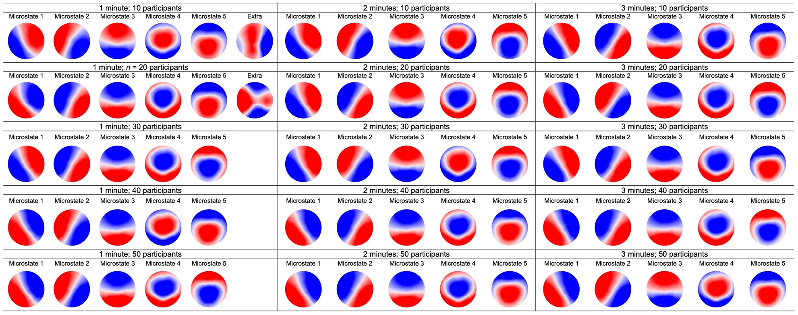
Note. Microstates are polarity-invariant (i.e., colors do not indicate polarity).

B5. Linear Mixed-Effects Models (with outliers removed)

See lin_mix_effect_temp_prop_all_data.nb.html and lin_mix_effect_trans_prob_all_data.nb.html available on https://github.com/gaffreylab/EEG-Microstate-Analysis-Tutorial/

B6. Linear Mixed-Effects Models (without outliers removed)

See lin_mix_effect_temp_prop_outliers_removed.nb.html and lin_mix_effect_trans_prob_outliers_removed.nb.html available on https://github.com/gaffreylab/EEG-Microstate-Analysis-Tutorial/

B7. Split-Half Reliability of Temporal Properties (with and without outliers removed)

See sb_rel_temp_prop.nb.html available on https://github.com/gaffreylab/EEG-Microstate-Analysis-Tutorial/

B8. Split-Half Reliability of Transition Probabilities (with and without outliers removed)

See sb_rel_trans_prob.nb.html available on https://github.com/gaffreylab/EEG-Microstate-Analysis-Tutorial/

B9. Stability and Split-Half Reliability of Neural Sources

See calculated DSC files for stability and split-half analyses available on https://github.com/gaffreylab/EEG-Microstate-Analysis-Tutorial/

B10. Neural Sources of Microstates

Source-localized files are available on https://github.com/gaffreylab/EEG-Microstate-Analysis-Tutorial/. Sources from the five-minute duration data overlayed on the MRI brain template (axial and sagittal slices) are provided below.

Microstate 1

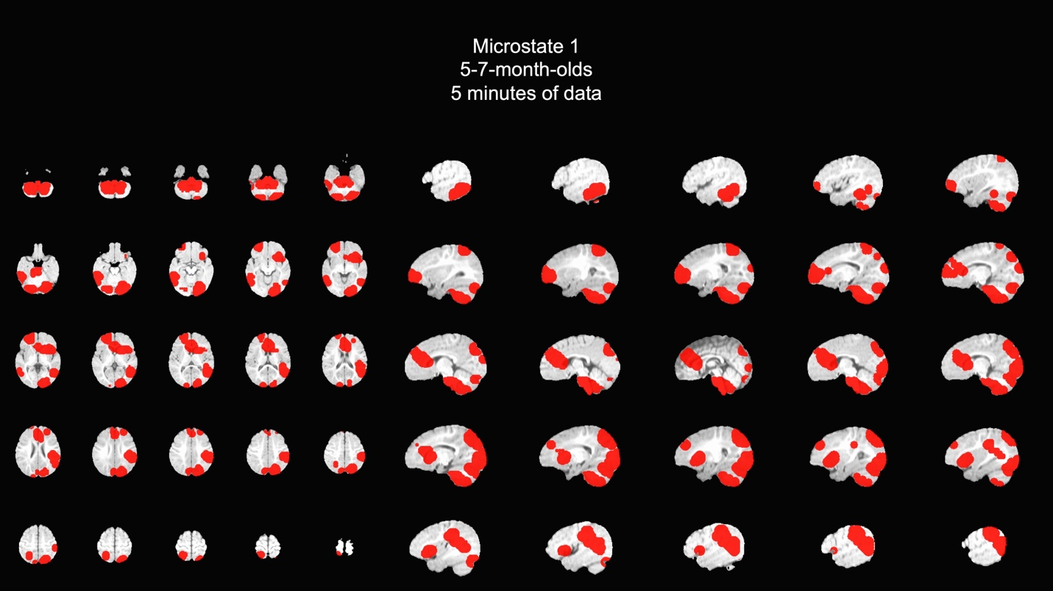

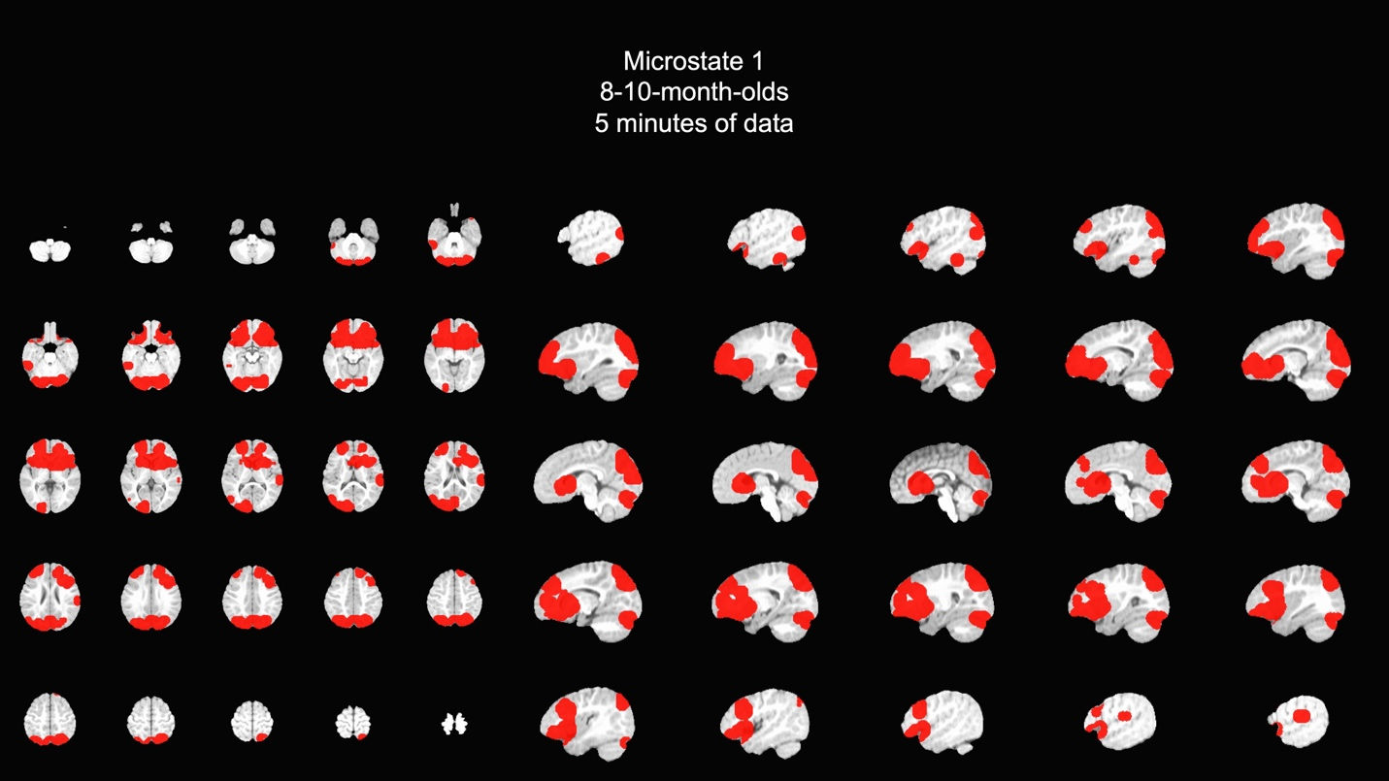

Microstate 2

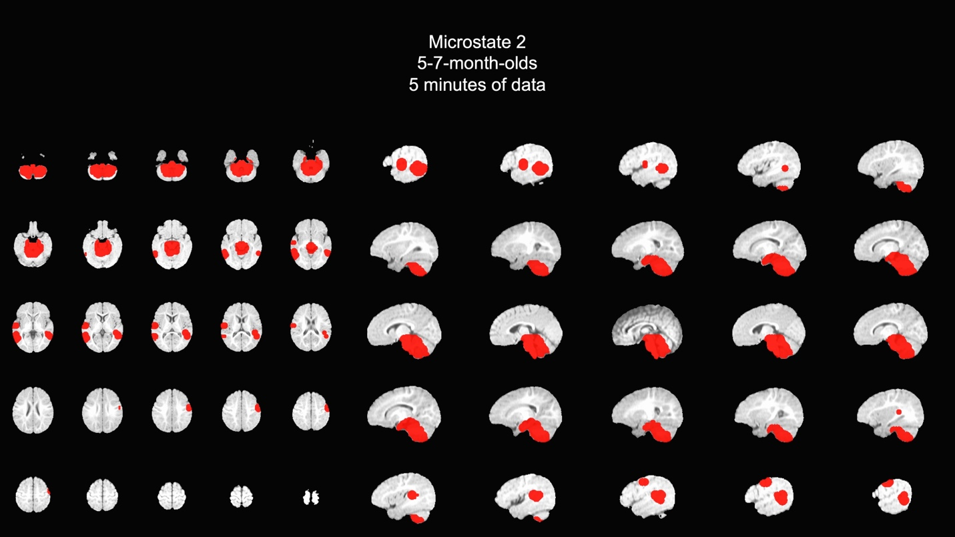

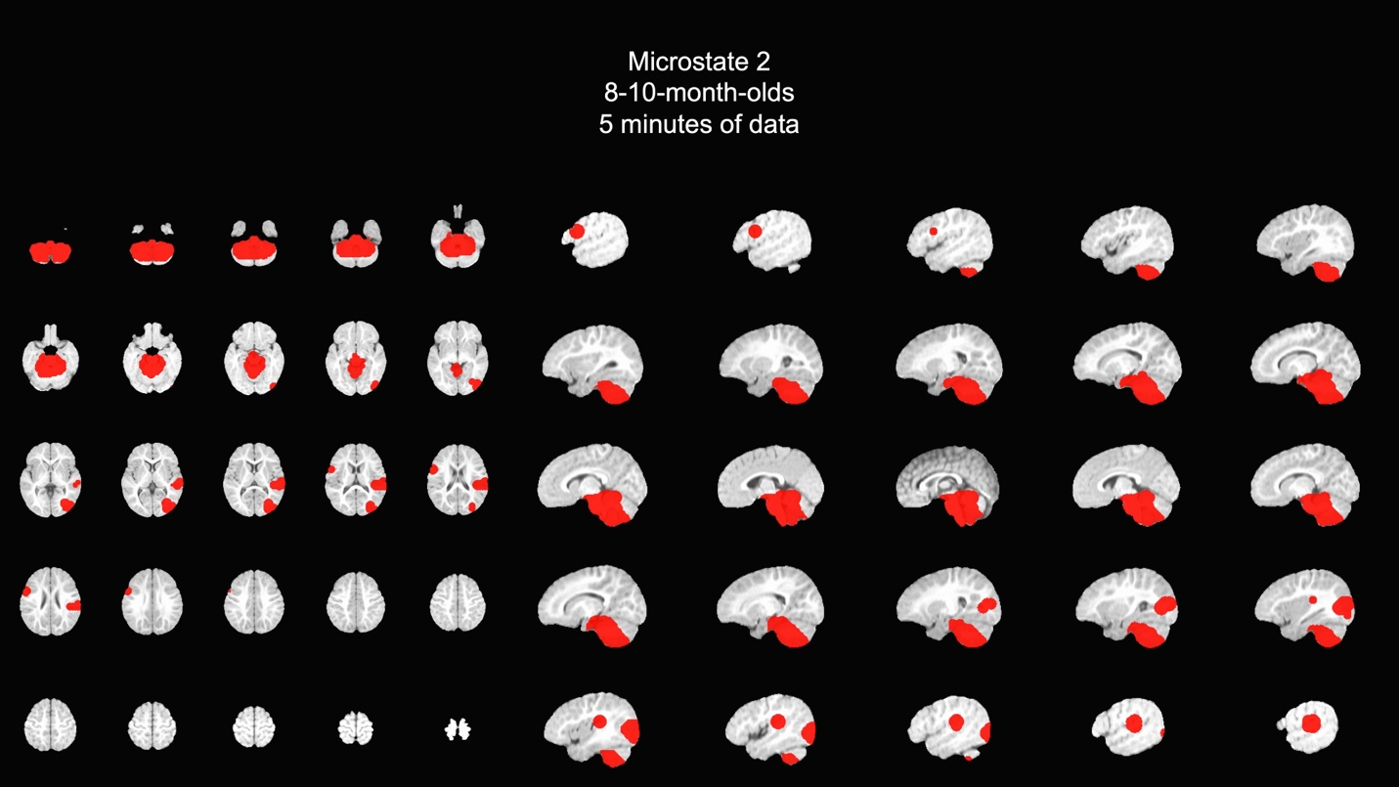

Microstate 3

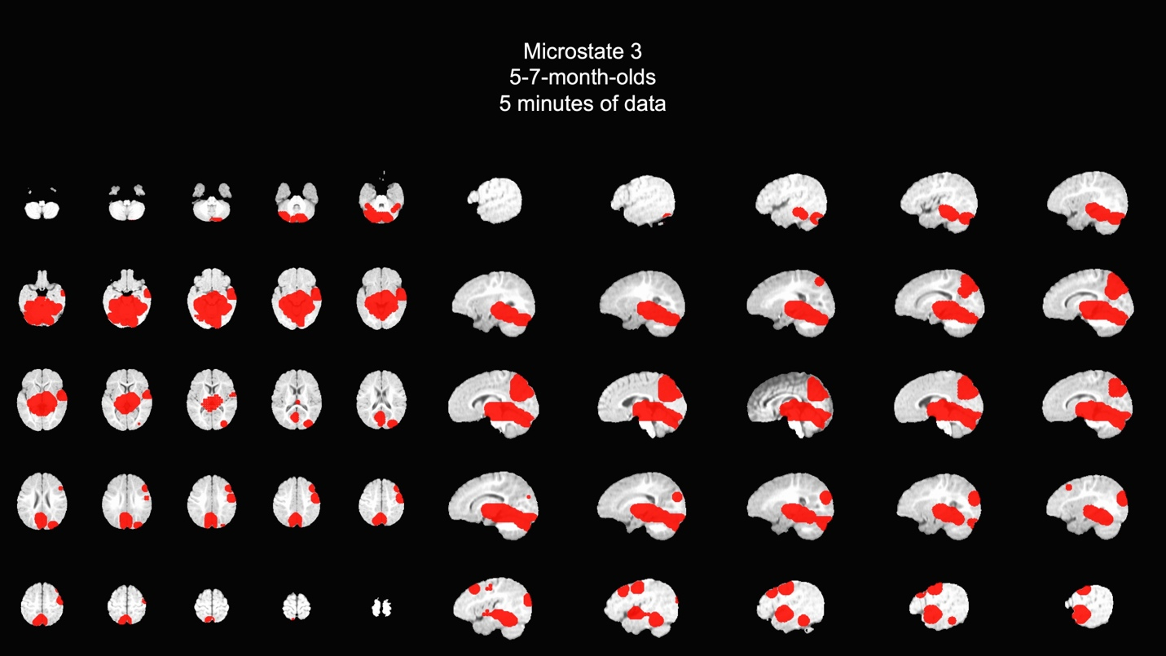

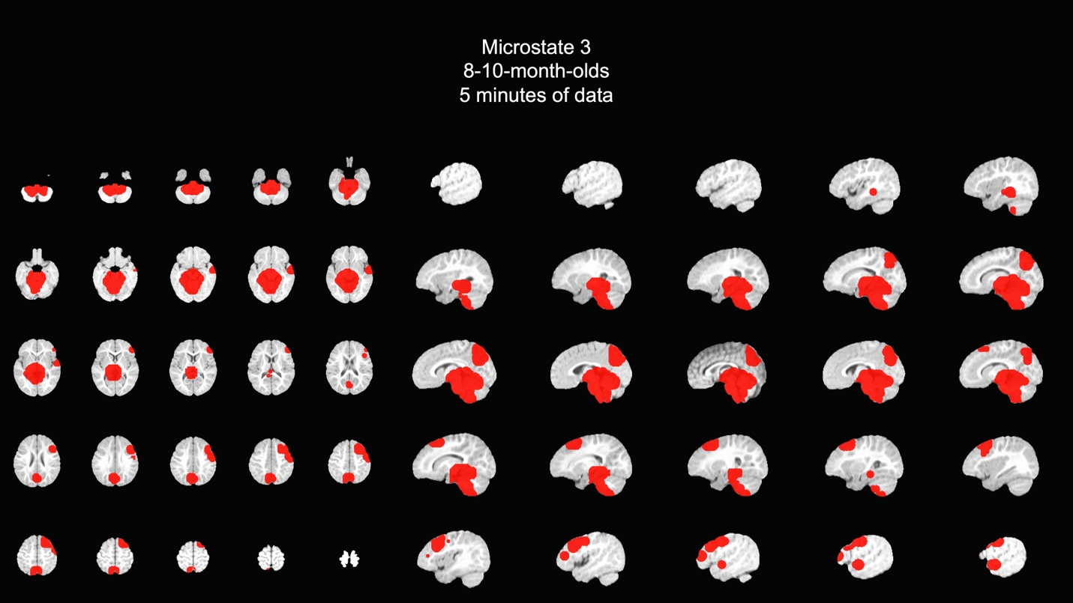

Microstate 4

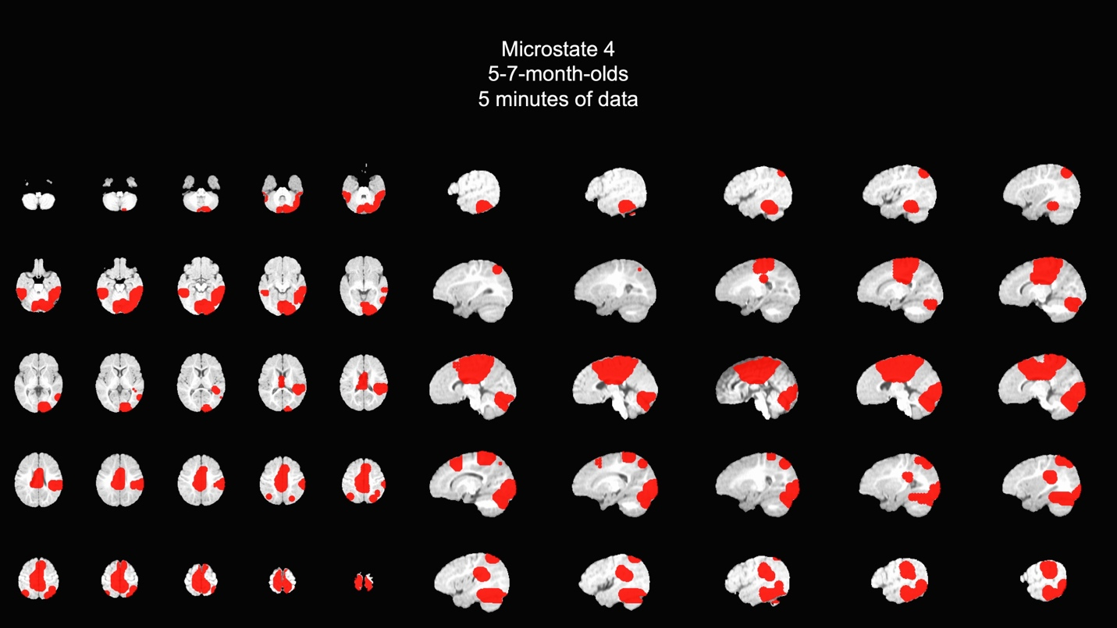

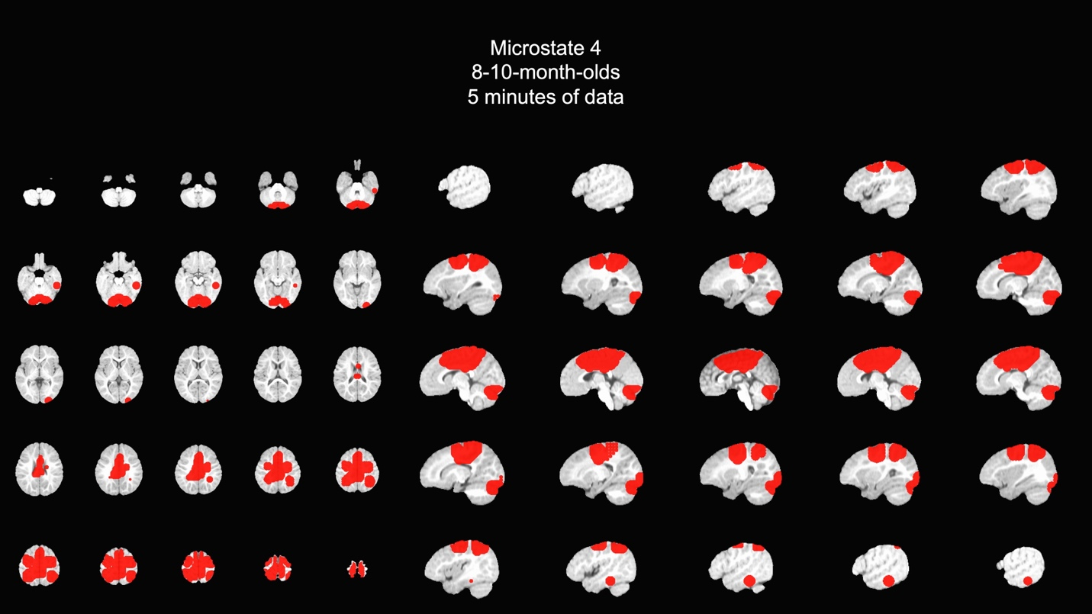

Microstate 5

