Supplementary Material
Appendix 1 (.JPG): Modified Newcastle-Ottawa scale (NOS): Randomised Control Trial

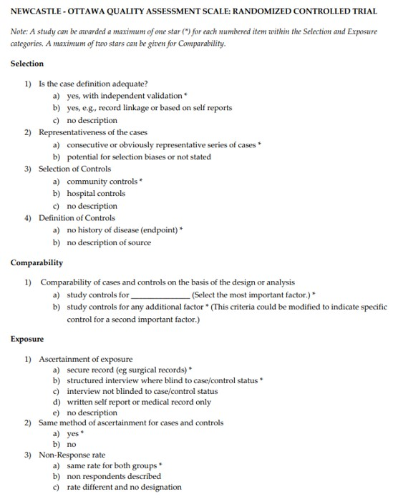

Appendix 2 (.JPG): Risk of bias of included studies

