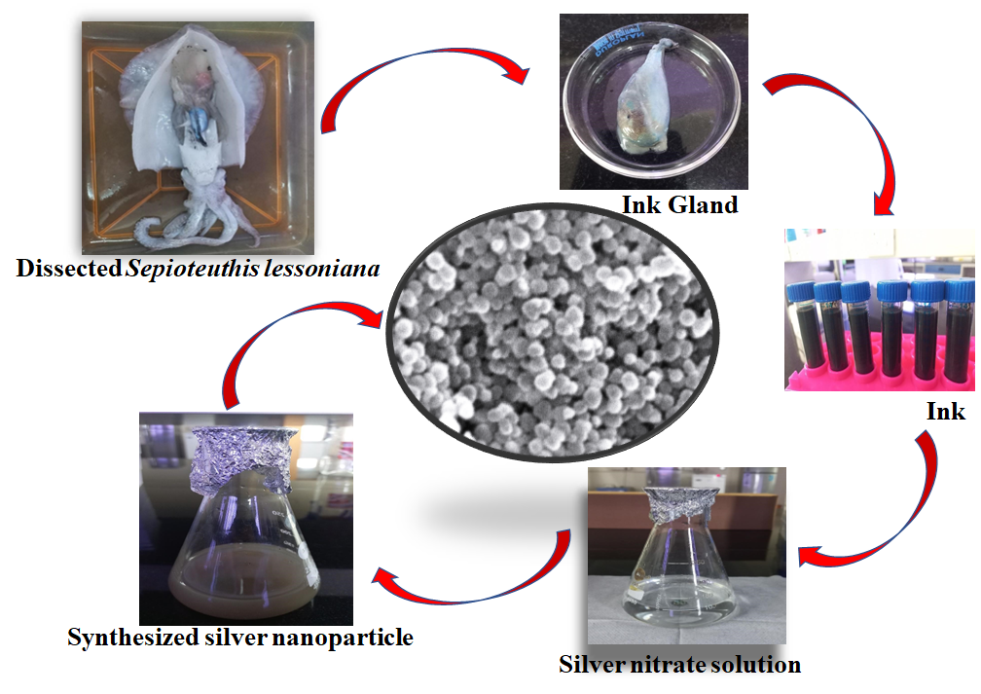

Supp Fig 1: Flow chart showing synthesis method of SI-AgNPs.

